Rishita Gupta

Your mail

Library management system

In this modern era of the internet, almost all of us rely on web-based applications from small to big tasks. Well, Library management system is one of the most popular use-cases considered by the professionals while building applications in Java.

[High level design (hld)]

[Library management system]

Objective/ Vision

A library management software where admin can add/view/delete librarian and librarian can add/view books, issue, view issued books and return books.

Users of the System

1. Libraian

Functional Requirements

**1. Librarian**

1. Can add/edit/delete/view books
2. Can issue books
3. View issued books
4. Return Books
5. Can logout

Tools to be used

1. Use eclipse IDE to develop the project.
2. MySQL for the database.

Front End and Back End

1. **Front End:** Servlet , JSP.
2. **Back End:** MySQL , Java

.

Introduction

**INTRODUCTION**

The Library management system in java is developed using JSP and servlets. It uses MYSQL to manage the backend activities. This java project is using maven to manage the dependencies and follows MVC architecture to manage the project resources.

It uses a tomcat server for deployment and we can use eclipse, as IDE to run this project.

Let’s understand the features and functionalities of the library management system in detail according to the module and application actors.

So there are one main actors of the application User.

## Objective of library management

The objective of the library management system is to design a web application in java that can manage a library. An easy and user-friendly interface that is easy to operate and understand for the students as well as for librarians.  An Easy platform to manage books and the records of books like the issued book and the student records.

**1) librarian:**

The librarian can Add/edit/update the record of students.

The librarian can Add/edit/update the record of Books.

The librarian can Search Books.

The librarian can Search Students.

The librarian can Issue books and library cards.

**2)User(Student):**

A student can register in the system

A student can view his profile(Edit/Update).

A student can check the history of issuing books.

## Technologies and Platform

**Library management** software is being designed and developed on an Open Platform i.e. J2EE. MYSQL will be used to maintain the database. To achieve a high degree of modularity, scalability, and maintainability, it is recommended to adopt n- tier architecture while designing the Library management System.

Accordingly, it is proposed that the entire application development logic, database logic, and presentation logic shall be segregated. It is proposed that the LMS software package shall be running on Apache Tomcat Web Server. The Web Server will be responsible for rendering the JSP pages and the result is shown back to the end-user.

**Hardware requirements**

* 4 GB of RAM with 20GB HDD.

**Software requirements**

* OS platform which supports JDK(Java) Like windows, mac, or Linux.
* JDK 1.8
* Eclipse.
* MYSQL v5.6 or above.
* Tomcat 8.5 or above.

## Library Management Project Source code

**In package com.ineuron.controllers :-**

(MainController Method) –

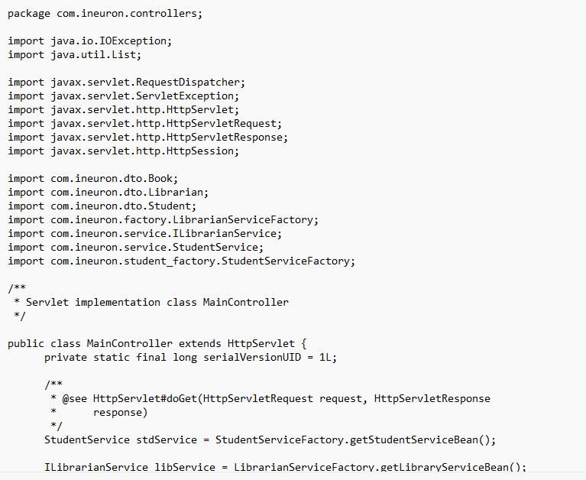

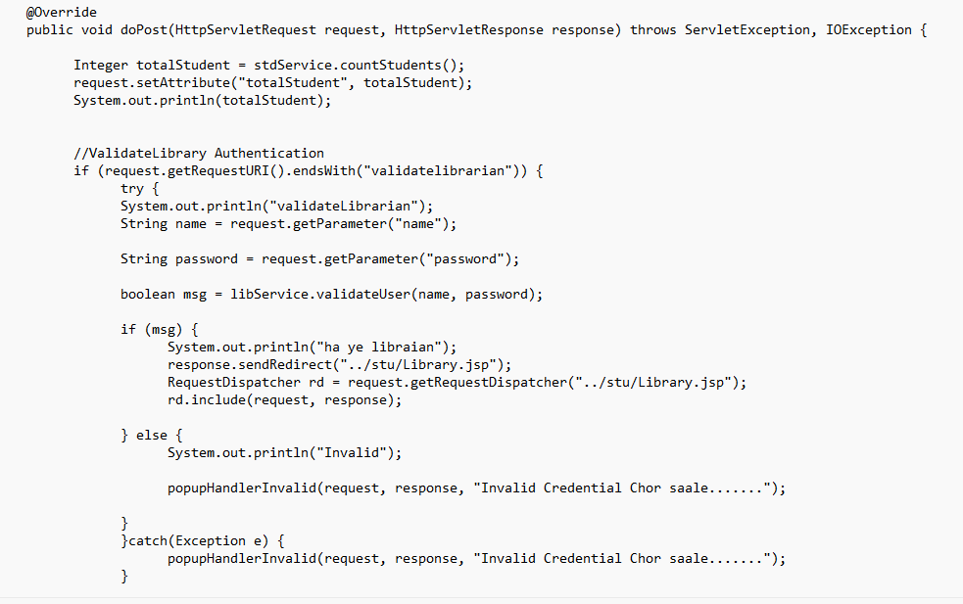

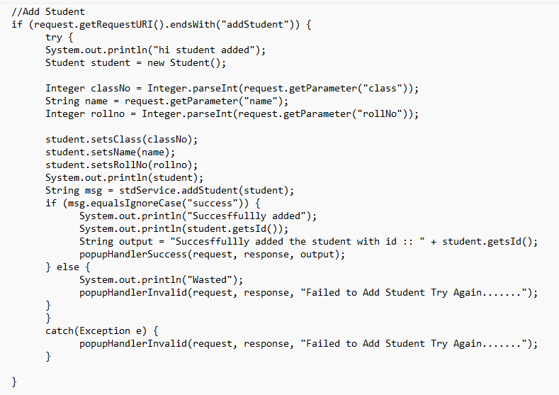

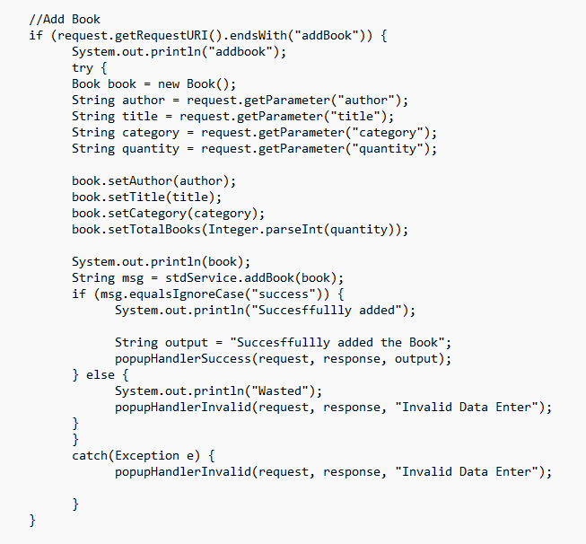

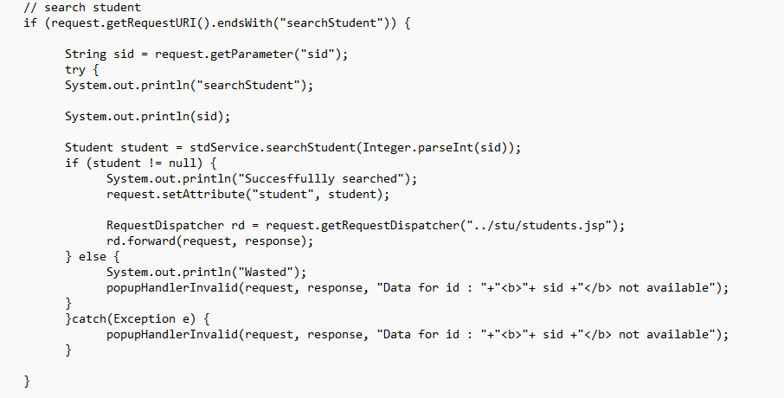

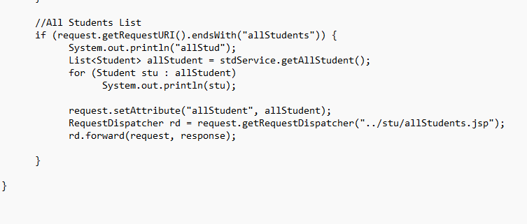

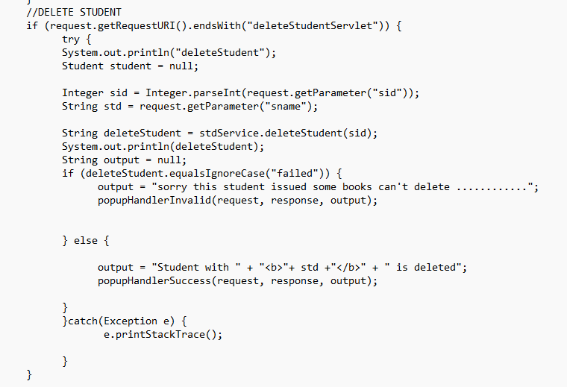

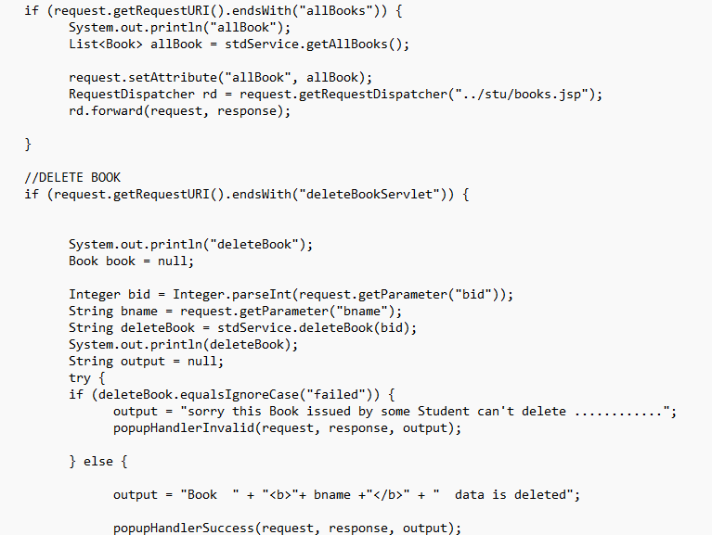

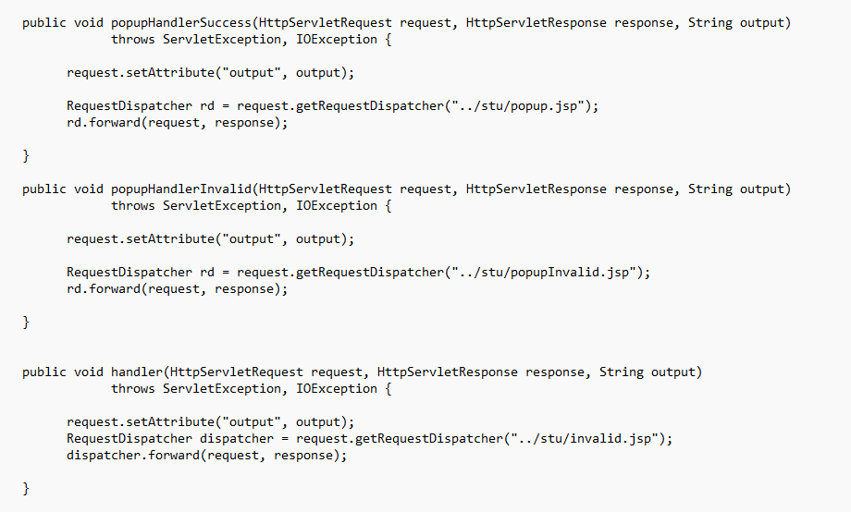

(StudentServlet Method)

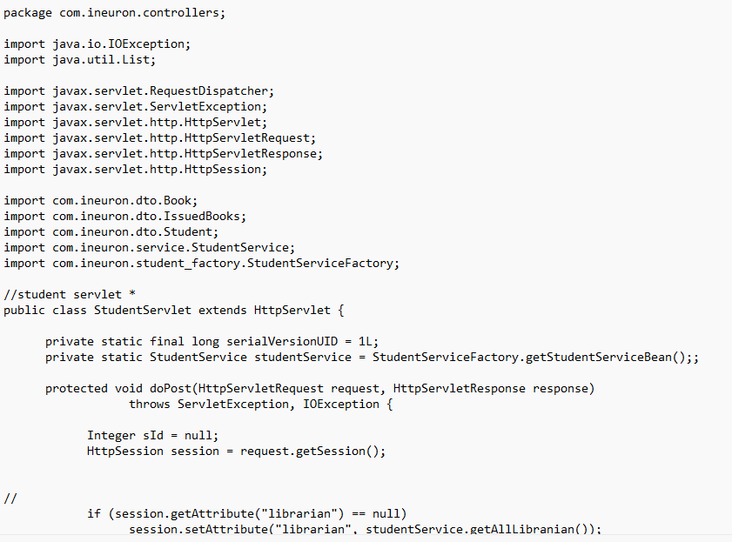

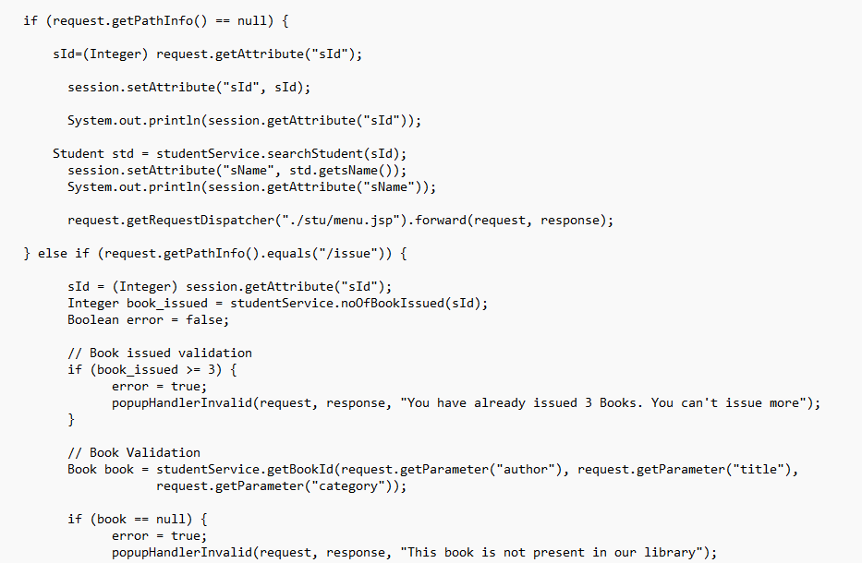

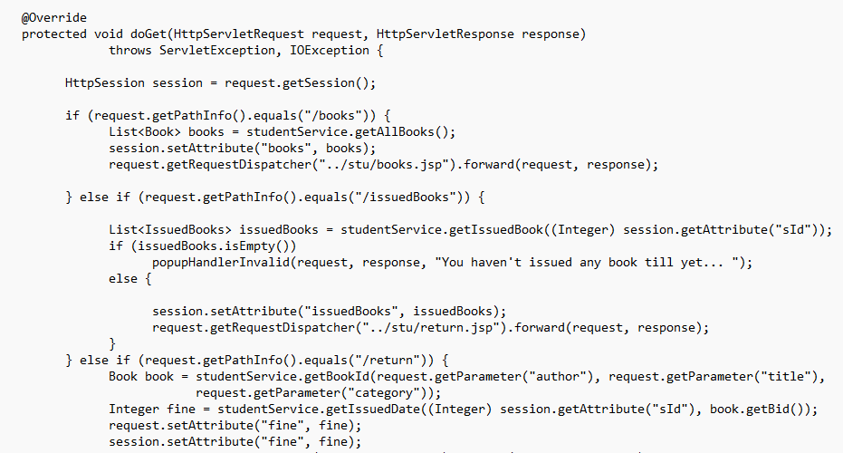

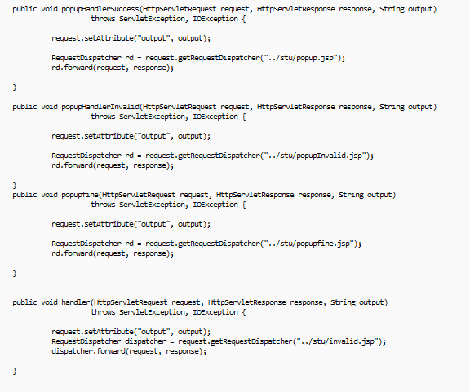

**In package com.ineuron.dto :-**

(Book Method) –

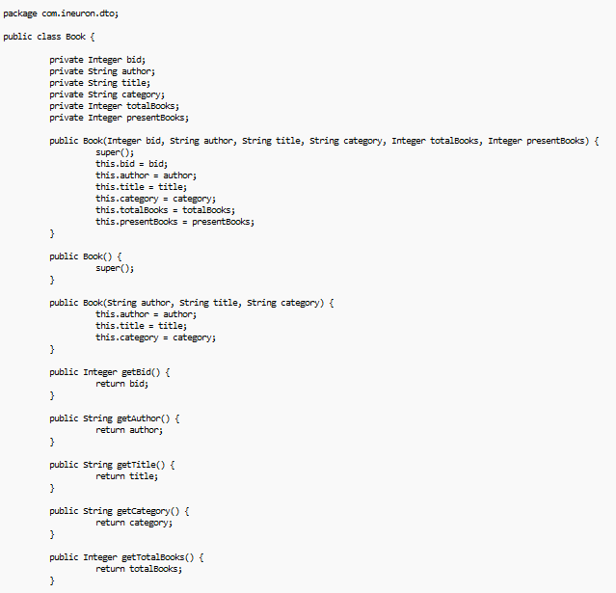

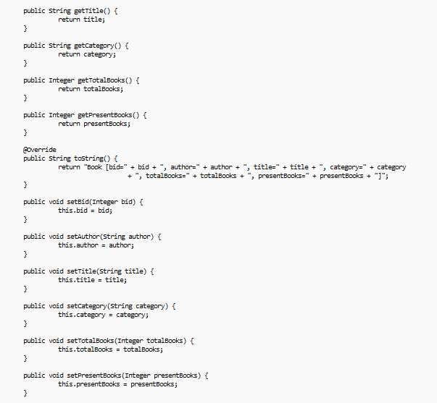

(IssuedBooks Method) –

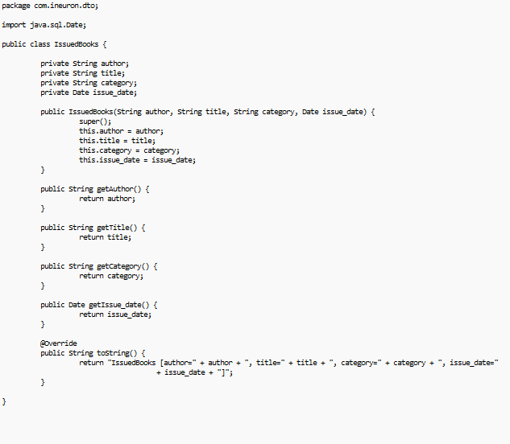

(Librarian Method) –

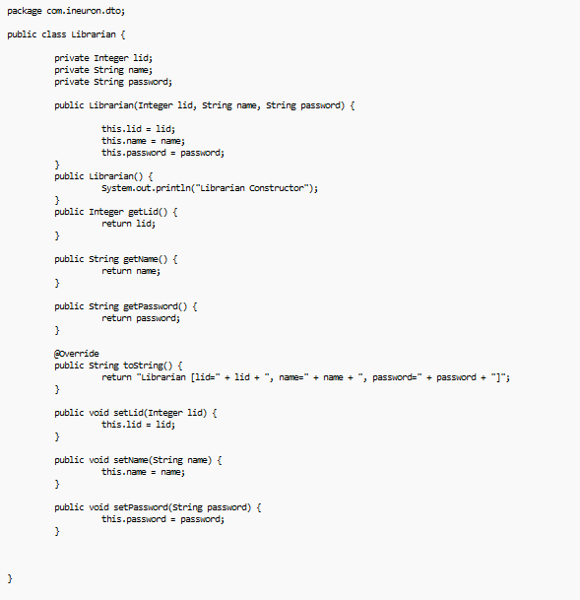

(Student Method) –

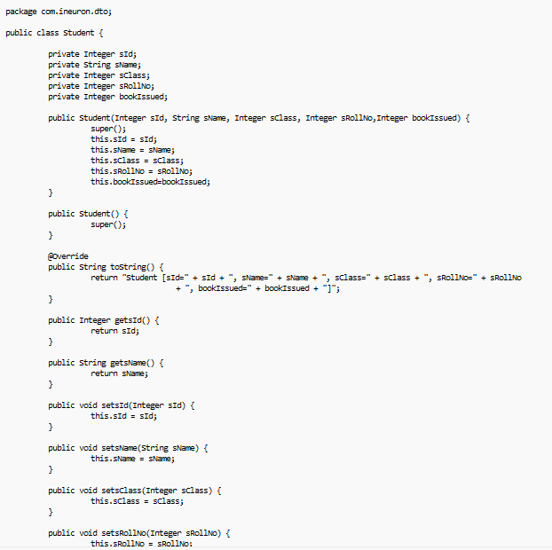

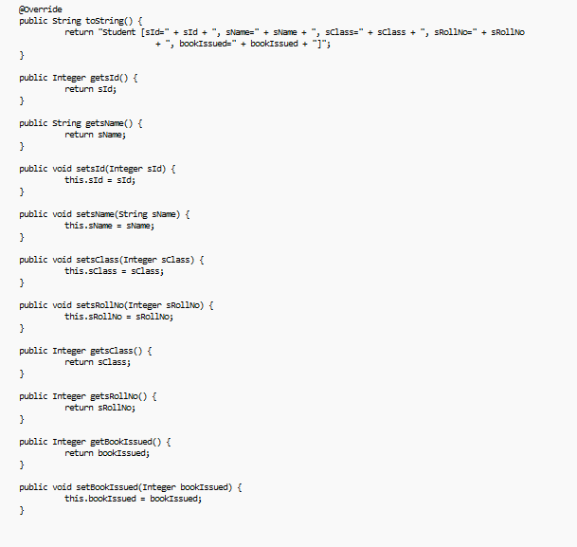

**In package com.ineuron.factory :-**

(LibrarianServiceFactory Method) –

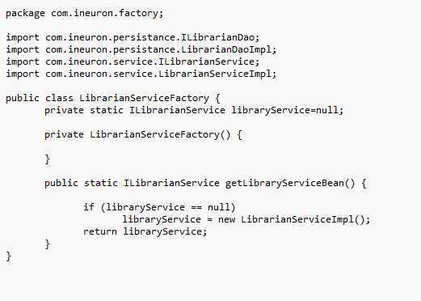

(LibrarianDaoFactory Method) –

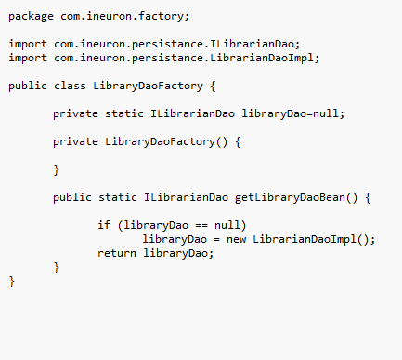

**In package com.ineuron.filters :-**

(StudentFilter Method) –

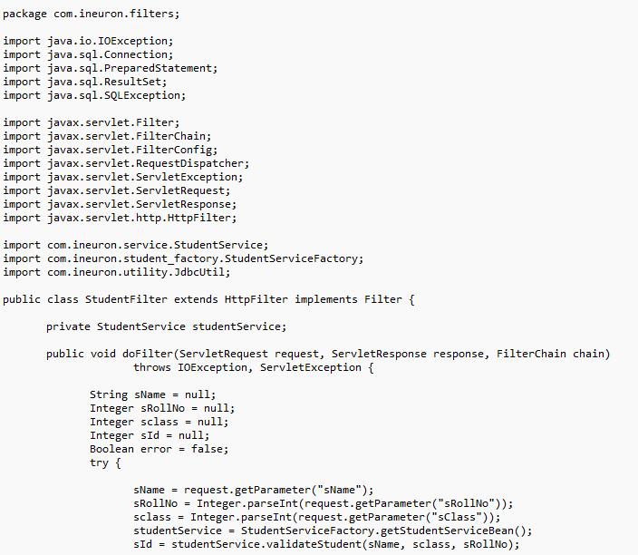

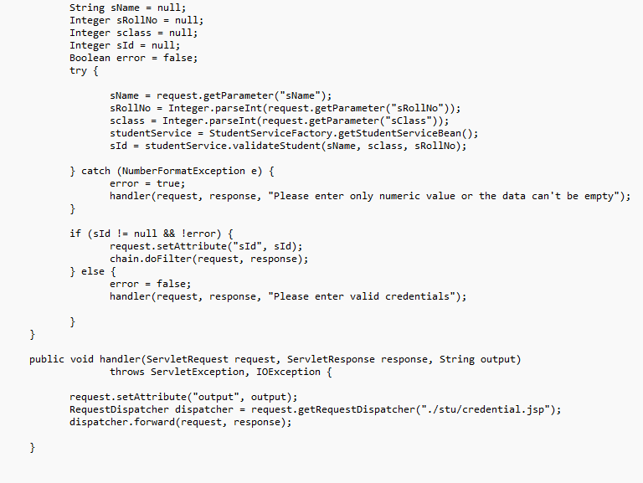

**In package com.ineuron.persistance :-**

(ILibrarianDao Method) –

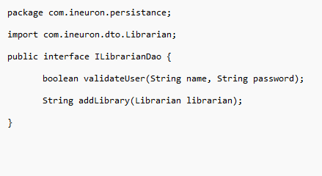

(LibrarianDaoImpl Method) –

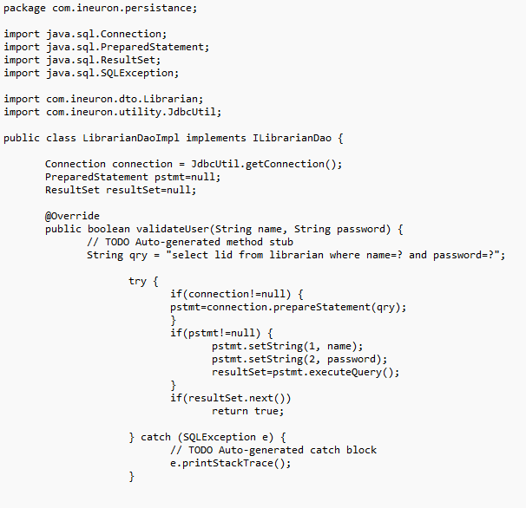

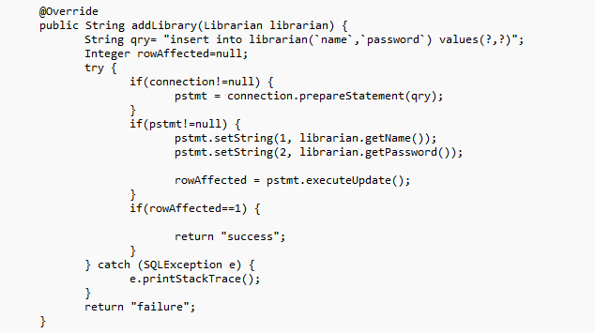

(StudentDao Method) –

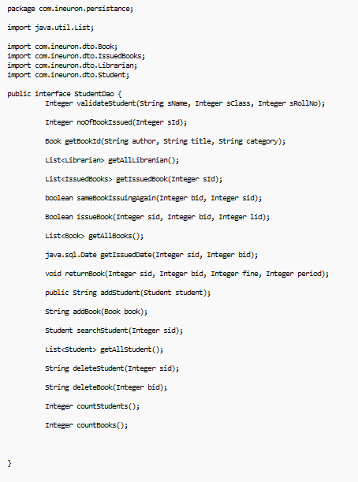

(StudentDaoImpl Method) –

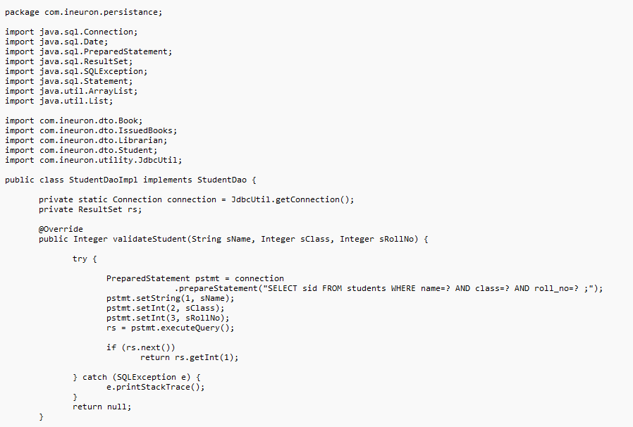

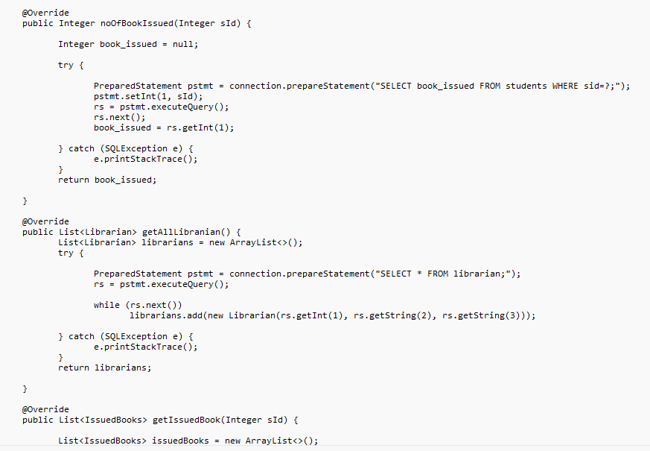

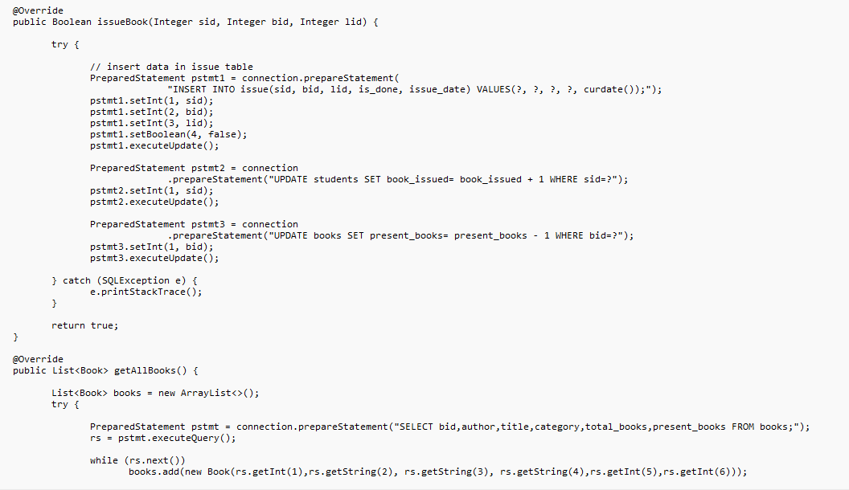

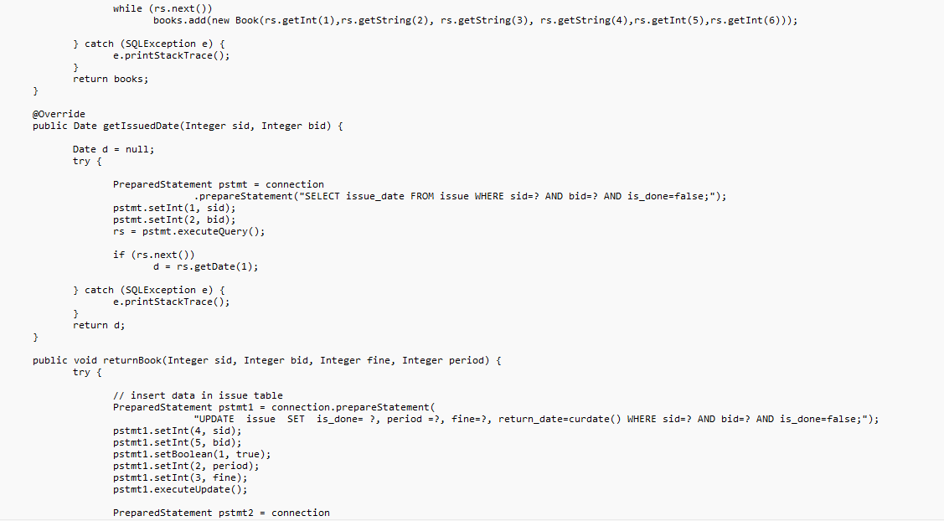

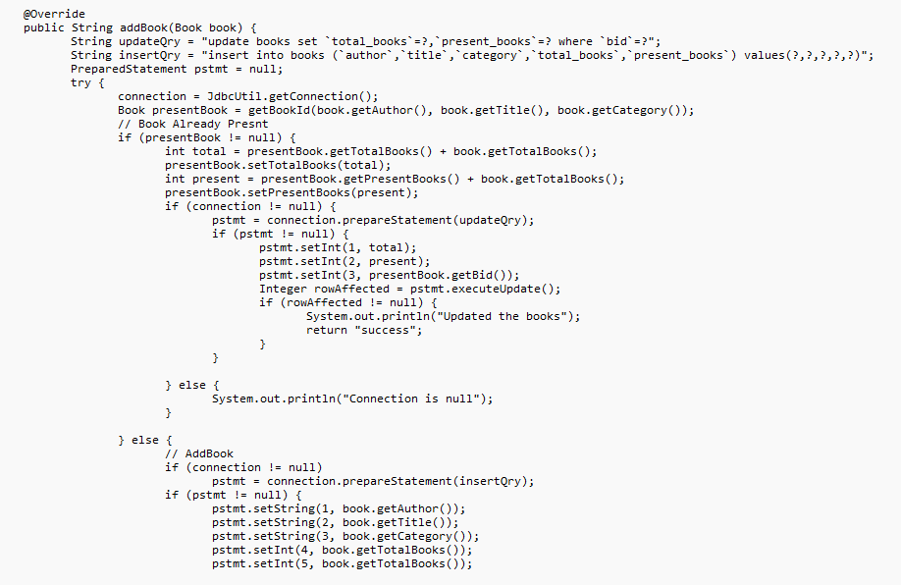

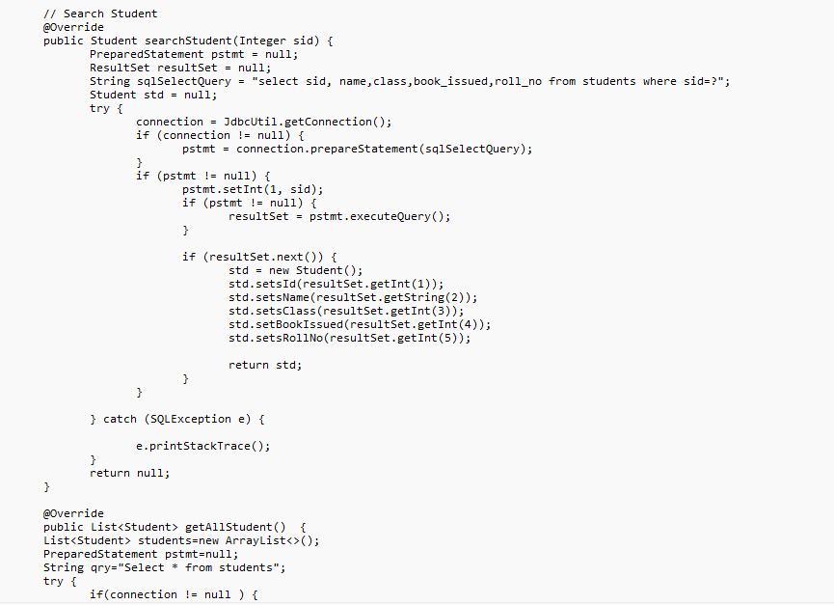

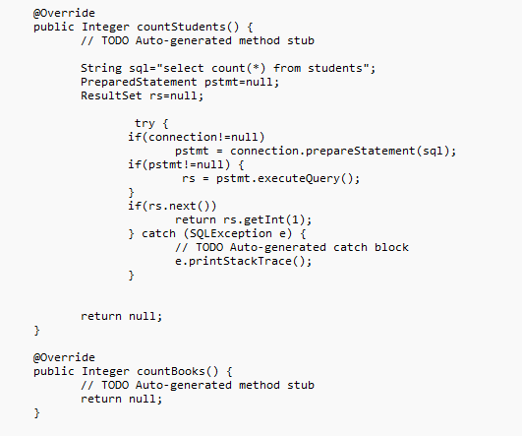

**In package com.ineuron.properties :-**

(Application properties File) –

url=jdbc:mysql:///octbatch

username=root

password=Salam@785

**In package com.ineuron.service :-**

(ILibrarian Method) –

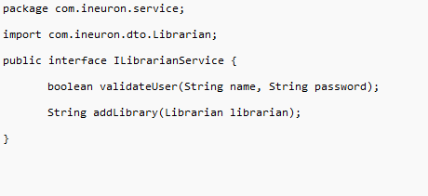

(LibrarianServiceImpl Method) –

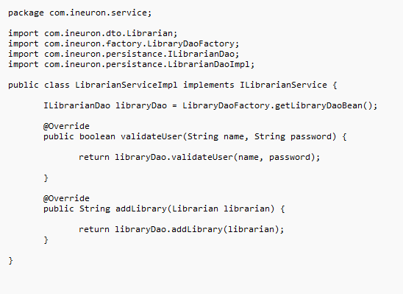

(StudentService Method) –

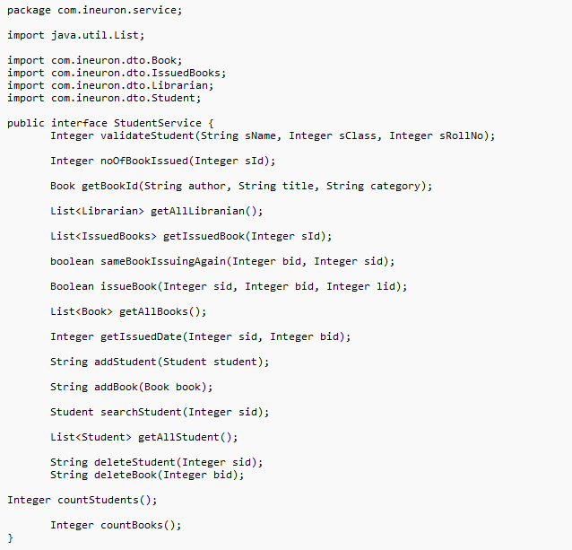

(StudentServiceImpl Method) –

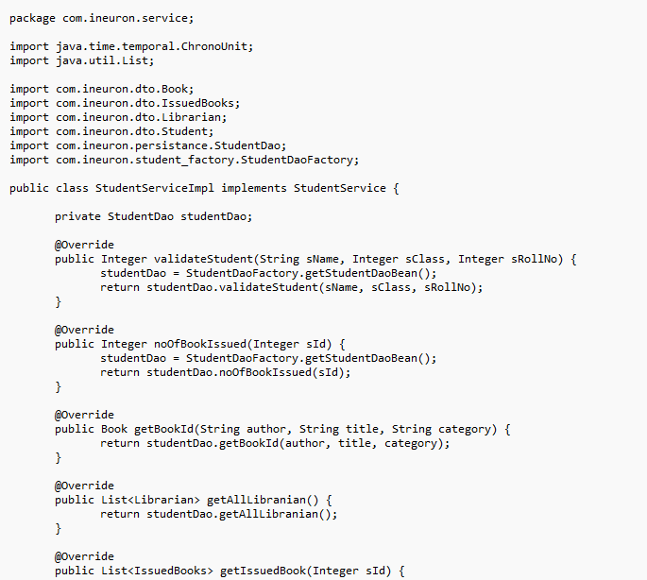

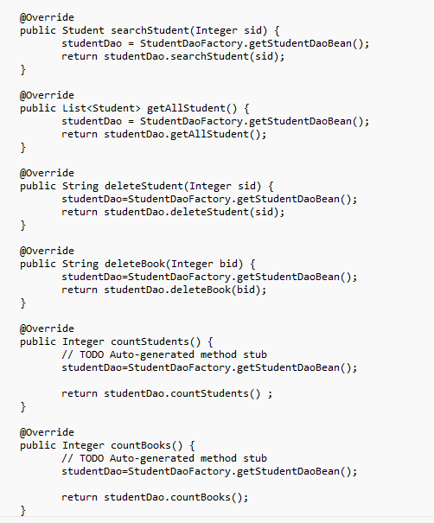

**In package com.ineuron.student_factory :-**

(StudentDaoFactory Method) –

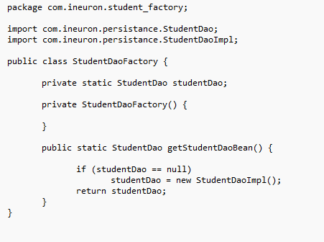

(StudentServiceFactory Method) –

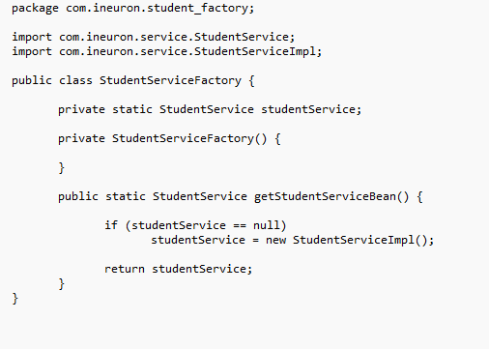

**In package com.ineuron.utility:-**

(JdbcUtil Method) –

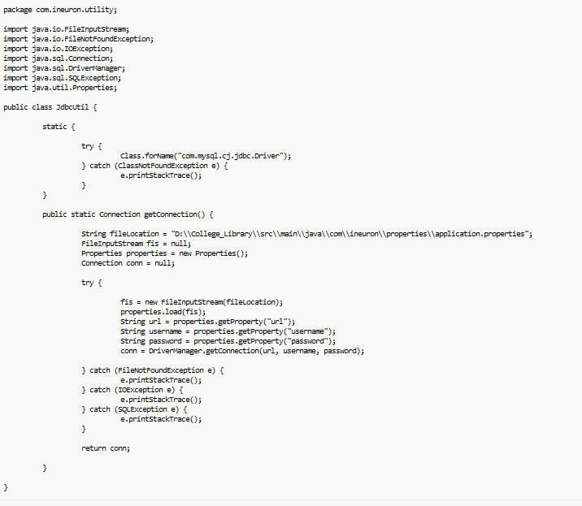

Conclusion

The Library Management System has become an essential tool for public libraries, school libraries, college libraries. The Library management system helps librarians to manage, maintain and monitor the library.

“ THANK YOU ”