INFT 2101 – Database Development Major Project

LRCH DATABASE DESIGN

Kuldeep Mohanta

Logan Spagnolo

Zulkifli Salami

Valentine Sah

INFT 2101

**Table of Contents**

Case Overview 2

Project Requirements 2

Specific Tasks and Challenges 2

Formal Introduction to Database Design 3

Introduction 3

Mission Statement 3

Project Deliverables 4

Functional & Non-functional Requirements 4

Contextual and Level 1 Data-Flow Diagrams 6

3NF Normalized Relational Schema in “shorthand” 7

Entity Relationship Diagram 8

Entity Relationship Diagram 9

Data Dictionary – LRCH Database Schema 10

SQL CREATE Scripts 11

SQL INSERT Scripts with Example Data 11

SQL SELECT – Examples of Data Usage 12

# Case Overview

* **Objective**: Develop a database design for LRCH.
* **Setting**: Lake Ridge Community Hospital, a not-for-profit short-term stay general hospital in Oshawa.
* **Issues Identified**: Current information systems are batch-oriented and have several deficiencies, such as lack of support for medical staff, paper-based treatment prescriptions, and inflexibility in data updating and management.

# Project Requirements

1. **Group Work**: Teams of 3-4 students to collaborate.
2. **Requirements Determination**: Engage in activities to fully define the problem. This includes interviewing the Professor (as a stakeholder simulation) and utilizing MS Teams for discussions and openness.
3. **Deliverables**:
   * Develop a formal report containing database design recommendations.
   * Create a development database using SQL Server with sample data.
   * Design SQL queries for various functionalities like Room Utilization, Physician-Patient Details, etc.
   * Considerations for views and stored procedures.
4. **Timelines & Due Dates**: Specific deliverables are due across different weeks, including draft introductions, mission statements, diagrams, SQL scripts, and presentations.

# Specific Tasks and Challenges

* **Data Handling**: Addressing patient record management, billing, and revenue reporting issues.
* **Design Elements**: Creating patient and physician displays and various reports (e.g., Daily Revenue Report, Room Utilization Report).
* **Database Development**: Including tables, relationships, and test data for patients, appointments, treatments, physicians, cost centres, etc.

# Formal Introduction to Database Design

## Introduction

Effective information management is crucial for delivering top-tier patient care in the evolving healthcare sector. Our team is tasked on an essential project with Lake Ridge Community Hospital (LRCH) to overhaul its information systems. LRCH currently grapples with outdated batch-oriented processes and reliance on paper-based prescriptions which pushes them to looking for a transformative database solution.

Implementing a successful data management (database) solution will not only improve the technical functionalities of LRCH, but it will have cascading impacts that will extend towards reduced technical errors, increased security and performance of information systems, and investment in future-proof infrastructure that will be able to handle future patient information with minimal conflict.

Our project focuses on comprehensive database design, introducing efficiency, accuracy, and accessibility to LRCH's data landscape. Through in-depth analysis and strategic planning, we aim to address existing deficiencies, streamline workflows, and pave the way for a modernized and agile information infrastructure.

## Mission Statement

Our mission is to revolutionize healthcare data management at Lake Ridge Community Hospital (LRCH). We share a profound purpose with LRCH—to enhance patient care through modernized information systems. This project aligns with LRCH's commitment to progressive, patient-centric healthcare.

With dedication, we aim to swiftly empower LRCH with an efficient database solution, ensuring rapid access to critical patient data. Our approach is meticulous and designed to excel in healthcare delivery.

This mission statement serves LRCH's leadership, medical staff, and stakeholders, pledging to benefit all organizational groups. It bridges the gap between traditional systems and the future of healthcare, supported by a well-thought-out plan. Our project uniquely aligns with LRCH's operations, providing immeasurable value by enhancing efficiency and patient care.

# Project Deliverables

## Functional & Non-functional Requirements

**Context:** *List and explain the functional (what the system should do) and non-functional requirements (system performance or usability standards).*

**Functional Requirements:**

1. **User Authentication and Authorization**:
   * The system should allow authorized users, including hospital staff and administrators, to log in securely.
   * Different user roles should have varying levels of access to the system.
2. **Patient Information Management**:
   * The system should enable the addition, retrieval, update, and deletion of patient records.
   * It should maintain comprehensive patient information, including personal details, medical history, and contact information.
3. **Appointment Scheduling**:
   * The system should provide a scheduling feature to book and manage patient appointments.
   * It should allow staff to view, edit, and cancel appointments.
4. **Prescription and Medication Management**:
   * The system should support the creation and management of electronic prescriptions.
   * It should include a medication database for easy prescription selection.
5. **Billing and Financial Management**:
   * The system should generate bills for patients based on their treatment and services.
   * It should record financial transactions, including payments and outstanding balances.
6. **Reports and Analytics**:
   * The system should generate various reports, such as patient demographics, billing summaries, and appointment statistics.
   * It should provide data analytics capabilities to identify trends and insights.
7. **Data Security**:
   * Patient data should be encrypted and stored securely to comply with privacy regulations.
   * Access to sensitive data should be restricted based on user roles.

**Non-Functional Requirements:**

1. **Performance**:  
   * The system should respond quickly to user requests, with a maximum response time of 2 seconds (ideally) for common operations.
   * It should handle concurrent users efficiently, supporting multiple users, information requests, etc.
2. **Reliability**:  
   * The system should have a priority on up-time (ideally 99.9%) for reliability.
   * Regular backups of data should be performed to prevent data loss.
3. **Scalability**:  
   * The system should be scalable to accommodate future growth in the number of patients and staff.
   * It should support increase(s) in usage without performance degradation.
4. **Usability**:  
   * The user interface should be intuitive and user-friendly to minimize training requirements.
   * It should be accessible from different devices, including desktop and mobile.
5. **Security**:  
   * The system should implement role-based access control (RBAC) to ensure data security.
   * Data transmission should be encrypted using industry-standard protocols.
6. **Support and Maintenance**:  
   * The system should have a support and maintenance plan in place, including regular updates and bug fixes.
   * Technical support should be available during business hours.

## Contextual and Level 1 Data-Flow Diagrams

**Context**: *Create diagrams that represent the current data flow and processes at Lake Ridge Community Hospital (LRCH).*

A Level 1 Data Flow Diagram (DFD) provides a more detailed insight into an information system's subsystems and internal processes. It expands on the overview provided by a Level 0 DFD by decomposing the main system process into several subprocesses, detailing the flow of information between them and how they interact with data stores and external entities.

The image depicts a Level 1 DFD for a healthcare system, breaking down the interactions between patients, physicians, rooms, and treatments. It illustrates how patient information flows from an external entity to room assignments, physician analysis, and treatment procedures, which subsequently inform cost estimations in the cost center.

## 3NF Normalized Relational Schema in “shorthand”

**Context**: Develop a database schema in the Third Normal Form (3NF) to ensure data integrity and reduce redundancy.  
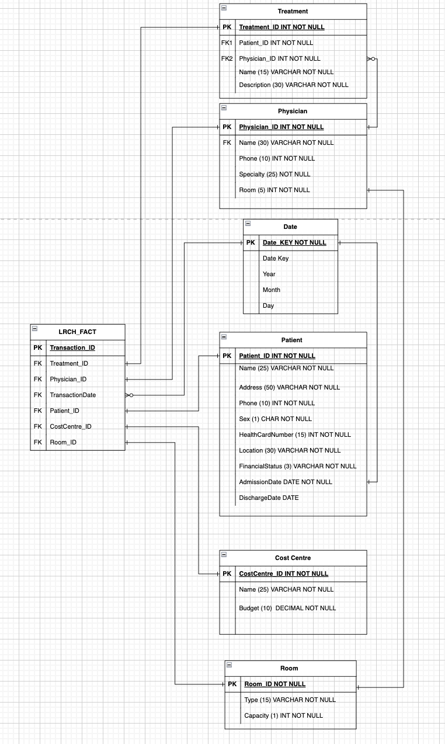

This diagram serves as a roadmap for building the database, ensuring all necessary information is captured accurately and efficiently.

It is an essential tool for understanding the flow of data and the relationships between different elements of hospital operations.

## Entity Relationship Diagram

What is the purpose of the ERD?

This diagram shows all of the entities that are in the LRCH database and shows their attributes as well as their interactions with each other.

At the heart of this diagram, we have the patients. Each patient's record includes their name, where they live, phone number, and other personal details. Patients are linked to the doctors treating them and the specific treatments they receive, such as medications or surgeries.

Doctors, on the other hand, have their section in this diagram. For each doctor, there's information like their name, contact number, and their area of expertise, such as cardiology or pediatrics. The diagram shows which doctor is responsible for which patient and which room they use for treatments.

Then there are treatments, which are like the services the hospital offers. Each treatment is carefully recorded with a unique ID, what it's called, and a description. Also, a part deals with the financial side, showing which department is responsible for the cost of treatments. This helps the hospital keep track of their budget and expenses.

Lastly, a calendar within the diagram breaks down when each treatment happens, keeping everything organized by year, month, and day.

## Entity Relationship Diagram

**Context**: *Create a diagram illustrating the database's relationships between data entities.*

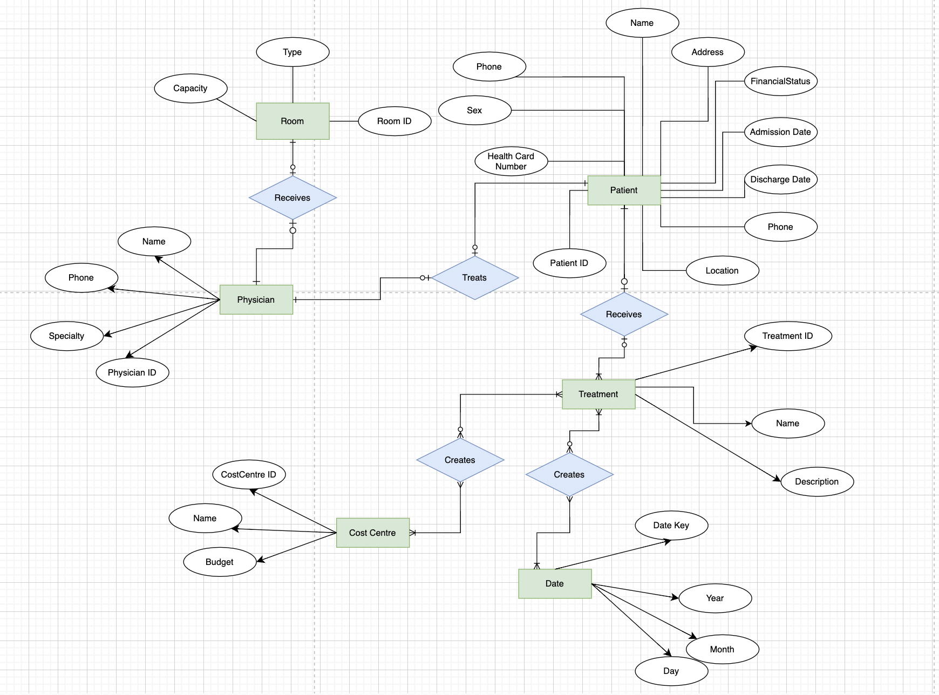

## Data Dictionary – LRCH Database Schema

**Context**: Prepare a comprehensive dictionary defining data elements, types, and their respective meanings within the database.

A data dictionary is a reference guide detailing each piece of data in a database, including its meaning, relationships, format, and usage. It's useful because it ensures consistency and clarity, helping users understand and correctly use the database's components.  
  
For Lake Ridge Community Hospital (LRCH), detailed documentation of each database table is vital. This includes thorough descriptions of table attributes, meticulous attention to data type formatting, and clarity on whether certain data types are mandatory. Identifying where Primary Keys and Foreign Keys are utilized and referenced is also critical. Such meticulous documentation ensures sustained accuracy, performance, and functionality of the database over time. As the system evolves and scales, this level of detail in the database structure will be instrumental in maintaining its integrity and efficiency.  
  
Below is an image preview of the Excel document that contains the Data Dictionary, this document is also attached within the report as a standalone Excel file for further review/inspection.

## SQL CREATE Scripts

**Context**: Write SQL scripts for creating database tables and other necessary structures.

The SQL creation scripts for this database serve to establish the foundational structure of the Lake Ridge Community Hospital's information system. They define and create essential tables like **Patient**, **Physician**, **Treatment**, and **FinancialTransaction**, among others. These tables are intricately designed to store crucial data ranging from patient details and treatment records to financial transactions.   
  
The scripts ensure data integrity and relationships between different entities, such as linking patients with their treatments and physicians. By dropping existing tables and recreating them, these scripts provide a clean start for the database, ensuring that it is up-to-date and reflective of current hospital operations and requirements. This setup is vital for efficient data management and retrieval, facilitating smoother hospital administration and patient care.

## SQL INSERT Scripts with Example Data

**Guidance**: Develop scripts to insert sample data into the database for testing purposes.

The SQL insert statements help to populate the newly created tables with initial data, crucial for the operational simulation of Lake Ridge Community Hospital's (new Database) information system. These insertions cover a wide range of essential data**: patient demographics, physician details, treatments provided, financial transactions**, and more.

By feeding in an appropriate amount of data that could simulate a hospital system, the system becomes more true-to-life as a proposal. By creating and utilizing specific data for each table, like patient names, addresses, treatment types, and transaction details, the script creates a realistic and functional dataset.   
  
This data not only allows for practical demonstrations of the database's capabilities but also enables thorough testing and analysis. It's essential for generating meaningful reports, analytics, and ensuring that the database can handle real-life scenarios effectively, such as tracking patient treatments, managing financial transactions, and maintaining physician assignments. This process is a critical step in bringing the database to a state where it can be effectively utilized for both professional and hypothetical hospital management purposes.

## SQL SELECT – Examples of Data Usage

**Context**: Provide SQL query examples to demonstrate how data can be retrieved and utilized.

There are several realistic datasets and queries that were made to simulate a real hospital database system, here are a few examples for the report:

**Patient Financial Summary for Specific Date  
(file name: DailyRevenueReport.SQL)**

This SQL query generates a financial summary for each patient treated on a specific date ('2023-04-10'). It lists patient IDs, names, locations, financial sources, associated cost centers, item codes, descriptions, charges, and total transaction amounts, ordering the data by patient ID.

**Detailed Patient Financial Statement for Specific Date**

**(file name: ExamplePatientBillReport.SQL)**

This SQL query provides a comprehensive financial statement for a specific patient (ID '1001') on a specific date ('2023-01-05'). It includes the patient's details, cost center, item charges, total charges, and balance due, ordered by cost center name and transaction date.

**Daily Physician-Patient Interaction Report**

**(file name: PhysicianPatientReportQuery.SQL)**

This SQL query generates a report detailing the interactions of a specific physician (ID '2001') with patients on a given day ('2023-01-01'). It includes physician and patient IDs, names, patient location, admission, and discharge dates, ordered by admission date.

**Weekly Cost Centre Financial Summary**

**(file name: RevenueAnalysis.SQL)**

This SQL query summarizes financial transactions for each cost centre in a specific week (from '2023-04-09' to '2023-04-16'). It displays the number of transactions, total charges, and amounts categorized by transaction types (Assure, ESI, Self Pay, Other) for each cost centre, ordered by centre ID.

**Current Patient Room Occupancy as of Specific Date**

**(file name: RoomUtilizationReportQuery.SQL)**

This SQL query lists the occupancy of hospital rooms as of '2023-12-06', showing each room's ID, type, and occupied patient details, including patient ID, name, and admission date, ordered by room ID.

**Daily Patient Discharge Count**

**(file name: BedsDischargingToday.SQL)**

This SQL query calculates the number of patients scheduled for discharge from the hospital on the current day, using the system's date as a reference.

**Current Empty Beds by Room Type**

**(file name: EmptyRoomsByRoomType.SQL)**

This SQL query calculates the number of empty beds in the hospital, grouped by room type. It differentiates between occupied and unoccupied rooms based on patient discharge dates and current dates.

**Current Empty Beds by Room Type**

**(file name: OccupyByRoomType.SQL)**

This SQL query calculates the number of empty beds in the hospital, grouped by room type. It differentiates between occupied and unoccupied rooms based on patient discharge dates and current dates.

**Total Number of Currently Occupied Beds**

**(file name: OverallOccupancyBeds.SQL)**

This SQL query calculates the total number of beds currently occupied in the hospital, based on patients who have not been discharged as of the current date.

**Total Number of Currently Occupied Rooms**

**(file name: OverallOccupancyRooms.SQL)**

This SQL query determines the total number of different hospital rooms currently occupied, considering patients whose discharge date is either not set or is after the current date.