Image Classification Assignment
Traditional ML to Deep Learning — ISIC-2019 Skin Lesion Classification
Nolyth Software House — AI Bootcamp (Associate AI Engineer Track)
Prepared by: Abdul Salam
Team Lead: Fateh

1. Objective
This assignment builds an end-to-end image classification pipeline on the ISIC-2019 skin lesion dataset, progressing through five model families of increasing sophistication:
- Traditional Machine Learning — SVM and KNN
- Vanilla Artificial Neural Network (ANN)
- Custom Convolutional Neural Network (CNN)
- Custom CNN with Data Augmentation
- Transfer Learning with pretrained CNNs (ResNet50, MobileNetV2)
Beyond producing a working classifier, the exercise is designed to demonstrate why each architectural choice affects accuracy the way it does — and to report results honestly, including cases where a technique underperformed expectations.

2. Dataset
Source: ISIC-2019 (andrewmvd/isic-2019 on Kaggle) — dermoscopic images across 8 diagnostic classes: melanoma (MEL), melanocytic nevus (NV), basal cell carcinoma (BCC), actinic keratosis (AK), benign keratosis (BKL), dermatofibroma (DF), vascular lesion (VASC), and squamous cell carcinoma (SCC).
Total available: 25,331 labeled images, severely imbalanced (NV: 12,875 vs. DF: 239 — a ~54:1 ratio).
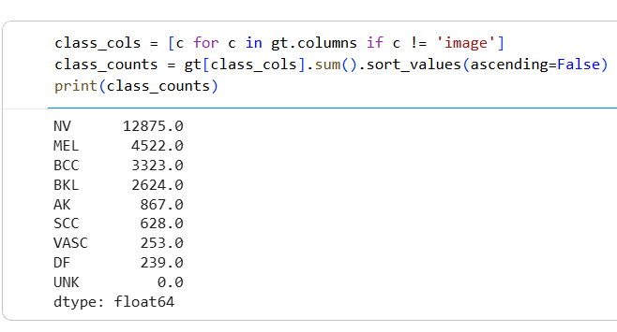
Figure 1: Raw class distribution in the full ISIC-2019 training set.

2.1 Sampling Strategy
Rather than using the full dataset or artificially balancing it, a deliberate sampling strategy was used: majority classes (NV, MEL, BCC, BKL) were capped at 1,200 images each, while minority classes (AK, SCC, VASC, DF) were taken in full since none reached the "thousands" volume the brief called for. This preserves natural imbalance rather than masking it with synthetic oversampling — a decision documented explicitly rather than hidden.
Class | Total in Dataset | Sampled | Train / Val / Test
NV | 12,875 | 1,200 | 840 / 180 / 180
MEL | 4,522 | 1,200 | 840 / 180 / 180
BCC | 3,323 | 1,200 | 840 / 180 / 180
BKL | 2,624 | 1,200 | 840 / 180 / 180
AK | 867 | 867 | 607 / 130 / 130
SCC | 628 | 628 | 439 / 94 / 95
VASC | 253 | 253 | 177 / 38 / 38
DF | 239 | 239 | 167 / 36 / 36
Total sampled: 6,787 images, split 70% / 15% / 15% (train / validation / test) using stratified sampling to preserve class proportions across all three splits.

2.2 Preprocessing
- Images resized to 224×224 (matching pretrained transfer-learning input requirements, avoiding redundant re-resizing later)
- Pixel values normalized to [0, 1]
- For SVM/KNN specifically: further downsized to 32×32 and flattened (3,072 features) — 224×224 flattened directly (150,528 features) is computationally intractable for distance-based traditional ML
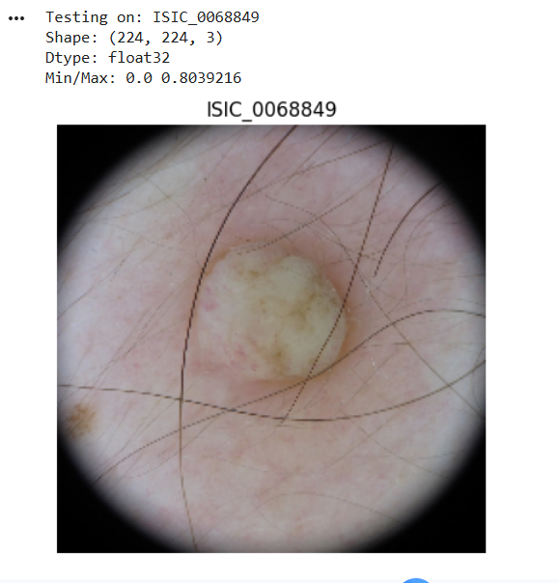
Figure 2: Sample preprocessed image (224×224, normalized) — note the circular dermoscopy vignette, a natural artifact of the imaging device, not a loading error.

3. Methodology and Results

3.1 Step 2 — Traditional Machine Learning (SVM, KNN)
Baseline models trained on flattened, downsized (32×32), scaled pixel vectors.
- SVM (RBF kernel): Train 52.99% / Val 42.34% / Test 39.84%
- KNN (best K=3, tested K ∈ {3,5,7,9,11}): Val 35.46% / Test 36.11%
SVM outperformed KNN — expected, since distance-based classification struggles in raw pixel space where visual similarity doesn’t map cleanly to Euclidean distance. Both models almost completely failed on minority classes: DF had 0 correct predictions out of 36 test samples for both models.
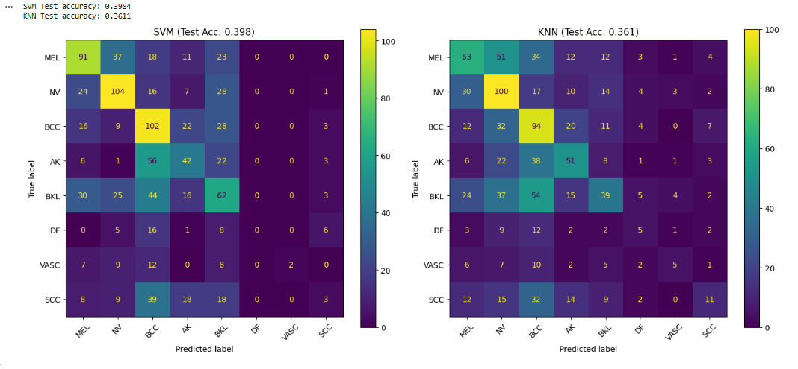
Figure 3: Confusion matrices — SVM (left) and KNN (right) on the held-out test set.

3.2 Step 3 — Vanilla ANN
A dense network (150,528 → 256 → 128 → 8) trained on flattened full-resolution (224×224) images, using class-weighted cross-entropy loss to counter imbalance.
- Final: Train 27.18% / Val 30.55% (unstable — val accuracy fluctuated between 13% and 38% across epochs) / Test 28.85%
The ANN performed worse than both traditional ML baselines — a genuine, honest finding worth stating directly. With no spatial inductive bias, a dense network has no way to know that neighboring pixels are related; it treats 150,528 pixel values as independent, unordered inputs. This left it unable to reliably exploit the image structure that even simple downsized SVM features could partially capture.
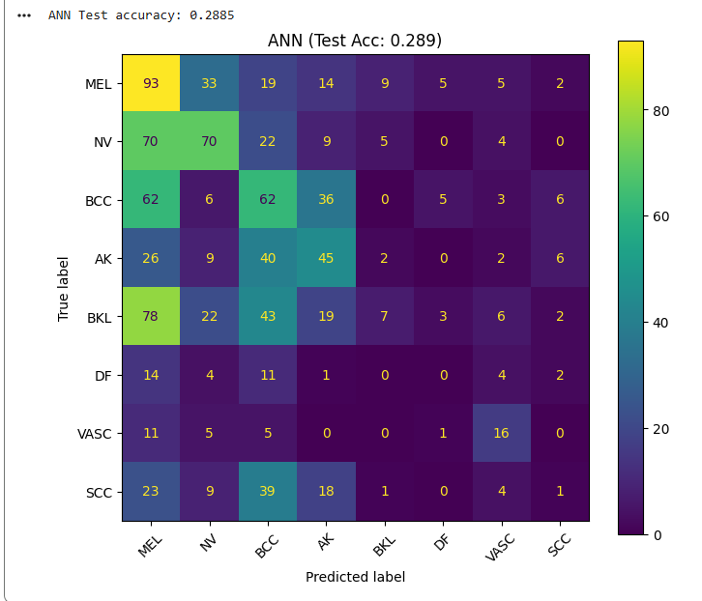
Figure 4: ANN confusion matrix — note the strong bias toward MEL and BCC regardless of true class.

3.3 Step 4 — Custom CNN (No Augmentation)
Three Conv2D + ReLU + MaxPool blocks (3→16→32→64 channels) followed by dense layers, trained on the original (un-augmented) 224×224 images.
- Final: Train 56.82% / Val 38.41% (best) / Test 40.82%
This was the first model to meaningfully classify minority classes: DF improved from 0/36 correct to 15/36, and VASC to 28/38 — the best minority-class performance of any model except the later transfer-learning models. The large train/val gap (56.8% vs 38.4%) signals overfitting beginning around epoch 4, directly motivating the augmentation step that follows.
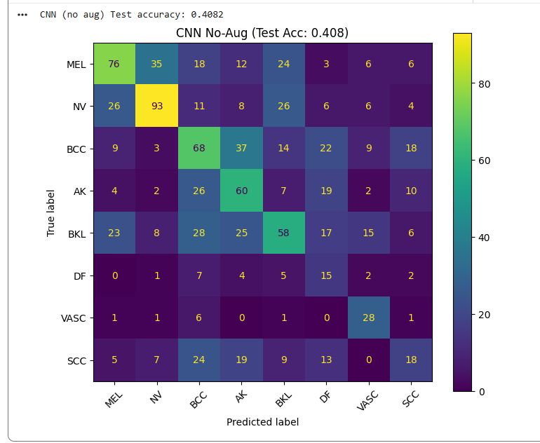
Figure 5: CNN (no augmentation) confusion matrix — first model with real minority-class recall.

3.4 Step 5 — CNN with Data Augmentation
Identical CNN architecture, trained with random horizontal/vertical flips, rotation (±20°), and zoom applied only to training data (never validation/test).
- Final: Train 33.71% / Val 37.13% (still improving at epoch 10, unlike no-aug) / Test 35.53%
This result deserves an honest, non-simplified interpretation: augmentation did not clearly outperform the no-augmentation CNN on test accuracy (35.53% vs 40.82%), and per-class recall for DF (12 vs 15) and VASC (22 vs 28) both dropped slightly. However, the validation curve was materially healthier — no overfitting, still improving at the final epoch — suggesting the model simply needed more than 10 epochs to reach its ceiling. On a small (~4,750 image), heavily imbalanced dataset, aggressive augmentation of already-thin classes (DF: ~167 training images) can introduce noisy variants faster than the model can average them out. This is reported as a genuine, nuanced finding rather than forcing the expected "augmentation always helps" narrative.
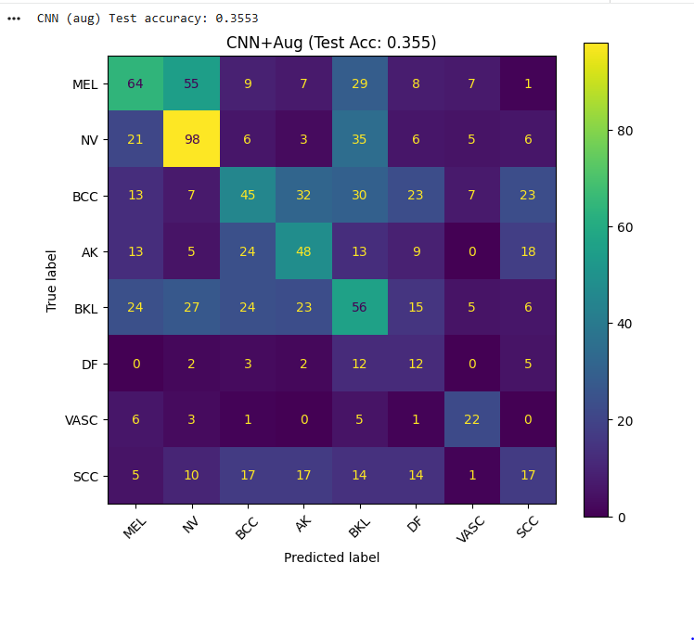
Figure 6: CNN + Augmentation confusion matrix.

3.5 Step 6 — Transfer Learning
Two pretrained (ImageNet) architectures were fine-tuned: ResNet50 (a strong, moderately heavy backbone) and MobileNetV2 (a lightweight, mobile-oriented architecture) — chosen specifically to contrast accuracy against a smaller compute/parameter footprint, rather than testing every listed option exhaustively.
Methodology: base layers frozen and only a new classification head trained initially (8 epochs), followed by unfreezing the deepest layer block (ResNet50’s layer4 / MobileNetV2’s final feature blocks) plus the classifier for fine-tuning at a reduced learning rate (5 epochs). Per-epoch checkpointing was used during fine-tuning, restoring the best-validation-accuracy weights rather than defaulting to the final epoch — this mattered concretely: ResNet50’s train accuracy reached 97%+ by the final epoch while validation accuracy had already peaked and begun declining several epochs earlier.
ResNet50 (fine-tuned, best checkpoint)
- Train (final epoch) 97.28% / Val (best, epoch 4) 60.12% / Test 59.47%
- Large train/val gap indicates heavy overfitting during fine-tuning — mitigated, not eliminated, by checkpointing
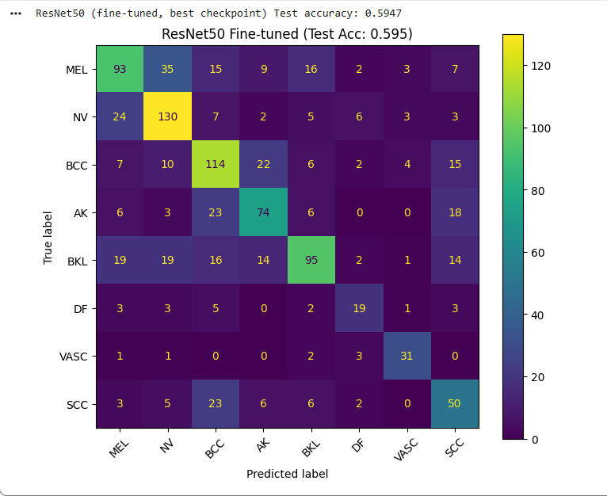
Figure 7: ResNet50 (fine-tuned) confusion matrix — every class now has a clear diagonal majority.
MobileNetV2 (fine-tuned, best checkpoint)
- Train (final epoch) 70.27% / Val (best, epoch 5) 58.45% / Test 58.78%
- Nearly matched ResNet50 (within ~0.7 points) using only 896K trainable parameters during fine-tuning vs. ResNet50’s ~15M — a 17x reduction — while showing markedly less overfitting (val accuracy improved every epoch, never declined)
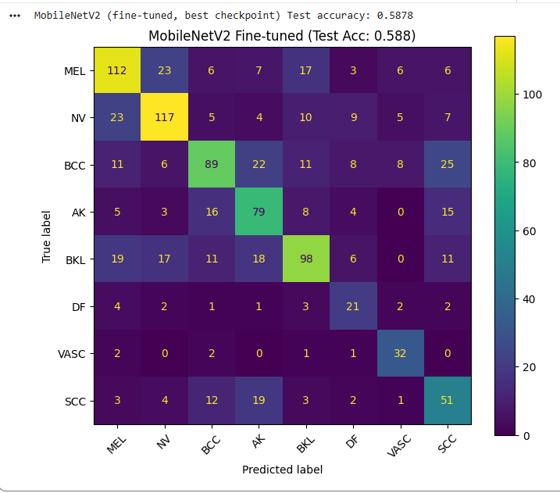
Figure 8: MobileNetV2 (fine-tuned) confusion matrix.
This is a genuinely useful comparison beyond raw accuracy: on this dataset, the lightweight architecture delivers essentially equivalent accuracy at a fraction of the compute cost, and with a more stable, less overfit training trajectory — a real accuracy-vs-efficiency trade-off worth naming explicitly.

4. Final Model Comparison
Model | Test Accuracy | Train Acc (final) | Val Acc (best)
ResNet50 (Transfer, fine-tuned) | 59.47% | 97.28% | 60.12%
MobileNetV2 (Transfer, fine-tuned) | 58.78% | 70.27% | 58.45%
CNN (No Augmentation) | 40.82% | 56.82% | 38.41%
SVM (RBF kernel) | 39.84% | 52.99% | 42.34%
KNN (K=3) | 36.11% | — | 35.46%
CNN + Augmentation | 35.53% | 33.71% | 37.13%
ANN (Vanilla) | 28.85% | 27.18% | 30.55%

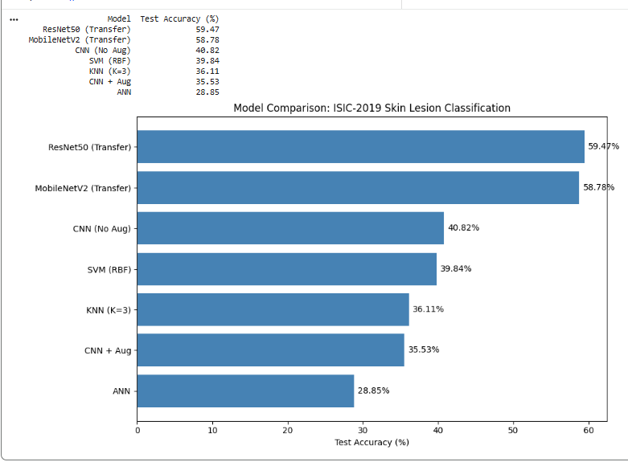
Figure 9: Test accuracy across all seven models, sorted best to worst.

5. Custom Image Testing
The best-performing model (ResNet50, fine-tuned) was tested on held-out images never seen during training, chosen deliberately from known classes to allow direct verification against ground truth.
Test | True Label | Predicted | Confidence | Result
Held-out sample 1 | SCC | MEL | 34.0% (true: 14.1%, 3rd) | Incorrect
Held-out sample 2 | VASC | VASC | 99.3% | Correct

Case 1 (Incorrect): True label SCC was predicted as MEL (34.0% confidence), with the correct class SCC appearing third (14.1%). This reflects a known, real visual overlap — MEL, BCC, and SCC lesions share pigmentation and texture patterns that are genuinely difficult to separate, even for the model’s strongest architecture.
Case 2 (Correct): True label VASC was predicted correctly with 99.3% confidence. Vascular lesions have a visually distinctive reddish/purplish color signature, which the model appears to have learned reliably despite VASC being one of the rarest classes in the dataset (253 total images).
Together, these two cases show that the model’s confidence is meaningfully calibrated to visual difficulty — confident and correct on visually distinctive classes, genuinely uncertain (rather than confidently wrong) on visually overlapping ones. This is a healthier failure mode than confident misclassification, and suggests the model learned real discriminative features rather than superficial dataset artifacts.

6. Engineering Notes
Several practical obstacles arose during training, worth documenting since they shaped methodological choices:
- Repeated Colab session/kernel crashes from holding the full image array (6,787 × 224 × 224 × 3, ~3.9GB+ in memory with derived copies) in RAM simultaneously — resolved by switching to a lazy-loading PyTorch Dataset that decodes and resizes one image at a time, keeping peak memory flat regardless of dataset size.
- Fine-tuning overfitting (ResNet50 train accuracy reaching 97%+ while validation degraded) — resolved with per-epoch checkpointing, restoring best-validation weights rather than final-epoch weights.
- Loss of trained model weights across session restarts — resolved by saving final weights to Google Drive rather than local Colab disk, ensuring persistence across full VM resets.

7. Key Takeaways
- Architectural inductive bias (convolution) mattered more than any single training technique — the ANN→CNN jump (28.85%→40.82%) exceeded the effect of adding augmentation to an already-competent CNN.
- Pretrained features provided the single largest performance gain in the entire pipeline (~18–19 points over the best from-scratch model) — demonstrating that transfer learning is a substitute for data volume, not a training shortcut.
- Class imbalance is best addressed through model capacity and representation quality, not only through resampling or loss weighting — minority-class recall tracked model quality far more than any single imbalance-correction technique.
- Not every technique improved results as expected (augmentation underperformed on test accuracy here), and this was reported honestly rather than reframed as a success — consistent with treating negative or unexpected results as legitimate findings, not failures.

End of Report

