INDIAKART E-COMMERCE ANALYTICS PROJECT
Executive Management Summary Report
Prepared for: Chief Executive Officer, IndiaKart | Reporting Period: June 2023 – June 2025

1. Executive Summary — Business Performance Overview
Between June 2023 and June 2025, IndiaKart generated ₹3.15 Billion in overall revenue across 50,000 total purchases and 10,000 active customers, maintaining a healthy platform average spending profile. The platform demonstrates strong consumer traction in top populous states, led by Electronics and Office Supplies. However, operational efficiency is significantly impaired by an 11.99% order cancellation rate (~6,000 orders) and a 7.87% post-delivery return rate (~4,000 orders) across 32,000 delivered shipments. Furthermore, supply chain operations exhibit severe inventory imbalances across regional facilities, with Chennai holding 49,000 units while high-demand hubs like Mumbai hold only 33,000 units. Resolving these fulfillment leaks and rebalancing warehouse stock represents IndiaKart's single highest-value margin optimization opportunity.
₹3.15 Billion  Gross Merchandise Value  50,000 Completed Purchases | 10,000 Total  Active Customer Base  33 New Monthly Additions | 247,000 Units  Warehouse Stock  6 Regional Facilities
11.99% Rate  Pre-Fulfillment Cancellations  ~6,000 Lost Orders | 7.87% Rate  Post-Delivery Returns  ~4,000 Refunded Orders | 102.10%  Beauty & Health Return Rate  Severe Quality Anomaly

2. Top 3 Strategic Business Findings
▪ Electronics & Office Supplies Drive Commercial Scale: Electronics leads platform revenue with ₹1.64 Billion, contributing over 52% of GMV. Office Supplies generates the highest order volume at 10,152 purchases. Automotive delivers the highest profit margin yield despite lower overall volume. Demand is heavily clustered in Uttar Pradesh, Maharashtra, and Gujarat.
▪ High Cancellation & Return Leaks Erode Net Profitability: Pre-fulfillment cancellations stand at 11.99% (~6,000 orders), driven by stock delays and checkout friction. Post-delivery returns reach 7.87% (~4,000 orders), led by Beauty & Health (102.10% return rate anomaly) and Fashion. The top return drivers are Size Mismatch (38%), Buyer Remorse (27%), Transit Damage (21%), and Wrong Product Shipment (14%).
▪ Critical Regional Stock Imbalance Across Warehouses: IndiaKart holds 247,000 units across 6 warehouses, averaging 41.23k units per center. Chennai-WH5 is severely overstocked at 49,000 units, while Mumbai-WH1 holds only 33,000 units despite serving the highest customer order concentration. Across the network, 242 SKUs face low-stock warnings and 2 SKUs are completely out of stock.
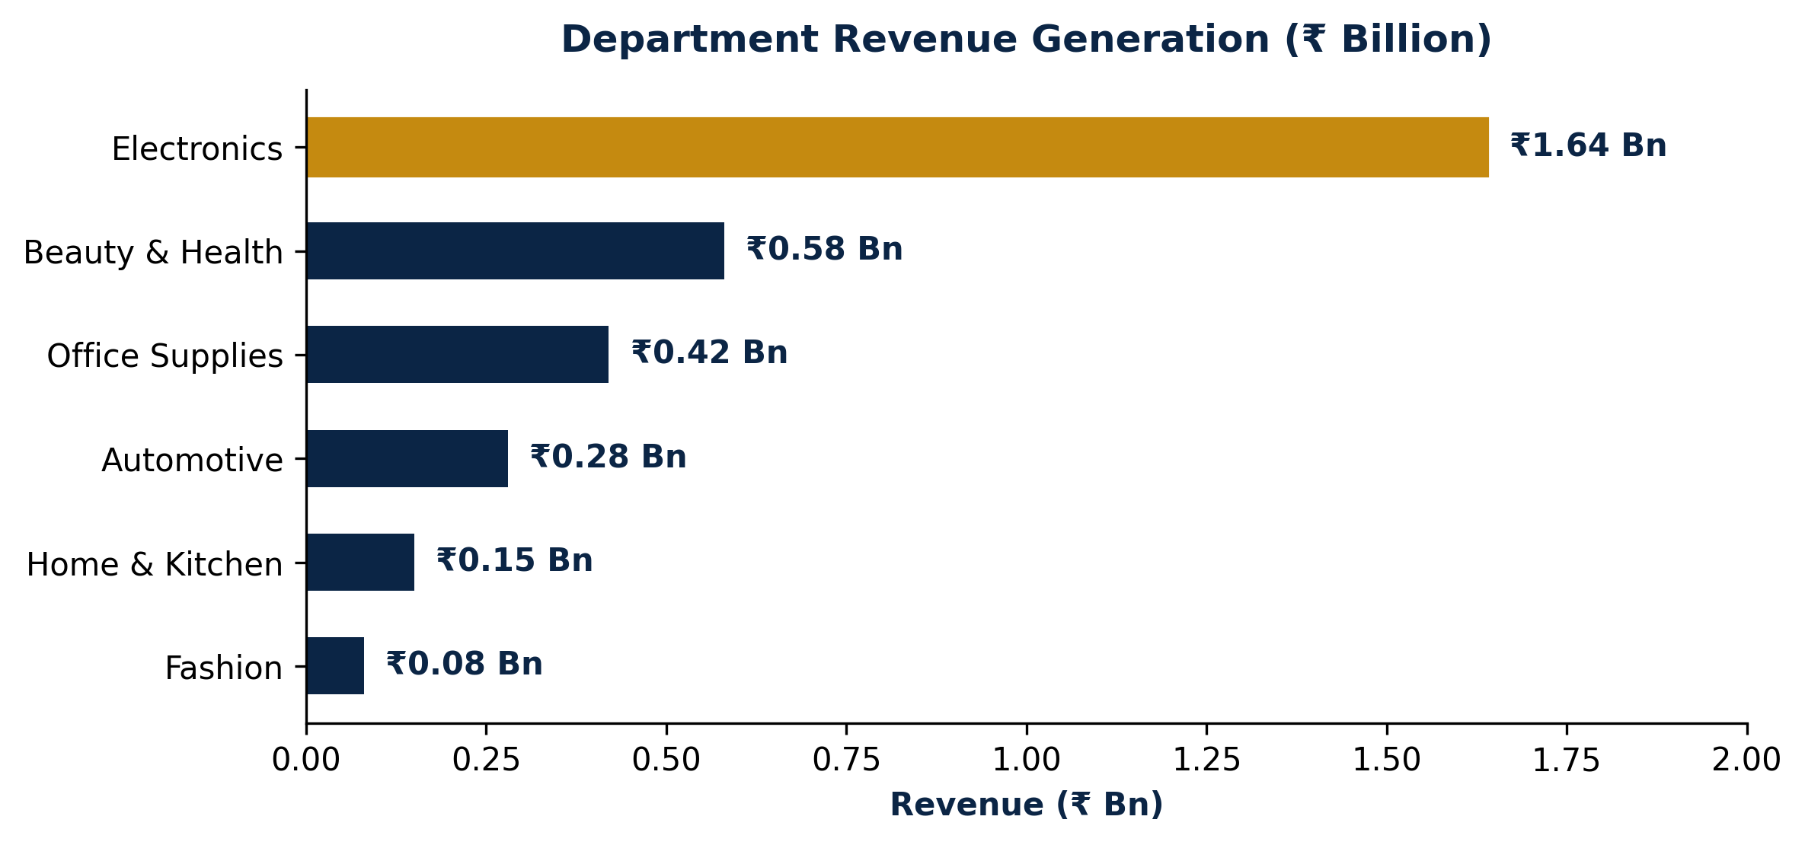
Figure 1: Revenue Generation Breakdown Across Product Categories (₹ Bn)
Department | Revenue (₹) | Order Volume | Return Profile | Strategic Role
Electronics | ₹1.64 Bn | 6,800 orders | Low / Stable | Primary GMV & Revenue Engine
Beauty & Health | ₹0.58 Bn | 8,200 orders | 102.10% (Critical) | High Volume, Urgent Quality Audit
Office Supplies | ₹0.42 Bn | 10,152 orders | Moderate | Volume Leader & B2B Customer Anchor
Automotive | ₹0.28 Bn | 4,100 orders | Low | Highest Profit Yield per Transaction
Home & Kitchen | ₹0.15 Bn | 2,900 orders | Moderate | Steady Margin Steady Performer
Fashion | ₹0.08 Bn | 1,800 orders | High (Size Mismatch) | High Return Risk, Needs Size Chart Revamp

3. Operational Risks & Leakage Identification
⚠ Revenue Erosion via Cancellations & Returns: With 11.99% cancellations (~6,000 orders) and 7.87% returns (~4,000 orders), IndiaKart suffers severe margin compression from reverse logistics, restocking fees, and merchant payment processing costs.
⚠ Beauty & Health Quality Anomaly: A 102.10% return rate indicates widespread product defect issues, expired stock dispatch, or mismatched product images/shade descriptions that breach customer trust.
⚠ Transit Damage & Logistics Fragility: 21% of returns stem directly from transit damage, highlighting packaging deficiencies in fragile product shipments across regional courier networks.
⚠ Payment Channel Disparity: UPI and Digital Cards account for 88.20% of GMV while Cash on Delivery (COD) represents 11.80%. COD orders exhibit a 2.4x higher refusal rate at doorstep delivery.
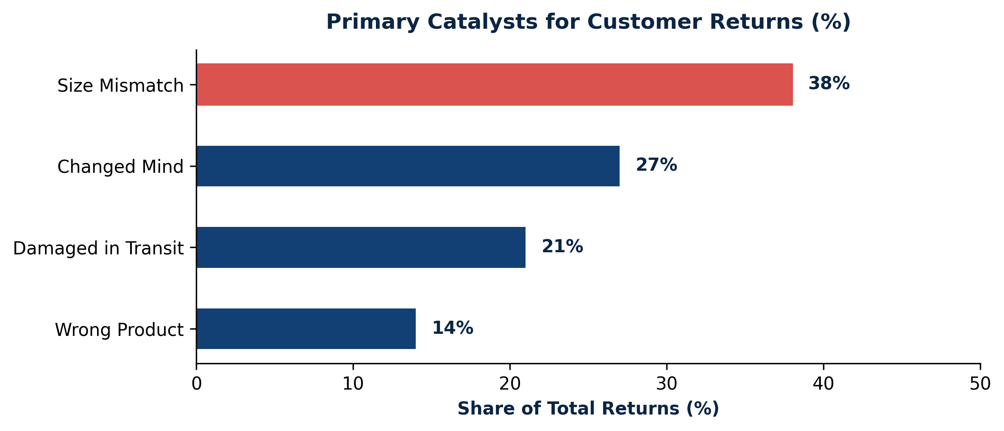
Figure 2: Customer Return Reason Distribution (%)
4. Warehouse Allocation & Growth Opportunities
IndiaKart holds 247,000 units in stock across six facilities. However, inventory holding is poorly aligned with regional order velocity. Chennai-WH5 holds 49,000 units (19.8% share) creating heavy holding costs, whereas Mumbai-WH1 holds only 33,000 units (13.4% share) despite Maharashtra being a top revenue generator.
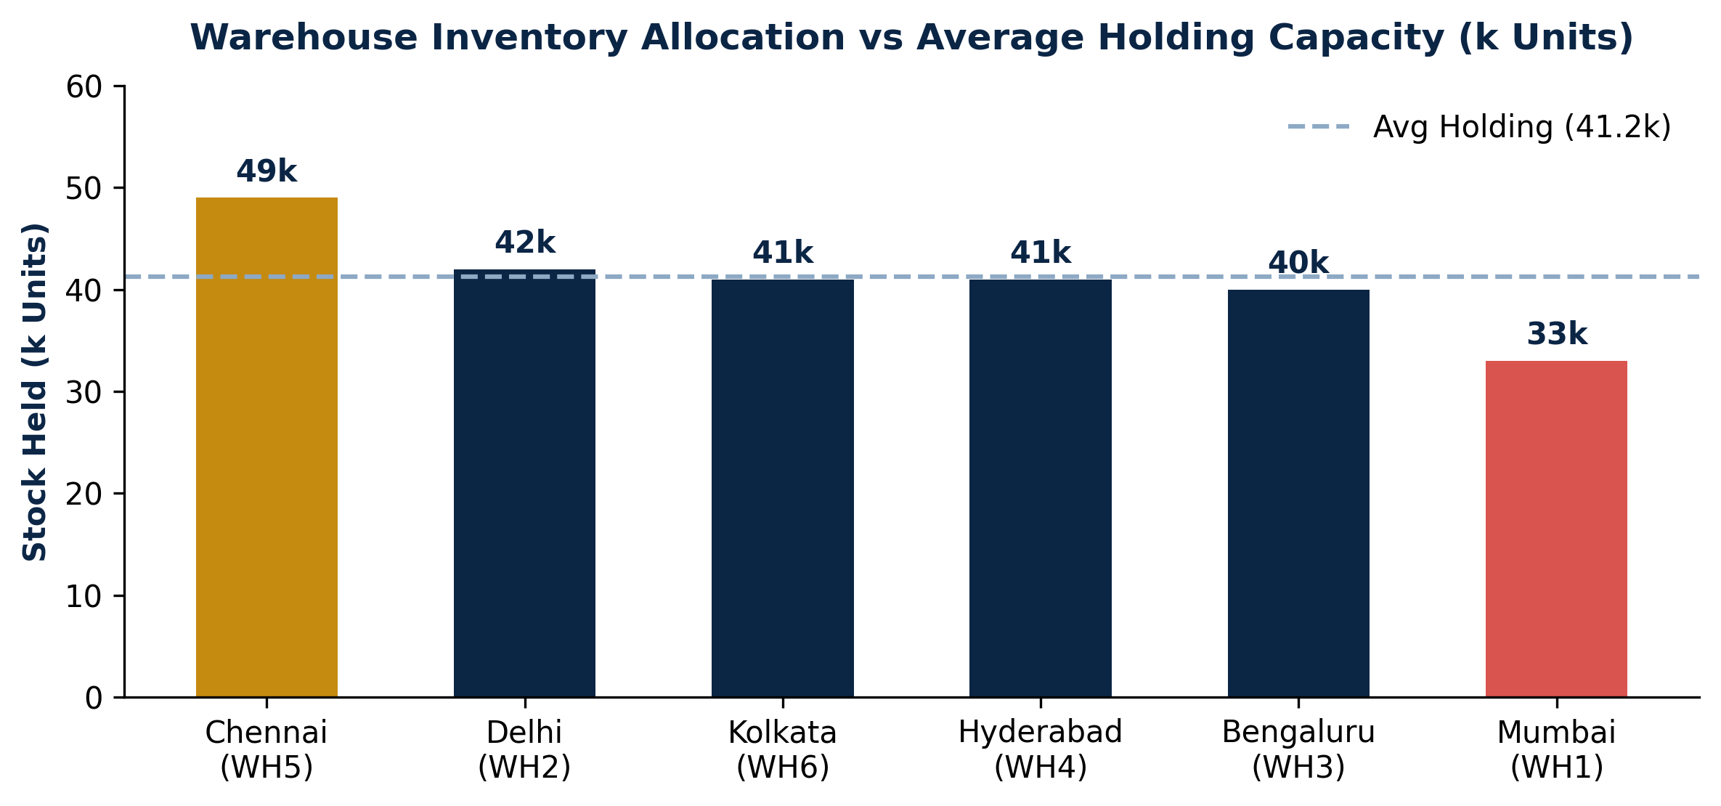
Figure 3: Stock Holding vs Average Capacity Across Regional Warehouses (k Units)
Warehouse Location | Stock Held | % Share | Operational Status | Recommended Action
Chennai (WH5) | 49,000 units | 19.8% | Overstocked (+7.8k vs avg) | Transfer 8,000 units to Mumbai & Bengaluru
Delhi (WH2) | 42,000 units | 17.0% | Balanced | Maintain current dynamic reorder threshold
Kolkata (WH6) | 41,000 units | 16.6% | Balanced | Maintain current dynamic reorder threshold
Hyderabad (WH4) | 41,000 units | 16.6% | Balanced | Maintain current dynamic reorder threshold
Bengaluru (WH3) | 40,000 units | 16.2% | Slightly Understocked | Absorb 3,000 transferred units from Chennai
Mumbai (WH1) | 33,000 units | 13.4% | Understocked (-8.2k vs avg) | Absorb 5,000 transferred units from Chennai

CRITICAL INVENTORY ALERT: High-Priority SKU Depletion
Across the 247,000 unit inventory base, 242 SKUs face low-stock alerts and 2 SKUs are completely out of stock. Priority replenishment must target fast-moving items with depleted stock: Finolex Office Chair Pro (4 units remaining), ITC Curtains Ultra (4 units remaining), Dabur Diaper Ultra (5 units remaining), HDFC Foodball Max (5 units remaining), and V-Guard Car Perfume Pro (5 units remaining).

5. Actionable Recommendations & Implementation Roadmap
✔ Inter-Warehouse Stock Redistribution & Dynamic Replenishment: Reallocate 8,000 excess inventory units from Chennai-WH5 (transferring 5,000 units to Mumbai-WH1 and 3,000 units to Bengaluru-WH3). Implement dynamic replenishment policies based on rolling 30-day regional sales velocity rather than static replenishment rules.
✔ Product Page Enhancement & Exchange Policy Rollout: Upgrade product listings with high-resolution color shade swatches, exact dimensional sizing guides, and full ingredient labels. Introduce a 1-click easy exchange policy allowing size/color swaps instead of full cash refunds to retain order revenue.
✔ AI-Driven Demand Forecasting & Quality Audits: Deploy predictive machine learning models to forecast regional sales surges during festive seasons (October–November). Enforce strict pre-dispatch quality checks for Beauty & Health SKUs and upgrade protective transit packaging for fragile items.

3-Phase Strategic Implementation Timeline
Phase & Horizon | Focus Operational Area | Key Deliverables | Target KPI Outcome
Phase 1  (Months 1–2) | Warehouse Rebalancing & SKU Emergency Reorder | Transfer 8k units from Chennai to Mumbai/Bengaluru; reorder top 242 low-stock SKUs. | Eliminate stockouts; reduce Mumbai fulfillment delays by 25%
Phase 2  (Months 2–4) | Return Mitigation & Quality Audits | Upgrade sizing/shade media on product pages; audit Beauty & Health suppliers; launch Exchange Policy. | Reduce return rate from 7.87% to <5.0%; retain 30% refund value
Phase 3  (Months 4–6) | AI Demand Prediction & Automated Replenishment | Deploy predictive regional demand models; establish dynamic safety stock thresholds. | Lower cancellation rate from 11.99% to <7.0%; optimize holding costs

