APL LOGISTICS (KWE GROUP)
Margin Intelligence & Profitability Performance Report
A Comprehensive Data-Driven Assessment of Supply Chain Leakage, Discount Governance, and Customer Economics
Target Organization: APL Logistics (KWE Group) | Date: September 2026
Focus Areas: Supply Chain Profitability, Discount Control | Status: Executive Recommendation

1. EXECUTIVE SUMMARY & KEY PERFORMANCE INDICATORS
This formal business report delivers an end-to-end commercial performance evaluation for APL Logistics (KWE Group). By auditing enterprise sales, order fulfillment, freight logistics, and promotional pricing datasets, this analysis reveals critical commercial dynamics: while gross sales volume is robust at $36.78M, net earnings stand at $3.97M (a 10.78% net profit margin). Financial performance is severely compromised by unmonitored discount leakage totaling $3.73M and operational freight surcharges during expedited fulfillment cycles.
TOTAL REVENUE  $36.78M  Reconciled Sales | NET PROFIT  $3.97M  10.78% Net Margin | TOTAL DISCOUNT  $3.73M  10.17% Avg Rate | TOP PRODUCT  $756.22K  16 Gun Fire Safe

Core Strategic Takeaways
- Discount Degradation: Orders receiving 0–10% discounts yield a healthy ~22% margin. However, as discounts reach 20–30%, net margins drop sharply to ~16%, stripping $3.73M in potential revenue.
- Day 1 Shipping Bottleneck: Fulfillment completed on Day 1 encounters an acute margin dip to 9.50% (vs 10.78% portfolio baseline) due to expedite fees and premium freight handling.
- Account Cross-Subsidization: The Consumer segment contributes 52.2% ($2.07M) of total profit, but severe loss accounts (e.g., Account ID 1428 at -$3.87K) erase gains.
2. CORPORATE BACKGROUND & PROBLEM STATEMENT
Operating within the KWE Group global logistics network, APL Logistics manages complex multi-regional supply chains across 10 primary global territories (Western Europe, Central America, South America, Northern Europe, Southern Europe, Oceania, Southeast Asia, Caribbean, West of USA, and South Asia). Traditionally, executive performance metrics prioritized top-line freight and order volumes. However, opaque cost structures, uncoordinated commercial discounting, and heavyweight freight cost liabilities have caused silent margin erosion.
3. METHODOLOGY & DATA RECONCILIATIONS
Key performance indicators were normalized and verified across Power BI models and Streamlit analytical frameworks:
Metric Dimension | Reconciled Value | Business Definition & Formula
Gross Revenue | $36,784,734.31 | Total invoiced transaction value before adjustments
Net Profit | $3,966,902.97 | Gross Revenue minus Freight, COGS, and Handling Costs
Net Profit Margin % | 10.78% | (Net Profit ÷ Gross Revenue) × 100
Total Commercial Discount | $3,729,800.72 | Cumulative value of field discounts applied
Average Discount Rate | 10.17% | Mean promotional percentage across all filled orders
Discount Impact Ratio | 10.14% | Proportional margin dilution factor
Top Customer Revenue | $10.52K | Maximum revenue generated by a single account
Top Customer Net Profit | $2.44K (ID 2641) | Maximum net earnings derived from a single account
Worst Loss Account | -$3.87K (ID 1428) | Maximum net financial deficit incurred by an account

4. GRANULAR DASHBOARD INSIGHTS & VISUALIZATIONS
4.1 Regional Sales & Profit Overview
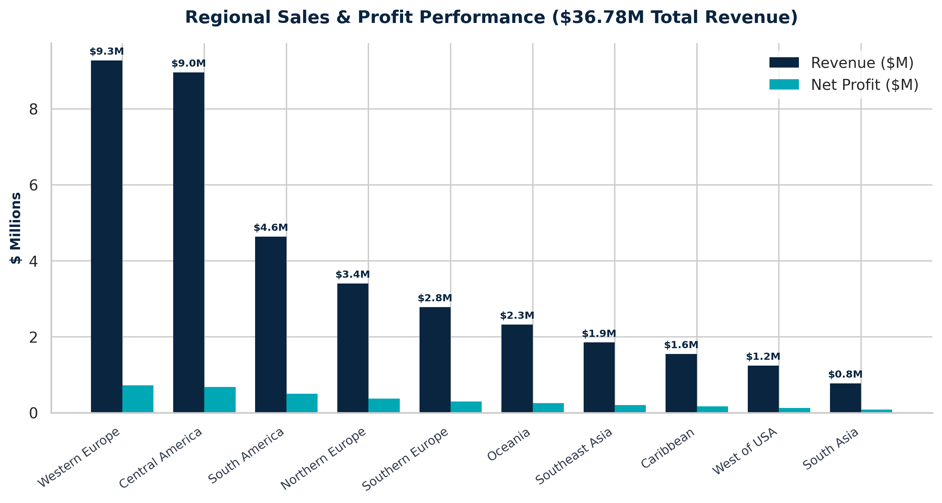
Figure 1: Regional Sales & Profit Performance across 10 Operating Territories.
4.2 Shipping Lead Time & Day 1 Bottleneck
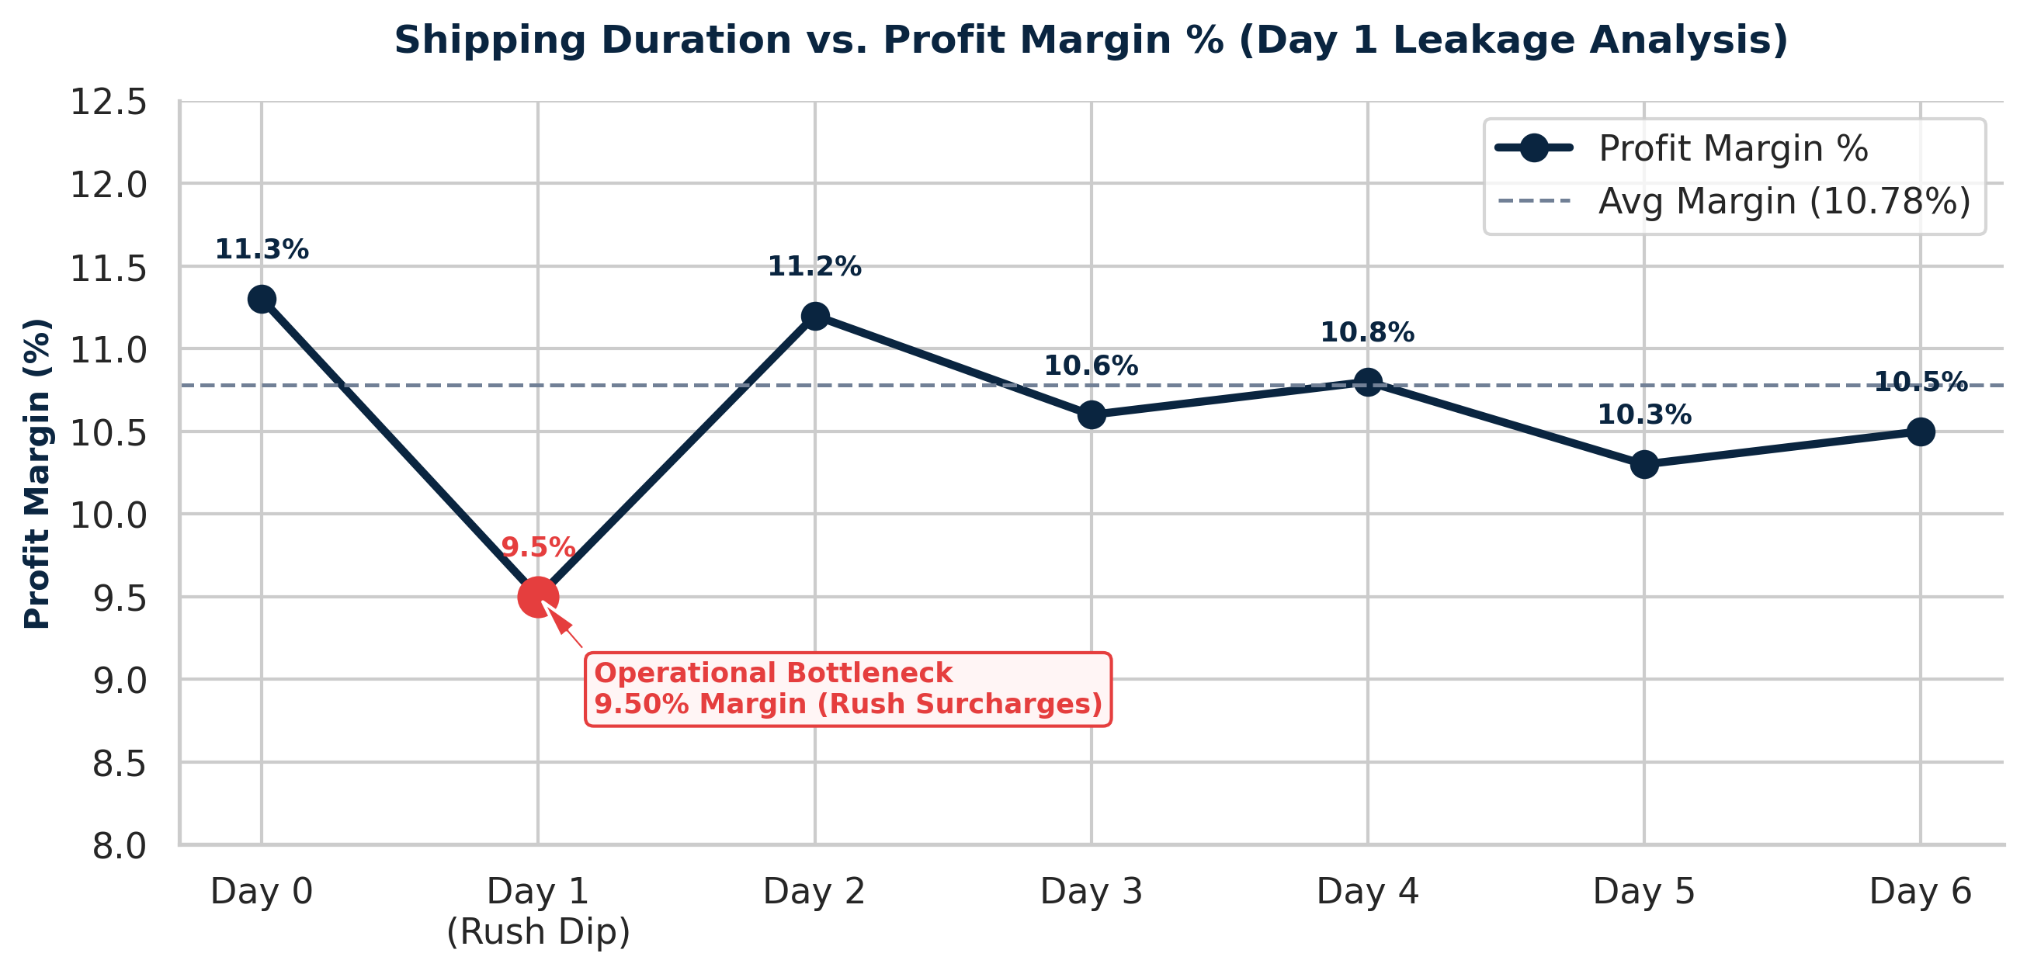
Figure 2: Shipping Lead Time vs. Net Profit Margin % (Highlighting Day 1 Rush Freight Dip).
4.3 Account Profitability Extremes
Top 5 Profitable Accounts | Net Profit | Bottom 5 Loss Accounts | Net Deficit
Account ID 2641 | +$2,440.00 | Account ID 1428 | -$3,870.00
Account ID 1657 | +$2,210.00 | Account ID 14086 | -$3,400.00
Account ID 9833 | +$1,950.00 | Account ID 18109 | -$3,400.00
Account ID 2626 | +$1,910.00 | Account ID 14313 | -$3,020.00
Account ID 5004 | +$1,880.00 | Account ID 7211 | -$2,850.00

4.4 Category Net Profit Rankings
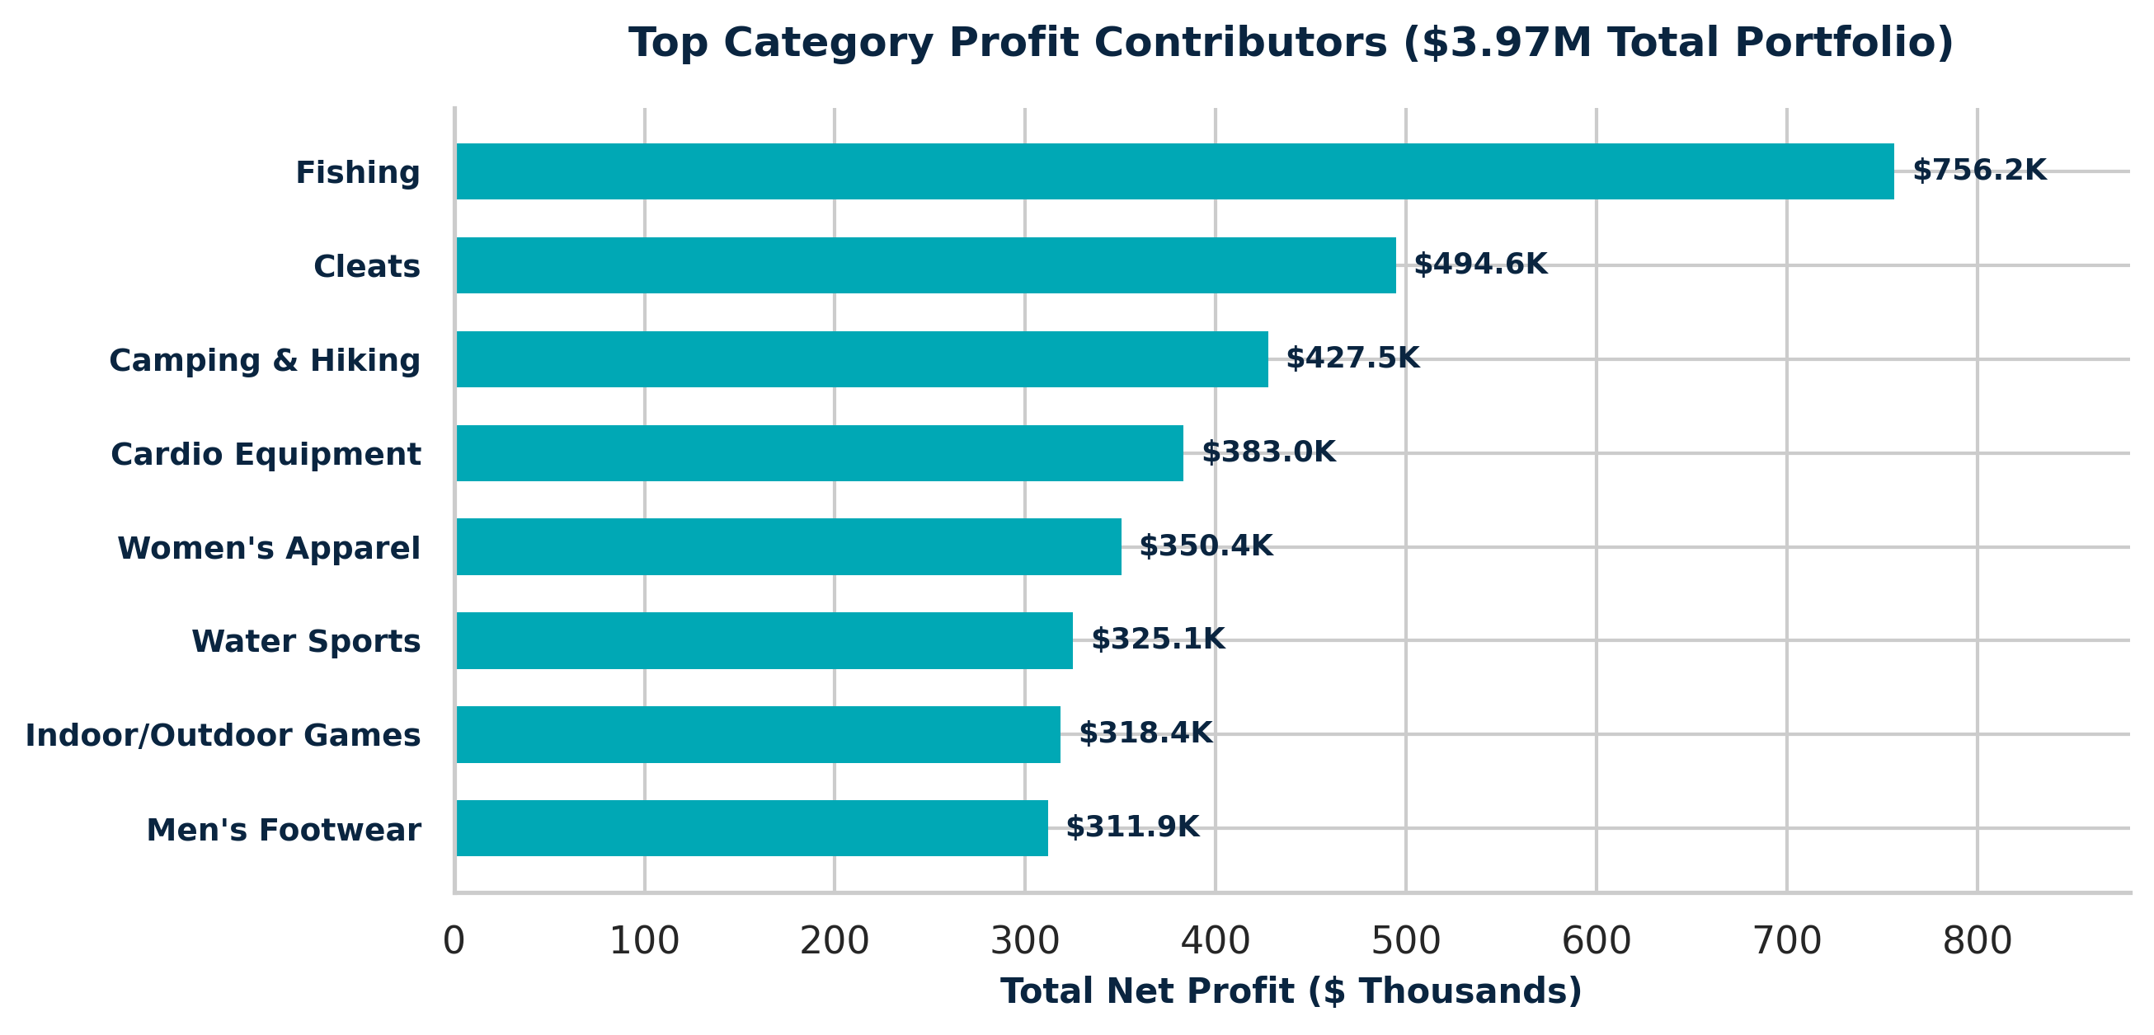
Figure 3: Category Net Profit Rankings across Key Product Lines.
4.5 Discount Sensitivity & Margin Compression
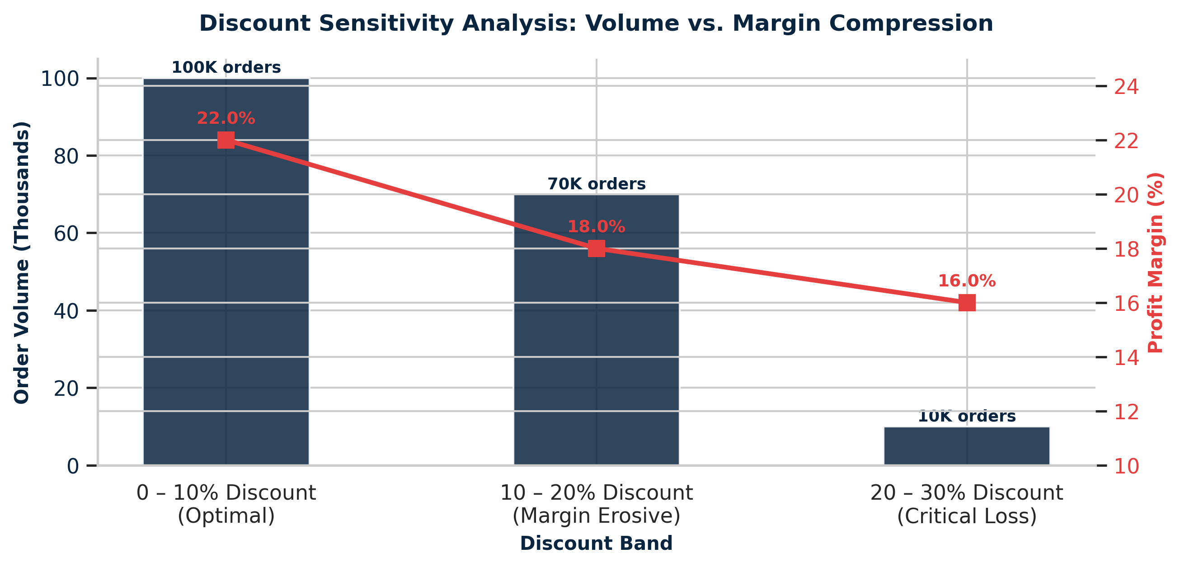
Figure 4: Discount Band Sensitivity — Volume vs. Margin Compression.
5. STRATEGIC ACTION MATRIX: QUICK WINS VS. LONG-TERM STRATEGY
Implementation Horizon | Strategic Initiative | Operational Action & Metric Target | Projected Impact
QUICK WINS (0–90 Days) | ERP Hard Cap on Discounts | Implement mandatory ERP approval workflows for any promotional price cuts exceeding 10%. | +$450K Margin Recovery
QUICK WINS (0–90 Days) | Loss Account Re-Pricing | Apply freight surcharges or minimum order sizes to top 10 deficit accounts (e.g., ID 1428). | +$180K Loss Elimination
QUICK WINS (0–90 Days) | Day 1 Dispatch Surcharge | Introduce expediting fees for 1-day turnaround orders to cover emergency labor costs. | +$120K Cost Offset
LONG-TERM (3–12 Mos) | SKU Portfolio Rationalization | De-list or restructure supplier terms for heavy loss products (e.g., SOLE E35 Elliptical). | +$250K Freight Savings
LONG-TERM (3–12 Mos) | Dynamic Rating Engine | Embed real-time volumetric freight calculation at point-of-sale in Power BI / Streamlit. | +150 bps Margin Expansion

6. CONCLUSION & NEXT STEPS
By transitioning from volume-based tracking to margin intelligence, APL Logistics (KWE Group) can eliminate commercial leakage while reinforcing its market leadership. Implementing strict discount controls, optimizing Day 1 fulfillment logistics, and restructuring unprofitable customer accounts will safeguard sustainable commercial growth.

