Flowcharts of SDOF Newton-Raphson Pushover Code

Written by Salar Delavar Ghashghaei
Displacement-controlled Newton-Raphson monotonic pushover of parallel nonlinear springs: Python solver vs. OpenSeesPy verification.
Files covered: SDOF_NEWTON_METHOD.py, ANALYSIS_FUNCTION.py, PLOT_FORCE_DISP_FUN.py

Flowchart symbols
Symbol | Meaning
Rounded box | Start / End / Return
Rectangle | Process / calculation
Parallelogram | Input / output (define data, print)
Diamond | Decision / loop test
Rounded box (purple) | Call to another function
Rounded box (red) | Failure exit (non-convergence)

Contents
- Fig. 1 – Overall program flow (main script)
- Fig. 2 – SDOF_NUMERICAL_PUSHOVER_NEWTON(): custom Newton-Raphson solver
- Fig. 3 – Helper functions INTERNAL_FORCE() and TANGENT()
- Fig. 4 – SDOF_OPENSEES(): OpenSeesPy model and pushover loop
- Fig. 5 – ANALYSIS(): convergence fallback strategies
- Fig. 6 – PLOT_FORCE_DISP_FUN(): backbone and stiffness plot

1. Overall program flow
The main script defines the multilinear backbone and spring coefficients, runs the custom solver, runs OpenSeesPy for inelastic and elastic cases, then compares and plots the results.
Fig. 1 – Main script flowchart
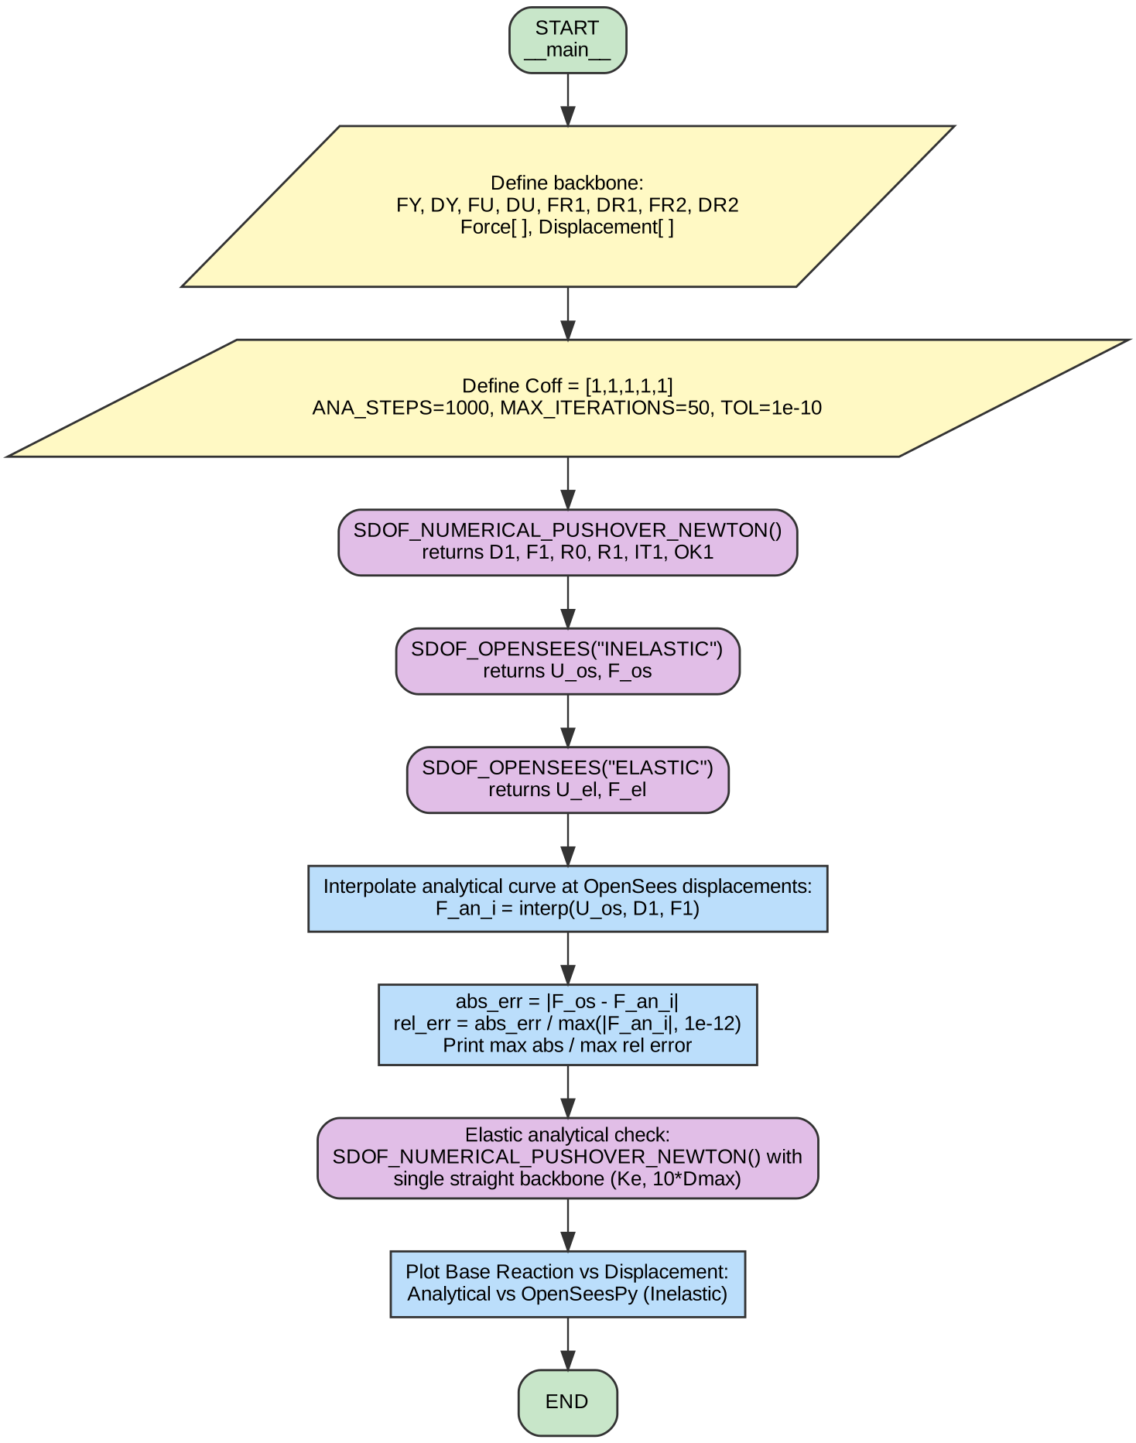

2. Custom Newton-Raphson solver
Predictor (committed tangent) → residual → Newton corrector → commit. A nonzero residual only appears when a step crosses a kink of the backbone.
Fig. 2 – SDOF_NUMERICAL_PUSHOVER_NEWTON()
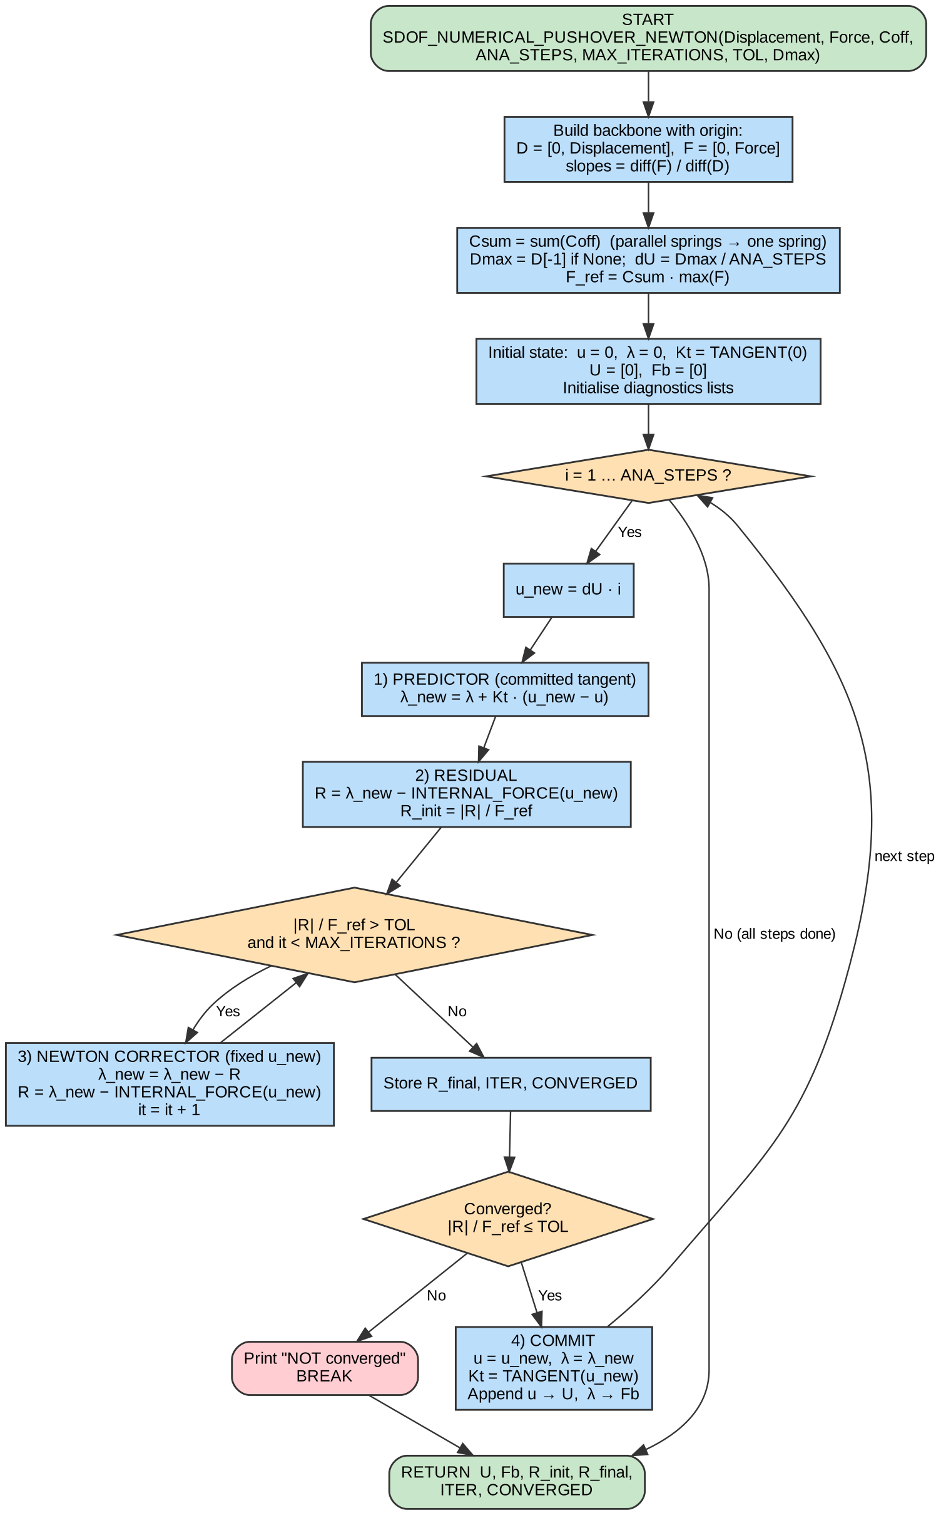

3. Helper functions
Fig. 3 – INTERNAL_FORCE(u) and TANGENT(u)
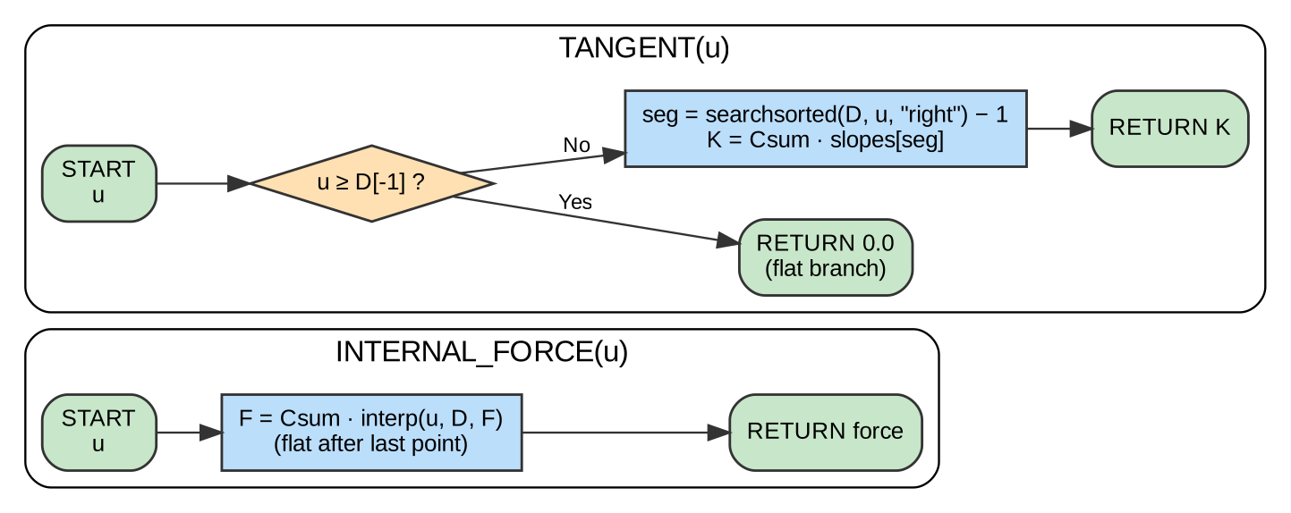
INTERNAL_FORCE interpolates the backbone and scales by Csum (flat beyond the last point). TANGENT returns the slope of the segment containing u, scaled by Csum, or zero past the last point.

4. OpenSeesPy model and pushover
One zeroLength element per spring, DisplacementControl integrator, step-by-step loop recording u and base reaction.
Fig. 4 – SDOF_OPENSEES(MAT_TYPE)
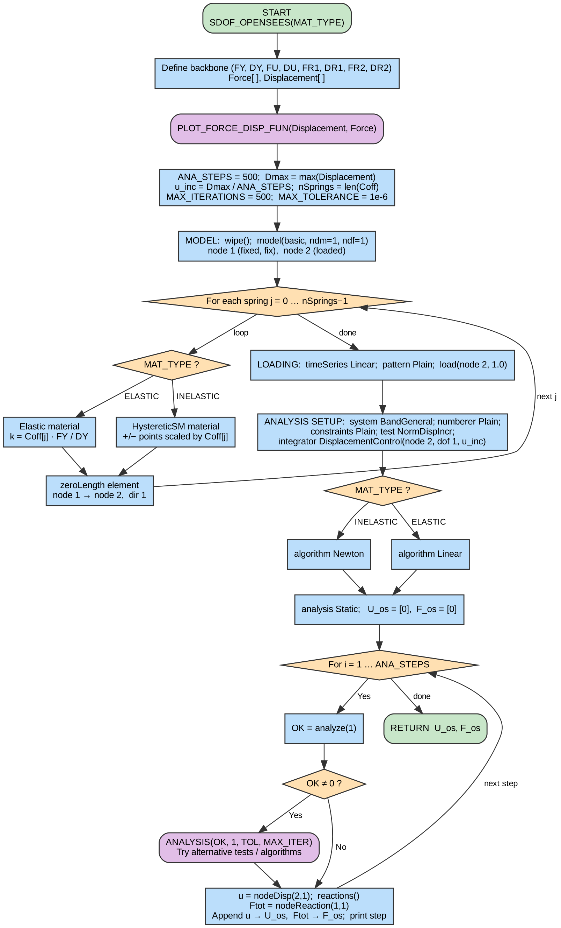

5. Convergence fallback (ANALYSIS_FUNCTION.py)
When ops.analyze() returns a nonzero flag, this routine cycles through combinations of convergence tests and algorithms until the step converges.
Fig. 5 – ANALYSIS()
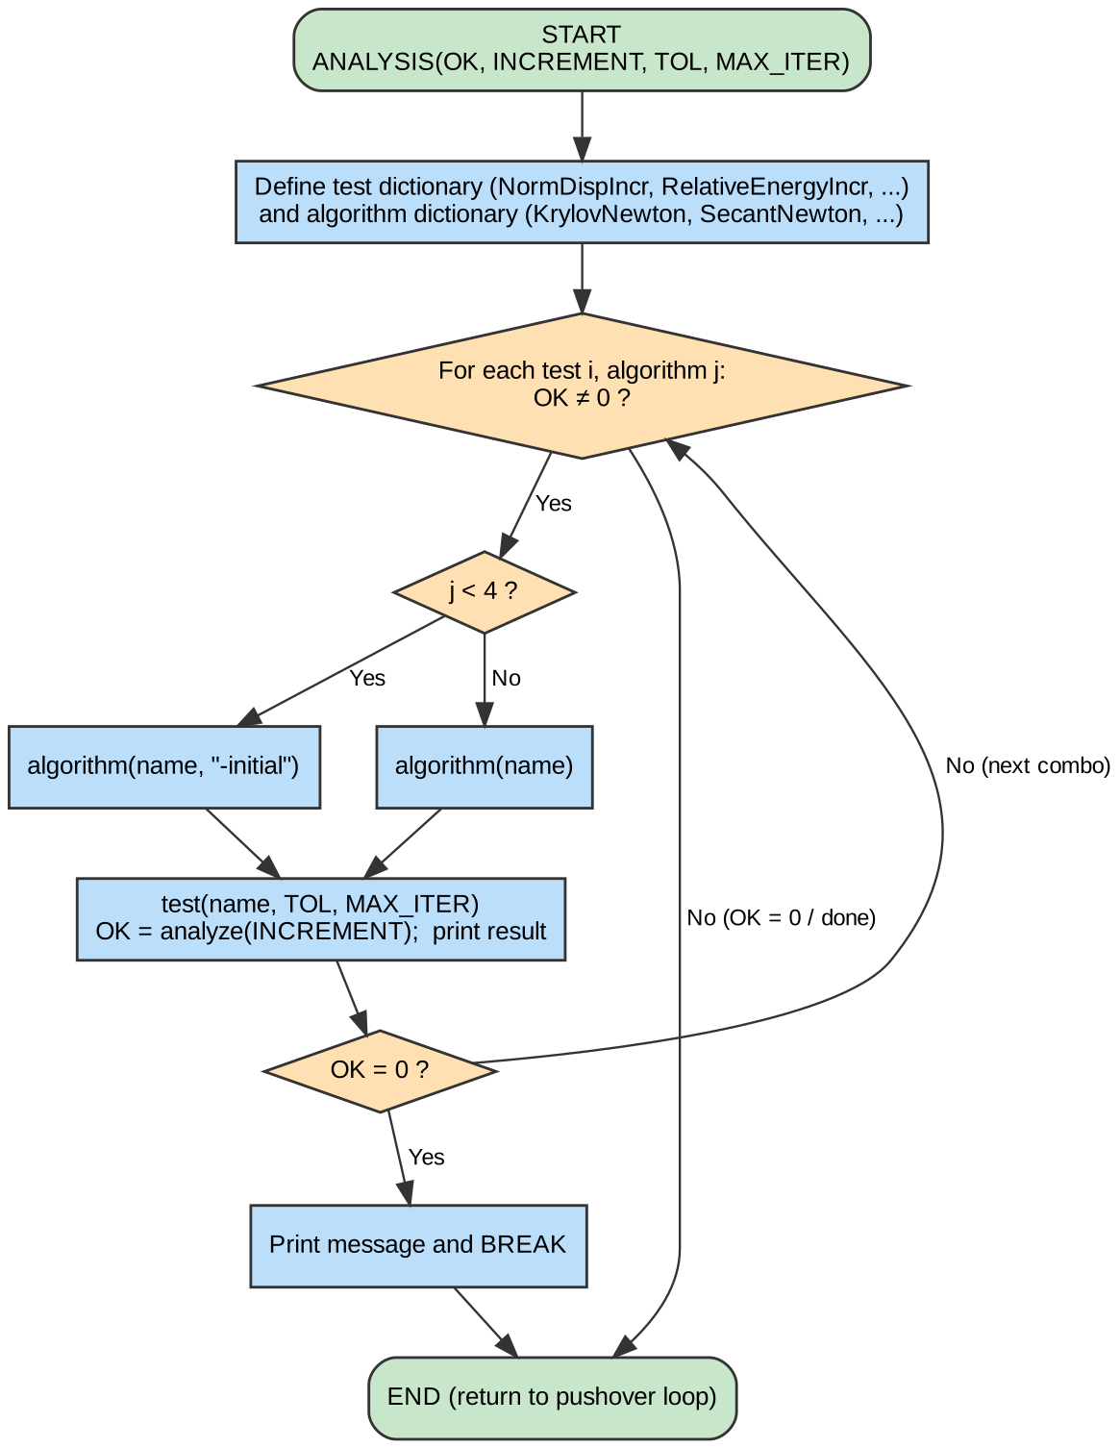

6. Backbone and stiffness plot (PLOT_FORCE_DISP_FUN.py)
Fig. 6 – PLOT_FORCE_DISP_FUN()


