Flow Chart of the Numerical Method

Written By Salar Delavar Ghashghaei
Nonlinear SDOF time-history: Newmark-β with Newton-Raphson and peak-oriented hysteresis
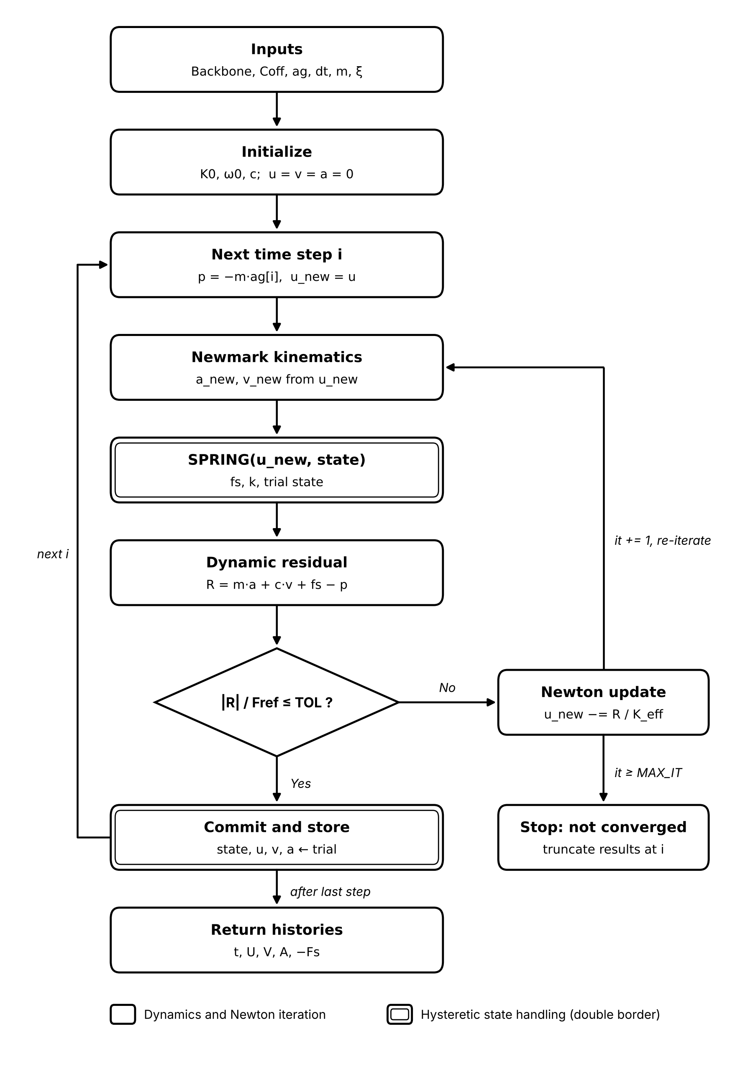

Step-by-step description
Step | Operation | Equation / action
1 | Initialize | K0 = Σ Coff · FY/DY; ω0 = √(K0/m); c = 2·ξ·ω0·m; u = v = a = 0
2 | Load and guess | p = −m·ag[i]; u_new = u (previous committed displacement)
3 | Newmark kinematics | a_new = (u_new − u)/(β·Δt²) − v/(β·Δt) − (1/(2β) − 1)·a; v_new = v + Δt·[(1 − γ)·a + γ·a_new]
4 | Hysteretic spring | SPRING(u_new, committed state) returns fs, tangent k and trial state (state is not modified)
5 | Residual | R = m·a_new + c·v_new + fs − p; converged if |R|/Fref ≤ TOL
6 | Newton update | K_eff = k + γ·c/(β·Δt) + m/(β·Δt²); u_new −= R / K_eff; it += 1
7 | Commit | state, u, v, a, fs ← trial values; store U, V, A, FS
8 | Failure exit | If it ≥ MAX_ITERATIONS and not converged: print message, truncate results at step i

Key notes
- Equation of motion: m·u″ + c·u′ + Fs(u, history) = −m·ag(t), with mass-proportional damping c = 2·ξ·ω0·m.
- Default Newmark parameters are the average acceleration method (γ = 0.5, β = 0.25), which is unconditionally stable for linear systems.
- SPRING is a pure function of the committed state and the trial displacement, so it can be re-evaluated in every Newton iteration without corrupting the hysteresis history.
- State is committed only after the residual satisfies the tolerance, which matches the converged-step behaviour of OpenSees.
- The residual is normalized by Fref = Csum · max(F), so the tolerance is dimensionless.
- Chart legend: single-border boxes are dynamics and Newton iteration; double-border boxes are hysteretic state handling.

