Flow Charts of the Numerical Methods

Written By Salar Delavar Ghashghaei
Part 1. Nonlinear MDOF shear building time-history: Newmark-β with Newton-Raphson and peak-oriented hysteresis
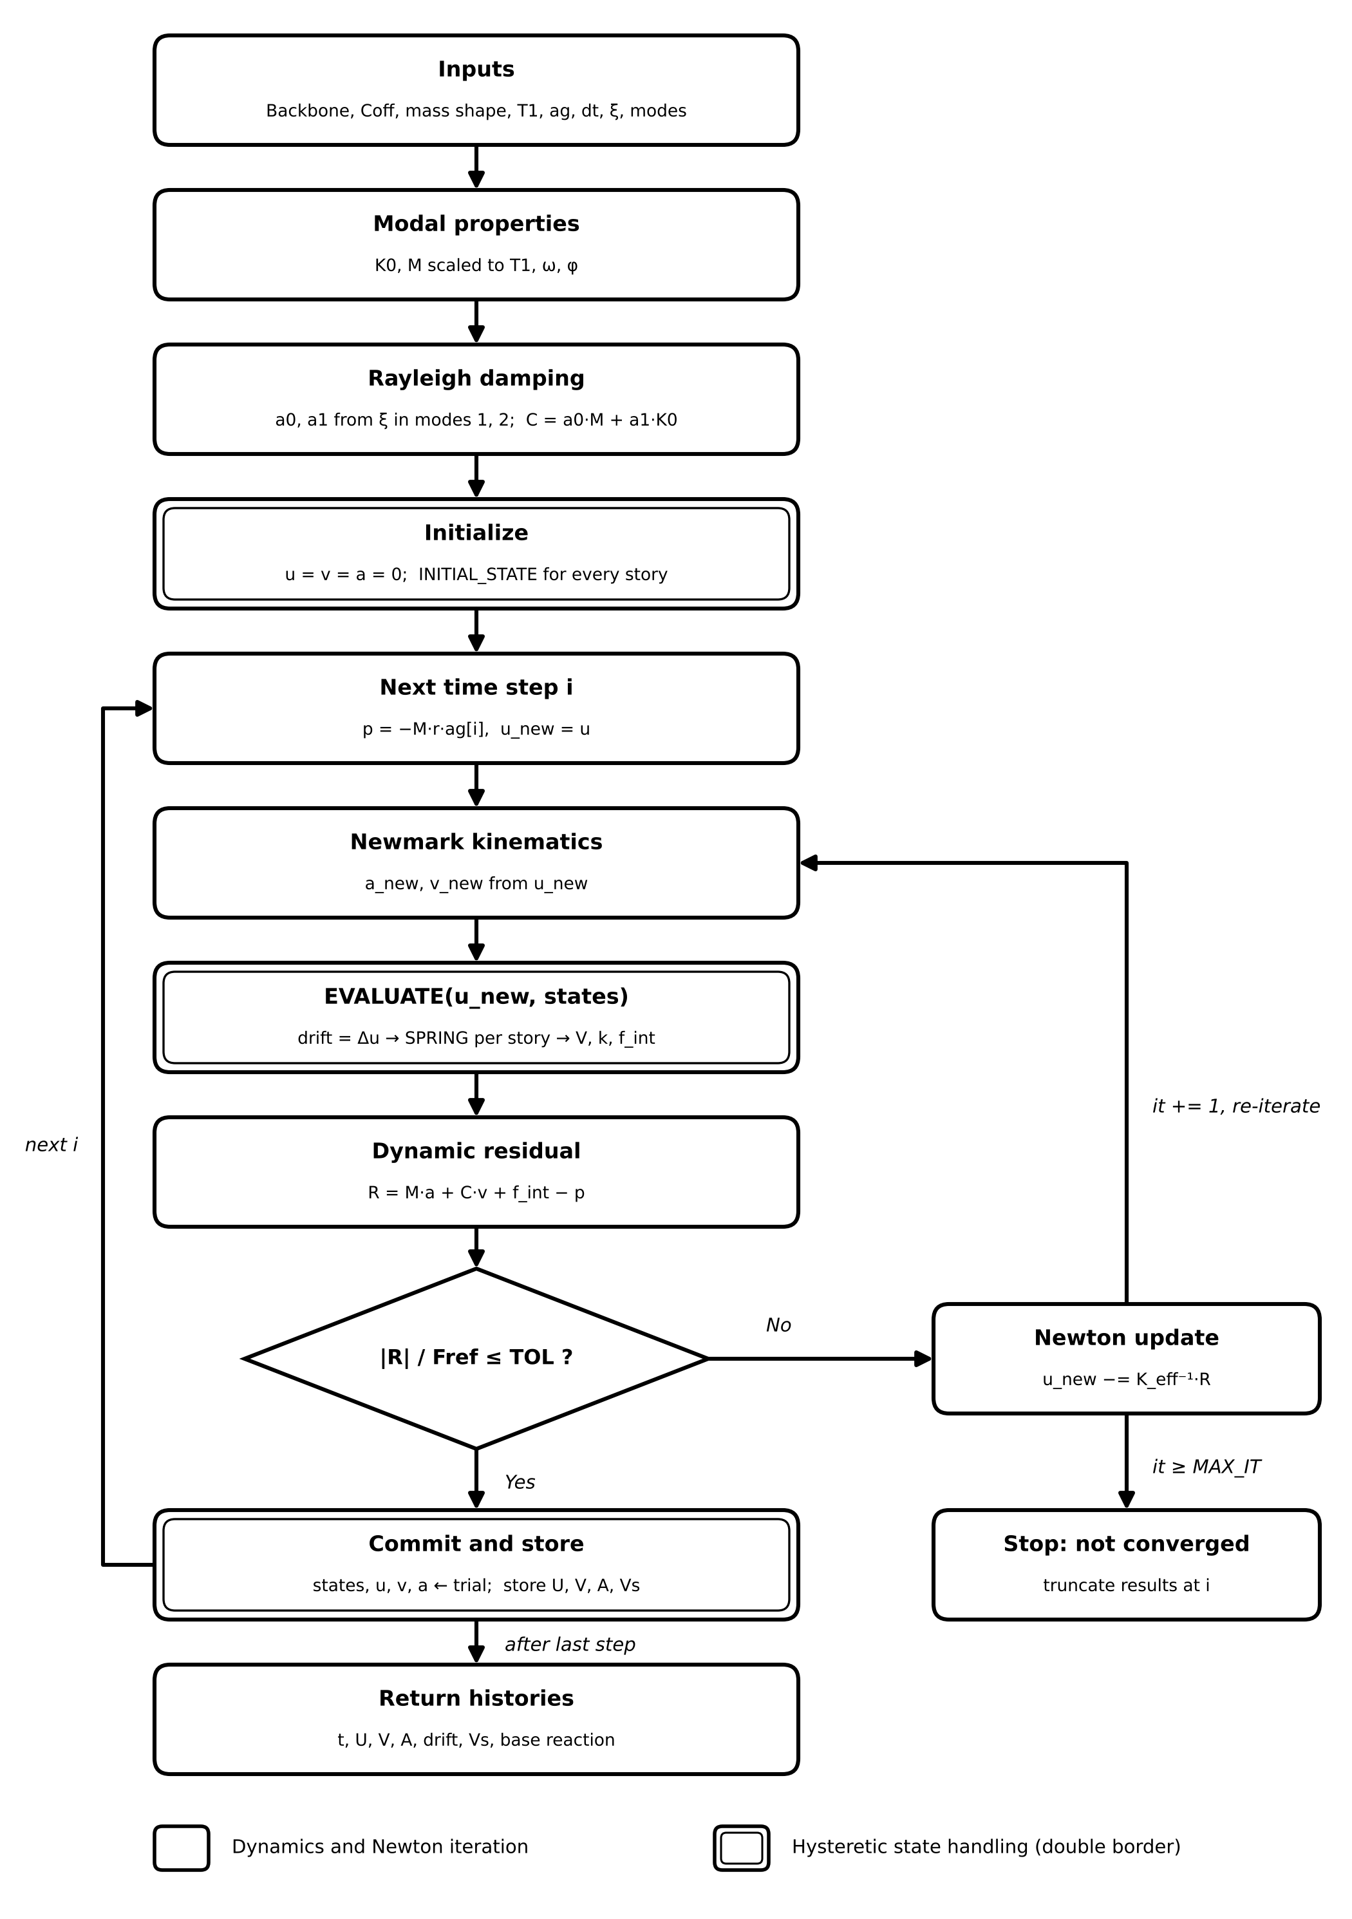

Step-by-step description
Step | Operation | Equation / action
1 | Inputs | Backbone (F, D), STORY_COFF, MASS_SHAPE, T1, ag, Δt, ξ, MODES
2 | Modal properties | K0 = ASSEMBLE_K(Coff·k0); eigen-solve M^-½·K0·M^-½ → ω, φ; masses scaled so that T1 matches the target: M = shape·(ω1·T1/2π)²
3 | Rayleigh damping | a0 = 2ξ·ωi·ωj/(ωi + ωj); a1 = 2ξ/(ωi + ωj); C = a0·M + a1·K0 (constant in time)
4 | Initialize | u = v = a = 0; states = INITIAL_STATE() for each of the N stories; Fref = max(Coff)·max(F)
5 | Load and guess | p = −M·r·ag[i], r = {1,…,1}; u_new = u (previous committed displacement)
6 | Newmark kinematics | a_new = (u_new − u)/(β·Δt²) − v/(β·Δt) − (1/(2β) − 1)·a; v_new = v + Δt·[(1 − γ)·a + γ·a_new]
7 | EVALUATE | drift_j = u_j − u_(j−1); (f, k, trial_j) = SPRING(drift_j, state_j); V_j = Coff_j·f; f_int,j = V_j − V_(j+1)
8 | Residual | R = M·a_new + C·v_new + f_int − p; converged if |R|/Fref ≤ TOL
9 | Newton update | K_eff = ASSEMBLE(k) + γ·C/(β·Δt) + M/(β·Δt²); u_new −= K_eff⁻¹·R; it += 1; back to step 6
10 | Commit | states, u, v, a ← trial values; store U, VEL, ACC and story shears Vs
11 | Failure exit | If it ≥ MAX_ITERATIONS and not converged: print message, truncate results at step i
12 | Return | t, U_floor, V_floor, A_floor, drift, V_story, base_reaction = −V_story[:, 0]

Key notes
- Equation of motion: M·u″ + C·u′ + f_int(u, history) = −M·r·ag(t), with Rayleigh damping C = a0·M + a1·K0 built on the initial stiffness.
- Default Newmark parameters are the average acceleration method (γ = 0.5, β = 0.25), unconditionally stable for linear systems.
- Each story owns its committed hysteresis state. SPRING is a pure function of the committed state and the trial drift, so it can be re-evaluated in every Newton iteration without corrupting history.
- K_t is a tridiagonal matrix assembled from the story tangents. Tangents below k_floor = 1e-8·k0·min(Coff) are replaced by k_floor so K_eff stays non-singular on flat post-peak branches.
- State is committed only after the residual satisfies the tolerance, which matches the converged-step behaviour of OpenSees.
- The residual norm is normalized by Fref = max(Coff)·max(F), so the tolerance is dimensionless.
- Chart legend: single-border boxes are dynamics and Newton iteration; double-border boxes are hysteretic state handling.

Part 2. OpenSeesPy verification model: HystereticSM story springs, transient analysis and fallback solver
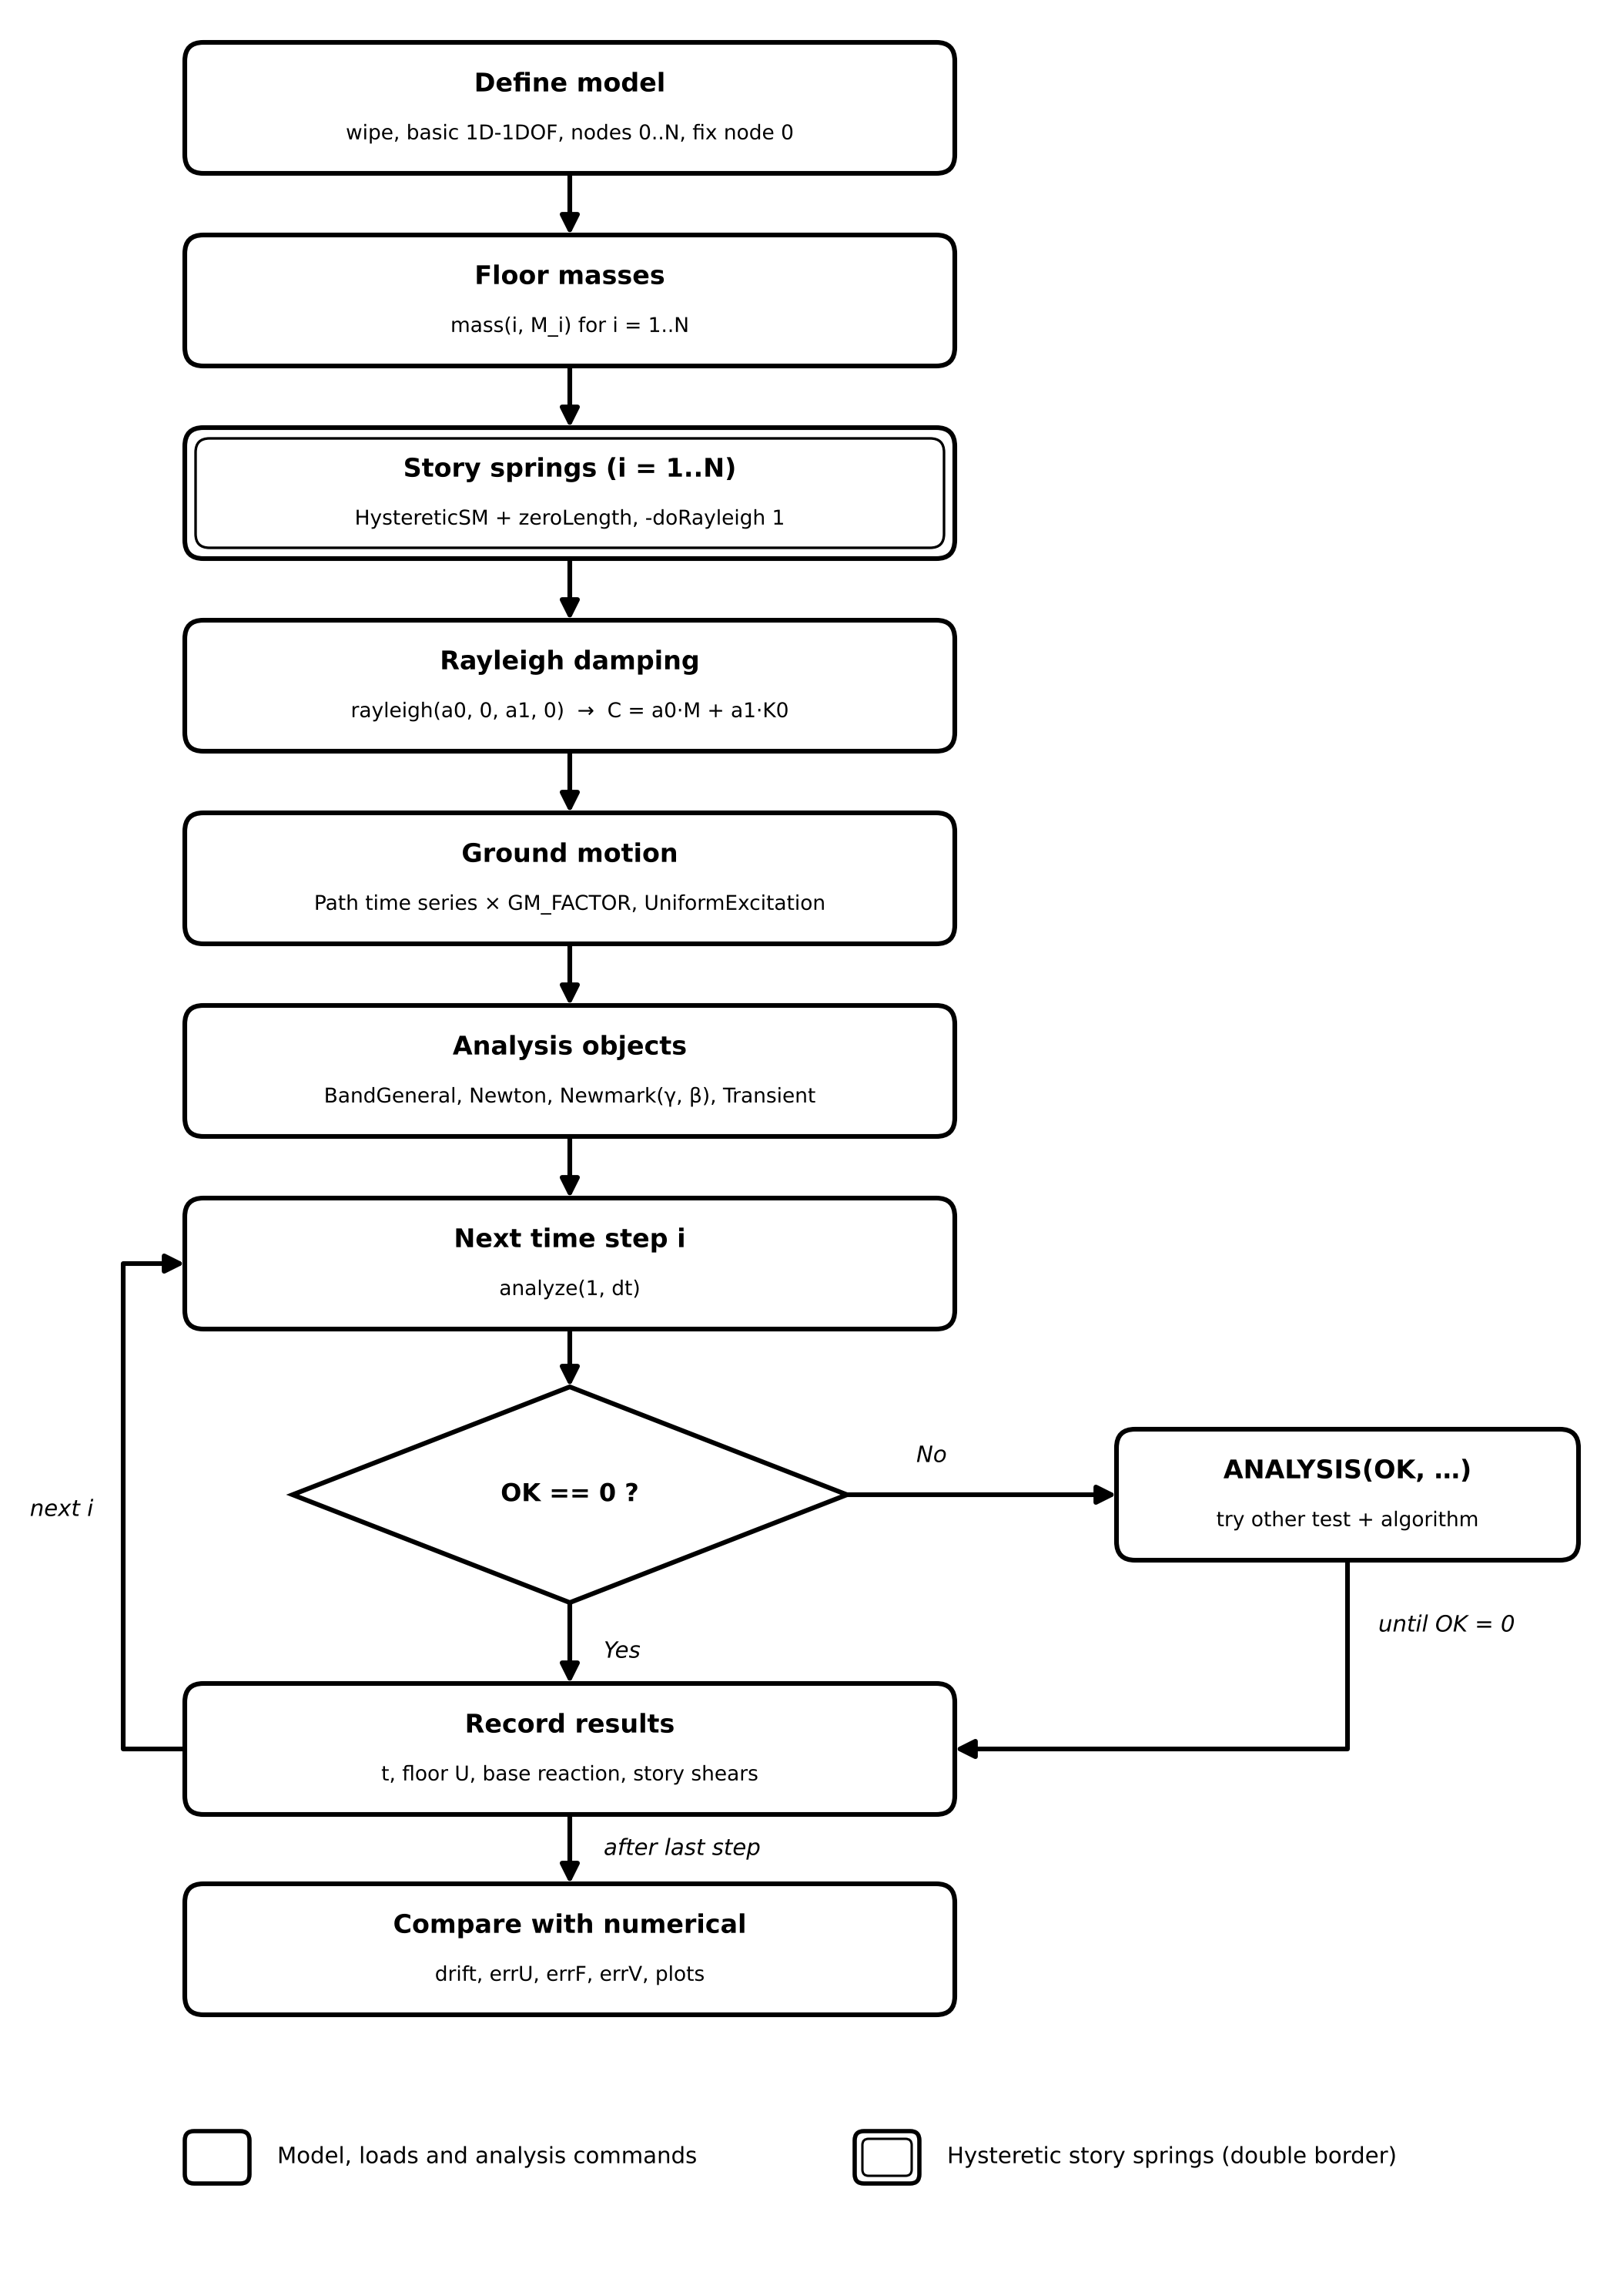

Step-by-step description
Step | Operation | Equation / action
1 | Define model | ops.wipe(); model basic, ndm = 1, ndf = 1; nodes 0..N (0 = ground); fix(0, 1)
2 | Floor masses | ops.mass(i, M_i) for i = 1..N
3 | Story springs | For each story i: HystereticSM with points ±Coff_i·F and ±D (no pinching, no damage); zeroLength(i, i−1, i, -mat i, -dir 1, -doRayleigh 1)
4 | Rayleigh damping | ω from MODAL_PROPERTIES; (a0, a1) from RAYLEIGH_COEFFICIENTS; ops.rayleigh(a0, 0, a1, 0) gives the same constant C as the numerical model
5 | Ground motion | timeSeries('Path', -dt, -values ag_raw, -factor GM_FACTOR); pattern UniformExcitation, direction 1, -accel
6 | Analysis objects | system BandGeneral; numberer Plain; constraints Plain; test NormDispIncr(TOL, MAX_IT); algorithm Newton; integrator Newmark(γ, β); analysis Transient
7 | Time step | OK = ops.analyze(1, dt) for i = 1..len(ag_raw) − 1
8 | Convergence check | If OK ≠ 0, call ANALYSIS(OK, 1, TOL, MAX_IT) from ANALYSIS_FUNCTION.py
9 | Fallback | ANALYSIS loops over alternative tests (NormDispIncr, RelativeEnergyIncr, RelativeNormUnbalance, RelativeNormDispIncr, NormUnbalance) and algorithms (KrylovNewton, SecantNewton, RaphsonNewton, PeriodicNewton, BFGS, Broyden, NewtonLineSearch) until analyze succeeds
10 | Record results | ops.reactions(); t = getTime(); floor U = nodeDisp(n, 1); base reaction = nodeReaction(0, 1); story shear = −eleResponse(j, force)[0]
11 | Compare | drift = Δ floor displacement; errU, errF, errV = |OpenSees − numerical|; plot roof displacement, global and story hysteresis, drift profile

Key notes
- Both solvers use the same backbone, the same constant Rayleigh matrix, and Newmark with γ = 0.5, β = 0.25, so differences should be at the level of round-off and convergence tolerance.
- '-doRayleigh', 1 is required on the zeroLength elements, otherwise the stiffness-proportional Rayleigh term is ignored.
- ops.rayleigh(a0, 0, a1, 0) puts a1 on the initial stiffness (betaKinit), which corresponds to a1·K0 in the Python code.
- After a fallback succeeds, the new test and algorithm stay active for all later steps because the script does not reset them to Newton.
- The message printed inside ANALYSIS appears when a fallback combination succeeds, i.e. when the default Newton setting failed at that step.
- Chart legend: single-border boxes are model, load and analysis commands; the double-border box defines the hysteretic story springs.

