1. UC1a and b - RMC-SS Create Service request (Defect) on EAMS

|  |  |  |  |
| --- | --- | --- | --- |
| **Name** | RMC -SS creates SR on EAMS | | |
|  | | | |
| **Description** | Process about RMC-SS creates a Service Request (SR) in case of automatic notification from ITS subsystem on an ITS asset fault or anomaly. | | |
| **Primary User Role** | RMC-SS | | |
| **Secondary User Role** |  | | |
| **Triggers** | Automatic trigger:   * a fault is detected on any of the ITS assets; * the fault on the asset shall be configured to generate automatically a SR | | |
| **Preconditions** | * ITS Asset has a MXASSETNUM in RMC-SS * ITS Asset has a [ASSETNUM] ref in EAMS * EAMS has a Service Request type "Asset Fault" * At least one fault type shall be configured to create service request * following fields are populated for the creation of the Service Request:  |  |  |  | | --- | --- | --- | | **Attribute** | **Datatype** | **Remarks** | | PriorityOfIssueReported | Integer | Priority **Value Description** 1 Urgent (Default value) 2 High 3 Medium 4 Low | | ExternalDefectType | String | RMC fault type. Default type: “EAMS” | | SiteId | String | Default value "101" | | Source | String | Default value "RMC" | | Status | String | Default value "QUEUED" | | ShortDescripton | String | RMC fault description | | ExternalDepartment | String | Default value "ROADS" | | ExternalSRType | String | Possible values "Defects" | | ExternalExternalId | String | RMC fault id | | AssetNumber | String | MXASSETNUM | | ExternalFrameZone | String | ExternalFrameZone of the correspondent asset (from GIS).  Default: “Inner Doha” | | ImpactedUserName | String | Default type = “TEST” | | LongDescription | String |  | | ExternalDefectCategory | String | Default value“CAT1” | | ExternalLatitudeX |  |  | | ExternalLongitudeY |  |  | | ExternalSRGroup |  | Default value “RD_RNMC” | | ExternalSource |  | Default value “RMC” | | ReportedBy |  | Default value “RMCINTUSER” | | | |
| **Successful outcome** | * New Service Request is created on EAMS with [TICKETID] and [STATUS]. The mapping in RMC-SS is:   + [TICKETID]= IncidentId,   + [TICKETUID]=IncidentUID and   + [STATUS]=Status. * SR [IncidentID] related to the asset fault is saved in RMC-SS DB * SR is shown on the corresponding Asset on the map view (on a separate layer). | | |
| **Unsuccessful outcome** | **Failure** | **Result** | **Condition** |
| Error handling messages as defined on RMC-SS. Following Error messages will be configured:  “Could not create a Service Request”. | No record of SR is on RMC-SS DB. | Not successful. |
| **Normal Task Flow** | 1. ITS subsystem sends a fault record on an ITS Asset to RMC-SS 2. RMC-SS inserts the fault in the RMC-SS DB and retrieves the configuration for SR generation 3. If the fault type is configured to generate a SR    1. RMC-SS retrieves the MXASSETNUM from the database for the specific asset    2. RMC-SS requires the creation of SR to EAMS via BU.IF2 “Create Service Request” of type “Asset Fault”    3. EAMS creates a SR and sends confirmation with EAMS-SR identifier (IncidentId) back to RMC-SS via BU.IF2    4. RMC-SS stores the SR IncidentId in the RMC-SS DB 4. If the ITS Asset is localized on geographical coordinates, the SR icon is displayed on the map | | |
| **Alternative**  **Task Flow 1** |  | | |
| **Alternative**  **Task Flow 2** |  | | |
| **Linked**  **Activities** |  | | |
| **Further information** | The creation of the SR is active only for the ITS assets that have not active “alarm block” (alarm suppression).  The creation of the SR is active only for the ITS assets fault belonging to fault type configured to generate service requests. | | |

* 1. SR Creation (Defect) - Data flow diagram

|  |  |
| --- | --- |
| **Input** | ITS subsystem 🡪 ITS asset fault message  RMC-SS DB 🡪 SR creation configuration  RMC-SS DB 🡪 Asset [MXASSETNUM]  EAMS 🡪 SR creation for [MXASSETNUM] confirmation with [IncidentID] |
| **Function** | RMC-SS Creates Service request on EAMS |
| **Output** | * New Service Request is created on EAMS with [TICKETID] and [STATUS]. The mapping in RMC-SS is:   + [TICKETID]= IncidentId,   + [TICKETUID]=IncidentUID and   + [STATUS]=Status. * SR [IncidentID] related to the asset fault is saved in RMC-SS DB * SR is shown on the corresponding Asset on the map view. |

1. UC2 - CAT1 SR ALIGNMENT

|  |  |  |  |
| --- | --- | --- | --- |
| **Name** | Update CAT1 SR | | |
| Diagram is deprecated | | | |
| **Description** | RMC-SS request to EAMS every 5 minutes an updated list of CAT1 SR (only QUEUED and IN PROGRESS status) to be updated on the RMC-SS database.  RMC-SS:   * inserts new CAT1 SR on DB * update CAT1 SR with new status * delete CAT1 SR no longer in the list from EAMS | | |
| **Primary User Role** | EAMS over ESB | | |
| **Secondary User Role** | IIB service on BU.IF2 | | |
| **Triggers** | Automatic Trigger:   * ~~every 5 minutes~~ * message on queue (currently only on status update) | | |
| **Preconditions** |  | | |
| **Successful outcome** | New CAT1 SR are inserted on RMC-SS DB.  CAT1 SR with updated fields are updated  CAT1 SR no more in the list of QUEUED and IN PROGRESS are marked as deleted in RMC-SS DB  The filed that are required to EAMS via BU.IF2 are the following:   * AssetNumber * AssetSiteId * ExternalFrameZone * ActualReportedtDate * ActualStartDate * IncidentDate * IncidentId * ExternalCRMsrId * ShortDescripton * LongDescription * Source * Status * StatusDate * Urgency * ExternalDefectCategory * ExternalDefectType * ExternalLattitudeX * ExternalLongittudeY * LatitudeY * LongitudeX   Fields IncidentId, ExternalCRMsrId, Status, ExternalDefectCategory, ShortDescription, LongDescription must be saved into the main SR db table, other fields must be saved in the SR parameters table.  Inventory of parameters must be managed automatically from the system. | | |
| **Unsuccessful outcome** | **Failure** | **Result** | **Condition** |
| Error handling as defined on RMC-SS. | SR not updated on RMC-SS DB. | Not successful |
| **Normal Task Flow** | Every 5 minutes RMC-SS requests to EAMS, via BU.IF2, the list of CAT1 SR, with status QUEUED and IN PROGRESS.  RMS-SS uses this list to compare with the one stored in RMC-SS DB.  In case of differences:   * RMC-SS inserts new CAT1 SR (in the retrieved list but not in the RMC-SS DB) * RMC-SS updates existing CAT1 SR (for those already in the list, but with a different status) * RMC-SS marks as deleted CAT1 SR that are in RMC-SS, but not in the retrieved list. | | |
| **Alternative**  **Task Flow 1** |  | | |
| **Alternative**  **Task Flow 2** |  | | |
| **Linked**  **Activities** |  | | |
| **Further information** | 5 minutes interval is the default period to request an update of CAT1 SR. This parameter can be modified during configuration of the system | | |

* 1. Update EAMS-SR – data flow

|  |  |
| --- | --- |
| **Input** | EAMS 🡪 CAT1 SR in QUEUED and IN PROGRESS status |
| **Function** | The function updates the list of CAT1 SR in RMC-SS database, according the list of CAT1 SR retrieved from EAMS via BU.IF2. |
| **Output** | New CAT1 SR are inserted on RMC-SS DB.  CAT1 SR with updated fileds are updated  CAT1 SR no more in the list of QUEUED and IN PROGRESS are marked as deleted in RMC-SS DB |

1. UC3 - RMC operator monitors SR for outstanding SRs (overview)

|  |  |  |  |
| --- | --- | --- | --- |
| **Name** | RMC operators monitors SR for outstanding SRs (overview) | | |
|  | | | |
| **Description** | Process about RMC operator monitors the list of all CAT1 Service Requests ~~in~~ ~~QUEUED or IN PROGRESS status~~. | | |
| **Primary User Role** | RMC operator | | |
| **Secondary User Role** |  | | |
| **Triggers** | Manual intervention | | |
| **Preconditions** | * RMC-SS DB has records from EAMS and CRMS updated RMC-SS DB with SR numbers, status and some details (see UC2) * User with proper privileges is logged in * For the Alternative 1: CAT1 Service Requests should be localized on coordinates or associated to an RMC ITS asset. | | |
| **Successful outcome** | * RMC-SS opens the Service Request overview form showing a list of ~~QUEUED~~ CAT1 Service Requests. ~~By default, IN PROGRESS service requests are not displayed on the list~~. * Only SR with status flagged as “Visible on SRO” (OMNIA DB CONFIGURATION) are displayed on SRO * ~~For Alternative 1: CAT1 Service Request (both QUEUED and IN PROGRESS) are displayed on the Map View~~ * Only SR with status flagged as “Visible on Map” (OMNIA DB CONFIGURATION) are displayed on Map View | | |
| **Unsuccessful outcome** | **Failure** | **Result** | **Condition** |
| Error handling messages as defined on RMC-SS. Following Error messages will be configured:  “failed to get Service Requests”. | Service Request list is not Displayed. | Not successful |
| **Normal Task Flow** | * RMC operator opens the Service Request Overview page. * RMC-SS retrieves all CAT1 SRs from the RMC-SS DB and returns a list of all Service Requests. * RMC-SS shows the Service Request Overview form with all outstanding Service Requests ~~(QUEUED status)~~ according to OMNIA DB CONFIGURATION (“Visible on SRO”) * Service Request overview page shows the following information/headers:  |  |  | | --- | --- | | **Field on the overview** | **Field from DB (coming from BU.IF2)** | | Incident ID | IncidentId | | CRMS ID | ExternalCRMsrId | | Last Update | StatusDate | | Status | Status | | Category | ExternalDefectCategory | | Short Description | ShortDescripton | | Long Description | LongDescription |  * Other fields must be displayed on main view if ShowInReport flag for the corresponding parameter is true. * SR Overview View   From this view, selecting a single row, the RMC operator can   * Localize the SR on the map (button available only if coordinates of the SR are available) * Open details of EAMS SR * Open details of the CRMS SR (if CRMS identifier available) * EAMS details and CRMS details must be opened on the same popup on different tabs * On Open Details, all main fields must be visible. Other fields must be displayed if ShowInPopup flag for the corresponding field is true. * Furthermore, the operator can sort (on total of items and not only on current page), filter (on total of items and not only on current page), export (total items filtered and sorted) and print the table, as for any RMC-SS grid. * SR Overview must have pagination support. * Every column on SR Overview must be filterable (according to the column data type) on the total of items retrieved (not only on the current page). | | |
| **Alternative**  **Task Flow 1** | * RMC operator opens the map view and activates the Service Request Layer. * RMC-SS queries the RMC-SS DB for all Service Request records * RMC-SS Displays all Service Requests with updated state above every corresponding location with different Icons for the state on the Map view.   + QUEUED   + IN PROGRESS * Must be possible to configure SR Inventory status. In particular it must be possible to configure status icon color and if a particular status is visible on MapView and / or SR Overview (no icon on SR Overview). * Severity of the status (for the ranking) must be configurable. * In case the SR is related to an ITS asset already displayed by RMC-SS, the icon is shown with the picker on the top part of the icon. * SR Icon is placed on stand alone layer (not the same of the assets). * In case of multiple SR (defects) on the same asset a single icon is shown with the color of the worst status (according to ranking). * In case of multiple SR when clicking on the SR icon a popup presenting the list of the SR (only the ones with visible status configured) is displayed (as for cluster popup, but, the icon is NOT a cluster). From the SR popup is possible to select and open the single detailed SR popup.     Clicking on the icon, the pop-up of the SR is displayed:     * In case of single SR the details popup is opened when clicking on the icon. * The details SR popup must show the same columns of the SR Overview (main data)   From the pop-up, the RMC operator can:   * Open details of EAMS SR * Open details of the CRMS SR (if CRMS identifier available) * Popup is the same that can be opened from SR Overview (1 popup with 2 tabs) | | |
| **Alternative**  **Task Flow 2** |  | | |
| **Linked**  **Activities** | EAMS Updates the status of Service Requests on EAMS. | | |
| **Further information** |  |  |  |

* 1. Monitor outstanding-SR status – data flow

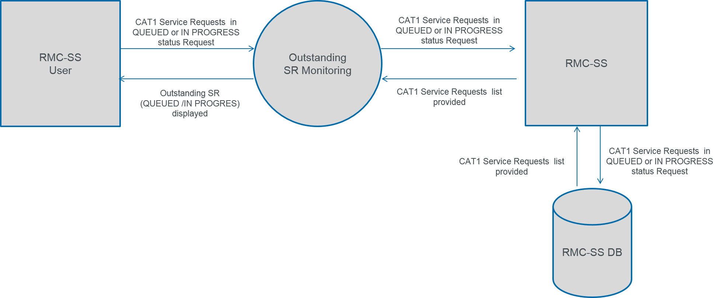

|  |  |
| --- | --- |
| **Input** | RMC-SS User  → SR Overview Request  RMC-SS DB 🡪 SR list and details |
| **Function** | To provide to RMC-SS users an overview of the CAT1 SR in QUEUE and IN PROGRESS status |
| **Output** | * RMC-SS opens the Service Request overview form showing a list of QUEUED CAT1 Service Requests. By default, IN PROGRESS service requests are not displayed on the list. The user, with a checkbox, can show both QUEUED and IN PROGRESS CAT1 SR * For Alternative 1: CAT1 Service Request (both QUEUED and IN PROGRESS) are displayed on the Map View |

1. UC4.1 and 4.2 – RMC operators monitors SR state for a specific SR (detailed monitoring)

|  |  |  |  |
| --- | --- | --- | --- |
| **Name** | RMC operators monitors SR state for a specific SR (detailed monitoring) | | |
|  | | | |
| **Description** | Process about RMC operator checks the latest status for all SRs created on EAMS with status QUEUED or IN PROGRESS and if required check CAT1 CRMS Service requests that were the origin for some EAMS Service Requests. | | |
| **Primary User Role** | RMC operator | | |
| **Secondary User Role** |  | | |
| **Triggers** | Manual intervention | | |
| **Preconditions** | * CAT1 SR Overview is opened by the user * For the Alternative Workflow 1: Map View is opened by the user, with SR layer enabled | | |
| **Successful outcome** | * RMC-SS displays a form with Service Request details of the selected Service Request. | | |
| **Unsuccessful outcome** | **Failure** | **Result** | **Condition** |
| Error handling messages as defined on RMC-SS. Following Error messages could be shown:  “Could not return SR details”. | No SR details are retrieved from EAMS. | Not successful |
| **Normal Task Flow** | * RMC operator has Service Request Overview page open. * RMC operator selects a specific Service Request record. * RMC-SS sends a GET request with the [IncidentID] to EAMS via BU.IF2 * EAMS queries all Attributes of the [IncidentID] * EAMS sends a response to RMC-SS via BU.IF2 with all Service Request details for the selected SR. * RMC-SS displays the Service Request detail form with all Service Request details of the selected SR.   If the EAMS-SR has a reference for a CRMS SR,   * optionally RMC operator opens the CRMS details * RMC-SS sends a GET request via BU.IF4 with the [ExternalCRMsrId] to CRMS * CRMS queries all attributes of the [ExternalCRMsrId] * CRMS sends a response to RMC-SS via BU.IF4 with all Service Request details for the selected SR. * RMC-SS shows the Service Request detail form with attributes for the original CRMS-SR. | | |
| **Alternative**  **Task Flow 1** | **Only for Service Requests with locations (type; “Defect” or CAT1)**   * RMC operator opens the map view and activates the Service Request Layer. * RMC-SS Selects a Service Request record icon above an Asset * RMC-SS sends a GET request with the [IncidentID] to EAMS via BU.IF2 * EAMS queries all Attributes of the [IncidentID] * EAMS sends a response to RMC-SS via BU.IF2 with all Service Request details for the selected SR. * RMC-SS displays the Service Request detail form with all Service Request details on the Map view.   If the SR has a reference for a CRMS SR,   * optionally RMC operator opens the CRMS details * RMC-SS loads the CRMS SR references number * RMC-SS sends a GET request via BU.IF4 with the [ExternalCRMsrId] to CRMS * CRMS queries all attributes of the [ExternalCRMsrId] * CRMS sends a response to RMC-SS via BU.IF4 with all Service Request details for the selected SR. * RMC-SS shows the Service Request detail form with attributes for the original CRMS-SR on the map view. | | |
| **Alternative**  **Task Flow 2** |  | | |
| **Linked**  **Activities** | RMC operator Opens a List of outstanding Service Requests | | |
| **Further information** |  |  |  |

* 1. Display EAMS-SR details on RMC-SS system by RMC-SS User – data flow

|  |  |
| --- | --- |
| **Input** | RMC-SS User → EAMS SR Details Request  EAMS 🡪 Specific SR details |
| **Function** | To display details for a specific IncidentID SR on RMC-SS system by RMC-SS User |
| **Output** | RMC-SS displays a form with Service Request details of the selected Service Request. Data are collected directly from EAMS |

* 1. Display EAMS-SR/CRMS-SR details – data flow

|  |  |
| --- | --- |
| **Input** | RMC-SS User → EAMS SR Details Request  EAMS 🡪 Specific SR details |
| **Function** | To display details for a specific ExternalCRMsrId SR on RMC-SS system by RMC-SS User |
| **Output** | RMC-SS displays a form with Service Request details of the selected Service Request. Data are collected directly from CRMS |
|  |  |

1. UC 5 – RMC operator show Asset Information from EAMS

|  |  |  |  |
| --- | --- | --- | --- |
| **Name** | RMC operator shows asset information and status from EAMS | | |
|  | | | |
| **Description** | Process about RMC operator requires asset information and asset status from EAMS. | | |
| **Primary User Role** | RMC operator | | |
| **Secondary User Role** | RMC-SS | | |
| **Triggers** | Manual trigger | | |
| **Preconditions** | The asset shall be identified in GIS by the following code:   * RMC_GUID * MXASSETNUM * ASSET_TAG | | |
| **Successful outcome** | Detailed Asset information is shown on the page EAMS Asset Details. | | |
| **Unsuccessful outcome** | **Failure** | **Result** | **Condition** |
| Error handling messages as defined on RMC-SS. Following Error messages could be shown:  “Could not retrieve Asset Details”. | No Asset details form shows for the selected ITS asset. | Not successful |
| **Normal Task Flow** | 1. RMC operator selects a single ITS asset from    1. System overview    2. Map View    3. EAMS Asset Overview 2. RMC operator requests EAMS Asset Details for the selected asset 3. ~~RMC-SS retrieves MXASSETNUM~~ 4. ~~RMC-SS sends a request to EAMS to get Asset details for the selected Asset with MXASSETNUM.~~ 5. ~~EAMS runs a query and sends Asset details to RMC-SS~~ 6. RMC-SS displays Asset details including condition on the form  * On Open Details, all main fields of Asset Overview must be visible. Other fields must be displayed if ShowInPopup flag for the corresponding field is true. | | |
| **Alternative**  **Task Flow 1** |  | | |
| **Alternative**  **Task Flow 2** |  | | |
| **Linked**  **Activities** |  | | |
| **Further information** | ~~For each asset are displayed all the information available in MAXIMO, regardless of the value of the field. Details are different for each asset type.~~ | | |

* 1. Display asset information from EAMS – data flow

|  |  |
| --- | --- |
| **Input** | RMC-SS operator  → Select ITS asset / Asset details request  EAMS 🡪 SR details provided |
| **Function** | RMC operator calls Asset information and condition from EAMS and display asset details. |
| **Output** | RMC-SS displays Asset details including condition on the form. |
|  |  |

1. UC 5A – RMC operator show Asset list from EAMS

|  |  |  |  |
| --- | --- | --- | --- |
| **Name** | RMC operator Show Asset list from EAMS | | |
| Diagram Is deprecated | | | |
| **Description** | Process about RMC operator requires Assets list from EAMS. | | |
| **Primary User Role** | RMC operator | | |
| **Secondary User Role** | RMC-SS | | |
| **Triggers** | Manual trigger | | |
| **Preconditions** | Asset are loaded on EAMS | | |
| **Successful outcome** | Assets list is shown on the page EAMS Asset Overview (See Appendix 2)   * Asset overview page shows the following information/headers:  |  | | --- | | **Field on the overview** | | Asset tag | | MXAssetNum | | Last update | | MXStatus | | Asset Name<non esiste> | | Latidute | | Longitude | | RMC-SS id |  * Other fields must be displayed on main view if ShowInReport flag for the corresponding parameter is true. * Asset Overview View   From this view, selecting a single row, the RMC operator can   * Localize the asset on the map (button available only if asset matching with an RMC-SS id has a valid value) * Open asset details * On Open Details, all main fields must be visible. Other fields must be displayed if ShowInPopup flag for the corresponding field is true. * Furthermore, the operator can sort (on total of items and not only on current page), filter (on total of items and not only on current page), export (total items filtered and sorted) and print the table, as for any RMC-SS grid. * Asset Overview must have pagination support. * Every column on Asset Overview must be filterable (according to the column data type) on the total of items retrieved (not only on the current page). * Asset overview must show in the west panel the supported asset types (from dedicated management inventory). * Asset type can match with RMC-SS object type (example EAMS traffic cameras with RMC-SS cameras) or not match (example EAMS bridges or tunnels) * Asset type can have an associated and configurable icon * Asset type can be configured on the RMC-SS db associating a specific end point     (fields in the mockup are not the correct ones, see the list of correct fields in the descriptive section) | | |
| **Unsuccessful outcome** | **Failure** | **Result** | **Condition** |
| Error handling messages as defined on RMC-SS. Following Error messages could be shown:  “Could not retrieve Asset List”. | No Asset list shows for the selected ITS asset type | Not successful |
| **Normal Task Flow** | 1. Operator clicks on link to open EAMS Asset Overview  2. RMC-SS retrieves EAMS Asset Overview from database  3. RMC-SS displays to operator EAMS Asset Overview page  4. Operator selects the asset type on EAMS Asset Overview  5. ~~RMC-SS queries EAMS to retrieve asset list for the specific asset type~~  6. RMC-SS displays to operator asset list retrieved from EAMS | | |
| **Alternative**  **Task Flow 1** |  | | |
| **Alternative**  **Task Flow 2** |  | | |
| **Linked**  **Activities** | EAMS Asset information and status monitoring | | |
| **Further information** | ~~The available asset types, and information for each asset type are:~~   * ~~Bridges~~   + ~~ASSET_TAG~~   + ~~DESCRIPTION~~   + ~~MXASSETNUM~~   + ~~MXSTATUS~~   + ~~OBJECTID~~   + ~~REMARKS~~   + ~~ROAD_TYPE~~   + ~~SHAPE.AREA~~   + ~~SHAPE.LEN~~   + ~~VERTICAL_CLEARANCE~~ * ~~Traffic signals~~   + ~~ASSET_TAG~~   + ~~MXASSETNUM~~   + ~~MXSTATUS~~   + ~~OBJECTID~~   + ~~MOUNTING_TYPE~~ * ~~Traffic cameras~~   + ~~ASSET_TAG~~   + ~~MXASSETNUM~~   + ~~MXSTATUS~~   + ~~OBJECTID~~   + ~~CAMERA_TYPE~~   + ~~DISTRICT~~   + ~~MUNICIPALITY~~   + ~~MXSITEID~~   + ~~RMC_GUID~~   + ~~ZONE_NO~~ * ~~Speed Cameras~~   + ~~ASSET_TAG~~   + ~~MXASSETNUM~~   + ~~MXSTATUS~~   + ~~OBJECTID~~   + ~~ASSET_CONDITION~~   + ~~DISTRICT~~   + ~~MUNICIPALITY~~   + ~~REMARKS~~   + ~~RMC_GUID~~   + ~~ROAD_TYPE~~   + ~~ZONE_NO~~ * ~~Electronic signs~~   + ~~ASSET_TAG~~   + ~~MXASSETNUM~~   + ~~MXSTATUS~~   + ~~OBJECTID~~ * ~~Parking~~   + ~~ASSET_TAG~~   + ~~MXASSETNUM~~   + ~~MXSTATUS~~   + ~~OBJECTID~~   + ~~ROAD_TYPE~~   + ~~SHAPE.AREA~~   + ~~SHAPE.LEN~~   + ~~TYPE~~ * ~~Barriers~~   + ~~ASSET_TAG~~   + ~~MXASSETNUM~~   + ~~MXSTATUS~~   + ~~OBJECTID~~   + ~~RD_ENAME~~   + ~~SHAPE.LEN~~   + ~~TYPE~~ * ~~Tunnels~~   + ~~ASSET_TAG~~   + ~~MXASSETNUM~~   + ~~MXSTATUS~~   + ~~OBJECTID~~   + ~~LENGTH~~   + ~~REMARKS~~   + ~~SHAPE.AREA~~   + ~~SHAPE.LEN~~   + ~~VERTICAL_CLEARANCE~~   + ~~WIDTH~~   + ~~ZONE_NO~~ | | |
|  |  | | |

* 1. EAMS Asset List Monitoring

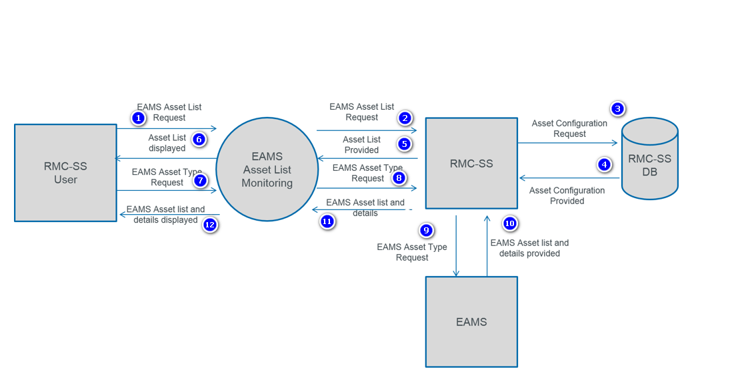

|  |  |
| --- | --- |
| **Input** | RMC-SS operator  → EAMS Asset List Request  RMC-SS operator  → EAMS Asset Type Request  RMC-SS 🡪Asset List Provided  RMC-SS 🡪EAMS Asset list and details |
| **Function** | RMC operator calls Asset list information and condition from EAMS and display asset details. |
| **Output** | RMC-SS displays to operator asset list retrieved from EAMS |
|  |  |
|  |  |