Customer Churn Analysis - EDA with Visualizations

1. Churn Distribution
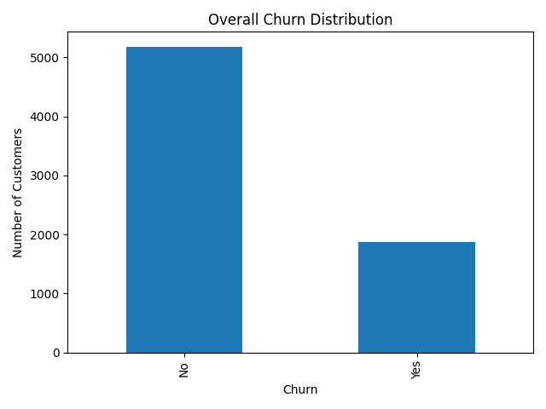
This bar chart shows the overall distribution of churned vs non-churned customers. Although most customers are retained, a significant portion has churned, indicating the need for proactive retention strategies.

Tenure Distribution
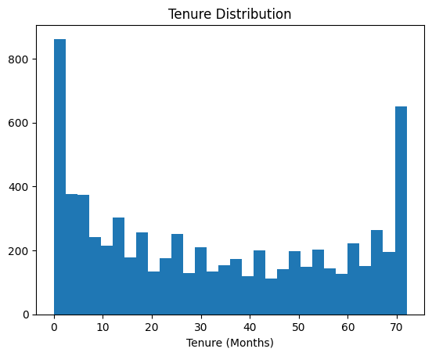
The data shows a "U-shaped" trend, where the highest concentrations of customers are either brand new (0–5 months) or highly loyal (70+ months), suggesting that the first few months are the most critical for customer retention.

Monthly Charges Distribution
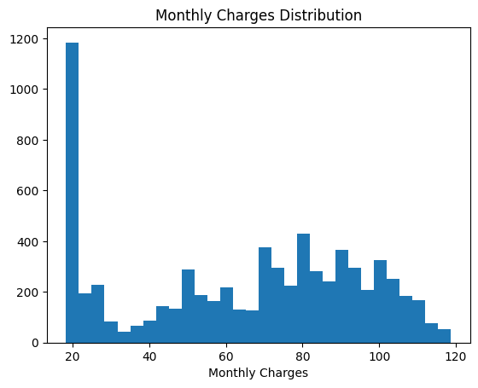
The distribution is bimodal, with a massive spike of customers paying the minimum (around 20) and another significant cluster paying higher rates between 70 and 100, indicating a split between basic and premium service tiers.

3.Total Charges Distribution
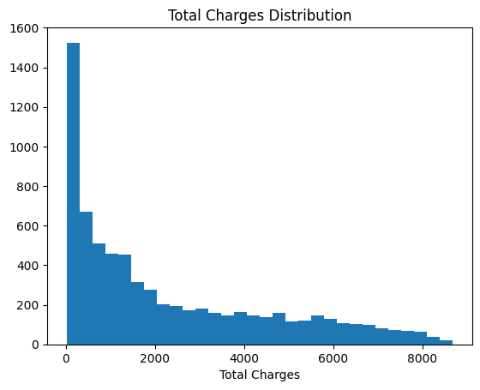

The distribution is heavily right-skewed, showing that a vast majority of customers have low cumulative lifetime charges, with the frequency dropping sharply as total charges exceed 2,000.

4. Categorical Feature Analysis vs Churn

4. Churn by Contract Type
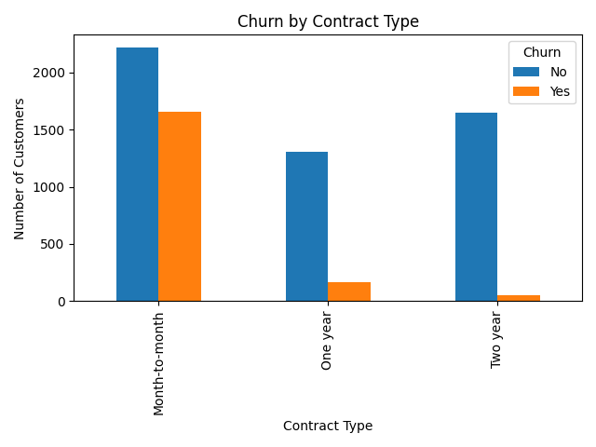
Customers on month-to-month contracts show significantly higher churn compared to one-year or two-year contracts. Longer contracts indicate stronger customer commitment.

3. Tenure vs Churn
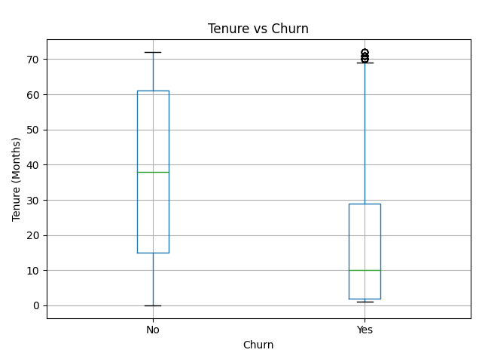
This box plot shows that customers who churn generally have lower tenure. Early-stage customers are more likely to leave, emphasizing the importance of strong onboarding and early engagement.

4. Internet Service vs Churn
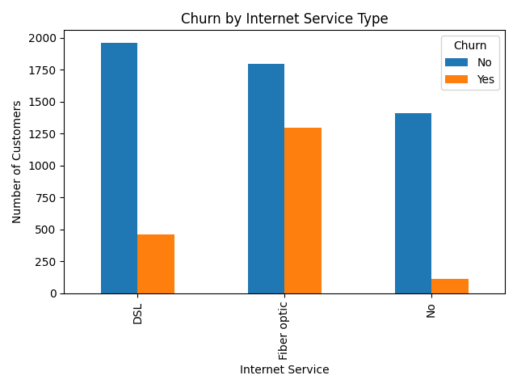
Fiber optic customers show higher churn compared to DSL users. This may indicate pricing concerns or service quality issues that require further investigation.

5. Churn vs Senior Citizen

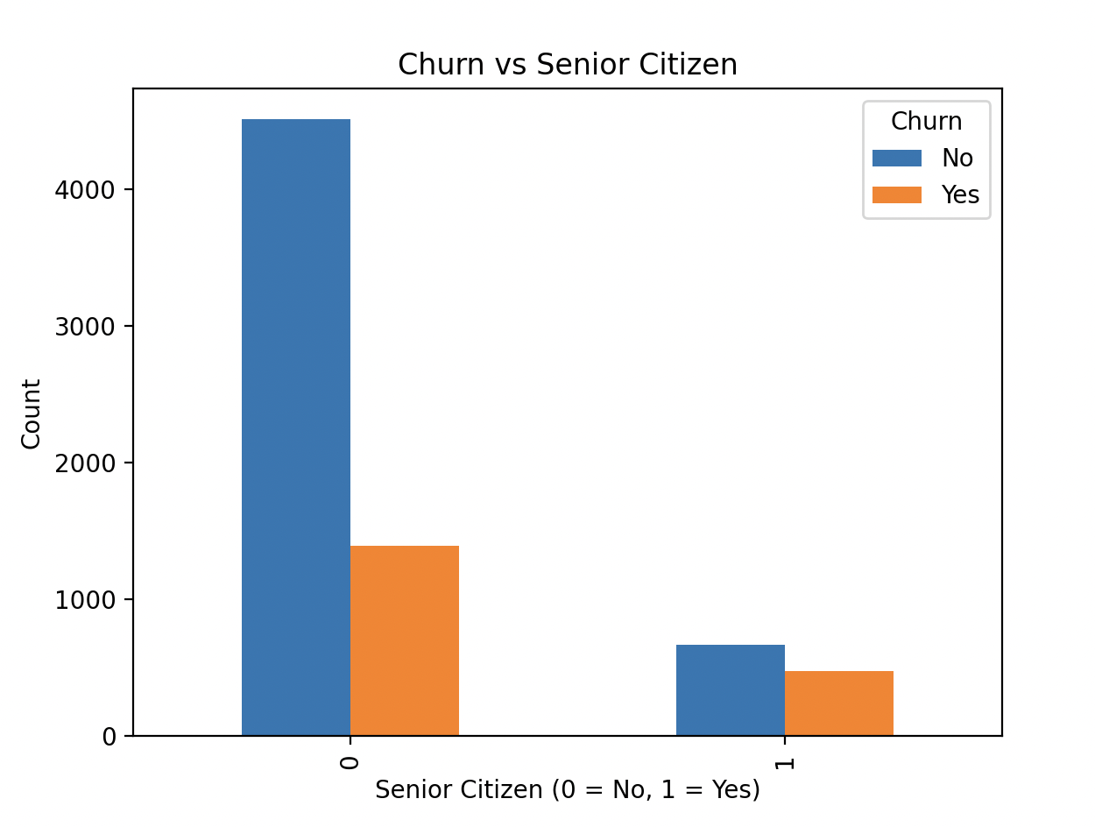
While the total number of senior citizen customers (represented by "1") is much smaller than the non-senior group, they exhibit a disproportionately high churn rate, with nearly half of all senior customers choosing to leave the service.

