**Graph ADT**

# Data Items

Each vertex in a graph has a label that uniquely identifies it. Vertices may include additional data.

# Structure

The relationship between the vertices in a graph is expressed using a set of directed/undirected Edges, where each edge connects one pair of vertices. Here is an example of undirected graph and its representation in the form of adjacency list.

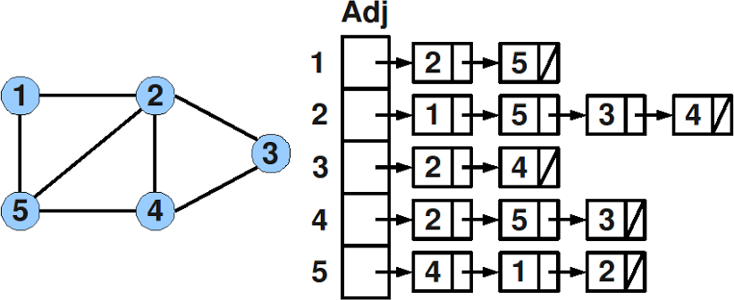

## __init__ (maxVertices)

Requirements:

None

Results:

Constructor. Creates an empty graph. Allocates enough memory for a graph containing maxNumber vertices.

## createVertex (newVertex )

Requirements:

None

Results:

Create and return a Vertex.

## insertEdge (int src, int dest)

Requirements:

Graph includes vertices src and dest.

Results:

Inserts an undirected edge connecting vertices src and dest into a graph.

## showGraphStructure ()

Requirements:

None

Results:

Outputs a graph with the vertices in array form and the edges in adjacency list form. If the graph is empty, outputs “Empty graph”. Note that this operation is intended for testing/debugging purposes only.

## BFS (int startVertex)

Requirements:

Graph contains start vertex. You can create an array of visited vertexs (size is same as size of graph).

Results:

Outputs vertexs of graph in BFS.

## DFS (int startVertex)

Requirements:

Graph contains start vertex. You can create an array of visited vertexs (size is same as size of graph).

Results:

Outputs vertexs of graph in DFS.

## Task 2:

A clique in a graph corresponds to a sub-graph where all pairs of vertexs are adjacent. Write a function **is_clique(list)** to add to the Graph class, that given a list of vertex as input, checks if the sub-graph containing those vertexs is a clique or not. Returns True or False.

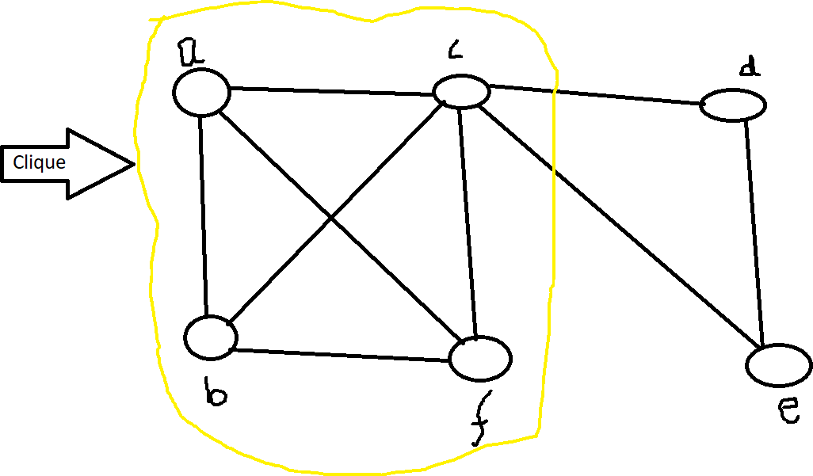

## Task 3 :

A graph contains N vertices (1. . .N). There is an edge between two vertices i and j if (i + j) is a prime.

For example if 1<N<7 then the graph will be like.

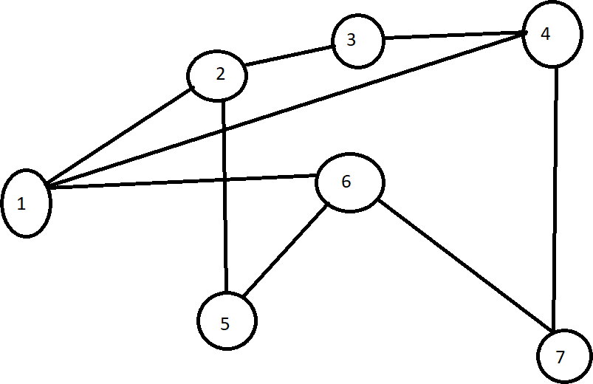

Implement it using list-based and traverse the graph output should be like.

## 1: 2, 4,6

**2: 1,3,5**

**3:2,4**

**4: 1,3,7**

**5:2,6**

**6:5,7**

**7:4,6**