Database Systems Project

**Group Members:**

**Ahmed Wadood 19I-1858**

**Salar Ahmed 19I-1716**

**Muhammad Absar Khalid 19I-2176**

# 

**Entity Relationship Diagram** **3**

**Relational Schema** **4**

**Table’s Description:** **6**

**Datasets:** **7**

**SQL Statements Used to Create And Populate Tables:** **7**

Course Table: 10

Father Table: 11

Fee Table: 12

Guardian Table: 12

History Table: 13

Mother Table: 14

Parent Table: 14

Registers Table: 15

Student Table: 16

Subject Table: 17

**Sql Queries:** **18**

# 

# 

# 

# 

# Entity Relationship Diagram

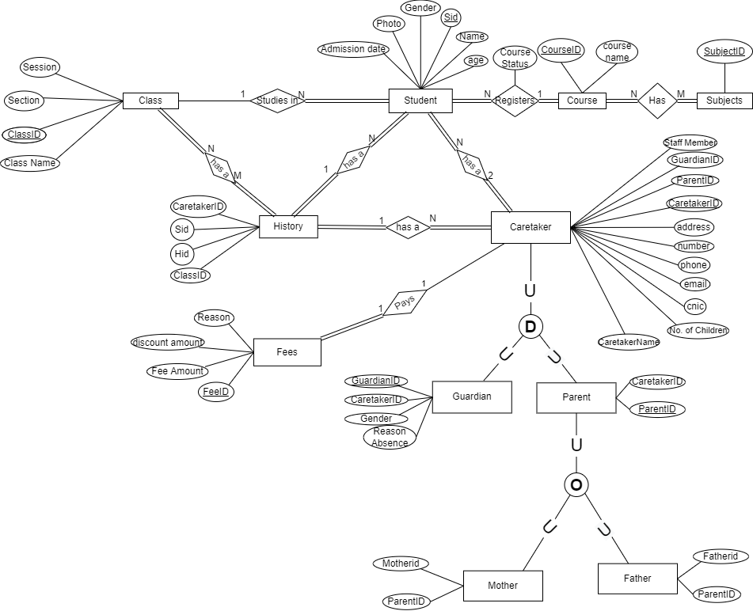

# Relational Schema

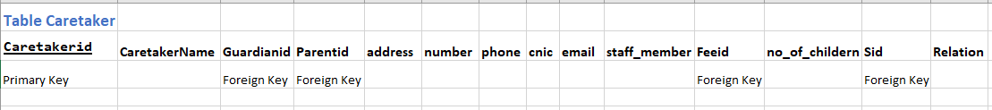

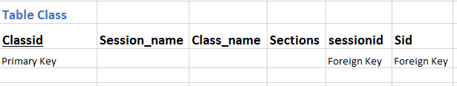

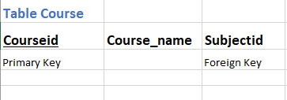

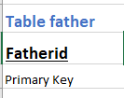

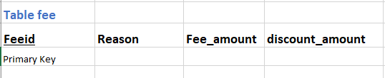

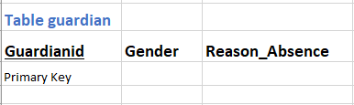

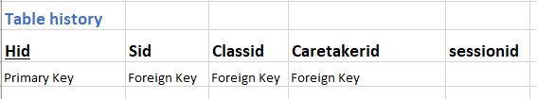

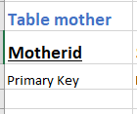

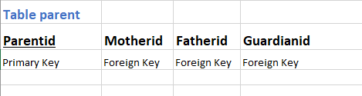

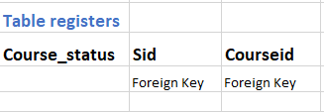

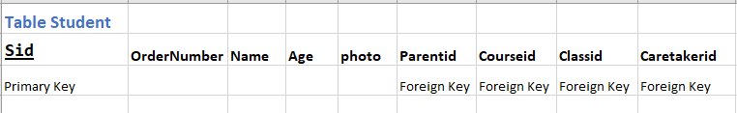

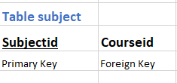

# Table’s Description:

**Subject**

This table describes the subjects of each through each subject

**Course**

This tables the courses that are offered by the institution, it is linked to subject and student

**Student**

This table contains the information of every student and is linked to various entities like caretaker, course, class

**Registers**

This is a bridge entity between course and student it defines how a student will interact with course, It also has an additional attribute course status which tells us whether has completed or not completed his or her course

**Parent**

This is a child attribute of caretaker and spawns further child entities mother and father

**Caretaker**

This defines information in regards to the caretaker of a particular student, it also spawns 2 further child entities which are parent and guardian

**Fee**

It a entity which defines the amount of fee that a caretaker of a student should pay

**Father**

It is a child entity of parent

**Mother**

It is a child entity of parent

**History**

It is an entity that keeps track of the history of a particular student, each history id represent a unit of time, it also has a sessionid which keeps track of the session of a particular student

**Class**

It is an entity which tells us about the class that a student belongs to and tells the display information regarding a class like section, class name and subject

# Datasets:

Sample datasets of every table(**excel files**) are included in the **Report** folder.

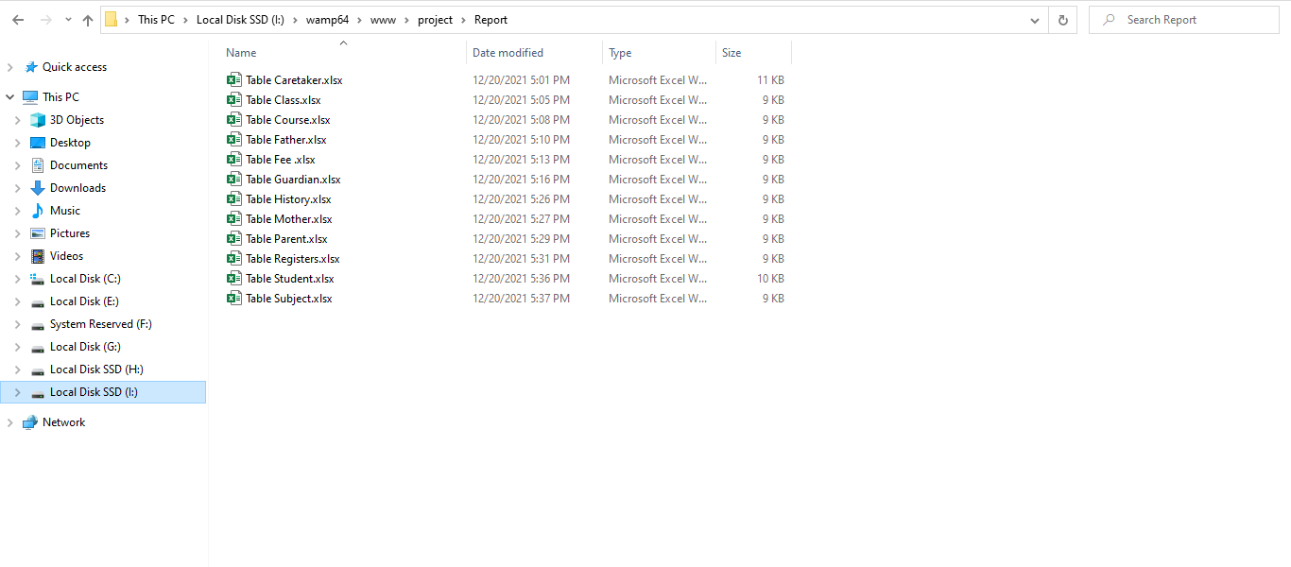

# SQL Statements Used to Create And Populate Tables:

## Caretaker Table:

--

-- Table structure for table `caretaker`

--

DROP TABLE IF EXISTS `caretaker`;

CREATE TABLE IF NOT EXISTS `caretaker` (

`Caretakerid` int(255) NOT NULL,

`CaretakerName` varchar(255) NOT NULL,

`Guardianid` int(255) DEFAULT NULL,

`Parentid` int(255) DEFAULT NULL,

`address` varchar(255) NOT NULL,

`number` int(255) NOT NULL,

`phone` int(255) NOT NULL, -- phone INT

`cnic` int(255) NOT NULL,

`email` varchar(255) NOT NULL,

`staff_member` varchar(255) NOT NULL, -- staff member = YES or NO

`Feeid` int(255) DEFAULT NULL,

`no_of_childern` int(255) NOT NULL,

`Sid` int(255) DEFAULT NULL,

`Relation` varchar(255) NOT NULL,

PRIMARY KEY (`Caretakerid`),

KEY `Feeid` (`Feeid`),

KEY `Parentid` (`Parentid`),

KEY `Guardianid` (`Guardianid`),

KEY `Sid` (`Sid`)

) ENGINE=MyISAM DEFAULT CHARSET=latin1;

## -- ----------------Populating caretaker Table

## INSERT INTO `caretaker`(`Caretakerid`,`CaretakerName`,`Guardianid`,`Parentid`,`address`,`number`,`phone`,`cnic`,`email`,`staff_member`,`Feeid`,`no_of_childern`,`Sid`,`Relation`) VALUES

## (100,'Ahmed',NULL,101,'WahCantt',0316,453,37406,'ahmed@gmail.com','No',01,2,1111,'Father'),

## (200,'Salar',NULL,102,'Islamabad',0333,521,4860,'salar@gmail.com','No',02,1,1112,'Father'),

## (300,'Fatima',NULL,103,'Rawalpindi',0334,456,7353,'wadood@gmail.com','No',03,1,1113,'Mother'),

## (400,'Ayesha',NULL,104,'Lahore',0321,567,6784,'kamran@gmail.com','No',04,2,1114,'Mother'),

## (500,'Sobia',NULL,105,'Attock',0331,675,1112,'tahir@gmail.com','Yes',05,1,1115,'Mother'),

## (600,'Areeba',006,NULL,'Islamabad',0332,588,3455,'areeba@gmail.com','No',06,1,1116,'Sister');

## 

## 

## Class Table:

--

-- Table structure for table `class`

--

DROP TABLE IF EXISTS `class`;

CREATE TABLE IF NOT EXISTS `class` (

`Classid` int(255) NOT NULL,

`Session_name` varchar(255) NOT NULL,

`Class_name` varchar(255) NOT NULL,

`Sections` varchar(255) NOT NULL,

`sessionid` int(255) DEFAULT NULL,

`Sid` int(255) DEFAULT NULL,

PRIMARY KEY (`Classid`),

KEY `sessionid` (`sessionid`),

KEY `Sid` (`Sid`)

) ENGINE=MyISAM DEFAULT CHARSET=latin1;

-- populating class table

INSERT INTO `class`(`Classid`,`Session_name`,`Class_name`,`Sections`,`sessionid`,`Sid`)VALUES

(1,'Spring','Grade One','A',10,1111),

(2,'Autumn','Grade Two','A',20,1112),

(3,'Summer','Grade Three','A',30,1113),

(4,'Winter','Grade Four','A',40,1114);

-- --------------------------------------------------------

## Course Table:

--

-- Table structure for table `course`

--

DROP TABLE IF EXISTS `course`;

CREATE TABLE IF NOT EXISTS `course` (

`Courseid` int(255) NOT NULL,

`Course_name` varchar(255) NOT NULL,

`Subjectid` int(255) DEFAULT NULL,

PRIMARY KEY (`Courseid`),

KEY `Subjectid` (`Subjectid`)

) ENGINE=MyISAM DEFAULT CHARSET=latin1;

-- populating course table

INSERT INTO `course`(`Courseid`,`Course_name`,`Subjectid`)VALUES

(1000,'Playgroup',1111),

(2000,'Nursery',2222),

(3000,'Prep',3333),

(4000,'Advance',4444),

(5000,'Primary',5555);

## Father Table:

--

-- Table structure for table `father`

--

DROP TABLE IF EXISTS `father`;

CREATE TABLE IF NOT EXISTS `father` (

`Fatherid` int(255) NOT NULL,

PRIMARY KEY (`Fatherid`)

) ENGINE=MyISAM DEFAULT CHARSET=latin1;

-- populating father table

INSERT INTO `father`(`Fatherid`)VALUES

(301),

(302),

(303),

(304),

(305);

-- --------------------------------------------------------

## Fee Table:

--

-- Table structure for table `fee`

--

DROP TABLE IF EXISTS `fee`;

CREATE TABLE IF NOT EXISTS `fee` (

`Feeid` int(255) NOT NULL,

`Reason` varchar(255) NOT NULL,

`Fee_amount` int(255) NOT NULL, -- Fee amount INT

`discount_amount` int(255) NOT NULL,

PRIMARY KEY (`Feeid`)

) ENGINE=MyISAM DEFAULT CHARSET=latin1;

-- populating fee table

INSERT INTO `fee`(`Feeid`,`Reason`,`Fee_amount`,`discount_amount`)VALUES

(01,'Financial Reasons',2000,1000),

(02,'Financial Reasons',2000,500),

(03,'Financial Reasons',3000,1500),

(04,'Financial Reasons',3000,2000),

(05,'Child of a staff member',2000,2000);

-- --------------------------------------------------------

## Guardian Table:

--

-- Table structure for table `guardian`

--

DROP TABLE IF EXISTS `guardian`;

CREATE TABLE IF NOT EXISTS `guardian` (

`Guardianid` int(255) NOT NULL,

`Gender` varchar(255) NOT NULL,

`Reason_Absence` varchar(255) DEFAULT NULL,

PRIMARY KEY (`Guardianid`)

) ENGINE=MyISAM DEFAULT CHARSET=latin1;

-- populating guardian table

INSERT INTO `guardian`(`Guardianid`,`Gender`,`Reason_Absence`)VALUES

(001,'male','Out of City'),

(002,'male','Out of City'),

(003,'female','Sick'),

(004,'female','Sick'),

(005,'female','Sick'),

(006,'female','Sick');

## History Table:

--

-- Table structure for table `history`

--

DROP TABLE IF EXISTS `history`;

CREATE TABLE IF NOT EXISTS `history` (

`Hid` int(255) NOT NULL,

`Sid` int(255) DEFAULT NULL,

`Classid` int(255) DEFAULT NULL,

`Caretakerid` int(255) DEFAULT NULL,

`sessionid` int(255) NOT NULL,

PRIMARY KEY (`Hid`),

KEY `Sid` (`Sid`),

KEY `Caretakerid` (`Caretakerid`),

KEY `Classid` (`Classid`)

) ENGINE=MyISAM DEFAULT CHARSET=latin1;

-- populating history table

INSERT INTO `history`(`Hid`,`Sid`,`Classid`,`Caretakerid`,`sessionid`)VALUES

(010,1111,1,100,10),

(020,1112,2,200,20),

(030,1113,3,300,30),

(040,1114,4,400,40),

(050,1115,5,500,50);

## Mother Table:

--

-- Table structure for table `mother`

--

DROP TABLE IF EXISTS `mother`;

CREATE TABLE IF NOT EXISTS `mother` (

`Motherid` int(255) NOT NULL,

PRIMARY KEY (`Motherid`)

) ENGINE=MyISAM DEFAULT CHARSET=latin1;

-- populating mother table

INSERT INTO `mother`(`Motherid`)VALUES

(201),

(202),

(203),

(204),

(205);

-- --------------------------------------------------------

## Parent Table:

--

-- Table structure for table `parent`

--

DROP TABLE IF EXISTS `parent`;

CREATE TABLE IF NOT EXISTS `parent` (

`Parentid` int(255) NOT NULL,

`Motherid` int(255) DEFAULT NULL,

`Fatherid` int(255) DEFAULT NULL,

`Guardianid` int(255) DEFAULT NULL,

PRIMARY KEY (`Parentid`),

KEY `Motherid` (`Motherid`),

KEY `Fatherid` (`Fatherid`),

KEY `Guardianid` (`Guardianid`)

) ENGINE=MyISAM DEFAULT CHARSET=latin1;

-- populating parent table

INSERT INTO `parent`(`Parentid`,`Motherid`,`Fatherid`,`Guardianid`)VALUES

(101,201,301,NULL),

(102,202,302,NULL),

(103,203,303,NULL),

(104,204,304,NULL),

(105,205,305,NULL),

(NULL,NULL,NULL,006);

-- --------------------------------------------------------

## Registers Table:

--

-- Table structure for table `registers`

--

DROP TABLE IF EXISTS `registers`;

CREATE TABLE IF NOT EXISTS `registers` (

`Course_status` varchar(255) NOT NULL,-- completed / Not completed

`Sid` int(255) DEFAULT NULL,

`Courseid` int(255) DEFAULT NULL,

KEY `Sid` (`Sid`),

KEY `Courseid` (`Courseid`)

) ENGINE=MyISAM DEFAULT CHARSET=latin1;

-- populating registers table

INSERT INTO `registers`(`Course_status`,`Sid`,`Courseid`)VALUES

('Not Completed',1111,1000),

('Not Completed',1112,2000),

('Not Completed',1113,3000),

('Not Completed',1114,4000),

('Completed',1115,5000);

## Student Table:

--

-- Table structure for table `student`

--

DROP TABLE IF EXISTS `student`;

CREATE TABLE IF NOT EXISTS `student` (

`Sid` int(255) NOT NULL,

`OrderNumber` int(255) NOT NULL,

`Name` varchar(255) NOT NULL, -- Name Varchar

`Age` int(255) NOT NULL,

`photo` blob,

`Parentid` int(255) DEFAULT NULL,

`Courseid` int(255) DEFAULT NULL,

`Classid` int(255) DEFAULT NULL,

`Caretakerid` int(255) DEFAULT NULL,

PRIMARY KEY (`Sid`),

KEY `Parentid` (`Parentid`),

KEY `Courseid` (`Courseid`),

KEY `Classid` (`Classid`),

KEY `Caretakerid` (`Caretakerid`)

) ENGINE=MyISAM DEFAULT CHARSET=latin1;

-- populating student table

INSERT INTO `student`(`Sid`,`OrderNumber`,`Name`,`Age`,`photo`,`Parentid`,`Courseid`,`Classid`,`Caretakerid`)VALUES

(1111,1,'Talha',11,'',101,1000,1,100),

(1112,2,'Sabir',13,'',102,2000,2,200),

(1113,3,'Haris',10,'',103,3000,3,300),

(1114,4,'Usman',9,'',104,4000,4,400),

(1115,5,'Hamza',7,'',105,5000,5,500);

-- --------------------------------------------------------

## Subject Table:

--

-- Table structure for table `subject`

--

DROP TABLE IF EXISTS `subject`;

CREATE TABLE IF NOT EXISTS `subject` (

`Subjectid` int(255) NOT NULL,

`Courseid` int(255) DEFAULT NULL,

PRIMARY KEY (`Subjectid`),

KEY `Courseid` (`Courseid`)

) ENGINE=MyISAM DEFAULT CHARSET=latin1;

-- populating subject table

INSERT INTO `subject`(`Subjectid`,`Courseid`)VALUES

(1111,1000),

(2222,2000),

(3333,3000),

(4444,4000),

(5555,5000);

## Sql Queries:

USE dbproject;

#Query 1

SELECT *

FROM student;

# Query 2

SELECT Motherid,Fatherid

FROM parent

WHERE Motherid IS NOT NULL AND Fatherid IS NOT NULL

# Query 3

SELECT *

FROM caretaker

GROUP BY Sid

HAVING Parentid = NULL;

# Query 4

SELECT c.Caretakerid, c.sid, CaretakerName, s.Name

FROM caretaker c JOIN student s

ON(c.sid);

# Query 5

SELECT c.Caretakerid, c.sid, CaretakerName, s.Name, classid

FROM caretaker c JOIN student s

ON(c.sid)

GROUP BY classid;

# Query 6

SELECT c.sessionid , c.Sid, c.Classid

FROM class c

ORDER BY sessionid DESC;

# Query 7

#SELECT c.Classid,Session_name,sessionid,Class_name,Sections,Sid,OrderNumber,Name,Age

#FROM class c JOIN student s

#ON(c.Classid = s.Classid)

#ORDER BY sessionid DESC

SELECT c.sessionid , c.Sid, c.Classid

FROM class c

ORDER BY sessionid DESC;

# Query 8

SELECT h.Caretakerid , h.Hid, h.sessionid, s.Sid, s.OrderNumber, s.Name, s.Age, s.photo, s.Courseid

FROM history h JOIN student s

ON(h.hid)

ORDER BY sessionid DESC;

# Query 9

SELECT *

FROM caretaker

WHERE sid = (

SELECT sid

FROM student

WHERE age = 15

)

# Query 10

update history of student

UPDATE class

SET session_name ="Autumn", Class_name = "Grade Four", Sections = "B"

WHERE session_name REGEXP "Summer" AND Class_name REGEXP "Grade Three" AND Sections REGEXP "A" AND sessionid > 10