E

**Working Experience**

**Projects**

**Education Details**

**Career Objective**

**MD Ayub Ali**

**Contact**

**Address:**

Bhawal Mirzapur, Gazipur, Dhaka

**Phone:**

+8801910546032

**Email:**

**LinkedIn:**

www.linkedin.com/in/salauddin--ayub

**Languages**

Bangla

English

**Hobbies**

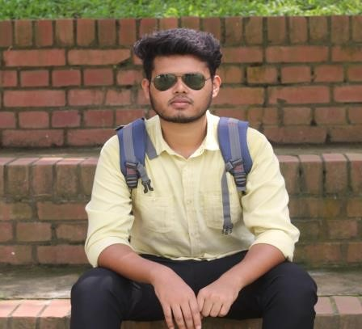

✩ Playing Cricket

✩ Fishing

✩ Travelling

✩ kiting

✩ Reading books

ayub35-265@diu.edu.bd

☆ Hospital Apothecary

Django, Python

https://github.com/salauddin-ayub/Hospital-Apothecary.git

☆ Ornament

Django, Python

https://github.com/salauddin-ayub/Ornament-Gallery.git

☆ Social media App

Django, python

https://github.com/salauddin-ayub/MySocialProject.git

☆ Ecommerce Application

Django, Python

https://github.com/salauddin-ayub/My_Ecom_Project.git

➣**Skill.Jobs**

Tower (Level-7), House, DF, 11 Rd No 14, Dhaka 1209

Position: Junior web Developer

July 15, 2021 – November 20, 2021

I am working in web App development with python Django here.

☑ Training on Web Development Course March, 2021 - June, 2021

Institute: Bohubrihi

☑ Bachelor of Software Engineering (BSWE) 2017-2021

Institute: Daffodil International University CGPA: 3.65 scale 4.00

☑ Higher Secondary School Certificate (Science) 2015-2017

Institute: Gazipur Ideal College CGPA: 3.92 scale 5.00

☑ Secondary School Certificate (Science) 2013-2015

Institute: Bahawal Mirzapur High School CGPA: 4.83 scale 5.00

Looking for an entry-level position as a Software Engineer in a dynamic firm that values my analytical and technical skills and provides scope for updating my knowledge, I seek a company that will help me contribute to its development.

✯ Management

✯ Leadership

✯ Googling

✯ Creativity

✯Communication

✯Innovative

✯Creative Design

S A M Matiur Rahman

Associate Professor

Department of Software Engineering

Daffodil International University

Email: matiur.swe@diu.edu.bd

**Hard Skills**

**Soft Skills**

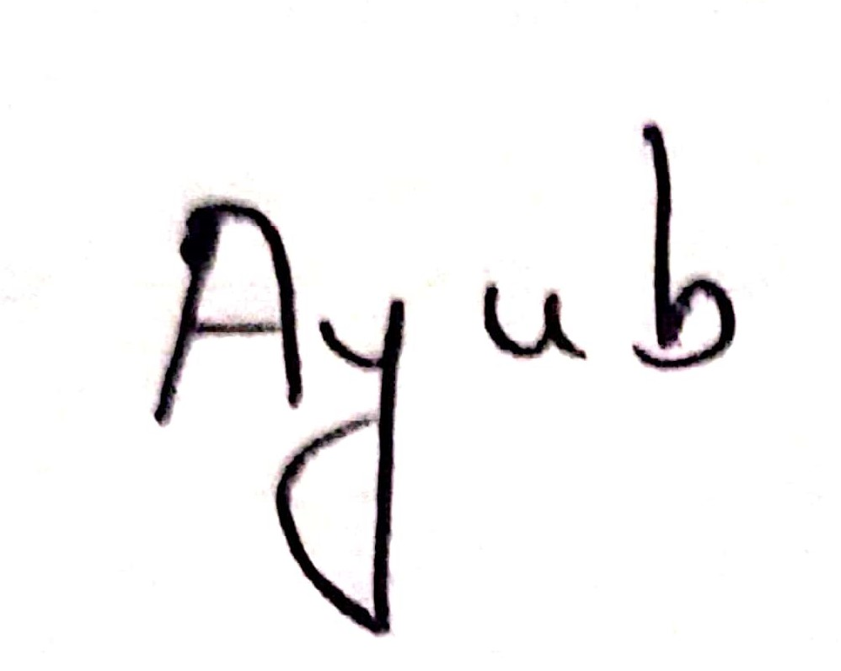

**Signature**

**Reference**

✯ Programming Language

C, Python (OOP), Django, JS

✯ Web Development

Html, CSS, Bootstrap

✯ Database

MySQL, MongoDB, Oracle

✯ Working Tools

Git, Github, MS Office, Vs Code

**Programming Contest **

✯DIU Take Off, Summer-18(Position: 36)

✯Diu SWE intra-dept. contest, Fall-17

Position: 19