LOAD TEST WITH JMETER STRATEGY

Load test for 167 users in 60 second:

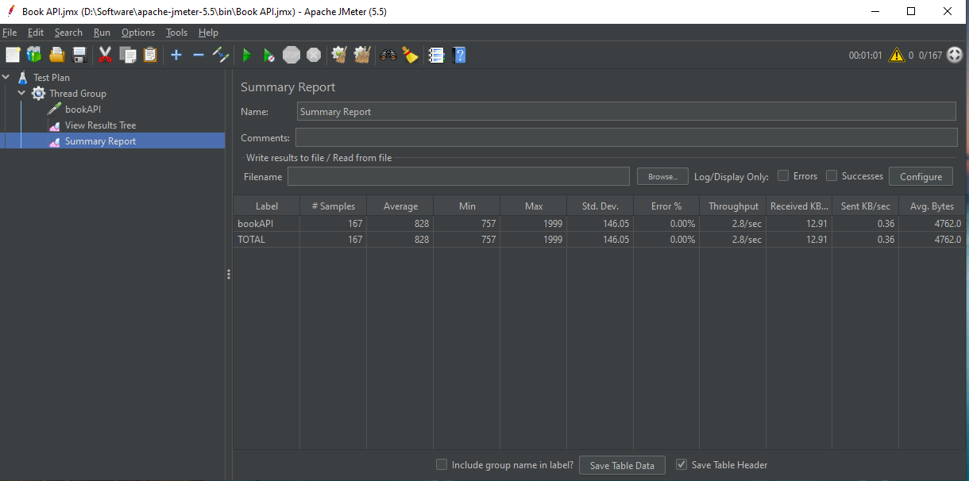

Load test for 833 users in 300 second:

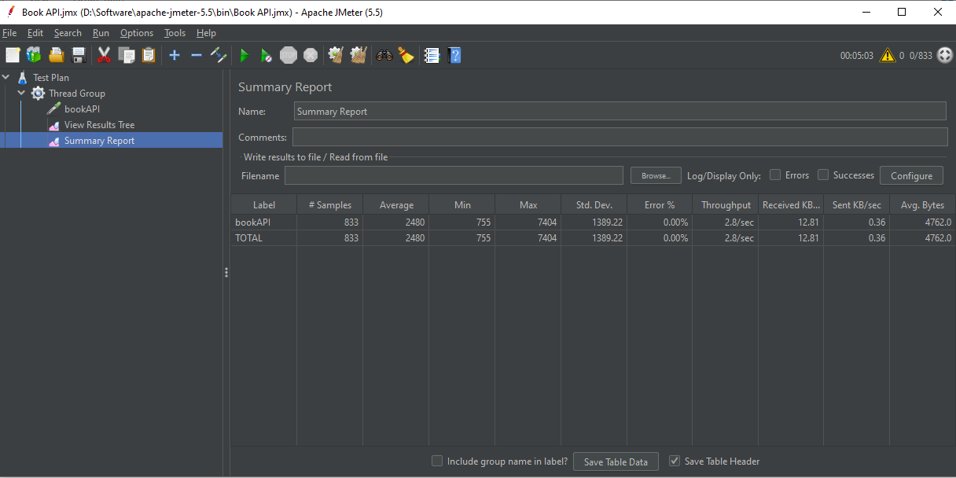

Load test for 1667 users in 600 second:

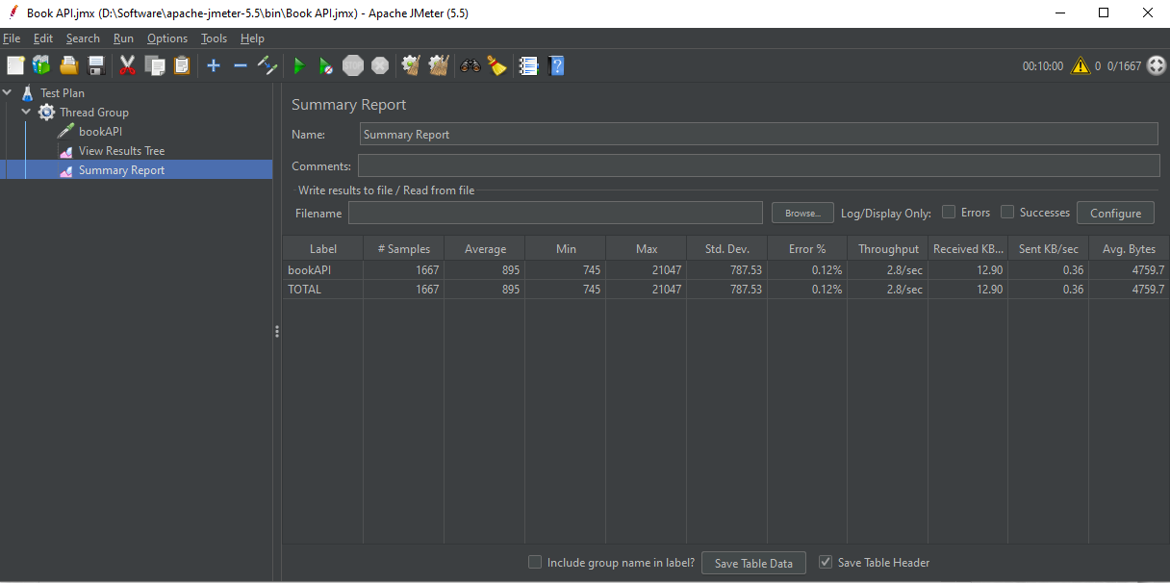

Load test for 1667 users in 650 second:

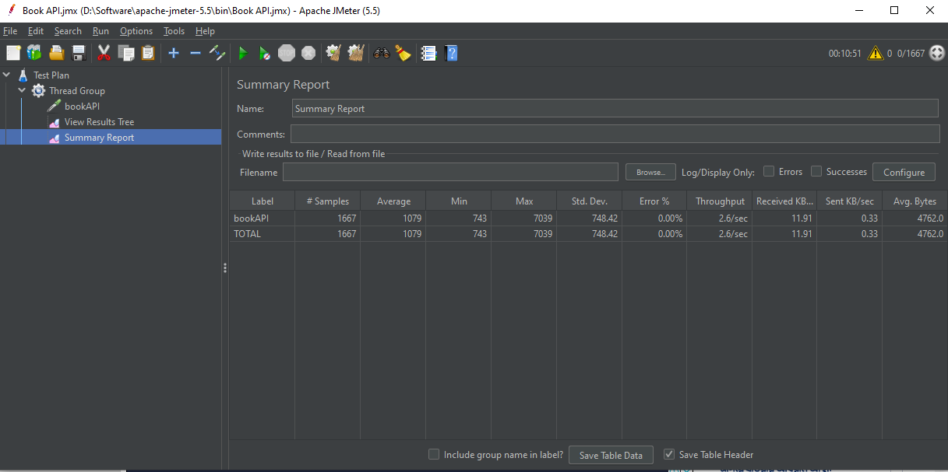

Load test for 2500 users in 900 second from backend:

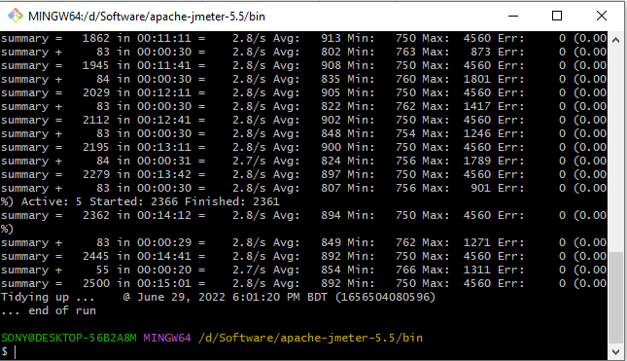

Reports for 2500 users in 900 second:

