**Instructions for downloading and installing R and RStudio**

In class, you will need to bring your laptops with R and RStudio installed on them. If you do not have a laptop that you can bring to class, the School of Public Health and Health Sciences can provide one for you. Instructions for installing R and RStudio are below.

***Please email me to confirm that you have received this message and whether you were able to install R and RStudio or if you need to borrow a laptop for class.*** This is important since some of these emails will probably make it into students' Spam or Promotions inboxes and be ignored. I would like to have everything up and running as much as possible by the first day of class.

Here are the instructions for installing R and RStudio:

1) Go to <https://cran.r-project.org/>

2) Click on "Download R for ...", where "..." stands for your operating system (Mac, Windows, or Linux)

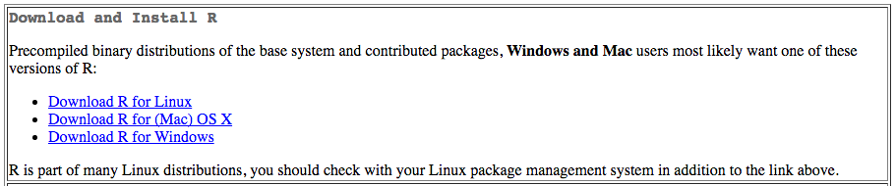

If you have a Mac:

- Click on the R package that corresponds with your OS X version. If you are unsure of your OS X version, click on the apple in the upper left-hand corner of your screen and click on "About This Mac", and it should say "OS X El Capitan", "OS X Mavericks", "OS X Mountain Lion", etc.

  - For El Capitan, download the latest version (as of today 3.4.1)

  - For Mavericks, download R 3.3.3

  - For earlier versions, download R 3.2.1

If you have a Windows:

- Click on the link for "base" or "install R for the first time"

If you have a Linux and don't know what to do, let me know and I'll ask our IT department.

3) After the download run the pkg or exe file and follow your system commands to install R.

4) Go to RStudio's downloads site: <https://www.rstudio.com/products/rstudio/download/#download>

5) Under "Installers for Supported Platforms" choose the version that matches your operating system.



6) After the download run the pkg or exe file and follow your system commands to install RStudio.

(If you would like to get a jump start on learning R, you can use [Swirl](http://swirlstats.com/students.html) to teach you the basics)