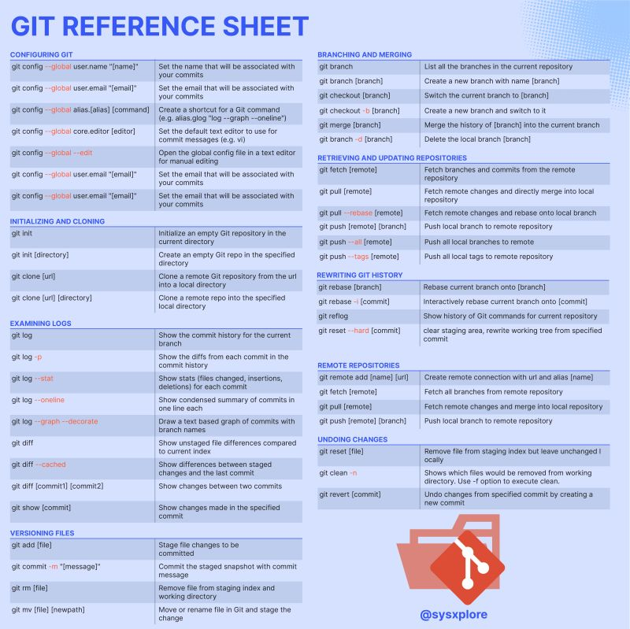

**Key Takeaways**

|  |  |  |
| --- | --- | --- |
| **Difference** | **git switch** | **git checkout** |
| Working with older git versions (2.22 and below) | Only works with newer Git versions (2.23 and above) | Works with both older and new Git versions |
| Search for a branch in the remote repository if it’s not found in the local repository | Supported | Not Supported |
| Capable of doing other things besides switching branches | Only works with branches | Does other things besides switching branches |
| Merge the current branch into another branch and switch to it | Supported | Not supported |