AccredX: Record Management and Archiving System
For NEUST Peñaranda Off-Campus


A CAPSTONE AND RESEARCH PROJECT

BY:

JULIUS CESAR P. REYES
JOHN PAULO S. SAMSON
CHRISTOPHER A RAMOSO JR.
GREGORY GRANT C. ALARILLA

NOVEMBER 2025
Chapter 1
THE PROBLEM AND ITS BACKGROUND

Introduction

In today's digital age, proper document management and archiving are critical to the efficiency, security, and compliance of organizational operations. Records management is the systematic control of records from creation to disposal, ensuring that critical information is available, protected, and kept (Dearstyne, 2020; Bailey, 2021).
As technology has advanced, organizations have switched from conventional manual procedures to electronic records management systems (ERMS), that automate classification, retrieval, and storage processes. These modern systems help reduce manual effort, improve security through encryption and access control, and support compliance with legal and regulatory requirements (Smith & Johnson, 2020; Patterson, 2022).
According to trends, digital archiving solutions are especially beneficial to the education industry. Academic institutions manage massive amounts of crucial papers, and the necessity for secure, organized, and easily available data is especially important during accreditation processes (Mitchell & Carter, 2020). Implementing a reliable record management system ensures that accreditation documents are well-organized, secure from data loss, and easily accessible for review. According to studies, organizations that use cloud-based archiving benefit from increased collaboration, faster information retrieval, and lower infrastructure expenses (Harris, 2021; Thomassen, 2021). However, challenges remain, particularly in smaller academic institutions like Nueva Ecija University of Science and Technology (NEUST) Peñaranda Off-Campus. Current manual or semi-digital record-keeping processes have resulted in inefficiencies such as missing data, retrieval delays, and security issues. These issues not only affect everyday administrative operations, but also compromise the institution's preparedness for accreditation and review processes.
This study aims to create a Record Management and Archiving System for NEUST Peñaranda Off-Campus. The system will replace manual or semi-digital processes, improve document retrieval, storage, and organization, and strengthen the security of sensitive academic and office documents with access control and user authentication. Furthermore, the system is to be evaluated based on ISO/IEC 25010:2011 software quality standards, with a focus on usability, performance efficiency, and maintainability.
This study makes a valuable contribution by giving an innovative yet practical solution to academic institutions' pressing documentation and preservation difficulties. The project provides ongoing quality assurance, institutional accreditation, and general administrative improvement through the use of digital technologies and organized system development. The solution serves as a scalable structure for other educational institutions looking to improve their records management procedures while maintaining long-term data integrity.

Review of Related Literature

Record management and archiving are essential for maintaining organizational efficiency and compliance with regulations. Records management involves the systematic control of records throughout their life-cycle. Effective record management ensures compliance, security, and accessibility (Dearstyne, 2020). The development of records management and archiving systems has significantly evolved with the advancement of digital technology. A well-organized records management system is essential for businesses and institutions to store, retrieve, and secure essential documents efficiently. According to Bailey (2021), modern electronic records management systems (ERMS) enable organizations to automate the classification, storage, and retrieval of records, reducing manual effort and improving document security.
Records management and archiving systems ensure compliance with legal and regulatory requirements. As stated by Smith & Johnson (2020), organizations that implement electronic records management can improve regulatory compliance by automatically tracking document retention schedules and ensuring that sensitive records are disposed of properly. Additionally, automated archiving reduces the risk of document misplacement and enhances information retrieval speed. Digital archives ensure long-term preservation and retrieval of critical documents (Thomassen, 2021).
Digital records management also enhances data security and accessibility. According to Patterson (2022), cloud-based archiving solutions provide organizations with encrypted storage and role-based access, ensuring that only authorized personnel can access sensitive records. Furthermore, implementing a structured digital archiving system minimizes data loss and ensures disaster recovery (Thompson & Lee, 2020). Studies indicate that organizations using cloud storage experience improved collaboration and reduce infrastructure costs (Harris, 2021). In the educational sector, a study by Mitchell & Carter (2020) highlighted that digital archiving systems help academic institutions manage student records efficiently, ensuring long-term storage and easy retrieval. Additionally, digital solutions prevent unauthorized alterations, ensuring data integrity. Encryption, role-based access control (RBAC), and audit trails are crucial for protecting sensitive records (Anderson, 2022).

The adoption of standardized frameworks and best practices in records management further improves efficiency and compliance. According to Wilson (2021), implementing international standards such as ISO 15489 for records management ensures systematic control over document creation, maintenance, and disposal. Proper indexing and metadata tagging also enhance the retrieval process, allowing organizations to locate records quickly and accurately (Miller & Adams, 2022). Additionally, digitization of paper records reduces physical storage requirements and mitigates risks associated with document deterioration or loss (Clark, 2020). Effective training programs for staff on records management policies and procedures are essential in maintaining consistency and preventing mishandling of sensitive information (Henderson, 2021). Moreover, backup strategies, such as redundant storage and offsite archiving, play a crucial role in disaster recovery and business continuity (Turner & Scott, 2022).
The integration of electronic document management systems (EDMS) has further enhanced the efficiency of records management. According to Ramirez (2021), EDMS allows organizations to store, categorize, and retrieve records with greater accuracy and speed. The use of version control mechanisms ensures that the latest document revisions are accessible while preserving historical records for reference (Collins & Hayes, 2020). Additionally, implementing automated retention schedules helps organizations comply with legal and regulatory requirements by systematically disposing of outdated records (Stewart, 2022). Regular system maintenance and data migration strategies are also essential to ensure long-term accessibility and prevent data corruption or loss (Foster, 2021).

Conceptual Framework
PROCESS
- Software Development Life Cycle (SDLC)
- Planning
- Analysis
- Design
- Implementation
- Testing & Integration
- Maintenance
INPUT
- Identified Challenges
  - Current manual and digital systems used.
  - Misplaced/lost files
  - Slow retrieval and difficulty securing files
  - Inefficiency during accreditation
  - Duplication in files
- Desired Features & Functionalities
- Fast Search and retrieval
- Secure file storage
- Document version control
- Role-based access
- Audit trails
- Folder Checklist
- Download & Print
- General Reports

OUTPUT
- Record Management and Archiving System

FEEDBACK

Figure 1. Research Paradigm

As shown in Figure 1, the researchers identified key challenges in the current record-keeping practices at NEUST Peñaranda Off-Campus during the input phase. These challenges include misplaced files, delayed retrieval, limited security measures, and inefficiencies in managing accreditation-related documents. Additionally, user needs such as fast search and retrieval, document version control, role-based access, and audit trails were considered essential in guiding system development.

For the process phase, the researchers applied the Software Development Life Cycle (SDLC) as the guiding methodology. This framework consists of six stages: Requirements Analysis, Design, Development, Testing, Deployment, and Maintenance. Each step was followed to ensure that the system would meet both technical and user-centered quality standards.

The output of the process is a fully developed Record Management and Archiving System designed to digitize and streamline the institution’s document storage, retrieval, and security processes. By automating file management, implementing robust access control, and ensuring auditability, the system addresses the current inefficiencies and supports the university’s accreditation processes. This leads to improved organizational efficiency, data integrity, and ease of access to vital records.
Statement of the Problem

NEUST Peñaranda Off-Campus faces challenges in managing and archiving important documents. The current manual or semi-digital record-keeping process leads to inefficiencies in file organization, retrieval delays, security risks, and tracking document history. These challenges reduce the overall efficiency of administrative tasks and accreditation processes, resulting in misplaced files, inconsistent record updates, and time-consuming searches.
To address these issues, the goal of this study is to develop a Record Management and Archiving System that will improve document organization, accessibility, and security during storage and retrieval. The system will streamline administrative processes by providing structured digital record-keeping, search and filtering capabilities, and file tracking mechanisms. Specifically, the study seeks to answer the following questions:

- Problem Identification and Contextual Questions:
- How do staff members at NEUST Peñaranda Off-Campus currently manage and archive records, and what challenges do they face?

- How can a Record Management and Archiving System improve file retrieval, security, and overall efficiency?

- Technical Development and Evaluation Questions:
- What are the essential features and functionalities needed for an effective Record Management and Archiving System?

- How can the system be developed following the Software Development Life Cycle (SDLC) stages:
  - planning;
  - analysis;
  - design;
  - implementation;
  - testing and integration;
  - maintenance;
- How may the Record Management and Archiving System be evaluated by IT consultants based on ISO/IEC 25010:2011 standards for the following criteria:
  - Functional suitability
  - Performance efficiency
  - Compatibility
  - Usability
  - Reliability
  - Security
  - Portability

- How may the system be evaluated by end users in terms of:
  - functional suitability;
  - performance efficiency; and
  - usability?

By addressing these questions, the study aims to develop a structured and efficient record-keeping system that enhances document management, security, and accessibility at NEUST Peñaranda Off-Campus.

Scope and Delimitation

This project focuses on developing and implementing a record management and archiving system for NEUST Peñaranda Off-Campus. The system is intended to handle academic and administrative documents by offering a single digital platform for storing, organizing, and retrieving data. It is specifically designed to improve the efficiency, security, and accessibility of papers used by school personnel.
The primary users of the system include school administrators, staff, and faculty, who will benefit from features such as fast document search, version tracking, audit trails, and role-based access. The scope also covers the system’s role in supporting the accreditation process, ensuring that required documentation is readily available, complete, and well-organized.
The study is delimited to the Peñaranda Off-Campus of NEUST and does not encompass other branches or external institutions. It focuses only on document management functions and does not address other administrative operations such as financial systems, student grading, or enrollment. Additionally, this study is limited to the system’s design, development, and basic functional testing, without including long-term implementation analysis or user experience research.
Significance of the Study

The significance of this study lies in its potential to address the challenges of managing and organizing documents within the NEUST Peñaranda Off-Campus. By introducing a Record Management and Archiving System, the researchers aim to enhance the efficiency, security, and accessibility of school records.

The school: The system allows for centralized control and management of academic and administrative documents. It improves the way records are stored, retrieved, and maintained—supporting institutional operations, especially during evaluations and audits. With features like audit trails and role-based access, the system also promotes accountability and data integrity.

Staff and Teachers: The system reduces the time and effort required for manual filing and record searching. With fast search functions, folder checklists, and version control, staff can perform their tasks more efficiently. The ability to access files digitally minimizes delays in document processing, helping them focus more on instruction and academic responsibilities.
Accreditation Process: During accreditation, the availability and organization of school records play a critical role. This system ensures that required documents are complete, up-to-date, and easy to locate, thereby simplifying the preparation for accreditation visits. The improved document control also contributes to the institution’s credibility and compliance with quality standards.

Overall, this study contributes to the school’s goal of achieving a more systematic, secure, and responsive approach to document management.
Definition of Terms

Accreditation – a formal recognition that an institution meets certain standards of quality. In the context of NEUST, it involves reviewing documents to assess academic and administrative practices.

Archiving – the process of storing records and documents, either digitally or physically, for long-term preservation and future reference.

Audit Trail – a feature of the system that records every activity or modification made to documents, helping to track changes and ensure accountability.

Document Management – a structured method for handling documents, including creation, storage, retrieval, and disposal.

Electronic Records Management System (ERMS) – a software-based system designed to manage records in digital format, automate document workflows, and enhance security and accessibility.

File Retrieval – The process of locating and accessing stored documents quickly and efficiently.
ISO/IEC 25010:2011 – an international standard used to evaluate software quality based on criteria like usability, reliability, maintainability, and performance.

Record Management – the systematic control of records from creation through maintenance to disposal. It ensures records are accurate, secure, and accessible when needed.
Role-Based Access Control (RBAC) – a system security feature that grants or restricts access to documents based on the user's role (e.g., admin, teacher, staff).

SDLC (Software Development Life Cycle) – a structured process for developing software that includes phases such as planning, design, development, testing, deployment, and maintenance.

System Evaluation – the process of assessing a system’s performance and usability based on specific standards or user feedback.

Version Control – a system feature that tracks changes to documents and maintains a history of previous versions, ensuring data consistency.

Chapter 2
METHODS AND PROCEDURES

Research Design
The research design serves as a structured framework that guides the selection and application of appropriate methods and strategies in the development of the study. This study adopts a developmental research design, which emphasizes the iterative creation and refinement of a functional prototype of an Integrated Point of Sale (POS) and Inventory Management System. The approach centers on continuous feedback from end-users and stakeholders to inform each development cycle, ensuring that the system evolves in response to actual needs and practical challenges.

To structure the development process, the study applies the Software Development Life Cycle (SDLC), particularly utilizing the Agile Methodology. Agile is well-suited for dynamic and user-centered systems, as it promotes adaptability, close collaboration, and incremental delivery of functional components.
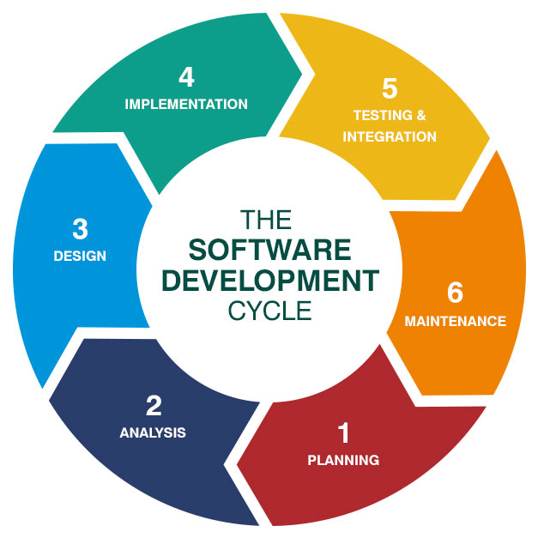
Figure 2 below shows the study of the Record Management and Archiving System developed using the SDLC.

Figure 2. SDLC Model

The Agile methodology in this study consists of the following phases:

Planning Stage: This phase involves collecting requirements through consultations and interviews with the business owner and staff. It aims to identify existing challenges in sales transactions and inventory management, which inform the direction of the system’s development.

Analysis Stage: The development team analyzes the gathered requirements to determine the features to be implemented in the current cycle. User stories are broken down into actionable tasks, and acceptance criteria are established. Continuous communication with stakeholders ensures a clear understanding of expectations.

Design Stage: A lightweight system design is formulated based on the requirements of the current iteration. This stage emphasizes simplicity, functionality, and alignment with user needs.

Implementation Stage: Developers construct the code that realizes the planned features. Agile practices such as pair programming and early-stage testing are integrated to ensure code reliability and maintainability.

Testing and Integration Stage: Testing is conducted concurrently with development. Each feature undergoes unit and integration testing to detect and resolve issues promptly. Continuous integration practices are employed to preserve system stability as new components are added.

Maintenance Stage: After initial deployment, the system enters a maintenance phase wherein minor updates, bug fixes, and enhancements are implemented. User feedback and evolving operational requirements drive further iterations to ensure the system remains responsive and effective.

The Agile approach reflects a shift from rigid, traditional models toward a more flexible, collaborative, and user-focused development paradigm. By breaking the project into smaller, time-bound iterations or "sprints," the methodology allows for rapid feedback cycles, increased user involvement, and the delivery of high-quality, value-driven outcomes.
Research Locale

This study takes place at Nueva Ecija University of Science and Technology (NEUST) Peñaranda Off-Campus, with a particular emphasis on the accreditation process. The researchers are undergraduate students enrolled in the Bachelor of Science in Information Technology (BSIT) program, majoring in Web Systems Technology.

Located in Pob. 1, Peñaranda, Nueva Ecija, Central Luzon, Philippines, NEUST Peñaranda Off-Campus is an educational institution offering various degree programs, including BSIT, Bachelor of Science in Business Administration (BSBA), and Bachelor of Science in Secondary Education (BSEd).

Figure 3 shows the front view of CNEUST Peñaranda Off-Campus. Figure 4 provides a detailed map and location of the NEUST Peñaranda Off-Campus.


Figure 3. Front view of NEUST Peñaranda Off-Campus

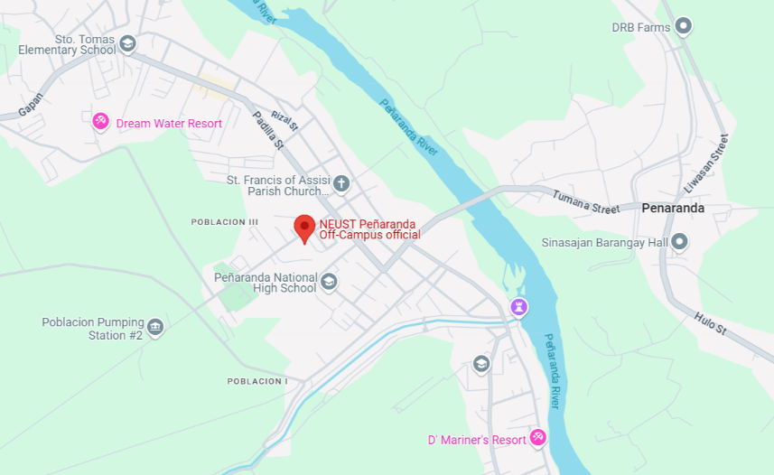

Figure 4. Location Map

Research Respondents

The researchers identify two (2) sets of respondents involved in this study. These are: (1) the IT consultants who will evaluate the technical aspects of the developed system based on software quality standards; and (2) the end-users who will evaluate the usability and functionality of the developed system.

The first set of respondents consists of ten (10) IT consultants, selected based on their expertise in software development and system analysis. Their role is to assess the technical and functional quality of the system.

The second set of respondents consists of twenty-three (23) end-users, composed of three (3) administrative staff, five (5) teachers, and fifteen (15) assistants. These end-users will provide feedback based on their experience in using the system in an academic or administrative setting.

Table 1 below shows the distribution of the respondents for the developed system’s evaluation according to its category.

Table 1. Distribution of Respondents
CLASSIFICATION | POPULATION | PERCENTAGE
IT CONSULTANT | 10 | 30.30%
END-USER | 23 | 69.70%
ADMIN | 3
TEACHER | 5
ASSISTANT | 15
TOTAL | 33 | 100%

Sample and Sampling Procedure

The researchers employed a purposive sampling technique in selecting the respondents for this study. Two groups of respondents were identified based on their relevance and expertise in evaluating the developed Record Management and Archiving System.

The first group consists of ten (10) IT consultants. They were chosen according to the following criteria: (a) professional background in Information Technology, (b) knowledge and experience in software evaluation and system development, and (c) specialization in areas such as usability, security, and system performance. Their evaluation is necessary to assess the system based on technical quality standards.

The second group is composed of twenty-three (23) end-users, distributed as follows: three (3) administrative staff, five (5) teachers, and fifteen (15) assistants. These respondents were selected based on their direct involvement in the academic and administrative operations of NEUST Peñaranda Off-Campus. Their role is to evaluate the developed system in terms of usability, functional suitability, and performance efficiency, reflecting its applicability in the actual institutional setting.

This purposive selection ensured that the system was evaluated both from a technical perspective (IT consultants) and a practical user perspective (end-users).

Research Instruments

The primary research instrument used in this study was a structured questionnaire distributed in both printed and digital (Google Forms) formats. The questionnaire was designed to gather quantitative and qualitative feedback from respondents regarding the developed system.

For the IT consultants, the questionnaire covered the following criteria: functional suitability, performance efficiency, security, usability, maintainability, and reliability.

For the end-users, the questionnaire focused on user-centered criteria such as functional suitability, usability, and performance efficiency, aligned with their experience in using the system for record management and archiving tasks.

The questionnaire consisted of a 5-point Likert scale ranging from “Strongly Disagree” to “Strongly Agree,” supplemented with open-ended questions to allow respondents to provide additional insights and suggestions for improvement.

Data Gathering Procedure

The data gathering process followed several stages. First, the researchers conducted an initial needs assessment through informal consultations with NEUST Peñaranda Off-Campus staff to identify existing issues in record management and archiving. These insights guided the development of the system.

After the system prototype was developed, the researchers prepared the evaluation instruments and secured permission from the school administration to conduct the study. The questionnaires were then distributed to the identified respondents. IT consultants received digital copies of the evaluation forms, while end-users were provided with both printed and online versions for convenience.

Respondents were given adequate time to explore the system and assess its functionalities before completing the questionnaires. The researchers also provided demonstrations and guidance, especially for the end-users, to ensure that they could navigate and evaluate the system properly.

Once the responses were collected, the researchers consolidated and analyzed the data to determine the system’s effectiveness according to the specified software quality standards. The feedback was used to validate the strengths of the system and identify areas requiring further refinement.

Data Analysis Technique

After gathering the required data, the researchers employed both descriptive and statistical techniques to analyze and interpret the results of the system evaluation. For Statement of the Problem (SOP) numbers 1 and 2, the researchers applied qualitative description and narrative analysis to present the existing challenges in records management and to describe the development process of the proposed system. For SOP numbers 3, 4, 5, and 6, the researchers utilized frequency distribution and weighted mean to summarize and interpret the feedback of the respondents. The IT consultants evaluated the system in terms of functional suitability, performance efficiency, compatibility, usability, reliability, security and portability, while the end-users assessed it mainly in terms of functional suitability, performance efficiency and usability.

Percentage.
It is used to determine the rate of the responses for each question. To compute the percentage, the researchers used the following formula:
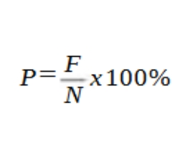

Where: P = Percentage
F = Frequency
N = Total population

Weighted Arithmetic Mean.
It is an average computed by giving different weights to some individual values.
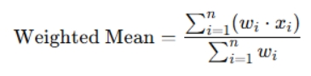

Where: ∑ = denotes the sum
w = weight
x = value

Table 2. Ranges of Weighted Mean and Interpretation for End Users’ Evaluation

RANGE OF WEIGHTED MEAN | INTERPRETATION
3.25 – 4.00 | Very Functional/ Efficient/ Usable
2.50 – 3.24 | Functional/ Efficient/ Usable
1.75 – 2.49 | Needs Improvement
1.00 – 1.74 | Poor

Table 3. Ranges of Weighted Mean and Interpretation for Consultants’ Evaluation

RANGE OF WEIGHTED MEAN | INTERPRETATION
3.25 – 4.00 | Very Functional/ Efficient/ Compatible/ Usable/ Reliable/ Secured/ Portable
2.50 – 3.24 | Functional/ Efficient/ Compatible/ Usable/ Reliable/ Secured/ Portable
1.75 – 2.49 | Needs Improvement
1.00 – 1.74 | Poor

Chapter 3
RESULTS AND DISCUSSION
This chapter explains the analysis and interpretation of the data on the development and evaluation of AccredX: Record Management and Archiving System. It also addresses the issues identified in the study’s Statement of the Problem:

- Problems Encountered in the Existing System.
The existing system of record management at NEUST Peñaranda Off-Campus still relies heavily on manual and semi-digital processes that make document organization, retrieval, and archiving inefficient. While Google Drive is used to store and share files, it lacks a centralized structure, proper categorization for academic and administrative records, and a checklist feature for tracking required documents or completion status. This results in difficulties in locating specific documents and monitoring file requirements when needed. File duplication, inconsistent naming conventions, and the absence of version control further complicate the process. Moreover, since Google Drive access depends on individual user management, data security and control are limited, increasing the risk of unauthorized access or accidental deletion. There is also no automated tracking or monitoring of uploaded files, making it challenging for the administration to ensure accountability and proper record maintenance. These inefficiencies highlight the need for a more structured, secure, and dedicated Record Management and Archiving System tailored to the institution’s operational needs.

- The Design and Development of AccredX: Record Management and Archiving System through the use of Agile Development Life Cycle.
The researchers applied the different phases of the Agile Model for the practical completion of the AccredX: Record Management and Archiving System. Each stage of the Agile Model is defined and explained as follows:

  - Planning Stage
The researchers began the planning stage by identifying the need to improve the existing record management and archiving processes at NEUST Peñaranda Off-Campus. The starting point for this research stemmed from the recurring issues encountered during accreditation processes, where locating and organizing necessary documents proved time-consuming and inefficient. To gain a clearer understanding of these challenges, the researchers conducted interviews and discussions with the school staff and faculty members who were directly involved in managing institutional records. Through these consultations, they were able to identify specific concerns such as document misplacement, lack of centralized access, and difficulties in retrieving accreditation files.

Furthermore, the researchers collaborated to define the study’s objectives, scope, and limitations, ensuring that the proposed system would effectively address the identified issues. Brainstorming sessions were conducted to determine the most essential features of the system, including file categorization, secure data storage, and streamlined document retrieval. The researchers also reviewed existing digital record management tools and practices to gather insights on effective methods of organizing and safeguarding institutional data. Based on these findings, they formulated a system design that would not only
support accreditation requirements but also enhance the overall efficiency and reliability of record handling within the campus.

As a result of the planning, the Gantt Chart was produced. It contains the Agile Model stages which are the following: Planning, Analysis, Design, Implementation, Testing and Integration, and Maintenance.
The schedule of activities performed by the researchers every stage and during the development of the Integrated Point of Sale and Inventory Management System is depicted in Figure 5.
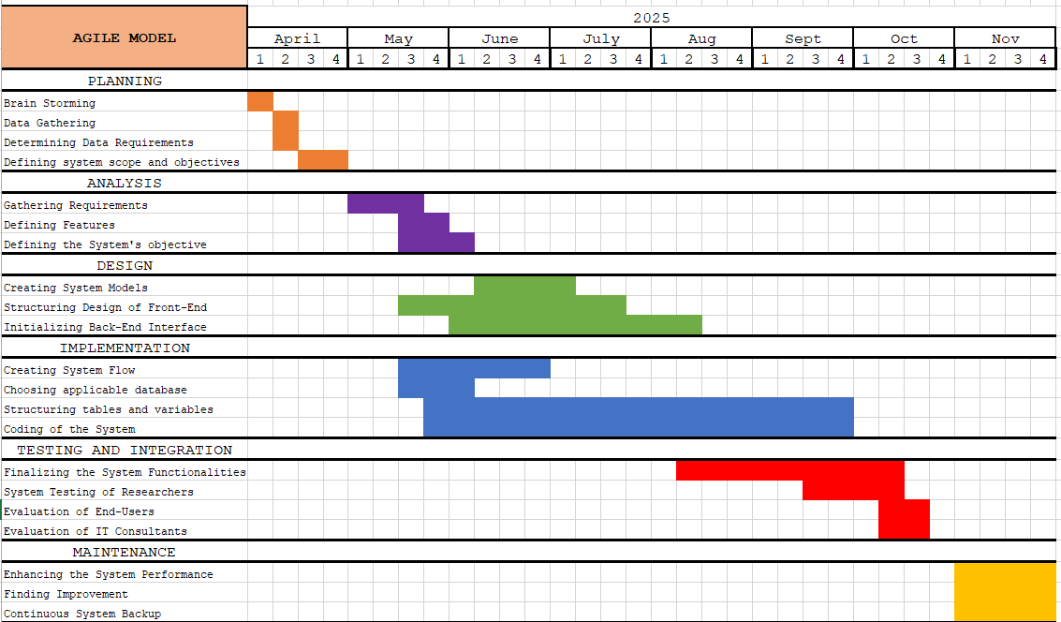

Figure 5. Gantt Chart of Activities

  - Design Stage

After the initial study of the researchers, they now proceed to the Design Stage. Here, diagrams are presented as a guide to the development of the system. These tools became essential for creating the system's functionalities, front-end and back-end interfaces, and database. The visual diagrams included in this stage are the Use Case Diagram, Entity Relationship Diagram, Database Normalization, Data Dictionary, and Data Flow Diagram.

Use Case Diagram
Use case diagrams provide an overview of a complete system or its key components, showcasing the relationship between system users and the various system activities. The developed system's use-case diagram is shown in Figure 6 below.
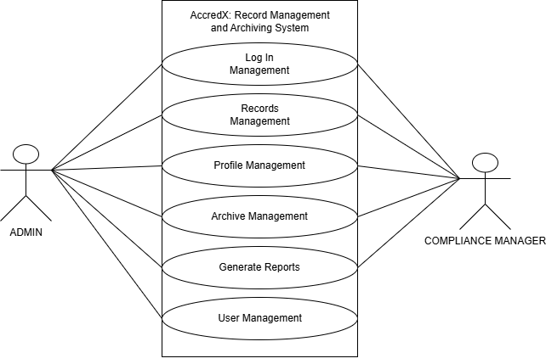

Figure 6. Use Case Diagram

The Use Case Diagram of the AccredX: Record Management and Archiving System illustrates the interaction between the system and its three main users — the Admin, Teacher and Assistant (Which is grouped into Compliance Manager since they have the same capabilities in the system). The admin serves as the system’s primary controller with full access to all major functions, including managing user accounts, creating and uploading folders and files and checklists, archiving and deleting records, viewing analytics in the dashboard, and generating accreditation reports. The Compliance Manager share similar privileges but with limited access, focusing mainly on uploading, organizing, and managing their own folders and files within the system. They can also view the dashboard for their respective activities and generate accreditation reports. This use case setup ensures a structured workflow and access control, supporting the institution’s goal of maintaining an efficient and secure record management process.

Data Flow Diagram
A data flow diagram (DFD) is a graphical representation of data flow through a system. It’s employed to understand how data is processed, stored, and communicated within a system. Moreover, DFD is used to support the analysis of how the data flows in existing or proposed systems from one page or module to another (using a flowchart). The context diagram of the system is displayed in Figure 7 below.

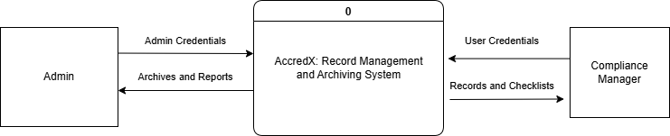
Figure 7. Context Diagram

The Data Flow Diagram (DFD) of the AccredX: Record Management and Archiving System illustrates how data moves between the three main user types—Admin, Teacher and Assistant (Grouped into Compliance Manager since they have the same capabilities in the system) and the system’s core processes. As shown in Figure 7, the admin has full control over system operations, including user management, file and folder creation, checklist management, and report generation. Data from the Admin flows into the system, where it is processed, stored, and made accessible according to defined roles. Compliance Managers interact with the system through limited access features, allowing them to upload and organize their own folders and files, as well as access and submit files for checklists. This structured flow of information ensures that data is efficiently managed, securely stored, and easily retrievable for accreditation and administrative purposes. The DFD emphasizes clear boundaries of responsibility and data access among user types, promoting data integrity, accountability, and streamlined communication within NEUST Peñaranda Off-Campus.

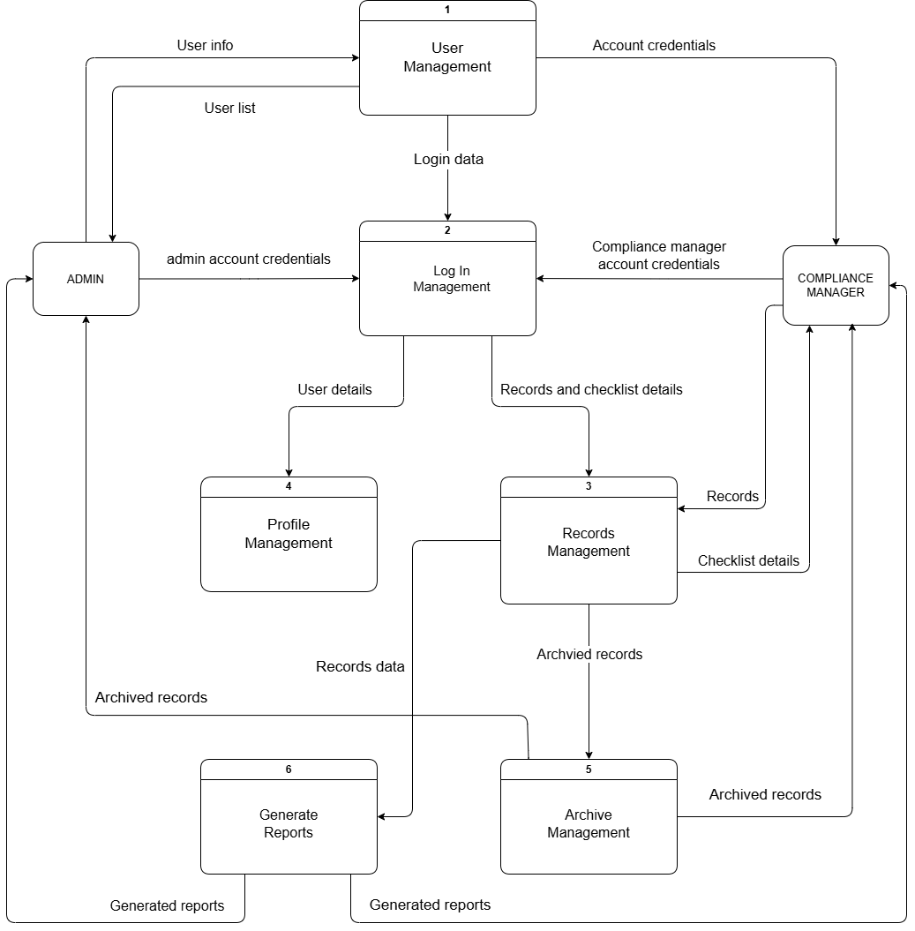
Figure 8. DFD Level 1

Figure 8 illustrates the Level 1 Data Flow Diagram, which provides a clear view of how the system works, focusing on essential functions. User Management is managed by admins and deals with user registration, folder access setting and enabling/disabling accounts. Log In Management deals with authentication, access control and forget password function. Profile Management is where users can manage their profiles, or change and update their email and password. Records management is where records are stored and managed by users and compliance managers have limited access to records; only being able to access the folders assigned to them by the admin, and Admins are able to set checklist requirements for folders. Archive Management deals with archived records, and both Admin and Compliance Manager can view, but only Admin can delete or restore. Generate Reports compiles the data from Records Management and generates compliance reports showing compliance status and required files summary.
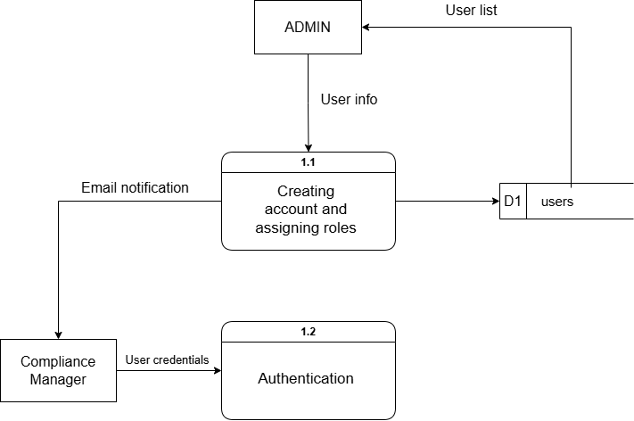
Figure 9. DFD Level 2 – User Management

In level 2 of User management the Admin creates compliance manager accounts by inputting user info and assigns roles and the data is stored into the users table. An email is sent to the Compliance Manager containing their credentials which they can use to log in. The data from the users table is shown in the user list for Admin.

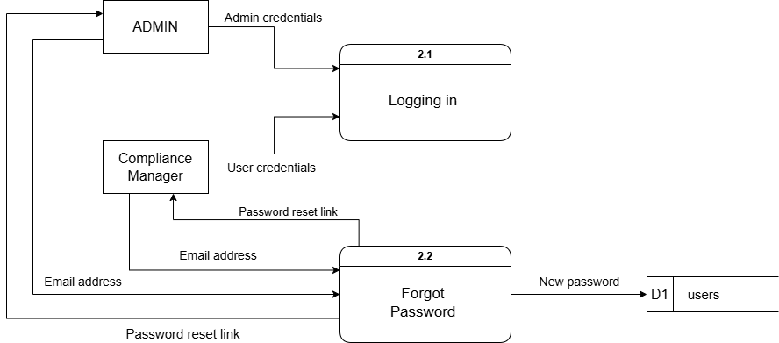
Figure 10. Level 2 – Login Management

Level 2 of Login Management involves both users inputting their credentials to login. If they forgot their passwords the users can enter their email addresses, in which the system sends a password reset link and the new password is stored to the users table.

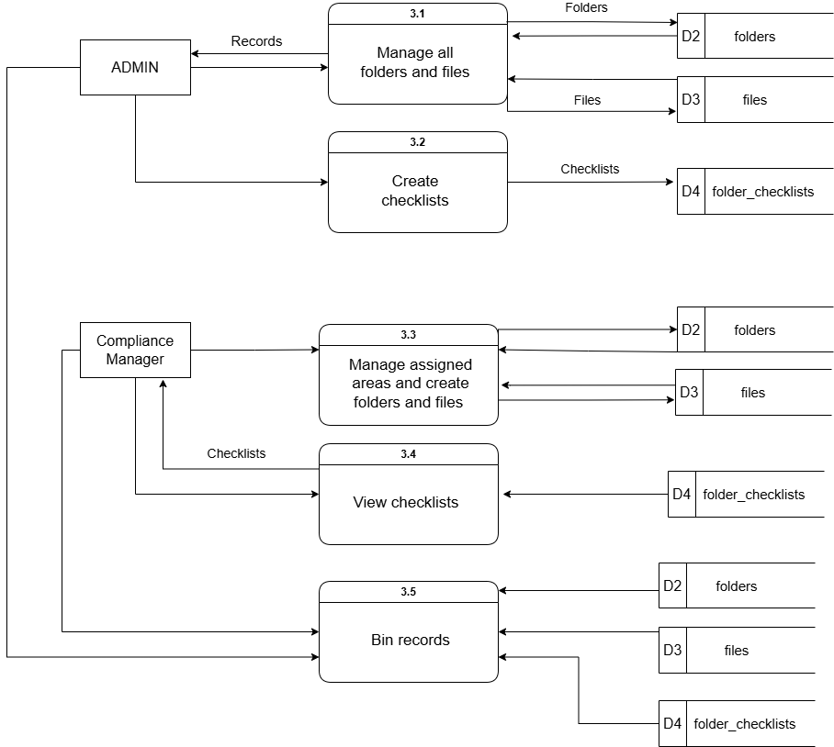
Figure 11. Level 2 – Records Management

Level 2 of Records Management, the Admin has access to and manages all records, which are folders and files, and can create checklists for compliance managers to fulfil. The compliance manager is assigned areas (which are root folders) by the admin on account creation, and can only manage those areas, create folders and files and view checklists in which they can upload files to fulfill those checklists. Both users can bin but compliance manager can only bin records from assigned areas.

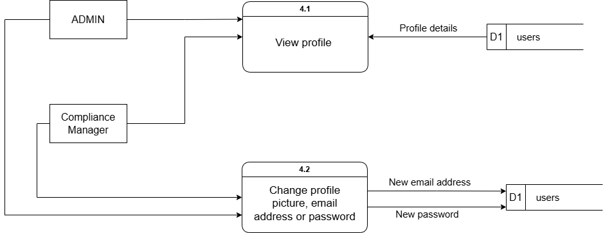
Figure 12. Level 2 – Profile Management

Level 2 of Profile Management. Both users can view their profiles as well as change their profile pictures, email addresses or passwords.

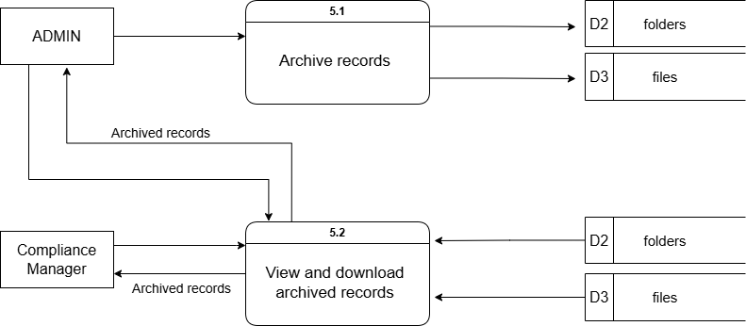

Figure 13. Level 2 – Archive Management

In Archive Management, only admins can archive records and bin archived records. Both users can view and download archived records from the system.

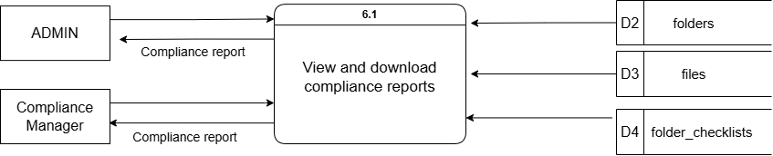

Figure 14. Level 2 - Generate Reports

In Generate Reports, both users can generate a compliance report which they can view and download. Data from tables folders, files and folders_checklists are summarized and compiled to generate the compliance reports.
Database Normalization
Database normalization is a principle used to organize data clearly and consistently within a database. Its objectives are simplifying complexity, removing duplicate information, and ensuring consistent data organization (K.Chris, 2023). The unnormalized form (UNF) of the developed system is depicted in Figure below.
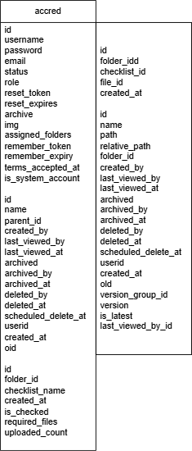

Figure 15. Unnormalized Form (UNF)

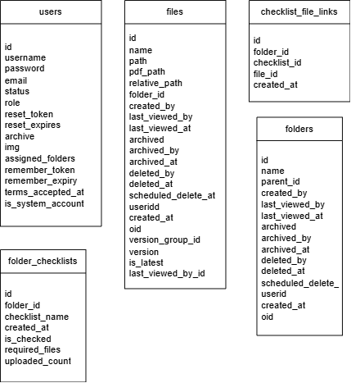

Figure 16. First Normal Form (1NF)

Entity Relationship Diagram
A visual depiction of the relationships between entries in a database is called an entity relationship diagram (ER diagram or ERD). ERDs are a specific kind of flowchart that illustrates the kinds of relationships that exist between various elements in a system.
The provided set of tables appears to represent an Entity-Relationship Diagram (ERD) for the developed system. The relationships between these tables are established through the primary and foreign keys.
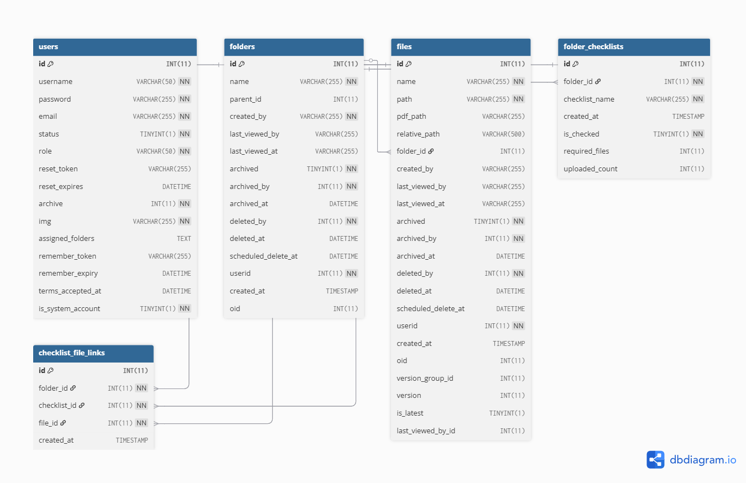
The ERD helps visualize how these entities are interconnected and how data flows within the system, which is crucial for understanding the structure and relationships in a database or system.

Figure 17. Entity Relationship Diagram

Data Dictionary
Data components are used or recorded in databases, information systems, and research projects. To better understand these data elements, a data dictionary is created, which contains their names, definitions, and properties. The developed system's data dictionary is displayed in the following tables.

Table 4. users Table
Fields Name | Description | Type/Length | Constraint
id | Unique Identifier  for each user | int (11) | Primary key
username | Username of the user | varchar(255)
password | Password of the user | varchar(255)
email | Email of the user | varchar(255)
status | Status of the user account, whether Enabled or Disabled | tinyint(4)
role | Role of the user (Admin, Teacher, Assistant) | varchar(50)
reset_token | Token for resetting password | varchar(255)
reset_expires | Date and time the reset token expires | datetime
archive | Whether user account is archived or not | int(11)
img | Profile picture of the user | varchar(255)
assigned_folders | Which folders the user is assigned to | text
remember_token | Remember token | varchar(255)
remember_expiry | Date and time remember token expires | datetime
terms_accepted_at | Date and time terms and conditions were accepted at | datetime
is_system_account | Whether or not user is system account or not | tinyint(1)

Table 5. folders Table
Fields Name | Description | Type/Length | Constraint
id | Unique Identifier  for each folder | int(11) | Primary key
name | Name of the folder | varchar(255)
parent_id | Parent ID of the folder | int(11)
created_by | User that created the folder | varchar(255)
last_viewed_by | Which user last viewed the folder | varchar(255)
last_viewed_at | Date and time the folder was last viewed at | varchar(255)
archived | Whether folder is archived or not | tinyint(1)
archived_by | User that archived the folder | int(11)
archived_ at | Date and time the folder was archived | datetime
deleted_by | User that deleted the folder | int(11)
deleted_at | Date and time folder was deleted | datetime
scheduled_delete_at | Scheduled delete | datetime
user_id | User ID | int(11)
created_at | Time the folder was created | timestamp
oid | OID | int(11)

Table 6. folder_checklists Table
Fields Name | Description | Type/Length | Constraint
id | Unique Identifier  for each checklist | int(11) | Primary key
folder_id | ID of the folder the checklist is in | int(11) | Foreign Key
checklist_name | Name of the checklist | varchar(255)
created_at | Date and time checklist was created | timestamp
is_checkedd | Whether checklist is checked or not | tinyint(1)
required_files | Required number of files for the checklist | int(11)
uploaded_count | Number of files uploaded | int(11)
Table 7. checklist_file_links Table
Fields Name | Description | Type/Length | Constraint
id | Unique Identifier  for each checklist file link | int(11) | Primary key
folder_id | Folder ID | int(11)
checklist_id | Checklist ID | int(11) | Foreign Key
file_id | File ID | int(11) | Foreign Key
created_at | Time checklist file link was created | timestamp

Table 8. files Table
Fields Name | Description | Type/Length | Constraint
id | Unique Identifier  for each file | int(11) | Primary key
name | Name of the file | varchar(255)
path | Filepath where the file is | varchar(255)
pdf_path | Filepath for the PDF preview of the file | varchar(255)
relative_path | Relative path of the file | varchar(500) | Foreign Key
folder_id | Folder ID | int(11)
created_by | User that created the file | varchar(255)
last_viewed_by | User that last viewed the file | varchar(255)
last_viewed_at | Date and time the folder was last viewed | varchar(255)
archived | File is archived or not | tinyint(1)
archived_by | User that archived the file | int(11)
archived_at | Date and time file was archived | datetime
deleted_by | User that deleted the file | int(11)
deleted_at | Date and time the file was deleted | datetime
scheduled_delete_at | Scheduled delete | datetime
userid | User ID | int(11)
created_at | Time file was created | timestamp
oid | OID | int(11)
version_group_id | Version group ID | int(11)
version | Version of the file | int(11)
is_latest | Is the latest version of the file | tinyint(1)
last_viewed_by_id | Last viewed by ID | int(11)

2.3 Development Stage
The researchers chose Visual Studio Code as the text editor for writing the source code of the developed system, because it simplifies the process of code editing and debugging. The sample is shown in Figure 18 below.

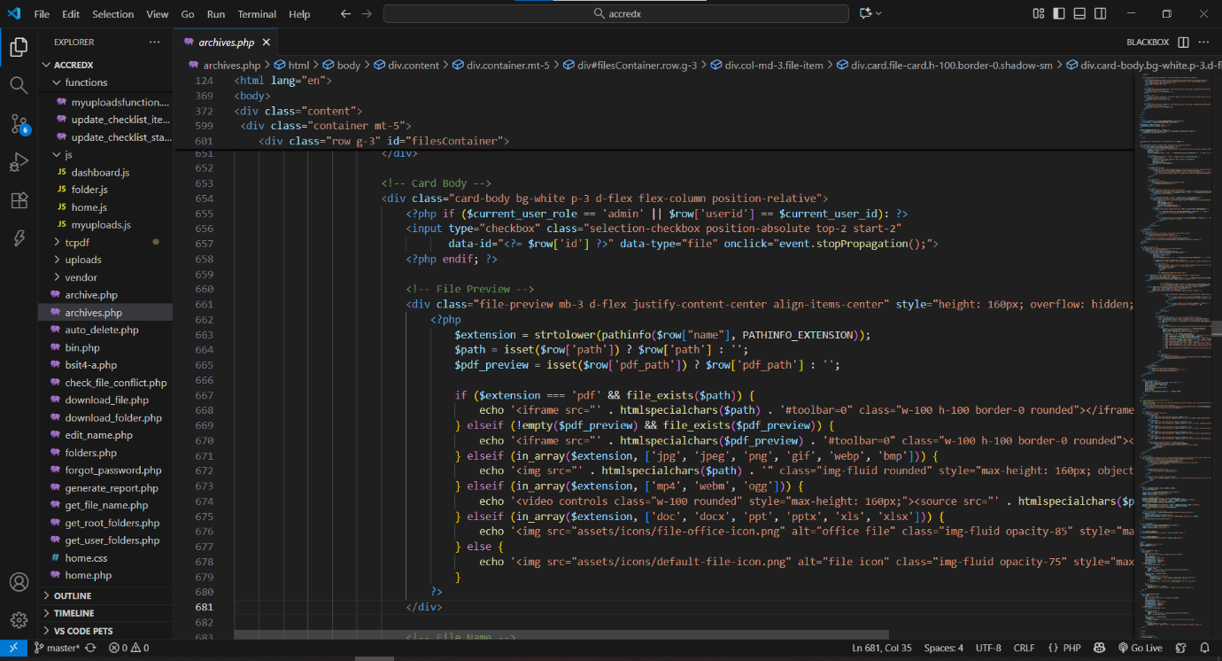
Figure 18. Visual Studio Code

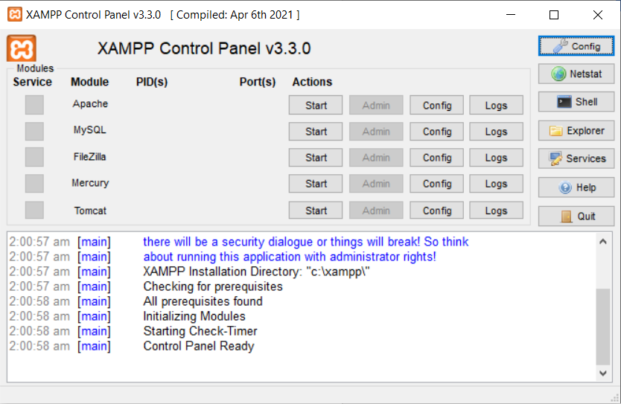
XAMPP Control Panel was used to test and run the developed system, while the output was reviewed through browsers Google Chrome and Microsoft Edge. The system’s data and functionality were tested and validated within the database using XAMPP.

Figure 19. XAMPP Control Panel
Using phpMyAdmin, the researchers were able to create the necessary databases and tables to store the system’s data.
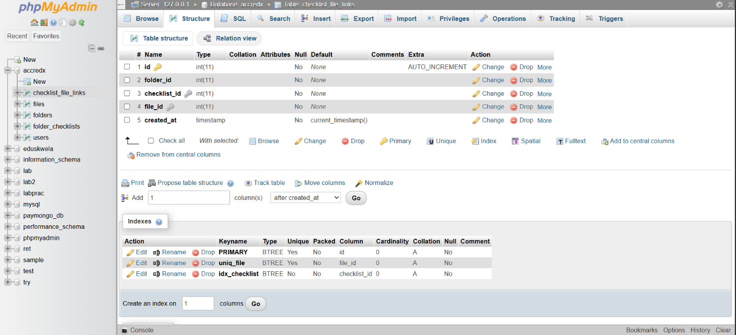

Figure 20. phpMyAdmin Page

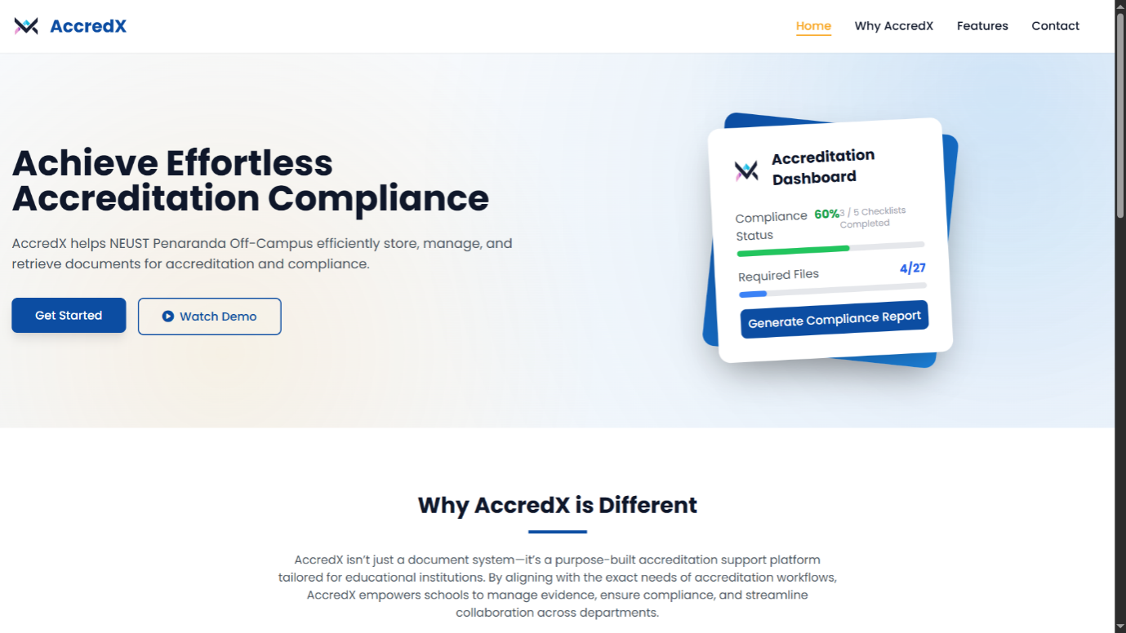
The created system user web pages are shown in the figures below.

Figure 21. Homepage of the System

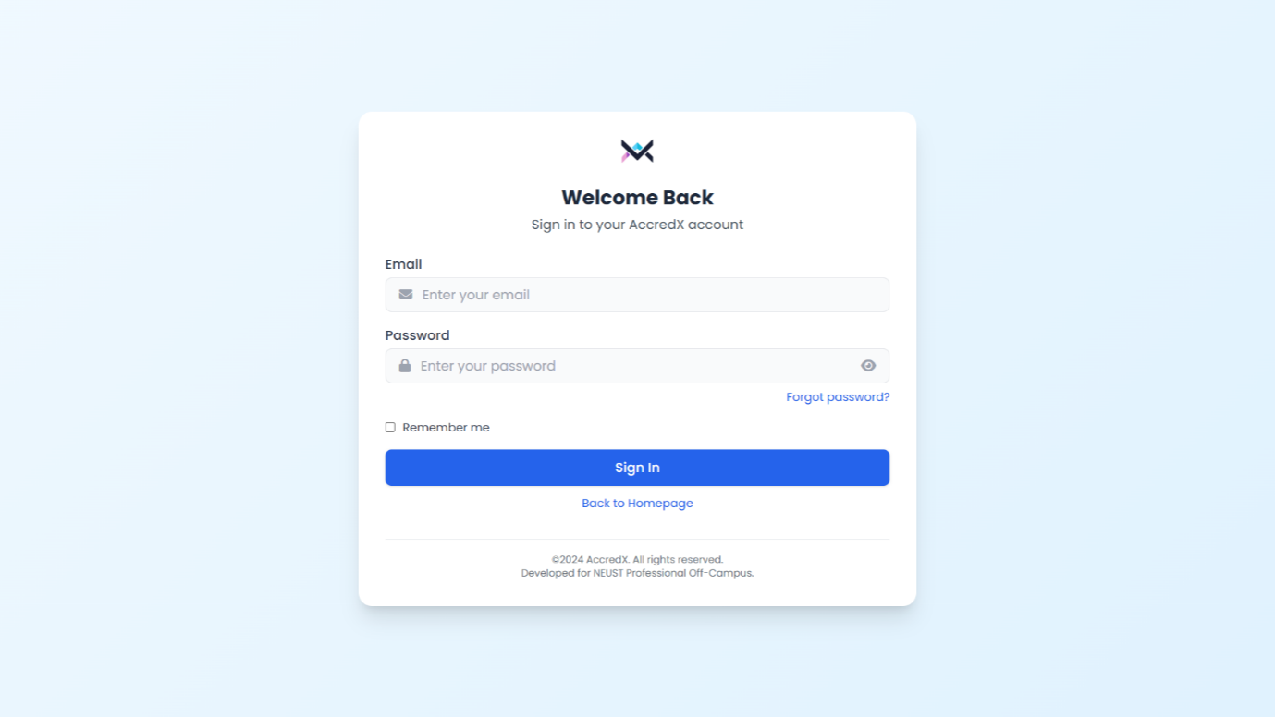
Figure 22. Login Page

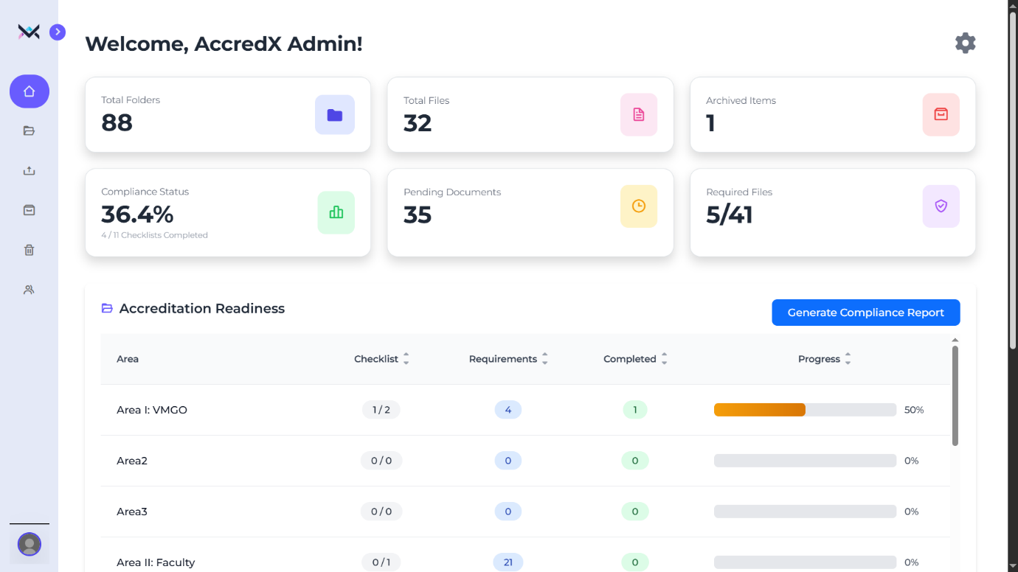

Figure 23. Dashboard Page

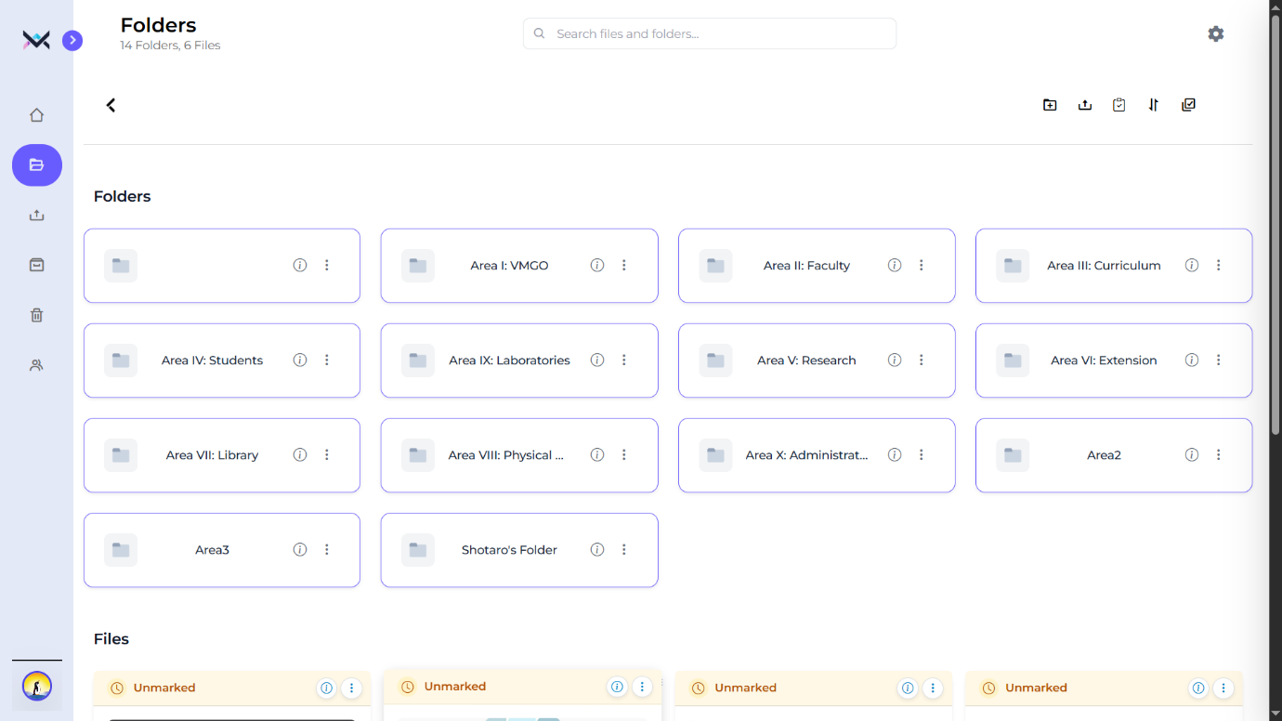

Figure 24. Folders Page

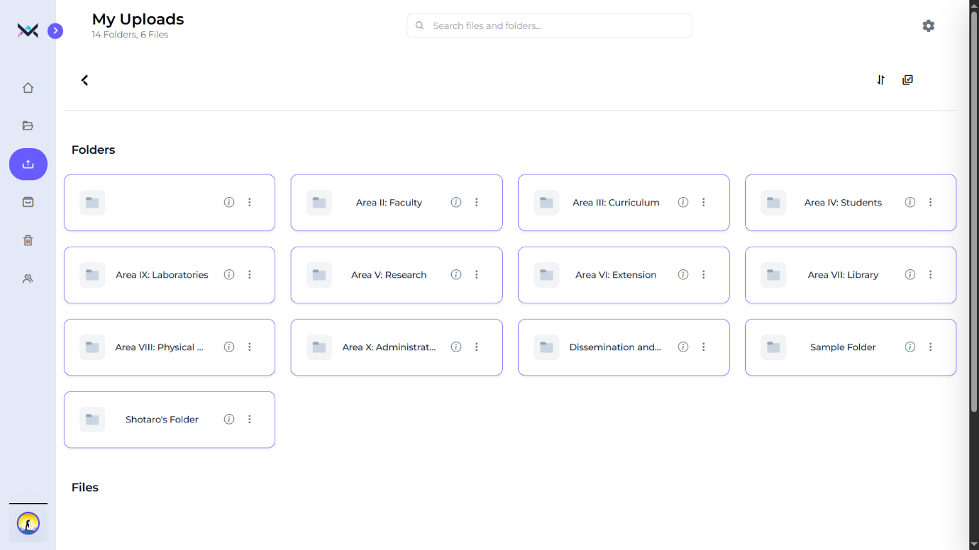

Figure 25. My Uploads Page

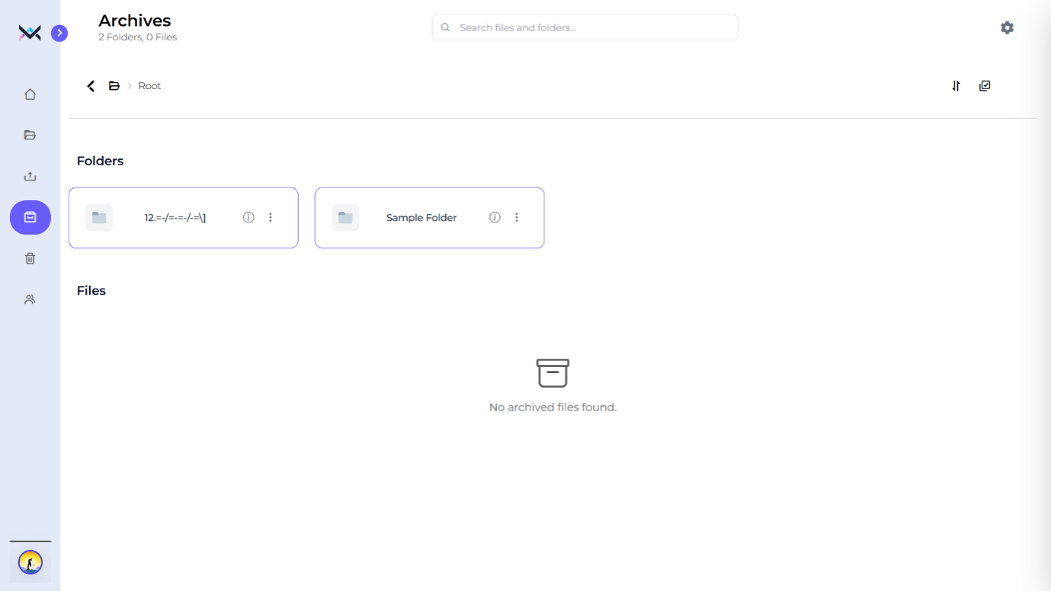

Figure 26. Archives Page

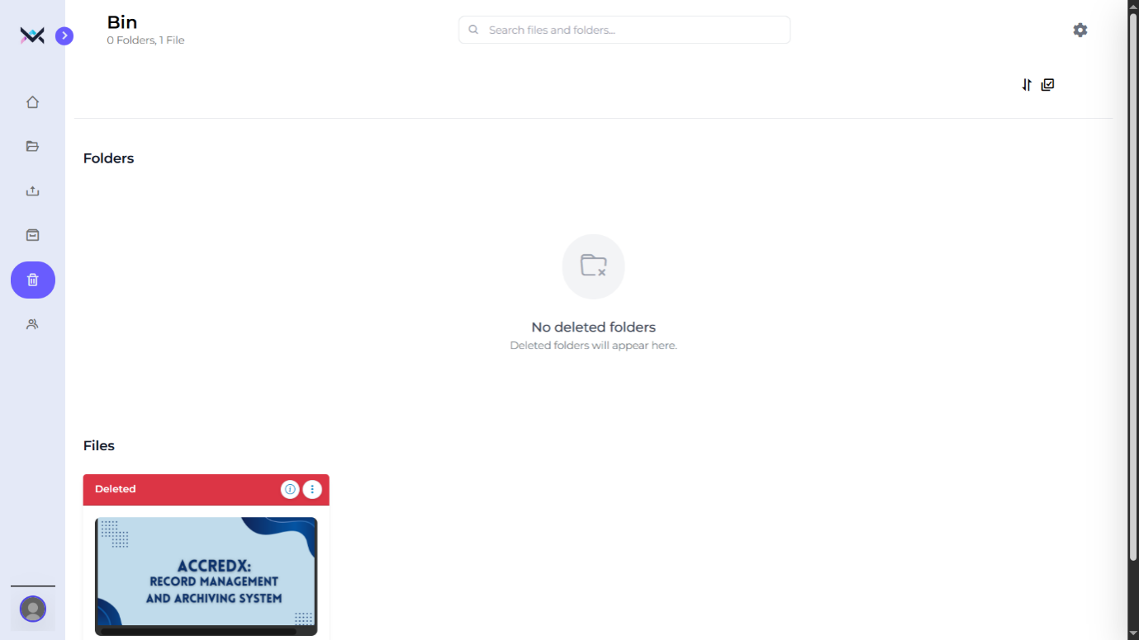

Figure 27. Bin Page

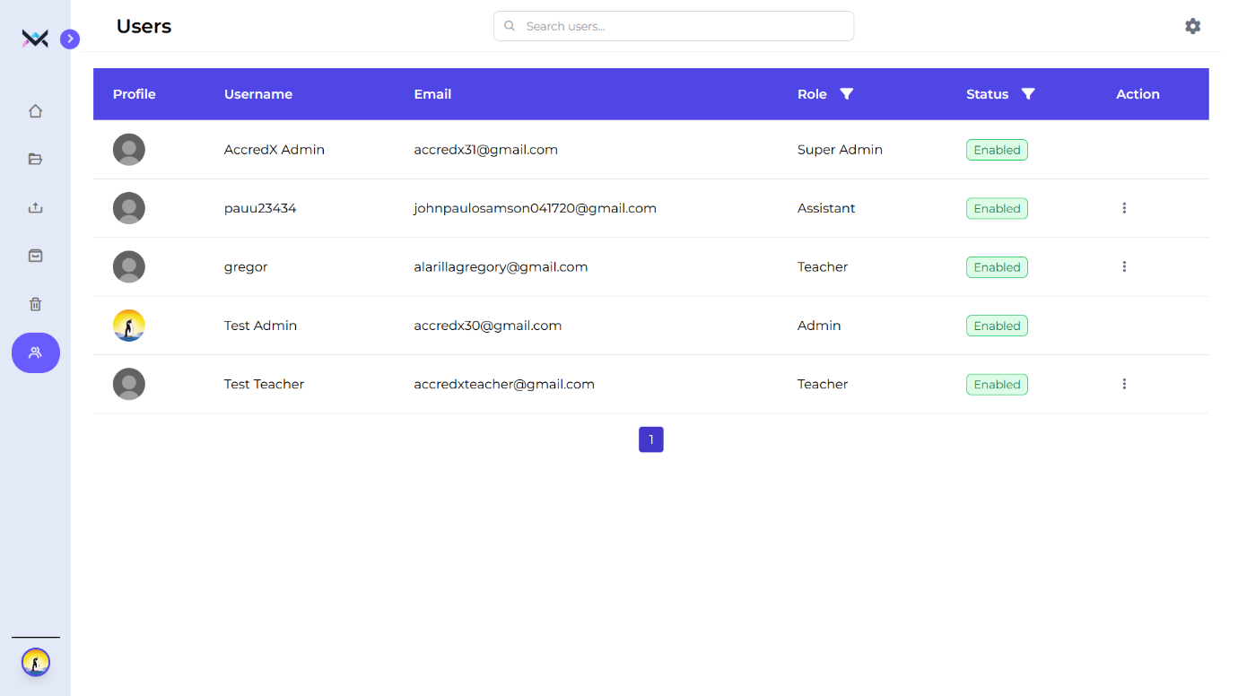

Figure 28. Users Page (Admin Only)
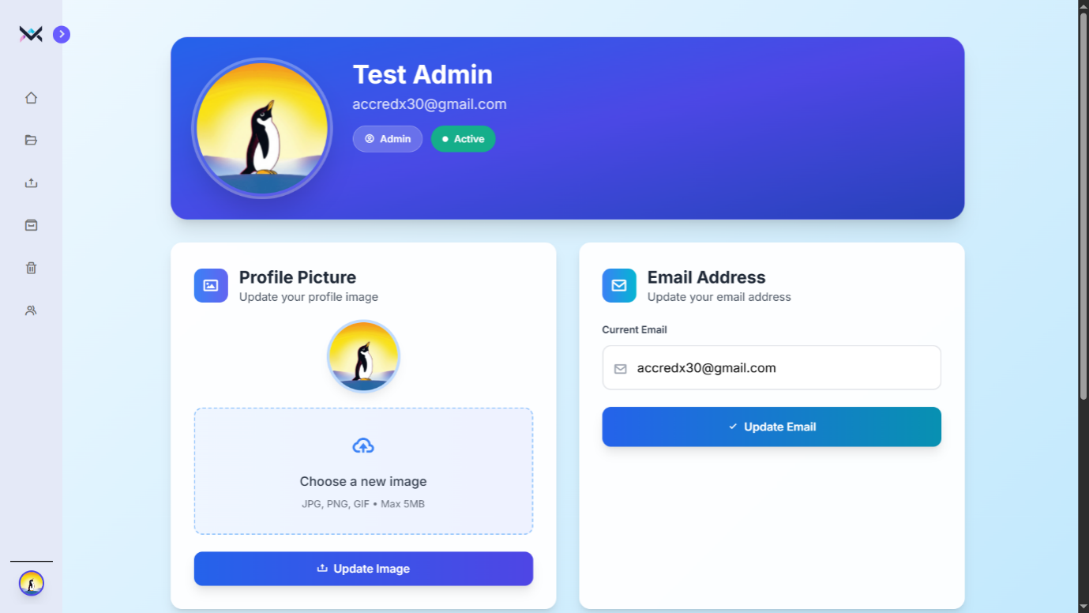

Figure 29. Profile Page

2.4 Testing Stage

During this phase, the researchers conducted thorough testing of the system to identify and resolve any issues, ensuring it functions as intended. Adjustments were made to refine the system’s performance and align it with the project requirements. This testing phase took place after completing the development of both the system interface and back-end components. It involved verifying that all features work seamlessly together and that the system meets the expected usability and functionality standards. The researchers collaborated with IT consultants and end-users to test the system, identify errors, and gather recommendations for improvement. Their feedback helped refine the system’s functionality and usability.

2.5 Deployment Stage
In this stage, AccredX: Record Management and Archiving System had been thoroughly tested and evaluated by the researchers, so it can now be put into deployment. The researchers uploaded the system online via web hosting under a domain name.
An Estimated Project Cost contains the expenses related to the system maintenance upon its deployment.
Domain Costing: Domain costing is needed to maintain the system’s online availability.
The total cost to maintain the AccredX: Record Management and Archiving system is 1,100.00 as reflected below.
Table 9. Estimated Project Cost
COMPONENT | COST
Domain Costing | ₱1,100.00
Total Estimated Project Cost | ₱1,100.00

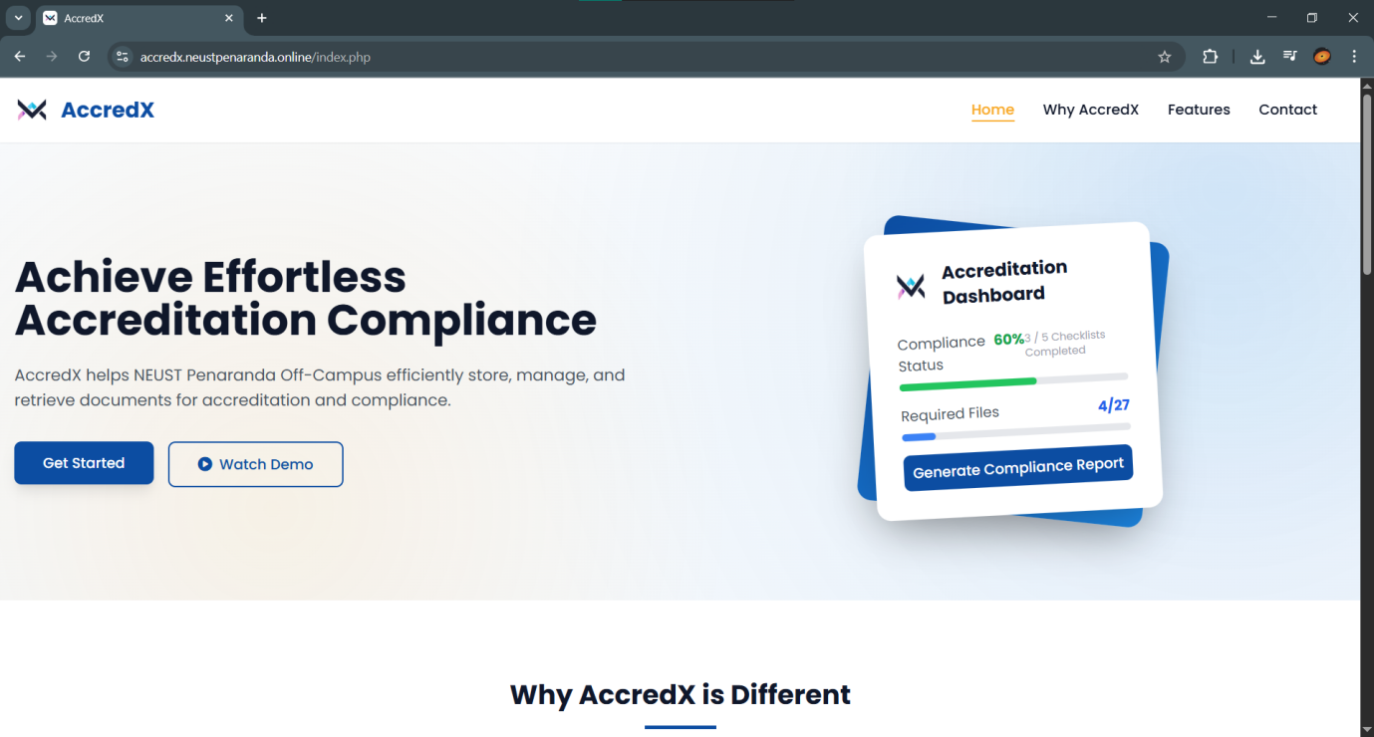

Figure 30. System Successfully Deployed

2.6 Operational Stage
The researchers continuously monitored the system to ensure it has been functioning properly from its launch up to the present. The researchers reviewed and addressed any potential issues or weaknesses in the system, striving to make consistent improvements. Importantly, the researchers listened closely to user feedback and suggestions. By incorporating these insights, they made the system more intuitive and user-friendly, ensuring it better meets the needs of those who rely on it.

3. IT Consultants’ evaluation results of AccredX: Record Management and Archiving System
The developed system was evaluated by ten (10) IT Consultants. The IT Consultants evaluated the performance and features of the AccredX: Record Management. The following sections include tables that provide a clear view of the data collected. These tables highlight the findings from the IT consultants’ responses.

3.1 Functional Suitability
Table 10 shows the functional suitability of the developed AccredX: Record Management and Archiving System assessed by the IT consultants that consists of three (3) sub-characteristics namely: functional completeness, functional correctness, and functional appropriateness.

Table 10. Assessment of the IT consultants on the Functional Suitability of the developed system
Software Product Categories | Weighted Mean | Verbal Interpretation
Functional Completeness | 3.5 | Very Functional
Functional Correctness | 3.7 | Very Functional
Functional Appropriateness | 3.4 | Very Functional
Functional Suitability | 3.53 | Very Functional

Effectively meets user requirements by ensuring all necessary features, operates as expected without errors, and is well-aligned with the intended purpose, making it a reliable and efficient solution for users.

3.2 Performance Efficiency
Table 11 shows the performance efficiency of the developed AccredX: Record Management and Archiving System assessed by the IT consultants that consist of three (3) sub-characteristics, namely: time behavior, resource utilization and capacity.

Table 11. Assessment of the IT consultants on the Performance Efficiency of the developed system
Software Product Categories | Weighted Mean | Verbal Interpretation
Time behavior | 3.4 | Very Efficient
Resource utilization | 3.6 | Very Efficient
Capacity | 3.3 | Very Efficient
Performance Efficiency | 3.43 | Very Efficient

As presented in Table 11, the evaluation results for the Performance Efficiency category indicate a weighted mean of 3.43, with a verbal interpretation of “Very Efficient”.

3.3 Compatibility
Table 11 shows the compatibility of the developed AccredX: Record Management and Archiving System assessed by the IT consultants that consist of two (2) sub-characteristics, namely: coexistence and interoperability.
Table 12. Assessment of the IT consultants on the Compatibility of the developed system

Software Product Categories | Weighted Mean | Verbal Interpretation
Co-existence | 3.4 | Very Compatible
Inter-operability | 3.2 | Very Compatible
Compatibility | 3.3 | Very Compatible

As shown in Table 12, the evaluation results for the Compatibility category indicate a weighted mean of 3.3, and a verbal rating of “Very Compatible”.

3.4 Usability
Table 13 shows the usability of the developed AccredX: Record Management and Archiving System assessed by the IT consultants that consist of six (6) sub-characteristics, namely: appropriateness recognizability, learnability, operability, user error protection, user interface aesthetics and accessibility.

Table 13. Assessment of the IT consultants on the Usability of the developed system
Software Product Categories | Weighted Mean | Verbal Interpretation
Appropriateness recognizability | 3.3 | Very Usable
Learnability | 3.3 | Very Usable
Operability | 3.1 | Usable
User error protection | 3.4 | Very Usable
User interface aesthetics | 3.5 | Very Usable
Accessibility | 3.3 | Very Usable
Usability | 3.32 | Very Usable

As presented in Table 13, the evaluation results for the Compatibility category indicate a weighted mean of 3.32, and a verbal rating of “Very Usable”.

3.5 Reliability
Table 14 shows the reliability of the developed AccredX: Record Management and Archiving System assessed by the IT consultants that consist of four (4) sub-characteristics, namely: maturity, availability, fault tolerance and recoverability.

Table 14. Assessment of the IT consultants on the Usability of the developed system
Software Product Categories | Weighted Mean | Verbal Interpretation
Maturity | 3.3 | Very Reliable
Availability | 3.3 | Very Reliable
Fault tolerance | 2.9 | Reliable
Recoverability | 3.5 | Very Reliable
Reliability | 3.25 | Very Reliable

The evaluation results for the Reliability category indicate a weighted mean of 3.25 and a verbal rating of “Very Reliable”.
3.6 Security
Table 15 shows the Security of the developed AccredX: Record Management and Archiving System assessed by the IT consultants that consist of five (5) sub-characteristics, namely: confidentiality, integrity, non-repudiation, accountability and authenticity.

Table 15. Assessment of the IT consultants on the Security of the developed system
Software Product Categories | Weighted Mean | Verbal Interpretation
Confidentiality | 3.6 | Very Secured
Integrity | 3.5 | Very Secured
Non-repudiation | 3.6 | Very Secured
Accountability | 3.4 | Very Secured
Authenticity | 3.3 | Very Secured
Security | 3.48 | Very Secured

As shown in Table 15, the evaluation results for the Security category indicate a weighted mean of 3.48, and a verbal rating of “Very Secured”.

3.7 Portability
Table 16 shows the Portability of the developed AccredX: Record Management and Archiving System assessed by the IT consultants that consist of three (3) sub-characteristics, namely: adaptability, installability and replaceability.
Table 16. Assessment of the IT consultants on the Security of the developed system
Software Product Categories | Weighted Mean | Verbal Interpretation
Adaptability | 3.3 | Very Portable
Installability | 3.7 | Very Portable
Replaceability | 3.1 | Portable
Portability | 3.37 | Very Portable

The evaluation results for the Reliability category indicate a weighted mean of 3.37 and a verbal rating of “Very Portable”.

3.8 IT Consultants Evaluation Summary
The following table displays the overall summary result of the evaluation conducted by the IT Consultants on the developed system, AccredX: Record Management and Archiving System.

Table 17. IT Consultants’ Evaluation Summary Result
Software Product Categories | Weighted Mean | Verbal Interpretation
Functional suitability | 3.53 | Very Satisfactory
Performance Efficiency | 3.43 | Very Satisfactory
Compatibility | 3.3 | Very Satisfactory
Usability | 3.32 | Very Satisfactory
Reliability | 3.25 | Very Satisfactory
Security | 3.48 | Very Satisfactory
Portability | 3.37 | Very Satisfactory
Overall | 3.38 | Very Satisfactory

4. End users’ Evaluation Results of AccredX: Record Management and Archiving System

The end users assessed the performance and qualities of the developed AccredX: Record Management and Archiving System based on the selected criteria: functional suitability, performance efficiency and usability.
The respondents were grouped into three categories: administrator, teachers, and assistants. This grouping reflects their roles as the primary users of the system. The developed system was evaluated by 3 admins, 5 teachers and 15 assistants, with a total of 23 respondents. The respondents did the evaluation of the system by answering the prepared questionnaires given by the researchers. The following sections include tables that provide a clear view of the data collected. These tables highlight the findings from the system users’ responses.

4.1 Functional Suitability
Table 18 shows the functional suitability of the developed AccredX: Record Management and Archiving System assessed by the end users that consist of three (3) sub-characteristics, namely: functional completeness, functional correctness and functional appropriateness.

Table 18. Assessment of the end users on the Functional Suitability of the developed system
Software Product Categories | Weighted Mean | Verbal Interpretation
Functional Completeness | 3.2 | Very Functional
Functional Correctness | 3.6 | Very Functional
Functional Appropriateness | 3.6 | Very Functional
Functional Suitability | 3.46 | Very Functional

The system is very functional, with nearly complete features, correct functionality, and appropriate characteristics for its intended use. These ratings suggest that the system effectively meets user needs and performs well in all key areas of functionality.

4.2 Performance Efficiency
Table 19 shows the performance efficiency of the developed AccredX: Record Management and Archiving System assessed by the end users that consist of three (3) sub-characteristics, namely: time behavior, resource utilization and capacity.

Table 19. Assessment of the end users on the Performance Efficiency of the developed system
Software Product Categories | Weighted Mean | Verbal Interpretation
Time behavior | 3.6 | Very Efficient
Resource Utilization | 3.4 | Very Efficient
Capacity | 3.4 | Very Efficient
Performance Efficiency | 3.46 | Very Efficient

It demonstrates very high-performance efficiency. The system performs efficiently in terms of time, effectively utilizing resources, and handling capacity requirements.

4.3 Usability
Table 20 shows the usability of the developed AccredX: Record Management and Archiving System assessed by the end users that consist of six (6) sub-characteristics, namely: appropriateness recognizability, learnability, operability, user error protection, user interface aesthetics and accessibility.

Table 20. Assessment of the end users on the Usability of the developed system
Software Product Categories | Weighted Mean | Verbal Interpretation
Appropriateness recognizability | 3.4 | Very Usable
Learnability | 3.5 | Very Usable
Operability | 3.7 | Very Usable
User error protection | 3.6 | Very Usable
User interface aesthetics | 3.6 | Very Usable
Accessibility | 3.6 | Very Usable
Usability | 3.55 | Very Usable

The system is very usable. The system excels in areas such as recognizability, learnability, and operability, ensuring users
can easily understand, navigate, and interact with it.

4.4 End-users’ Evaluation Summary
Table 21 displays the overall result of the evaluation conducted by the End Users on the developed AccredX: Record Management and Archiving System.

Table 21. End-users’ Evaluation Summary Result
Software Product Categories | Weighted Mean | Verbal Interpretation
Functional suitability | 3.46 | Very Satisfactory
Performance Efficiency | 3.46 | Very Satisfactory
Usability | 3.55 | Very Satisfactory
Overall | 3.49 | Very Satisfactory

Chapter IV
SUMMARY, CONCLUSIONS AND RECOMMENDATIONS

Summary
This study aimed to develop AccredX: Record Management and Archiving System for NEUST Peñaranda Off-Campus in response to the institution’s need for a more efficient, secure, and organized method of managing academic and administrative documents. The existing manual and semi-digital processes, including reliance on Google Drive without structured categorization or checklist tracking, resulted in misplaced files, retrieval delays, limited security measures, and inefficiencies during accreditation.

To address these concerns, the researchers designed and developed a digital system using the Software Development Life Cycle (SDLC) under the Agile methodology. The system integrated essential features such as fast search and retrieval, folder and file management, version control, audit trails, role-based access control, accreditation checklists, and report generation. Visual tools including Use Case Diagrams, Data Flow Diagrams (DFD), Entity Relationship Diagrams (ERD), and Database Normalization guided the system’s structure and functionality.

Two groups evaluated the system: ten (10) IT consultants assessing technical quality based on ISO/IEC 25010:2011 and twenty-three (23) end-users evaluating usability and actual functionality in an academic context. Both groups rated the system highly across all criteria.

IT consultants rated the system as Excellent overall (WM = 3.38), with high ratings in functional suitability, performance efficiency, compatibility, usability, reliability, security, and portability. End users likewise rated the system Excellent overall (WM = 3.49), highlighting its ease of use, efficient performance, and completeness of features.

The study successfully delivered a functional, secure, and user-friendly record management system capable of supporting NEUST Peñaranda Off-Campus in improving administrative processes, ensuring document integrity, and strengthening accreditation preparation.

Conclusion
Based on the findings of the study, the following conclusions were drawn:

1. The existing record management system at NEUST Peñaranda Off-Campus was inadequate for the institution's operational and accreditation needs. The reliance on Google Drive without structured organization, proper categorization, checklist functionality, or centralized control created significant inefficiencies, security risks, and difficulties in document retrieval and accountability.

2. The Agile methodology and SDLC framework proved effective in developing a comprehensive and responsive record management system. The iterative development approach allowed for continuous refinement based on stakeholder feedback, ensuring the final product aligned closely with institutional requirements and user expectations.
3. AccredX successfully addresses the identified problems through its implementation of essential features including centralized storage, role-based access control, audit trails, version control, and accreditation checklist management. These functionalities collectively enhance document organization, security, accessibility, and accountability.

4. The system demonstrates high technical quality as evidenced by IT consultants' ratings across all ISO/IEC 25010:2011 criteria. Particularly strong performance in functional suitability, security, and performance efficiency confirms that the system meets professional software development standards and is technically sound.

5. End-users find the system highly functional and usable in actual operational contexts. The consistently high ratings from administrative staff, teachers, and assistants indicate that the system is intuitive, efficient, and well-suited to the daily tasks and workflows of its intended users.

6. The system significantly improves accreditation preparedness by ensuring required documents are complete, organized, well-tracked through checklists, and easily retrievable. This structured approach reduces preparation time and enhances the institution's credibility during accreditation reviews.

Recommendations
The conclusions and findings of the study have led to the formulation of the following recommendations:

- Implement Additional Security Enhancements
Although the system already meets high security standards, integrating advanced features such as two-factor authentication (2FA), IP logging, and automated security alerts can further strengthen protection against unauthorized access and data breaches.

- Develop a Mobile-Friendly or Mobile App Version
Creating a responsive mobile layout or a dedicated mobile application would allow users—especially teachers and staff—to access records conveniently using smartphones or tablets, improving overall accessibility.

- Integrate Automated Backups and Cloud Storage Options
To ensure long-term data preservation, the system should implement automated backup schedules. Cloud-based backup integration may also be considered to prevent data loss in the event of system failures or disasters.

- Add an Enhanced Search and Filtering System
Introducing advanced search filters such as metadata filtering, search history, and predictive search would help users locate documents faster, improving daily workflows and accreditation preparations.

- Provide Comprehensive User Training and Documentation
Conducting regular training sessions, creating user manuals, and producing tutorial videos would help ensure that all users—teachers, assistants, and administrators—maximize the system’s features effectively.

- Conduct Continuous System Maintenance and Updates
Regular updates are recommended to fix emerging bugs, improve the user interface, enhance performance, and incorporate new features based on user feedback.

- Explore Integration with Other NEUST Systems
Future studies may focus on integrating the system with other academic or administrative platforms within NEUST to create a more unified and streamlined workflow across the campus.

- Expand the Checklist Feature for Accreditation
Enhancing the checklist module by adding automated reminders, due-date notifications, and compliance percentage tracking will further improve accreditation readiness and user accountability.

- Conduct Further Studies and User Experience Testing
Researchers may conduct additional evaluations, usability testing sessions, and longitudinal studies to assess long-term user satisfaction, system reliability, and its overall impact on institutional efficiency.

References

Bailey (2021). Modern electronic records management systems (ERMS) and their impact on document security. National Archives and Records Administration (NARA). Retrieved from https://ussm.gsa.gov/assets/files/ERM/NARA%20ERM%20Overview%20of%20Use%20Cases%20for%20Electronic%20Records%20March%202021.pdf

Clark, P. (2020). The Advantages of Digitizing Paper Records. Records Management Quarterly, 55(3), 25-33.

Collins, M., & Hayes, J. (2020). Document Version Control: A Guide to Effective Version Management. Retrieved from https://www.sharefile.com/resource/blogs/document-version-control-guide

Foster, G. (2021). Document Version Control: A Comprehensive Guide for Project Managers. Retrieved from https://www.getguru.com/reference/document-version-control

Health Care Compliance Brief. (2020). Records management and regulatory compliance. Health Care Compliance Brief.

Henderson, L. (2021). The Importance of Staff Training in Records Management. Information and Records Management Society Journal, 12(1), 15-22.

Managed Outsource Solutions. (2021). Major factors driving electronic records management. Managed Outsource Solutions. Retrieved from https://www.managedoutsource.com/blog/key-factors-driving-electronic-records-management-in-2021/

MES Ltd. (2021). Records management trends for 2021. MES Ltd. Retrieved from https://blog.mesltd.ca/records-management-trends-for-2021

Miller, S., & Adams, R. (2022). Enhancing Document Retrieval through Proper Indexing and Metadata Tagging. Journal of Documentation, 78(4), 112-130.

Mitchell, R., & Carter, L. (2020). Digital archiving systems in academic institutions: Enhancing efficiency and data security. Records Management Journal.

National Archives and Records Administration (NARA). (2021). Use cases for electronic records management. NARA.

Ramirez, L. (2021). Efficiency of Electronic Document Management Systems: A Case Study. Retrieved from https://www.academia.edu/88983141/Efficiency_of_Electronic_Document_Management_Systems_A_Case_Study

Stewart, P. (2022). Best Practices for Document Version Control: A Comprehensive Guide for Modern Businesses. Retrieved from https://www.eisenvault.com/post/best-practices-for-document-version-control-a-comprehensive-guide-for-modern-businesses

Turner, M., & Scott, D. (2022). Backup Strategies for Disaster Recovery and Business Continuity. Journal of Business Continuity & Emergency Planning, 16(2), 89-101.

Wilson. (2021). Implementing ISO 15489 for Effective Records Management. International Journal of Information Management, 37(2), 45-53.

