VeriScan: Development of an Integrated Employee Management System with Dynamic QR Code and Facial Verification for Attendance Recording and Automated Payroll at Balong’s Kitchenette



A CAPSTONE AND RESEARCH PROJECT

BY:

ALMAZAN, ANGELINE B.
SALAZAR, PRINCE LEO A.
ROQUE, PEARL DOLLY R.
PAJARILLAGA, MARK JUSTINE D.

MAY 2026

VeriScan: Development of an Integrated Employee Management System with Dynamic QR Code and Facial Verification for Attendance Recording and Automated Payroll at Balong’s Kitchenette

A Capstone and Research Project
Presented to the Faculty of the College of
Information and Communications Technology

NUEVA ECIJA UNIVERSITY OF SCIENCE AND TECHNOLOGY
OFF-CAMPUS PROGRAM-PEÑARANDA

In Partial Fulfillment of the Requirements for the Degree Bachelor of Science in Information
Technology with Specialization in Web System
Technology

BY

ALMAZAN, ANGELINE B.
SALAZAR, PRINCE LEO A.
ROQUE, PEARL DOLLY R.
PAJARILLAGA, MARK JUSTINE D.

Chapter I
THE PROBLEM AND ITS BACKGROUND

Introduction
In today’s digital age, many organizations are now using technology to improve their daily operations. Traditional paper-based employee management has slowly been replaced by digital systems that use tools such as biometric authentication, cloud storage, and mobile access. The growth of smartphones and Internet of Things (IoT) devices also changed the way attendance and payroll are managed, making the process more accurate, secure, and easier to handle. According to Abd El-Mawla and Ismaiel (2022), the use of QR code and facial verification in attendance systems helped solve problems connected to manual monitoring, especially in situations where contactless transactions are needed. These technologies also improve attendance recording and identity checking, which helps lessen fraud and recording mistakes. Because of this, many businesses now consider digital employee management system as an important part of their operations.
Many organizations around the world still experience problems with manual attendance and payroll systems because of inaccurate records, delays, and possible data manipulation. Studies show that paper-based attendance logs and manual encoding may lead to missing files, delayed reports, and falsified attendance records (Nuralif & Fachrie, 2023). At the same time, workforce management has become more demanding because companies now need systems that can process real-time data and provide useful information for decision-making. The use of QR code scanning together with facial verification has been found effective in reducing processing time, minimizing human mistakes, and improving work efficiency (Fuady & Hidayat, 2025). These developments show the growing need for organizations to shift from manual systems to automated employee management solutions.
In Southeast Asia, many small and medium-sized enterprises (SMEs) are slowly adapting to digital transformation. Even though digital tools are available, many SMEs still rely on manual HR processes, especially in payroll computation and leave management. According to Tan and Widarman (2025), this dependence on manual processes often causes delays, additional paperwork, and compliance problems. Limited resources, resistance to change, and lack of technical skills are some of the reasons why many businesses struggle to adopt digital HR systems. Studies also show that systems that are easy to use and flexible are more likely to be accepted by users. In schools and institutions within the region, QR code attendance systems were also proven helpful in reducing paperwork and improving attendance monitoring (Narangammana & Shamila, 2025). These situations show both the challenges and benefits of using digital systems in developing countries.
In the Philippines, digital employee management systems are becoming more common in schools and business establishments. A study by Agripa and Astillero (2022) showed that QR code-based attendance systems improved efficiency, accuracy, and reliability in monitoring employee attendance. These systems also provide real-time access to records, automatic report generation, and reduced paperwork. Aside from this, the use of Agile methodologies in developing Human Resource Information Systems (HRIS) has helped organizations improve systems through continuous testing and feedback (Encarnacion et al., 2023). These studies prove that digital systems can improve employee management when they are designed according to the needs of an organization.
At the local level, Balong’s Kitchenette still uses traditional methods in handling employee attendance, payroll, and leave requests. Attendance is recorded manually, payroll is computed by hand, and employee records are monitored through physical files. While these methods may still work for small businesses, they are more likely to cause errors, delays, and security problems. Incorrect attendance records, delayed salary computation, and lack of organized data storage can affect both work performance and employee satisfaction. Because of these issues, there is a need for a more organized and technology-based employee management process in the establishment.
Although many digital HR systems already exist, most studies focus on large companies and institutions. There are only a few studies about affordable and customized systems for small businesses like Balong’s Kitchenette. Studies about QR codes and facial verification are also often discussed separately, with limited research about combining both technologies into one web-based employee management system. This gap shows the need to develop a system that can manage attendance, payroll, and employee records in one platform while still fitting the needs and budget of small businesses.
This study uses established theories and frameworks in developing information systems. The Agile Model serves as the main development approach because it focuses on continuous improvement, flexibility, and regular feedback from users during system development. Through this approach, the system can easily adapt to the needs of the business. The study also uses the ISO/IEC 25010:2023 software quality standards in evaluating the system’s functionality, usability, reliability, and security. These frameworks help ensure that the developed system is effective and meets accepted software quality standards.
This study is based on the need to improve employee management processes in small businesses. As technology continues to become part of business operations, organizations that still depend on manual systems may experience delays, inefficiency, and operational problems. The proposed Employee Management System aims to provide a centralized and secure platform for managing employee information. By using QR code scanning and facial verification, the system can improve attendance accuracy, lessen fraud, and simplify payroll computation. The study may also help business owners reduce administrative workload, assist employees through accurate salary computation, and provide future researchers with additional information about digital HR systems for SMEs.
Specifically, this study aims to examine how Balong’s Kitchenette currently handles employee attendance, payroll computation, and leave management. It also seeks to identify the problems connected with these processes. The study further aims to determine how QR code and facial verification technologies can improve attendance monitoring, security, and operational efficiency. It also discusses the important features of an effective employee management system and explains how the system will be developed using the Agile Model, including planning, design, testing, implementation, and maintenance. Lastly, the developed system will be evaluated by IT professionals and end-users using the ISO/IEC 25010:2023 software quality standards.
This study focuses on the design and development of a web-based Employee Management System for Balong’s Kitchenette. The system is intended to manage employee attendance, payroll, and records through a centralized platform that uses QR code scanning and facial verification. It includes automated payroll computation, real-time attendance monitoring, report generation, and role-based access control. The study is limited to one business establishment only and does not cover multi-branch operations, mobile application access, or offline functionality. Although the system automates payroll computation, it does not include actual salary distribution through banks or cash transactions. These limitations were set to keep the study focused and manageable.

Review of Related Literature
Digital employee management systems are now widely used in small and medium enterprises (SMEs), especially in food service setups like restaurants and kitchenettes where daily operations are very hands-on. Yulianto (2025) explains that automated attendance tools have helped reduce the weaknesses of manual tracking, which often leads to delays and wrong entries. His study found that combining facial recognition with data-based analysis improved attendance accuracy by about 25% and reduced manual HR tasks by 40%. This shows how digital tools make attendance recording easier and give IT professionals clearer, data-based inputs for decision-making. For many SMEs, this shift also means less paperwork and fewer mistakes caused by human handling.
Payroll systems also play a big role in improving how workplaces handle employee compensation. Chaturvedi and Dwivedi (2022) point out that payroll is a core part of HR systems because it helps keep records organized and automates salary computation. Their findings show that moving away from manual payroll work reduces errors and makes operations more consistent. For small businesses like Balong’s Kitchenette, manual payroll often leads to delays and miscalculations that affect employee trust. Using automated payroll systems helps ensure workers are paid correctly and on time, which improves workplace stability and morale.
The development of payroll systems also reflects how businesses are shifting from paper-based work to digital tools. Meenugu (2025) notes that modern payroll systems now use technologies like artificial intelligence, blockchain, and data analysis to improve accuracy and security. These systems also help businesses understand workforce patterns and plan better. Instead of being just administrative tools, they now support business planning and growth. This shift shows why integrated employee systems are becoming important for SMEs that want to improve their operations.
Attendance monitoring systems using biometrics and QR codes address many issues found in traditional methods. Ogundele et al. (2023) explain that manual attendance records often lead to problems like time loss, missing data, and proxy attendance. Their study introduced a system combining facial recognition and QR codes, reaching up to 98.8% accuracy. The system also produced faster reports and reduced processing delays. This combination shows how IT professionals can improve reliability and speed in employee tracking systems.
Benesa et al. (2024) also found that QR code systems improve attendance tracking in terms of speed, accuracy, and ease of use. Users reported fewer errors and smoother recordings of attendance. Still, some issues such as system adjustment and technical learning were observed, especially during early use. This means proper training and support are needed for smoother adoption. A blended approach between traditional and digital methods can help users adjust better.
Payroll efficiency is also directly affected by how attendance data is collected. Fuady and Hidayat (2025) found that dual-mode systems significantly reduced payroll processing time and minimized errors in salary computation. This led to more accurate and timely payments, which improved employee satisfaction. Their study highlights the connection between attendance accuracy and payroll correctness. For SMEs, combining these systems creates a more reliable workflow.
HRIS or Human Resource Information Systems also improve how organizations handle employee data. Feriandy (2025) reported that HRIS reduced processing time by up to 80% and lowered data errors significantly. These systems allow HR professionals to focus more on planning instead of repetitive tasks. This is especially useful for small businesses with limited staff. It also helps centralize records in one system, making data easier to manage.
Neeyamo (2023) adds that integrating HR and payroll systems removes duplicate work and reduces inconsistencies in data. It allows real-time updates and better reporting. Employees also benefit from clearer and more accessible records. This improves trust within the organization since information is more transparent. It also supports better internal decision-making.
Joshi and Sengupta (2025) explain that HR systems are now becoming part of broader business operations rather than just administrative tools. With better data access, managers can make informed decisions about staffing and planning. This shift shows why combining attendance and payroll into one system is practical. It supports accuracy and helps SMEs scale their operations more efficiently.
Agile development is commonly used in building information systems because of its flexible and step-by-step process. Bomström et al. (2023) highlight that Agile allows constant communication between developers and users. This makes it easier to adjust system features based on feedback. It also improves collaboration during development. For IT professionals, this approach helps ensure the system matches actual user needs.
Kuhrmann et al. (2022) explain that Agile success depends on how well practices are applied rather than just using the method itself. Its effectiveness varies depending on the project setup. However, it generally improves teamwork and user involvement. This makes it suitable for systems that require continuous updates. Flexibility remains its strongest advantage.
Hossain (2023) compares Agile with traditional methods like Waterfall and notes that Agile allows faster adjustments through continuous testing. This reduces risks of system failure and improves final output quality. It also supports step-by-step improvement based on feedback. Because of this, Agile is widely used in modern system development.
ISO/IEC 25010:2023 is used to assess software quality across different areas. Budianto et al. (2025) explain that using this framework helps improve system usability, stability, and alignment with user needs. It ensures both technical and user experience aspects are considered. This balance is important in creating effective systems. It also helps IT professionals maintain quality standards.
Pacific Certifications (2025) identifies key quality areas such as usability, security, reliability, and performance. These standards guide developers in building well-structured systems. Following this framework ensures that software meets global expectations. It also improves system consistency and dependability. This makes ISO standards useful in evaluating employee management systems.

Conceptual Framework
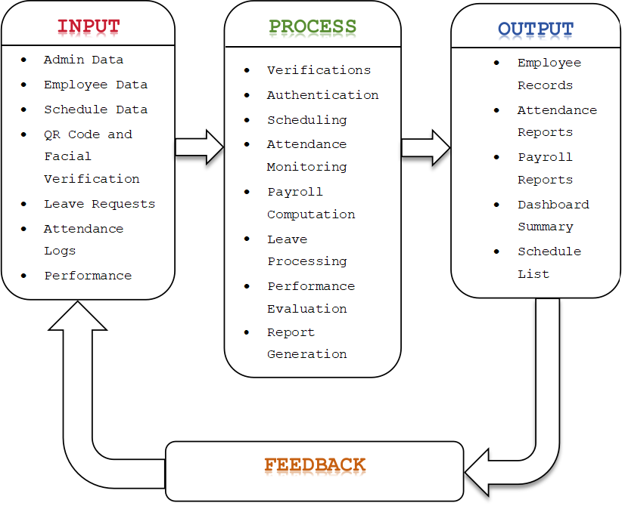

Figure 1. Research Paradigm

As shown in Figure 1. Research Paradigm follows the Input–Process–Output (IPO) model. In the input phase, the system collects important data such as admin information, employee details, schedules, QR code and facial verification data, leave requests, and attendance records. These inputs are needed to manage employee information and support the system’s operations.
In the process phase, the system performs different functions to handle the data. These include user authentication, attendance monitoring using biometrics such as QR code and facial verification, scheduling, payroll computation, leave management, and report generation. These processes help ensure that the system is accurate, secure, and efficient in managing employee attendance and payroll.
In the output phase, the system produces useful results such as employee records, attendance reports, payroll reports, dashboard summaries, and schedule lists. These outputs help the admin monitor employees and make better decisions. Feedback from users is also collected to improve the system and make it more effective over time.

Statement of the Problem
The Balong’s Kitchenette faces challenges in managing employee attendance, payroll, and records. The current manual process leads to inefficiencies such as inaccurate attendance recording, delayed payroll computation, and difficulty in monitoring employee performance. These issues may result in errors, attendance fraud, and time-consuming processes, which affect the overall efficiency of daily operations and employee management.
To address these challenges, the goal of this study is to develop a system that will improve attendance accuracy, payroll efficiency, and data security. The system will streamline employee management processes by providing automated attendance recording, real-time monitoring, and accurate payroll computation, as well as secure and organized data management. Specifically, the study seeks to answer the following questions:
- How may the system be designed and developed based on the stages of the Agile Model in terms of:
1.1. Planning;
1.2. Analysis;
1.3. Design;
1.4. Development;
1.5. Testing;
1.6. Deployment; and
1.7. Maintenance?
- How may the developed system be evaluated by IT Professionals in terms of quality characteristics:
- 2.1. Functional Suitability;
2.2. Performance Efficiency;
2.3. Compatibility;
2.4. Usability;
- 2.5. Maintainability
2.6. Reliability;
2.7. Security; and
2.8. Portability?
- How may the end-users assess the quality of the developed system in terms of:
3.1. Functional Suitability;
3.2. Performance Efficiency; and
3.3. Usability?

Scope and Delimitation
This project focuses on developing and implementing an Employee Management System for Balong’s Kitchenette. The system is designed to manage employee attendance, payroll, and records by providing a centralized web-based platform for recording, processing, and storing employee data. It aims to improve the accuracy, efficiency, and security of both attendance tracking and payroll management within the business.
The primary users of the system include the manager and staff, who will benefit from it. The scope of system features includes such as dynamic QR code scanning and facial verification for attendance, as well as automated payroll computation based on recorded working hours, including allowances and deductions. It also provides of using Kiosk module, real-time attendance monitoring, report generation, and role-based access to ensure proper control and transparency in managing employee records and payroll. It is designed to be simple and user-friendly to support daily operations efficiently.
The system also has some limitations. It is limited only for Balong’s Kitchenette business. It also does not have a mobile app version and can only be accessed through a web browser. . Then it does not support online functionality. Additionally, while the system automates payroll computation, it does not include payroll such as POS or bank transactions. Despite these limitations, the system is designed to improve attendance tracking, payroll accuracy, and overall employee management efficiently.

Significance of the Study
The significance of this study relies in addressing the challenges in managing employee attendance, payroll, and records at Balong’s Kitchenette. By developing an Integrated Employee Management System with Dynamic QR Code and Facial Verification for Attendance Recording and Automated Payroll, the researchers aim to improve the accuracy, efficiency, and security of employee management processes. The system also provides a more organized and reliable way of handling attendance and payroll, making operations faster and more effective for the organization.
Owner: This study is significant to the owner as it provides a clearer understanding of how the system improves business operations through efficient data management, secure record-keeping, and easy the process. The results of the study can guide the owner in making informed decisions regarding the implementation and enhancement of the system, helping reduce errors, prevent data loss, and improve overall service quality. The study supports the owner in identifying opportunities for system upgrades and long-term business growth through the adoption of reliable and innovative technology.
Manager: The system will help improve efficiency by automating attendance recording using QR code scanning and facial verification, reducing manual work and errors. It will allow the manager to easily monitor employee attendance and payroll in real time, helping in better decision-making and scheduling. The system will also generate accurate reports, making payroll management more organized, transparent, and easier to manage.
Staff: The system will benefit employees by ensuring that their attendance and payroll records are accurate and transparent. With QR code and facial verification, employees can easily confirm their time-in and time-out without disputes about working hours or salary. It will also allow them to view their own attendance and payroll records, promoting trust and fairness in the workplace.
Future Researchers: This study will serve as a useful reference for future researchers who want to study or develop similar systems. It provides ideas on how to combine QR code technology and facial recognition in managing attendance and payroll. The system can also be improved in the future by adding features such as offline access, support for multiple branches, or more advanced face recognition technology.

Definition of Terms

Administrative – refers to tasks, functions, or processes involved in managing and organizing an organization’s operations, such as record-keeping, coordination, decision-making, and implementation of policies.
Agile Methodology – A software development approach that emphasizes iterative progress, collaboration, and flexibility throughout the development process.
Attendance Fraud – Any dishonest act in recording attendance, such as “buddy punching,” where one employee logs attendance for another.
Attendance Monitoring – The process of recording and tracking employee presence, including time-in and time-out, within an organization.
Automated Payroll Computation – A computerized process of calculating employee salaries based on attendance, working hours, deductions, and allowances, ensuring accurate and efficient payroll processing.
Biometrics – refers to an automated method of identifying or verifying individuals using unique physical or behavioral characteristics such as facial recognition.
Buddy Punching – A fraudulent practice where an employee records attendance on behalf of another employee.
Contactless – refers to a method or system that allows interaction or data exchange without physical contact, typically using technologies such as QR codes, or wireless communication.
Digital Transformation – The integration of digital technologies into business processes to improve efficiency and performance.
Dynamic QR Code – A type of QR code that changes periodically and is time-sensitive, making it more secure for attendance tracking.
Employee Management System – A system used to manage employee information, attendance, payroll, and related records.
Facial Capture Verification – A biometric method that captures and verifies a person’s facial features to confirm identity.
Face Recognition Technology – A system that identifies or verifies a person by analyzing facial features from images or video.
Functional Suitability – The degree to which the system provides functions that meet user needs and requirements.
ISO/IEC 25010:2023 – An international standard used to evaluate software quality based on characteristics such as usability, reliability, and security.
Likert Scale – A rating scale used in surveys to measure respondents’ opinions or perceptions, typically ranging from strongly agree to strongly disagree.
Maintainability – The ease with which a system can be modified, updated, or improved over time.
Performance Efficiency – The ability of the system to perform tasks quickly and effectively with minimal resource usage.
Requirement Analysis – The process of identifying and defining the needs and expectations of users for system development.
SMEs (Small and Medium Enterprises) – refer to businesses with a limited number of employees and relatively low to moderate capital, which operate on a small or medium scale and contribute significantly to local and national economies.
QR Code (Quick Response Code) – A machine-readable code that stores data and can be scanned using a device for quick access to information.
Web-Based System – A system that is accessible through a web browser using an internet connection.
Weighted Mean – A statistical method used to calculate the average of data while considering the importance or weight of each value.
Workforce – refers to all employees or workers within an organization who are responsible for performing tasks and contributing to its daily operations, productivity, and overall goals.

CHAPTER II
METHODS AND PROCEDURE

Research Methodology

This study used a developmental research design following the Agile methodology to Development of an Integrated Employee Management System with Dynamic QR Code and Facial Verification for Attendance Recording and Automated Payroll at Balong’s Kitchenette. Data were collected through interviews with the manager and employees, as well as surveys using Likert scales based on ISO 25010:2023 standards to identify problems and system requirements. The Agile process allowed continuous improvement through stages such as requirement analysis, design, implementation, testing, deployment, and maintenance, with feedback gathered in each stage to ensure the system meets user needs. Weighted mean was used to analyze the data and evaluate the system in terms of functionality, performance, and usability, helping improve the system to be more accurate, efficient, and user-friendly.

Research Design
The research design serves as a structured framework that guides the selection and use of appropriate methods and strategies in developing the study. This study uses a developmental research design, which focuses on the creation and improvement of a functional system for managing employee attendance, payroll, and records. The approach involves continuous feedback from users to ensure that the system meets their needs and solves existing problems.
To organize the development process, the study applies the Software Development Life Cycle (SDLC) using the Agile Methodology. Agile is suitable for this study because it allows flexibility, continuous improvement, and close collaboration with users. The system is developed step by step, with regular feedback from the manager and employees to improve its features and performance.
Figure 2 shows the development of the system using the SDLC with Agile Methodology.
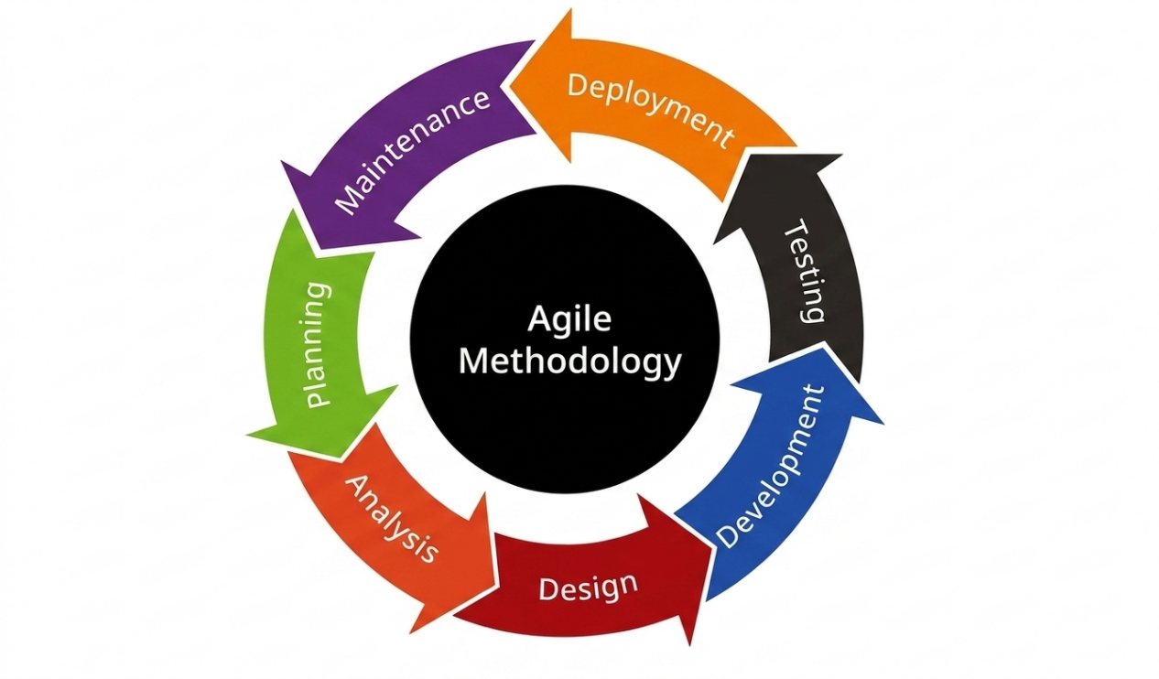

Figure 2: Agile Development Life Cycle
The Agile methodology in this study consists of the following phases:
Planning Stage: This phase involves identifying the problems and gathering system requirements through interviews and discussions with the manager and employees of Balong’s Kitchenette. It focuses on understanding the challenges in attendance monitoring, payroll computation, and employee record management to guide the system development.
Analysis Stage: In this stage, the researchers analyzed the current manual process used at Balong’s Kitchenette. Data gathered from observations and interviews revealed issues such as inaccurate attendance recording, delayed payroll processing, and difficulty in managing employee records. These findings served as the basis for determining the system requirements and features.
Design Stage: In this phase, the system design is created based on the gathered requirements. This includes designing the user interface, database structure, and system flow. The design focuses on making the system simple, user-friendly, organized, and efficient.
Development Stage: In this stage, the system was developed using appropriate programming languages and technologies. Features such as dynamic QR code attendance, facial verification, employee record management, and automated payroll computation were implemented based on the approved system design.
Testing Stage: The developed system was tested to identify and fix errors and system issues. Each feature was evaluated to ensure accuracy, reliability, and proper functionality, especially in attendance recording and payroll computation.
Deployment Stage: After successful testing, the system was deployed and implemented at Balong’s Kitchenette for actual use. The users began using the system for attendance monitoring, payroll processing, and employee record management.
Maintenance Stage: This phase involves monitoring the performance of the system after deployment and providing necessary updates, improvements, and fixes to ensure that the system continues to operate efficiently and meet the needs of the users.

Research Locale
The study was conducted at Balong’s Kitchenette, a local food service business located at Purok 1, Sto. Tomas, Peñaranda, Nueva Ecija. The establishment operates as a 24-hour service provider, offering continuous food services to customers while managing multiple employees across different shifts. For the purpose of this research, the focus was on this specific location, where the system will be implemented and tested.
This location was selected because it provides a clear representation of the daily operations and challenges encountered in managing a small food service business.
In Figure 3 shows the front view of Balong,s Kitchenette. While in Figure 4 provides an exact detailed map and location of the Balong,s Kichenette.



Figure 3. Front view of Balong’s Kitchenette
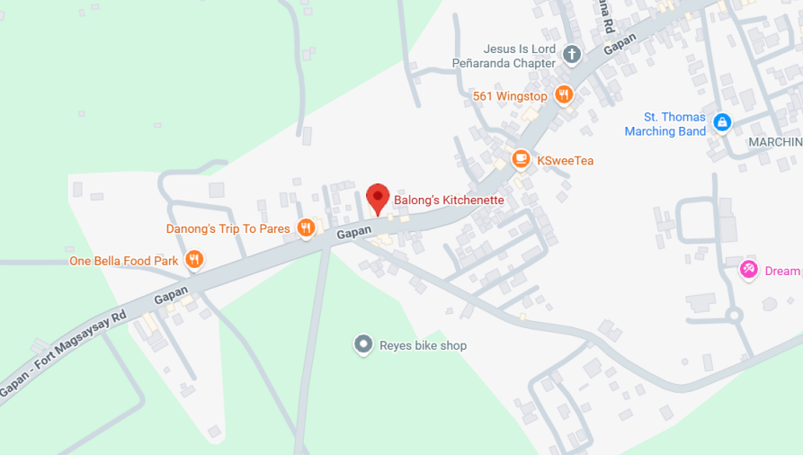

Figure 4. Location Map

Research Respondents
The researchers identified two (2) groups of respondents involved in this study: (1) IT Professionals, and (2) End Users. These respondents were selected to evaluate the developed system in terms of technical quality, usability, and functionality.
The first group consists of ten (10) IT Professionals. They are responsible for evaluating the technical aspects of the system, particularly its software quality, performance, and overall system design.
The second group consists of thirty-nine (39) End Users, composed of one (1) owner, one (1) manager, and thirty-seven (37) staff members. These respondents assess the usability and functionality of the system based on their actual experience in using it in an operational environment.
Table 1 below shows the distribution of the respondents for the evaluation according to its category.

Table 1. Distribution of Respondents
CLASSIFICATION | POPULATION | PERCENTAGE
IT Professionals | 10 | 27.78%
End Users
Owner | 1 | 1.85%
Manager | 1 | 1.85%
Staff | 37 | 68.52%
Total | 39 | 100%

Sample and Sampling Procedure
The researchers employed a purposive sampling technique in selecting the respondents for this study. Two groups of respondents were identified based on their relevance and direct involvement in evaluating the developing system
The study involved a total of thirty-nine (39) respondents, consisting of ten (10) IT professionals and thirty-nine (39) end-users. The IT professionals were selected based on the following criteria: (a) technical knowledge in information technology, (b) experience in software development, and (c) expertise in system evaluation. Their role was to assess the system's technical aspects, including functionality, reliability, and overall software quality.
The end-users were composed of one (1) owner, one (1) manager, and thirty-seven (37) staff members. They were selected based on the following criteria: (a) active participation in the daily operations of the organization, (b) direct involvement in employee management processes such as attendance, scheduling, and payroll, and (c) actual usage of the proposed system during its implementation and testing.
These respondents were chosen because they are the primary users and evaluators of the system. Their feedback is essential in determining the system's effectiveness in meeting organizational needs and improving business operations.

Research Instrument
The primary research instrument used in this study was a structured questionnaire distributed to the respondents. The questionnaire was designed to gather quantitative and qualitative feedback regarding the developed system.
For the end-users, the questionnaire covered the following criteria: functional suitability, performance efficiency, and usability, based on their actual experience in using the system for attendance monitoring and payroll management.
The questionnaire consisted of a 4-point Likert scale ranging from “Poor” to “Very Functional / Efficient / Usable,” allowing respondents to evaluate the system clearly.
In addition, interviews were conducted with the manager and selected employees to gather deeper information about the current problems in attendance and payroll processes. This helped support the evaluation and improvement of the system.

Data Gathering Procedure
The data gathering process was conducted in several steps. First, the researchers performed a needs assessment through interviews and informal discussions with the manager and employees of Balong’s Kitchenette. This helped identify existing problems in attendance and payroll management, such as inaccurate time recording, delayed payroll computation, difficulty in monitoring employee records and leave request management. These findings served as the basis for the development of the proposed system.
After identifying the problems, the researchers designed and developed the system based on the gathered information. At the same time, survey questionnaires were prepared in line with the objectives of the study. Permission was then secured from the management to conduct the study and distribute the questionnaires to the selected respondents.
The questionnaires were distributed to the respondents, and the purpose of the study was clearly explained to them before answering. The researchers also guided the respondents to ensure that the questions were properly understood.
The researchers explained the features and functions of the system to the respondents. A short discussion was conducted to help them understand how the system works, including attendance monitoring using QR code and facial verification, as well as automated payroll computation. This allowed the respondents to provide more accurate and meaningful feedback.
After collecting all the responses, the researchers organized and analyzed the data. The results were used to evaluate the system in terms of functionality, usability, and performance. The feedback also helped identify possible improvements to enhance the system.

Data Analysis
This study utilized the Likert scale to gather the opinions and feedback of employees regarding the proposed Development of an Integrated Employee Management System with Dynamic QR Code and Facial Verification for Attendance Recording and Automated Payroll at Balong’s Kitchenette. The respondents were asked to rate each statement based on their level of agreement, which allowed the researchers to determine the effectiveness, efficiency, and usability of the system. To analyze the gathered data, the researchers applied the weighted mean technique. This statistical method provided a clear interpretation of the responses by assigning numerical values to each scale and computing the average score for every indicator.

The researchers used the 4-point Likert scale shown below to interpret the responses of the employees.

Table 2: Range of Weighted Mean Likert Scale Table

Scale | Range | Description
4 | 3.25 – 4.00 | Very Functional / Efficient / Usable
3 | 2.50 – 3.24 | Functional / Efficient / Usable
2 | 1.75 – 2.49 | Needs Improvement
1 | 1.00 – 1.74 | Poor

The weighted mean was computed using the following formula:


Where:
Σ = summation
w = weight of each response
x = frequency of responses
N = total number of respondents

Percentage was also used to determine the proportion of responses for each indicator. The formula for percentage is:

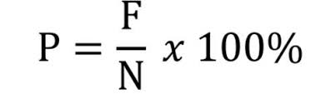

Where:
F = frequency of responses
N = total number of respondents
During the evaluation phase, IT Professionals assessed the system using the ISO 25010 standards. These include Functional Suitability, Performance Efficiency, Compatibility, Usability, Reliability, Security, Maintainability, and Portability. These criteria were used to make sure the system works properly, performs well, is easy to use, secure, and reliable. The evaluation results from both IT Professionals and employees were based on the Likert scale, as shown in the tables below.

Overall Evaluation
And here, at the end of the study, the researchers used weighted means, percentages, and ranking to analyze all responses from IT professionals and employees. This helped determine the overall performance of the system and identify areas for improvement.

Table 3. Range of Weighted Mean and Interpretation of Over-all Evaluation

Scale | Range | Description
4 | 3.25 – 4.00 | Very Functional / Efficient / Usable
3 | 2.50 – 3.24 | Functional / Efficient / Usable
2 | 1.75 – 2.49 | Needs Improvement
1 | 1.00 – 1.74 | Poor

Ethical Consideration
In conducting the study, the researchers followed proper ethical standards to protect the participants and the organization involved. Before starting the study, permission was first requested from the management of Balong’s Kitchenette. The purpose of the study, its process, and expected outcomes were clearly explained to make sure that the management understood and approved of the research.
The participants were also informed about the study and their role in it. Their participation was completely voluntary, which means they were free to decide whether to participate or not. They were also allowed to withdraw from the study at any time if they felt uncomfortable, without any pressure or negative consequences. This helped ensure that the rights and comfort of the participants were respected throughout the study.
The researchers made sure that all information gathered was kept confidential and used only for academic purposes. Personal information such as employee records, attendance, and payroll data was handled carefully and were not shared with unauthorized people. The identities of the participants were also kept private by presenting the collected data in a general manner.
The study also followed the Data Privacy Act of 2012, which protects personal information and ensures that sensitive data are properly handled. To support this, the proposed system includes security features such as user authentication, role-based access, and facial verification to help protect employee information from unauthorized access.
And the researchers practiced honesty and integrity throughout the study. All data were recorded and presented accurately without changing or manipulating the results. Proper credit was also given to the sources used in the research to avoid plagiarism. Most importantly, the researchers ensured that the study would not cause harm to the participants or the organization. Respect, responsibility, and confidentiality were always observed to maintain the trust and credibility of the study.

References
Abd El-Mawla, N., & Ismaiel, M. (2022). Smart attendance system using QR-code, finger print and face recognition. Nile Journal of Communication and Computer Science, 2(1), 1–10. https://www.researchgate.net/publication/373771357_Smart_Attendance_System_Using_QR-Code_Finger_Print_and_Face_Recognition

Agripa, D. J. B., & Astillero, S. F. (2022). Development of employee attendance and management system using quick response (QR) code in Sorsogon State University, Castilla Campus, Philippines. European Journal of Education Studies, 9(11). https://doi.org/10.46827/ejes.v9i11.4545

Nuralif, I., & Fachrie, M. (2023). Development of a QR code-based attendance system for factory employees. International Journal Software Engineering and Computer Science (IJSECS), 3(3), 281–286. https://doi.org/10.35870/ijsecs.v3i3.1774

Fuady, A. F., & Hidayat, A. T. (2025). Assessing the impact of face recognition and QR code-based attendance systems on payroll processing and business efficiency. Journal of Information System and Education Development, 3(4), 51–56. https://doi.org/10.62386/jised.v3i4.190

Tan, C. Y., & Widarman, B. (2025). Digital transformation in SME HR operations: A conceptual framework for payroll and leave process automation. International Journal of Academic Research in Business and Social Sciences, 15(8). https://doi.org/10.6007/IJARBSS/v15-i8/26274

Narangammana, B. P. K., & Shamila, L. M. A. (2025). QR code based attendance management system. International Journal of Research and Innovation in Social Science, 9(4), 5173–5220. https://dx.doi.org/10.47772/IJRISS.2025.90400372

Chandaka, S., & Thandra, A. R. (2024). Face recognition-based attendance system using deep learning. ResearchGate. https://www.researchgate.net/publication/384605314_Face_Recognition-Based_Attendance_System_using_Deep_Learning

Encarnacion, M. N. P., Tañedo, J. M. Y., Recasata, F. N. A., & Ng, G. (2023). An agile approach to a Human Resources Information System for Company B. Zenodo. https://doi.org/10.5281/zenodo.8069219

Benesa, A. B., Tubice, R. M. A., & Tubice, E. D. T. (2024). Enhancing attendance tracking efficiency and effectiveness through the implementation of a QR code-based system. International Journal of Research and Innovation in Social Science, 8(8), 2411–2421. https://dx.doi.org/10.47772/IJRISS.2024.8080202

Bomström, H., Kelanti, M., Annanperä, E., Liukkunen, K., Kilamo, T., Sievi-Korte, O., & Systä, K. (2023). Information needs and presentation in agile software development. Information and Software Technology, 162, Article 107265. https://doi.org/10.1016/j.infsof.2023.107265

Budianto, A. E., Othman, M. F. I., Ariff, N. A. M., & Rashid, I. M. A. (2025). An integrated framework for improving online counseling system quality: A case study using HOT-FIT, ISO/IEC 25010, and SPBE models. International Journal of Research and Innovation in Social Science. https://dx.doi.org/10.47772/IJRISS.2025.923MIC3ST25009

Chaturvedi, S., & Dwivedi, V. K. (2022). Study of implementing a payroll management system for improving workplace management effectiveness. International Journal of Innovative Research in Engineering, 3(5), 13–16. https://www.researchgate.net/publication/386211516_Study_of_Implementing_a_Payroll_Management_System_for_Improving_Workplace_Management_Effectiveness

Feriandy. (2025). Analysis of the role of Human Resource Information System (HRIS) in improving work efficiency and effectiveness in modern organizations. International Journal of Applied Business and Management, 4(5), https://doi.org/10.55927/ijabm.v4i5.619
Fuady, A. F., & Hidayat, A. T. (2025). Assessing the impact of face recognition and QR code-based attendance systems on payroll processing and business efficiency. Journal of Information System and Education Development, 3(4), 51–56. https://doi.org/10.62386/jised.v3i4.190

Hossain, M. I. (2023). Software development life cycle (SDLC) methodologies for information systems project management. International Journal for Multidisciplinary Research, 5(5). https://doi.org/10.36948/ijfmr.2023.v05i05.6223

Joshi, K. A., & Sengupta, S. (2025). Information systems in HR processes: Perspectives and processes. In Research handbook on information systems and technology (pp. 191–209). Edward Elgar Publishing. https://doi.org/10.4337/9781035324583.00018

Kuhrmann, M., Tell, P., Hebig, R., Klünder, J., Münch, J., Linssen, O., Pfahl, D., Felderer, M., Prause, C. R., MacDonell, S. G., Nakatumba-Nabende, J., Raffo, D., Beecham, S., Tüzün, E., López, G., Paez, N., Fontdevila, D., Licorish, S. A., Küpper, S., . . . Richardson, I. (2022). What makes agile software development agile? IEEE Transactions on Software Engineering, 48(9), 3523–3539. https://doi.org/10.1109/TSE.2021.3099532

Meenugu, S. (2025). The technical evolution of payroll systems: From manual processing to intelligent automation. Global Journal of Engineering and Technology Advances, 23(1), 201–208. https://doi.org/10.30574/gjeta.2025.23.1.0103

Neeyamo. (2023, September 13). Streamlining success: The benefits of an integrated HRIS and payroll system. https://www.neeyamo.com/blog/streamlining-success-benefits-integrated-hris-and-payroll-system

Ogundele, I. O., Akinade, A. O., Akinsola, A. A., & Ishola, P. E. (2023). Development of an employee attendance system using face recognition and QR-code technology. International Journal for Research in Applied Science & Engineering Technology, 11(3), 1530–1536. https://www.academia.edu/99430550/Development_of_an_Employee_Attendance_System_Using_Face_Recognition_and_QR_Code_Technology

Pacific Certifications. (2025, May 10). ISO/IEC 25010:2023 guide to software product quality standards. https://blog.pacificcert.com/iso-25010-software-product-quality-model/
Yulianto, T. (2025). Enhancing employee attendance systems through integrated monitoring and automation. International Journal of Educational Research Excellence (IJERE), 4(2), 829–835. https://doi.org/10.55299/ijere.v4i2.1572

CHAPTER III

RESULTS AND DISCUSSION
This chapter presents the findings of the study on the VeriScan: Development of an Integrated Employee Management System with Dynamic QR Code and Facial Verification for Attendance Recording and Automated Payroll at Balong's Kitchenette. It discusses the existing challenges encountered in the current employee management practices and explains the design and development of the proposed system using the Agile Development Life Cycle (Agile SDLC). Furthermore, this chapter presents the different phases of system development, including planning, analysis, design, development, testing, deployment, and maintenance. It also discusses the system architecture, database design, and functional components developed to address the identified problems. Finally, the developed system is evaluated using the ISO/IEC 25010 software quality model to determine its compliance with internationally recognized software quality standards in terms of functional suitability, performance efficiency, compatibility, usability, reliability, security, maintainability, and portability.

1. Problems Encountered in the Existing System
The preliminary investigation conducted by the researchers revealed that Balong's Kitchenette continues to rely on conventional and largely manual procedures in managing employee attendance, payroll computation, and employee records. Attendance is recorded manually, employee information is maintained through paper-based documentation, and payroll computations are performed using manually prepared attendance records. Although these procedures have been sufficient for the establishment's daily operations, they have become increasingly inefficient as administrative demands continue to grow.
Interviews and on-site observations identified several operational issues associated with the existing system. Manual attendance recording increases the likelihood of inaccurate time entries, incomplete attendance records, and attendance discrepancies, which consequently affect payroll accuracy. Since payroll computation depends entirely on manually encoded attendance data, the preparation of employee salaries requires considerable time and effort while remaining susceptible to computational errors involving regular working hours, overtime, undertime, allowances, and deductions.
The researchers likewise observed that employee records are maintained through physical documents, making data retrieval, updating, and verification both time-consuming and inefficient. As employee records accumulate over time, the risks of document misplacement, duplication, deterioration, and data inconsistency likewise increase. These limitations adversely affect record management and delay the preparation of administrative reports needed for managerial decision-making.
Another significant concern identified during the assessment is the absence of an integrated system capable of verifying employee identity during attendance recording and automatically processing payroll based on validated attendance information. Without automated monitoring and centralized record management, the establishment experiences delays in generating reports, monitoring employee attendance, and maintaining accurate personnel information. Consequently, these challenges increase administrative workload, reduce operational efficiency, and create opportunities for human error throughout the employee management process.
Considering these operational deficiencies, the researchers developed the proposed Integrated Employee Management System incorporating Dynamic QR Code technology, Facial Verification, Attendance Monitoring, Employee Record Management, Leave Management, and Automated Payroll Computation within a centralized web-based platform. The proposed system is designed to improve the accuracy of attendance recording, strengthen identity verification, automate payroll computation, enhance data security, and provide timely generation of operational reports, thereby improving the overall efficiency and reliability of employee management at Balong's Kitchenette.

2. Design and Development of the Proposed Employee Management System Based on the Agile Development Life Cycle
The development of the proposed VeriScan: Development of an Integrated Employee Management System with Dynamic QR Code and Facial Verification for Attendance Recording and Automated Payroll at Balong's Kitchenette followed the Agile Software Development Life Cycle (Agile SDLC). This development methodology provided a systematic yet flexible framework that enabled the researchers to develop the system through iterative and incremental phases while continuously incorporating stakeholder feedback throughout the project.
The Agile methodology emphasizes continuous collaboration, adaptability, and progressive improvement, allowing each development iteration to refine system functionality based on the operational requirements of Balong's Kitchenette. Through regular consultation with the business owner, manager, and employees, the researchers ensured that every module developed effectively addressed the actual challenges encountered in attendance monitoring, payroll administration, employee information management, and operational reporting.
The development process consisted of seven major phases: Planning, Analysis, Design, Development, Testing, Deployment, and Maintenance. Each phase contributed to the systematic realization of the proposed system by establishing clear objectives, validating user requirements, designing system architecture, implementing functional modules, verifying software quality, deploying the completed application, and ensuring its continuous improvement after implementation. This structured development approach ensured that the final system satisfied both the functional requirements of the establishment and the software quality characteristics prescribed by the ISO/IEC 25010 standard.

2.1 Initial Study
The Initial Study served as the foundation of the entire system development process. During this phase, the researchers conducted comprehensive interviews, direct observations, and consultations with the owner, manager, and employees of Balong's Kitchenette to obtain an in-depth understanding of the organization's existing employee management procedures and operational requirements.
Particular attention was given to the processes involved in employee registration, attendance monitoring, payroll computation, leave management, and report preparation. The researchers carefully analyzed the existing workflow to identify operational inefficiencies, procedural limitations, and opportunities where information technology could significantly improve organizational performance.
Based on the information gathered, the researchers identified both the functional and non-functional requirements of the proposed system. The identified functional requirements included secure user authentication, Dynamic QR Code generation, Facial Verification for attendance validation, employee information management, attendance monitoring, automated payroll computation, leave management, report generation, and role-based access control. Likewise, the necessary hardware specifications, software platforms, development frameworks, database technologies, and supporting tools required for system implementation were determined during this phase.
The Initial Study also established the overall project scope, development objectives, implementation schedule, and resource requirements necessary for the successful completion of the project. More importantly, continuous communication with the stakeholders during this phase ensured that the proposed Employee Management System was designed to address the actual operational needs of Balong's Kitchenette while maintaining software quality, usability, security, reliability, and maintainability throughout the development process.

Gantt Chart
The project timeline for the development of the proposed Employee Management System is presented through the Gantt Chart. This project management tool illustrates the sequence and duration of each development activity performed throughout the implementation of the Agile Software Development Life Cycle.
The Gantt Chart outlines the scheduled activities beginning with project planning and requirements gathering, followed by system analysis, interface and database design, software development, module integration, system testing, deployment, documentation, system evaluation, and project completion. Each activity was assigned a corresponding timeframe to ensure the orderly execution of development tasks and the timely accomplishment of project objectives.
Throughout the development process, the Gantt Chart served as an effective monitoring and management instrument that enabled the researchers to track project progress, monitor milestone completion, allocate development resources efficiently, identify task dependencies, and minimize possible project delays. It likewise facilitated continuous coordination among the researchers and project stakeholders, allowing necessary revisions and improvements to be incorporated whenever additional system requirements or user feedback were identified.
The structured implementation schedule provided by the Gantt Chart contributed significantly to the successful completion of the project by ensuring that every phase of system development was executed systematically, efficiently, and within the established project timeline.

