Design and Development of Barangay Information Management System for Barangay San Josef, Peñaranda, Nueva Ecija



A CAPSTONE AND RESEARCH PROJECT
OF
BSIT WITH SPECIALIZATION IN
WEB SYSTEMS TECHNOLOGY

BY

REYES, JENNYLYN C.
GERONIMO, JERWIN ANGELO E.
LEMENCE, ALTHEA G.
DELESTE, CLAIRE G.

November 2025
CHAPTER III
RESULT AND DISCUSSION
This chapter presents the findings gathered from surveys, interviews, and system testing conducted in Barangay San Josef, Peñaranda, Nueva Ecija. The results are discussed based on the research questions identified in the statement of the problem:
1. Problems Encountered in the Existing System
The study revealed that Barangay San Josef, Peñaranda, Nueva Ecija still relies on traditional and manual methods for managing barangay records, resident information, and transactions. Most documents, such as certificates, permits, and resident profiles, are recorded and stored on paper, making it time-consuming to retrieve and update data. This manual process often results in errors, misplaced files, and delays in service delivery.
Additionally, announcements and important barangay information are typically communicated verbally or through printed notices, which may not reach all residents, especially those living in remote areas. These challenges highlight the need for a computerized system that ensures data accuracy, accessibility, efficiency, and effective communication between barangay secretary and residents.
Table 1. Assessment of the admin/secretary on using the Existing System
Item Statements | Weighted Mean | Verbal Interpretation
- The existing system for managing barangay records is easy to use. | 3 | Agree
- The existing system is accessible to barangay officials and staff at all times. | 3 | Agree
- The data and records in the existing system are safely stored and protected from loss or damage. | 3 | Agree
- The current system efficiently issues certificates and documents. | 2.8 | Slightly Agree
- The system provides accurate and updated resident information. | 2.9 | Slightly Agree
- The existing system allows easy retrieval of barangay records when needed. | 3.1 | Agree
- The existing system ensures secure access to sensitive information. | 3 | Agree
means that the existing system works well but requires some improvements.

2. The Design and Development of the Barangay Information Management System (BIMS) Based on the Agile Development Life Cycle
The design and development of the Barangay Information Management System (BIMS) followed the phases of the Agile Development Life Cycle, ensuring a structured yet adaptive approach to system creation. Each phase was carefully planned and executed with continuous collaboration between developers and barangay stakeholders. This approach allowed flexibility in addressing user feedback and making necessary improvements throughout the process.
The Agile model ensured that every iteration of the system addressed the identified needs of Barangay San Josef, such as efficient record management, faster certificate processing, and enhanced data security. Detailed documentation was maintained at each stage to monitor progress, validate outcomes, and ensure alignment with the project’s objectives, as explained in the following phases:
2.1 Initial Study
This phase served as the foundation of the project, focusing on thorough planning and preparation. During this stage, the researchers explored how the Barangay Information Management System (BIMS) could be effectively designed and implemented to improve the efficiency of barangay operations and record management. Emphasis was placed on identifying key tasks, establishing timelines, and ensuring that all activities aligned with the project’s overall objectives.
To guarantee that the system would integrate seamlessly with the existing workflows of barangay officials and staff, the researchers conducted a series of interviews, surveys, and observations within Barangay San Josef, Peñaranda, Nueva Ecija. These activities provided valuable insights into the daily administrative processes and the specific challenges encountered, such as delays in record retrieval, manual certificate issuance, and data management inefficiencies. Understanding these issues was crucial in shaping a system tailored to the barangay’s actual needs.
A key deliverable during this phase was the creation of a Software Development Life Cycle (SDLC) Gantt Chart, which served as a roadmap for tracking project progress. This chart allowed the researchers to visualize timelines, organize development tasks, and ensure that each phase of the system’s development was executed on schedule and according to plan.
Gantt Chart
The project timeline and schedule of activities are illustrated in the Gantt Chart (Figure 3). This tool played a vital role in organizing and monitoring each phase of the system’s development. By providing a visual representation of the project timeline, the Gantt chart enabled the researchers to track progress, identify key milestones, and ensure that all tasks were completed within the planned timeframe.
The chart served as a roadmap that guided the development team in determining the start and end points of each project phase. It also supported the efficient allocation of resources and ensured that all critical requirements were addressed throughout the development process.
By breaking the development into clear, manageable tasks with defined schedules, the Gantt chart helped maintain the project’s focus and ensured alignment with the overall objectives of the Barangay Information Management System (BIMS).
This structured and organized approach provided clarity and direction, allowing the researchers to effectively manage the complexities of the system’s design and implementation while ensuring the timely delivery of a functional and efficient system that meets the operational needs of Barangay San Josef, Peñaranda, Nueva Ecija.
The careful planning and groundwork established during this initial stage provided a solid foundation for the project. It fostered effective collaboration among stakeholders and set the stage for developing a system that directly addresses the real-world operational challenges of Barangay San Josef.
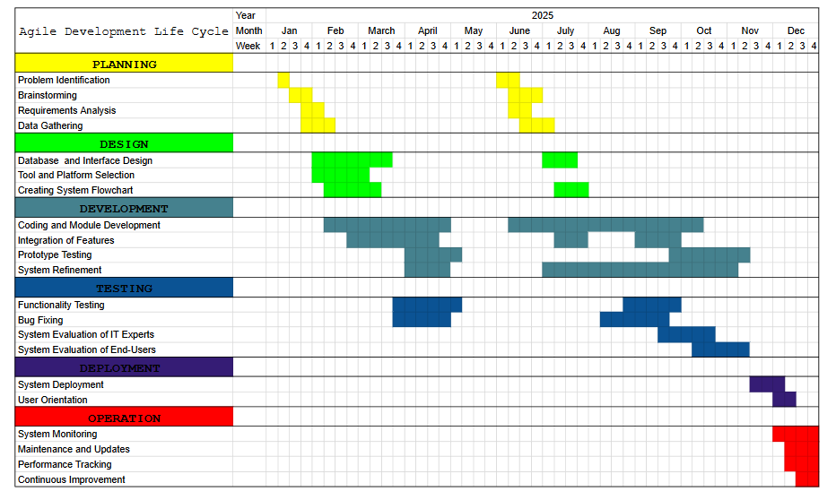

Figure 5. Gantt Chart
2.2 Design Stage
After the initial study, the team proceeded to the Design Stage, where the focus was on creating detailed diagrams and blueprints to guide the development of the Barangay Information Management System (BIMS). This stage was crucial in defining the system’s key functionalities, designing user interfaces, and structuring the database to ensure efficiency and reliability.
Various design tools and diagrams were utilized to visualize the system’s processes and data relationships. The main diagrams developed during this phase included the Use Case Diagram, Data Flow Diagram (DFD), Data Dictionary, and Entity-Relationship Diagram (ERD). Together, these diagrams provided a comprehensive roadmap for the development process—illustrating how users interact with the system, how data flows between modules, and how information is stored and managed within the database.
The careful design of these components ensured that the system would be both user-friendly and functionally aligned with the needs of Barangay San Josef, supporting efficient record management, certificate issuance, and information accessibility for barangay officials and residents.

Use Case Diagram
To provide a clear and concise representation of the Barangay Information Management System (BIMS), the researchers developed a use-case diagram after analyzing the system’s core components and user interactions. This diagram served as a visual guide that illustrates how the system functions and how it interacts with its users, ensuring that all key features are properly defined and implemented.
The use-case diagram identifies two primary actors: the Barangay Secretary and the Resident. The Barangay Secretary serves as the main system administrator responsible for managing resident records, updating household information, generating barangay certificates, and sending email notifications regarding announcements or updates. The secretary can also generate reports and manage user accounts to ensure data accuracy and security.
The Resident, on the other hand, interacts with the system to request barangay certificates, update basic personal information, and receive notifications or announcements sent by the barangay. This role ensures that residents have easier access to barangay services without the need for manual paper-based transactions.
The use-case diagram visualizes essential processes such as managing resident records, certificate generation, sending email notifications, report generation, and resident service requests. Through this visual representation, the researchers ensured that all system functions were aligned with the actual needs of Barangay San Josef.

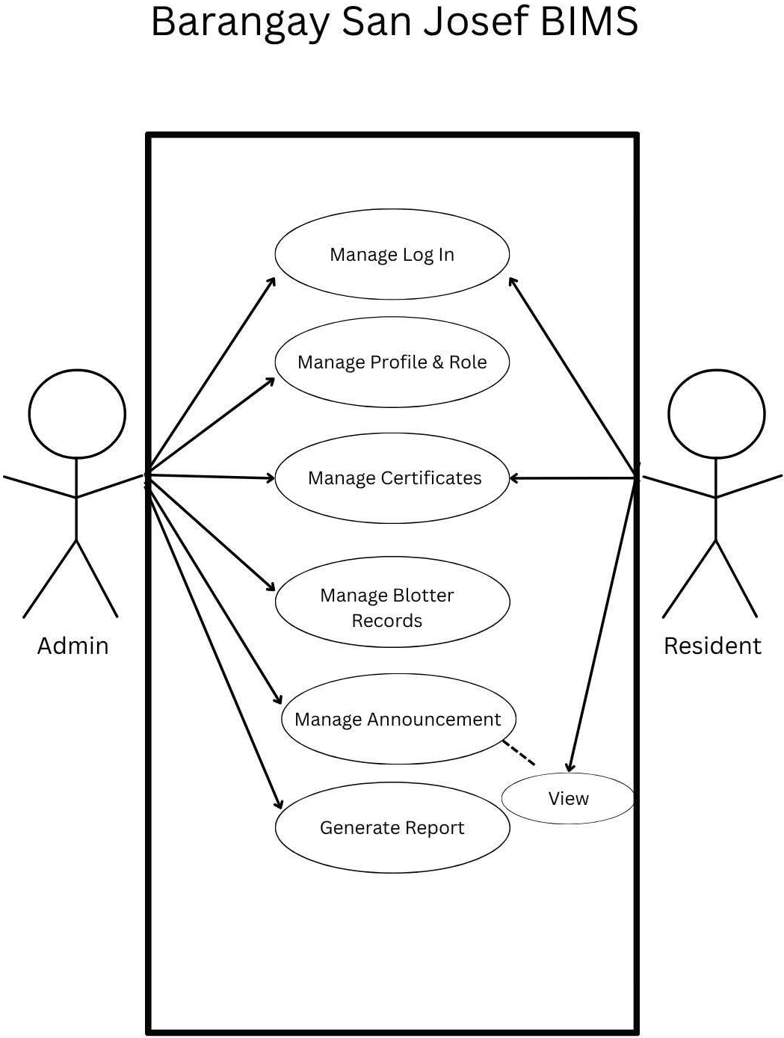
Figure 6: Use Case Diagram

Data Flow Diagram
According to Visual Paradigm (2023), Data Flow Diagrams (DFDs) are a powerful and long-established tool for visually representing how information flows within a system. They provide a clear and structured overview of the movement of data between processes, storage components, and outputs such as reports.
In the development of the Barangay Information Management System (BIMS), a DFD was created to illustrate the flow of information within the barangay’s digital environment. It mapped out how data—such as resident information, household records, certificate requests, and notifications—moved through various components of the system. The diagram highlighted key processes, including data input and management by the Barangay Secretary, secure storage of records in the system’s database, and the generation of reports and email notifications for residents.
This visualization was crucial in ensuring that all aspects of the system were interconnected efficiently. It served as a blueprint for developers, confirming that there were no data flow bottlenecks or inconsistencies within the system’s design. By breaking down complex interactions into a comprehensible format, the DFD bridged the gap between technical processes and user requirements. It ensured that the system’s design met its intended goals—enhancing data accessibility, accuracy, and efficiency in barangay operations. The context diagram of the Barangay Information Management System is displayed in Figure 4 below.
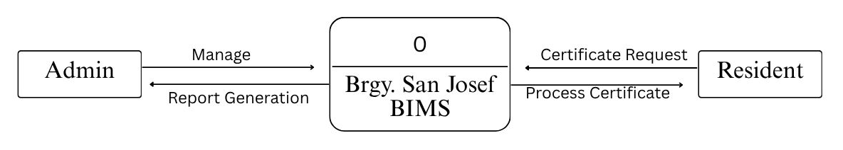
Figure 7: Context Diagram
The context diagram provides a clear, high-level overview of the Barangay Information Management System (BIMS), emphasizing its two primary user roles: Barangay Secretary and Resident. It illustrates how these key users interact with the system and how information flows between them and its core processes. The diagram depicts an organized exchange of data, highlighting essential tasks such as record management, certificate requests, report generation, and email notifications. This interaction reflects the system’s main objective of delivering a more efficient, secure, and well-organized approach to barangay information management and service delivery.

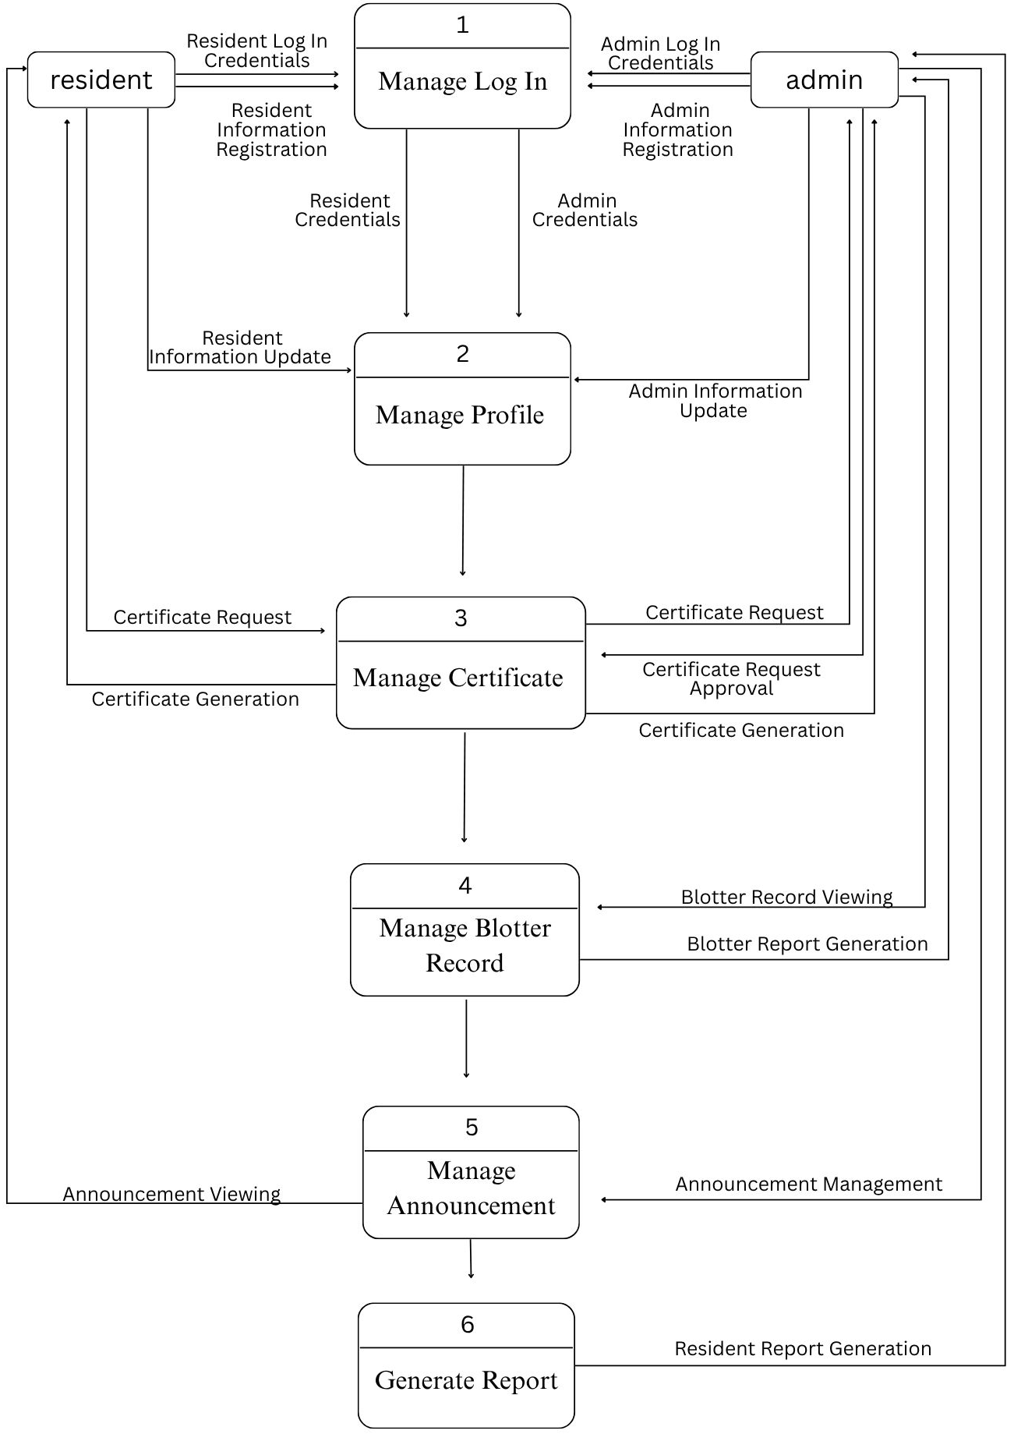
Figure 8: DFD Level 1
The Flow Diagram (DFD) provides a clear view of how the Barangay Information Management System (BIMS) operates, focusing on its essential functions and data movement. The Barangay Secretary plays a key role in managing day-to-day operations, such as updating resident information, processing certificate requests, and generating reports. The system ensures that only authorized users, like the secretary, can access administrative features through proper authentication and access control. On the other hand, Residents interact with the system to request certificates and receive email notifications or announcements from the barangay. This structured flow of information promotes accuracy, efficiency, and transparency in barangay services and information management.
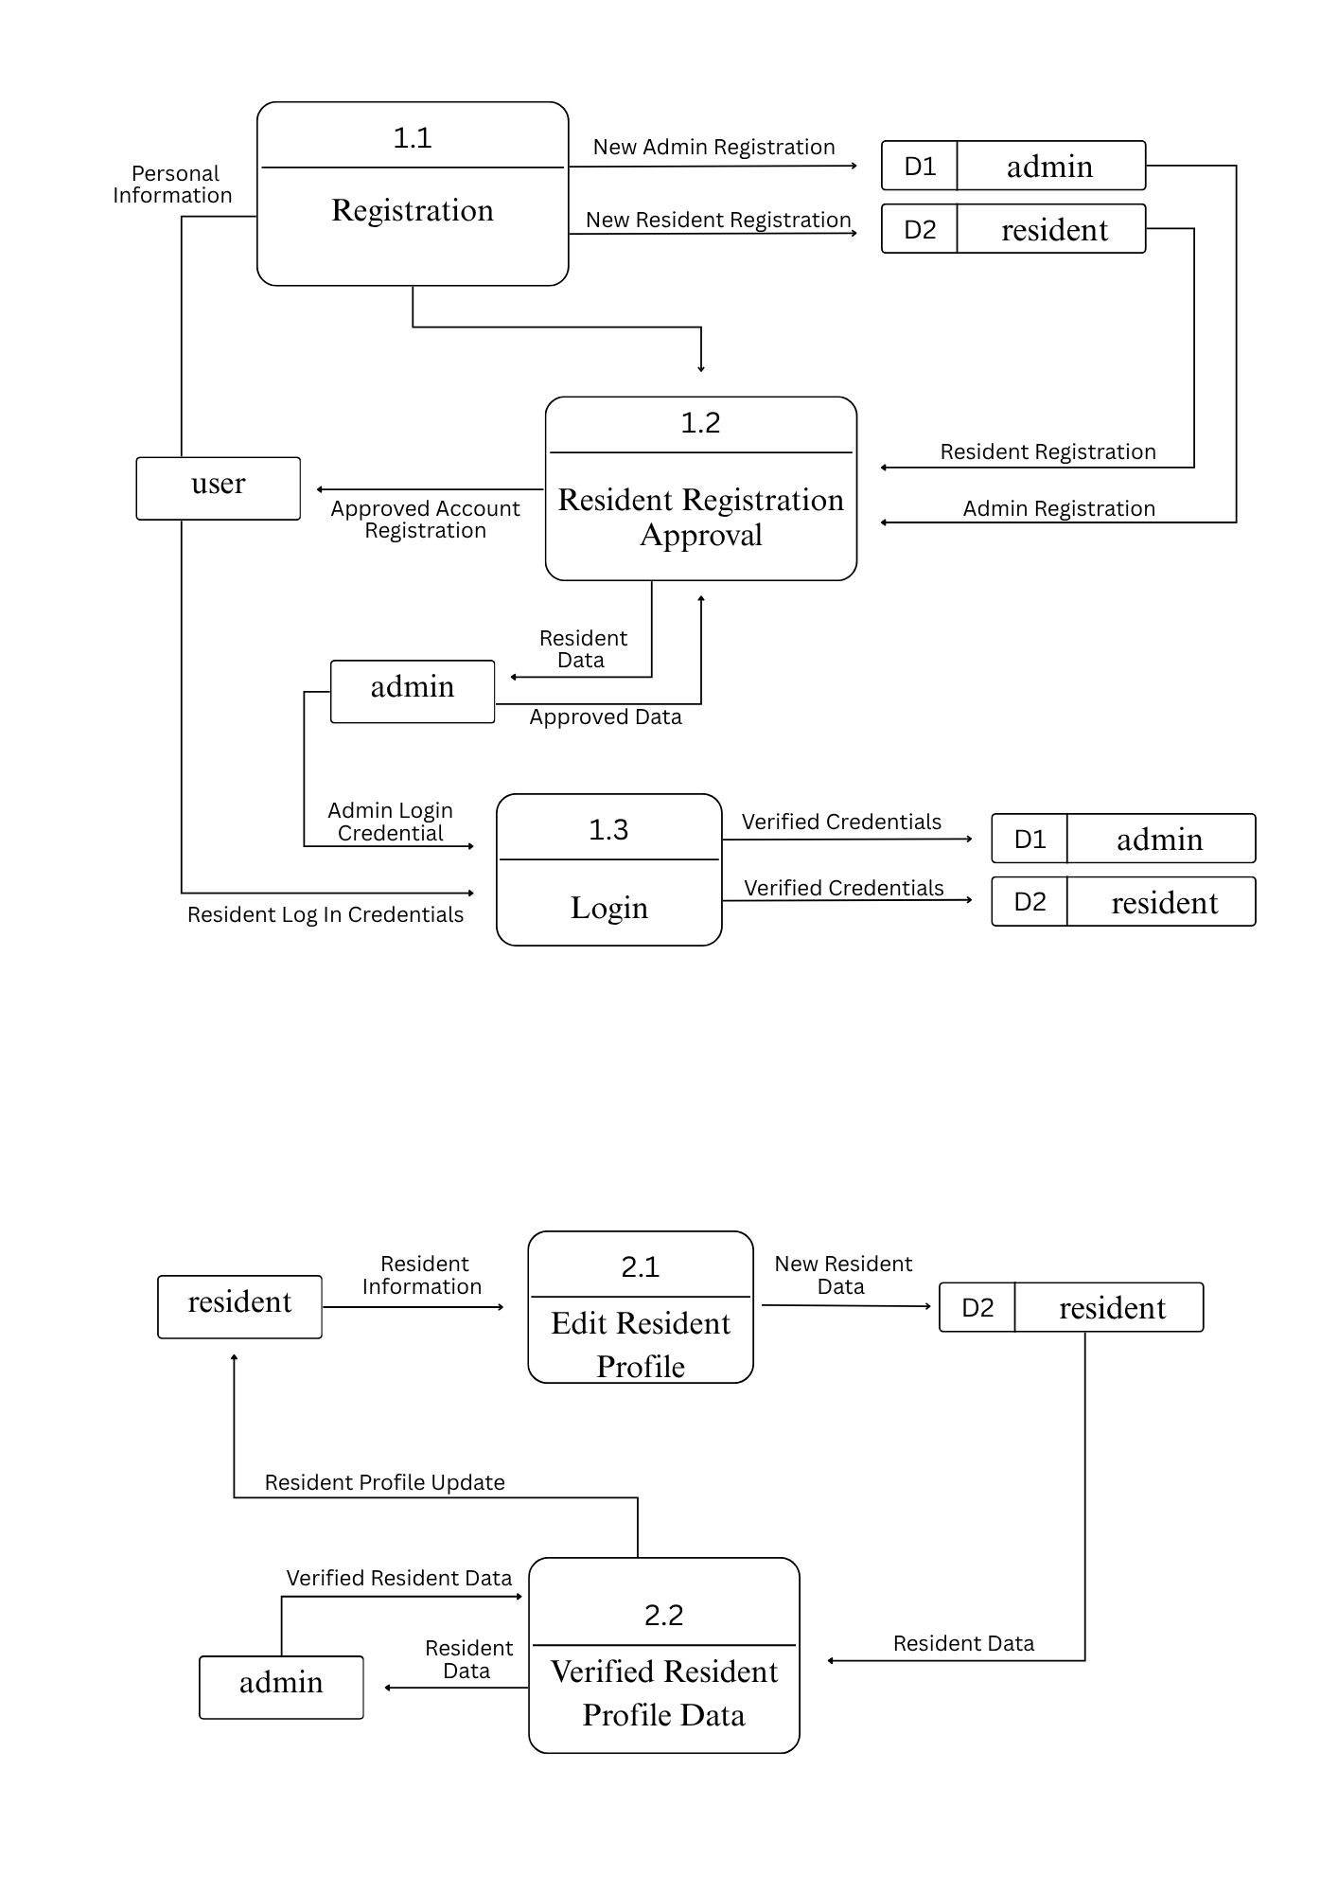

Figure 9: Manage Log In
In the Level 2 diagram, the Manage Log In process ensures that all users must enter valid credentials and undergo identity verification before gaining access to their designated system features.

Figure 10: Manage Profile
In the Level 2 diagram, the Manage Profile process enables the Barangay Secretary to oversee and maintain user accounts within the system. This includes creating, updating, and managing user profiles while assigning appropriate roles and access levels. Through this process, the system ensures that each user—such as the secretary or resident—has access only to the features relevant to their responsibilities. This role-based management strengthens system security, promotes accountability, and ensures organized user interactions within the Barangay Information Management System.
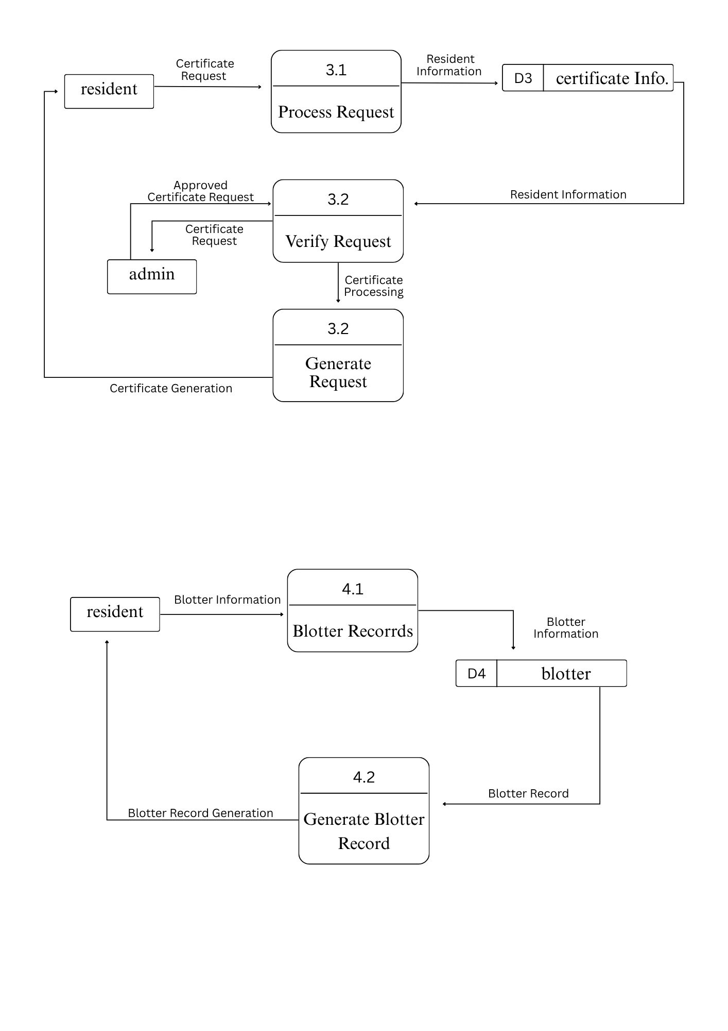

Figure 11: Manage Certificate
In the Level 2 Diagram, the Manage Certificate process focuses on the creation and issuance of official barangay documents. It allows authorized personnel, particularly the Barangay Secretary, to generate certificates such as Barangay Clearance, Certificate of Residency, and Certificate of Indigency directly through the system. This process ensures that all certificates are accurately prepared, systematically recorded, and securely stored in the database for future reference. By automating the preparation and record-keeping of certificates, the system minimizes errors, reduces manual paperwork, and enhances the overall efficiency of barangay document management.

Figure 12: Manage Blotter Report
In the Level 2 Diagram, the Manage Blotter Report process handles the recording, monitoring, and management of incident reports within the barangay. It allows authorized personnel to document details of complaints, disputes, and other incidents filed by residents. Through the system, the Barangay Secretary or designated staff can record essential information such as the date, time, parties involved, and a summary of the incident. All blotter records are securely stored in the database, allowing for easy retrieval and tracking of case progress. This process ensures accurate documentation, enhances transparency, and promotes efficient handling of barangay incident reports.
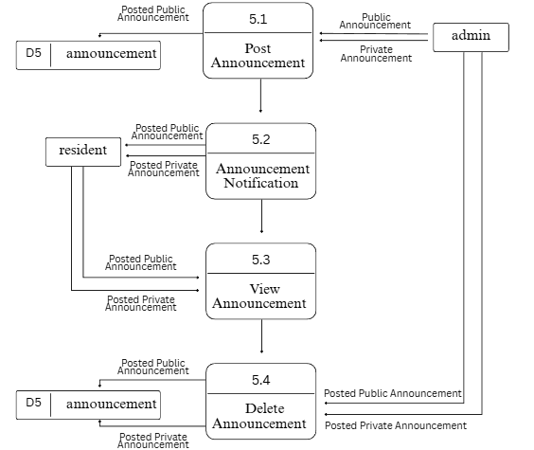

Figure 13: Manage Announcement
In the Level 2 Diagram, the Manage Announcement process handles the creation, updating, and dissemination of official barangay announcements. It allows authorized personnel to post important information such as upcoming events, public advisories, and community updates. Through the system, the Barangay Secretary or designated staff can compose announcements, set publication dates, and manage visibility for residents. All announcements are securely stored in the database for future reference and record tracking. This process ensures timely communication, promotes transparency, and keeps residents well-informed about barangay activities and important notices.
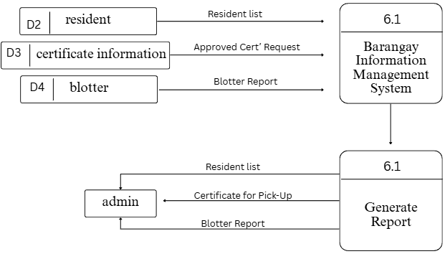
Figure 14: Generate Report
In the Level 2 Diagram, the Generate Report process handles the creation and compilation of various barangay reports based on stored data within the system. It allows authorized personnel to generate detailed summaries such as resident records, certificate issuance, blotter reports, and other activity logs. Through the system, the Barangay Secretary or designated staff can select specific report types, apply filters (such as date range or category), and automatically produce organized reports in printable or downloadable formats. This process ensures accurate record-keeping, supports data-driven decision-making, and promotes efficient documentation and transparency in barangay operations.

Database Normalization
Database normalization is a process in relational database design that structures data into organized tables to minimize redundancy and maintain data integrity. This process ensures that the database operates efficiently, allowing for accurate, consistent, and easily manageable information updates. According to Database Star (2022), normalization simplifies database maintenance by dividing data into related tables and establishing clear relationships between them.
In this study, database normalization was applied to the Barangay Information Management System (BIMS) to ensure efficient data storage and retrieval of resident information, certificates, and records. The normalization process also helped prevent duplication of data entries and ensured consistency across different modules of the system.
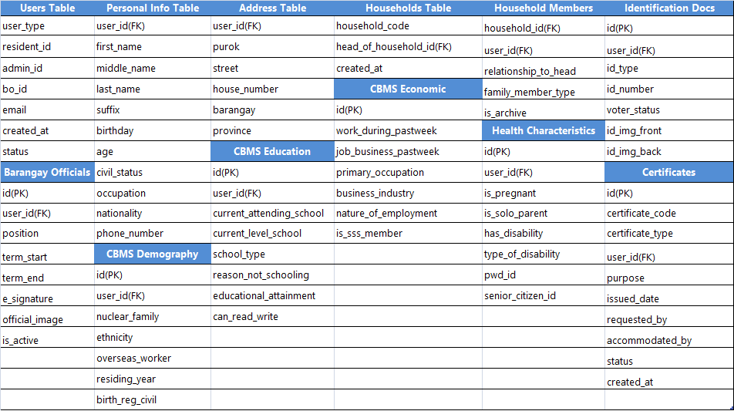
The figure below illustrates the Database Normalization Process used in the development of the BIMS, showing the progression from unorganized data structures to a fully normalized database design that supports accuracy, reliability, and efficient system performance.
Figure 15: First Normal Form
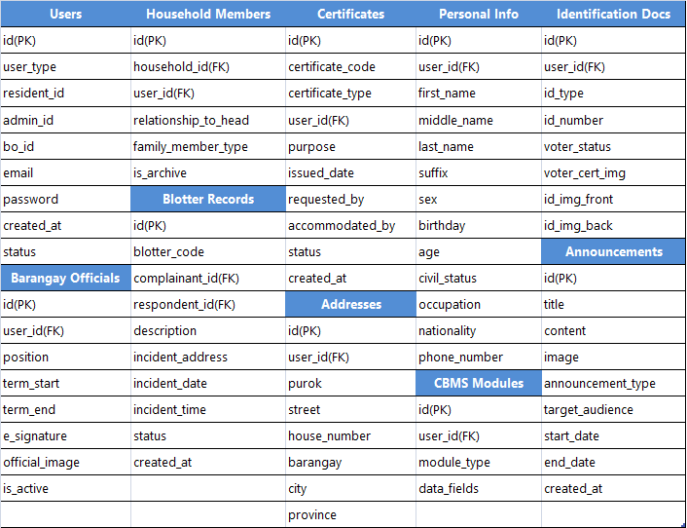
Figure 16: Second Normal Form (2NF)

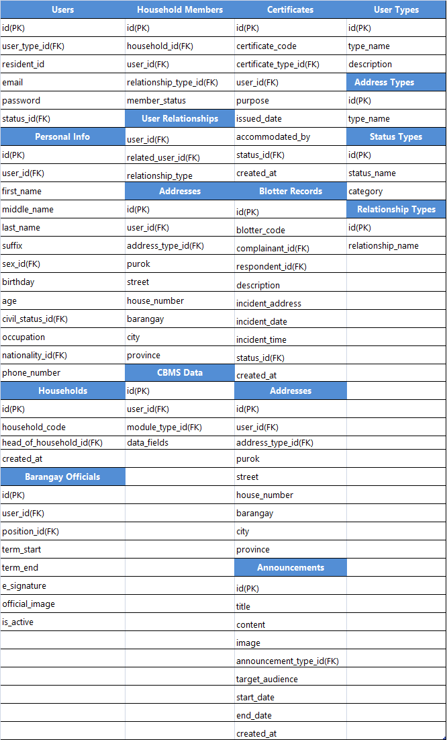
Figure 17: Third Normal Form (3NF)
Data Dictionary
A Data Dictionary is an essential tool in database management and information system design. It documents and defines the various components of data used within the system, providing detailed information about each data element, such as the field name, data type, size, and description of its purpose. This ensures that all data stored in the system is clearly defined, consistently used, and easily maintained.
For the Barangay Information Management System (BIMS), the data dictionary plays a vital role in organizing and defining all data fields related to barangay operations. It provides a clear structure for managing resident records, certificate details, announcements, and other barangay information. Each entry in the dictionary includes essential details such as the field name (e.g., resident_name), data type (e.g., text, integer, or date), and description (e.g., “stores the full name of a registered resident”).
The data dictionary for BIMS is presented in the tables below, offering a comprehensive overview of all the data elements utilized in the system. This documentation helps the development team maintain accuracy and uniformity throughout the database while supporting future updates or modifications. It also ensures that users and developers can easily interpret and interact with the stored data efficiently and reliably.

Table 2: admin_user
Fields Name | Data Type | Description
ID | Int (255) | A unique identifier for each household resident record. Acts as the primary key for the table.
residentID | varchar(255) | The unique identification number assigned to the resident.
household_code | varchar(255) | A unique code identifying the household the resident belongs to.
fName | varchar(255) | The first name of the resident.
mName | varchar(255 | The middle name of the resident.
lName | varchar(255) | The last name of the resident.
suffix | varchar(255) | The name suffix of the resident (e.g., Jr., Sr., III).
sex | varchar(255) | The gender of the resident.
age | int (11) | The current age of the resident.
birthday | date | The birth date of the resident.
civil_status | varchar(255) | The marital status of the resident (e.g., Single, Married).
occupation | varchar(255) | The job or profession of the resident.
nationality | varchar(255) | The nationality of the resident.
phonenumber | varchar(255) | The contact phone number of the resident.
purok | varchar(255) | The purok or zone where the administrative user resides.
street | varchar(255) | The street name part of the administrative user's address.
housenumber | varchar(255) | The house number part of the administrative user's address.
barangay | varchar(255) | The barangay where the administrative user resides.
city | varchar(255) | The city or municipality where the administrative user resides.
province | varchar(255) | The province where the administrative user resides.
ad_email | varchar(255) | The email address of the administrative user, used for account access.
ad_password | varchar(255) | The password for the administrative user's account, stored securely.
voter_status | varchar(255) | The voter registration status of the administrative user.
voter_cert_img | varchar(255) | The file path to the image of the voter's certificate.
ID_type | varchar(255) | The type of government-issued identification provided.
ID_number | varchar(255) | The identification number from the provided ID.
ID_img_front | varchar(255) | The file path to the image of the front side of the ID.
ID_img_back | varchar(255) | The file path to the image of the back side of the ID.
ID_with_selfie | varchar(255) | The file path to the image of the ID held with a selfie for verification.
brgy_ID_front | varchar(255) | The file path to the image of the front side of the barangay ID.
brgy_ID_back | varchar(255 | The file path to the image of the back side of the barangay ID.
created_at | datetime | The timestamp when the administrative user record was created.
user_type | varchar(255) | The role or type of the administrative user (e.g., Super Admin, Staff).
reg_status | varchar(255) | The registration status of the administrative user (e.g., Approved, Pending).
Table 3: resident_household
Fields Name | Data Type | Description
ID | int (255) | A unique identifier for each household resident record. Acts as the primary key for the table.
residentID | varchar(255) | The unique identification number assigned to the resident.
household_code | varchar(255) | A unique code identifying the household the resident belongs to.
fName | varchar(255) | The first name of the resident.
mName | varchar(255) | The middle name of the resident.
lName | varchar(255) | The last name of the resident.
Suffix | varchar(255) | The name suffix of the resident (e.g., Jr., Sr., III).
sex | varchar(255) | The gender of the resident.
age | int (11) | The current age of the resident.
birthday | date | The birth date of the resident.
civil_status | varchar(255) | The marital status of the resident (e.g., Single, Married).
occupation | varchar(255) | The job or profession of the resident.
nationality | varchar(255) | The nationality of the resident.
phonenumber | varchar(255) | The contact phone number of the resident.
email | varchar(255) | The email address of the resident.
voter_status | varchar(255) | The voter registration status of the resident.
voter_cert_img | varchar(255) | The file path to the image of the voter's certificate.
ID_type | varchar(255) | The type of government-issued identification provided.
ID_number | varchar(255) | The identification number from the provided ID.
fam_member | varchar(255) | The designation of the resident within the family (e.g., Head, Spouse, Child).
ID_img_front | varchar(255) | The file path to the image of the front side of the ID.
ID_img_back | varchar(255) | The file path to the image of the back side of the ID.
ID_with_selfie | varchar(255) | The file path to the image of the ID held with a selfie for verification.
purok | varchar(255) | The purok or zone where the resident resides.
street | varchar(255) | The street name part of the resident's address.
housenumber | varchar(255) | The house number part of the resident's address.
barangay | varchar(255) | The barangay where the resident resides.
city | varchar(255) | The city or municipality where the resident resides.
province | varchar(255) | The province where the resident resides.
created_at | datetime | The timestamp when the household resident record was created.
is_archive | varchar(255) | The archive status of the record, indicating if it is active or archived.

Table 4: resident
Fields Name | Data Type | Description
ID | int (255) | A unique identifier for each resident record. Acts as the primary key for the table.
residentID | varchar(255) | The unique identification number assigned to the resident.
fName | varchar(255) | The first name of the resident.
mName | varchar(255) | The middle name of the resident.
lName | varchar(255) | The last name of the resident.
Suffix | varchar(255) | The name suffix of the resident (e.g., Jr., Sr., III).
sex | varchar(255) | The gender of the resident.
age | int (11) | The current age of the resident.
birthday | date | The birth date of the resident.
civil_status | varchar(255) | The marital status of the resident (e.g., Single, Married).
occupation | varchar(255) | The job or profession of the resident.
phonenumber | varchar(255) | The contact phone number of the resident.
nationality | varchar(255) | The nationality of the resident
purok | varchar(255) | The purok or zone where the resident resides.
street | varchar(255) | The street name part of the resident's address.
housenumber | varchar(255) | The house number part of the resident's address.
barangay | varchar(255) | The barangay where the resident resides.
city | varchar(255) | The city or municipality where the resident resides.
province | varchar(255) | The province where the resident resides.
re_email | varchar(255) | The email address of the resident, used for account access.
re_password | varchar(255) | The password for the resident's account, stored securely.
voter_status | varchar(255) | The voter registration status of the resident.
voter_cert_img | varchar(255) | The file path to the image of the voter's certificate
ID_type | varchar(255) | The type of government-issued identification provided.
ID_number | varchar(255) | The identification number from the provided ID.
ID_img_front | varchar(255) | The file path to the image of the front side of the ID.
ID_img_back | varchar(255) | The file path to the image of the back side of the ID.
ID_with_selfie | varchar(255) | The file path to the image of the ID held with a selfie for verification.
user_type | varchar(255) | The role or type of the user within the system.
household | int (255) | A reference to the household the resident belongs to.
fam_member | varchar(255) | The designation of the resident within the family (e.g., Head, Spouse, Child).
created_at | datetime | The timestamp when the resident record was created.
reg_status | varchar(255) | The registration status of the resident (e.g., Approved, Pending).

Table 5: add_account
Fields Name | Data Type | Description
ID | int (11) | A unique identifier for each additional account record. Acts as the primary key for the table.
add_accountID | varchar(255) | The unique identification number assigned to the additional account.
residentID | varchar(255) | The resident identification number that this additional account is linked to.
add_email | varchar(255) | The email address associated with the additional account.
add_password | varchar(255) | The password for the additional account, stored securely.
created_on | datetime | The timestamp when the additional account was created.
account_status | varchar(255) | The current status of the additional account (e.g., Active, Inactive).

Table 6: announcement
Fields Name | Data Type | Description
ID | int (11) | A unique identifier for each announcement record. Acts as the primary key for the table.
title | varchar(255) | The title or headline of the announcement.
about | varchar(255) | A detailed description or body of the announcement.
Announcement_img | varchar(255) | The file path to an imagfe associated with the announcement.
time_in | time | The start time for when the announcement is relevant or an event begins.
time_out | time | The end time for when the announcement is relevant or an event concludes.
announcement_date | date | The date the announcement was made or is scheduled for.
announce_type | varchar(255) | The category or type of the announcement (e.g., Public, Emergency, Event).
announcement_for | varchar(255) | The target audience for the announcement (e.g., All Residents, Specific Purok).
announcement_filter | varchar(255) | Additional criteria used to filter or segment the announcement's audience.
created_at | datetime | The timestamp when the announcement record was created in the system.

Table 7: barangay_blotter
Fields Name | Data Type | Description
ID | int(11) | Unique identifier for each blotter record. Primary key.
blotterID | varchar(255) | Unique ID assigned to the blotter case.
record_code | varchar(255) | Specific code for tracking the blotter record.
complainantID | varchar(255) | ID of the complainant.
complainant_fName | varchar(255) | First name of the complainant.
complainant_mName | varchar(255) | Middle name of the complainant.
complainant_lName | varchar(255) | Last name of the complainant.
complainant_suffix | varchar(255) | Last name of the complainant.
respondentID | varchar(255) | ID of the respondent.
respondent_fName | varchar(255) | First name of the respondent.
respondent_mName | varchar(255) | Middle name of the respondent.
respondent_lName | varchar(255) | Last name of the respondent.
respondent_suffix | varchar(255) | Name suffix of the respondent.
description | varchar(255) | Detailed description of the incident.
blotter_address | varchar(255) | Physical address where the incident occurred.
blotter_date | date | Date of the incident.
blotter_time | time | Time of the incident.
created_at | datetime | Timestamp when the record was created.
blotter_status | varchar(255) | Status of the blotter case (e.g., Open, Resolved, Under  Investigation).

Table: barangay_blotter_printed
Fields Name | Data Type | Description
ID | int(11 | Unique identifier for each printed blotter record. Primary key.
blotterPrintID | varchar(255) | Unique ID for the printed blotter copy.
blotterID | varchar(255) | Reference to the original blotter record.
requested_by | varchar(255) | Person who requested the printed copy.
accommodated_by | varchar(255) | Staff member who accommodated the print request.
requested_on | datetime | Timestamp of the print request.

Table 8: barangay_officials
Fields Name | Data Type | Description
ID | int(11 | Unique identifier for each official. Primary key.
boID | varchar(255) | Unique ID assigned to the official.
barangay_official_image | varchar(255) | File path to the official’s photograph.
first_name | varchar(255) | First name of the official.
middle_name | varchar(255) | Middle name of the official.
last_name | varchar(255) | Last name of the official.
suffix | varchar(255) | Name suffix (e.g., Jr., Sr., III).
position | varchar(255) | Official position or title.
gender | varchar(255) | Gender of the official.
contact_number | varchar(255) | Contact phone number.
email | varchar(255) | Email address.
term_start | date | Start date of the term.
term_end | date | End date of the term.
e_signature | varchar(255) | File path to the electronic signature.
is_active | varchar(255) | Status indicating if the official is active.
created_at | datetime | Timestamp of record creation.

Table 9: cbms_demography
Fields Name | Data Type | Description
ID | int(255) | Unique identifier for each CBMS demographic record.Primary key.
memberID | varchar(255) | Reference to the resident’s ID.
fName | varchar(255) | First name of the household member.
nuclear_fam | varchar(255) | Indicates if member belongs to nuclear family unit.
relationship_to_head | varchar(255) | Relationship to household head (e.g., Spouse, Son,  Daughter).
sex | varchar(255) | Gender of the member.
birthday | date | Birth date of the member.
age | int(11) | Current age of the member.
birth_reg_civil | varchar(255) | Birth registration status with civil registry.
civil_status | varchar(255) | Marital status of the member.
ethnicity | varchar(255) | Ethnic group or tribe of the member.
overseas_worker | varchar(255) | Status indicating if member is an overseas worker.
residing_year | varchar(255) | Number of years member has resided in the area.
household_code | int(255) | Household code for CBMS grouping.

Table 10: cbms_economic_activity
Fields Name | Data Type | Description
ID | int(255) | Unique identifier for each CBMS economic
memberID | varchar(255) | Reference to the resident’s ID.
fName | varchar(255) | First name of the household member.
work_during_pastweek | varchar(255) | Indicates if member did any work for pay/profit  last week.
job_business_pastweek | varchar(255) | Main job or business the member had.
number_work_job | varchar(255) | Number of jobs worked in past week.
primary_occupation | varchar(255) | Primary occupation of the member.
business_industry | varchar(255) | Industry or sector of the business/employment.
number_work_job | int(11) | Number of jobs worked in past week.
primary_occupation | varchar(255) | Primary occupation of the member.
business_industry | varchar(255) | Industry or sector of the business/employment.
nature_of_employment | varchar(255) | Nature of employment (e.g., Regular, Casual,  Self-employed).
normal_working_hours_pastweek | int(11) | Normal working hours in past week.
total_work_hours_pastweek | int(11) | Actual total hours worked.
want_work_hours | varchar(255) | Indicates if member wants more hours.
household_code | varchar(255) | Household code for CBMS grouping.

Table 11: cms_economic_activity_2
Fields Name | Data Type | Description
ID | int(11) | Unique identifier for each additional economic  record. Primary key.
memberID | varchar(255) | Reference to the resident’s ID.
fName | varchar(255) | First name of the household member.
additional_work | varchar(255) | Information about secondary jobs.
class_of_worker | varchar(255) | Classification of worker (e.g., Government,  Private, Family Business)
establish_business | varchar(255) | Status of having an established business.
first_establish_business | varchar(255) | Information about first-time business  establishment.
find_work | varchar(255) | Indicates if member is actively looking for work.
many_weeks_finding_work | varchar(255) | Number of weeks searching for a job.
not_look_for_work | varchar(255) | Reason for not looking for work.
last_time_look_for_work | varchar(255) | Last time member actively looked for work.
opportunity_for_work | varchar(255) | Indicates if work opportunities exist.
willing_to_work | varchar(255) | Willingness to work if opportunity arises.
how_much_total_wages_cash | varchar(255) | Total cash wages received.
how_much_total_wages_inkind | varchar(255) | Total wages received in kind.
is_sss_member | varchar(255) | Indicates if member contributes to SSS.
household_code | int(255) | Household code for CBMS grouping.

Table 12: cbms_education_literacy
Field Name | Data Type | Description
ID | int (11) | A unique identifier for each CBMS education and literacy record. Acts as the primary key for the table.
memberID | varchar(255) | The reference to the resident's identification number.
fName | varchar(255) | The first name of the household member.
current_attending_school | varchar(255) | Indicates if the member is currently attending school.
current_level_school | varchar(255) | The current grade level or year in school the member is attending.
school_type | varchar(255) | The type of school the member attends (e.g., Public, Private).
reason_not_schooling | varchar(255) | The primary reason why the member is not attending school, if applicable.
educational_attainment | varchar(255) | The highest level of education the member has completed.
can_read_write | varchar(255) | ndicates the member's literacy status (ability to read and write).
household_code | int (255) | The unique code identifying the household for CBMS grouping.

Table 13: cbms_health_characteristics_household
Field Name | Data Type | Description
ID | int (11) | A unique identifier for each CBMS health characteristics record. Acts as the primary key for the table.
memberID | varchar(255) | The reference to the resident's identification number.
fName | varchar(255) | The first name of the household member.
is_pregnant | varchar(255) | Indicates if the female member is currently pregnant.
is_solo_parent_with_child | varchar(255) | Indicates if the member is a solo parent living with a child.
has_physical_mental_disability | varchar(255) | Indicates if the member has a physical or mental disability.
type_of_disability | varchar(255) | Specifies the type of disability the member has, if any.
pwdID varchar(255) | varchar(255) | The Person With Disability (PWD) identification number, if registered.
pwdID_img | varchar(255) | The file path to the image of the PWD ID.
senior_citizenID | varchar(255) | The Senior Citizen identification number, if applicable.
senior_citizenID_img | varchar(255) | The file path to the image of the Senior Citizen ID.
household_code | int (255) | The unique code identifying the household for CBMS grouping.

Table 14: cbms_political_participation
Field Name | Data Type | Description
ID | int (11) | A unique identifier for each CBMS political participation record. Acts as the primary key for the table.
memberID | varchar(255) | The reference to the resident's identification number.
fName | varchar(255) | The first name of the household member.
registered_voter | varchar(255) | Indicates if the member is a registered voter in the precinct.
vote_last_election | varchar(255) | Indicates if the member voted in the last national or local election.
household_code | int (255) | The unique code identifying the household for CBMS grouping.

Table 15: certificates_barangay_cedula
Field Name | Data Type | Description
ID | int (11) | A unique identifier or tracking number for the issued cedula certificate.
certificate_ID | varchar(255) | A specific code associated with the cedula certificate.
cert_code | varchar(255) | A specific code associated with the indigency certificate.
residentID | varchar(255) | The identification number of the resident requesting the cedula.
fName | varchar(255) | The first name of the applicant.
mName | varchar(255) | The middle name of the applicant.
lName | varchar(255) | The last name of the applicant.
suffix | varchar(255) | The name suffix of the applicant (e.g., Jr., Sr., III).
sex | varchar(255) | The gender of the applicant.
nationality | varchar(255 | The nationality of the applicant.
civil_status | varchar(255) | The marital status of the applicant.
purok | varchar(255) | The purok or zone where the applicant resides.
barangay | varchar(255) | The barangay where the applicant resides.
city | varchar(255) | The city or municipality where the applicant resides.
province | varchar(255) | The province where the applicant resides.
height | int (11) | The height of the applicant in centimeters.
weight | int (11) | The weight of the applicant in kilograms.
icr_no | varchar(255) | The Identity Certificate Reference (ICR) number.
date_of_birth | date | The birth date of the applicant.
place_of_birth | varchar(255) | The place of birth of the applicant.
occupation | varchar(255) | The occupation of the applicant.
email | varchar(255) | The email address of the applicant.
phonenumber | varchar(255) | The contact phone number of the applicant.
cedula_number | varchar(255) | The unique number of the issued community tax certificate (cedula).
tin_id_number | int (11) | The Tax Identification Number (TIN) of the applicant.
year_issued | year(4) | The year the cedula was issued.
place_issued | varchar(255) | The location where the cedula was issued.
date_issued | date | The specific date the cedula was issued.
basic_tax | decimal(10,2) | The amount of basic community tax assessed.
additional_com_tax | decimal(10,2) | The amount of additional community tax assessed.
earning_from_business | decimal(10,2) | The declared earnings from business.
salary | decimal(10,2) | The declared salary or compensation.
income_real_property | decimal(10,2) | The declared income from real property.
business_tax | decimal(10,0) | The computed business tax.
salary_tax | decimal(10,0) | The computed tax on salary.
property_tax | decimal(10,0) | The computed tax on property income.
total | decimal(10,2) | The total tax amount computed.
interest | decimal(10,2) | The interest charged on late payment, if applicable.
total_amount_paid | decimal(10,2) | The total amount actually paid by the applicant.
total_amount_with_interest | decimal(10,2) | The total amount due including any interest.
requested_by | varchar(255) | The name or identifier of the person who made the request.
requested_on | datetime | The date and time when the request was submitted.
accomodate_by | varchar(255) | The name or identifier of the staff member who processed the request.
type_of_request | varchar(255) | The specific category or type of the cedula request.
created_at | datetime | The timestamp when the cedula record was created.
req_status | varchar(255) | The current status of the request (e.g., Pending, Approved-sent, Cancelled, Printed).

Table 16: certificates_barangay_indigency
Field Name | Data Type | Description
ID | int (11) | A unique identifier for each barangay indigency record. Acts as the primary key for the table.
certificate_ID | varchar(255) | A unique identifier or tracking number for the issued indigency certificate.
cert_code | varchar(255) | A specific code associated with the indigency certificate.
residentID | varchar(255) | The identification number of the resident requesting the certificate.
fName | varchar(255) | The first name of the applicant.
mName | varchar(255) | The middle name of the applicant.
lName | varchar(255) | The last name of the applicant.
suffix | varchar(255) | The name suffix of the applicant (e.g., Jr., Sr., III).
date_birth | date | The birth date of the applicant.
place_birth | varchar(255) | The place of birth of the applicant.
sex | varchar(255) | The gender of the applicant.
civil_status | varchar(255) | The marital status of the applicant.
nationality | varchar(255) | The nationality of the applicant.
housenumber | varchar(255) | The house number part of the applicant's address.
purok | varchar(255) | The purok or zone where the applicant resides.
street | varchar(255) | The street name part of the applicant's address.
barangay | varchar(255) | The barangay where the applicant resides.
city | varchar(255) | The city or municipality where the applicant resides.
province | varchar(255) | The province where the applicant resides.
phonenumber | varchar(255) | The contact phone number of the applicant.
email | varchar(255) | The email address of the applicant.
reason_for_request | varchar(255) | The stated reason for requesting the indigency certificate.
requested_by | varchar(255) | The name or identifier of the person who made the request.
requested_on | datetime | The date and time when the request was submitted.
accomodate_by | varchar(255) | The name or identifier of the staff member who processed the request.
created_at | datetime | The timestamp when the indigency record was created.
type_of_request | varchar(255) | The specific category or type of the indigency request.
req_status | varchar(255) | The current status of the request (e.g., Pending, Approved-sent, Cancelled, Printed).

Table 17: certificates_business_clearance
Field Name | Data Type | Description
ID | int (11) | A unique identifier for each business clearance record. Acts as the primary key for the table.
certificate_ID | varchar(255) | A unique identifier or tracking number for the issued business clearance certificate.
cert_code | varchar(255) | A specific code associated with the business clearance certificate.
residentID | varchar(255) | The identification number of the resident requesting the business clearance.
fName | varchar(255) | The first name of the business owner/applicant.
mName | varchar(255) | The middle name of the business owner/applicant.
lName | varchar(255) | The last name of the business owner/applicant.
suffix | varchar(255) | The name suffix of the business owner/applicant (e.g., Jr., Sr., III).
phonenumber | varchar(255) | The contact phone number of the business owner/applicant.
email | varchar(255) | The email address of the business owner/applicant.
business_name | varchar(255) | The registered name of the business.
business_address | varchar(255) | The physical address where the business is located.
nature_of_business | varchar(255) | A description of the business activities or services provided.
or_no | varchar(255) | The official receipt number for the payment associated with the clearance.
date_issued | date | The date when the business clearance certificate was officially issued.
issued_at | varchar(255) | The location where the certificate was issued.
requested_by | varchar(255) | The name or identifier of the person who made the request.
requested_on | datetime | The date and time when the request was submitted.
accomodate_by | varchar(255) | The name or identifier of the staff member who processed/accommodated the request.
type_of_request | varchar(255) | The specific category or type of the business clearance request.
created_at | datetime | The timestamp when the business clearance record was created in the system.
req_status | varchar(255) | The current status of the request (e.g., Pending, Approved-sent, Cancelled, Printed).

Table 18: emergency_certificate
Fields Name | Data Type | Description
ID | int (11) | A unique identifier for each emergency certificate record. Acts as the primary key for the table.
certificate_ID | varchar(255) | A unique identifier or tracking number for the issued emergency certificate.
cert_code | varchar(255) | A specific code associated with the emergency certificate.
created_on | datetime | The timestamp when the emergency certificate record was created.
cert_type | varchar(255) | The specific type of emergency certificate being issued.

Table 19: household_characteristic
Fields Name | Data Type | Description
ID | int (11) | A unique identifier for each household characteristic record. Acts as the primary key for the table.
residentID | varchar(255) | The reference to the resident's identification number, typically the household head.
number_of_OFW | int (11) | The total number of Overseas Filipino Workers (OFW) in the household.
number_of_nuclear_family | int (11) | The number of distinct nuclear family units within the household.
pregnant_household_status | varchar(255) | Indicates if there is a pregnant member in the household.
solo_parents_household_status | varchar(255) | Indicates if there is a solo parent in the household.
disabled_member_household_status | varchar(255) | ndicates if there is a member with a disability in the household.
household_code | int (255) | The unique code identifying the household for CBMS grouping.

Table 20: housing_characteristics
Fields Name | Data Type | Description
ID | int (11) | A unique identifier for each housing characteristic record. Acts as the primary key for the table.
residentID | varchar(255) | The reference to the resident's identification number, typically the household head.
type_of_building | varchar(255) | The type of building the household resides in (e.g., Single House, Duplex, Apartment).
number_of_beds | int (11) | The number of beds available in the housing unit.
type_of_construction_roof | varchar(255) | The primary material used for the roof construction.
type_of_construction_walls | varchar(255) | The primary material used for the walls construction.
household_code | int (255) | The unique code identifying the household for CBMS grouping.

Table 21: certificates_barangay_residency
Fields Name | Data Type | Description
ID | int (11) | A unique identifier for each certificate record. Acts as the primary key for the table.
certificate_ID | varchar(255) | A unique identifier or tracking number for the issued certificate.
cert_code | varchar(255) | A specific code associated with the type or category of the certificate.
residentID | varchar(255) | The identification number of the resident requesting the certificate.
fName | varchar(255) | The first name of the resident.
mName | varchar(255) | The middle name of the resident.
lName | varchar(255) | The last name of the resident.
Suffix | varchar(255) | The name suffix of the resident (e.g., Jr., Sr., III).
sex | varchar(255) | The gender of the resident.
civil_status | varchar(255) | The civil status of the resident (e.g., Single, Married, Divorced).
nationality | varchar(255) | The nationality of the resident.
housenumber | varchar(255) | The house number part of the resident's address.
purok | varchar(255) | The purok or zone number within the barangay.
street | varchar(255) | The street name part of the resident's address.
barangay | varchar(255) | The barangay part of the resident's address.
city | varchar(255) | The city or municipality part of the resident's address.
province | varchar(255) | The province part of the resident's address.
phonenumber | varchar(255 | The contact phone number of the resident.
email | varchar(255) | The email address of the resident.
years_of_residency | int (11) | The number of years the resident has lived at the address.
requested_by | varchar(255) | The name or identifier of the person who made the request.
requested_on | datetime | The date and time when the request was submitted.
accomodate_by | varchar(255) | The name or identifier of the staff member who processed/accommodated the request.
created_at | datetime | The timestamp when the certificate record was created in the system.
type_of_request | varchar(255) | The specific type of business clearance being requested.
req_status | varchar(255) | The current status of the request (e.g., Pending, Approved-sent, Cancelled, Printed).

Relationship Diagram
An Entity Relationship Diagram (ERD), also known as an Entity Relationship Model, is a visual representation that illustrates how different entities—such as people, records, and processes—are related within an information system. It serves as a foundational tool in designing relational databases, showing how data elements interact and connect with one another.
For the Barangay Information Management System (BIMS), the ERD provides a clear overview of the relationships between major entities, including Residents, Certificates, Barangay Officials, Announcements, and User Accounts. By mapping these relationships, the diagram ensures that data flows logically and efficiently across various modules of the system.
The Entity Relationship Diagram helps the developers understand how information is stored, accessed, and shared between entities. This structured approach ensures data consistency, eliminates redundancy, and supports accurate and efficient system operations. The figure below presents the ERD used in the development of the BIMS, illustrating how each entity is connected and how their relationships support the system’s overall functionality.

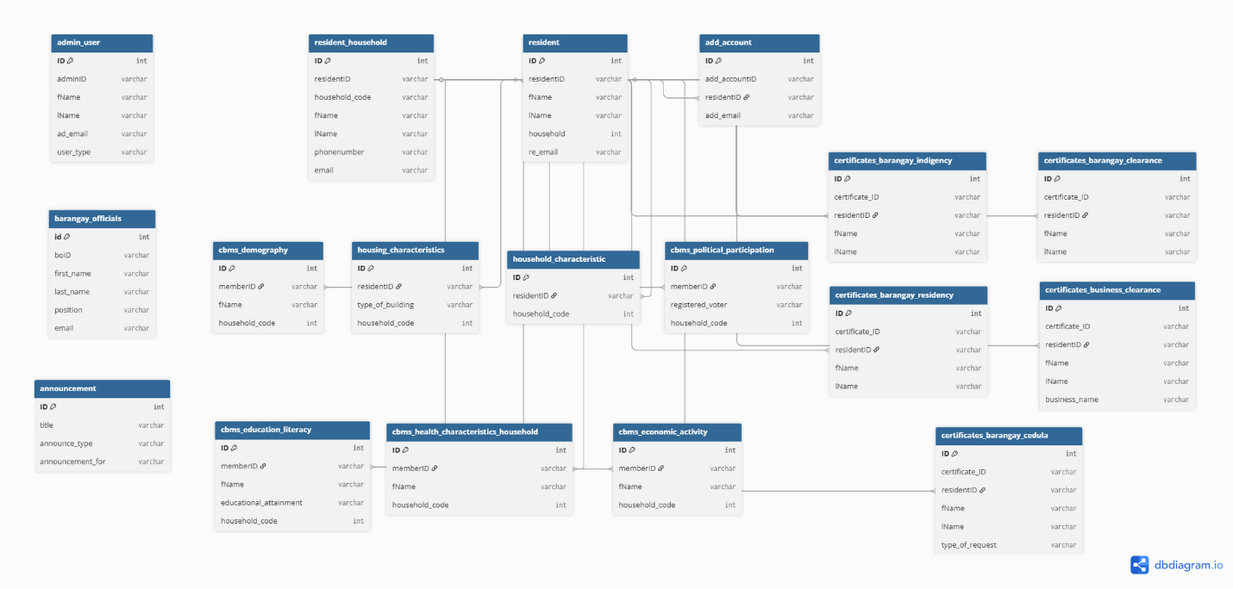
Figure 18: Relationship Diagram
2.3 Development Stage
During the Development Stage, the researchers began the actual coding and construction of the Barangay Information Management System (BIMS) based on the designs and plans created in the previous phases. This stage focused on transforming the system’s design into a fully functional software application that addresses the identified needs of Barangay San Josef, Peñaranda, Nueva Ecija.
The researchers utilized Microsoft Visual Studio as the primary development environment for writing the source code. This platform was chosen for its efficiency in code editing, debugging, and project management, which streamlined the entire development process. Using Visual Studio allowed the team to integrate various system components smoothly, ensuring proper functionality and compatibility across modules such as resident profiling, certificate issuance, and announcement management.
A sample of the system’s coding interface is shown in Figure below. This figure demonstrates how the development environment was used to build and organize the source code, contributing to a stable and maintainable system structure.
Through this stage, the researchers continuously tested and refined each function to ensure that the BIMS operated efficiently and aligned with the requirements established during the initial and design phases.

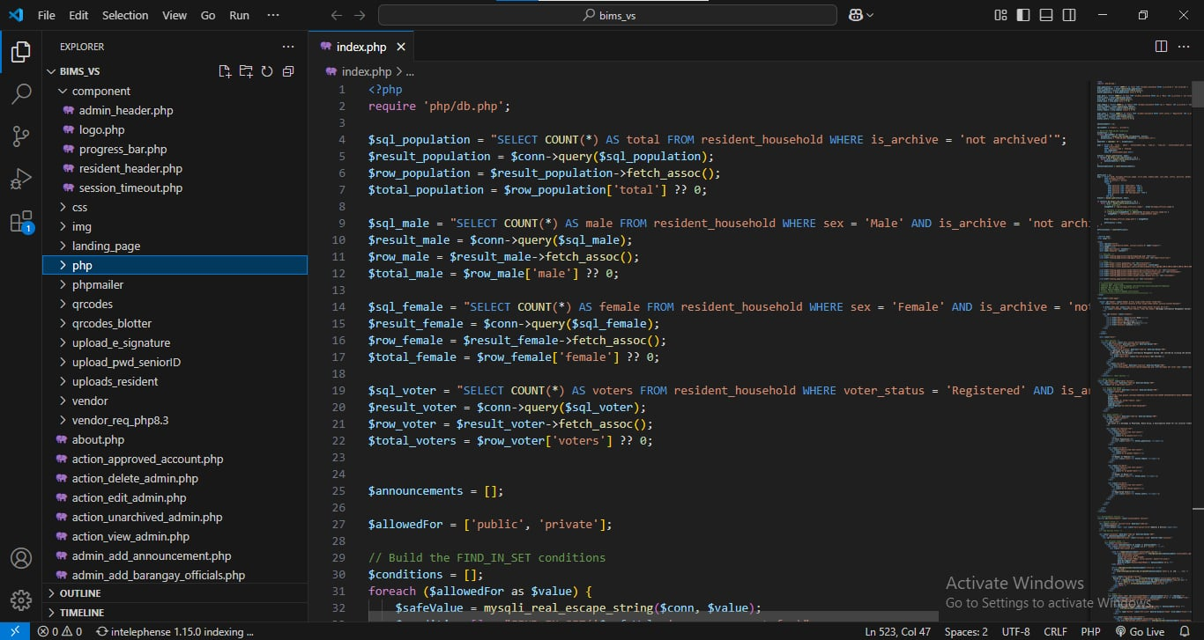

Figure 19: Studio Visual Code
As shown in Figure below, the XAMPP Control Panel was utilized to test and run the Barangay San Josef BIMS during development. The system’s interface and outputs were viewed and evaluated using Google Chrome, ensuring that all modules displayed correctly. Meanwhile, the system’s data processes and overall functionality were thoroughly tested and validated within the database environment provided by XAMPP, helping confirm that the Barangay San Josef BIMS operated smoothly and accurately.
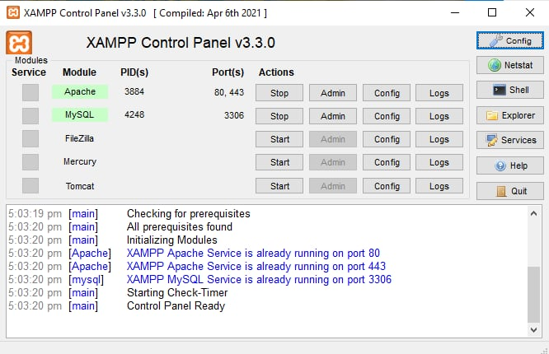

Figure 20: XAMPP Control Panel
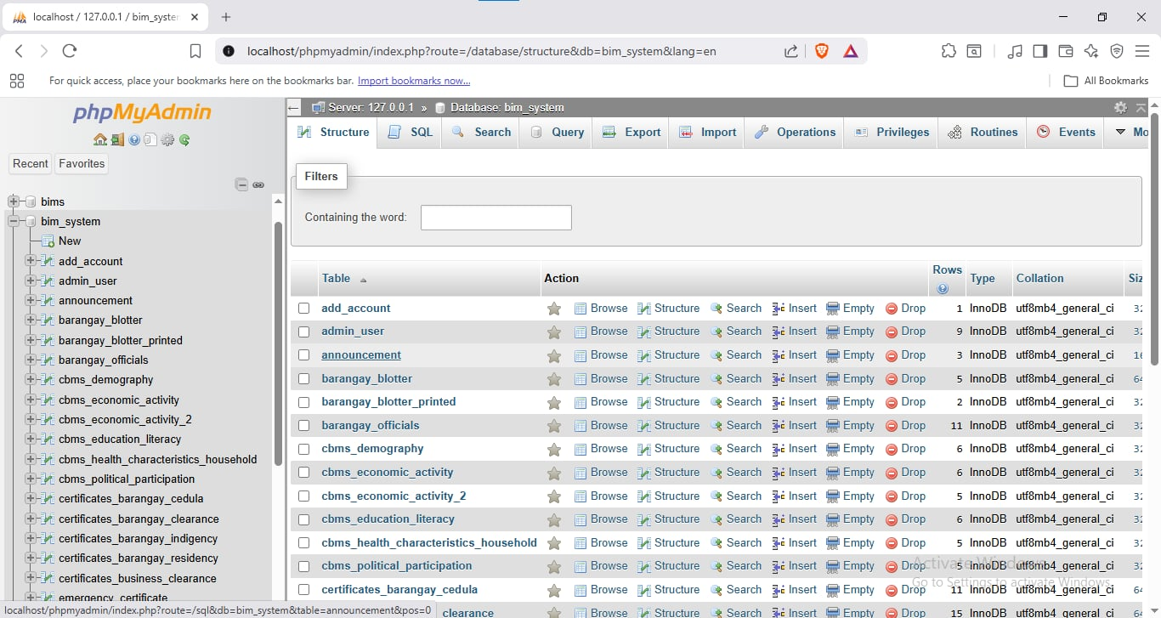
Through XAMPP, as shown in Figure below, the researchers were able to create the necessary databases and tables required to store and manage the data of the Barangay San Josef BIMS. This tool allowed for efficient structuring, organizing, and maintaining of all system-related information.
Figure 21: XAMPP
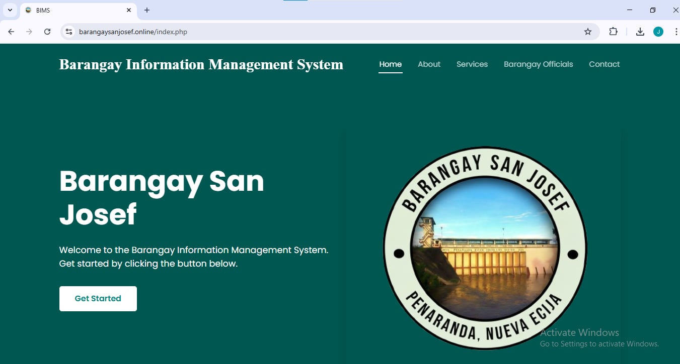
The landing page of the created system are displayed in the figure below.
Figure 22: San Josef BIMS Landing Page
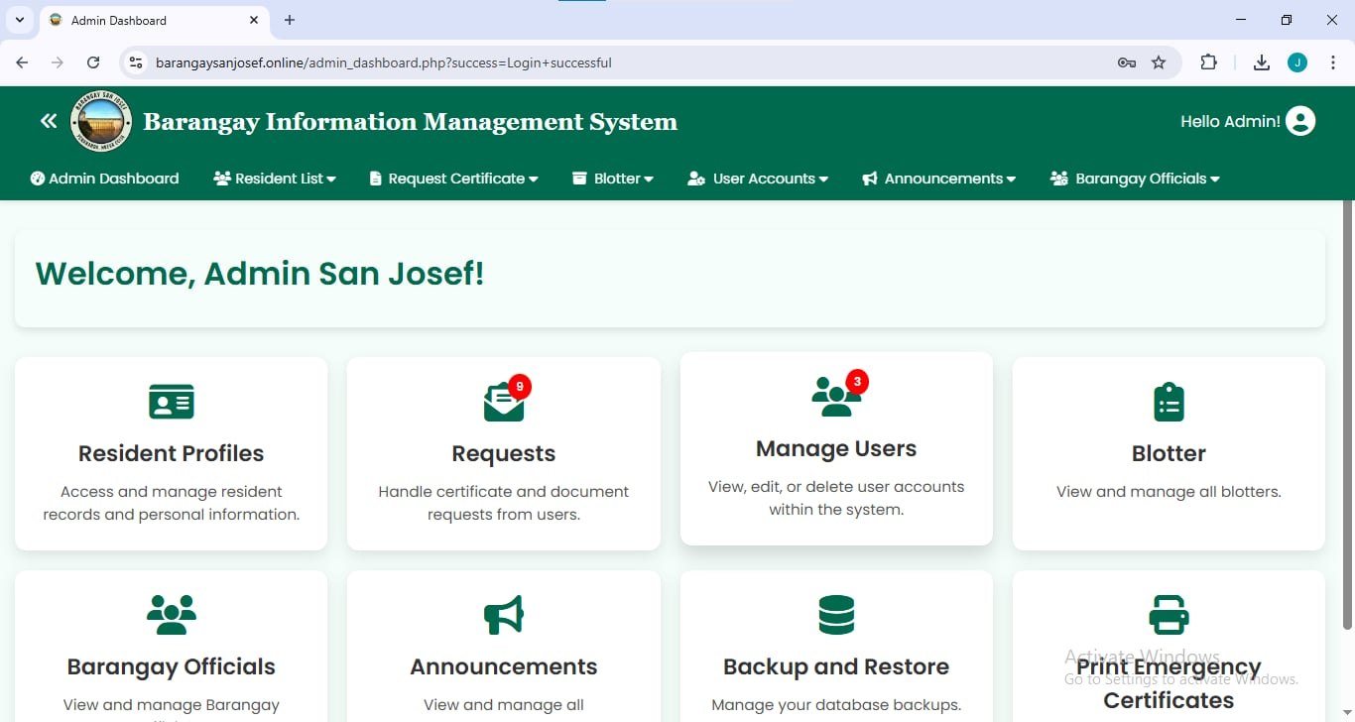
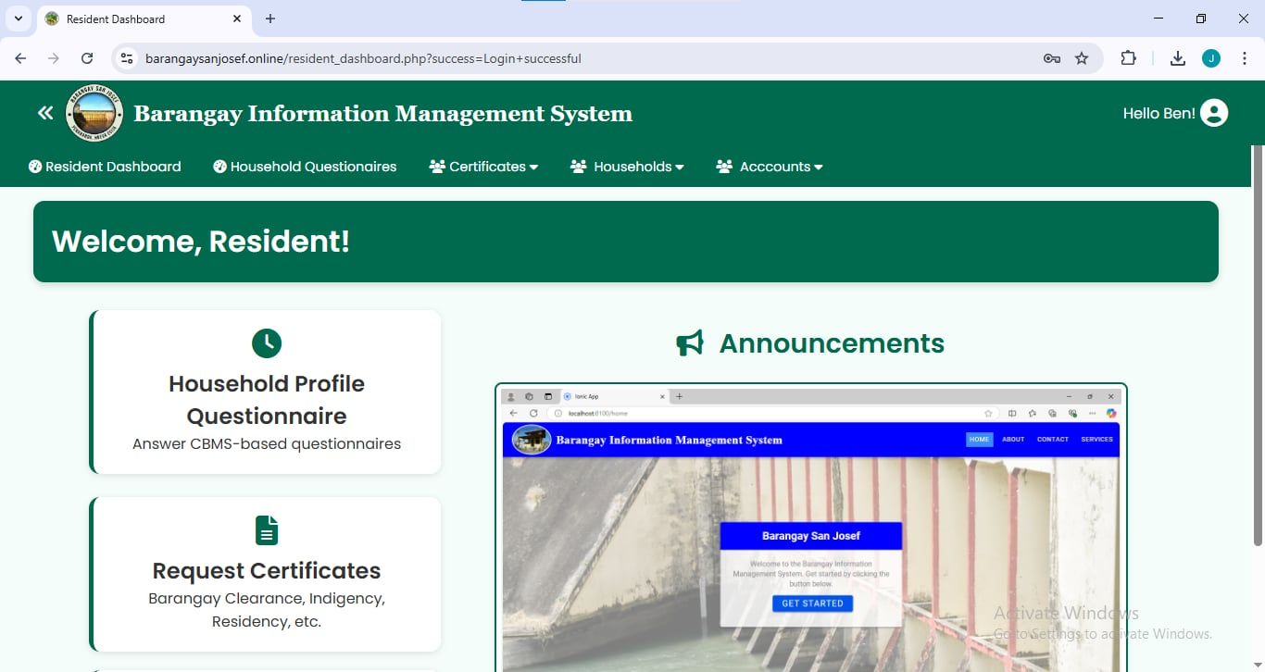
Figure 23: Admin Home Page

Figure 24: Resident Home Page

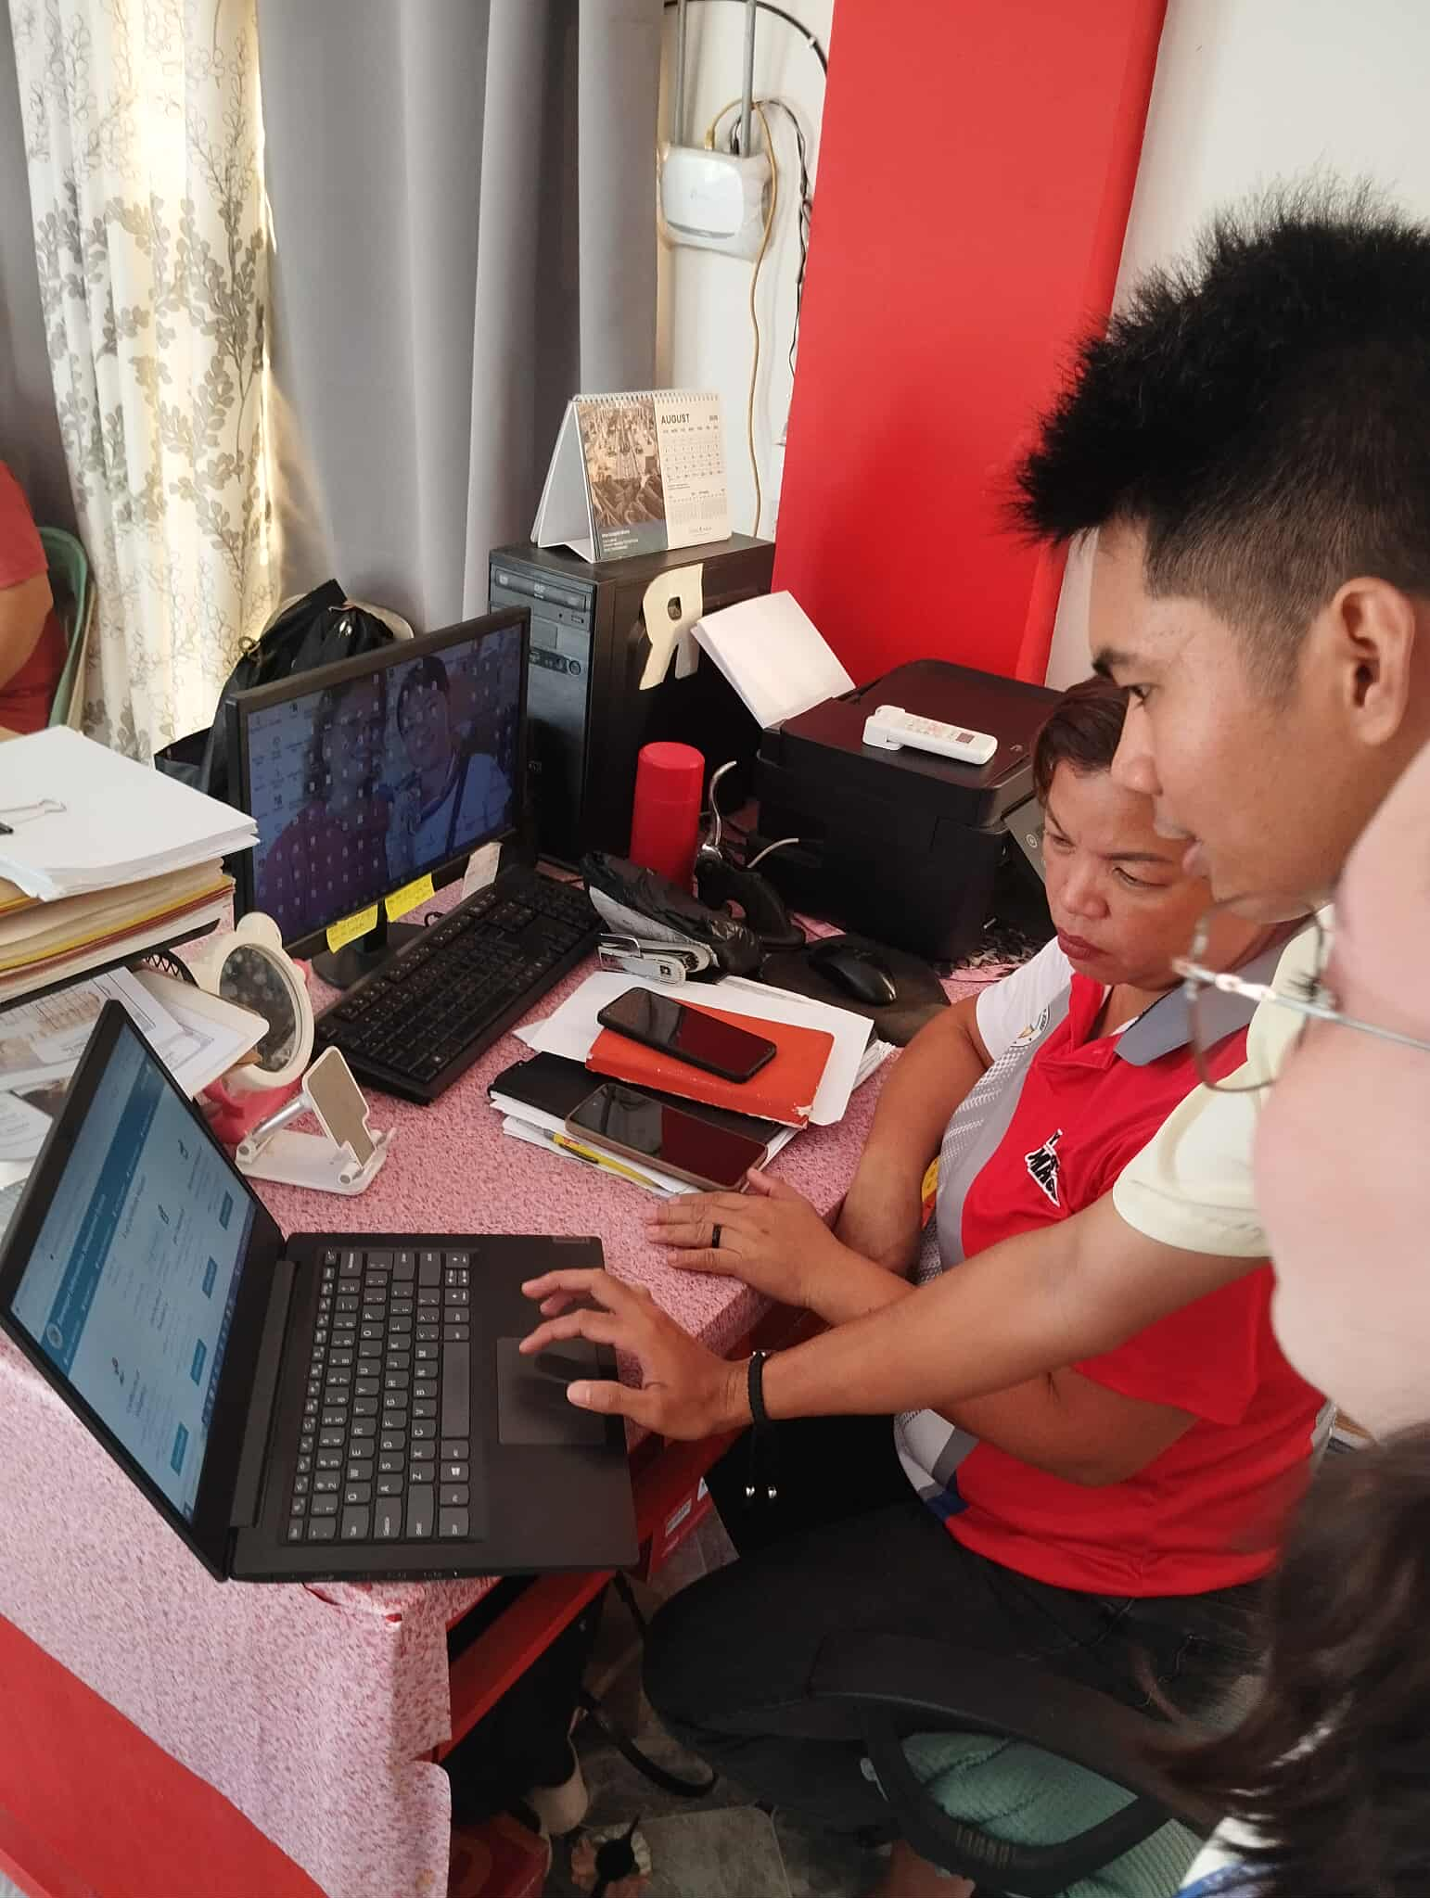
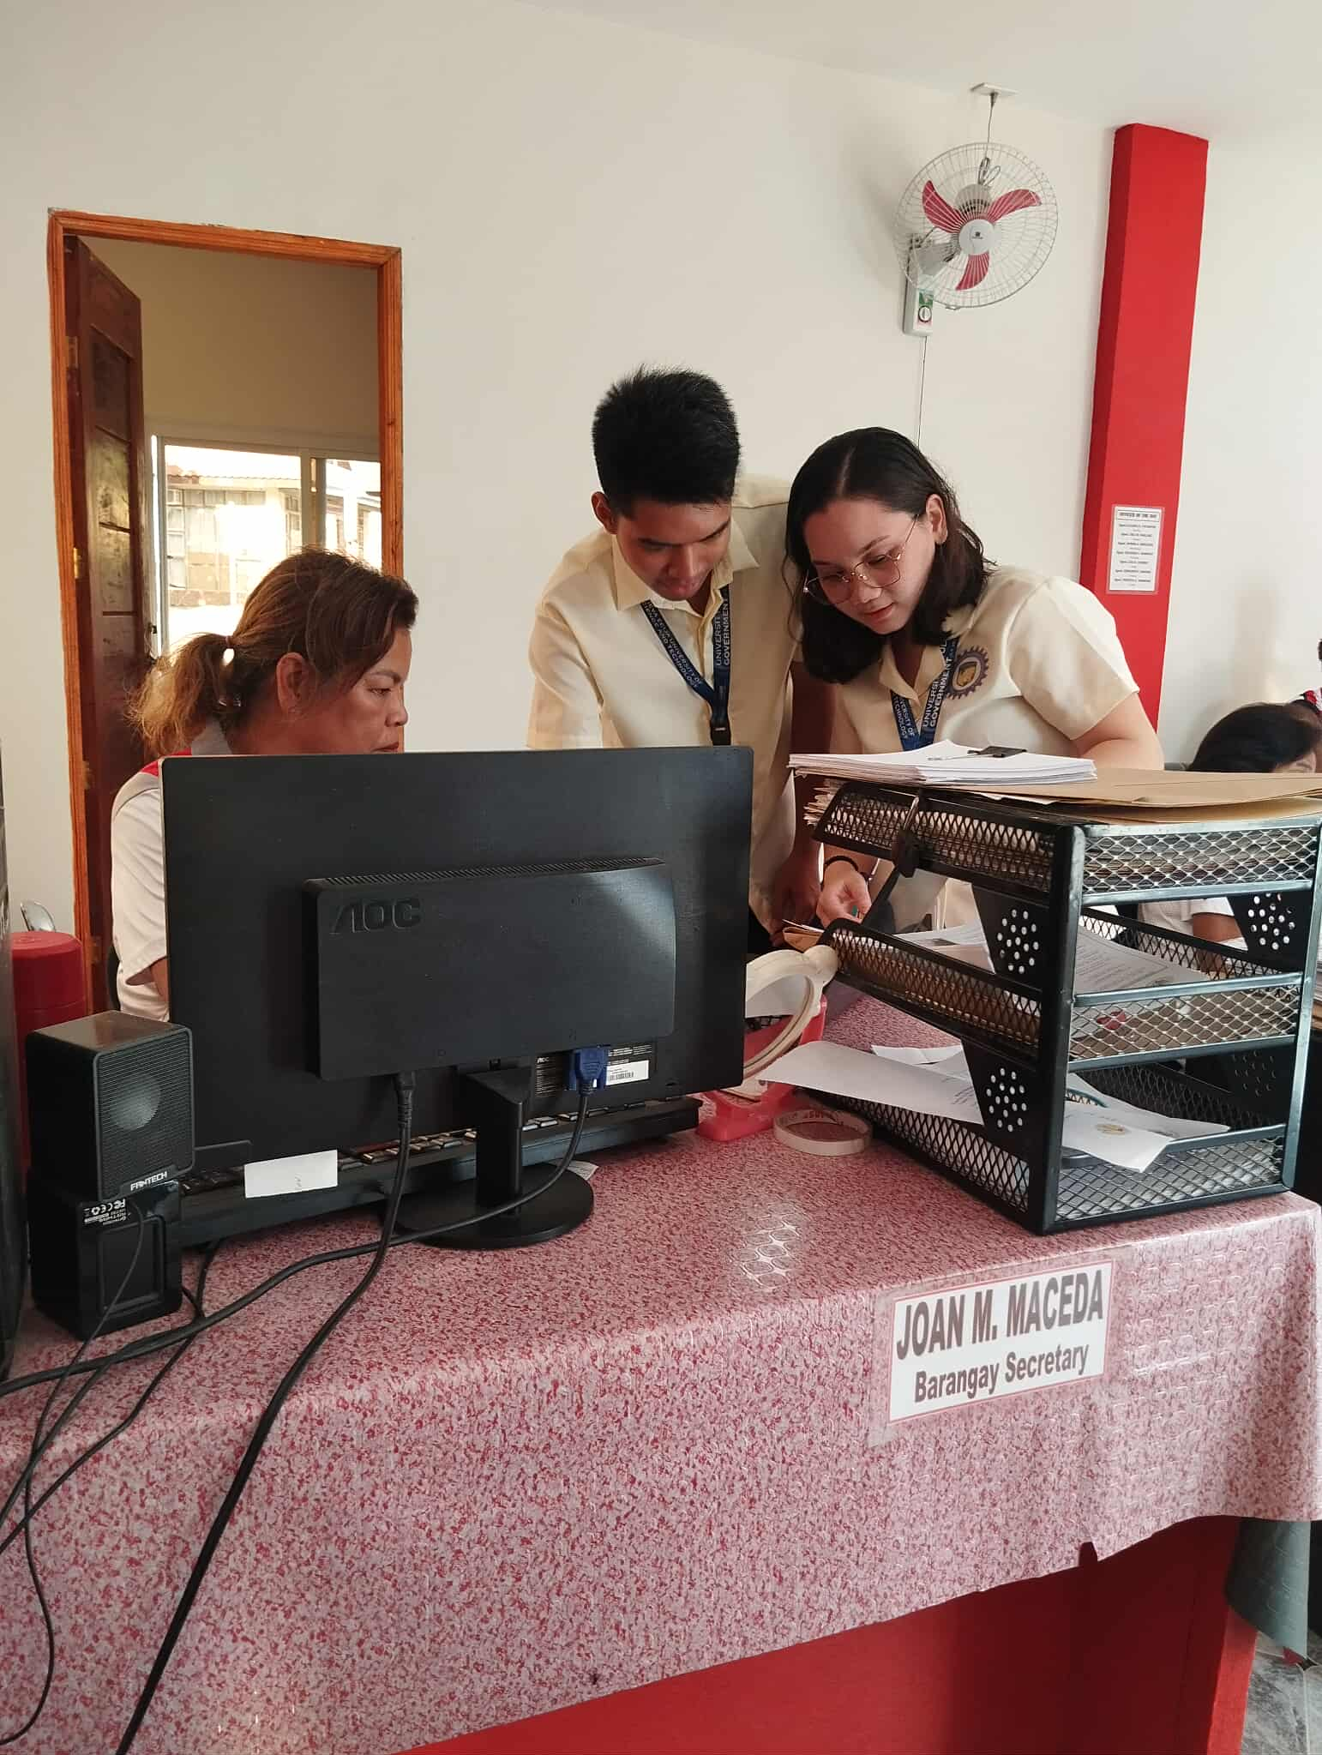
2.4 Testing Stage

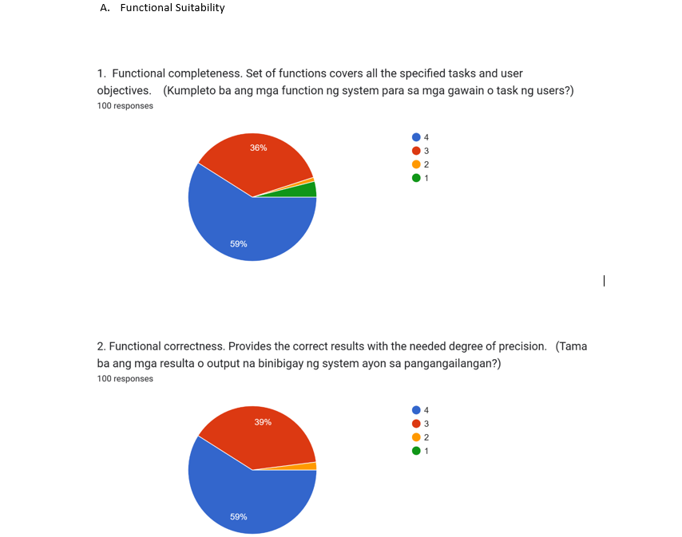
Figure 25. System Evaluation Respondents
2.5 Deployment Stage
In this stage, after successfully completed tested and evaluated by the researchers, the BIMS for Barangay San Josef is ready for deployment. It has also been uploaded online using web hosting with a sponsored domain name purchased from Mr. Aljohn M. Viloria, which is connected to the sponsored server. An Estimated Project Cost contains the expenses related to the system maintenance upon its deployment.
- Domain Costing: Domain costing is needed to maintain the system's online availability.
The total cost to maintain the BIMS for Barangay San Josef is 1,100.00 as reflected in the matrix below.
Table 22. Estimated Project Cost
Component Cost per year
Domain Costing ₱1,100.00
Total Estimated Project Cost ₱1,100.00
The hosting process involved transferring all system files from the local development environment in PhpMyAdmin to the live server directory. This step ensured that the BIMS for Barangay San Josef could be accessed and used efficiently by its intended users.
2.6 Operational Stage
Continuously monitored the system to ensure it has been functioning properly from its launch up to the present. The researchers reviewed and addressed any potential issues or weaknesses in the system, striving to make consistent improvements. Importantly, the researchers listened closely to user feedback and suggestions. By incorporating these insights, they made the system more intuitive and user- friendly, ensuring it better meets the needs of those who rely on it.
3. IT consultants’ evaluation results of Barangay Information Management System for Barangay San Josef
3.1 Functional Suitability
Table 23 shows the functional suitability of the developed Barangay Information Management System for Barangay San Josef assessed by the IT consultants that consists of three (3) sub- characteristics namely: functional completeness, functional correctness, and functional appropriateness.
Table 23. Assessment of the IT consultants on the Functional Suitability of the developed system
Software Product Categories | Weighted  Mean | Verbal  Interpretation
Functional Completeness | 3.8 | Very Functional
Functional Correctness | 3.7 | Very Functional
Functional Appropriateness | 3.9 | Very Functional
Functional Suitability | 3.8 | Very Functional
Effectively meets user requirements by ensuring all necessary features, operates as expected without errors, and is well-aligned with the intended purpose, making it a reliable and efficient solution for users.
3.2 Performance Efficiency
Table 24 shows the performance efficiency of the developed BIMS for Barangay San Josef assessed by the IT consultants that consists of three (3) sub- characteristics, namely: time behavior, resource utilization, and capacity.
Table 24. Assessment of the IT consultants on the Performance Efficiency of the developed system
Software Product Categories | Weighted  Mean | Verbal  Interpretation
Time Behavior | 3.9 | Very Efficient
Resource Utilization | 3.9 | Very Efficient
Capacity | 3.9 | Very Efficient
Performance Efficiency | 3.9 | Very Efficient
Meets the needs of its users while delivering strong performance and ensuring everything runs smoothly under the given conditions.

3.3 Compatibility
Table 25 shows the compatibility of the developed BIMS for Barangay San Josef assessed by the IT consultants that consists of two (2) sub-characteristics, namely: co-existence and interoperability.
Table 25. Assessment of the IT consultants on the Compatibility of the developed system
Software Product Categories | Weighted  Mean | Verbal  Interpretation
Co-existence | 3.9 | Very Compatible
Inter-operability | 3.8 | Very Compatible
Compatibility | 3.8 | Very Compatible
Effectively meet user needs, enabled to exchange information and perform necessary functions.
3.4 Usability
Table 26 shows the Usability of the developed BIMS for Barangay San Josef assessed by the IT consultants that consists of six (6) sub-characteristics, namely: appropriateness and recognizability, learnability, operability, user error protection, user interface aesthetics, and accessibility.
Table 26. Assessment of the IT consultants on the Usability of the developed system
Software Product Categories | Weighted  Mean | Verbal  Interpretation
Appropriateness  recognizability | 3.7 | Very Usable
Learnability | 3.8 | Very Usable
Operability | 3.9 | Very Usable
User error protection | 3.4 | Very Usable
User interface aesthetics | 3.8 | Very Usable
Accessibility | 3.8 | Very Usable
Usability | 3.7 | Very Usable
Designed to meet user needs, offering ease of use, strong security, easy maintenance, and adaptability, ensuring a practical and reliable experience.
3.5 Reliability
Table 27 shows the Reliability of the developed BIMS for Barangay San Josef assessed by the IT consultants that consists of four (4) sub-characteristics, namely: maturity, availability, fault tolerance, and recoverability.
Table 27. Assessment of the IT consultants on the Reliability of the developed system
Software Product Categories | Weighted  Mean | Verbal  Interpretation
Maturity | 3.8 | Very Reliable
Availability | 3.7 | Very Reliable
Fault tolerance | 3.6 | Very Reliable
Recoverability | 3.9 | Very Reliable
Reliability | 3.7 | Very Reliable
User standards, having the ability to handle errors without disruption, and quick recovery from issues, and support user needs.

3.6 Security
Table 28 shows the BIMS for Barangay San Josef assessed by the IT consultants that consists of five (5) sub-characteristics namely: confidentiality, integrity, non-repudiation, accountability, and authenticity.
Table 28. Assessment of the IT consultants on the Security of the developed system
Software Product Categories | Weighted  Mean | Verbal  Interpretation
Confidentiality | 3.5 | Very Secured
Integrity | 3.4 | Very Secured
Non- repudiation | 3.7 | Very Secured
Accountability | 3.9 | Very Secured
Authenticity | 3.5 | Very Secured
Security | 3.6 | Very Secured
Ensures robust information and data protection tailored to user roles and access levels, providing a comprehensive solution to safeguard sensitive data.
3.7 Maintainability
Table 29 shows the Maintainability of the developed BIMS for Barangay San Josef assessed by the IT consultants that consists of four (4) sub-characteristics, namely: modularity, reusability analyzability, and modifiability.
Table 29. Assessment of the IT consultants on the Maintainability of the developed system

Software Product Categories | Weighted  Mean | Verbal  Interpretation
Modularity | 3.7 | Very Maintainable
Reusability | 3.7 | Very Maintainable
Analyzability | 3.8 | Very Maintainable
Modifiability | 3.9 | Very Maintainable
Maintainability | 3.8 | Very Maintainable
It is highly modular, making it easier to manage and update specific components without affecting the overall functionality, with a solid foundation for updates and efficient management.
3.8 Portability
Table 30 shows the Portability of the developed BIMS for Barangay San Josef assessed by the IT consultants that consists of three (3) sub-characteristics, namely: adaptability, installability, and replaceability.
Table 30. Assessment of the IT consultants on the Portability of the developed system
Software Product Categories | Weighted  Mean | Verbal  Interpretation
Adaptability | 3.9 | Very Portable
Installability | 3.8 | Very Portable
Replaceability | 3.8 | Very Portable
Portability | 3.8 | Very Portable
Designed with strong portability features, ensuring that it can be deployed and adapted to various environments with relative ease. However, there may be room for improvement in making certain components more easily replaceable.

3.9 IT Consultants Evaluation Summary
The following table displays the overall summary result of the evaluation conducted by the IT consultants on the developed system, BIMS for Barangay San Josef.
Table 31. IT Consultants’ Evaluation Summary Result
Software Product Categories | Weighted  Mean | Verbal  Interpretation
Functional Suitability | 3.8 | Excellent
Performance Efficiency | 3.9 | Excellent
Compatibility | 3.8 | Excellent
Usability | 3.7 | Excellent
Reliability | 3.7 | Excellent
Security | 3.6 | Excellent
Maintainability | 3.8 | Excellent
Portability | 3.8 | Excellent
Overall | 3.76 | Excellent

4. End user’s evaluation results of Barangay Information Management System for Barangay San Josef
The end users evaluated the performance and features of the BIMS for Barangay San Josef based on product quality standards, including functionality suitability, performance efficiency, and usability. The developed system was evaluated, consisting of one (1) admin, and ninety- nine (99) residents, with a total of one hundred (100) respondents. The respondents did the evaluation of the system by answering the prepared google form given by the researchers.
The following sections include tables that provide a clearer view of the data collected. These tables highlight the findings from the system users' responses. The analysis brings together the results from both groups, focused on combined results as follows:
4.1 Functional Suitability
Table 32 shows the functional suitability of the developed BIMS for Barangay San Josef assessed by the end users that consists of three (3) sub-characteristics namely: functional completeness, functional correctness, and functional appropriateness.
Table 32. Assessment of the end users on the Functional Suitability of the developed system
Software Product Categories | Weighted  Mean | Verbal  Interpretation
Functional Completeness | 3.51 | Very Functional
Functional Correctness | 3.57 | Very Functional
Functional Appropriateness | 3.54 | Very Functional
Functional Suitability | 3.54 | Very Functional
The system is very functional, with nearly complete features, correct functionality, and appropriate characteristics for its intended use. These ratings suggest that the system effectively meets user needs and performs well in all key areas of functionality.
4.2 Performance Efficiency
Table 33 shows the Performance Efficiency of the developed BIMS for Barangay San Josef assessed by the end users that consists of three (3) sub-characteristics, namely: time behavior, resource utilization, and capacity.

Table 33. Assessment of the end-users on the Efficiency of the developed system
Software Product Categories | Weighted  Mean | Verbal  Interpretation
Time Behavior | 3.65 | Very Efficient
Resource Utilization | 3.50 | Very Efficient
Capacity | 3.47 | Very Efficient
Performance Efficiency | 3.55 | Very Efficient
It demonstrates very high performance efficiency. The system performs efficiently in terms of time, effectively utilizing resources, and handling capacity requirements.
4.3 Usability
Table 34 shows the Usability of the developed BIMS for Barangay San Josef assessed by the end users that consists of six (6) sub-characteristics, namely: appropriateness and recognizability, learnability, operability, user error protection, user interface aesthetics, and accessibility.
Table 34. Assessment of the end-users on the Usability of the developed system
Software Product Categories | Weighted  Mean | Verbal  Interpretation
Appropriateness  recognizability | 3.49 | Very Usable
Learnability | 3.46 | Very Usable
Operability | 3.47 | Very Usable
User error protection | 3.44 | Very Usable
User interface aesthetics | 3.53 | Very Usable
Accessibility | 3.53 | Very Usable
Usability | 3.49 | Very Usable
The system is very usable. The syste excels in areas such as recognizability, learnability, and operability, ensuring users can easily understand, navigate, and interact with it.
4.4 End-users Evaluation Summary
Table 35 displays the overall result of the evaluation conducted by the End Users on the developed BIMS for Barangay San Josef.
Table 35. End-users’ Evaluation Summary Result
Software Product Categories | Weighted  Mean | Verbal  Interpretation
Functional Suitability | 3.54 | Excellent
Performance Efficiency | 3.55 | Excellent
Usability | 3.49 | Excellent
Overall | 3.53 | Excellent

CHAPTER IV
SUMMARY, CLUSION, AND RECOMMENDATION
Summary
This study aimed to modernize and streamline the barangay information management process in Barangay San Josef through the development of the Barangay Information Management System (BIMS). The project was initiated in response to the significant challenges observed in the existing setup, which relied heavily on manual methods for recording resident data, processing transactions, and maintaining barangay records. These traditional practices often resulted in delays, errors, and difficulties in retrieving important information, affecting the efficiency of daily operations and service delivery. In addition, announcements regarding community programs and events were usually disseminated verbally, a method that often failed to reach all residents, especially those living in remote areas.
Based on the results of the system evaluation using Likert-scale responses from the barangay officials, system users and IT professional the developed Barangay San Josef Information Management System was found to be effective, reliable, and easy to use. Respondents strongly agreed that the system improved accuracy, reduced processing time, and provided faster access to resident records and barangay documents. The system also enhanced information dissemination through digital announcements, ensuring that updates reached more residents on time.
Overall, the findings show that the Barangay San Josef Information Management System successfully addressed the limitations of the manual process and significantly improved the management of barangay data, document processing, and communication. The system contributed to a more organized workflow, better decision-making, and more responsive public service, supporting the barangay San joseph in achieving a more efficient and technology-driven governance.

Conclusion
The results of this study show the importance of improving how Barangay San Josef manages its records, certificates, and daily transactions. By studying the problems of the current manual system and using the Agile method, the researchers were able to create a system that fits the needs of the barangay. The following points summarize the main conclusions of the study:
1. Solving Problems in the Manual System
The Barangay Information Management System (BIMS) helped fix many issues in the old manual process. These include slow data retrieval, misplaced papers, and delays in issuing certificates. With the new system, information is easier to find, records are safer, and the work of barangay staff becomes faster and more organized.
2. Benefits of Going Digital
Moving to a digital system greatly improved the barangay’s services. Online certificate requests, QR code verification, and a centralized announcement feature made communication clearer and faster. The new system also protects important data and limits access only to authorized users.
3. Easier Use for Officials and Residents
The system was designed to be simple and easy to use. With clear menus and organized features, both barangay officials and residents can quickly learn how to use it. Feedback during development helped make the system more user-friendly and suitable for real barangay operations.
4. Help in Improving Barangay Governance
The system supports better governance by making work faster, reducing errors, and improving record-keeping. It also helps the barangay become more transparent and efficient in serving its community.
5. Basis for Future Improvements
The system can still be improved in the future. More features may be added, such as mobile app access, online payments, or connections to other government systems. This study can guide future researchers in creating similar systems for other barangays.

Recommendation
The following recommendations are presented to enhance the effectiveness of Barangay Information Management System for Barangay San Josef and ensure its sustained impact on improving Barangay Services at the Barangay San Josef. These suggestions aim to address the current gaps identified during the study and promote the adoption of innovative solutions for better barangay services.
- Adoption of the Barangay Information Management System (BIMS) in Other Barangays
It is recommended that the local government of Peñaranda (or Barangay San Josef) expand the implementation of the Barangay Information Management System (BIMS) to other Barangays within the municipality or neighboring areas facing similar challenges in record management. This expansion will allow for a standardized approach to administrative and information management, improving public service delivery and data accuracy across multiple communities. A phased implementation plan should be developed to gradually introduce the system in new regions, ensuring sufficient training and technical support for barangay officials and staff before and during the transition.
- Regular System Updates and Enhancements
To ensure that the Barangay Information Management System (BIMS) remains effective and responsive to the needs of Barangay San Josef, periodic system updates should be carried out. These updates may include the addition of new features such as advanced analytics for population and record trends, integration with municipal or provincial databases, and expanded support for various barangay services. Enhancements may also involve improving the user interface and adding options for multilingual support to better serve diverse residents. Regular feedback from barangay staff and system users should be collected and incorporated into each update to address emerging requirements and ensure continuous improvement.
- Comprehensive Training for Users
Training programs for barangay staff and system administrators should be prioritized to ensure the effective use of the Barangay Information Management System (BIMS). These programs should cover all system functionalities, with emphasis on troubleshooting common issues and maintaining data security. Hands-on workshops, along with the development of user manuals or video tutorials, can help address gaps in technical knowledge and equip users with the skills needed to operate the system efficiently.
- Strengthening Data Security
While BIMS already incorporates measures for secure data handling, it is essential to continuously enhance these security features. Implementing advanced encryption protocols, conducting regular security audits, and enabling multi-factor authentication will help ensure that sensitive barangay records and resident information remain protected. Additionally, establishing a comprehensive data backup and recovery plan will safeguard the system against potential data loss or failures, ensuring uninterrupted access to important records.
- Partnerships with Government
Collaborations with municipal and provincial government offices can support the expansion and long-term sustainability of BIMS. These partnerships may provide access to additional funding, technical expertise, and policy guidance that can enhance the system’s functionality and integration with broader governance initiatives. Working closely with local government units (LGUs) and relevant agencies can also strengthen barangay operations, improve data coordination, and ensure that the system effectively serves the needs of all residents, including those in remote areas.
- Conducting Further Studies
Future research should explore the long-term impact of BIMS on the efficiency and effectiveness of barangay operations, particularly in areas such as record management, service delivery, and accessibility of information for residents. Studies may also examine the cost-effectiveness of implementing similar systems in other barangays or municipalities, providing valuable insights that could support wider adoption. Further investigations into user experience, system scalability, and integration with higher-level government databases can also guide future enhancements and policy development.
By following these recommendations, BIMS has the potential to transform barangay records management and public service delivery, ensuring improved efficiency, reliability, and accessibility for the entire community.

