Are incarceration rates in the United States impacted by inflation and/or unemployment rates?

Sal J Denova III, M00351673

12/2/2023

## Abstract

The United States incarcerates more of its citizens, per capita, than any other country in the world. These prisons and county jails place a significant burden on the tax payers in terms of cost per inmate. For violent offenses such as murder or armed robbery, the cost per inmate increases significantly given the length of the prison terms for these crimes. For crime victims, there is some solstice in the fact that offenders in the United States will face a justice system levying some of the most severe prison terms in the world. There are many politicians and law enforcement leaders who are exploring cause and effect relationships with the hope to create laws or policies that would reduce the overall prison populations.

One such connection that will be explored as part of this research is the impact of inflation on incarceration rates across the US. If this research is able to draw a significant correlation between inflation and incarceration rates, perhaps leaders can implement policies accordingly to reduce inflation. Accordingly, the cost of crime victim impact, prosecution through US court systems and ultimately the cost of inmate incarceration will need to be a factor when evaluation anti-inflation policies.

While there are multiple variables that influence unemployment rates in the United States, it is known that increased interest rates to leverage inflation lead to higher unemployment. Most politicians as well as the Federal Reserve understand the impact of these mitigating actions. This research will also seek to analyze the impact of unemployment rates on prison populations.

## Introduction

There are several variables that one can consider when performing analysis on incarceration rates. For example, many are interested in understanding recidivism and its impacts; others may want to analyze total prison populations. In this research we choose to analyze the number of prison admissions across a period of 10 years: 2013 through 2022.

The analysis will be comprised of determining the correlation of prison admissions to 1) US unemployment and 2) inflation as measured by Cunsumer Pricing Index (CPI).

Table 1 below provides a high level overview of the average of our variables to provide a feel for the data. We will of course perform our analysis against a more granular data set with specific monthly and annual data points.

Table 1: Sample Average Population, Admissions, Inflation rates, and Unemployment

| Year | Avg Prison Population | Avg Prison Admissions | Avg Inflation (CPI) | Avg Unemployment |
| --- | --- | --- | --- | --- |
| 2013 | 30379 | 874 | 232.95 | 7.36 |
| 2014 | 30419 | 883 | 236.72 | 6.16 |
| 2015 | 30179 | 622 | 237.00 | 5.28 |
| 2016 | 29387 | 683 | 240.00 | 4.88 |
| 2017 | 28990 | 965 | 235.12 | 4.35 |
| 2018 | 28675 | 976 | 251.10 | 3.89 |
| 2019 | 28244 | 1035 | 255.65 | 3.68 |
| 2020 | 27611 | 570 | 258.85 | 8.09 |
| 2021 | 23315 | 750 | 270.97 | 5.37 |
| 2022 | 23043 | 781 | 290.64 | 3.64 |

## Literature Review

Inflation, which is defined as increased cost of consumer products such as milk or eggs, has been a major topic on the political scene since COVID-19. The US and world have shown record year over year increases in consumer pricing index; often the standard measure of inflation. In an article in The Hill, Howard Henderson points out that inflation growth often “impacts low-income families more severely” (Howard, 2022). Henderson goes on to surmise that inflation also creates an uptick in violent crimes such as robbery, property crimes and murder. More notably, in his article, he denotes that there was an increase of 4.2% in the first half of 2022.

Policy makers need to analyze and include the costs of these crimes when assessing policy decisions in regards to inflation. Congress and the Federal Reserve in general need to monitor consumer pricing indexes and take the relevant actions necessary to stop inflationary growth with a sense of urgency. Perhaps providing concrete analysis against impact of inflation on incarcerations and total associated costs will shed some light on the importance and urgency required for anti-inflationary policy decisions.

## Theory

If US inflation rates impact incarceration, the following hypothesis is expected to be true:

H1: Higher (or increasing) inflation rates will cause corresponding incarceration rates in the United States in comparison to periods of lower (or decreasing) inflation rates.

As a second area of analysis, we will analyze US Unemployment rates impact on incarceration rates. If there is a correlation, the below hypothesis is expected to be true:

H2: Higher (or increasing) unemployment rates will cause corresponding incarceration rates in the United States in comparison to periods of lower (or decreasing) unemployment rates.

## Data

The data will be provided from two individual datasets found on Kaggle.com. Prison population in the US dataset was published in June of 2023 by Konrad Banachewicz. This dataset contains information related to incarceration intakes and releases as well as total US prison populations from December 1999 through August 2022. The variables contained within the datasets will allow for comparison of US CPI, incarceration levels as well as incarceration intakes and releases.

The data includes:

## [1] "/Users/airfruity/Library/CloudStorage/OneDrive-murraystate.edu/CIS663-22-FA23/TermProject/Source"

The second dataset from Kaggle.com is entitled US Inflation Dataset by Pavan Narne. It contains the running consumer pricing index (CPI) for the US for each month from December 1946 through May 2023.

## [1] "/Users/airfruity/Library/CloudStorage/OneDrive-murraystate.edu/CIS663-22-FA23/TermProject/Source"

As part of continuing analysis, a third dataset has from the US Bureau of Labor Statistics. This dataset contains US civilian unemployment rates for each month from 2003 until October of 2023.

## [1] "/Users/airfruity/Library/CloudStorage/OneDrive-murraystate.edu/CIS663-22-FA23/TermProject/Source"

In order to ensure consistent data types, we take this opportunity to convert all date fields from character to date data type.

library(lubridate)  
#convert character to date format  
admissions.data$date <- ymd(admissions.data$date)  
inflation.data$date <- ymd(inflation.data$date)  
unemployment.data$Month <- ymd(unemployment.data$Month)  
  
#Here is a view of the first rows of our 3 data sets  
head(admissions.data)

## date admissions_total admissions_white admissions_black  
## 1 2015-02-01 1583 600 193  
## 2 2015-03-01 1580 615 189  
## 3 2015-04-01 1779 706 235  
## 4 2015-05-01 1821 730 260  
## 5 2015-06-01 1689 704 215  
## 6 2015-07-01 1871 758 223  
## admissions_hispanic admissions_amerind admissions_asian admissions_other  
## 1 633 130 6 21  
## 2 640 114 3 19  
## 3 701 115 4 18  
## 4 669 125 8 29  
## 5 618 129 0 23  
## 6 738 121 5 26  
## releases_total releases_white releases_black releases_hispanic  
## 1 1649 653 194 688  
## 2 1559 644 169 610  
## 3 1693 703 206 657  
## 4 1659 685 193 616  
## 5 1570 651 174 603  
## 6 1718 673 224 662  
## releases_amerind releases_asian releases_other state  
## 1 85 7 22 Arizona  
## 2 111 6 19 Arizona  
## 3 93 5 29 Arizona  
## 4 136 3 26 Arizona  
## 5 111 7 24 Arizona  
## 6 132 5 22 Arizona

head(inflation.data)

## date value  
## 1 1947-01-01 21.48  
## 2 1947-02-01 21.62  
## 3 1947-03-01 22.00  
## 4 1947-04-01 22.00  
## 5 1947-05-01 21.95  
## 6 1947-06-01 22.08

head(unemployment.data)

## Month Total  
## 1 2003-10-01 6.0  
## 2 2003-11-01 5.8  
## 3 2003-12-01 5.7  
## 4 2004-01-01 5.7  
## 5 2004-02-01 5.6  
## 6 2004-03-01 5.8

While we have admissions data based on race, for this initiative we have chosen to exclude race from our scope. As a result, we will limit our dataset to only “total” admissions, Admissions data will be limited to only those items of interest: Date, Total Admissions

#reduce columns in admission data  
admission.slim <- select(admissions.data,date, admissions_total)

Inflation data goes back to 1947, however we only have matching prison admissions and unemployment data from January 2013 onward. As such , we need to reduce the inflation data set to remove years 1947 through December 2012

#Filter data <Dec 2012  
inflation.slim2 <- subset(inflation.data, inflation.data$date > "2012-12-01")

Prison admissions data goes back to 2000, however because we need to account for ALL of the United States, we must have a complete state inventory. The Prisons admissions data set only contains all states from January 2013 onward. As such , we need to reduce the admissions data set to remove years 2000 through December 2012.

Additionally, given our admissions data is at the state level of granularity, we need to sum the data, on a per monthly basis, such that we convert it to ‘US based’ data to align with the inflation and unemployment data sets.

#Filter data <Dec 2012  
admission.slim2 <- subset(admission.slim, admission.slim$date > "2012-12-01")  
# compute admissions by month  
admission.slim2$month<-floor_date(admission.slim2$date, "month")  
  
admission.slim3 = admission.slim2%>%  
 group_by(month) %>%  
 summarize(sum = sum(admissions_total))

Since we only have a complete set of Prison admissions data for entire US from January 2013 onward, we must reduce our unemployment data set to align. We need to reduce the unemployment data to remove all data prior to December 2012.

The column names were updated from abbreviations to names that are more easily understood.

Now we can join the three transformed and cleansed data sets into a single data frame using left join based on date.

#left join using dlplr based on date  
pop.inf.merge<-left_join(inflation.slim2, admission.slim3, by ='Date')  
pop.inf.unemp<-left_join(pop.inf.merge, unemployment.slim2, by ='Date')  
#displaying first rows of final, cleansed and joined dataset to be used for analysis  
head(pop.inf.unemp)

## Date CPI Monthly US Admissions UnEmployment Rate  
## 1 2013-01-01 231.679 4297 8.0  
## 2 2013-02-01 232.937 4167 7.7  
## 3 2013-03-01 232.282 4395 7.5  
## 4 2013-04-01 231.797 4329 7.6  
## 5 2013-05-01 231.893 4560 7.5  
## 6 2013-06-01 232.445 4181 7.5

## Methodology

Lets analyize our dataset using coorelation analyisis.  
Step 1 will be to check to see if the data is normally distributed. The most straight forward way to do that is to create a histogram against our 3 independent variables: US Admissions, unemployment rate and CPI.

library(ggplot2)  
#historgram  
Adm.histogram <- hist(pop.inf.unemp$`Monthly US Admissions`, col='steelblue')

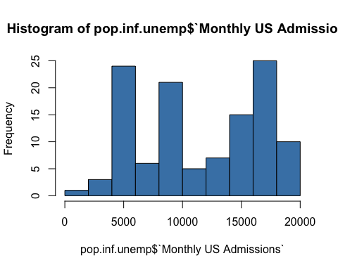

CPI.histogram<-hist(pop.inf.unemp$CPI, col='steelblue')

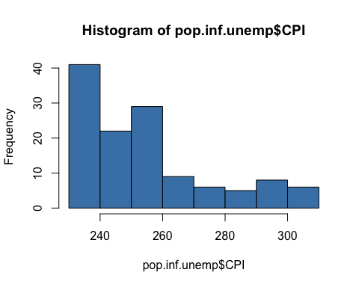

UnEmp.histogram<-hist(pop.inf.unemp$'UnEmployment Rate', col='steelblue')

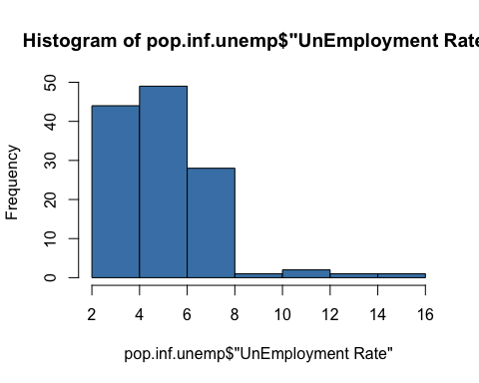

A quick view of the distributions of our variables show that they are NOT normally distributed. As a result, we must use a nonparametric measure of the strength and direction of association that exists between unemployment, CPI and admissions as measured on at least an ordinal scale.

The Spearman rank-order correlation coefficient (Spearman’s correlation, for short) will be used.

Given that we are trying to determine the best indicator of increased incarceration, we will analyze both inflation (CPI) and US Unemployment rates independently of one another.

First we analyze US Prision admissons against CPI. Then we analyze US Prison admissions against unemployment.

Below are the regression lines for each of the scenarios.

#perform Spearman’s correlation agains admissions and CPI  
cor.CPI.result<-cor.test(pop.inf.unemp$`Monthly US Admissions`, pop.inf.unemp$`CPI`, method=c('spearman'))

#Loading ggplot2  
 require(ggplot2)  
  
# visualize how a regression line looks like of US Prision admissons against CPI  
 ggplot(pop.inf.unemp, aes(x=pop.inf.unemp$`Monthly US Admissions`, y=pop.inf.unemp$`CPI`)) + geom_point() +  
 geom_smooth(method="lm") + labs(x="US Admissions", y="CPI")

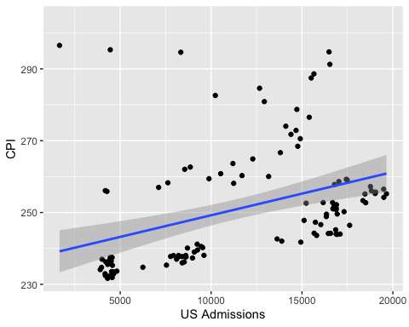

#perform Spearman’s correlation against admissions and unemployment  
cor.unemp.result<-cor.test(pop.inf.unemp$'UnEmployment Rate', pop.inf.unemp$'Monthly US Admissions', method=c('spearman'))

#Loading ggplot2  
 require(ggplot2)  
  
#visualize how a regression line looks like of US Prision admissons against Unemployment  
 ggplot(pop.inf.unemp, aes(x=pop.inf.unemp$`Monthly US Admissions`, y=pop.inf.unemp$'UnEmployment Rate')) + geom_point() +  
 geom_smooth(method="lm") + labs(x="US Admissions", y="UnEmployment Rate")

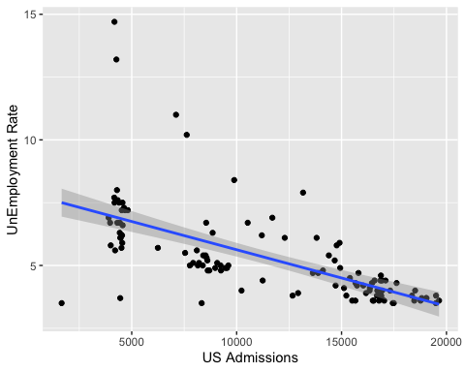

## Conclusion

As we look at the relationship between US Prison Admissions and CPI, we see from Spearman’s Correlation analysis that there is a positive, moderate and statistically significant relationship between Monthly US Prison Admissions and CPI (r=53.0%, p-value<0.001).

This analysis, combined with the regression line in chart X above, leads us to the conclusion that as CPI rises so does the prison admissions rate. Our hypothesis “H1: Higher (or increasing) inflation rates will cause corresponding incarceration rates in the United States in comparison to periods of lower (or decreasing) inflation rates” is confirmed.

If we turn our focus onto the relationship between US Prison Admissions and US Unemployment rate we again deploy Spearman’s Correlation analysis. The results indicate that there is a negative, quite strong and statistically significant relationship between US Prison admissions and unemployment rate (r=-75.5%, p-value < 0.001).

This analysis, combined with the regression line in chart Y above, leads us to the conclusion that as unemployment rises, US prison admissions are lower. Our hypothesis “H2: Higher (or increasing) unemployment rates will cause corresponding incarceration rates in the United States in comparison to periods of lower (or decreasing) unemployment rates” is NOT confirmed.

# References

Banachewicz, K. (2023, June). Prison population in the US, Version 1. Retrieved October 29, 2023 from <https://www.kaggle.com/datasets/konradb/prison-population-in-the-us>

Narne, P. (2023, August). US Inflation Dataset (1947 - 2023), Version 1. Retrieved October 29, 2023 from <https://www.kaggle.com/datasets/pavankrishnanarne/us-inflation-dataset-1947-present>

Henderson, H. (2022). “Controlling inflation is crime prevention”, The Hill, Retrieved October 29, 2023 from <https://thehill.com/opinion/congress-blog/3721574-controlling-inflation-is-crime-prevention/>

United States Department of Labor (2023, November). “The Employment Situation –October 2023”. Retrieved November 28, 2023 from <https://www.bls.gov/charts/employment-situation/civilian-unemployment-rate.htm>