**Output-Task-4**

**http://127.0.0.1:8000/**

This URL will likely display the default landing page or homepage of Django project

[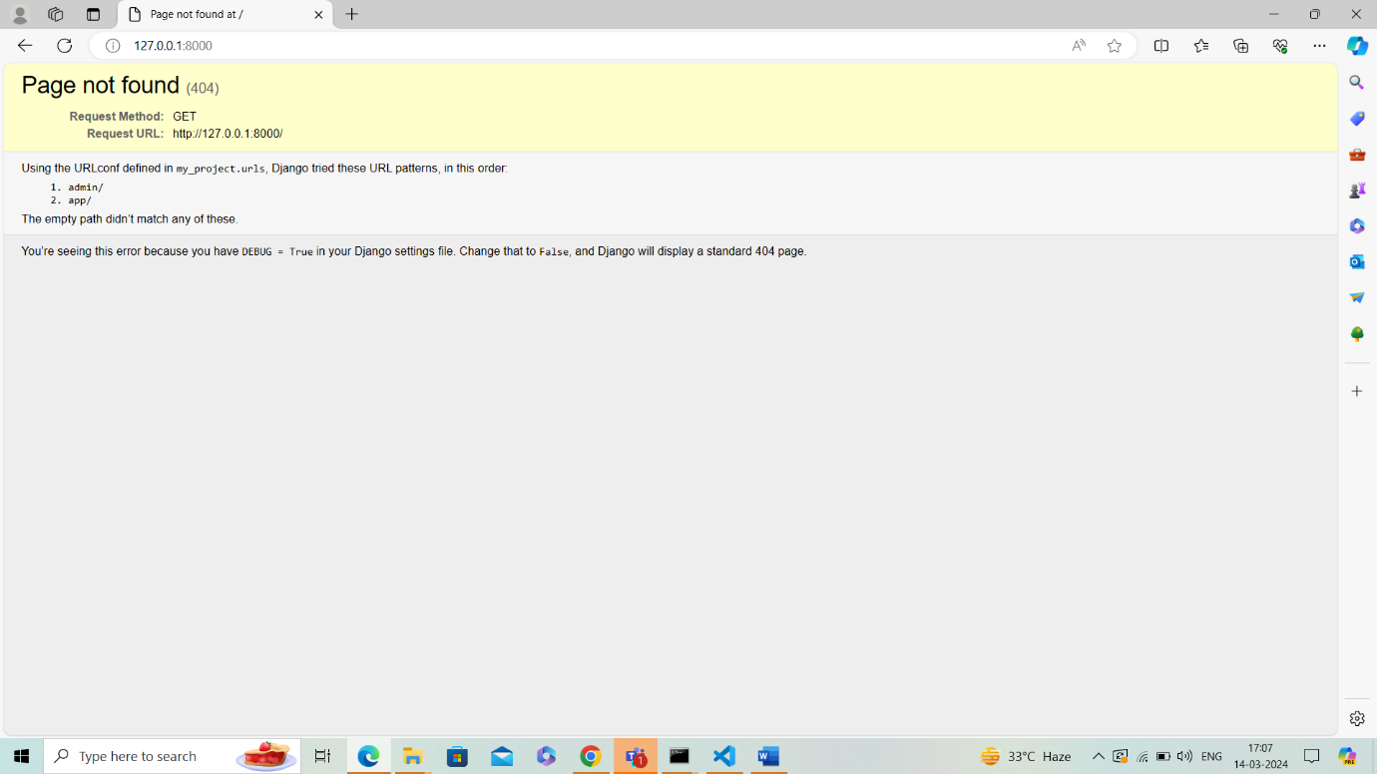](http://127.0.0.1:8000/%20%20%20)

[**http://127.0.0.1:8000/admin/**](http://127.0.0.1:8000/admin/)

This URL should take to the Django admin login page. Once logged in, you'll have access to the admin interface where you can manage your application's data models, including adding, editing, and deleting items.

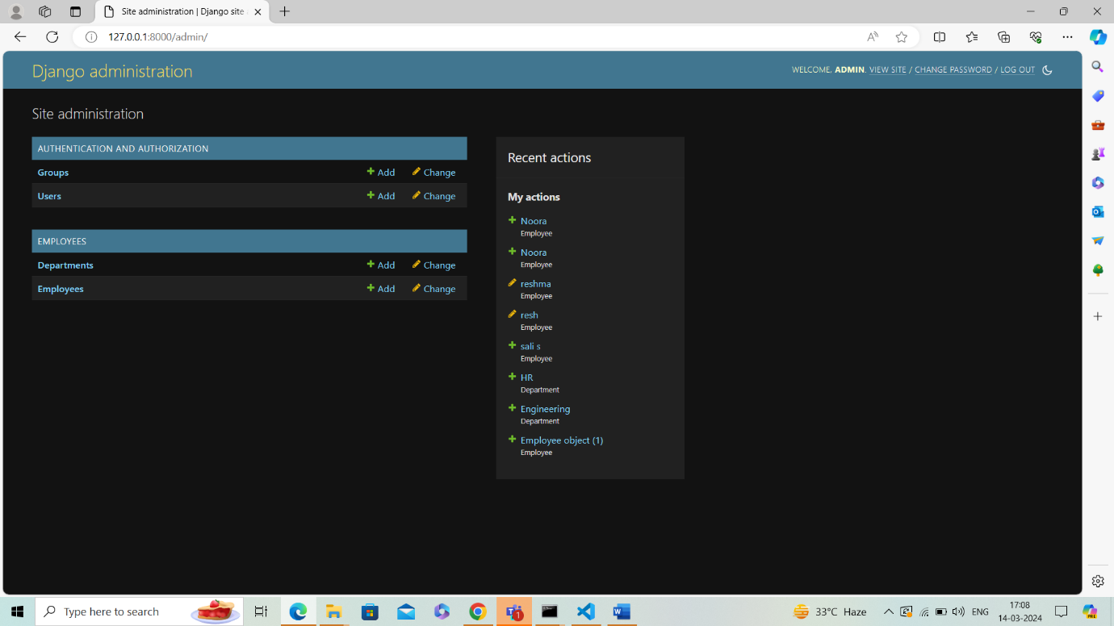

This shows the interface of employees details

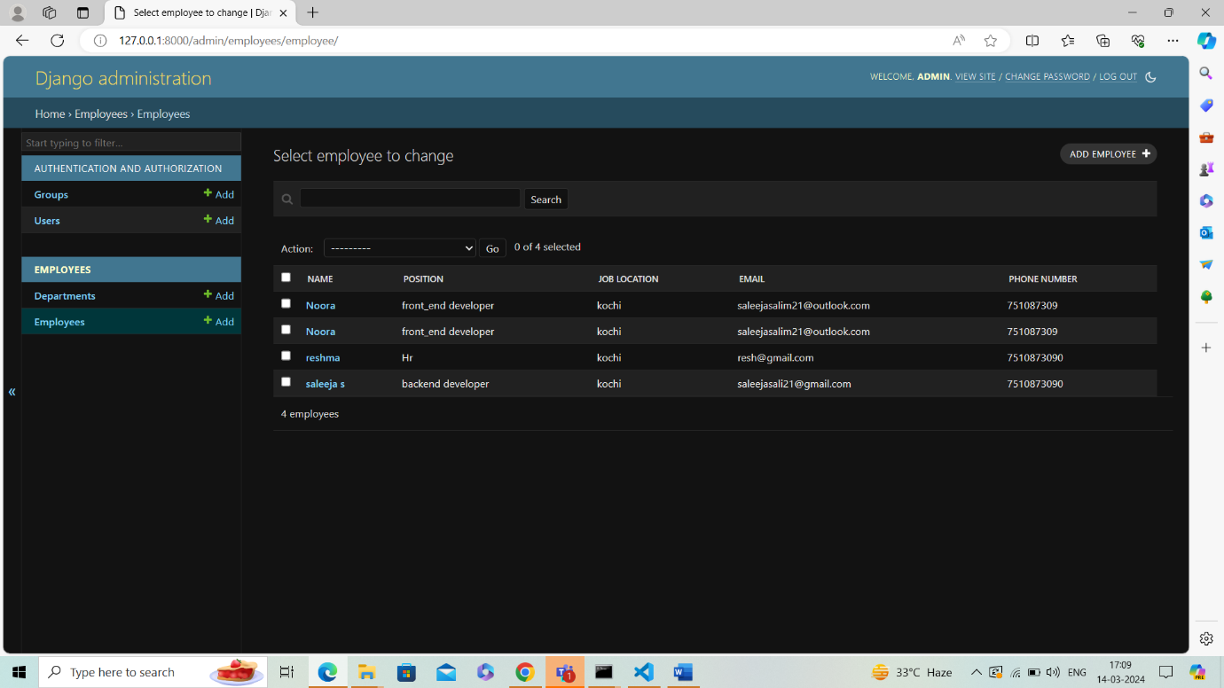

This shows the interface of department details

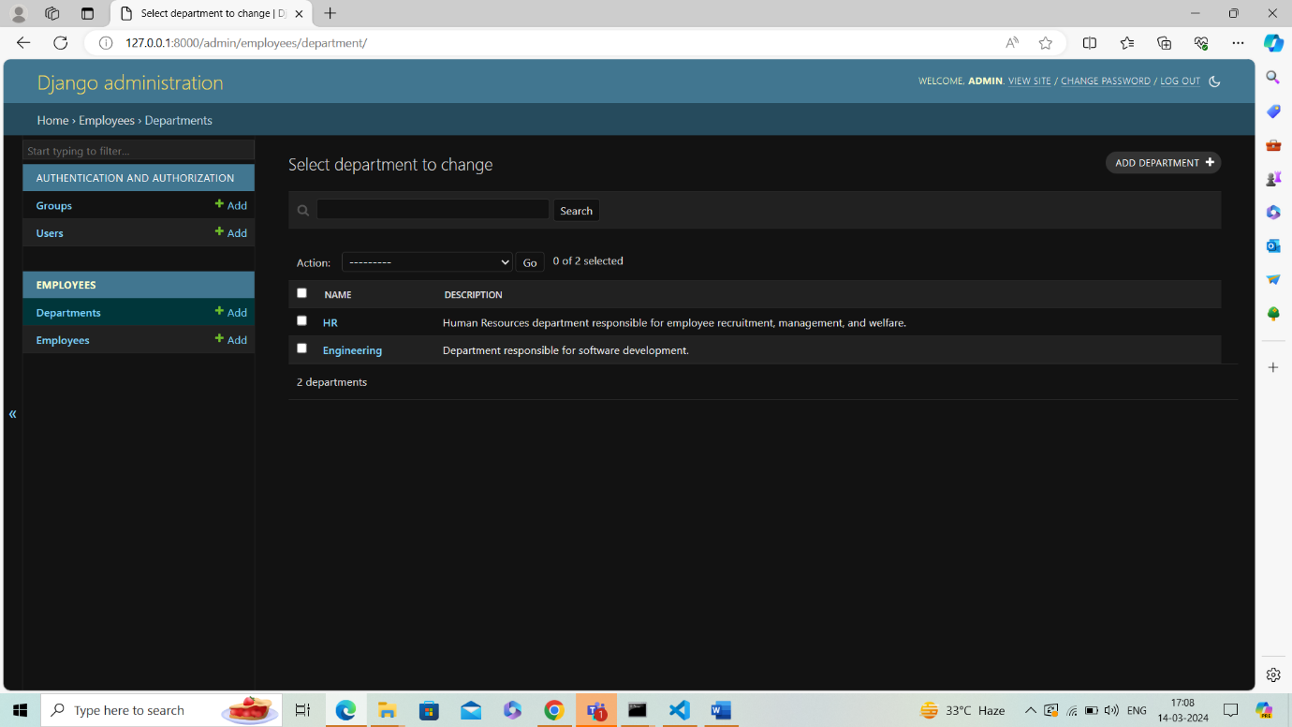

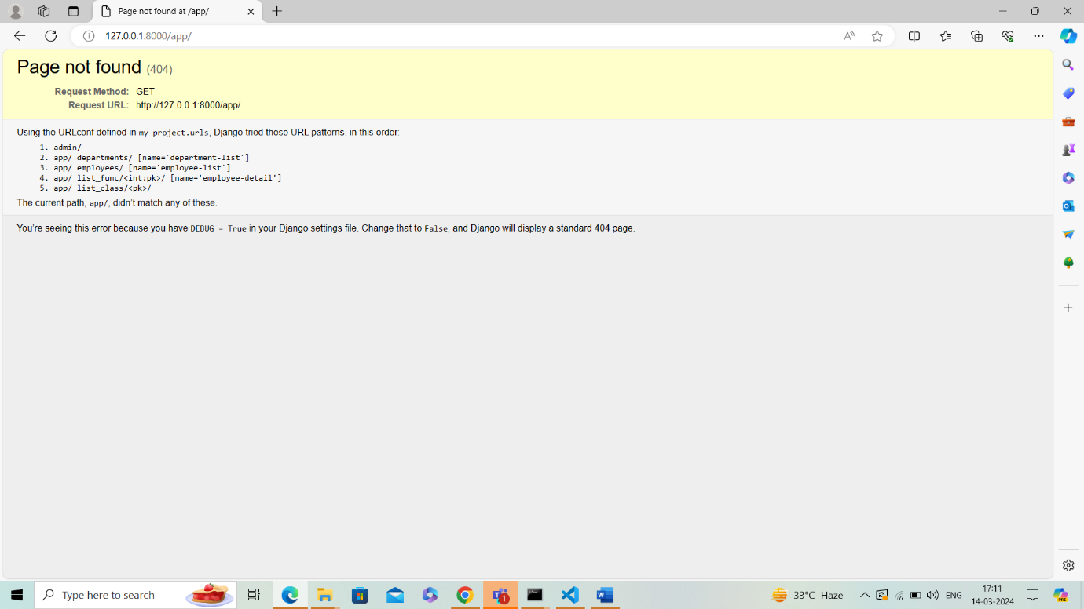

http://127.0.0.1:8000/app/departments/

This URL should display a list of departments stored in application's database. Each department entry will likely include details such as the department's name and description.

[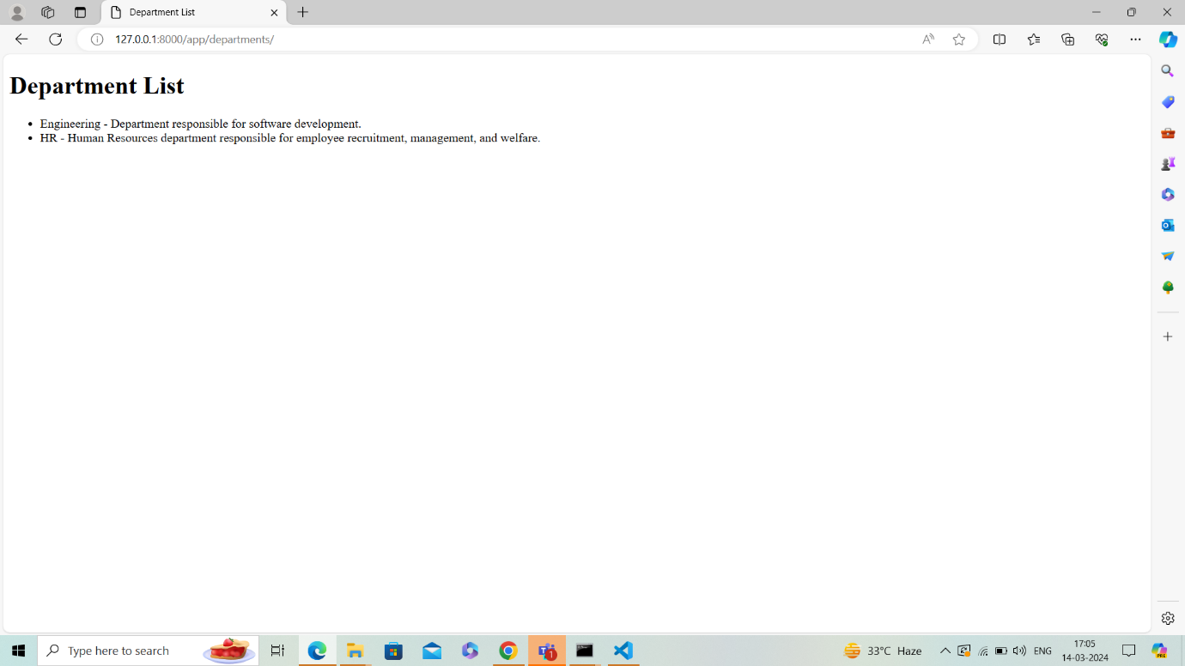](http://127.0.0.1:8000/app/departments/)

[**http://127.0.0.1:8000/app/employees/**](http://127.0.0.1:8000/app/employees/)

This URL should display a list of employees stored in application's database. Each employee entry will likely include details such as the employee's name, position, email, and phone number.

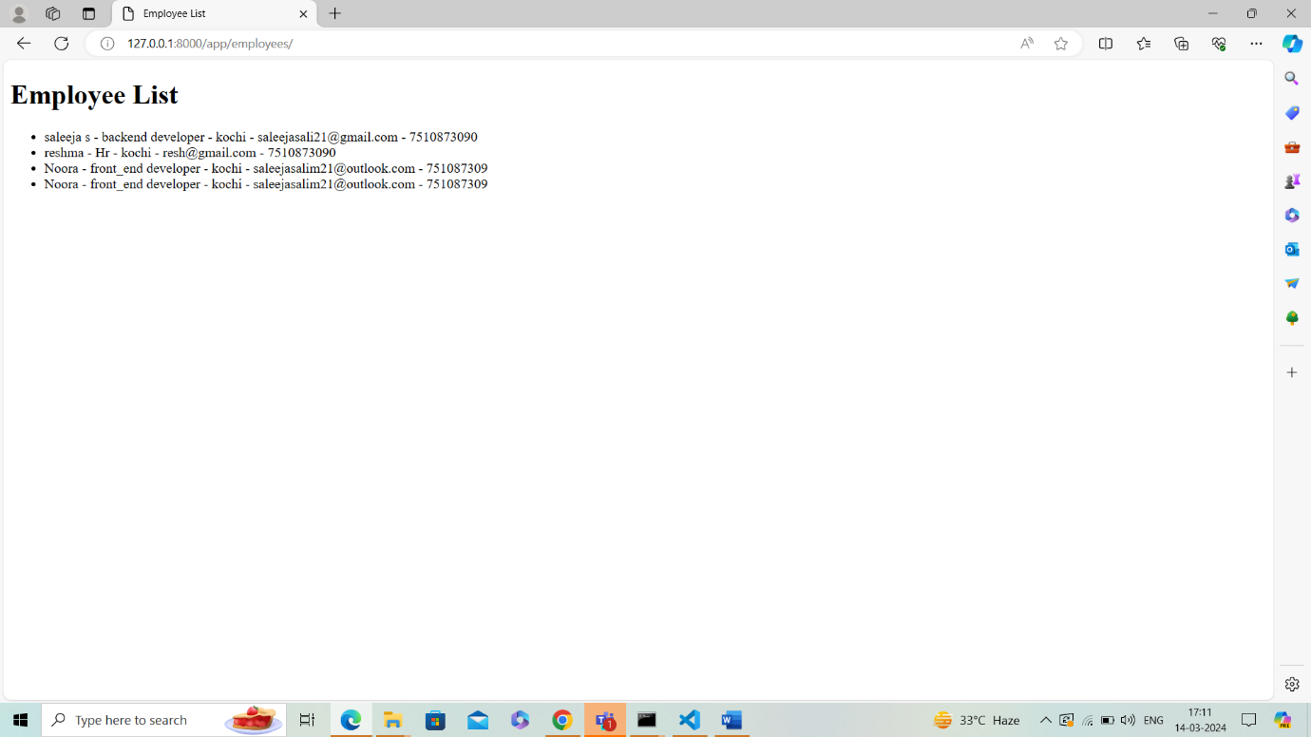

**http://127.0.0.1:8000/app/list_func/1/**

This URL may be intended to display the details of a specific department with the primary key (ID) of 1. The output should include details such as the department's name and description.

[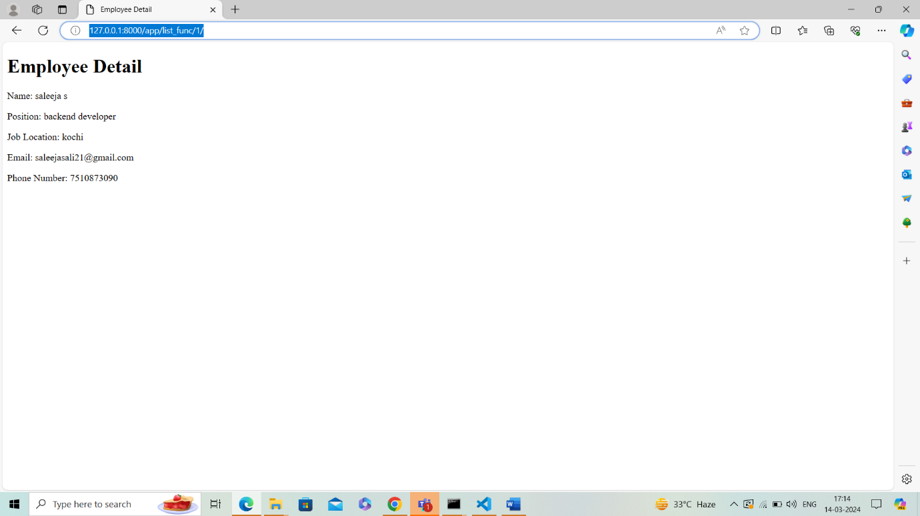](http://127.0.0.1:8000/app/list_func/1/)

[**http://127.0.0.1:8000/app/list_class/2/**](http://127.0.0.1:8000/app/list_class/2/)

This URL may be intended to display the details of a specific employee with the primary key (ID) of 2. The output should include details such as the employee's name, position, email, and phone number.