1. **INTRODUCTION**

The “Farmer welfare Society” is a web based application. It is implemented in Dreamweaver platform using PHP and MYSQL as back end database successfully designed and implemented according to the requirements and specifications. It helps the farmers by providing a smart management system for collecting, marketing, selling products to the buyers without the interference of external commission agents.

This portal is designed in such a way that it is a complete automated empowerment interface for agricultural sector. It also provides pensions, insurance policies, news services, awareness of government policies and schemes, education about the best practices and advanced method of cultivation, seeds and fertilizers. The customized modules satisfy the user needs.

The system is done with insight into the necessary modifications that may be required in the future. Hence the system can be maintained successfully without much rework. The system was tested with proper methods. User gets timely and accurate information from this system.

**1.1Objective and scope**

The project ‘**Farmer welfare society**’, this is proposed to be a new model of the day PDS system. In present there is no such functionalities in PDS. Software Requirement Specification is intends to develop a new idea for PDS through online by creating a website.

This project is used for maintain the public distribution system more effectively. They are the genuine customers of the website. They can view product and facility for identifying the product and also can know the information about the items.

The purpose of future enhancement is to make updating in the developed software and the needs arise and where technology comes. The future enhancement is subjected to the user needs and technological growth.

Through the new system provides a base for improving the efficiency of operations, there are lots of further enhancements that can be added to this projects. Keeping this in view, a provision has been made in the system to facilitate easy modification updating in the future. Any modification will not affect the normal working of the system. The developed system is very interactive, coded in such a way to ensure a maximum user friendliness, also allows flexibility for organization. The new system can be combined with an existing system as well. More and better advanced separation system can be build on the top of the proposed as and when the need arises. This is one of the main features of the proposed system.

**1.2 Problem definition**

The existing system is not a reliable method for the farmers or other goods producers to ensure the best price for their products in the market. The commission agents play a role in between these farmers and the market.

To overcome this problem a web based application can be developed which will resolve all these problems like,

* Excluding commission agents
* Automate the entire system, etc.

This portal is designed in such a way that it is a complete automated empowerment interface for agricultural sector.

**2. SYSTEM STUDY AND ANALYSIS**

**2.1 Existing system**

Farmers are the most Valuable assets of our society. At present a farmer faces a lot of problems in selling, marketing, collecting and transporting his products to the market. A farmer requires the help of a third person for making his products reach the market. There are possibilities of the products not reaching the market on time and hence the products might get spoilt. The delay might be due to the unavailability of proper transportation facilities. Our farmers are unaware of the pensions, insurance policies and many other policies provided by the government. In the existing system the process of billing is very complicated. The billing process is done manually. Due to this the amount of sold goods may take a long time to reach the farmer's hands. He may not even get it sometimes. There are so many policies approved by the government for farmers. These policies are known to the farmers only through the Gramsabha.

Every process that takes place in the Society regarding the selling of farmer's products are by a method called paadashekaram. The method of cultivation of same type of crops in three to four different fields is known as paadashekaram. The crops cultivated reach the Society by vehicles. All the products that reach the Society are manually examined and recorded. The Society consists of five people that are responsible for the complete process. It includes the President and the secretary.

The President adds the farmers manually by recording his details . He also adds the fields so that they can be allotted to the farmers for crop cultivation. This allotment is also done by the President. The payments are done to the farmers as soon the products reach the Society. The payment is done by cash. The secretary is the one who adds the new products arrived to the Society. He also updates abet the stocks in the Society. The President also provides the vehicles and many other tools and equipment’s for rent to the farmers. An organization named farmers producers company purchases the products from the Society and sell them. The purchased raw products are converted into many different items before selling. This is a government based company. This organization is managed by a manager. There are a lot of employees who works in this company. One part of the total profit gained by selling these products is given to the farmers as commission every year. Since all this is a Manual process it is time taking.

**Limitations of the existing system**

The limitation of the existing system is that manual work is used where clients contact through phone and so that they may not get correct details about availability of products, schemes provided transportation facilities and locations to view sites where the products are available.

* Since there is no automated system currently in this sector farmer and other goods producers are being exploited by different agents.
* Farmers have to sell their products to the commission agents at the price they insist.

**2.2 Proposed system**

The project "farmer welfare society web based application" is developed to improve the well being of the farmers and also to make their process of selling products easier.

The Society mainly consists of the President, secretary and three other people. Initially the President registers himself onto the website and once registered he can login to his profile using a username and password. The secretary can register once the President has created a profile for himself. If a new president or secretary has to be added them the already members i.e, the President or secretary has to be removed. Once they are removed a new profile can be created.

This website works on the basis of paadashekaram scheme. The method of cultivation of same type of crops in three to four different fields is known as paadashekaram. The homepage displays the main users. The companies data wish to purchase the goods can also register into this system. Both the company and the Society that compromises of the President and secretary can login to their individual profiles using the username and password assigned to them. The President adds different farmers to this system, he also has the authority to add different fields of different location . These fields are allotted to the farmers for farming. This site also allows the farmers to rent some vehicles like tractors and many other tools and equipment’s like hoe, pickaxe , etc. All these are monitored by the President.

All the newly arrived products are added by the secretary, all the products that has been added are displayed in the product list. The farmers who have been added also visible to the secretary. The product order status, delivery and the payment is monitored and managed by the secretary. The secretary also manages the existing and newly added companies .

Once a company has successfully Registered and logged in , the order of different products can be placed. The order placed by the company and the delivery of the order placed is managed by the secretary.

The companies convert the raw products purchased from the Society into different items. And one share of the total profit is credited to the farmers account every year.

Proposed system is a software application which avoids more manual hours.it is very easy to manage historical data in database.no specific training is required for the customers to use this application.

**Advantages**

* Simple to use and highly efficient.
* Maximum efficiency
* easy to enquire without going there
* Security of data get the information fast
* Reduce the work load of manager

**2.3 Feasibility study**

Feasibility study is an analysis and evaluation of proposed project to determine if it is feasible in term of technical, operational and economical feature. In this development team has to make communication with customer and make analysis of their requirement and analysis the system.

Various types of feasibilities are:

* Economic feasibility
* Operational feasibility
* Technical feasibility

**2.3.1 Economic feasibility**

In Economic feasibility, we found that the organization requires a computer system with windows OS. For ensuring smooth functioning of website in future, database have to be hosted at some paid server. So the system is found to be economically feasible currently.

**2.3.2 Technical feasibility**

The Technical feasibility is concerned with determining whether it is possible to do the project with the technology exists. The farmer welfare society is a web application. The front end is PHP and back end is MySQL. In the server side, a well-defined database is required. The system provides a centralized data base for storage. The system will run on window operating system with version 7 and above. A user friendly interface, easier of access, less effort and data security is provided to the user by the proposed system. Hence the system is found to be technically feasible.

**2.3.3Operational feasibility**

The proposed system is intended to be user friendly application with no former computer training required for the system user. As our system is a website it require only a web browser like internet explorer, Google chrome for execution. Our system will make the organizations work easier. The proposed system offers, security, ease of access, greater understands ability to the user. The operations of this site are absolutely simple. The reports are generated easily according to the user’s convenience.

**2.4 Cost-benefit analysis**

Cost benefit analysis give a clear picture on various costs and benefits associated with the proposed system. If the benefits of the proposed system weigh more than its cost, then system is considered feasible.

Let us consider the hardware requirements of the system. For the development, the developer requires a computer system with windows7 or above platform. These are easily available to the developer within a low cost. The personal cost includes human resource needed to operate the system, Cost for training etc. In this case, the system is very user friendly and easy to understand. So, no user training is needed.

The main cost required for the project is at the time of developing and implementing the software. Here the developing cost is on the basis of which software is used to develop the project. Here this project uses PHP in frontend and MySQL in backend. The developing cost is also depending on the scheduling of the project. In this project, no additional equipment is required. So it is cost effective.

**2.5 Module description**

There are four modules are available in this project they are

• Registration module

• Stock Management module

• Society module

•          Payment module

**2.5.1 Registration module**

Registration module contain so many functionalities. Company can choose products based on products categories. The important activities of this module are,

• User Registration (president, secretary, farmers)

• Company registration

**2.5.2 Stock management module**

This module is responsible for Collecting, Stocking and Selling the goods of farmers to the desired customer.

• Collecting the crops

• Manage Stock

• Company collect the products

• Update the stock

• Generate Reports on income and Expenditure

• Generate Reports on Stock

.

**2.5.3 Society module**

Societycan register in the system to get the quality agro products with affordable price and can avoid the intermediate sales agencies.

• Add new products

• Add Price details of items

• View items

• Company order items

• Receive order from company

• Society accept order

• Company purchase this item

• Society delivered to company

• Manage current news, events

• Manage government policies and schemes

**2.5.4 Payment module**

Payment module contain all payment details.

• Manage the Payment of society

• Manage the Payment of Farmers

• Manage commission

**2.6 Methodology**

The frontend of the application will be developed on PHP. So we need dream weaver. The back end will be MySQL.

The data is mainly collected from two sources such as primary and secondary sources. Primary data was collected through the use of following fact finding techniques such as questionnaire and interview. And the secondary data is collected from internet.

It is a web application to manage overall project within a software company. This project is use the waterfall model to complete the project. The reason for using waterfall model is that, it is the traditional method for managing projects and also the simplest method to understand. Here one task must be completed before the next one begins. It is an ideal method for projects that result in physical objects such as buildings, computers etc. And project plans can be easily replicated for future use. The power of this methodology is that every step is pre planned and layered out in the proper sequence.

**3. SYSTEM REQUIREMENTS**

**3**.**1** **Software requirements**

1 Minimum Softwarerequirements for the developer

Operating System : WINDOWS7/8

Front end : PHP and HTML

IDE : Dreamweaver

Back end : MySQL

Web browser : Internet Explorer/Google Chrome

Web server : Wamp

2 Software requirements for the user

Operating system : Microsoft windows 7or above

Browser : Mozilla firebox, chrome, internet explorer

**3.2 Hardware requirements**

1 Hardware requirements for the developer

Processor : Pentium III

Memory : 2 GB RAM with 10 GB disk space

2 Hardware requirements for the user

Processor :Intel atom/MT/Qualcomm snapdragon

Memory :1 GB RAM with 10 MB free ROM

Misc :Internet access

**4 .SYSTEM DESIGN**

**4.1Data flow diagram**

Data Flow Diagrams are used to define the flow of system and its resources such as information. DFDs are a way of expressing system requirements in a graphical manner. DFD represents one of the most ingenious tools used for structured analysis. A DFD is also known as a bubble chart. In the normal condition, logical DFD can be completed using only four notations.

Represents source or destination of data

Represents data flow

Represents a process that transforms incoming data.

Represents data store.

**Level 0**

This data flow diagram shows how the secretary, president and company can process farmer welfare society.



**LEVEL 1 : Functional units**

This data flow diagram describes the process of registration, view, and add. Registration process is done by secretary and president. The company can view products and purchase item. Secretary have the option to adding category, product.



**Level 2.2 society management**

Diagram shows the society details. Secretary can control four processes they are, login, add product category, add product, payment.

Secretary can login by using username and password. Secretary can add product category, add product, payment.

President can login by using username and password. president can add farmers, add field, and rental item.



**Level 2.3**



**Level 2.4 stock management**

Dataflow diagram shows the stock details The secretary can view the product, stock, famer, company, product order and payment. The president can view the profile, rental item.



**4.2 Database design**

**TABLE 4.2.1: Company**

Description : To store the details of the company.

Primary key : User name

|  |  |  |  |
| --- | --- | --- | --- |
| **FIELD** | **DATA TYPE** | **CONSTRAINTS** | **DESCRIPTION** |
| C_id | Int(11) | Primary key | Company id |
| Password | Varchar(20) | Not null | Password |
| Company Name | Varchar(30) | Not null | Name of the company |
| Address | Varchar(30) | Not null | Address of the company |
| Contact no | Varchar(20) | Not null | Phone number of the company |
| Email | varchar (30) | Not null | Email of the company |
| Accno | Varchar(20) | Not null | Company account number |
| Amount | Decimal(15,2) | Not null | Amount |

Table 4.2.1

**TABLE 4.2.2: User registration table**

Description : To store the details of the user.

Primary key : U_id

|  |  |  |  |
| --- | --- | --- | --- |
| **FIELD** | **DATA TYPE** | **CONSTRAINTS** | **DESCRIPTION** |
| U_id | Int(11) | Primary key | User Registration id |
| Name | Varchar(30) | Not null | Name of the farmer |
| Address | Varchar(30) | Not null | Address |
| District | Varchar(30) | Not null | Farmer district |
| PIN | Int(11) | Not null | Pin |
| Email | Varchar(30) | Not null | Farmer email |
| Phone | Varchar(20) | Not null | Phone |
| Gender | Varchar(10) | Not null | Gender |
| Accno | Varchar(20) | Not null | user account number |
| Amount | Decimal(15,2) | Not null | Amount |

Table 4.2.2

**TABLE 4.2.3: society**

Description : To store the details of the society

Primary key : Username

|  |  |  |  |
| --- | --- | --- | --- |
| **FIELD** | **DATA TYPE** | **CONSTRAINTS** | **DESCRIPTION** |
| Username | Varchar(50) | Primary key | Username |
| Password | Varchar(50) | Not null | Password |
| Name | Varchar(50) | Not null | User name |
| Address | Varchar(50) | Not null | Address |
| Place | Varchar(50) | Not null | Place |
| Gender | Varchar(10) | Not null | Gender |
| Email | Varchar(50) | Not null | Email |
| Contactno | Varchar(20) | Not null | User contactno |
| Usertype | Varchar(20) | Not null | Type of user |
| Accno | Varchar(30) | Not null | Society Account Number |
| Amount | Decimal(15,2) | Not null | Society amount |

Table 4.2.3

**TABLE 4.2.4: field**

Description : To store the details of the field

Primary key : Fieldno

|  |  |  |  |
| --- | --- | --- | --- |
| **FIELD** | **DATA TYPE** | **CONSTRAINTS** | **DESCRIPTION** |
| Fieldno | Int(11) | Primary key | Field number |
| Description | Varchar(30) | Not null | Field description |
| Status | Varchar(30) | Not null | Field Status |
| Farmer | Varchar(30) | Not null | Farmer name |

Table 4.2.4

**TABLE 4.2.5: Product type**

Description : To store the details of the product type

Primary key : ProductID

|  |  |  |  |
| --- | --- | --- | --- |
| **FIELD** | **DATA TYPE** | **CONSTRAINTS** | **DESCRIPTION** |
| Product typeID | Int(11) | Primary Key | Product type id |
| Type | Varchar(30) | Not null | Type |

Table 4.2.5

**TABLE 4.2.6: Product**

Description : To store the details of the product.

Primary key : ProductID

Foreign key : Product typeID, U_id

|  |  |  |  |
| --- | --- | --- | --- |
| **FIELD** | **DATA TYPE** | **CONSTRAINTS** | **DESCRIPTION** |
| ProductID | Int(11) | Primary key | Product id |
| U_id | Varchar(30) | Foreign key | Farmer name |
| Product typeID | Varchar(30) | Foreign key | Product type |
| Description | Varchar(30) | Not null | Product description |
| Quantity | Int(11) | Not null | Product quantity |
| Unit | Varchar(30) | Not null | Product unit |
| Price | Decimal(10,2) | Not null | Product price |
| Date | Date | Not null | Date |
| Photo | Varchar(100) | Not null | Product image |

Table 4.2.6

**TABLE 4.2.7: Product order**

Description : To store the details of the product order.

Primary key : Order No

Foreign key : ProductID

|  |  |  |  |
| --- | --- | --- | --- |
| **FIELD** | **DATA TYPE** | **CONSTRAINTS** | **DESCRIPTION** |
| OrderNo | Int(11) | Primary key | Productorder number |
| ProductID | Varchar(30) | Foreign key | Product id |
| C_id | In(11) | Not null | Company id |
| Quantity | Int(11) | Not null | Product quantity |
| Amount | Decimal(10,2) | Not null | Product amount |
| OrderDate | Date | Not null | Order date |
| Status | Varchar(30) | Not null | status |

Table 4.2.7

**TABLE 4.2.8: purchase**

Description : To store the details of the purchase

Primary key : PurchaseID

Foreign key : OrderNo

|  |  |  |  |
| --- | --- | --- | --- |
| **FIELD** | **DATA TYPE** | **CONSTRAINTS** | **DESCRIPTION** |
| PurchaseID | Int(11) | Primary Key | Id of purchase |
| ProductID | Varchar(20) | Foreign key | Id of product |
| Quantity | Int(11) | Not null | Quantity |
| Amount | Decimal(1,2) | Not null | Amount |
| Date | Date | Not null | Date |

Table 4.2.8

**TABLE 4.2.9: payment**

Description : To store the details of the payment

Primary key : PaymentID,

Foreign key : U_id

|  |  |  |  |
| --- | --- | --- | --- |
| **FIELD** | **DATA TYPE** | **CONSTRAINTS** | **DESCRIPTION** |
| PaymentID | Int(11) | Primary Key | Payment id |
| Date | Date | Not null | Payment date |
| Bank name | Varchar(30) | Not null | Bank name |
| Amount | Decimal(10,2) | Not null | Amount |
| U_id | Varchar(30) | Foreign key | User id |
| ProductID | Int(11) | Foreign key | Product id |

Table 4.2.9

**TABLE 4.2.10: Stock**

Description : To store the details of the stock

Primary key : StockID

Foreign key : ProductID

|  |  |  |  |
| --- | --- | --- | --- |
| **FIELD** | **DATA TYPE** | **CONSTRAINTS** | **DESCRIPTION** |
| StockID | Int(10) | Primary key | stock id |
| ProductID | Int(10) | Foreign key | Product id |
| Quantity | Int(10) | Not null | Quantity |
| Date | Date | Not null | Date |

Table 4.2.1

**TABLE 4.2.11: Rent Items**

Description : To store the details of the rent items

Primary key : R_ID

|  |  |  |  |
| --- | --- | --- | --- |
| **FIELD** | **DATA TYPE** | **CONSTRAINTS** | **DESCRIPTION** |
| RentID | Int(11) | Primary key | Rentitems id |
| Item | Int(11) | Not null | Item |
| Farmer | Varchar(50) | Not null | Photo |
| No of Quantity | Int(11) | Not null | Quantity |
| No of Days | Int(11) | Not null | Rate |
| Amount | Decimal(10,2) | Not null | Amount |
| RentDate | Date | Not null | Rent date |
| Photo | Varchar(100) | Not null | photo |

Table 4.2.11

**TABLE 4.2.12: Rentalitems**

Description : To store the details of the rent items

Primary key : ID

Foreign key : RentID, U_id

|  |  |  |  |
| --- | --- | --- | --- |
| **FIELD** | **DATA TYPE** | **CONSTRAINTS** | **DESCRIPTION** |
| ID | Int(11) | Primary key | Rentallocation id |
| RentID | Int(11) | Foreign key | Rent id |
| Rate | Double(1,2) | Not null | Rate |
| Quantity | Int(11) | Not null | Quantity |
| U_id | Int (11) | Foreign key | User id |

Table 4.2.12

**4.3 Input design**

**4.3.1 company: Registration**

This is the companyregistration page. For the regular usage of the website is possible details and the registered data is stored into the company table.

|  |
| --- |
| Company Name :    Username  Password  Email  Contactno    **submit OK** OK |

**4.3.2 Login**

This is the login form for company. The company enters to the home page by entering the username and password corresponding to them by using the login button. This details are stored in the company table.

|  |
| --- |
| User name  Password      **Login** |

**4.3.3 Society:** **President Registration**

This is the presidentregistration page. For the regular usage of the website is possible only through the registration. For the purpose user must filled the form with personal details and the registered data is stored into the society table.

|  |
| --- |
| User Name :  Password :  Name  Address  Place  Gender Male Female  Email  Contactno    **submit OK** OK |

**4.3.4 Login**

This is the login form for president. The president enters to the home page by entering the username and password corresponding to them by using the login button. This details are stored in the user registration table.

|  |
| --- |
| User name  Password      **Login** |

**4.3.5 Farmer registration**

This is the farmer registration page. For the regular usage of the website is possible only through the registration. For the purpose user must filled the form with personal details and the registered data is stored into the farmer registration table.

|  |
| --- |
| Name  Address  District  Pin  Gender Male Female  Email  Contactno    **submit OK** OK |

**4.3.6 Add fields**

President can add field description by using this form. The field descriptions entered as text input. The add button is used to add this data to the field table.

|  |
| --- |
| field description  **Add** |

**4.3.7 Rent item**

The president allow the farmers to rent some items by using this form. This data store in to rent item table.

|  |  |  |  |  |  |  |
| --- | --- | --- | --- | --- | --- | --- |
| Item  Quantity  Photo  **Add**  Browse  Rate/one day  **Submit**       |  |  |  | | --- | --- | --- | | Item | Quantity | Rate/1 day | |  |  |  | |

**4.3.8 Society: Secretary registration**

This is the Secretary Registration page. For the regular usage of the website is possible only through the registration. For the purpose user must filled the form with personal details and the registered data is stored into the society table.

|  |
| --- |
| User Name :  Password :  Name  Address  Place  Gender Male Female  Email  Contactno    **submit OK** OK |

**4.3.9 Add product Category**

Secretary can add product category by using this form. The product category is entered as text input. The add button is used to add this data to the product type table.

|  |
| --- |
| Product category    Add  **Add** |

|  |  |
| --- | --- |
| Product type |  |
|  | Delete |
|  | Delete |
|  | Delete |

**4.3.10 Add Product**

Secretary can add product details by using this form. The description, choose farmer quantity, rs, image is entered as text input. The add button is used to add this data.

|  |
| --- |
| products  choose farmer  Description  Quantity  Unit  Rs  Image  **Browse Browse**  **Add** |

**4.3.11** Payment

Users can settle the payment using this form.

|  |
| --- |
| Farmer  Bank name  Account no  Ifsc code    Date  **Submit**    **vmit** |

**4.4 Output design**

**4.4.1 Profile**

The user can view profile in this form.. Registered data is stored into the society table.

|  |
| --- |
| Name |
| Address |
| Place |
| Gender |
| Email |
| Contact no |

**4.4.2 Company Profile**

The Company can view profile in this form.. Registered data is stored into the Company table.

|  |
| --- |
| Company Name |
| Address |
| Email |
| Contact no |

**4.4.3 Secretary: Product list**

Using this page Secretary can view items.

|  |  |
| --- | --- |
| Image | Quantity:  Price : |

**4.4.4 Stock list**

Secretary can view stock list by using this form.

**4.4.5 Farmers**

Secretary can view farmers profile

|  |  |  |  |
| --- | --- | --- | --- |
| Name | Address | District | Phone |
|  |  |  |  |

**4.4.6 Company**

Secretary can view companies.

|  |  |  |  |
| --- | --- | --- | --- |
| Name | Address | Email | Contact no |
|  |  |  |  |
|  |  |  |  |

|  |  |  |  |
| --- | --- | --- | --- |
| Stock ID | Product ID | Quantity | Date |
|  |  |  |  |

**4.4.7 Product Orders**

Secretary can view product order then accept or reject.

|  |  |  |  |  |  |  |
| --- | --- | --- | --- | --- | --- | --- |
| Product | Company | Quantity | Amount | Order date | Status |  |
|  |  |  |  |  |  | Accept Reject |

**4.4.8 Items Delivered**

Secretary can view items status.

|  |  |  |  |  |  |  |
| --- | --- | --- | --- | --- | --- | --- |
| Product | Company  Name | Quantity | Amount | Order date | Status |  |
|  |  |  |  |  |  | Delivered |

4.4.9 President: Rent to farmer

President can view rent details

|  |  |  |  |
| --- | --- | --- | --- |
| Item | Quantity | Rate/1 day |  |
|  |  |  | Rent to farmer |

**4.4.10 Company: View Product**

Using this page, company can view products.

|  |  |
| --- | --- |
| Image | Quantity:  Price : |

**4.4.11 Company: order status**

Company order this products by using this page.

|  |  |  |  |  |
| --- | --- | --- | --- | --- |
| Product | Quantity | Amount | Date |  |
|  |  |  |  | order |

**4.5 Entity Relationship (ER-Diagram)**

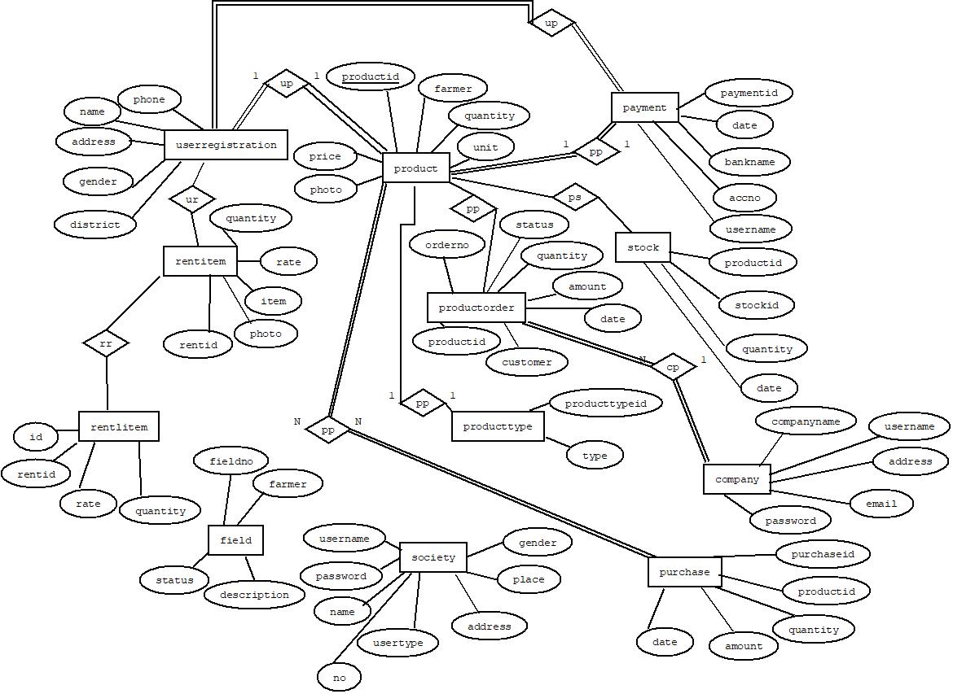

**5. SYSTEM TESTING AND MAINTENANCE**

### 5.1 SYSTEM TESTING

Testing is an activity to verify that a correct system is being built and is performed with the intent of finding faults in the system. However not restricted to being performed after the development phase is complete. But this is to carry out in parallel with all stages of system development, starting with requirement specification. Testing results once, gathered and evaluated, provide a qualitative indication of software quality and reliability and serve as a basis for design modification if required a project be set to be incomplete without proper testing.

System testing is a process of checking whether the development system is working according to the original objectives and requirements. The system should be tested experimentally with test data so as to ensure that the system works according to the required specification. When the system is found working, test it with actual data and check performance. All tests should be traceable to customer requirements. The focus of testing will shift progressively from programs. Exhaustive testing is not possible. To be more effective, testing should be one, which has probability of finding errors. Testing has been performed and they mainly come under the following categories...

1. Unit testing
2. Integration testing
3. Validation testing

## 5.1.1 Unit Testing

Unit testing is also known as component testing, it refers to verifying the functionality of a specific section of code, usually at the functional level. The website consist of different functional units. Each of the sections include different operations that are performed to the database. Each textboxes or fields will be tested and the data transmission from each field to database will be also tested.

On launching the website, it first displays the home page, then user registration occurs. Registration will completed using basic details of the users. After registration user can directly login to the system. Then they can request for different products. Secretary will verify the requests and accept it.

**5.1.2 Integration Testing**

Through each program work individually, they should work after linking together, this is referred to as integration testing, the reliable working of the application needs the movement of data across various forms and the database. The system is tested to verify that the user entered information are moving correctly. During data transfer, the format of the data should be in a consistent format, the incorrect data format cause the system to fail.

The database is checked against each operations from the system, that is behaves accordingly. There are different modules in the system. And each of these modules are integrated together. Then testing is performed to check the correctness of data transmission from these integrated modules to the database. Other possible errors are predicted and took prevention steps accordingly. There make testing each forms without filling the data in the appropriate boxes. If the necessary data is not enter in the textbox, then shows the validation errors.

## 5.1.3 Validation Testing

In validation testing make sure that the working capability of the system by retrieving the data from the database in proper way. In each form filling, the related information are moved in to the desired databases. To check the validity, that perform the desired task on the basis of the data from the databases. Validation test is used to check the correctness of each field in the form. In farmer welfare society, perform validation testing on all forms. Some fields are restricted as required. If submit the form without filling these fields raises the validation errors. Some are restricted to digits only and also gives the minimum and maximum length. Email is checked ‘@’ and’.’ symbol. Password is validated by checking the match of password and confirm password field.

**5.4 Maintenance**

A process of modifying a software system or component after delivery to correct faults, to improve performance is known as software maintenance. A common perception of maintenance is that it merely involves fixing defects. However, one study indicated that the majority, over 80%, of the maintenance effort is used for non-corrective actions. Software maintenance is a very broad activity that include error correction, enhancement of capabilities, deletion of obsolete capabilities, and optimization. Because change is inevitable, mechanism must be developed for evaluation, controlling and making modification. So many work done. The purpose is preserve the value of software over the time. The value can be enhanced by expanding the customer base, meeting additional requirements, becoming easier to use, more efficient and employing newer technology.

**6. IMPLEMENTATION**

Implementation is the stage where the theoretical design is turned into a working system. The implementation phase construct, install and operate the new system. Implementation phase of the software development is consigned with translating design of specification into source code. The primary goal of implementation is writes source code and internal documentation. So that conformance of the code to its specification easily verify and so that debugging and testing and modifications are erased. In the implementation phase the main challenge is adding security feature of the system. System implementation how we implement the system in a set of devices. It’s a web site. Web forms can be accessed using web browsers and which should be work on almost all the popular web browser. Then the developer can upload his product after the security verification. The user can find the site by search using the web site name.

Implementation is the process of converting a new or revised system design into operational one. Implementation is the stage in the project where the theoretical design is turned into a working system and is giving confidence on the new system for the users that it will work efficiently and effectively. It involves careful planning, investigation, design of methods to achieve the change over, an evaluation of change over methods. Apart from planning major tasks of preparing the implementation are training and education of users. Implementation of a computer system to replace a manual system. The problems encountered are converting files, training users, and verifying printouts for integrity. Implementation of a new computer system to replace an existing one. This is usually a difficult conversion. If not properly planned there can be many problems. Implementation of a modified application to replace an existing one using the same computer. Illegal use of any form is strictly avoided.Implementation is the final and important phase. The most critical stage is achieving a successful new system is giving the users confidence that the new system will work effective. The system can be implemented only after through testing is done and should be working according to the specification. This method also offers the greatest security since the old system can take over if the errors are found or inability to handle certain type of transactions while using the new system.

**7. SCREEN SHOTS**

**7.1 Homepage**

This is the main home page , and main users are company and society

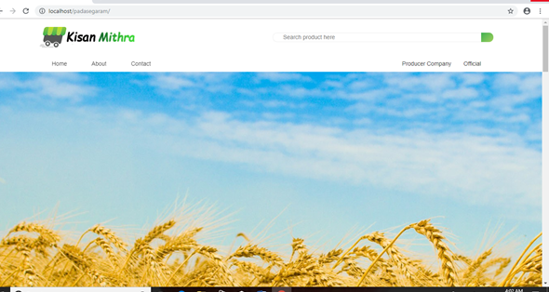

**7.2 Login**

Login form, where a secretary or president used to login into the web site. New user should click registration for the registration process. After registration process the user enter his username and password. By clicking the ‘login’ button he will be directed to the main window.



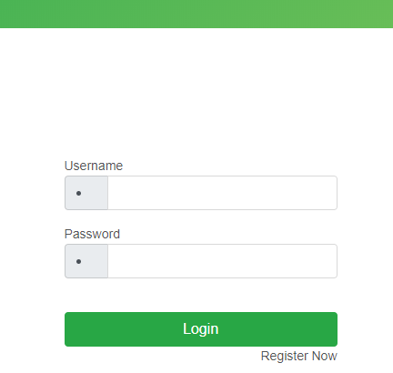

**7.3 Company Registration**

This is the company registration page. For thr purpose company user must filled the form with company details and the registerd data is stored into company table.

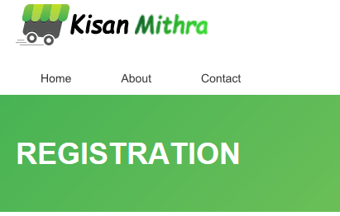

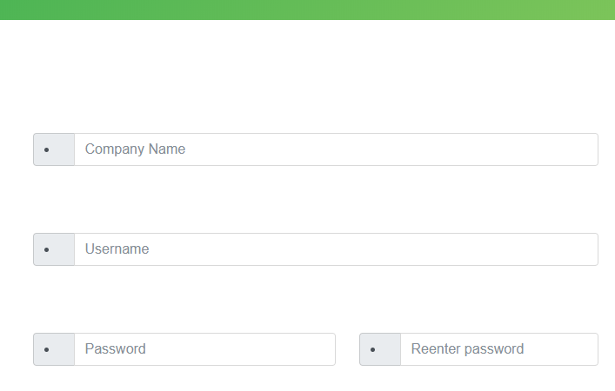

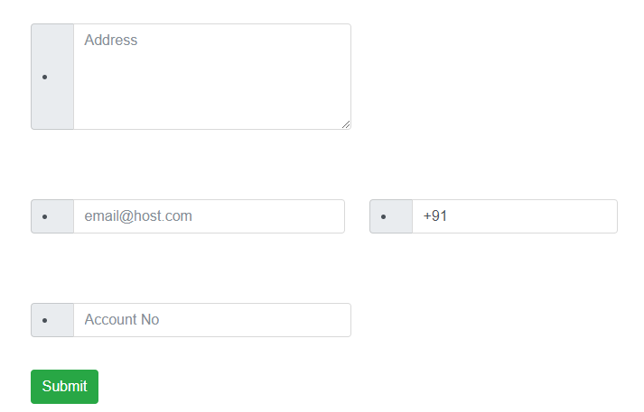

**7.4 Company profile**

Company can view company profile.

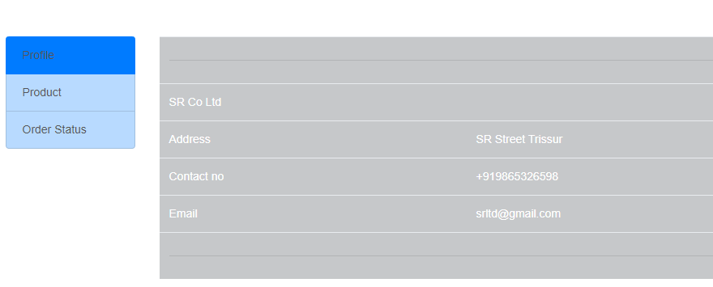

**7.5 Product**

Secretary can add new products. Then company can view this products by using this form.

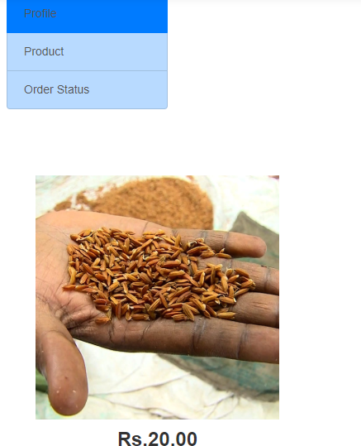

**7.6 Order Status**

Company can purchase the products by using this form.

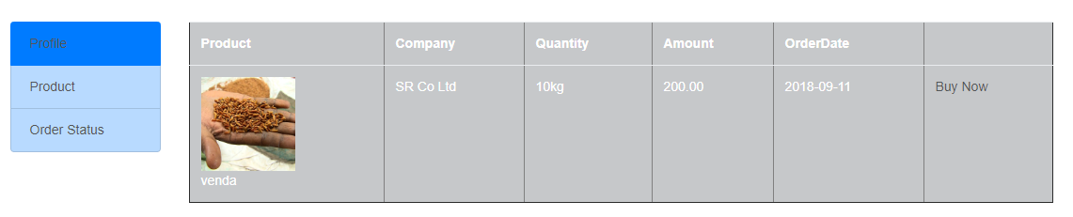

**7.7 Society :Secretary Login**

Secretary can login by using this form





**7.8 Profile**

Secretary can view the profile.



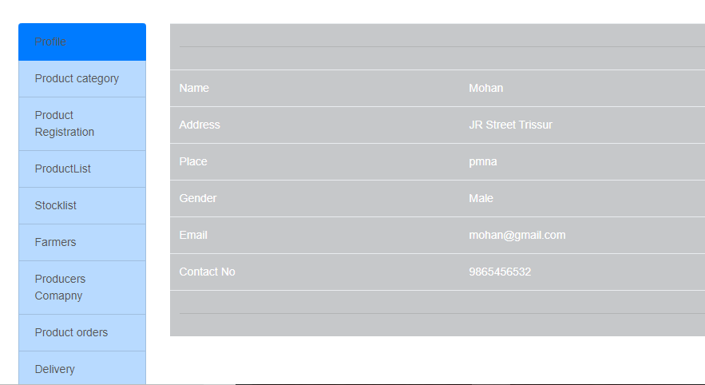

**7.9 Product Category**

Secretary can add new Product Category by using this form.

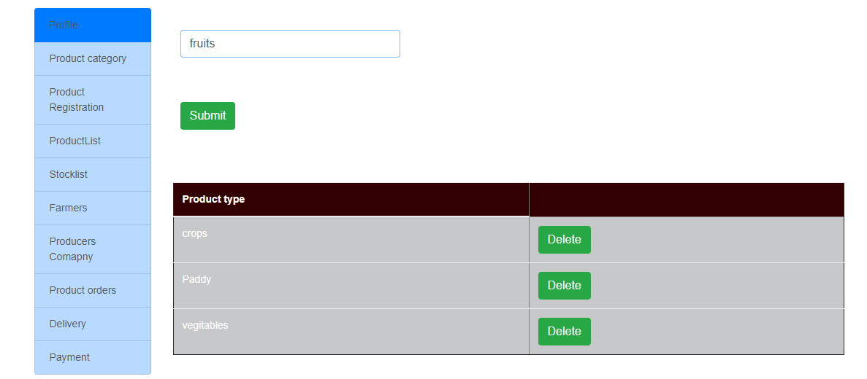

**7.10 Product Registration**

Secretary add new products.

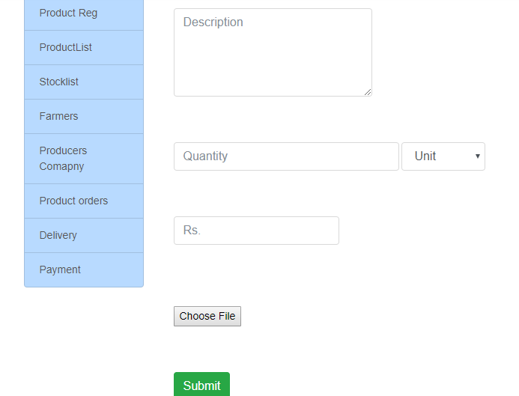

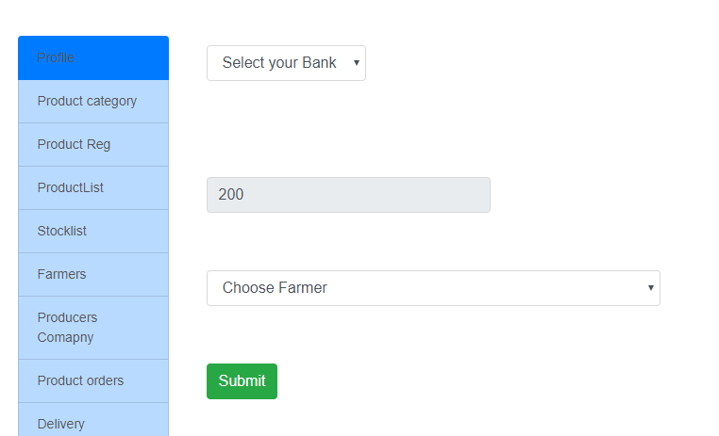

**7.11 Product List**

Secretary can view product list by using this form

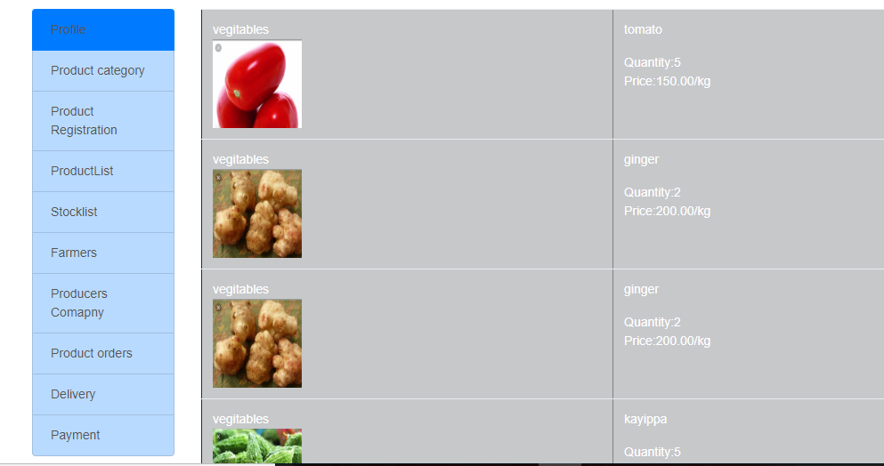

7.**12 Stock List**

Secretary can add product then update the stock list

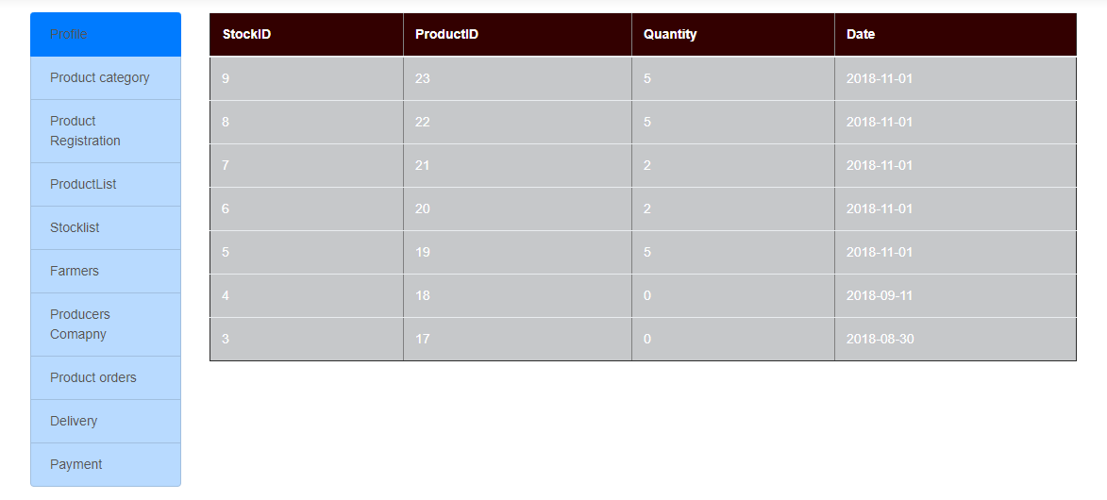

**7.13 Farmer**

Secretary can view the registered farmers by using this form

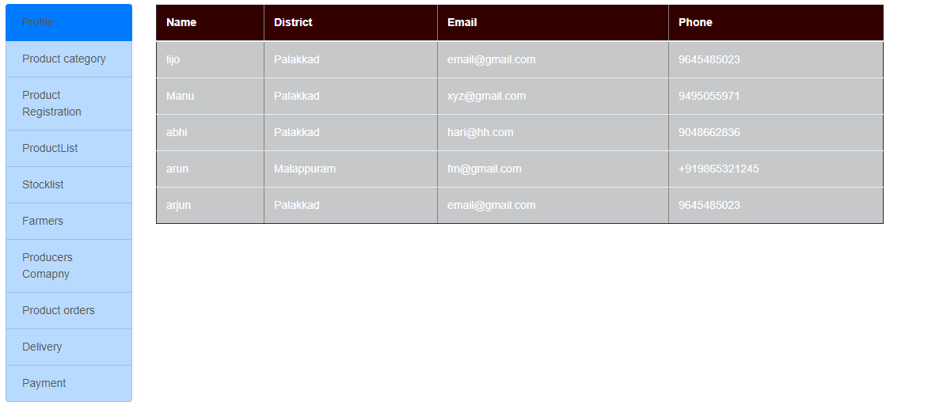

**7.14 Producers Company**

Secretary can view the registered company by using this form

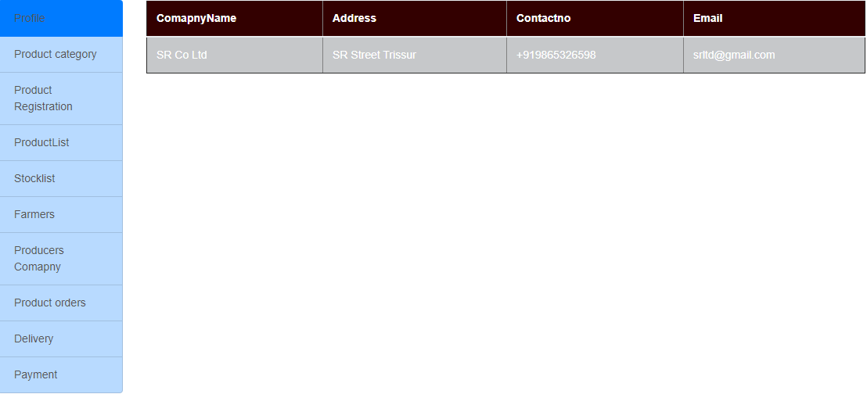

**7.15 Product order**

Secretary can add the products then company order the products by using this form

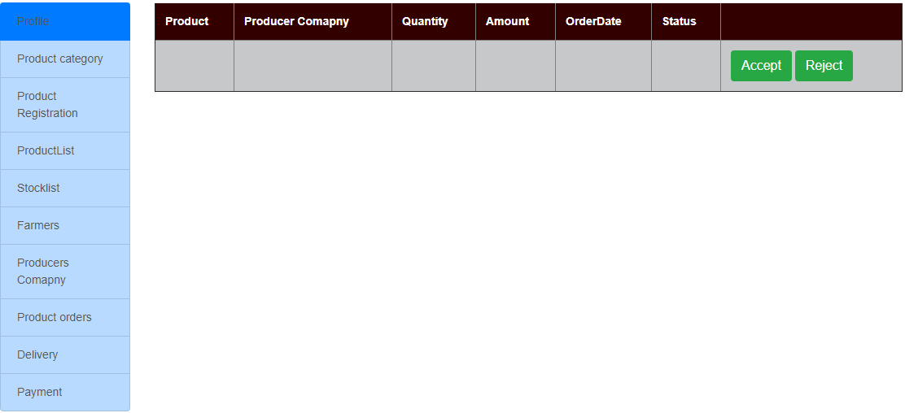

**7.16 Delivery**

Secretary can delivered the products by using this form

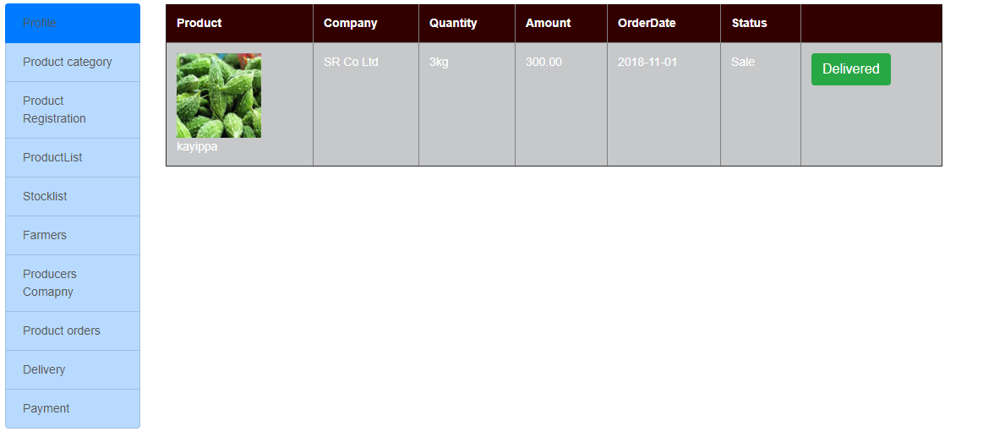

**7.17 Payment**

Secretary can view the payment details.

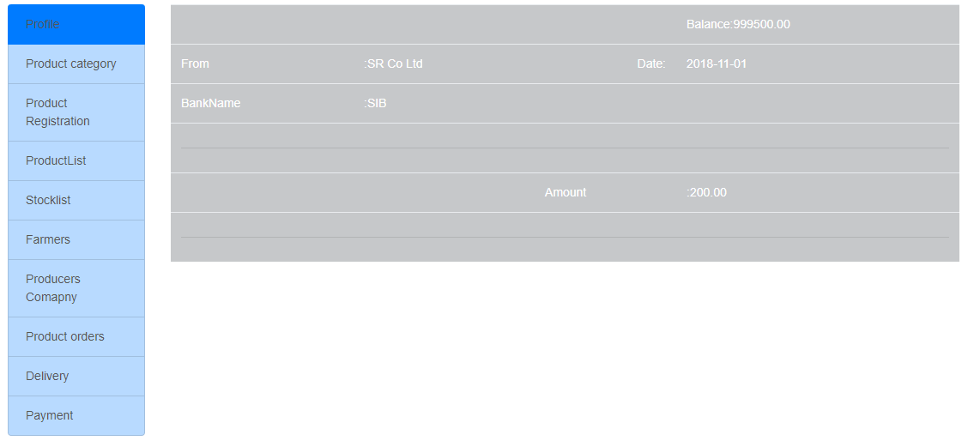

**7.18 Society: President Profile**

Presidentcan view the profile by using this page.



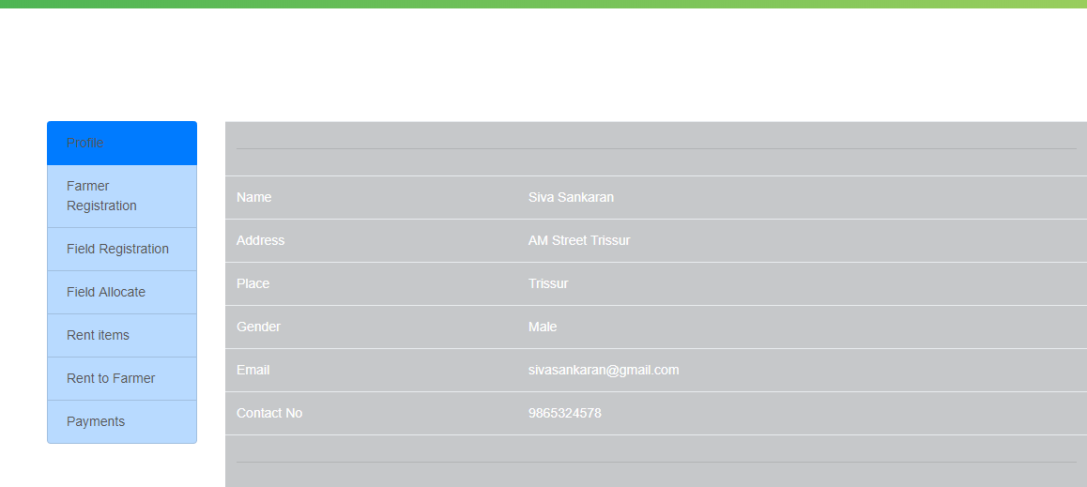

**7.19 Farmer Registration**

This is the farmer registration page. For the purpose farmer must filled the form and the registerd data is stored into userregistration table.



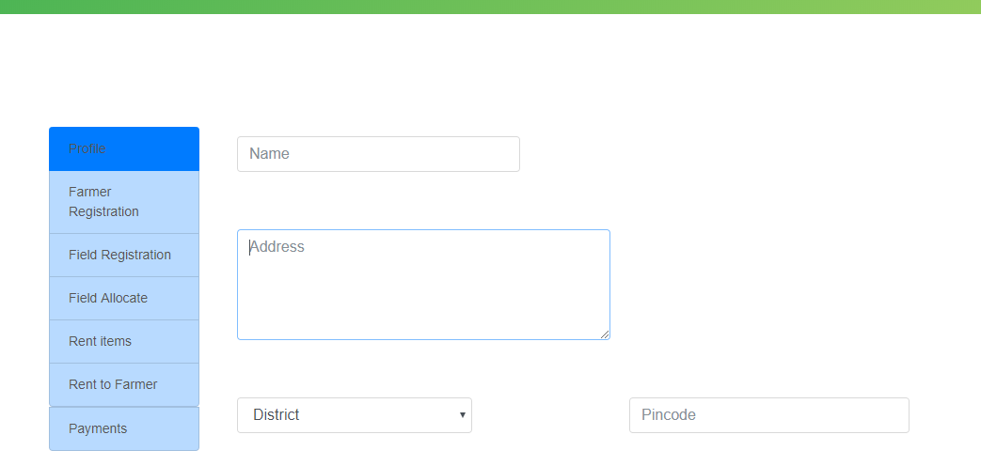

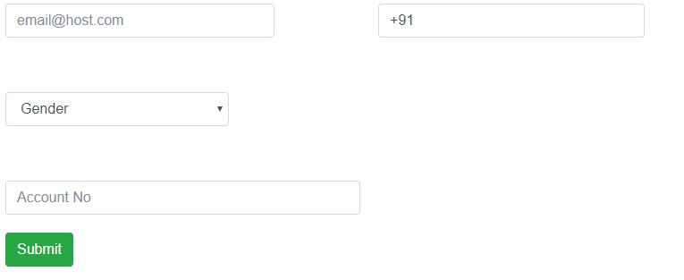

**7.20 Field Registration**

This is the field registration page. For thr purpose president user must filled the form details and the registerd data is stored into field table.

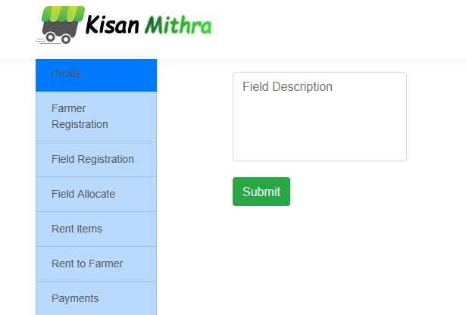

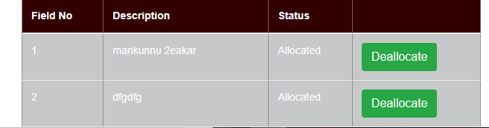

**7.21 Rent Item**

President can add new rent item by using this form

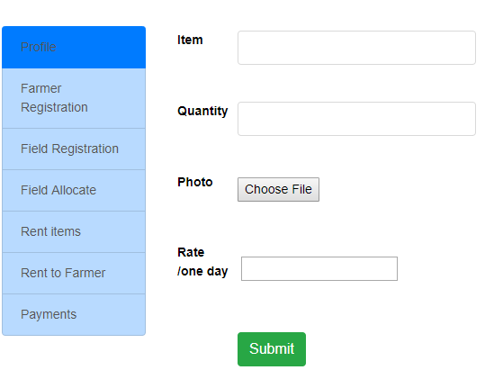

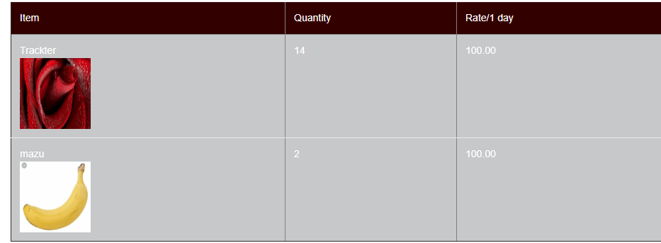

**7.22** Rent to Farmer

President can view the rent item

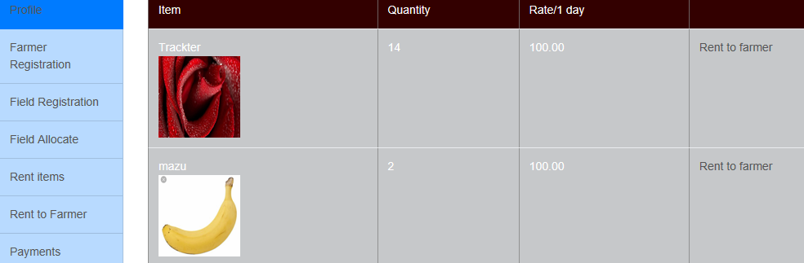

7.23 Payment

President can view payment details.

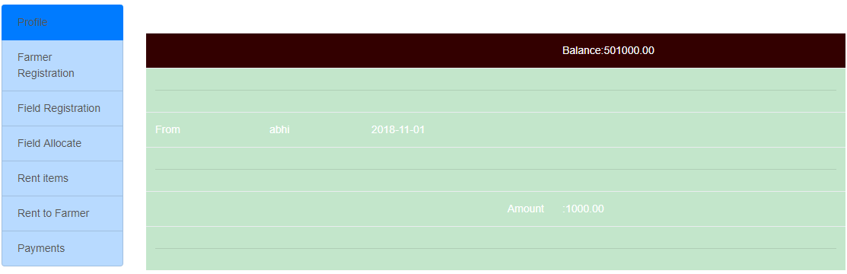

**8. FUTURE ENHANCEMENTS**

The future enhancement of the application is additional functionalities that can be added after the deployment of the application. Farmer welfare society has been designed and developed according to the current trend in the field and based on the basic limitations of the farmers of our country. This system is very flexible so that the maintenance and further development based on changing the environment and requirements can be made easily by adding further information. Agriculture is a sector which is important for the existence of the human race at any period of time. But the farmers who cultivate crops are still suffering. So these kinds of web portals which are meant to enhance the welfare of farmers must be reliably functioning and well maintained. The future scope has very much evolved in this sector.

In future, this web site will be changed into an app. Farmer welfare society can be involved online cash settlement

**9. APPENDICES**

**9.1 LIST OF TABLES**

|  |  |  |
| --- | --- | --- |
| SL NO | TABLE NAME | PAGE NUMBER |
| 1 | COMPANY | 20 |
| 2 | FARMER REGISTRATION | 20 |
| 3 | SOCIETY | 21 |
| 4 | FIELD | 21 |
| 5 | PRODUCT TYPE | 21 |
| 6 | PRODUCT | 22 |
| 7 | PRODUCT ORDER | 22 |
| 8 | PURCHASE | 23 |
| 9 | PAYMENT | 23 |
| 10 | STOCK | 24 |
| 11 | RENT ITEM | 24 |
| 12 | RENT ALLOCATE | 25 |

**9.2 List of Figures**

|  |  |  |
| --- | --- | --- |
| SL.NO | TABLE NAME | PAGE NUMBER |
| 1 | LEVEL 0 DFD | 14 |
| 2 | LEVEL 1 DFD | 15 |
| 3 | LEVEL 2.1 DFD: REGISTRATION | 15 |
| 4 | LEVEL 2.2 DFD: SOCIETY MANAGEMENT | 17 |
| **5** | LEVEL 2.3 DFD:STOCK MANAGEMENT | 19 |
|  | INPUT FORMS |  |
| **6** | COMPANY REGISTRATION | 26 |
| **7** | LOGIN | 27 |
| **8** | PRESIDENT REGISTRATION | 28 |
| **9** | LOGIN | 29 |

|  |  |  |
| --- | --- | --- |
| 10 | FARMER REGISTRATION | 30 |
| 11 | ADD FIELDS | 31 |
| 12 | RENT ITEM | 32 |
| 13 | SECRETARY REGISTRATION | 33 |
| 14 | ADD PRODUCT CATEGORY | 34 |
| 15 | ADD PRODUCT | 35 |
| 16 | PAYMENT | 36 |
|  | OUTPUT FORMS |  |
| 17 | PROFILE | 37 |
| 18 | COMPANY PROFILE | 37 |
| 19 | PRODUCT LIST | 37 |
| 20 | STOCK LIST | 38 |
| 21 | FARMER | 38 |
| 22 | COMPANY | 38 |
| 23 | PRODUCT ORDER | 38 |
| 24 | ITEM DELIVERED | 39 |
| 25 | RENT TO FARMER | 39 |
| 26 | VIEW PRODUCT | 39 |
| 27 | ORDER STATUS | 39 |

**10. CONCLUSION**

“Farmer Welfare Society" is successfully designed and implemented according to the requirements and specifications. It helps the farmers by providing a smart management system for collecting, marketing, selling products to the buyers without the interference of external commission agents. This portal is designed in such a way that it is a complete automated empowerment interface for agricultural sector. The system is done with insight into the necessary modifications that may be required in the future. Hence the system can be maintained successfully without much rework. The system was tested with proper methods. User gets timely and accurate information from this system.

**11.** **BIBLIOGRAPHY**

**BOOKS REFERRED**

[1] H. Abu-Libdeh, L. Princehouse, and H. Weatherspoon. RACS: A Case for Cloud Storage Diversity. In Proc. of ACM SoCC, 2010.

[2] R. Ahlswede, N. Cai, S.-Y. R. Li, and R. W. Yeung. Network Information Flow. IEEE Trans. on Information Theory, 46(4):1204–1216, Jul 2000.

[3] M. Armbrust, A. Fox, R. Griffith, A. D. Joseph, R. Katz, A. Konwinski, G. Lee, D. Patterson, A. Rabkin, I. Stoica, and M. Zaharia. A view of cloud computing. Communications of the ACM, 53(4):50–58, 2010.

[4] G. Ateniese, R. Burns, R. Curtmola, J. Herring, O. Khan, L. Kissner, Z. Peterson, and D. Song. Remote Data Checking Using Provable Data Possession. ACM Trans. on Information and System Security, 14:12:1– 12:34, May 2011.

[5] SQL The Complete Reference, 3rd Editionby [James R Groff](http://www.amazon.in/s/ref=dp_byline_sr_book_1?ie=UTF8&field-author=James+R+Groff&search-alias=stripbooks) (Author), [Paul N. Weinberg](http://www.amazon.in/Paul-N.-Weinberg/e/B001HCW97M/ref=dp_byline_cont_book_2)  (Author), [Andy Oppel](http://www.amazon.in/s/ref=dp_byline_sr_book_3?ie=UTF8&field-author=Andy+Oppel&search-alias=stripbooks) (Author) Paperback – Import, 1 Sep 2009

**WEBSITES REFERRED**

[1] [www.google.com](http://www.google.com)

[2] [www.w3schools.com](http://www.w3schools.com)

[3][www.tutorialspoint.com](http://www.tutorialspoint.com)