**Hard disk failed or not properly inserted**

**Below is the Summary to locate or troubleshoot the Hard disk failure for store**

Major Alert- Hypervisor Status store: -S13214-2M2126028V

Some time we get SOS & PagerDuty alerts and found that vNVR rebooting state in PF9.

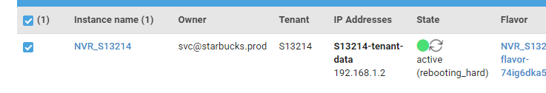

1. **First Step to get details about that store from docgen by running docclient command**

./docclient read S13214,ISC,document | jq -c '.Document | ( ( ( .nodes[] | { serial},{bmc_ip},{host_ip } ), { "region": .pf9.region } ), [ ( { "org": (

.meraki.organization | sub("609674799555281364";"a-l"

) | sub("609674799555281363";"m-z") ) }? | . ), ( .meraki.switch_ports[]? ) ] )';

1a. This docclient command gives you below information about store.

{"serial":"2M2126028V"}

{"bmc_ip":"10.112.51.206"}

{"host_ip":"10.112.51.205"}

{"region":"northwest-compute-2"}

[{"org":"a-l"},{"id":22,"type":"admin"},{"id":24,"type":"data"}]

1. **Check the Meraki Status for Store: - (Switch Reachability & Up time, Admin & Data port Traffic and link)**

2a. If you find Switch Reachability & Up time, Admin & Data port Traffic and link is ok!! then you are good with Meraki.

1. **check ILO & Host accessibility by using BMC IP and Host IP which we get from doclient command**

{"bmc_ip":"10.112.51.206"} and Host access {"host_ip":"10.112.51.205"}

3a. ILO accessibility check: - For this You must connect jump server first.

salahmed@VDI10a-1917:~$ ssh -D 2721 jump

USE OF THIS COMPUTING SYSTEM IS RESTRICTED TO THE CONDUCT OF COMPANY

BUSINESS BY AUTHORIZED USERS. ALL INFORMATION AND COMMUNICATIONS ON THIS

SYSTEM ARE SUBJECT TO REVIEW, MONITORING, AND RECORDING AT ANY TIME

WITHOUT NOTICE. UNAUTHORIZED ACCESS OR USE MAY BE SUBJECT TO PROSECUTION.

Last login: Thu Apr 21 09:20:18 2022 from vdi10a-1917.starbucks.net

USE OF THIS COMPUTING SYSTEM IS RESTRICTED TO THE CONDUCT OF COMPANY

BUSINESS BY AUTHORIZED USERS. ALL INFORMATION AND COMMUNICATIONS ON THIS

SYSTEM ARE SUBJECT TO REVIEW, MONITORING, AND RECORDING AT ANY TIME

WITHOUT NOTICE. UNAUTHORIZED ACCESS OR USE MAY BE SUBJECT TO PROSECUTION.

3b. Brows BMC IP https ://10.11X.1X5.19X

Username: - Administrator

Password you can get from password vault (pat.starbucks.net/PasswordVault/v10/Accounts)

3c. Now you have ILO screen in front you – first you check the health by clicking Right Tick on Top right

3d. Click on console (HTML5 Console) and sometimes you will get the screen with below Error msg that mean something wrong with Hard disk

**Failed to open system journal: input/output error**

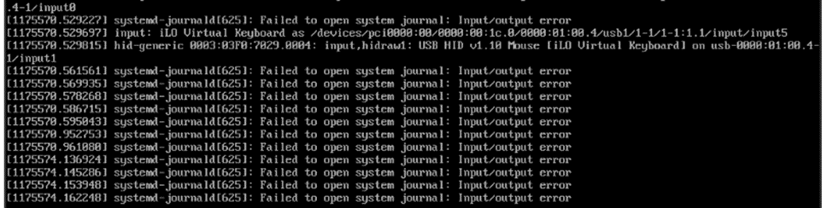

3e. To check the hard disk, you need to login system utility by pressing F9, after reboot or click on ctrl+Alt+dlt

Now you have system utility screen just click on system information—Storage Device information.

Here you see only one Hard Disk running second one may be failed not Disk latch not properly inserted.

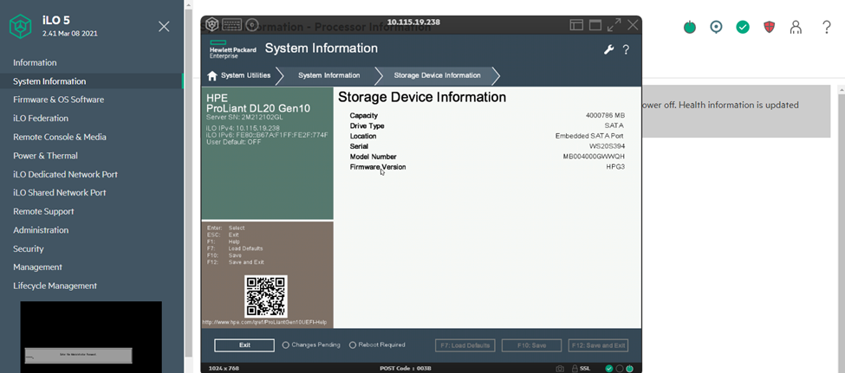

1. **For this we need to raised NCR ticket with Team.**