

**ROLL.NO: 19IT48**

**ASSIGNMENT: 2nd, 3rd**

**SUBJECT: DS&A**

**DEPARTMENT: IT**

**DATE: 12/06/2021**

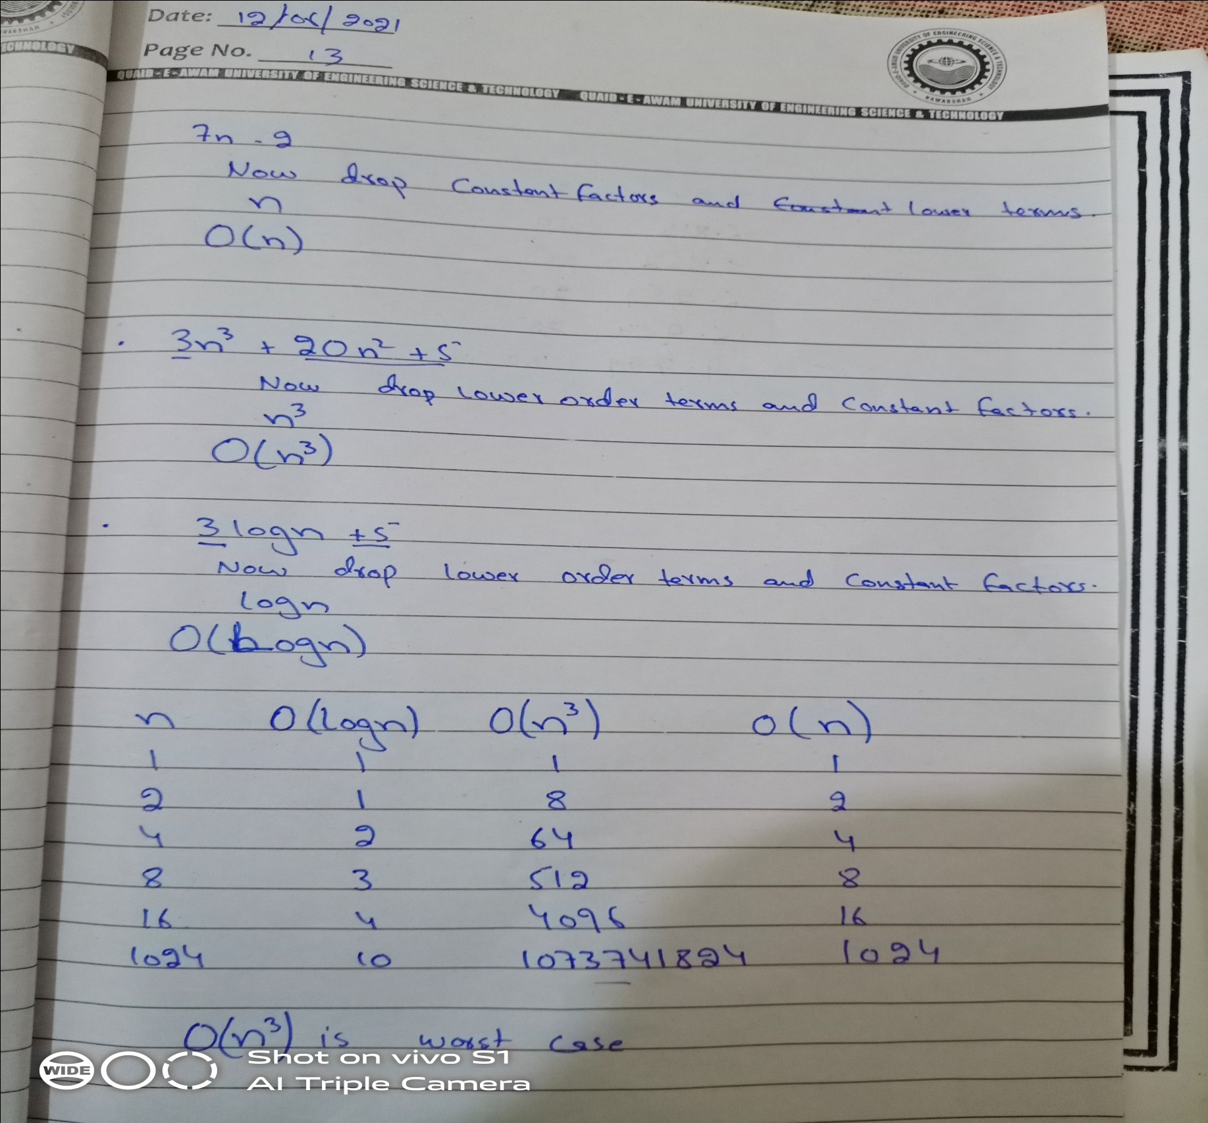

|  |  |  |
| --- | --- | --- |
| S. No | INPUT | RUNNING TIME |
| 1 | 5 | 7.24 |
| 2 | 10 | 6.81 |
| 3 | 15 | 5.15 |
| 4 | 20 | 6.25 |
| 5 | 25 | 6.8 |
| 6 | 30 | 4.79 |