MINI-PROJECT REPORT
Design & Structural Simulation of an Automotive Lower Control Arm
Specialization: Automotive | Deliverables: CAD model + simulation results + report

1. Introduction & Objective
The lower control arm (also called an A-arm or wishbone) is a primary link in an independent front suspension. It locates the wheel hub relative to the chassis while transmitting vertical, longitudinal (braking/acceleration) and lateral (cornering) loads between the road and the vehicle body. Because it is a safety-critical load path, it must not yield or fail under the most severe operating loads.
The objective of this mini-project is to (i) create a parametric 3D CAD model of a lower control arm, (ii) analyse it under realistic driving load cases using a finite-element beam model with classical combined-stress theory, and (iii) verify — and if necessary improve — the design so that it meets a target factor of safety of 1.5 against yielding.

2. CAD Model
The arm was modelled parametrically in CadQuery and exported to STEP (for CAD interchange) and STL (for meshing/printing). It uses the classic A-arm topology: two coaxial inboard bushings that pivot on the chassis mount, and a single outboard ball-joint boss at the apex that connects to the steering knuckle. Two tapered legs form the load-carrying structure.
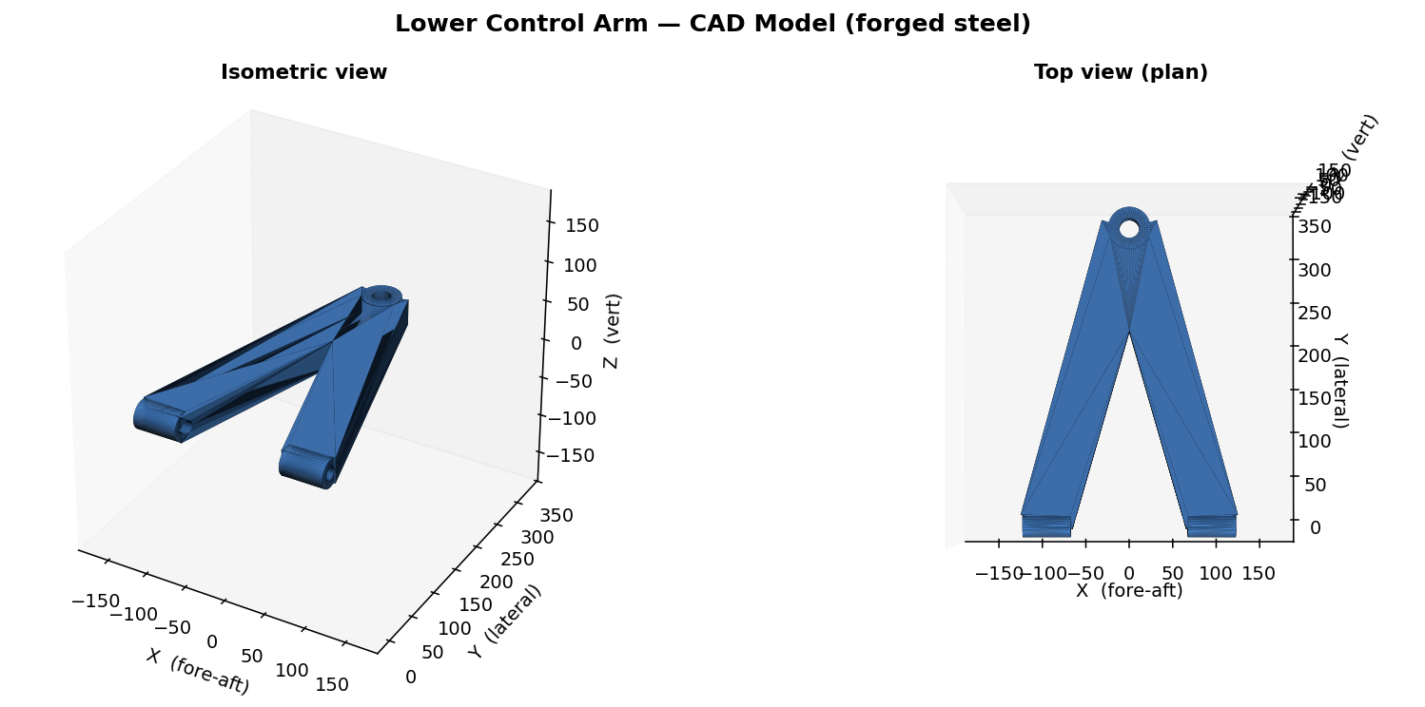
Figure 1 — Isometric and plan views of the lower control arm CAD model.
Overall envelope and mass properties of the final design:
Property | Value
Envelope (X x Y x Z) | 236 x 360 x 34 mm
Material volume | 1207 cm3
Mass (forged steel) | 9.48 kg
Bushing bore / ball-joint bore | 16 mm / 22 mm
Leg cross-section (final) | 58 x 32 mm

3. Material Selection
Forged steel AISI 1045 (normalized) was selected — a common, cost-effective choice for high-volume suspension components, offering good strength and fatigue performance. Key properties used in the analysis:
Property | Symbol | Value
Young's modulus | E | 205 GPa
Shear modulus | G | 80 GPa
Yield strength | Sy | 450 MPa
Ultimate strength | Sut | 585 MPa
Density | rho | 7850 kg/m3

4. Loading & Boundary Conditions
A front-corner static wheel load of ~4.7 kN was assumed (1600 kg vehicle, front-biased weight distribution). Three governing load cases were applied at the ball joint, representing the worst events the arm must survive:
- Vertical bump (3g): 14.1 kN vertical — hitting a pothole / hard landing.
- Braking (1g): 6.0 kN longitudinal + 4.7 kN vertical — emergency stop.
- Cornering (1.1g): 7.0 kN lateral + 4.7 kN vertical — hard turn on the loaded outer wheel.
Boundary conditions: the two inboard bushing centres were fully fixed (a conservative idealisation of the chassis mounts); loads were applied at the ball-joint node.

5. Analysis Methodology
The arm was idealised as a 3D frame of two Euler-Bernoulli beam elements (2 nodes, 6 DOF/node) joining the ball joint to each bushing. The global stiffness system was assembled and solved for nodal displacements and reactions; element internal forces (axial N, shear V, torsion T, bending moments My, Mz) were then recovered. At the critical section the combined normal and shear stresses were computed and reduced to an equivalent von Mises stress:
s = N/A + My/Sy + Mz/Sz ; t = T c/J + 1.5 V/A ; s_vM = sqrt(s^2 + 3 t^2)
The factor of safety against yielding is FoS = Sy / s_vM. A target of FoS >= 1.5 was set for all load cases.

6. Results & Discussion
The initial (baseline) design used a 22 mm-thick plate section. It passed the braking and cornering cases comfortably but FAILED the 3g bump case (von Mises 505 MPa > 450 MPa yield; FoS = 0.89). The bump load bends the arm about its weak vertical axis, where the thin plate has a small section modulus — the classic failure mode for plate-type control arms.
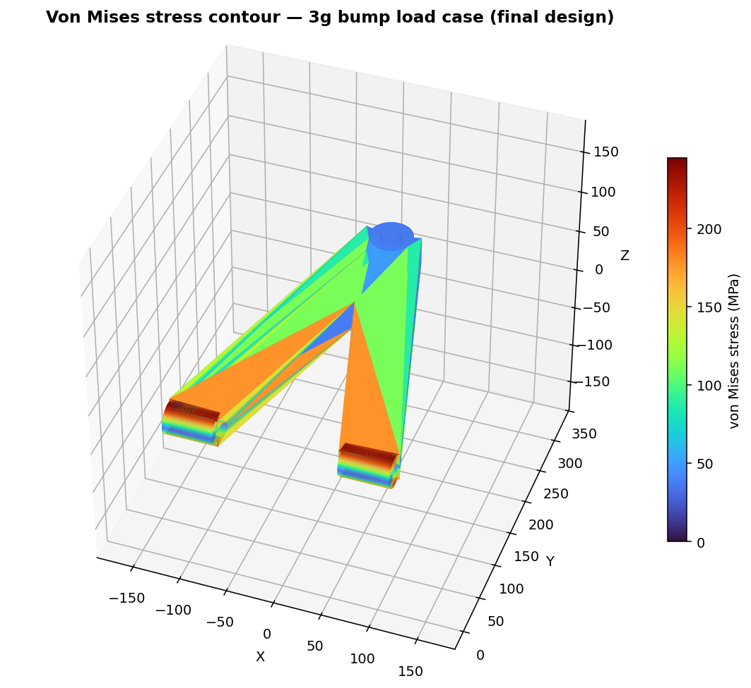
Figure 2 — Von Mises stress contour, 3g bump case (final design). Stress peaks at the outer fibres near the fixed bushings and is low near the loaded apex, consistent with a bending-dominated frame.
Design iteration: the plate thickness was increased from 22 mm to 32 mm (and the legs slightly widened). Because the weak-axis section modulus scales with thickness squared, this more than halved the bump stress at a mass penalty of ~3 kg. The revised design meets the FoS >= 1.5 target in every case.
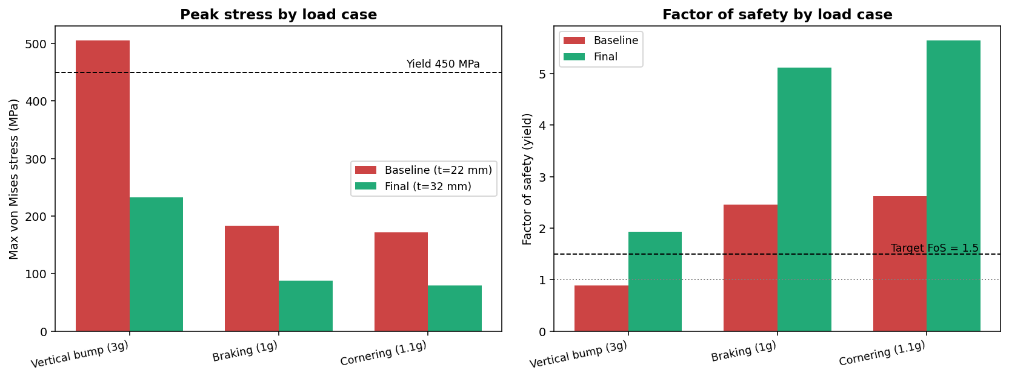
Figure 3 — Peak von Mises stress and factor of safety, baseline vs. final design, for all three load cases.
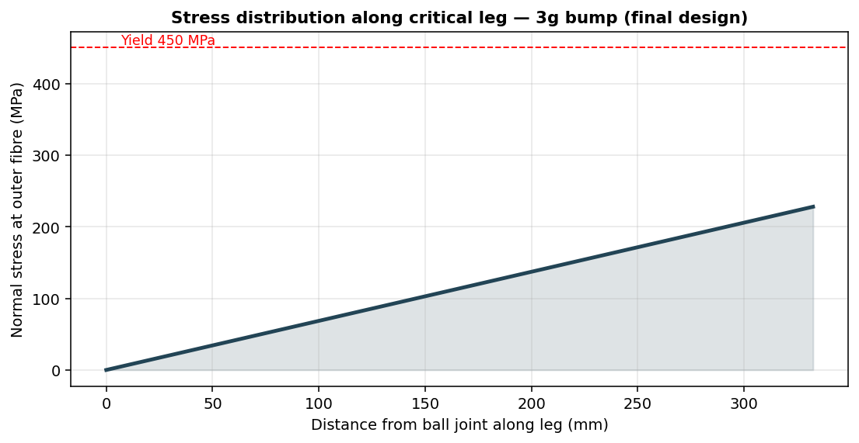
Figure 4 — Normal stress along the critical leg (3g bump, final design): maximum at the fixed bushing end, decreasing toward the ball joint.
Summary of results (critical element per load case):
Load case | vM baseline (MPa) | FoS baseline | vM final (MPa) | FoS final
Vertical bump (3g) | 505 | 0.89 (fail) | 233 | 1.93
Braking (1g) | 183 | 2.46 | 88 | 5.12
Cornering (1.1g) | 171 | 2.62 | 80 | 5.64
A first-order fatigue check (estimated endurance limit Se ~ 168 MPa) indicates the bump case is the fatigue-limiting condition and warrants generous fillet radii at the leg-to-boss junctions in detailed design.

7. Conclusion
- A parametric CAD model of an automotive lower control arm was created and exported to STEP and STL.
- A 3D beam-FEA plus combined-stress analysis was performed for bump, braking and cornering load cases.
- The baseline design failed the 3g bump case (FoS = 0.89); increasing the section thickness to 32 mm raised the minimum FoS to 1.93 — above the 1.5 target — at ~3 kg extra mass.
- Recommended next steps: continuum (solid) FEA to capture stress concentrations, topology optimisation to recover the added mass, and detailed fatigue analysis of the fillet regions.
Deliverables: suspension_control_arm.step, suspension_control_arm.stl, simulation figures (this report).

