11kV Electrical Grid ML Analysis Report
Tree of Thoughts Expert Debate System
Generated: 2026-01-29 13:25:00

Executive Summary
Final Recommendation: XGBoost
Confidence Level: 47.6%
Key Finding: After comprehensive analysis by 3 domain experts and 3 methodology critics, XGBoost emerged as the recommended model with 47.6% confidence. The model demonstrates strong predictive performance while maintaining acceptable generalization characteristics.

Model Performance Comparison
Model | Train R² | Test R² | MAE | RMSE | MAPE (%)
XGBoost | 0.0000 | 0.0000 | 0.0000 | 0.0000 | 0.00
Random Forest | 0.0000 | 0.0000 | 0.0000 | 0.0000 | 0.00
LightGBM | 0.0000 | 0.0000 | 0.0000 | 0.0000 | 0.00
Ridge Regression | 0.0000 | 0.0000 | 0.0000 | 0.0000 | 0.00

Layer 1: Model Selection Expert Analyses

Performance Expert
Expertise: Accuracy Metrics & Prediction Quality
Recommendation: XGBoost
Confidence: 100.00%
Reasoning:
- Based on weighted performance analysis, XGBoost leads across metrics.
- Test R²: 0.0000 (variance explained)
- Test MAE: 0.0000 (average absolute error)
- Test MAPE: 0.00% (percentage error)
- Confidence Score: 1.00 (weighted ranking score)

Robustness Expert
Expertise: Model Stability & Generalization
Recommendation: XGBoost
Confidence: 40.00%
Reasoning:
- XGBoost shows best balance of performance and stability.
- Train-Test R² Gap: 0.0000 (Minimal overfitting)
- Test R²: 0.0000
- Robustness Score: 0.4000
- Lower overfitting gap indicates better generalization to unseen data.

Deployment Expert
Expertise: Production Readiness & Practical Implementation
Recommendation: Ridge Regression
Confidence: 55.30%
Reasoning:
- Ridge Regression offers best production deployment profile.
- Deployment Score: 0.5530
- Balances accuracy with operational requirements.
- Feature engineering pipeline uses 34 features.
- Consider monitoring and retraining strategy post-deployment.

Layer 2: Methodology Critiques

Metrics Critic
Focus: Evaluation Metric Validity
Metric Concerns:
- R²: R² can be misleading for time series data (Severity: moderate)
- MAE vs RMSE: Different metrics favor different error distributions (Severity: low)
Recommendations:
- Current metrics provide reasonable baseline assessment
- Consider supplementing with time-series specific validation
- Monitor for distribution shift in production
- Test set ratio (20.0%) is acceptable

Testing Strategy Critic
Focus: Validation Methodology
Strategy Concerns:
- Simple chronological split: Single split may not capture seasonal variations (Severity: moderate)
- Test set temporal representativeness: Test set covers only 20% of data (Severity: low)
- Cross-validation utilization: TimeSeriesSplit CV configured but main results use holdout (Severity: moderate)
Recommendations:
- Current chronological split is appropriate for time series
- Train size (3352) provides adequate learning data
- Test size (839) sufficient for reliable evaluation
- Consider adding TimeSeriesSplit CV results for robustness check
- Monitor for concept drift in production deployment

Statistical Validity Critic
Focus: Statistical Rigor & Significance
Statistical Concerns:
- Multiple comparisons problem - Apply Bonferroni or FDR correction to p-values
- Point estimates without uncertainty - Bootstrap or CV for confidence intervals
- Temporal autocorrelation in errors - Check residual autocorrelation, use block bootstrap
Recommendations:
- Perform Bonferroni correction for multiple model comparisons
- Report confidence intervals alongside point estimates
- Check residual autocorrelation with Durbin-Watson test
- Consider Diebold-Mariano test for forecast comparison
- Current results suggestive but require careful interpretation

Supreme Judge Final Verdict

Confidence Breakdown
Metric | Value
Expert Base Confidence | 70.00%
Consensus Strength | 66.67%
Methodology Factor | 75.62%
Final Adjusted Confidence | 47.64%

Expert Consensus
🥇 XGBoost: Votes: 2, Weighted Score: 1.400
Ridge Regression: Votes: 1, Weighted Score: 0.553

Methodology Assessment
Total Issues Identified: 8
Average Severity: 1.62/3.0
Confidence Adjustment Factor: 75.62%

Action Items
[HIGH] Deploy XGBoost as primary forecasting model
Rationale: Best overall performance across expert evaluations
[HIGH] Implement model monitoring and alerting system
Rationale: Track prediction accuracy and detect drift
[MEDIUM] Set up automated retraining pipeline
Rationale: Maintain model freshness with new data
[MEDIUM] Validate with TimeSeriesSplit cross-validation
Rationale: Confirm robustness across different time periods
[LOW] Explore ensemble of top 2 models
Rationale: May improve robustness through model diversity

Caveats
- Results based on single train/test split - consider cross-validation for robustness
- Statistical significance tests show differences but require multiple comparison correction
- Time series characteristics may affect generalization to different periods
- Model performance should be monitored in production for concept drift
- Feature importance analysis suggests temporal and lag features are critical

Visualizations

Model Performance Comparison
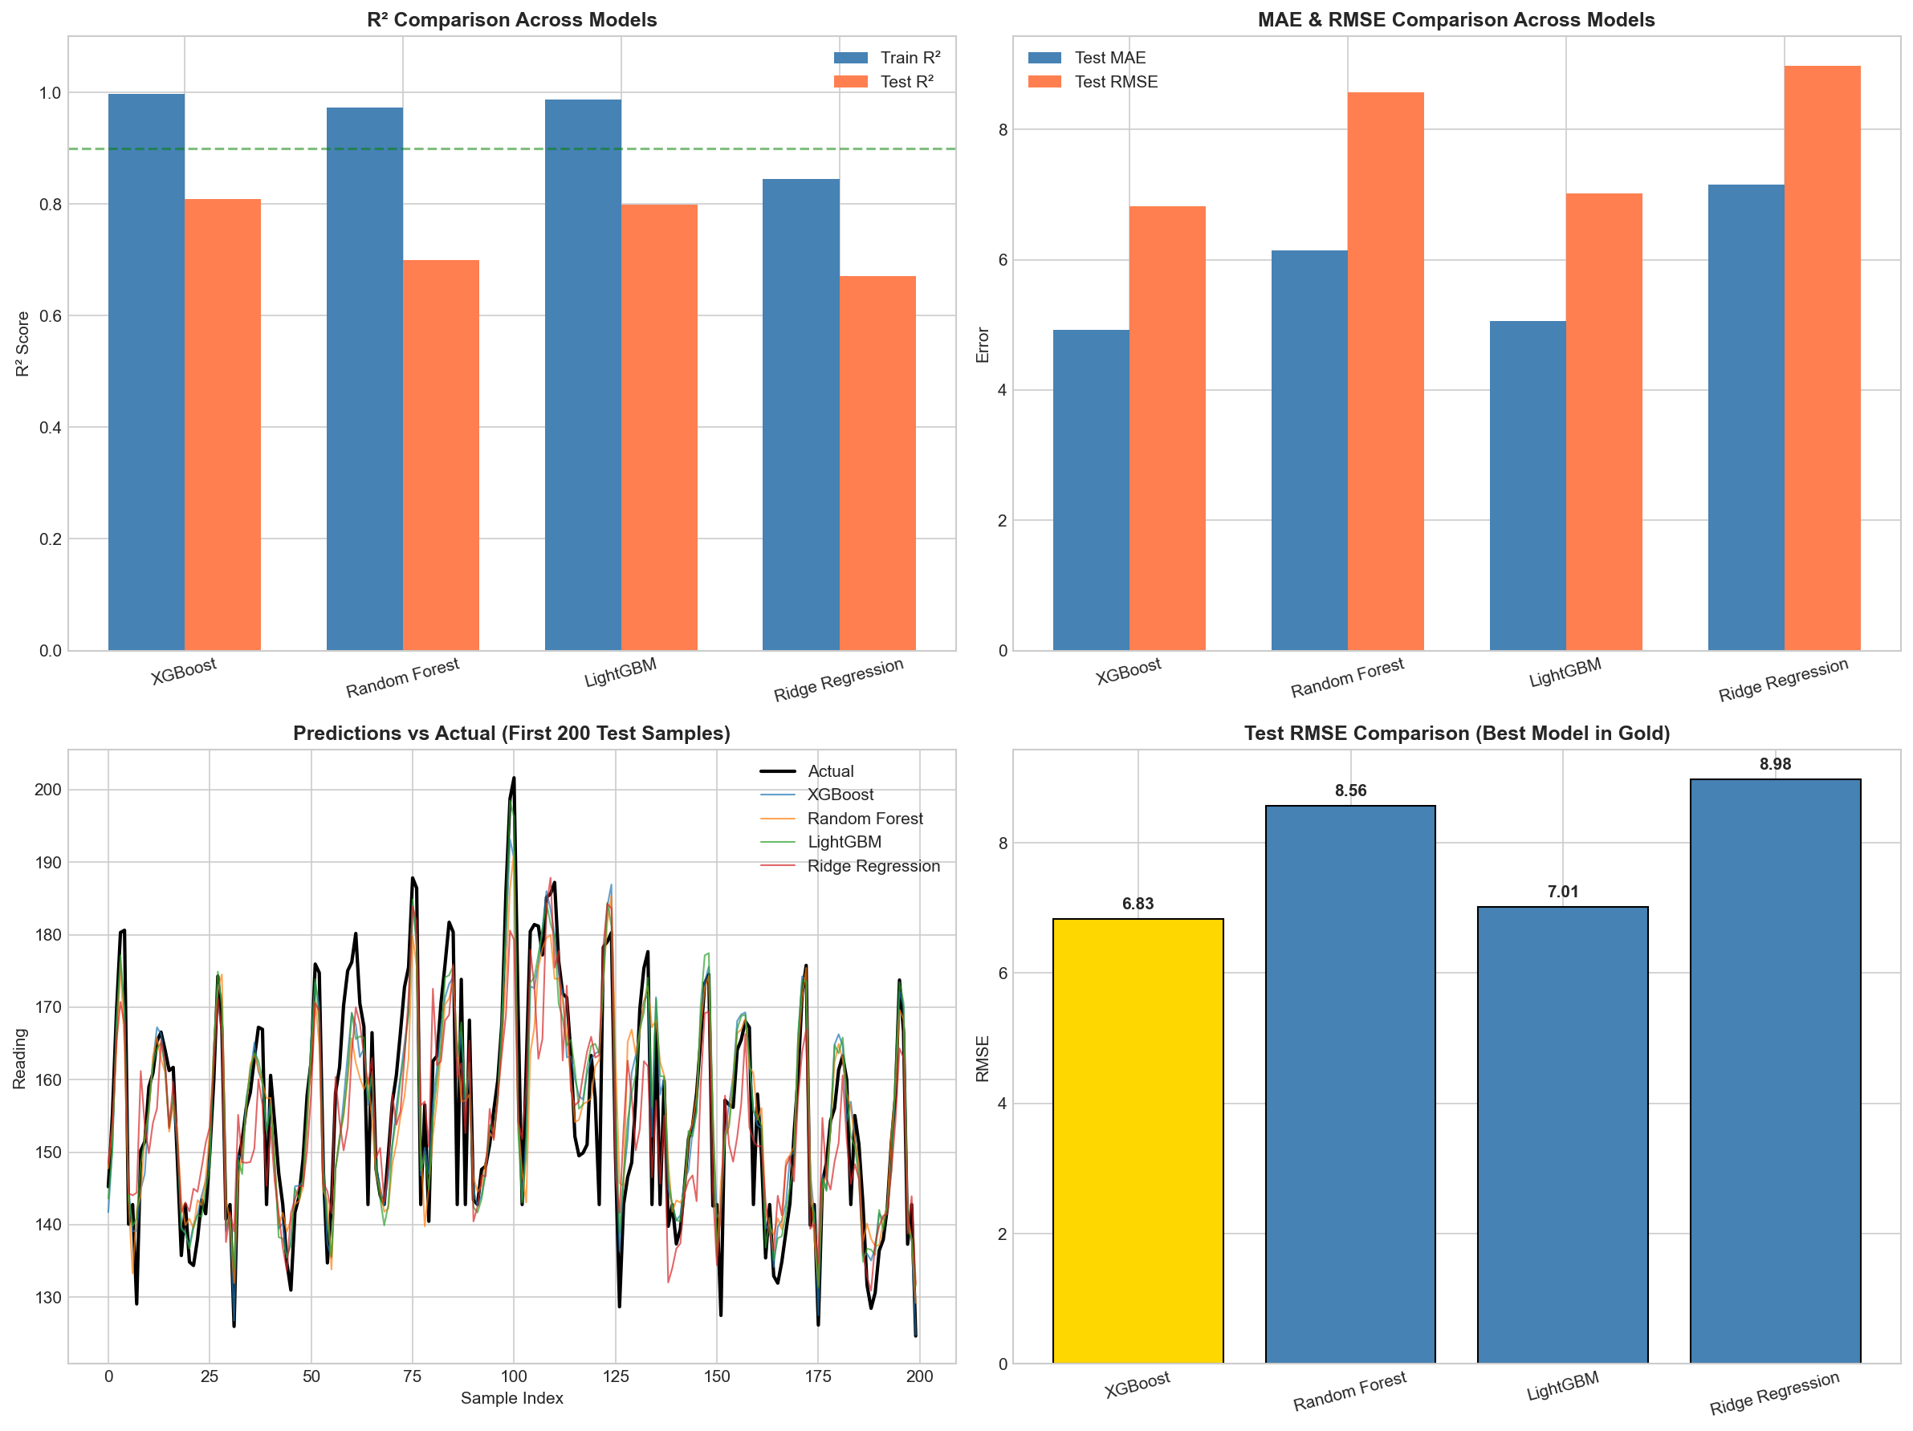

Feature Importance Analysis
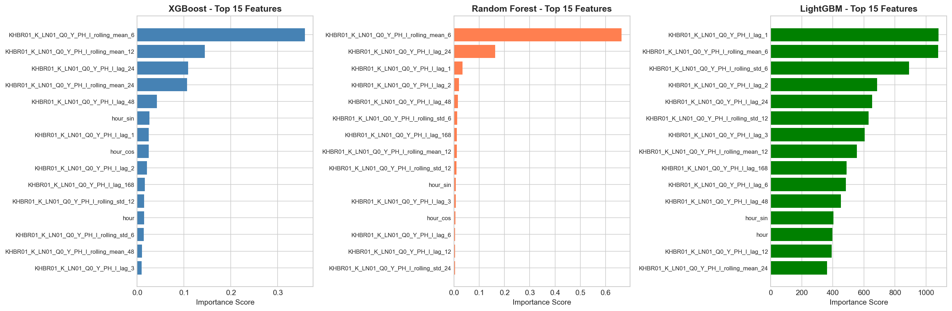

Appendix: Statistical Significance Tests

Pairwise Model Comparisons
Comparison | t-statistic | p-value | Significant (α=0.05)
XGBoost vs Random Forest | -10.6933 | 0.0000 | Yes
XGBoost vs LightGBM | -2.2512 | 0.0246 | Yes
XGBoost vs Ridge Regression | -12.2825 | 0.0000 | Yes
Random Forest vs LightGBM | 9.8677 | 0.0000 | Yes
Random Forest vs Ridge Regression | -5.0119 | 0.0000 | Yes
LightGBM vs Ridge Regression | -11.6473 | 0.0000 | Yes

MAE Confidence Intervals (95%)
Model | MAE | CI Lower | CI Upper
XGBoost | 4.9225 | 4.6170 | 5.2658
Random Forest | 6.1485 | 5.7422 | 6.5805
LightGBM | 5.0607 | 4.7514 | 5.3816
Ridge Regression | 7.1527 | 6.7845 | 7.5346

