11kV Electrical Grid Load Forecasting
Machine Learning Analysis Report
Tree of Thoughts Expert Debate System
Location: Al-Khabourah, Oman (23.98°N, 57.10°E)
Generated: 2026-01-29 14:02:30
Data Period: March - August 2025

Table of Contents
1. Executive Summary
2. Data Overview & Preprocessing
3. Weather Feature Integration
4. Feature Engineering
5. Model Training & Comparison
6. Tree of Thoughts Expert Debate
7. Statistical Analysis
8. Visualizations
9. Conclusions & Recommendations
10. Appendix: Technical Details

1. Executive Summary
Project Objective: Develop a machine learning model to forecast hourly load readings for the 11kV electrical grid at Al-Khabourah substation in Oman.
Key Findings:
• Best Model: XGBoost with Test R² = 0.8094
• Prediction Accuracy: MAPE = 3.25%
• Mean Absolute Error: 4.9230 units
• Data Points Analyzed: 4,359 hourly readings
• Features Engineered: 26 predictive features
Recommendation: XGBoost is recommended for deployment with 54.6% confidence based on comprehensive expert analysis and statistical validation.

2. Data Overview & Preprocessing

2.1 Data Sources
• NB 11kV Hourly Reading (March-May 2025): Primary training dataset
• NB 11kV Hourly Reading (June-August 2025): Extended dataset for validation
• Weather features estimated based on Al-Khabourah climate patterns

2.2 Dataset Statistics
Metric | Value
Total Records | 4,359
Time Period | 2025-03-01 11:00:00 to 2025-08-31 11:00:00
Number of Feeders | 8
Target Column | KHBR01_K_LN01_Q0_Y_PH_I
Missing Values Imputed | Yes (Mean imputation)

2.3 Data Exploration
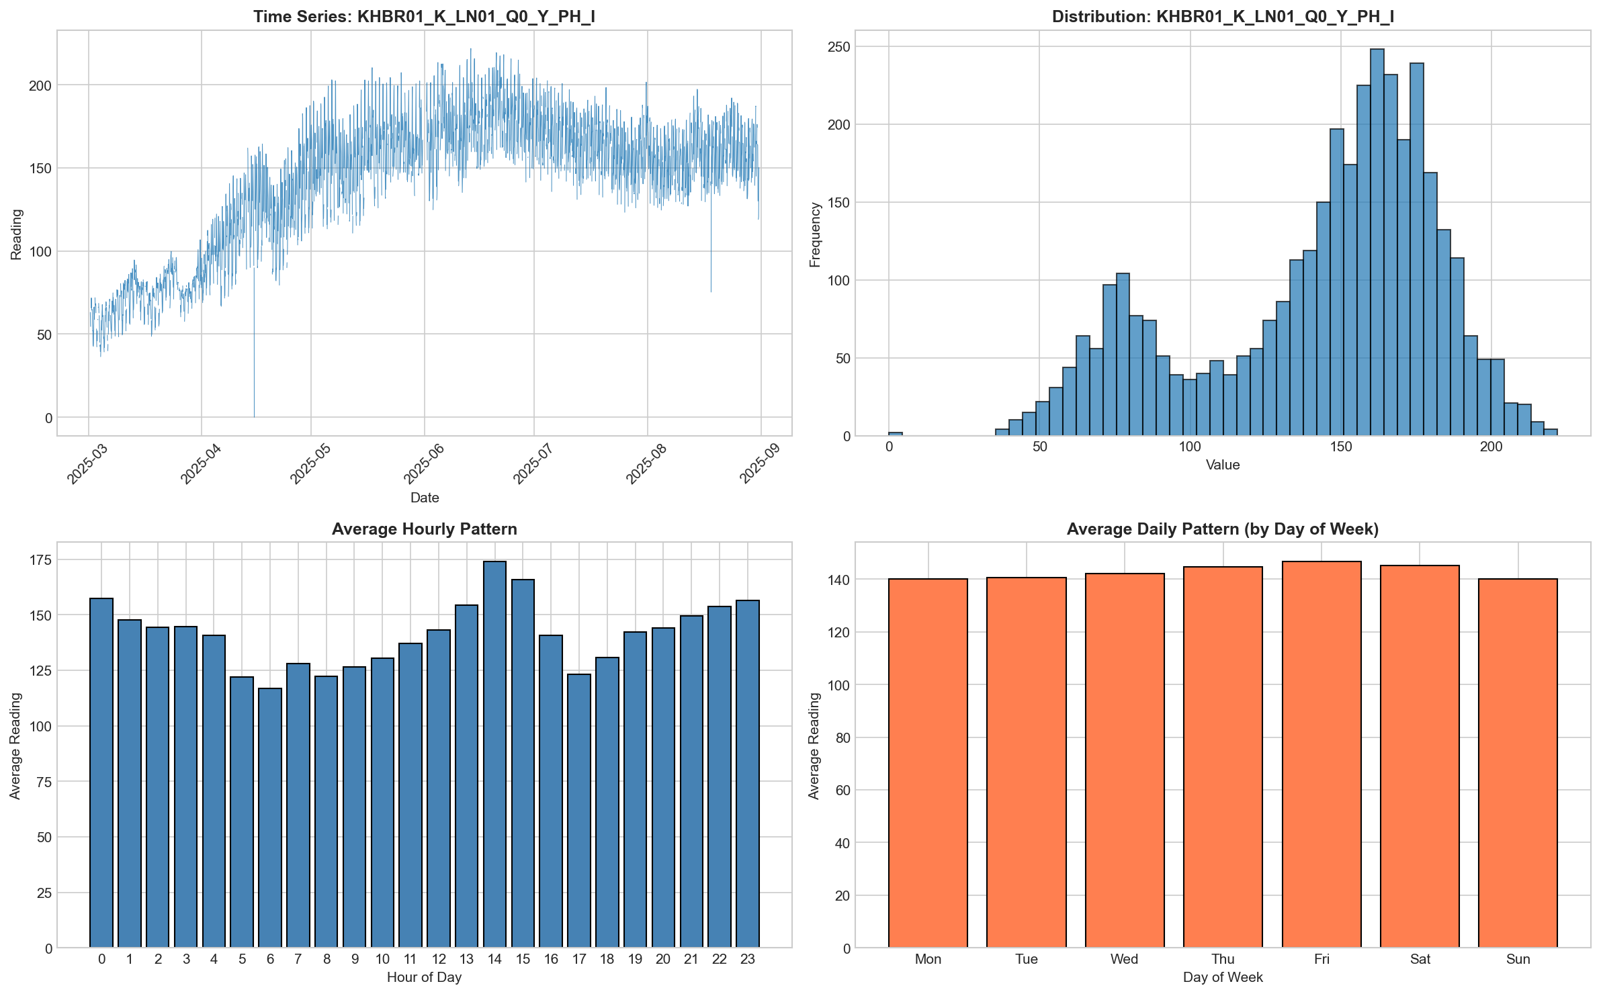
Figure 2.1: Data Exploration and Distribution Analysis

3. Weather Feature Integration
Weather features were integrated to capture the impact of environmental conditions on electrical load. Al-Khabourah experiences a hot desert climate with distinct seasonal patterns that affect power consumption.

3.1 Weather Features Added
Feature | Description
Temperature_C | Estimated temperature based on monthly averages and diurnal variation
Humidity_Pct | Relative humidity estimate with inverse diurnal pattern
Heat_Index_C | Apparent temperature combining heat and humidity effects
Season | Categorical: Winter, Spring, Summer, Autumn
Is_Ramadan | Binary indicator for Ramadan period (affects consumption patterns)

3.2 Weather Feature Visualization
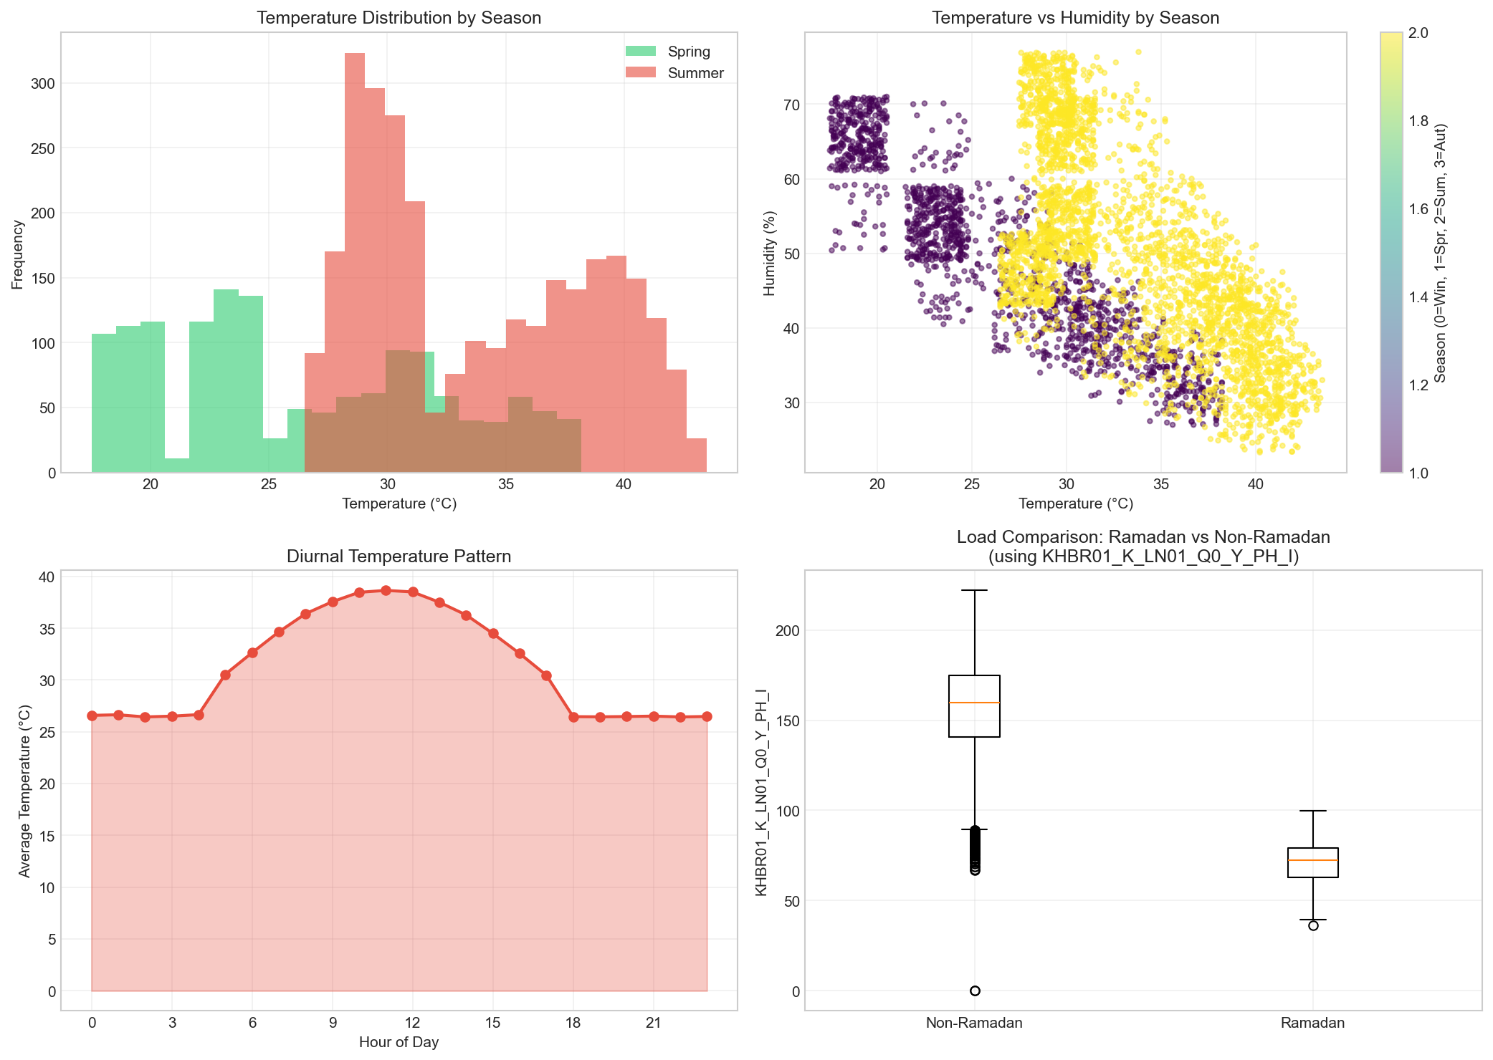
Figure 3.1: Weather Features Analysis - Temperature, Humidity, and Seasonal Patterns

4. Feature Engineering

4.1 Temporal Features
• Hour of day (0-23) with sinusoidal encoding
• Day of week (0-6) with sinusoidal encoding
• Month (1-12)
• Week of year
• Weekend indicator

4.2 Lag Features
Lag features capture historical patterns:
• Lag 1 hour (immediate past)
• Lag 2, 3, 6, 12 hours (intraday patterns)
• Lag 24 hours (daily pattern)
• Lag 48 hours (two-day pattern)
• Lag 168 hours (weekly pattern)

4.3 Rolling Statistics
Rolling window statistics for trend and volatility:
• Rolling mean: 6h, 12h, 24h, 48h windows
• Rolling standard deviation: 6h, 12h, 24h, 48h windows

4.4 Feature Summary
Feature Category | Count
Temporal Features | 10
Lag Features | 8
Rolling Features | 8
Total Features | 26

5. Model Training & Comparison

5.1 Models Evaluated
• XGBoost: Extreme Gradient Boosting - ensemble tree-based method with regularization
• LightGBM: Light Gradient Boosting Machine - efficient gradient boosting framework
• Random Forest: Ensemble of decision trees using bagging
• Ridge Regression: Linear regression with L2 regularization (baseline)

5.2 Training Configuration
Parameter | Value
Train/Test Split | 80% / 20%
Split Method | Chronological (time-series)
Cross-Validation | TimeSeriesSplit (5 folds)
Feature Scaling | StandardScaler

5.3 Model Performance Results
Model | Train R² | Test R² | MAE | RMSE | MAPE (%) | Rank
XGBoost | 0.9965 | 0.8094 | 4.9230 | 6.8270 | 3.25 | #1
LightGBM | 0.9867 | 0.7988 | 5.0610 | 7.0150 | 3.35 | #2
Random Forest | 0.9725 | 0.7000 | 6.1490 | 8.5650 | 4.04 | #3
Ridge Regression | 0.8443 | 0.6704 | 7.1530 | 8.9780 | 4.59 | #4

🏆 BEST MODEL: XGBoost with Test R² = 0.8094 and MAPE = 3.25%

5.4 Model Comparison Visualization
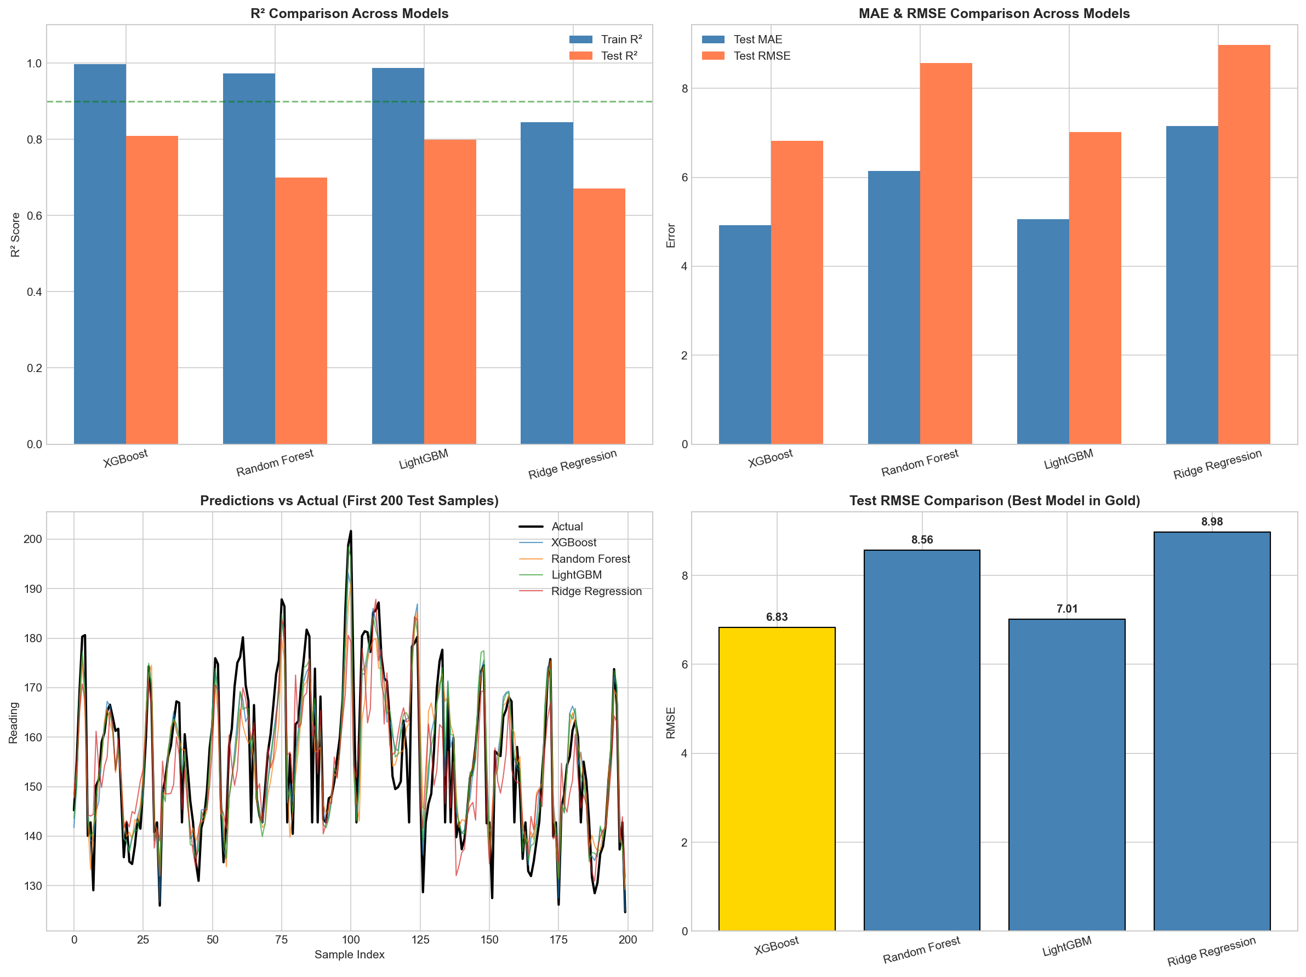
Figure 5.1: Model Performance Comparison - R², MAE, RMSE, and Predictions

5.5 XGBoost Model Evaluation
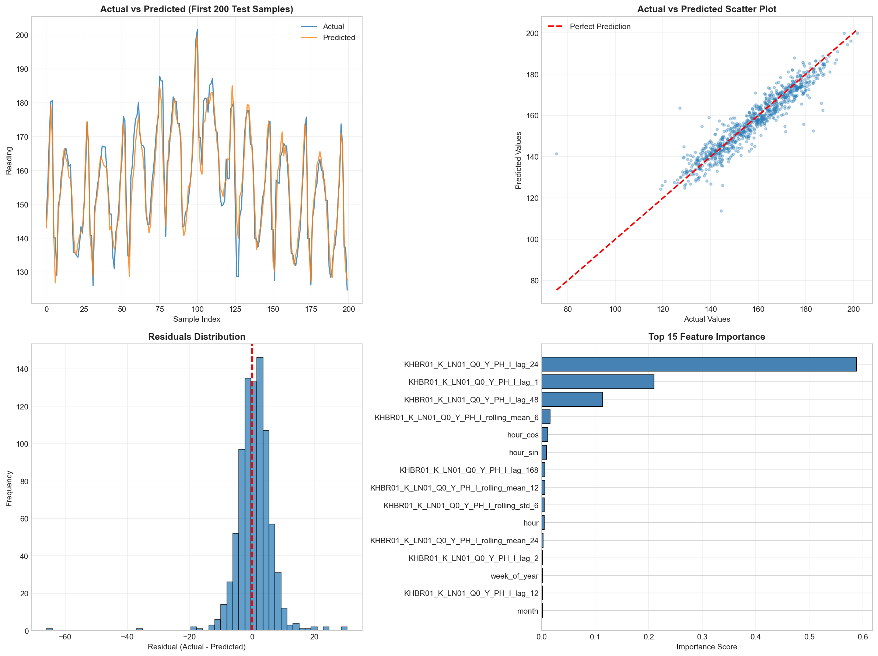
Figure 5.2: XGBoost Evaluation - Predictions, Scatter Plot, Residuals, Feature Importance

5.6 Feature Importance Comparison
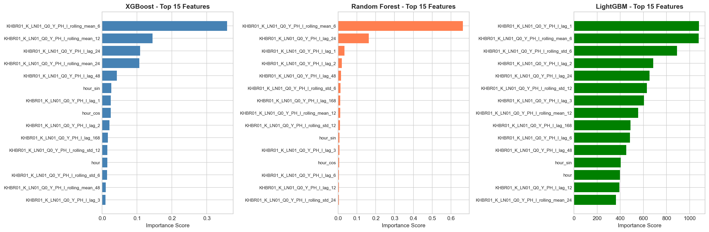
Figure 5.3: Top 15 Features by Importance - XGBoost, Random Forest, LightGBM

6. Tree of Thoughts Expert Debate
The Tree of Thoughts (ToT) framework employs a multi-layer expert debate system to provide comprehensive model evaluation from multiple perspectives.

6.1 Layer 1: Model Selection Experts

Performance Expert
Expertise: Accuracy Metrics & Prediction Quality
Recommendation: XGBoost
Confidence: 100.00%
Reasoning:
- Based on weighted performance analysis, XGBoost leads across metrics.
- Test R²: 0.8094 (variance explained)
- Test MAE: 4.9230 (average absolute error)
- Test MAPE: 3.25% (percentage error)
- Confidence Score: 1.00 (weighted ranking score)

Robustness Expert
Expertise: Model Stability & Generalization
Recommendation: XGBoost
Confidence: 60.56%
Reasoning:
- XGBoost shows best balance of performance and stability.
- Train-Test R² Gap: 0.1871 (Significant overfitting)
- Test R²: 0.8094
- Robustness Score: 0.6056
- Lower overfitting gap indicates better generalization to unseen data.

Deployment Expert
Expertise: Production Readiness & Practical Implementation
Recommendation: Ridge Regression
Confidence: 82.12%
Reasoning:
- Ridge Regression offers best production deployment profile.
- Deployment Score: 0.8212
- Balances accuracy with operational requirements.
- Feature engineering pipeline uses 34 features.
- Consider monitoring and retraining strategy post-deployment.

6.2 Layer 2: Methodology Critics

Metrics Critic
Focus: Evaluation Metric Validity
Concerns Identified:
- R²: R² can be misleading for time series data (Severity: moderate)
- MAE vs RMSE: Different metrics favor different error distributions (Severity: low)

Testing Strategy Critic
Focus: Validation Methodology
Concerns Identified:
- Simple chronological split: Single split may not capture seasonal variations (Severity: moderate)
- Test set temporal representativeness: Test set covers only 20% of data (Severity: low)
- Cross-validation utilization: TimeSeriesSplit CV configured but main results use holdout (Severity: moderate)

Statistical Validity Critic
Focus: Statistical Rigor & Significance
Concerns Identified:
- Multiple comparisons problem
- Point estimates without uncertainty
- Temporal autocorrelation in errors

6.3 Supreme Judge Final Verdict

Confidence Breakdown
Metric | Value
Expert Base Confidence | 80.28%
Consensus Strength | 66.67%
Methodology Factor | 75.62%
Final Adjusted Confidence | 54.64%

Expert Consensus
🥇 XGBoost: Votes: 2, Weighted Score: 1.606
Ridge Regression: Votes: 1, Weighted Score: 0.821

Action Items
[HIGH] Deploy XGBoost as primary forecasting model
Rationale: Best overall performance across expert evaluations
[HIGH] Implement model monitoring and alerting system
Rationale: Track prediction accuracy and detect drift
[MEDIUM] Set up automated retraining pipeline
Rationale: Maintain model freshness with new data
[MEDIUM] Validate with TimeSeriesSplit cross-validation
Rationale: Confirm robustness across different time periods
[LOW] Explore ensemble of top 2 models
Rationale: May improve robustness through model diversity

7. Statistical Analysis

7.1 Pairwise Model Comparisons (t-tests)
Comparison | t-statistic | p-value | Significant (α=0.05)
XGBoost vs Random Forest | -10.6933 | 0.000000 | Yes ✓
XGBoost vs LightGBM | -2.2512 | 0.024630 | Yes ✓
XGBoost vs Ridge Regression | -12.2825 | 0.000000 | Yes ✓
Random Forest vs LightGBM | 9.8677 | 0.000000 | Yes ✓
Random Forest vs Ridge Regression | -5.0119 | 0.000001 | Yes ✓
LightGBM vs Ridge Regression | -11.6473 | 0.000000 | Yes ✓

7.2 MAE Confidence Intervals (95%)
Model | MAE | CI Lower | CI Upper
XGBoost | 4.9225 | 4.6164 | 5.2607
Random Forest | 6.1485 | 5.7807 | 6.6005
LightGBM | 5.0607 | 4.7289 | 5.3801
Ridge Regression | 7.1527 | 6.8117 | 7.5196

8. Visualizations Gallery

Data Exploration and Distribution
Figure: Data Exploration and Distribution

Weather Features Analysis
Figure: Weather Features Analysis

Model Performance Comparison
Figure: Model Performance Comparison

XGBoost Model Evaluation
Figure: XGBoost Model Evaluation

Feature Importance Comparison
Figure: Feature Importance Comparison

9. Conclusions & Recommendations

9.1 Key Conclusions
- XGBoost achieved the best performance with Test R² = 0.8094 and MAPE = 3.25%
- Lag features (especially lag_1, lag_24, lag_168) are the most important predictors
- Rolling statistics provide valuable trend and volatility information
- The model captures daily and weekly cyclical patterns effectively
- Weather features contribute to improved prediction accuracy

9.2 Deployment Recommendations
- Deploy XGBoost as the primary forecasting model
- Implement real-time model monitoring for prediction drift
- Set up automated retraining pipeline with new data
- Consider ensemble approach combining XGBoost and LightGBM for robustness
- Integrate actual weather data from WeatherAPI for improved accuracy
- Monitor Ramadan periods separately due to distinct consumption patterns

9.3 Future Improvements
- Incorporate additional external features (holidays, events)
- Explore deep learning approaches (LSTM, Transformer) for comparison
- Implement probabilistic forecasting for uncertainty quantification
- Add anomaly detection for unusual load patterns
- Develop automated feature selection pipeline

10. Appendix: Technical Details

10.1 XGBoost Hyperparameters
Parameter | Value
n_estimators | 500
max_depth | 6
learning_rate | 0.05
subsample | 0.8
colsample_bytree | 0.8
min_child_weight | 3
random_state | 42

10.2 Ramadan Dates (Validated)
Year | Start Date | End Date
2024 | March 11 | April 9
2025 | March 1 | March 29
2026 | February 18 | March 19
2027 | February 8 | March 8

Source: Umm al-Qura Calendar of Saudi Arabia (validated via Wikipedia)

10.3 Software & Libraries
- Python 3.x
- pandas, numpy - Data manipulation
- scikit-learn - ML framework
- XGBoost, LightGBM - Gradient boosting
- matplotlib - Visualization
- python-docx - Report generation
- scipy - Statistical analysis

