Screenshot 1:
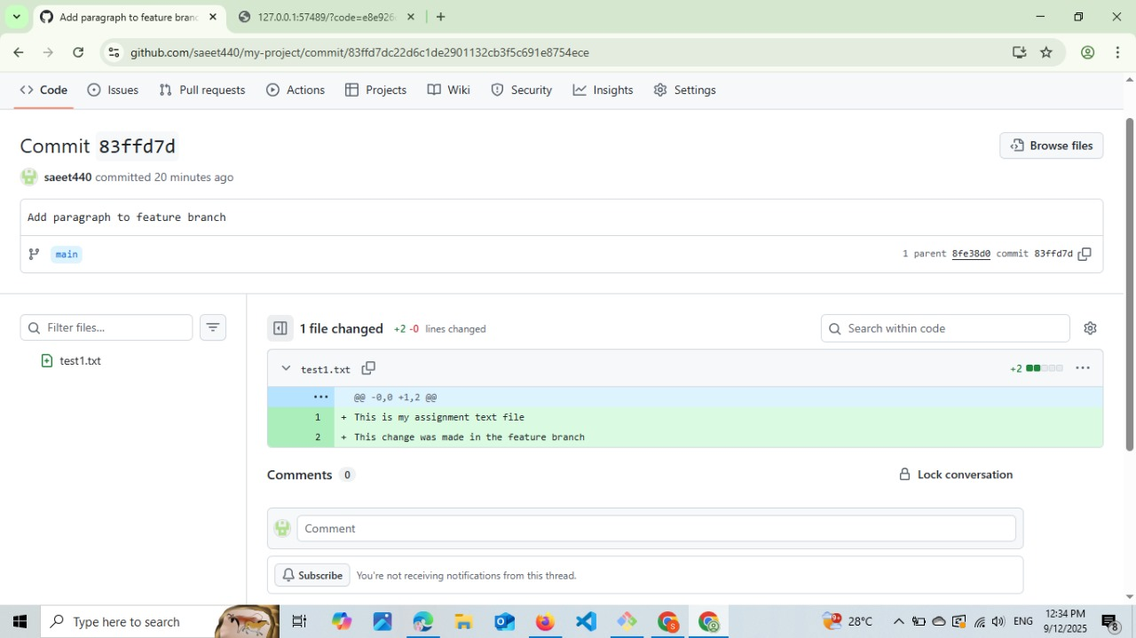

Screenshot 2:
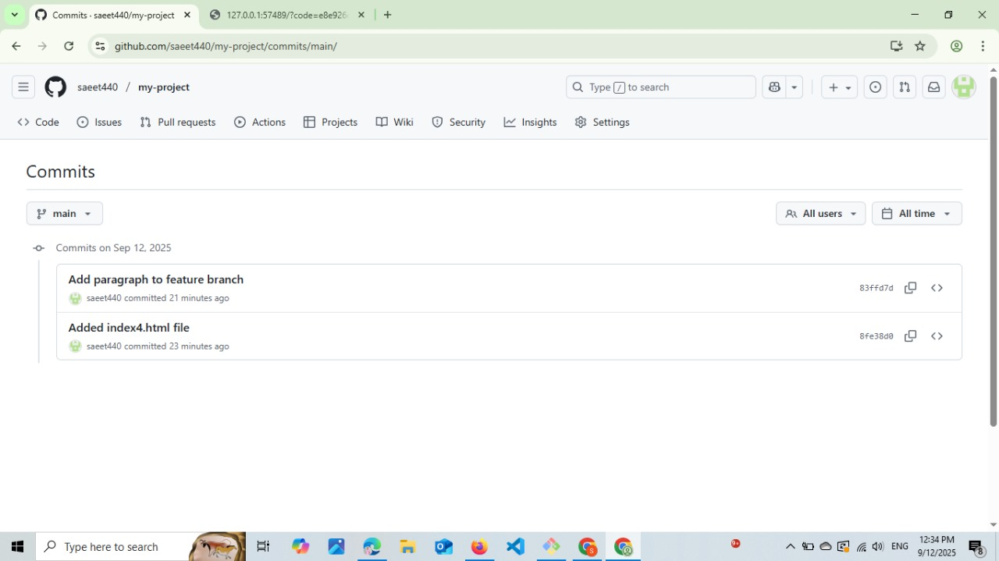

Screenshot 3:
Repository link: https://github.com/saeet440/my-project.git

