
Software Requirements Specification
for
Car Maintenance App
Version <1.0>

Prepared by Group 2
Name: Aly Kortam School Email: hk0839@wayne.edu
Name: Ahad Kidwai School Email: hm0634@wayne.edu
Name: Ali Mohamed School Email: hg7494 @wayne.edu
Name: Matthew Stumpff School Email: fq2235@wayne.edu
Name: Murad Saleh School Email: hl4178@wayne.edu

Instructor: | Jason Myers
Course: CSC 4110 | Course: CSC 4110
Date: 02/18/2025 | Date: 02/18/2025
Date: | <place the date of submission here>
Contents
Revisions iii
1 Introduction 1
1.1 Document Purpose 1
1.2 Product Scope 1
1.3 Intended Audience and Document Overview 1
1.4 Definitions, Acronyms and Abbreviations 1
1.5 Document Conventions 1
1.6 References and Acknowledgments 2
2 Overall Description 3
2.1 Product Perspective 3
2.2 Product Functionality 3
2.3 Users and Characteristics 3
2.4 Operating Environment 3
2.5 Design and Implementation Constraints 4
2.6 User Documentation 4
2.7 Assumptions and Dependencies 4
3 Specific Requirements 5
3.1 External Interface Requirements 5
3.2 Functional Requirements 6
3.3 Behaviour Requirements 6
4 Other Non-functional Requirements 7
4.1 Performance Requirements 7
4.2 Safety and Security Requirements 7
4.3 Software Quality Attributes 7
5 Other Requirements 8
Appendix A – Data Dictionary 9
Appendix B - Group Log 10

Revisions
Version | Primary Author(s) | Description of Version | Date Completed
1.0 | Mattew Stumpff  Murad Saleh | Creating initial application | 02/18/2025

Introduction

Document Purpose
The software covered in this SRS is the Car Maintenance App, created to help users manage vehicles. The app will allow users to create an account and check if their vehicle is in need of any services and/or add service entries, mileage entries, find local services, and more. This document is intended for our vendors, business partners, and investors, so that they can understand the full scope of our project.

The scope of the product covered in this SRS is a desktop environment available through an online URL. It will not be available on mobile devices and particularly not on systems currently unfamiliar with us such as LINUX. In the future this may change with revisions past version 1.0.

Product Scope
The name of the software product discussed in this document is “The Ultimate Car Maintenance Checklist”. This web application will allow a user to register an account, save their cars, track mileage, get notifications for service requirements, and find local automotive service providers.
The idea with this software is to help people understand how to care for their car and extend its lifespan. It will allow the average person to learn how a vehicle functions and how often it needs maintenance care. Hopefully, this application will be convenient enough that main competitors such as various search engines are not the go to resource.

Intended Audience and Document Overview
The document is currently intended for our professor as well as the users for our application. The rest of the SRS contains information regarding various specifics on the creation of our software and how it functions. More importantly for our users, how it will help them in their day to day life. The document is probably best read in a sequential order, from section 1.1 to 4.3.

Definitions, Acronyms and Abbreviations
Currently none.

Document Conventions
Bolded text may imply an important part of functionality in a section of the application. Font size is normally 11 with font Arial.

References and Acknowledgments

Render deploys backend: https://render.com/
Netlify deploys frontend: https://www.netlify.com/
Github manages our repository: https://github.com/

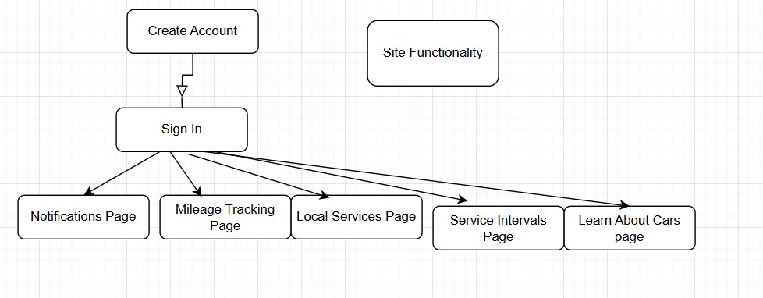

Overall Description

Product Perspective
The product is mostly a self contained project created from a common belief from group members that cars are complex and difficult to maintain. We wanted to learn more about cars, how they function, why they function, what makes them function better, and how it is definitely the case that knowing these things will help your vehicle in the long run.

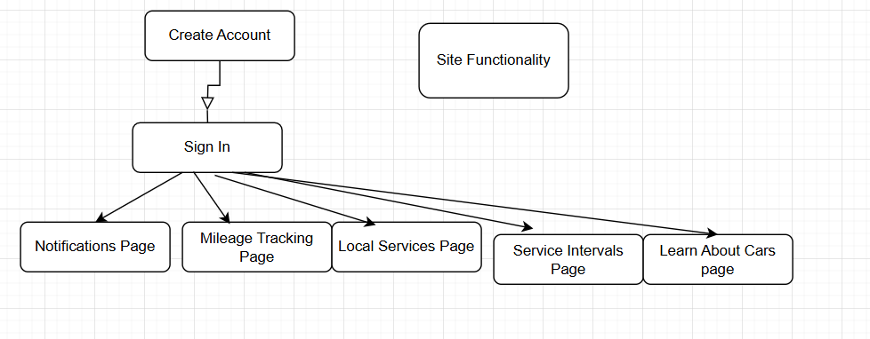

Product Functionality
- Check the status of various fluids and conditions of various car parts. Will show when to replace/refill
- Find local services
- Enable maintenance reminders
- Add service entries
- Learn about your vehicle

Users and Characteristics

The targeted user is one who bought a new/used car, someone who loves cars, someone who dislikes cars, and most importantly, someone who uses cars. You may want your car to last as long as possible, or want to learn about cars, or just want to keep track of your services because you don’t want to think about your car much and keep it all on our app.
The vast majority of people do not know much about their vehicle’s functions, and we can say it is targeted towards that audience as opposed to someone who is say a car enthusiast that actively keeps track of their vehicle and its status.

Operating Environment

Currently the application is intended to only really work with Windows operating systems as that is what our group uses. Once we’ve created a product we are happy with we can adapt and consider users on all types of systems.

Design and Implementation Constraints
Constraint 1: SQLite is not a database recommended for scalable use.
Constraint 2: The render service deploying the API is slow to send responses and can create site traffic.
Constraint 3: General programming is implemented to the best of out abilities, however, not for various systems or things such as screen readers.
Constraint 4: The database is currently not optimized for fast searching
Constraint 5: Passwords are not hashed before storing in a database and that is an immense security concern

User Documentation
The software is made to be simple and convenient for anyone, as there are simple prompts and no unnecessary features added for the sake of adding features. To use this application, you will simply make an account, and enter the vehicle information we ask for. Once the user has an understanding of what each page is needed for, such as “to find local services”, it becomes as easy as logging in when you are in need of our resources.

Assumptions and Dependencies

- We are assuming the user has a common vehicle available through the APIs we plan to access
- We assume the user is not knowledgeable of basic vehicle maintenance.
- We assume the user is not making constant refreshes or navigating between specific pages in an unexpected order.

Specific Requirements

External Interface Requirements

User Interfaces

Different screens available to user may include create account, sign in, mileage tracking, home page, service entries, service intervals (empty pages currently), and the default screen before a user logs in.

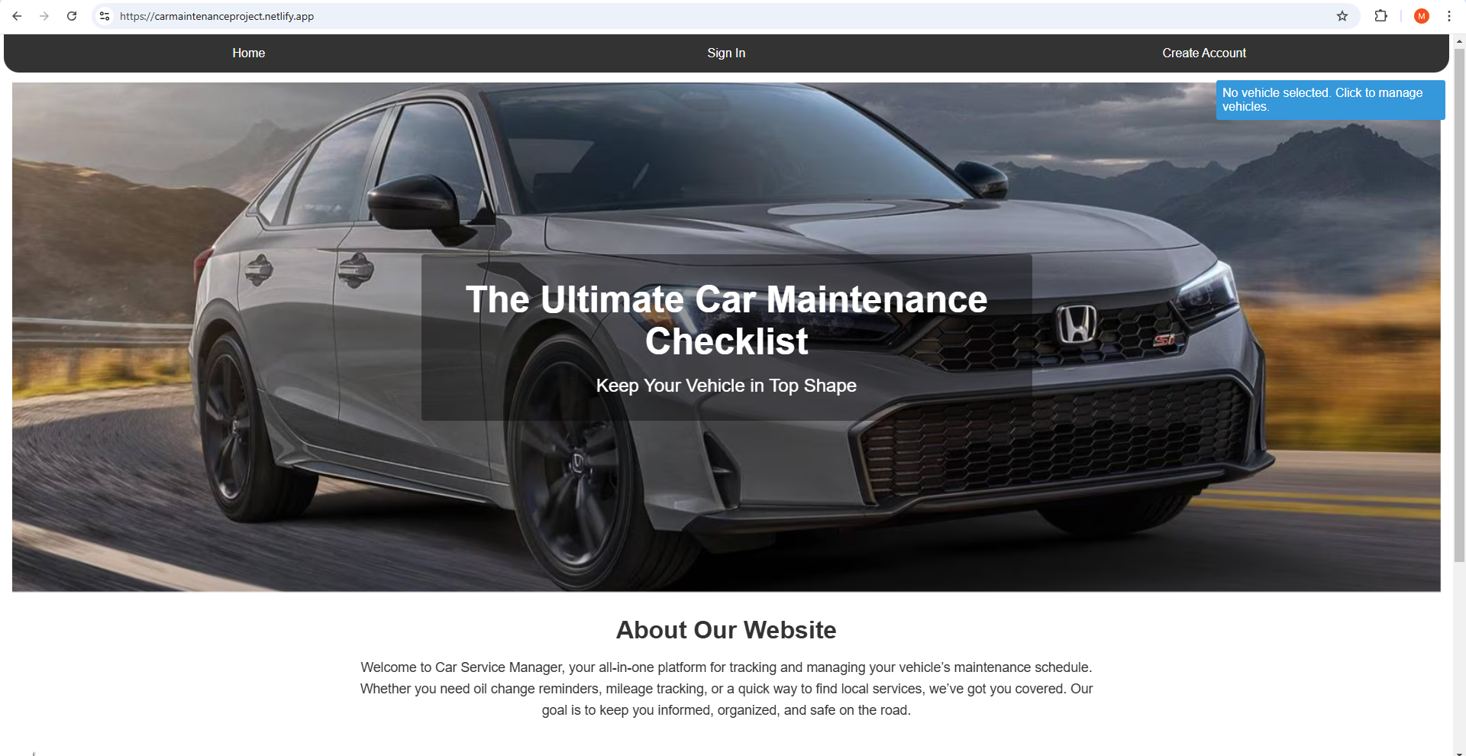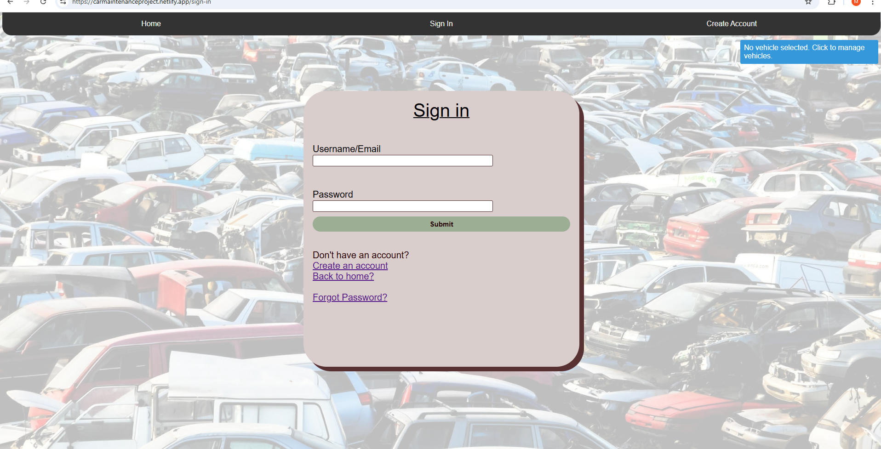

Hardware Interfaces

Mainly we use Node.js to run Javascript on the backend, specifically using the Express framework.

Software Interfaces
The backend relies on Node.js to make Javascript on the server side possible.

Communications Interfaces

We will probably look into very popular and conventional standards such as ISO. We do plan to be working with more data encryption when we look into hashing passwords before storing in the database.

Functional Requirements

Check the status of various fluids and conditions of various car parts. Will show when to replace/refill: There will be 3 circles next to each aspect of the car. Red means change soon, orange means get ready to change (or replace), and green means good to go.

Find local services: This uses Leaflet’s interactive maps and the overpass API to find nearby mechanic shops based on your location.

Enable maintenance reminders: We will send alerts to a specific phone number.

Add service entries: Simply tell us what you had done and where you went.

Learn about your vehicle: To learn more about a specific vehicle aspect find in in this page which may be implemented with web scraping techniques.

Behaviour Requirements

Use Case View

Client ---→ frontend (local services page) --→ (overpass+leaflet+neonatum)
Client ←- frontend (nearby mechanics) ←- (overpass+leaflet+neonatum)

Client ---→ frontend (sign in) --→ (render backend)
Client ←- frontend (user data/login message) ←- (render backend)

Other Non-functional Requirements

Performance Requirements

1.) Backend can take 50 seconds to send a response if its been inactive for a while
2.) Refreshing the page or navigating unintuitively may mess up certain styles
3.) Certain ASCII values are not used for passwords/usernames but user may want them
4.) Netlify may not allow too much site traffic for our frontend deployment
5.) SQLite is not very scalable

Safety and Security Requirements

Safety requirements include making sure passwords are not placed in the database before encrypting, that we use a secure HTTP URL (HTTPS), and that the user’s email is not being spammed with unsolicited messages from anyone.
As with any software, data security is important and the user is trusting us with their sensitive information. They should assume everything to be completely safe and not be at any risk of danger. With that said, security is not a heavy concern with a site like this, as opposed to a site that works with medical information. That is not to say that security is not a top priority.

Software Quality Attributes

The software is very simple and robust. and has not been overengineered unnecessarily. The site is a simple idea manifested, not a mental exercise

Other Requirements

Appendix A – Data Dictionary

Appendix B - Group Log
Scrum Master: Matthew Stumpff

- Sprint 1/16/2025 3:30 PM
- Attendees: Ahad Kidwai, Aly Kortam, Ali Muhammad, Murad Saleh, Matthew Stumpff
- Achievements:
We introduced seven very promising ideas for our software development project, including: a car maintenance app, a sports stats app, a news bias comparison app, a physics game, a calculus teaching tool, and a photo editing helping tool. We discussed the various pros and cons of going with each different idea, and some of the tools we could use to accomplish each one. In general, we decided that it would make the most sense to move forward with the project as a web application.
Additionally, we developed a PowerPoint presentation in order to share our ideas with the instructor and the rest of the group next Thursday.
- Backlog:
We have yet to make our final decision on which app idea we should move forward with.
- Goals:
- Make final decision on an idea
- Make GitHub repo to begin work
- Make decisions about tech stack

- Availability:
We all have a good amount of weekend availability in order to connect via WhatsApp. We intend to make a final decision on this matter in the near future.
- Assign Items:
It’s too early in the process to assign things at this point, we will discuss over WhatsApp this weekend how to accomplish our goals.

Scrum Master: Matthew Stumpff

- Sprint : 2/11/2025
- Attendees: Entire Group
- Achievements:
- Decided on course of action for 1st iteration
- Assigned work items to each group member
- Agreed on future times to check in and assess progress
- Made a few technical decisions as to the structure of the app and tech selection.
- Backlog:
One item still not resolved was the aesthetic configuration of the app, color scheme, etc.
- Goals:
- Achieve a MVP within one week

- Availability + Next Meeting Time:
2/16/24
Next Meeting: Click or tap to enter a date.
- Item Assignment:

