Group 2:

Murad Saleh

Matthew Stumpff

Ahad Kidwai

Aly Kortam

Ali Muhammed

WRITTEN

Why our team should be chosen:

Group 2 is working on an application that assists in managing and maintaining your vehicle. The world today is and has been completely reliant on vehicles for transportation for about a century or so, and one thing has always been the same. A vehicle is not simple, the same way a phone isn’t. How many people can you ask to look under the hood of your car and point out where everything is? To understand the information on the side of a tire, or to even know that it’s there? People know cars need gas and they know the interior, but they are not confident in their knowledge with the transmission, the differential, the brake pads, the engine, the air filter, power steering fluid, or other vital components within a vehicle. Nobody keeps track of any of this and it’s not encouraged because it sounds like a hassle to learn. The car maintenance app that we are building changes things. We introduce this as a way to get people to learn about their vehicles and help it last its full lifespan.

Artifacts:

Idea Generation:

Starburst:

Development Model:

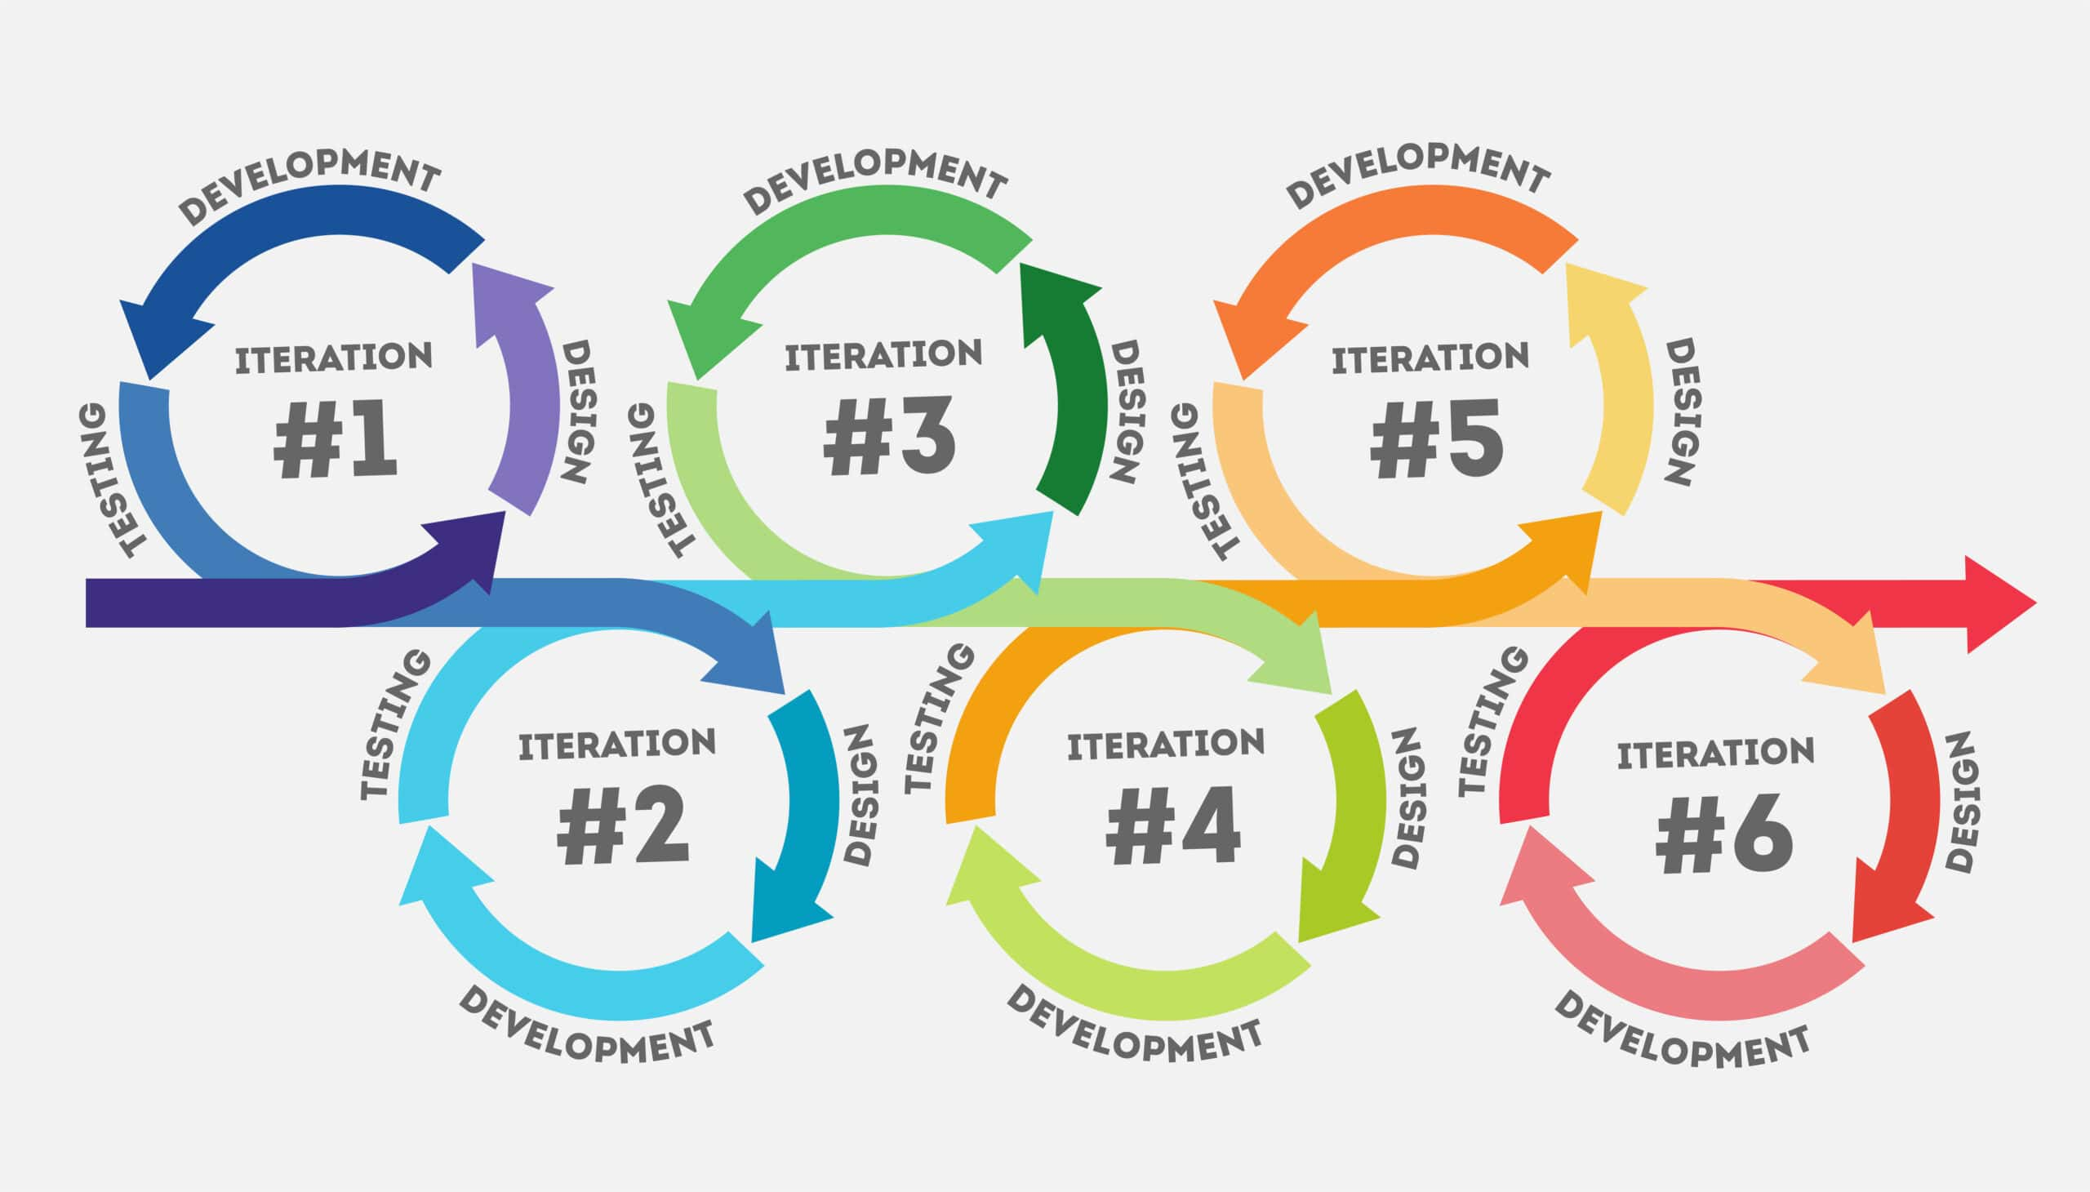

User Guide:

1. Create an account with your vehicle.
2. Sign In
3. Select feature on Navigation Pane:
   1. Mileage Tracking: for tracking miles
   2. Service Intervals: for tracking service appointments
   3. Local Services: for finding local services
   4. Learn About Cars: for learning information about cars
   5. Maintenance: For tracking general maintenance (oil change, air filter, etc.)
   6. Notifications: Activate notifications for maintenance and services
   7. Service history: See and add vehicle service entries

User Agreement:

1. **Data Privacy**

We take data privacy seriously. We understand that choosing to register your car with us is a statement of trust, and we intend to protect your data to the maximum extent possible with practices and policies that meet or exceed the industry standard.

1. **Application Sharing**

We do not share any of your information with anyone. None of our vendors, partners or investors will have access to your personal data. Additionally, we thoroughly vet all cloud partners to ensure that they meet or exceed the industry standard for data privacy and security, and periodically conduct compliance audits of all our vendors.

1. **Unilateral Indemnity Clause**

Customer agrees to protect, defend, [hold harmless,] and indemnify (collectively “Indemnify” and “Indemnification”) Forestview, its subsidiaries, and its and their respective successors, assigns, directors, officers, employees, agents, [stockholders (in the case of a privately held company),] and affiliates (collectively, “Indemnified Parties”) from and against all claims, demands, actions, suits, damages, liabilities, losses, settlements, judgments, costs, and expenses [of or by a third party OR whether or not involving a claim by a third party], including but not limited to reasonable attorneys’ fees and costs (collectively, “Claims”), actually or allegedly, directly or indirectly, arising out of or related to (1) any breach of any representation or warranty of customer contained in this Agreement; (2) any breach or violation of any covenant or other obligation or duty of customer under this Agreement or under applicable law; (3) any third party Claims which arise out of, relate to or result from any act or omission of customer; and (4) [other enumerated categories of claims and losses], in each case whether or not caused in whole or in part by the negligence of Forestview, or any other Indemnified Party, and whether or not the relevant Claim has merit.

1. **Periodic Vulnerability Assessments**

We conduct periodic vulnerability assessments that meet or exceed the industry standard. These assessments encompass the entirety of our IT systems, as well as those of our vendors. Our cybersecurity and compliance professionals are all familiar with industry leading vulnerability scanning software, and maintain familiarity with the latest in cybersecurity trends and analysis.

1. **Changes to our Requirements**

Over time, necessity and a changing technology environment will dictate that our requirements and specifications for our software will change. When changes are made that affect the end user, we will promptly provide information about what changed and why, how that will affect our customers and partners.

1. **Industry-Standard Compliance**

Our cybersecurity and compliance teams strive to maintain the highest quality defense of our client's personal information. Among other resources, we use the OWASP Top 10 list to maintain awareness of the most pressing security concerns for web applications at any given moment. We maintain a continuous scan of the threat environment to update our security posture. The app complies with ISO 26262, NIST, and OBD-II for the security and privacy of your data as well.

1. **Licensing**

This software is licensed, not sold. You are granted a non-exclusive, non-transferable license to use the app under the terms outlined in this agreement.

1. **Summary of User Agreement**

By using this app, you agree to our User Agreement, which outlines acceptable use, privacy policy, and compliance with relevant laws.

Stakeholders:

To ascertain the needs of our stakeholders we asked ourselves what we would want in a car maintenance application because we do not know much about vehicles ourselves. We asked what is it that would make us use our app as opposed to something like Google. Our final vision will be maintained and improved as we look to our users and ourselves and ask along every step of the way “what do we like” and “what do we not like”. The main idea will always be to create something more useful than competitors. The little things in every aspect of our software, in the finished product, will have been built with the idea of simplicity, convenience, and likability.

Team:

We functioned effectively as a team by frequently checking in on each other and asking about the technologies and concepts we were confused about whenever possible. If a member would reach out, a person would response honestly, quickly, and kindly. We learned to never sugarcoat, nothing is personal, and to be humble about our decisions so no issues arise. Additionally, our application is very easily divided into separate tasks because of our focus on generalized programming and abstract design, allowing our work not to affect each other.

Output satisfied areas:

**Features**: We have implemented a modest number of features that can be extended in the future. Features such as a login, local services, mileage tracking, a create account, and the basic structure of the frontend.

**Software Design**: Incorporated SOLID design, readable code, and practiced general programming every step of the way to ensure functions are isolated.

**Unit Testing**: Currently in preparation for iteration 2 using Jasmine framework; list of functions are easily accessible and well defined for unit testing.

**Code Reviews**: Whenever a team member would commit their code, we’d discuss changes and improvements in WhatsApp if necessary.

**Coding Convention**: Code is well commented, standard practices are implemented, and among other things, we followed all SOLID design principles.

**Bug Management:** Bugs are currently removed via the process of a team member passing the issue they’re concerned with to the communication platform & requesting assistance. This mostly applys when a team member found an issue with a section of code they were not familiar with.

**Documentation**: This area is probably something that needs much work, however, this will improve as our group develops technical ability, experience, and are passed the point of figuring out the fundamentals. We can now progress to a point where we can finetune the smaller details of the project and create more accurate and detailed documentation.

**Product backlog**: What mostly gave the project the most backlog was simply the learning phase. Learning JavaScript, HTML, CSS, React, Express, Powershell, Git, Github, HTTP, deployment, and just the many other intricacies involved in making an application.

**Sprint Planning:** Our plans for the sprint usually come down to very ambitious ideas so that we can implement plenty even though much will be left incomplete. It will give us familiarity with the concept when we work on it in the next iteration. For example, much of the backend implementation will be done now that we have introduced a bit of integration and have created basic functionality of our site.

**Collaboration**: Our team members are very friendly and enthusiastic about the project so it was easy to communicate almost daily and discuss what and when to do things. In the beginning stages, we would make polls and divide work up based off whatever made the most sense. As we make progress, our roles become more distinguished and we learn more about the right discussions to have.

**Scrum Meetings:** We would have informal discussions about the project daily, but we had a weekly discussion summarizing what we learned or implemented to put on the SCRUM.

**Sprint Retrospectives**: Successfully set up user login validation using SQLite. The frontend is in place and is ready for more features. The project has a foundation for backend development, with Express scripts integrated. We understand what we’ve done and what we need in the final draft.

References

*Standards*. ISO. (2024, January 24). https://www.iso.org/standards.html

Bloomberg (2024, September 9). Indemnification clause sample. Bloomberg Law. <https://pro.bloomberglaw.com/insights/transactions/indemnification-clauses-in-contracts/#sample>

*Standards*. NIST. (2024, September 25). https://www.nist.gov/standards

*Introduction to the OBD-II standard*. Kvaser. (2024, May 22). https://kvaser.com/about-can/can-standards/introduction-to-obd-ii/#:~:text=The%20OBD%2DII%20standard%20is,protocols%20and%20the%20messaging%20format.