XTEL CPG Hackathon

What’s the Challenge?
Welcome to the XTEL CPG Hackathon Challenge! Your main mission is to predict the weekly sales for a set of consumer packaged goods (CPG) products using real-world data. You will receive several years of historical data for each product, including information on prices, promotions, and marketing activities.
The primary goal is to forecast sales for an entire 'test year' where the actual sales numbers are missing. Your predictions will be evaluated for accuracy, and the most precise solutions will earn the highest scores.
Bonus Objective: In addition to forecasting actual sales, teams can earn extra points by predicting the baseline sales for each product—that is, the expected sales level if there had been no promotions. This will reward teams who can accurately model and separate the promotional uplift from the underlying demand.

Dataset Description
You will receive two datasets:
- weekly_train: Contains several years of historical weekly data for each product.
- weekly_test: Contains the same features for the test year, except for the sales column, which you are required to predict.
The main objective is to predict the TOTAL_SALES for each product-week in the weekly_test dataset. The XTEL team will compare your predictions with the actual sales values to calculate your prediction error.
Columns:
PRODUCT_DESC: Product description (name)
PRODUCT_ID: Product unique identifier
DATE: Reference date for the week
TOTAL_SALES: Number of units sold (target variable; missing in weekly_test)
PRICE: Selling price for the product that week
IS_COUPON: Support variable: indicates if a coupon was available that week
IS_DISPLAY: Support variable: indicates if the product was on display that week
IS_FEATURE: Support variable: indicates if the product had a feature promotion that week
IS_PROMO: Indicates if the week was a promotional week
IS_INDEPENDENCE_DAY: Special event: indicates if the week includes Independence Day
IS_PRE_CHRISTMAS: Special event: indicates if the week is the week before Christmas
IS_SUPER_BOWL_SUNDAY: Special event: indicates if the week includes Super Bowl Sunday
IS_PRE_THANKSGIVING: Special event: indicates if the week is the week before Thanksgiving
IS_EASTER_SUNDAY: Special event: indicates if the week includes Easter Sunday
IS_LABOR_DAY: Special event: indicates if the week includes Labor Day
IS_MEMORIAL_DAY: Special event: indicates if the week includes Memorial Day
IS_THANKSGIVING: Special event: indicates if the week includes Thanksgiving
IS_CHRISTMAS_DAY: Special event: indicates if the week includes Christmas Day
Notes:
- The columns IS_COUPON, IS_DISPLAY, and IS_FEATURE are called 'support variables' and indicate whether, in addition to any possible price reduction, there were other promotional activities. These supports can occur independently or together in the same week, and are not necessarily linked to a price reduction.
- The columns from IS_INDEPENDENCE_DAY to IS_CHRISTMAS_DAY indicate special events that can influence the baseline sales of a product. Each column refers to a specific recurring event, which occurs every year.
- The target variable to predict is TOTAL_SALES. This column will be missing in the test set and must be predicted for each row.
Example: Forecasting Future Sales for a Product
The figure below shows an example for a single product (Yogurt_Greek, Product ID: 3450014449).
- The blue and orange bars represent weekly sales during the training period (weekly_train), distinguishing between weeks with and without promotions.
- The dashed line shows the weekly price.
- Markers indicate the presence of promotional support activities (coupon, display, feature).
- The green background highlights the training period, while the pink background highlights the test period (weekly_test), for which you must predict sales.
Your task: Based on the patterns in the training data and the provided features (price, promotions, support activities, special events), estimate weekly sales for the test period (pink area) for this product and for all other products in the dataset. 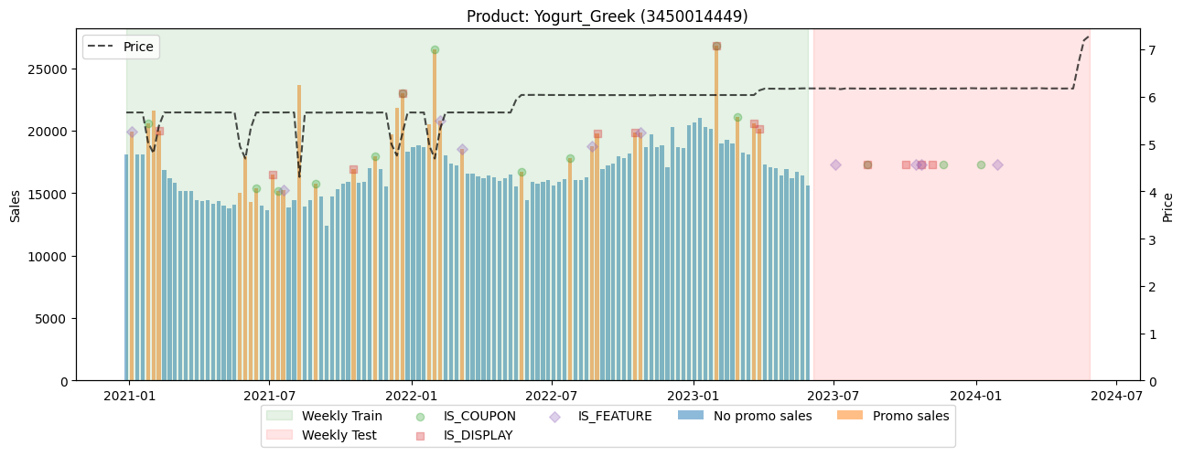
Below you can see an example of the first rows of both datasets.
- The training set (weekly_train) contains the column TOTAL_SALES.
- The test set (weekly_test) has the same structure but does not include the TOTAL_SALES column, which you are required to predict.
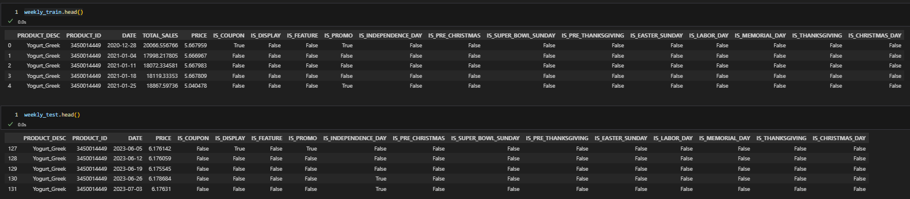

4. Technical Guidelines
- Recommended language: Python. XTEL team members will provide technical support and guidance for Python users.
- Other languages: You are free to use any programming language you prefer (e.g., R, Julia, etc.), but XTEL cannot guarantee technical support for languages other than Python.
- Deliverables: Your sales predictions for all products both in training and test year as a csv file with an extra column TOTAL_SALES_PRED (also another BASELINE_PRED column for the bonus point). Your code (preferably in a well-documented notebook or script). A presentation (slides) summarizing your approach, results, and key insights. (Optional) Baseline sales predictions for the bonus objective.

Pre-event Setup: What to Install
Before coming to the office, please make sure your laptop is ready for the hackathon.
You are required to install the following software and tools at home:
- Python 3
- Jupyter Notebook or JupyterLab
- pandas
- numpy
- matplotlib
Please make sure everything is working before arriving at the office!
If you encounter any issues during setup, feel free to contact us in advance for help.

5. Evaluation Criteria
Your project will be evaluated according to the following criteria:
Criterion | Weight
Prediction accuracy (MAPE) | 70%
Quality of presentation | 15%
Elegance, innovation, and solution quality | 15%
Bonus: Baseline prediction accuracy | extra
- Prediction accuracy: Calculated using Mean Absolute Percentage Error (MAPE) between your predictions and the actual sales on the test set.
Note: The MAPE will be computed for each product and then averaged across all products to obtain the final score.
- Presentation: Clarity, structure, and effectiveness of your final pitch.
- Elegance & innovation: Creativity, technical choices, and the overall quality of your solution.
- Bonus: Additional points for teams that provide accurate baseline (non-promotional) sales predictions.

