SOP optimization with Simulated annealing, GRASP

* Problem Description:

The Sequential Ordering Problem (SOP) with precedence constraints consists of finding a minimum weight Hamiltonian path on a directed graph with weights on the arcs and on the nodes, subject to precedence constraints among nodes.

* Instances Description:

Instances are provided by TSPLIB that it is a library of sample instances for the TSP (and related problems like SOP, ATSP, HCP) from various sources and of various types.

Each instance file consists of two part as **specification part** that contains information about the instance data and **data part**.

* Algorithm Description:

The algorithm designed base on the related paper as *(An Ant Colony System Hybridized with a New Local Search for the Sequential Ordering Problem).*

**Constructive heuristic** used for generating initial solution in the way that from the bingeing each time minimum possible length edge based on precedence condition selected.

For neighboring method to move from current solution to another, **Lexicographic Search** using **forwarding and back warding path-preserving-3-exchange** applied and best solution selected among them.

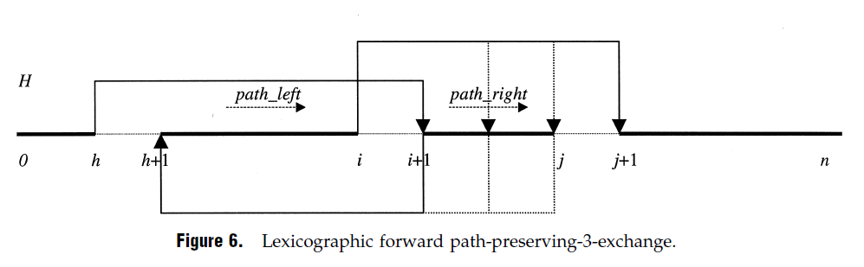

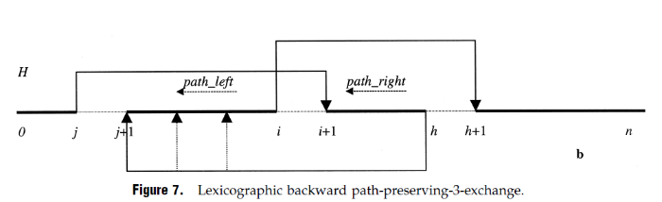

The only difference is that in this algorithm lexicographic search doesn’t applied on whole search space by iteratively change the parameters “h, i, j”, instead random “h” generated and according to that random “i,j” created to do the search.

With the use of loop with size half of dimension forward and with same size loop backward exchanging applied.

It means that in each simulated annealing iteration best solution selected from a list of solutions with size of problem dimension.

* + Initial Constructive heuristic
  + O(dimension/2) forward searching with random “h, i, j” parameters.
  + O(dimension/2) backward searching with random “h, i, j” parameters.
  + Selecting the best from search as next solution
* Algorithm time complexity:

for it in range(*int*(dimension/2)):

          h = randrange(0, dimension-3)

         i = h + 1

…

for j in range(i, len(solution)):

             for dep in deps[solution[j]]:

…

As code shows the forward and backward search consist of 3 loops so the time complexity is O(n3).

def get_neighbor(problem, dependencies, state, cost):

    …

    new_state1 = fpp3exchange(problem, dependencies, state)

    new_state2 = bpp3exchange(problem, dependencies, state)

…

and the neighboring function calling both of them for selecting new solution so

the searching algorithm complexity is O(n3).

For updating the temperature 3 methods (**linear** and **logarithmic** and **exponential**) applied to find the best to work with.

* Simulated annealing algorithm progress:

T = 1

ALPHA = 0.8 (for using in temperature updating)

TEMP_MODE = EXP (temperature updating method)

INIT_HEURISTIC = True (using initial heuristic)

NUM_ITERATIONS = 500

* + Algorithm progress plot for sample instances:

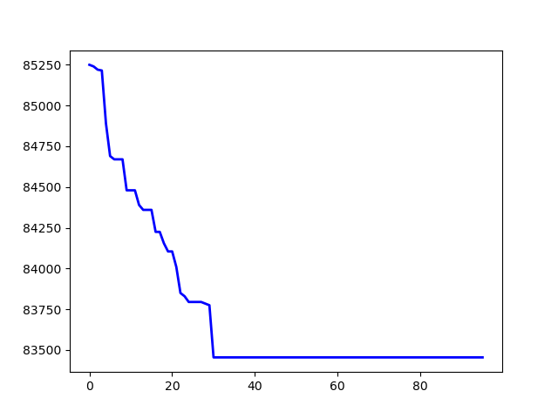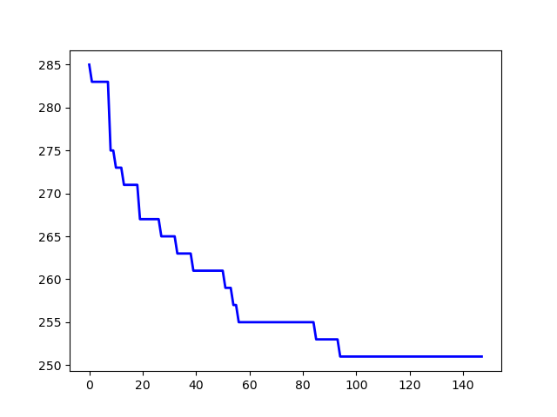

p43.4.sop jpeg.4753.54.sop

The whole results (main, max, avg) came at the end.

* Simulated annealing Initial methods comparison:

T = 1

ALPHA = 0.8

TEMP_MODE = EXP

NUM_ITERATIONS = 500

* + Random

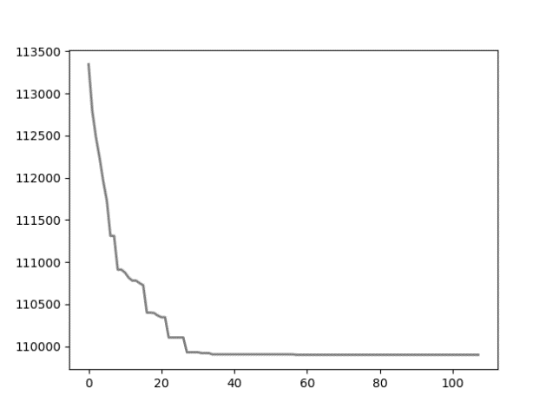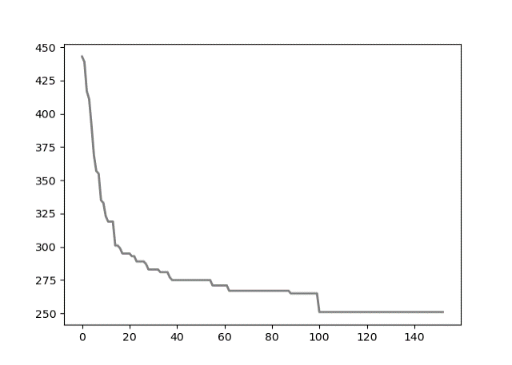

*p43.4.sop* *jpeg.4753.54.sop*

* + Heuristic:

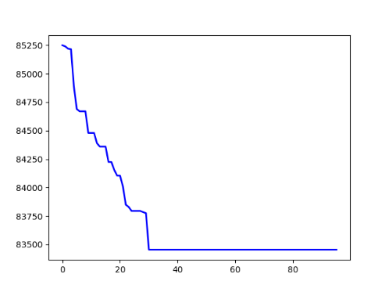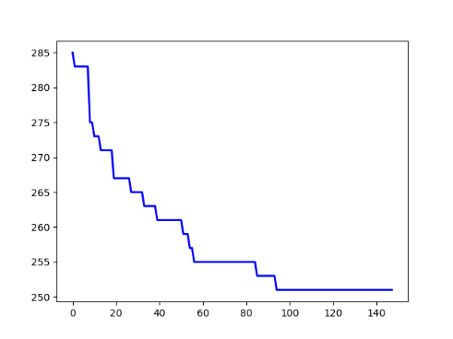

*p43.4.sop* *jpeg.4753.54.sop*

as result shows with heuristic method algorithm start from much better initial solution and in some cases leads to better final solution.

For 10 instances as test heuristic method gave better solution.

* Simulated annealing temperature update methods comparison:

T = 1

ALPHA = 0.9

INIT_HEURISTIC = True

NUM_ITERATIONS = 500

* + Linear (ALPHA * T):

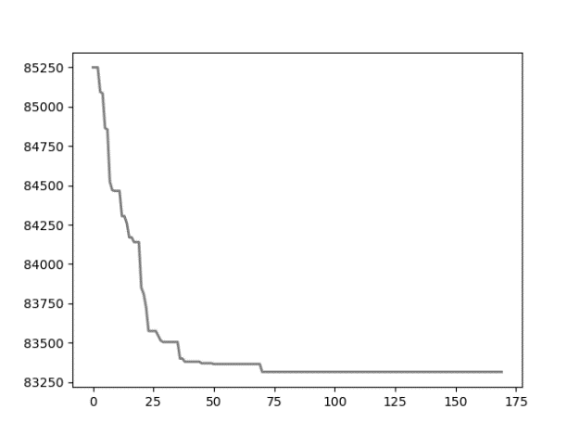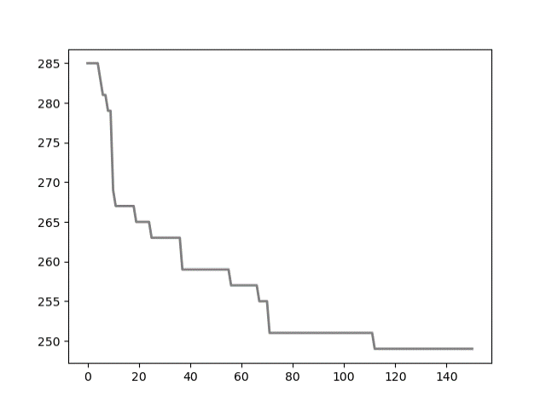

*p43.4.sop* *jpeg.4753.54.sop*

* + Logarithmic (T0 / math.log(step)):

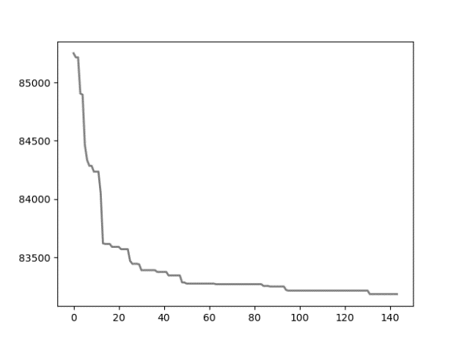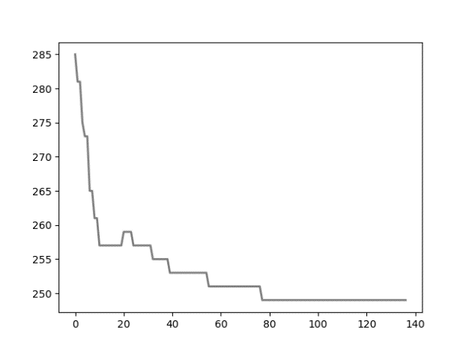

*p43.4.sop*  *jpeg.4753.54.sop*

* + Exponential exp(-ALPHA * step)*T0:

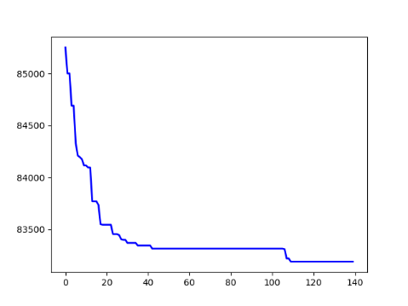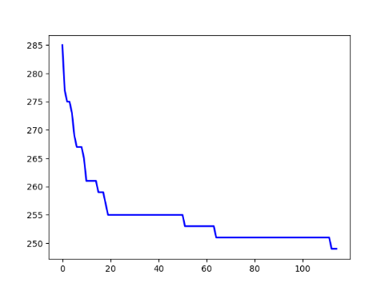

*p43.4.sop* *jpeg.4753.54.sop*

as plots show exponential method perform a little bit better search in compare with other.

* Simulated annealing Comparison with BKSs:

Instances run with bellow config:

T = 1

ALPHA = 0.9

TEMP_MODE = EXP

INIT_HEURISTIC = True

NUM_ITERATIONS = 500

Instances with run time under 30 seconds ran 20 times and other with ran 10 times.

On the “E” instances folder, results were near to the BK answers except bellow instance types: kro124p.*, prob.100, prob.7. *, rbg109a.sop.

it seems that from view of this algorithm, these problems were harder than other.

On the “H” instances folder, results were almost similar to the BK answers (with maximum difference equal to 7).

the “M” instances were much more time consuming and the results weren’t as good as “H” folder.

The whole results (main, max, avg) came at the end.

* Simulated annealing algorithm analysis:

**Strength:**

this algorithm is much faster that algorithm explained in the related origin paper cause instead of searching whole space with time complexity O(n3), perform the search just for ***“problem.dimension”*** times.

The results are really close to the paper method in most of the cases.

**Weakness:**

because of searching the less problem area that related paper method, in some instances it reaches a little bit worst result.

In overall the algorithm is a less time-consuming version of paper method with good acceptable results.

* Simulated annealing results:

|  |  |  |  |  |  |  |  |  |
| --- | --- | --- | --- | --- | --- | --- | --- | --- |
| Instance | BKS | best | average | worst | min_time | avg_time | max_time | Diff of Best |
| ft53.2.sop | 8026 | 9473 | 10312.8 | 11041 | 1.1050 | 1.2013 | 1.3194 | 1447 |
| ft70.2.sop | 40419 | 44076 | 45597.4 | 46640 | 2.0604 | 2.3552 | 2.7556 | 3657 |
| kro124p.1.sop | 39420 | 46934 | 48537.15 | 49917 | 7.9588 | 8.9360 | 9.8073 | 7514 |
| kro124p.3.sop | 49499 | 59438 | 62762.4 | 66501 | 3.4378 | 4.8182 | 5.6962 | 9939 |
| p43.1.sop | 28140 | 28290 | 28598.75 | 28810 | 0.8178 | 0.9116 | 1.0894 | 150 |
| p43.4.sop | 83005 | 83140 | 83270.5 | 83445 | 0.3390 | 0.3805 | 0.4697 | 135 |
| prob.100.sop | 1123 | 3158 | 3870.05 | 4849 | 4.0428 | 4.2812 | 4.5359 | 2035 |
| prob.5.sop | 243 | 421 | 548.15 | 682 | 0.7549 | 0.8216 | 0.9136 | 178 |
| prob.7.40.sop | 1071 | 1788 | 2301.3 | 2981 | 0.6532 | 0.7296 | 0.8986 | 717 |
| prob.7.60.sop | 912 | 1952 | 2545.5 | 2968 | 1.4327 | 1.5482 | 1.6655 | 1040 |
| prob.7.70.sop | 879 | 2310 | 2881.25 | 3525 | 1.9058 | 2.1013 | 2.2778 | 1431 |
| rbg050a.sop | 400 | 407 | 439.4 | 478 | 0.8008 | 0.9093 | 1.0082 | 7 |
| rbg050b.sop | 397 | 403 | 432.75 | 463 | 0.8028 | 0.9041 | 1.1270 | 6 |
| rbg050c.sop | 467 | 468 | 480.9 | 494 | 0.7749 | 0.8580 | 0.9614 | 1 |
| rbg105a.sop | 1023 | 1064 | 1104.55 | 1143 | 1.9378 | 2.1143 | 2.4140 | 41 |
| rbg118a.sop | 1423 | 1424 | 1450.35 | 1507 | 1.8151 | 1.9227 | 2.1562 | 1 |
| rbg124a.sop | 1361 | 1366 | 1397.25 | 1436 | 1.8051 | 1.9065 | 2.0226 | 5 |
| rbg126a.sop | 1381 | 1398 | 1421.6 | 1481 | 1.9942 | 2.2430 | 2.6624 | 17 |
| rbg143a.sop | 1765 | 1774 | 1801.35 | 1832 | 2.1233 | 2.2379 | 2.4345 | 9 |
| rbg219a.sop | 2544 | 2578 | 2605.35 | 2632 | 6.6901 | 7.2614 | 7.8829 | 34 |
| rbg247a.sop | 3062 | 3101 | 3140.35 | 3187 | 8.1642 | 8.7001 | 9.8681 | 39 |
| rbg341a.sop | 2568 | 3117 | 3217.9 | 3342 | 26.782 | 29.577 | 33.403 | 549 |
| ry48p.2.sop | 16666 | 18290 | 20884.7 | 23105 | 0.9273 | 1.0249 | 1.1865 | 1624 |
| ry48p.3.sop | 19894 | 22029 | 23826.5 | 25251 | 0.7129 | 0.8665 | 1.0328 | 2135 |
| prob.7.65.sop | 915 | 1649 | 1930.65 | 2188 | 1.6960 | 2.2015 | 2.6070 | 734 |
| rbg109a.sop | 198 | 1046 | 1081.1 | 1110 | 2.0425 | 2.5092 | 2.7716 | 848 |
| rbg117a.sop | 1494 | 1497 | 1516.55 | 1548 | 1.4388 | 1.6960 | 1.8951 | 3 |
| rbg150a.sop | 1750 | 1783 | 1829.5 | 1866 | 3.7965 | 4.4883 | 5.2027 | 33 |
| rbg174a.sop | 2033 | 2059 | 2114.5 | 2146 | 5.1369 | 6.4195 | 7.2307 | 26 |
| rbg190a.sop | 2241 | 2269 | 2290.0 | 2311 | 5.2462 | 6.6285 | 7.6026 | 28 |
| rbg285a.sop | 3482 | 3557 | 3604.55 | 3668 | 14.519 | 15.807 | 18.102 | 75 |
| rbg358a.sop | 2545 | 2884 | 3001.15 | 3141 | 37.397 | 41.883 | 47.849 | 339 |
|  |  |  |  |  |  |  |  |  |
| gsm.153.124.sop | 1109 | 1110 | 1121.05 | 1129 | 0.6336 | 0.7397 | 0.9579 | 1 |
| gsm.462.77.sop | 577 | 578 | 581.45 | 587 | 0.5404 | 0.5812 | 0.6931 | 1 |
| jpeg.3184.107.sop | 791 | 798 | 808.0 | 817 | 0.8498 | 0.9889 | 1.1526 | 7 |
| jpeg.4753.54.sop | 245 | 247 | 256.5 | 269 | 0.3554 | 0.4670 | 0.7355 | 2 |
| susan.260.158.sop | 1016 | 1022 | 1035.65 | 1055 | 1.7578 | 2.1034 | 2.4285 | 6 |
| typeset.15577.36.sop | 155 | 155 | 160.65 | 171 | 0.2309 | 0.2598 | 0.3679 | 0 |
| typeset.1723.25.sop | 64 | 64 | 69.85 | 78 | 0.1578 | 0.1951 | 0.3143 | 0 |
| typeset.19972.246.sop | 2018 | 2018 | 2021.6 | 2034 | 1.3684 | 1.4857 | 1.7511 | 0 |
| typeset.4724.433.sop | 3466 | 3468 | 3478.2 | 3496 | 6.0954 | 6.8138 | 8.1372 | 2 |
| typeset.16000.68.sop | 84 | 84 | 85.2 | 90 | 0.6667 | 0.8752 | 1.1691 | 0 |
| typeset.10835.26.sop | 127 | 127 | 130.9 | 137 | 0.1950 | 0.2186 | 0.2806 | 0 |
|  |  |  |  |  |  |  |  |  |
| R.200.100.1.sop | 61 | 340 | 402.3 | 453 | 27.408 | 28.773 | 30.956 | 279 |
| R.200.100.60.sop | 71749 | 72804 | 74300.15 | 75808 | 1.8221 | 1.9594 | 2.2568 | 1055 |
| R.200.1000.30.sop | 41196 | 46190 | 49303.0 | 52981 | 2.2330 | 2.5983 | 3.2566 | 4994 |
| R.200.1000.60.sop | 71556 | 72846 | 74722.2 | 76561 | 1.9925 | 2.5362 | 2.8859 | 1290 |
| R.300.1000.60.sop | 109471 | 110993 | 112747.95 | 114203 | 5.2474 | 6.6597 | 9.1146 | 1522 |
| R.400.1000.15.sop | 38963 | 64354 | 66147.15 | 68407 | 21.304 | 22.863 | 25.351 | 25391 |
| R.500.1000.1.sop | 1316 | 3532 | 3733.14 | 3926 | 631.41 | 738.70 | 858.61 | 2216 |
| R.600.100.60.sop | 23293 | 24300 | 24479.8 | 24711 | 42.649 | 49.824 | 66.338 | 1007 |
| R.600.1000.1.sop | 1337 | 3676 | 3681.5 | 3687 | 1073.2 | 10774.5 | 1081.7 | 2339 |
| R.600.1000.60.sop | 214608 | 224197 | 226373.6 | 228394 | 29.580 | 33.008 | 39.903 | 9589 |
| R.700.1000.15.sop | 65678 | 121526 | 123669.0 | 126399 | 77.331 | 81.251 | 92.250 | 55848 |
| R.700.1000.60.sop | 245589 | 257974 | 259705.3 | 261393 | 80.584 | 92.586 | 100.08 | 12385 |

* GRASP algorithm:

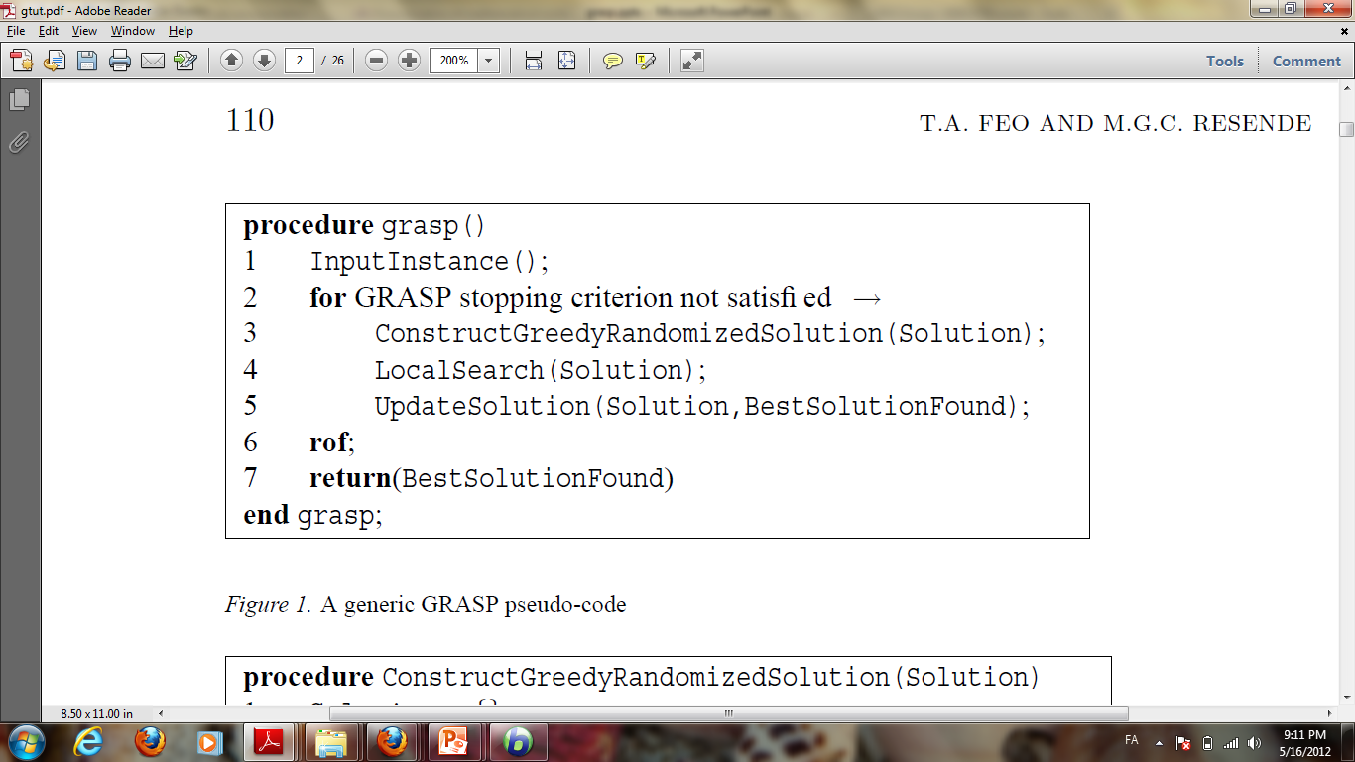

As the pseudo-code shows the algorithm contains of 3 main part.

For SOP problems we implement the methods as bellow:

***“ConstructGreedyRandomizedSolution()”:***

Like what we did in initial heuristic of simulated annealing, step by step we choose next feasible greedy node to add to the path, but instead of using the best node from candidate list we choose from randomly between (0, ALPH) percentages best of candidate list for next node selection (rank-based selection) and by this manner we add random factor beside greedy factor as GRASP behaves.

index = *int*(rnd.uniform(0, ALPHA) * graph.dimension)

dest = rnd.choice(*list*(candidates[0:1+index]))[0]

solution.append(dest)

***“LocalSearch()”:***

For searching the local area just like we mentioned in ***“get_neighbor()”*** previously ,we choose local optimal from best of backward and forward solutions.

***“UpdateSolution()”:***

At the end we update global best solution if local optimal was better (smaller cost).

* Local search role analysis:
  + ESC78.sop

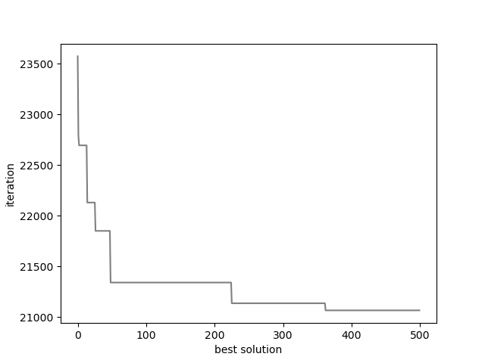 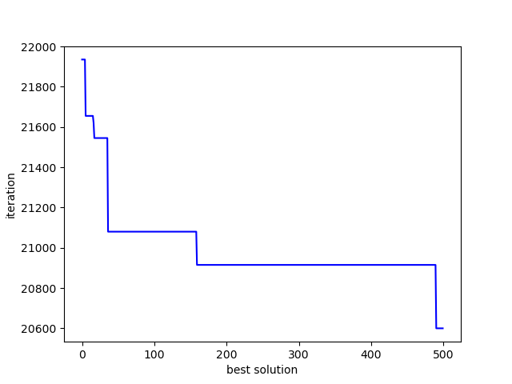

*Without local search With local search*

* + R.200.100.1

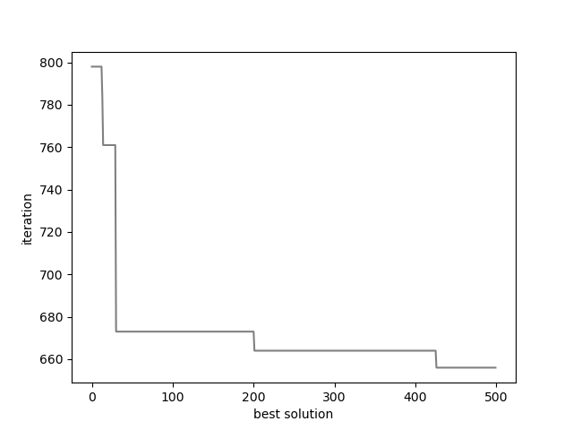 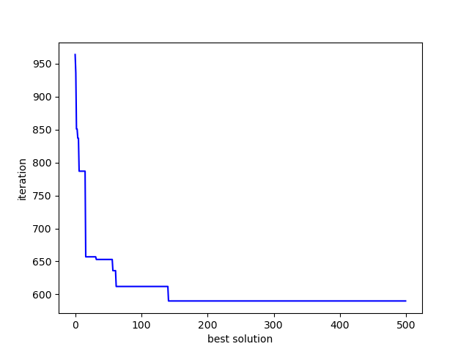

*Without local search With local search*

As plots shows local search operator cause finding better quality of solution at the end, it may or may not start from better solution. But the benefit of using it is obvious.

ALPHA = 0.02

NUM_ITERATIONS = 500

* + **Without local search:**

|  |  |  |  |  |
| --- | --- | --- | --- | --- |
| Instance | best | worst | average | avg_time |
| ESC78.sop | 20465 | 21370 | 21194.5 | 1.8862 |
| R.200.100.60.sop | 85057 | 87786 | 85892.3 | 24.435 |
| susan.260.158.sop | 1124 | 1143 | 1134.6 | 6.5894 |

* + **With local search:**

|  |  |  |  |  |
| --- | --- | --- | --- | --- |
| Instance | best | worst | average | avg_time |
| ESC78.sop | 20405 | 21220 | 20895.0 | 3.9388 |
| R.200.100.60.sop | 83444 | 87524 | 85955.7 | 26.316 |
| susan.260.158.sop | 1121 | 1139 | 1131.3 | 8.2227 |

(Results per 10 time of run for each instance)

Local search operation gives better result overall and due to its searching process, it takes more time.

* ALPHA value (maximum size of RCL list) comparison:

Plot of average cost for 20 time run of each instance per AlPHA comes in bellow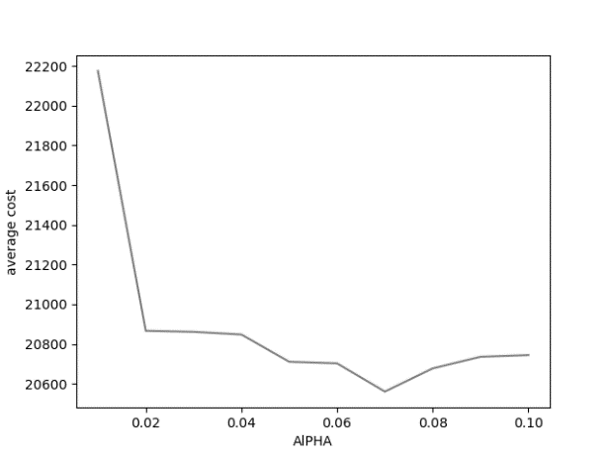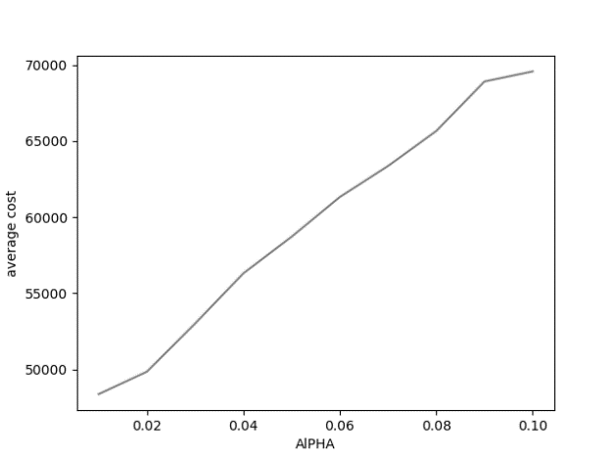

*ESC78.sop kro124p.1.sop*

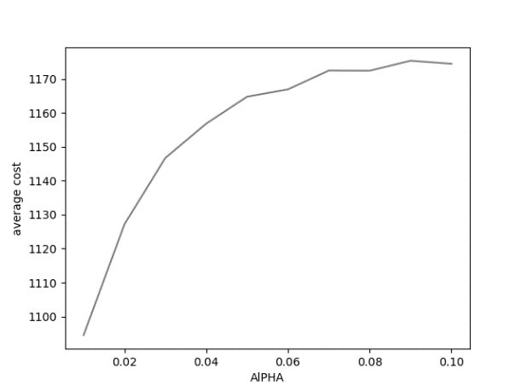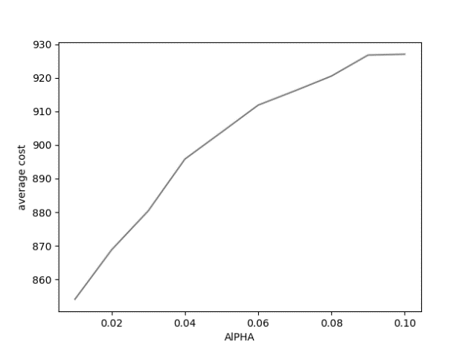

*sasan.260.158.sop jpeg.3184l.107.sop*

based on the result of some instances that plot of some of them came above, ALPHA=0.2 selected for all instances. In some cases, bigger alpha made better best solution.

It seems that bigger alpha cause bigger variance of solutions and due to bigger variance, it causes higher average.

Higher alpha value does more exploration and add more randomness on the other side lower alpha value does more exploitation.

* GRASP solutions variance analysis:
  + Solution variance of 10 times of running algorithm.

|  |  |  |  |  |
| --- | --- | --- | --- | --- |
| * Instance | best | average | worst | variance |
| ESC78.sop | 20400 | 20776.0 | 20970 | 200.88 |
| kro124p.3.sop | 62362 | 64364.6 | 66162 | 1332.38 |
| p43.4.sop | 84820 | 84820.0 | 84820 | 0.0 |
| prob.7.65.sop | 1689 | 1719.0 | 1774 | 30.78 |
| jpeg.3184.107.sop | 865 | 869.4 | 873 | 3.2 |
| susan.260.158.sop | 1116 | 1124.0 | 1132 | 5.32 |
| R.200.100.1.sop | 340 | 402.3 | 453 | 28.773 |
| R.600.100.60.sop | 28711 | 28765.5 | 28820 | 54.5 |

* + Solution variance of global optimal during running the algorithm.

|  |  |
| --- | --- |
| * Instance | variance |
| ESC78.sop | 301.89 |
| kro124p.3.sop | 1749.65 |
| p43.4.sop | 47.29 |
| prob.7.65.sop | 71.70 |
| jpeg.3184.107.sop | 8.47 |
| susan.260.158.sop | 13.26 |
| R.200.100.1.sop | 24.96 |

It seems that in some cases data variance is high and it’s because of randomness aspect of the algorithm.

* Simulated annealing vs GRASP comparison:
  + **Simulated annealing:**

|  |  |  |  |  |  |  |
| --- | --- | --- | --- | --- | --- | --- |
| Instance | BKS | best | average | worst | avg_time | Diff of Best |
| ESC78.sop | 18230 | 18250 | 18400.5 | 18535 | 1.7924 | 20 |
| kro124p.3.sop | 49499 | 59438 | 62762.4 | 66501 | 4.8182 | 9939 |
| prob.7.65.sop | 915 | 1649 | 1930.65 | 2188 | 2.2015 | 734 |
| susan.260.158.sop | 1016 | 1123 | 1128/8 | 1136 | 8.6370 | 6 |
| R.200.100.1.sop | 61 | 340 | 402.3 | 453 | 28.773 | 279 |
| R.400.1000.15.sop | 38963 | 64354 | 66147.15 | 68407 | 22.863 | 279 |

* + **GRASP:**

|  |  |  |  |  |  |  |
| --- | --- | --- | --- | --- | --- | --- |
| Instance | BKS | best | average | worst | avg_time | Diff of Best |
| ESC78.sop | 18230 | 20405 | 20895 | 21220 | 3.8190 | 2175 |
| kro124p.3.sop | 49499 | 60161 | 63202.9 | 67032 | 6.2631 | 10662 |
| prob.7.65.sop | 915 | 1560 | 1658/4 | 1812 | 3.2334 | 645 |
| susan.260.158.sop | 1016 | 1123 | 1128/8 | 1136 | 8.6370 | 107 |
| R.200.100.1.sop | 61 | 393 | 448.7 | 483 | 56.704 | 332 |
| R.400.1000.15.sop | 38963 | 144545 | 148052.9 | 150760 | 120.86 | 105582 |

The GRASP algorithm average solution is worse than simulated annealing in compare and its variances of solution are bigger.

It also takes more time in average.in compare with pure greedy, GRASP perform better due to having the random aspect beside greedy.

* GRASP results:

|  |  |  |  |  |  |  |  |  |
| --- | --- | --- | --- | --- | --- | --- | --- | --- |
| Instance | BKS | best | average | worst | min_time | avg_time | max_time | Diff of Best |
| br17.1.sop | 41 | 61 | 61 | 61 | 0.2543 | 0.2572 | 0.2632 | 20 |
| br17.10.sop | 55 | 63 | 63 | 63 | 0.2124 | 0.2153 | 0.2170 | 8 |
| br17.12.sop | 55 | 63 | 63 | 63 | 0.2064 | 0.2315 | 0.2732 | 8 |
| ESC78.sop | 18230 | 20405 | 20895 | 21220 | 3.7371 | 3.8190 | 4.0162 | 2175 |
| ESC98.sop | 2125 | 2125 | 2125 | 2125 | 7.9125 | 8.2295 | 8.5833 | 0 |
| ft53.2.sop | 8026 | 10741 | 11249.2 | 11475 | 1.9532 | 2.1721 | 2.4002 | 2715 |
| ft70.2.sop | 40419 | 44566 | 45606.9 | 46400 | 3.3997 | 3.6471 | 3.8445 | 4147 |
| kro124p.1.sop | 39420 | 48588 | 49968.0 | 51023 | 9.2160 | 9.4826 | 9.6200 | 9168 |
| kro124p.3.sop | 49499 | 60161 | 63202.9 | 67032 | 5.9466 | 6.2631 | 6.6445 | 10662 |
| p43.1.sop | 28140 | 29120 | 29120 | 29120 | 1.3682 | 1.4517 | 1.5105 | 980 |
| p43.4.sop | 83005 | 84820 | 84820 | 84820 | 1.0476 | 1.1261 | 1.2562 | 1815 |
| prob.100.sop | 1123 | 2062 | 2248/6 | 2378 | 7.8009 | 8.0781 | 8.3549 | 939 |
| prob.5.sop | 243 | 417 | 417 | 417 | 1.2846 | 1.3691 | 1.5334 | 174 |
| prob.7.40.sop | 1071 | 2477 | 2477 | 2477 | 1.0850 | 1.1679 | 1.3081 | 1406 |
| prob.7.60.sop | 912 | 1530 | 1563 | 1623 | 2.6015 | 2.7256 | 2.9206 | 618 |
| prob.7.65.sop | 915 | 1560 | 1658/4 | 1812 | 2.9690 | 3.2334 | 3.5530 | 645 |
| prob.7.70.sop | 879 | 1608 | 1665/2 | 1762 | 3.4080 | 3.7098 | 4.1187 | 729 |
| rbg050a.sop | 400 | 474 | 475/2 | 476 | 1.7683 | 1.8415 | 1.9509 | 74 |
| rbg050b.sop | 397 | 501 | 507/8 | 517 | 1.6675 | 1.7497 | 1.9154 | 104 |
| rbg050c.sop | 467 | 543 | 546/8 | 549 | 1.6695 | 1.8106 | 1.9277 | 76 |
| rbg105a.sop | 1023 | 1300 | 1343/2 | 1362 | 6.0060 | 6.0823 | 6.1843 | 277 |
| rbg109a.sop | 198 | 1323 | 1336/2 | 1352 | 6.5961 | 6.8382 | 7.0040 | 1125 |
| rbg117a.sop | 1494 | 1654 | 1668/6 | 1681 | 6.6315 | 6.8512 | 7.0958 | 160 |
| rbg118a.sop | 1423 | 1641 | 1683 | 1699 | 6.7349 | 7.0234 | 7.1377 | 218 |
| rbg124a.sop | 1361 | 1623 | 1635/4 | 1645 | 7.8546 | 8.1561 | 8.5900 | 262 |
| rbg126a.sop | 1381 | 1678 | 1709/2 | 1735 | 8.3840 | 8.5852 | 8.8323 | 297 |
| rbg143a.sop | 1765 | 2077 | 2091/6 | 2111 | 12.001 | 10.228 | 9.8187 | 312 |
| rbg150a.sop | 1750 | 2101 | 2128/4 | 2144 | 13.088 | 13.528 | 14.159 | 351 |
| rbg174a.sop | 2033 | 2461 | 2488/8 | 2501 | 18.461 | 19.102 | 19.628 | 428 |
| rbg190a.sop | 2241 | 2826 | 2857/2 | 2904 | 21.700 | 21.946 | 22.479 | 585 |
| rbg219a.sop | 2544 | 3301 | 3353/8 | 3396 | 30.687 | 31.354 | 31.793 | 757 |
| rbg247a.sop | 3062 | 3930 | 3992/8 | 4043 | 38.060 | 38.995 | 39.407 | 868 |
| rbg285a.sop | 3482 | 4576 | 4617/2 | 4674 | 54.148 | 55.410 | 56.633 | 1094 |
| rbg341a.sop | 2568 | 4583 | 4643/2 | 4716 | 100.00 | 99.833 | 99.956 | 2015 |
| rbg358a.sop | 2545 | 4746 | 4802/6 | 4859 | 118.75 | 120.36 | 123.48 | 2201 |
| ry48p.2.sop | 16666 | 20407 | 20407 | 20407 | 1.5763 | 1.6015 | 1.6224 | 3741 |
| ry48p.3.sop | 19894 | 26118 | 26118 | 26118 | 1.2955 | 1.3214 | 1.3502 | 6224 |
|  |  |  |  |  |  |  |  |  |
| gsm.153.124.sop | 1109 | 1177 | 1185 | 1194 | 4.7513 | 4.8959 | 5.1867 | 68 |
| gsm.462.77.sop | 577 | 585 | 586/4 | 587 | 2.1583 | 2.2547 | 2.4721 | 8 |
| jpeg.3184.107.sop | 791 | 856 | 865/2 | 875 | 3.9890 | 4.0605 | 4.1194 | 65 |
| jpeg.4753.54.sop | 245 | 257 | 259 | 261 | 1.1449 | 1.2211 | 1.3740 | 12 |
| susan.260.158.sop | 1016 | 1123 | 1128/8 | 1136 | 8.5176 | 8.6370 | 8.7726 | 107 |
| typeset.10835.26.sop | 127 | 137 | 137 | 137 | 0.4084 | 0.4323 | 0.4775 | 10 |
| typeset.15577.36.sop | 155 | 175 | 175 | 175 | 0.6161 | 0.6451 | 0.6712 | 20 |
| typeset.16000.68.sop | 84 | 85 | 86/2 | 87 | 1.6542 | 1.7778 | 1.8768 | 1 |
| typeset.1723.25.sop | 64 | 72 | 72 | 72 | 0.3459 | 0.3598 | 0.3951 | 8 |
| typeset.19972.246.sop | 2018 | 2068 | 2073/6 | 2080 | 23.296 | 23.464 | 23.676 | 50 |
| typeset.4724.433.sop | 3466 | 3657 | 3668/8 | 3679 | 107.35 | 107.63 | 107.94 | 191 |
|  |  |  |  |  |  |  |  |  |
| R.200.100.1.sop | 61 | 393 | 448.7 | 483 | 56.464 | 56.704 | 56.955 | 332 |
| R.200.100.60.sop | 71749 | 84814 | 85629/8 | 86253 | 24.674 | 25.005 | 25.163 | 13065 |
| R.200.1000.30.sop | 41196 | 71241 | 73088/8 | 74544 | 19.661 | 19.811 | 20.100 | 30045 |
| R.200.1000.60.sop | 71556 | 83161 | 86006 | 87744 | 24.430 | 24.736 | 24.873 | 11605 |
| R.300.1000.60.sop | 109471 | 134691 | 135201/8 | 136134 | 72.406 | 72.763 | 73.572 | 25220 |
| R.400.1000.15.sop | 38963 | 144545 | 148052.9 | 150760 | 120.11 | 120.86 | 121.68 | 105582 |
| R.500.1000.1.sop | 1316 | 11371 | 12200.9 | 12815 | 1025.4 | 1084.3 | 998.53 |  |
| R.600.100.60.sop |  | 28711 | 28765.5 | 28820 | 522.35 | 543.22 | 564.09 |  |