CCVRP optimization with ACO

* Problem Description:

The Clustered capacitated vehicle routing problem (CCVRP) consist of n-1 costumers with certain need and one depot with some vehicles with specific amount of capacity.

Each customer vi (i ∈ {1,…,n}) has a known nonnegative demand di to be delivered or collected and the depot has a fictitious demand d0 = 0. There exist m identical vehicles, each with a capacity Q and in order to ensure feasibility we assume that di ⩽ Q for each i ∈ {1,…,n}.

Problem assumption:

* + each route starts and ends at the depot vertex;
  + once a vehicle enters a cluster, it visits all the vertices within the cluster before leaving it;
  + the sum of the demands of the visited vertices by a route does not exceed the capacity of the vehicle, Q.
* Instances Description:

Instances are created based on CVRP instances form TSPLIB library with difference that we created new problem that is a clustered version of CVRP.

Each CVRP instance file consists of two part as **specification part** that contains information about the instance data and **data part**.

* Algorithm Description:

**ACS Algorithm**

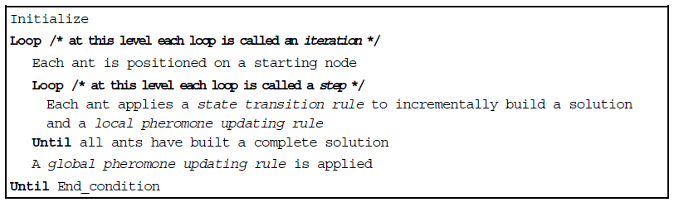

1. **ACS state transition rule**

an ant positioned on node *r* chooses the city *s* to move to by applying the rule given:

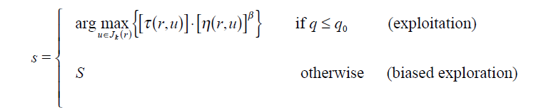

We S set as follow:

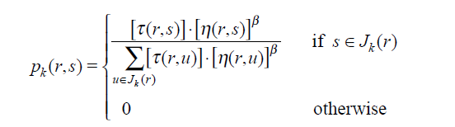

**B. ACS global updating rule**

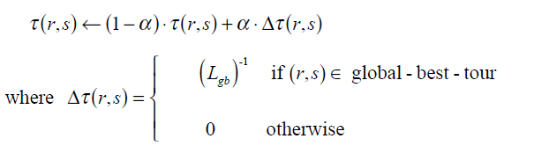

0<a<1 is the pheromone decay parameter, and *Lgb* is the length of the globally best tour from

the beginning of the trial

**C. ACS local updating rule**

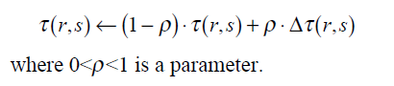

1. we set Dt (*r*,*s*) = t0 , where t0 is the initial pheromone level
2. (ii) we set Dt(*r*,*s*) = 0.

**D. ACS parameter settings**

b=2, *q*0=0.9, a=r=0.1, t0=(*n*·L*nn*)-1, where L*nn* is

the tour length produced by the nearest neighbor heuristic

values of the parameters were largely independent of the problem,

except for t0 for which, as we said, t0 =(*n*·L*nn*)-1. The number of ants used is *m*=10 (this

choice is explained in Section IV.B). Regarding their initial positioning, ants are placed

randomly, with at most one ant in each city.