CCVRP optimization with ACO

* Problem Description:

The Clustered capacitated vehicle routing problem (CCVRP) consist of n-1 costumers with certain need and one depot with some vehicles with specific amount of capacity.

Each customer vi (i ∈ {1,…,n}) has a known nonnegative demand di to be delivered or collected and the depot has a fictitious demand d0 = 0. There exist m identical vehicles, each with a capacity Q and in order to ensure feasibility we assume that di ⩽ Q for each i ∈ {1,…,n}.

Problem assumption:

* + each route starts and ends at the depot vertex;
  + once a vehicle enters a cluster, it visits all the vertices within the cluster before leaving it;
  + the sum of the demands of the visited vertices by a route does not exceed the capacity of the vehicle, Q.
* Instances Description:

Instances are created based on CVRP instances form TSPLIB library with difference that we created new problem that is a clustered version of CVRP.

Each CVRP instance file consists of two part as **specification part** that contains information about the instance data and **data part**.

* Algorithm Description:

**ACS Algorithm**

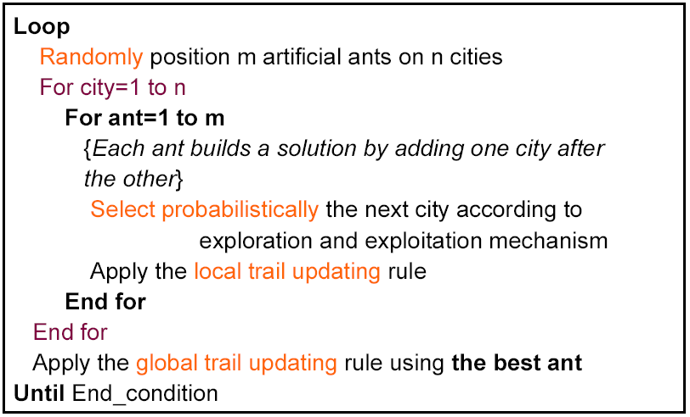 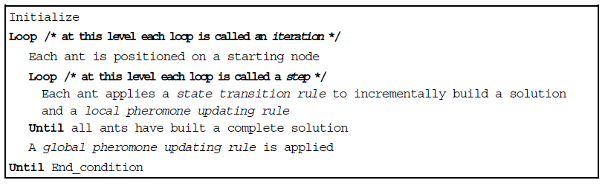

1. **ACS state transition rule**

an ant positioned on node *r* chooses the city *s* to move to by applying the rule given:

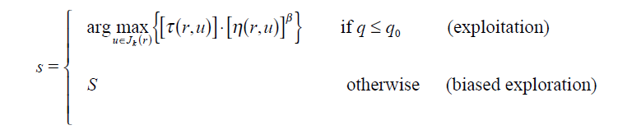

We S set as follow:

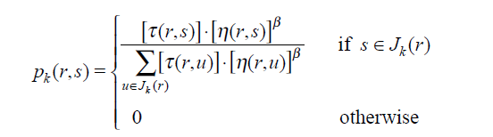

**B. ACS global updating rule**

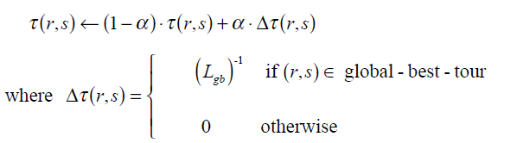

0<a<1 is the pheromone decay parameter, and *Lgb* is the length of the globally best tour from

the beginning of the trial

**C. ACS local updating rule**

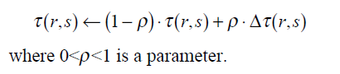

1. we set Dt (*r*,*s*) = t0 , where t0 is the initial pheromone level
2. (ii) we set Dt(*r*,*s*) = 0.

**D. ACS parameter settings**

b=2, *q*0=0.9, a=r=0.1, t0=(*n*·L*nn*)-1, where L*nn* is

the tour length produced by the nearest neighbor heuristic

values of the parameters were largely independent of the problem,

except for t0 for which, as we said, t0 =(*n*·L*nn*)-1. The number of ants used is *m*=10 (this

choice is explained in Section IV.B). Regarding their initial positioning, ants are placed

randomly, with at most one ant in each city.

* Each time an ant moves from the current city to the next the pheromone associated to the edge is modified in the following way:



* the initial pheromone value  is defined as 
* where is the tour length produced by the execution of one ACS iteration without the pheromone component (this is equivalent to a probabilistic nearest neighbor heuristic)

* The effect of local-updating is to make the desirability of edges change dynamically:

every time an ant uses an edge this becomes slightly less desirable and only for the edges which never belonged to a global best tour the pheromone remains t0.

* Results:

Because of HW limitation of execution time (1 minute per instance) bellow

configuration selected.

MUTATION_RATE = 0.2

POPULATION_SIZE = 40

MAX_GENERATION = 10

XOVER_METHOD = ORDER_2POINT

SELECTION = RANDOM

SURVIVOR_SEL_TYPE = ELITISM (best will be kept)

|  |  |  |  |  |  |  |  |  |  |  |
| --- | --- | --- | --- | --- | --- | --- | --- | --- | --- | --- |
| ρ = 10% |  |  |  |  |  |  |  |  |  |  |
| index | **clusters** | **vehicles** | **vertices** | **Q** | **BKS** | **Best** | **average** | **worst** | **variance** | **avg_time** |
| 1 | 120 | 9 | 241 | 550 | 5759/25 |  |  |  |  |  |
| 2 | 101 | 10 | 321 | 700 | 9247/92 |  |  |  |  |  |
| 3 | 96 | 10 | 401 | 900 | 12904/6 |  |  |  |  |  |
| 4 | 104 | 10 | 481 | 1000 | 17810/4 |  |  |  |  |  |
| 5 | 49 | 5 | 201 | 900 | 8960/31 |  |  |  |  |  |
| 6 | 67 | 7 | 281 | 900 | 10976/5 |  |  |  |  |  |
| 7 | 88 | 9 | 361 | 900 | 12485/8 |  |  |  |  |  |
| 8 | 108 | 11 | 441 | 900 | 13331/2 |  |  |  |  |  |
| 9 | 51 | 15 | 256 | 1000 | 710/64 |  |  |  |  |  |
| 10 | 56 | 18 | 324 | 1000 | 908/89 |  |  |  |  |  |
|  |  |  |  |  |  |  |  |  |  |  |
|  |  |  |  |  |  |  |  |  |  |  |
| ρ = 25% |  |  |  |  |  |  |  |  |  |  |
| index | **clusters** | **Vehicles** | **vertices** | **Q** | **BKS** | **best** | **average** | **Worst** | **variance** | **avg_time** |
| 1 | 40 | 10 | 241 | 550 | 6051/04 |  |  |  |  |  |
| 3 | 38 | 10 | 401 | 900 | 13692/6 |  |  |  |  |  |
| 5 | 19 | 5 | 201 | 900 | 9340/7 |  |  |  |  |  |
| 7 | 34 | 9 | 361 | 900 | 12348/1 |  |  |  |  |  |
| 9 | 51 | 16 | 256 | 1000 | 717/63 |  |  |  |  |  |
| 11 | 63 | 20 | 400 | 1000 | 1131/84 |  |  |  |  |  |
| 13 | 98 | 27 | 253 | 1000 | 1034/3 |  |  |  |  |  |
| 15 | 124 | 36 | 397 | 1000 | 1667/08 |  |  |  |  |  |
| 17 | 98 | 23 | 241 | 200 | 795/33 |  |  |  |  |  |
| 19 | 153 | 33 | 361 | 200 | 1538/2 |  |  |  |  |  |
|  |  |  |  |  |  |  |  |  |  |  |
| ρ = 50% |  |  |  |  |  |  |  |  |  |  |
| index | **clusters** | **vehicles** | **vertices** | **Q** | **BKS** | **best** | **average** | **worst** | **variance** | **avg_time** |
| 11 | 37 | 18 | 400 | 1000 | 1101/51 |  |  |  |  |  |
| 12 | 40 | 20 | 484 | 1000 | 1311/91 |  |  |  |  |  |
| 13 | 58 | 28 | 253 | 1000 | 1053/47 |  |  |  |  |  |
| 14 | 66 | 32 | 321 | 1000 | 1342/7 |  |  |  |  |  |
| 15 | 73 | 36 | 397 | 1000 | 1657/22 |  |  |  |  |  |
| 16 | 80 | 39 | 481 | 1000 | 2003/1 |  |  |  |  |  |
| 17 | 47 | 24 | 241 | 200 | 881/66 |  |  |  |  |  |
| 18 | 59 | 30 | 301 | 200 | 1199/12 |  |  |  |  |  |
| 19 | 69 | 35 | 361 | 200 | 1612/33 |  |  |  |  |  |
| 20 | 81 | 41 | 421 | 200 | 2278/64 |  |  |  |  |  |
|  |  |  |  |  |  |  |  |  |  |  |
| ρ = 75% |  |  |  |  |  |  |  |  |  |  |
| index | **clusters** | **vehicles** | **vertices** | **Q** | **BKS** | **best** | **average** | **worst** | **variance** | **avg_time** |
| 2 | 13 | 13 | 321 | 700 | 10204/3 |  |  |  |  |  |
| 4 | 13 | 13 | 481 | 1000 | 17077/5 |  |  |  |  |  |
| 6 | 9 | 9 | 281 | 900 | 11452/0 |  |  |  |  |  |
| 8 | 14 | 13 | 441 | 900 | 13882/23 |  |  |  |  |  |
| 10 | 22 | 21 | 324 | 1000 | 1000/507 |  |  |  |  |  |
| 12 | 27 | 26 | 484 | 1000 | 1475/679 |  |  |  |  |  |
| 14 | 42 | 41 | 321 | 1000 | 1520/546 |  |  |  |  |  |
| 16 | 51 | 51 | 481 | 1000 | 2265/537 |  |  |  |  |  |
| 18 | 38 | 37 | 301 | 200 | 1392/153 |  |  |  |  |  |
| 20 | 53 | 52 | 421 | 200 | 2502/34 |  |  |  |  |  |
|  |  |  |  |  |  |  |  |  |  |  |
|  |  |  |  |  |  |  |  |  |  |  |
| ρ = 100% | |  |  |  |  |  |  |  |  |  |
| index | **clusters** | **vehicles** | **vertices** | **Q** | **BKS** | **best** | **average** | **worst** | **variance** | **avg_time** |
| 1 | 9 | 9 | 241 | 550 | 6293/036 |  |  |  |  |  |
| 2 | 10 | 10 | 321 | 700 | 9879/586 |  |  |  |  |  |
| 4 | 10 | 10 | 481 | 1000 | 16130/39 |  |  |  |  |  |
| 5 | 5 | 5 | 201 | 900 | 8394/111 |  |  |  |  |  |
| 7 | 8 | 8 | 361 | 900 | 11346/11 |  |  |  |  |  |
| 8 | 10 | 10 | 441 | 900 | 13188/94 |  |  |  |  |  |
| 10 | 16 | 16 | 324 | 1000 | 837/516 |  |  |  |  |  |
| 11 | 18 | 18 | 400 | 1000 | 1054/133 |  |  |  |  |  |
| 19 | 34 | 34 | 361 | 200 | 1667/454 |  |  |  |  |  |
| 20 | 39 | 39 | 421 | 200 | 2128/597 |  |  |  |  |  |