**Max generation:** 300

**Population size:** 400

**N:** 10

**Mutation case:** Case2

**Survivor selection type:** Generational

Results of x_over methods:

(The green color shows the value in this dimension is approximately zero)

(f_array is function values in different dimensions)

* **XOVER_METHOD = LOCAL_DISC**

fitness = 0.00012727566263492918 (the result rounded)

x = [420.9687468, 420.9687467, 420.9687462,

420.968746, 420.9687451, 420.9687469,

420.9687472, 420.9687453, 420.9687467,

420.968745]

f_array = [1.2727566286230285e-05, 1.2727566286230285e-05,

1.2727566229386866e-05, 1.2727566229386866e-05,

1.272756651360396e-05, 1.2727566343073704e05,

1.2727566343073704e-05, 1.2727566399917123e-05,

1.2727566286230285e-05, 1.272756651360396e-05]

* **XOVER_METHOD = LOCAL_INT**

fitness = 1362.1149460891397

x = [420.9687465, 203.8142529, 65.5478653,

65.5478648, 203.8142533, 420.9687462,

203.8142524, 420.9687466, 420.9687466,

420.9687463]

f_array: [1.2727566229386866e-05, 217.13968211813918,

355.34791804844554, 355.34791804844554,

217.13968211813923, 1.2727566229386866e-05,

217.13968211813915, 1.2727566286230285e-05,

1.2727566286230285e-05, 1.2727566229386866e-05]

* **XOVER_METHOD = GLOBAL_DISC**

fitness = 0.00012727566263492918

x = [420.9687471, 420.9687455, 420.9687457,

420.9687475, 420.9687471, 420.9687469,

420.9687465, 420.9687475, 420.9687467,

420.9687475]

f_array: [1.2727566343073704e-05, 1.2727566343073704e-05,

1.2727566343073704e-05, 1.2727566399917123e-05, 1.2727566343073704e-05, 1.2727566343073704e-05, 1.2727566229386866e-05, 1.2727566399917123e-05, 1.2727566286230285e-05, 1.2727566399917123e-05]

* **XOVER_METHOD = GLOBAL_INT**

fitness = 868.5588048379536

x = [203.8142527, 203.8142524, 203.814253,

420.968746, 203.8142524, 420.968746,

420.9687462, 420.9687469, 420.9687465,

420.9687462]

f_array: [217.13968211813918, 217.13968211813915,

217.1396821181392, 1.2727566229386866e-05, 217.13968211813915, 1.2727566229386866e-05, 1.2727566229386866e-05, 1.2727566343073704e-05, 1.2727566229386866e-05, 1.2727566229386866e-05]

**Max generation:** 200

**Population size:** 400

**N:** 10

**Xover method:** LOCAL_DISC

**Survivor selection type:** Generational

Results of mutation methods:

* **MUTATION_MODE = CASE1**

**fitness = 355.34803259654154**

x = [420.9687455, 420.9687462, 420.9687467,

420.9687468, 420.9687466, 65.547864,

420.9687469, 420.9687472, 420.9687462,

420.968746]

f_array: [1.2727566343073704e-05, 1.2727566229386866e-05,

1.2727566286230285e-05, 1.2727566286230285e-05, 1.2727566286230285e-05, 355.34791804844565, 1.2727566343073704e-05, 1.2727566343073704e-05, 1.2727566229386866e-05, 1.2727566229386866e-05]

* **MUTATION_MODE = CASE2**

**fitness = 0.00012727566263492918 (the result rounded)**

x = [420.9687468, 420.9687467, 420.9687462,

420.968746, 420.9687451, 420.9687469,

420.9687472, 420.9687453, 420.9687467,

420.968745]

f_array = [1.2727566286230285e-05, 1.2727566286230285e-05,

1.2727566229386866e-05, 1.2727566229386866e-05,

1.272756651360396e-05, 1.2727566343073704e05,

1.2727566343073704e-05, 1.2727566399917123e-05,

1.2727566286230285e-05, 1.272756651360396e-05]

For 10 time running with mutation Case 1 and observe count non zero dimensions every time:

1 time non zero appears in two dimensions

3 time non zero appears in no dimensions

7 time non zero appears in one dimension

For 10 time of Case2:

0 time non zero appears in two dimensions

7 time non zero appears in no dimensions

3 time non zero appears in one dimension

Compare X-over methods:

(MUTATION_MODE = CASE2, SURVIVOR_SEL_TYPE = ELITISM, N = 10, MAX_GENERATION = 40 , POPULATION_SIZE = 50)

(Blue diagram is Average fitness and Green diagram fitness)

**LOCAL_DISC:** 10/10 of dimensions get approximate zero

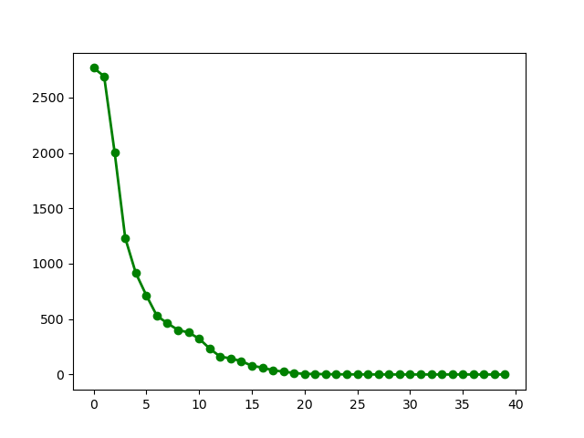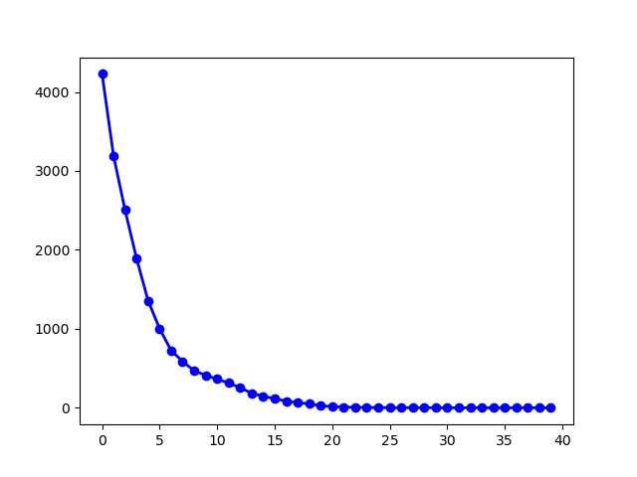

**LOCAL_INT:** 5/10 of dimensions get approximate zero

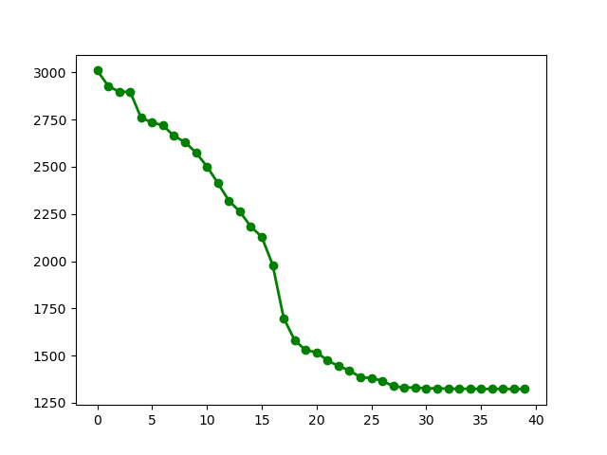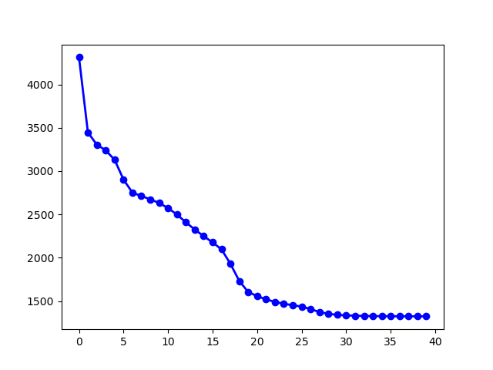

**GLOBAL_DISC:** 10/10 of dimensions get approximate zero

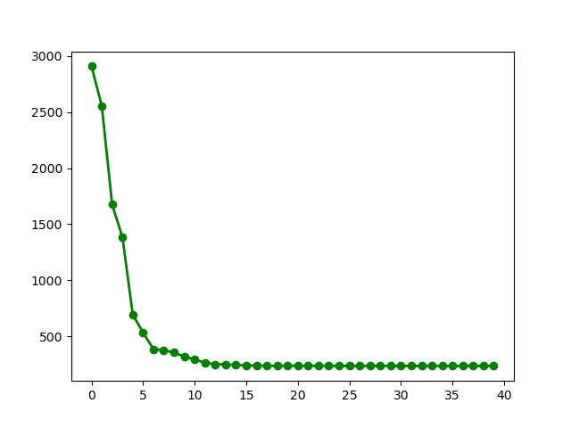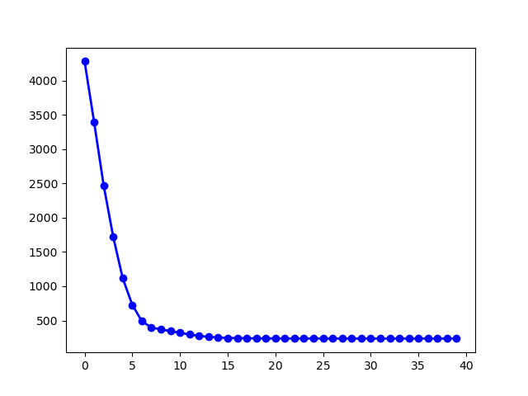

**GLOBAL_INT:** 6/10 of dimensions get approximate zero

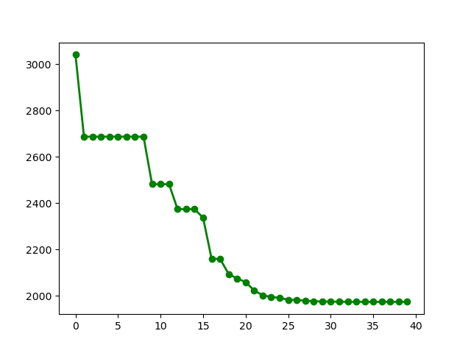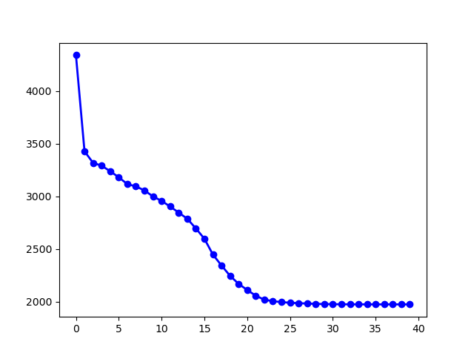

(The orange color show that this method got better value in compare with other)

**GLOBAL_DISC**

f_array: [1.2727566286230285e-05, 1.2727566229386866e-05, 1.2727566456760542e-05, 1.2727566286230285e-05, 1.2727566286230285e-05, 1.2727566229386866e-05, 1.2727566286230285e-05, 1.2727566229386866e-05, 1.2727566343073704e-05, 1.2727566172543447e-05]

**LOCAL_DISC**

f_array: [1.2727566343073704e-05, 1.2727566343073704e-05, 1.2727566343073704e-05, 1.2727566229386866e-05, 1.2727566343073704e-05, 1.2727566286230285e-05, 1.2727566229386866e-05, 1.2727566343073704e-05, 1.2727566286230285e-05, 1.2727566172543447e-05]

for comparing **GLOBAL_DISC** and **LOCAL_DISC** as we look at their f_array(function values in dimensions):

in **6** of dimensions **GLOBAL_DISC** got **better** value.

In **3** of dimensions **LOCAL_DISC** got **better** value.

and in **1** dimension they **got the same** value.

**10 time running of each Xover configuration**

N = 10

MUTATION_MODE = CASE2

SURVIVOR_SEL_TYPE = GENERATIONAL

MAX_GENERATION = 40

POPULATION_SIZE = 50

LOCAL_DISC solutions:

0.00015094456466613337

236.8768963543107

0.0003000986180268228

0.0005415958430603496

0.0001942444359883666

118.43852588414347

0.0002481079254721408

0.000507095779539668

0.0002352570727452985

0.0007377771980827674

**average: 35.531833735989174**

**variance: 75.83748173232169**

LOCAL_INT solutions:

3099.3409534010916

2586.238949801562

2605.753199263469

2823.480701842223

3178.8554887896566

3316.6526517083344

3040.2350163409747

2764.4121095245473

2665.154069110832

2822.9355104730344

**average: 2890.3058650255725**

**variance: 240.86941088199526**

GLOBAL_DISC solutions:

0.022856812952340988

118.45108254002889

118.48857073668842

118.44280131897949

0.008484420666718506

0.005451880581858859

0.005813965529341658

0.023427051593898796

0.010449188122038322

0.040173583998694085

**average: 35.549911149914166**

**variance: 54.27793164502578**

GLOBAL_INT solutions:

2862.703566071283

2724.314037300498

2981.4974372961615

3119.2021268522544

3040.3268200350035

3119.165429527669

2428.264431321057

2724.2654276406556

2310.0546264640657

2901.9836770732454

**average: 2821.177757958189**

**variance: 263.43883447631646**

|  |  |  |
| --- | --- | --- |
| Method | Average | Variance |
| Local discrete | 35.531833735989174 | 75.83748173232169 |
| Local intermediate | 2890.3058650255725 | 240.86941088199526 |
| Global discrete | 35.549911149914166 | 54.27793164502578 |
| Global intermediate | 2821.177757958189 | 263.43883447631646 |

**10 time running of each Mutation configuration**

N = 10

XOVER_METHOD = LOCAL_DISC

SURVIVOR_SEL_TYPE = GENERATIONAL

MAX_GENERATION = 40

POPULATION_SIZE = 50

|  |  |  |
| --- | --- | --- |
| Method | Average | Variance |
| Non Adaptive | 207.38739721690513 | 125.17673368351377 |
| Adaptive (Case 2) | 35.531833735989174 | 75.83748173232169 |

**10 time running of each Survivor Selection configuration**

N = 10

XOVER_METHOD = LOCAL_DISC

MUTATION_MODE = CASE2

MAX_GENERATION = 40

POPULATION_SIZE = 50

|  |  |  |
| --- | --- | --- |
| Method | Average | Variance |
| generational | 35.531833735989174 | 75.83748173232169 |
| Elitism | 23.688428345270175 | 47.37508298528252 |

**Conclusion**

Discrete methods of recombination’s are performing better that intermediate methods. intermediate method instead of combining the goodness of parents,

Calculate their genes average and it may not mean any good feature. (can be really bad even).

Other side discrete methods just transfer genes from parent and doesn’t change them.

Discrete Methods have Xover properties but intermediate methods acts like mutation.