EC-Grid problem:

- Population Model : Steady state model with probability 90%
- Chromosome length : 20 Bits
- Population size : 400
- Maximum number of generations : 4000
- Crossover probability : 90%
- mutation probability : 0.1% ( per individual, not per position )
- Selection pressure : in parent selection (select from 70% best)
- Crossover method : one-point & uniform

Representation:
Array with size 20 , each element determine location of number I as (x,y) tuple in grid environment.

results are for successful runs were solution found in determined generation limit. Algorithm time contains time for printing each generation info.

Uniform Crossover :

Generation Number | Algorithm Time (sec)
1059 | 2.79
827 | 1.98
1285 | 3.2
419 | 1.04
621 | 1.65
645 | 1.64
728 | 1.86
550 | 1.44
558 | 1.47
998 | 2.43

Results :

Average Generation Number : 769
Average Algorithm Time : 1.78 sec

One point Crossover:

Generation Number | Algorithm Time (sec)
1940 | 3.73
3011 | 5.43
836 | 1.53
1667 | 3.09
2242 | 4.20
1174 | 2.18
1559 | 2.83
3277 | 6.18
1632 | 2.95
2132 | 3.84

Results :

Average Generation Number : 1947
Average Algorithm Time : 3.596 sec

success rate of one-point was less than uniform.
convergence speed to local optimum solution is high

10 last best chromosome:
('generation:', 24, ' best fit:', 5.732050807568877)
('generation:', 25, ' best fit:', 3.414213562373095)
('generation:', 26, ' best fit:', 3.414213562373095)
('generation:', 27, ' best fit:', 2.0)
('generation:', 28, ' best fit:', 2.414213562373095)
('generation:', 29, ' best fit:', 2.0)
('generation:', 30, ' best fit:', 2.0)
('generation:', 31, ' best fit:', 2.0)
('generation:', 32, ' best fit:', 1.0)
('generation:', 33, ' best fit:', 0.0)

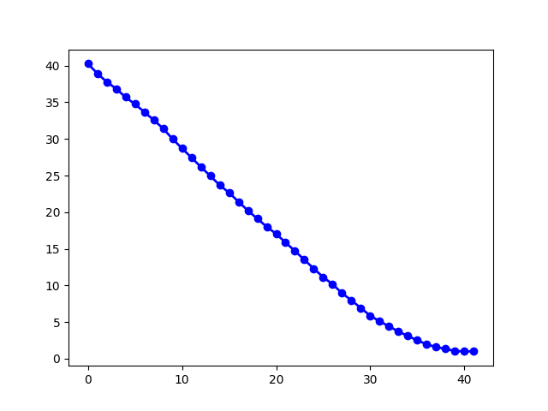Illustration 1: average fitness per generation
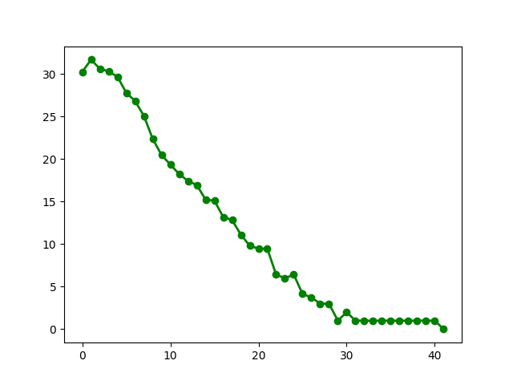Illustration 2: best fitness per generations

Robot problem:

- Population Model : Generational model
- Chromosome length : 243 Bits
- Population size : 300
- Maximum number of generations : 1000
- Crossover probability : 100%
- mutation probability : 0.5% ( per chromosome of individual )
- Selection pressure : in parent selection (select from 70% best) with Roulette wheel method .
- Crossover method : one-point & uniform

Representation:
Array with size 243 witch each elements of that is a possible robot action from the action list below :

["n","s","e","w","r","st","b"] :
n : go north
s : go south
e : go east
w : go west
r : choose random direction
st : stay up
b : bend down to pick up a can
results are for successful runs were solution found in determined generation limit. Algorithm time contains time for printing each generation info.

One point Crossover :

Generation Number | Algorithm Time (sec)
850 | 45.75
504 | 26.76
475 | 26.33
104 | 5.48
263 | 13.77
207 | 11.28
328 | 17.53
117 | 6.38
204 | 10.98
849 | 44.27
Results :

Average Generation Number : 390
Average Algorithm Time : 20.853 sec
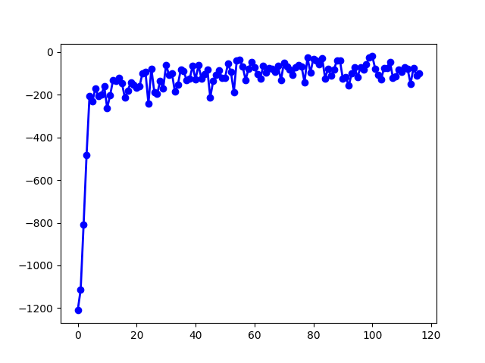Illustration 3: average fitness per generation

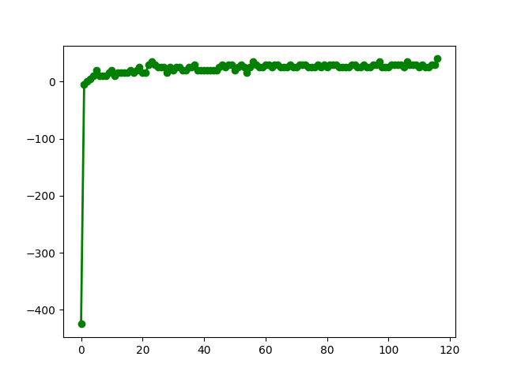Illustration 4: best fitness per generation

STD String problem:

- Population Model : Steady state model with probability 90%
- Chromosome length : equal to target chromosome length
- Population size : 900
- Maximum number of generations : 300
- Crossover probability : 90%
- mutation probability : 0.1% ( per individual, not per position )
- Selection pressure : in parent selection (select from 70% best)
- Crossover method : uniform

Representation:
string with size equal to target string size , each character can be alphabet (a-z) or digits (0-9).

results are for successful runs were solution found in determined generation limit. Algorithm time contains time for printing each generation info.

Uniform Crossover :

Generation Number | Algorithm Time (sec)
47 | 0.47
45 | 0.42
42 | 0.45
45 | 0.45
47 | 0.46
43 | 0.42
46 | 0.45
43 | 0.42
43 | 0.42
46 | 0.44

Results :
Average Generation Number : 45
Average Algorithm Time : 44 sec

convergence speed to local optimum solution is high such that for generation number in (40-50) , search algorithm stuck into local optimum.

because of high speed diversity lost we have to increase population size at the beginning.

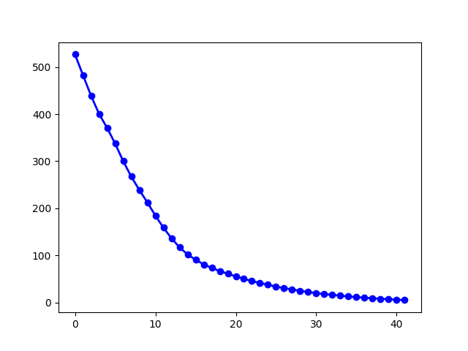Illustration 5: average fitness per generation

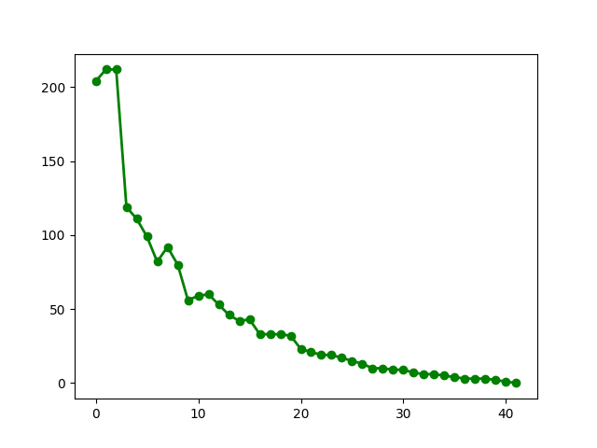Illustration 6: best fitness per generation

