Matrix transpose optimization with Cuda

- Algorithm

storing index (i,j) of input matrix in the index(j,i) of output matrix.

- Implementations

  - Serial transpose with CPU
The input matrix with size m*n stores as one-dimension list that contains all its elements in sequence.
For calculating the transpose, we change elements places in the follow manner:

for(int n = 0; n<dim1*dim2; n++) {
int i = n/dim1;
int j = n%dim1;
out[n] = in_[dim2*j + i];
}

For storing index (j,i) of output matrix with index(i,j) of input matrix we first find (i,j) and then calculate the destination index by (dim2*j + i) which means index (j,i)in output matrix.

  - Parallel, global memory transpose
Every GPU thread transpose one element of matrix.
Row and column of element for every thread calculate as follow:

int column = tile_size * blockIdx.x + threadIdx.x;
int row = tile_size * blockIdx.y + threadIdx.y;
out[column*dim2 + row] = in_[column + row*dim2];

  - Parallel, shared memory transpose
Shared memory is a memory that is shared among block threads and help performance.
We calculate row and column as previous manner but first we transfer input matrix element into shared memory and then place it from shared memory into output matrix.
M_Shared[threadIdx.y][threadIdx.x] = in_[index_in];
__syncthreads();
out[index_out] = M_Shared[threadIdx.y][threadIdx.x];

- commands:
installing dependencies as follow:

!pip install git+git://github.com/andreinechaev/nvcc4jupyter.git

%load_ext nvcc_plugin

for creating .cu file we place %%writefile transpose.cu
before including libraries and then running the Google Colab cell.

Then compiling .cu file by:

!nvcc transpose.cu -o out_int_10 -Wno-deprecated-gpu-targets

At last we profile output using nvprof as bellow:

!nvprof ./out_dataType_TileWidth dim1 dim2
Like:
!nvprof ./out_int_10 100 100

- Results
  - Checking result correctness
As the log shows the result calculated correctly in serial and parallel way:

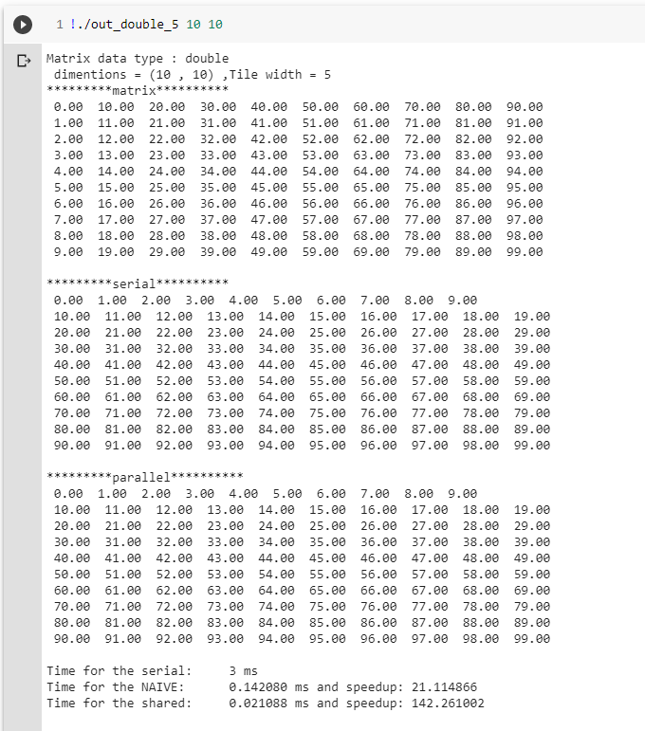
  - Algorithm analysis

Initialing the matrix is the same for serial and parallel manner but the way that algorithm process the input matrix is different and as image shows the serial way is significantly slower.

- Code analysis

As the profiling shows 77% of execution time is for copy data from device to host and 22.70% for copy data from host to device.

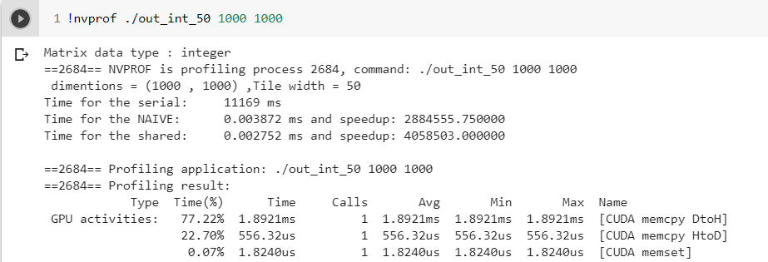

So for improving the performance we use cudaMemcpyAsync() instead of cudaMemcpy()
And performance improve by factor 1.272 (1.8921 ms/1.4875ms) for copy from device to host and 1.051 (556.32 ms/528.83ms) improvement for copy data from host to device.

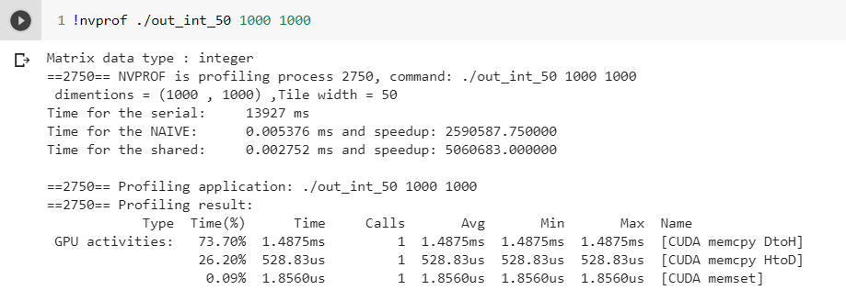

- Profiling the parallel execution

  - Integer type:

    - 10 * 10

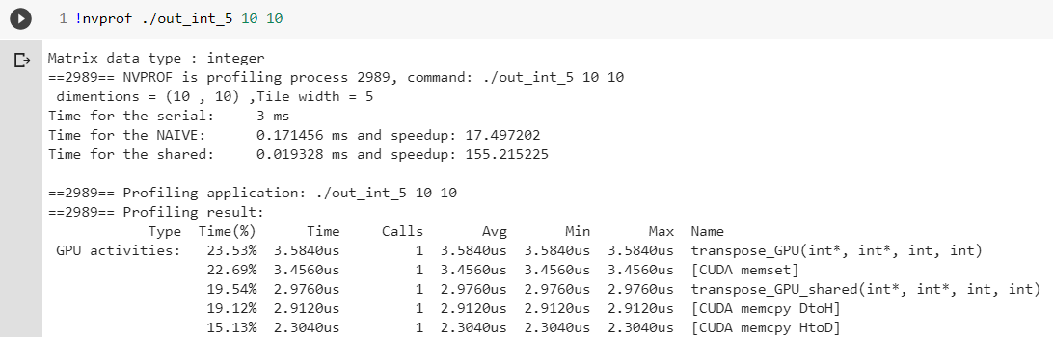

    - 100 * 100

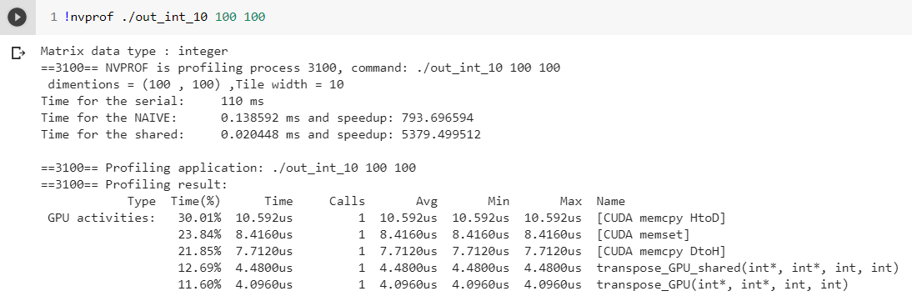

    - 1000 * 1000

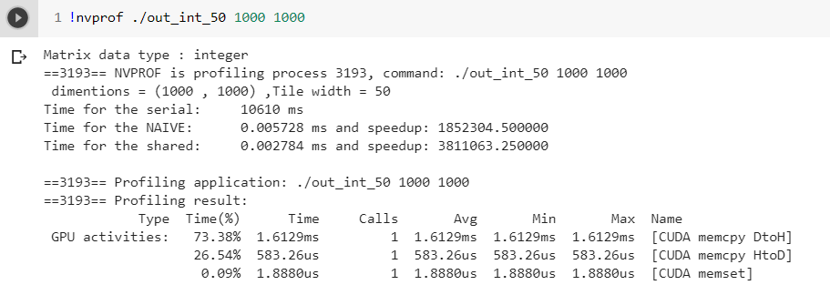

  - Double type:

    - 10 * 10

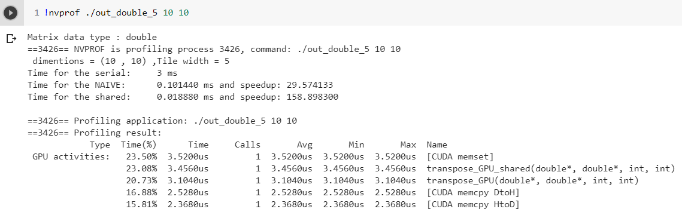

    - 100 * 100

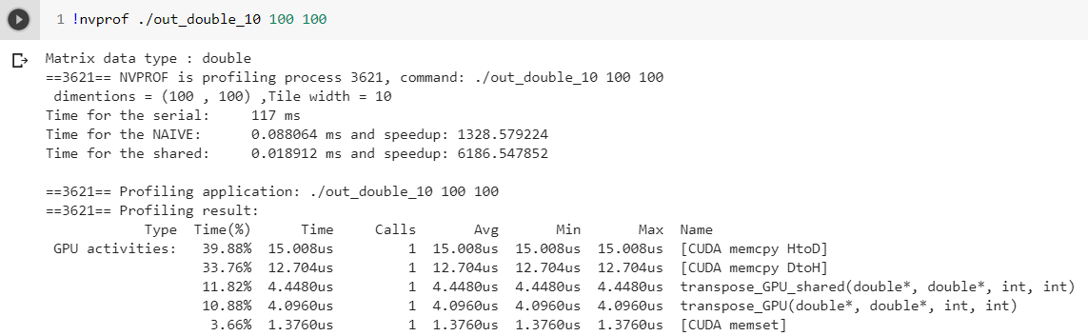

    - 1000 * 1000

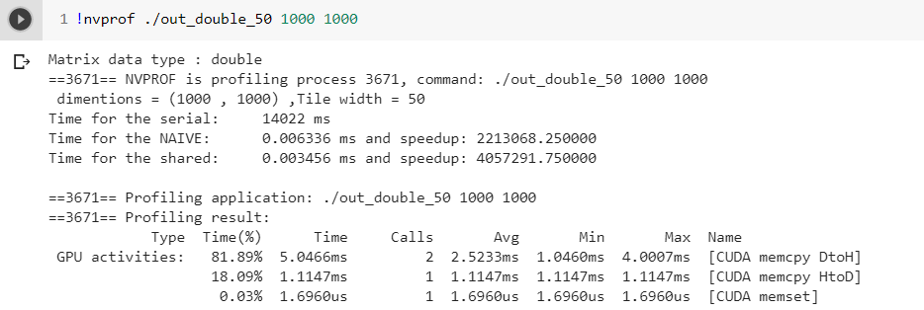

As result shows by increasing the matrix dimension data transferring overhead overcome the data process overhead and this shows that data transfer is still the bottle neck of the process.

GPU Shared memory size is another limitation of the process as bellow shows its dimensions for storing double can’t be 100*100:

- System configuration

GPU:
Model:Tesla K80
Architecture: Kepler 2.0
Base clock: 562 MHz
Memory clock: 1253 MHz ,5012 MHz effective
RAM:
Memory Type: GDDR5
Memory Size :12 GB
Cache:
L1 cache:16 KB (per SMX)
L2 cache: 1536 KB

