GA optimization wit cuda

- Problem description
The goal it to find the target string (HELLO WOLRD) from possible character combinations.

- GA specification
  - Representation:
Combination of capital English alphabet:
chromosome = EQNDM UDGGD
  - Fitness
String compare of chromosome string with target string.
  - Xover
Uniform xOver : by 50% probability each gene choose from either first or second parent.

if (rand()%10 < 5){

child_chor1[i] = p1->chromosome[i];

child_chor2[i] = p2->chromosome[i];

}

else{

child_chor2[i] = p1->chromosome[i];

child_chor1[i] = p2->chromosome[i];

}

  - Mutation
Switch mutation: one randomly chromosome position value replace with random alphabet.
  - Parent selection
Tournament selection with size 5: best of randomly 5 chosen individual selected.
  - Survivor selection
Elitism mode with 10%: 10% of current generation goes directly to next generation to improve GA memory history.

- serial GA running command:

Parameters: population size, max_generation , full_mode(run till the last iteration)

Like:

./ga_out 1000 200 1

- Serial GA Results:

MUTATION_RATE = 0.1
MAX_GENERATION = 300
TOURNAMENT_SIZE = 5
XOVER_METHOD = UNIFORM

  - Population = 100

  - Population = 500

  - Population = 1000

  - Population = 10000

- Parallel GA:

Our approach for parallelism is the way that we break the GA main loop into bunch of kernels as bellow:

initializing<<<pop_size/threadNum, threadNum>>>(d_pop,str_size);
cudaDeviceSynchronize();

for (int i = 0 ; i < max_iteration;i ++){
xover_mutate<<<pop_size/threadNum, threadNum>>>(d_pop,d_next_pop,
str_size,pop_size,i);
cudaDeviceSynchronize();

merge_sort<<<pop_size/threadNum, threadNum>>>(d_pop,temp1, 0, pop_size, 0);
merge_sort<<<pop_size/threadNum, threadNum>>>(d_next_pop,temp2, 0, pop_size, 0);

//selection_sort<<<pop_size/threadNum, threadNum>>>(d_pop,pop_size);
//selection_sort<<<pop_size/threadNum, threadNum>>>(d_next_pop,pop_size);

cudaDeviceSynchronize();
survivour_selection<<<pop_size/threadNum, threadNum>>>(d_pop,d_next_pop,
str_size,pop_size,i);
}

As code shows we first randomly initialized the population in “initializing” kernel.

After that in each iteration we first do the xover on parents that were chosen by tournament selection and then perform uniform xover and at the end performing the mutation operation based on mutation rate in “xover_mutate” kernel.

At the end of iteration, we first sort both current population(d_pop) and childs population(d_next_pop) by mean of merge sort or selection sort and in the “survivour_selection” kernel we transfer 10 percent best of current population beside 90 percent best of childs to the next population.

- Parallel GA running command (in google colab environment):

First, we do the installation environment for cuda programing in google colab as follow:

!pip install git+git://github.com/andreinechaev/nvcc4jupyter.git
!nvcc --version
%load_ext nvcc_plugin

Second, writing %%writefile ga.cu at the beginning of file to store .cu code file:
And at the end we compile, run and profile the code as bellow:

- Compilation:
!nvcc -arch=sm_35 -rdc=true ga.cu -o out -lcudadevrt

- Run
For example, with population size as 100 and max iteration equal to 300

!./out 100 300

- Profiling
!nvprof ./out 100 300

- Parallel GA proof of algorithm correctness:

- Parallel GA results with merge sort:

MUTATION_RATE = 0.1
MAX_GENERATION = 300
TOURNAMENT_SIZE = 5
XOVER_METHOD = UNIFORM
SORT_FUNCTION = MERGE_SORT

  - Population = 100

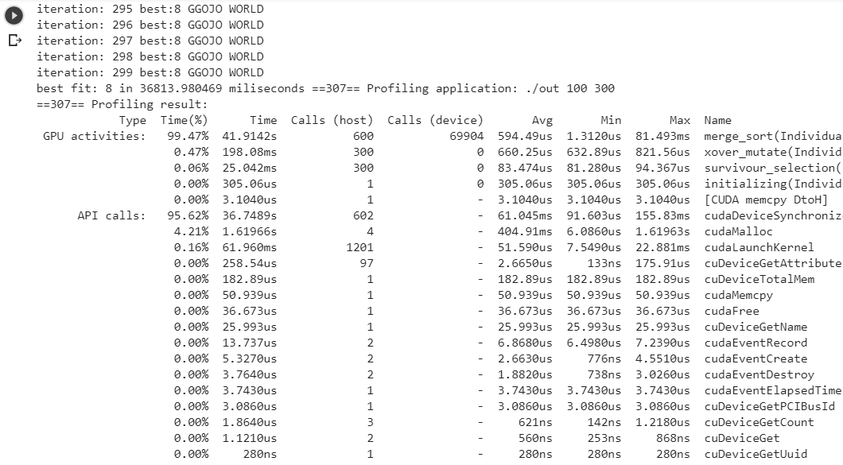

  - Population = 500

  - Population = 1000

  - Population = 10000

- Parallel GA analysis:

It seems that curand(&state) function that create random number in kernel have much lower performance in compare with rnd() function in cpu mode and it cause the algorithm to easily stuck in the local optima.

