Livermore loops optimization with OpenMP

Kernel 21:

- optimization manner:

  - changing loops order (bigger loop be outer)
  - loop unrolling (5 times)
  - omp_set_num_threads(THEADS);
  - #pragma omp parallel shared(px, vy, cx) private(k, i, j)

- compiling:

gcc -fopenmp ker21.c -m64 -lrt -lc -lm -o ker21

- analyzing best number of threads:

average speedup per 20 time of run

Threads | 2 | 3 | 4 | 5
N = 101 (array size) | 1.780 | 2.908 | 3.217 | 2.264

Threads | 6 | 8 | 10 | 12
N = 1001 (array size) | 7.373 | 9.508 | 0.862 | 0.782

- results:
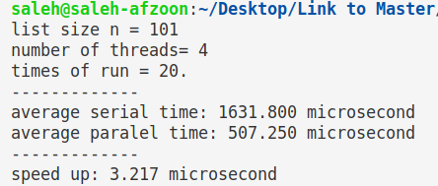
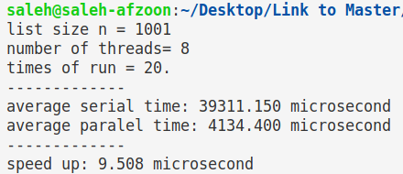

Kernel 22:

- optimization manner:
  - loop unrolling (4 times)
  - omp_set_num_threads(THEADS);
  - #pragma omp parallel shared(y, u, v, w, x) private(k)

- compiling:
gcc -fopenmp ker22.c -m64 -lrt -lc -lm -o ker22

- results:
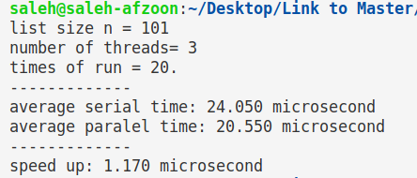
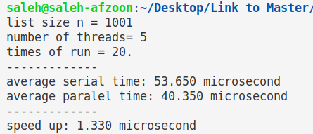

Kernel 23:

- optimization manner:

  - changing loops order (bigger loop be outer)
  - loop unrolling (2 times)
  - omp_set_num_threads(THEADS);
  - #pragma omp parallel private(j)
  - collapsing nested loops with #pragma omp collapse(2)

- compiling:
gcc -fopenmp ker23.c -m64 -lrt -lc -lm -o ker23

- results:
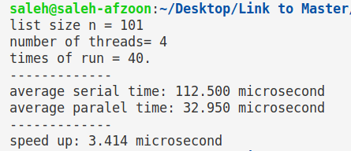
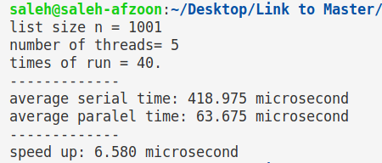

Kernel 24:

- optimization manner:

  - loop unrolling (4 times)
  - omp_set_num_threads(THEADS);
  - #pragma omp parallel private(k)

- compiling:

gcc -fopenmp ker24.c -m64 -lrt -lc -lm -o ker24

- results:

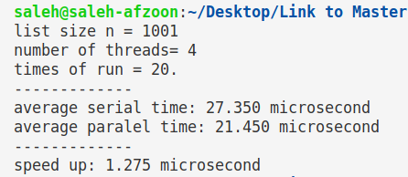

System configuration:
CPU: core i5 8 th generation
RAM: 8GB
OS: Ubuntu 16
Cache: 1L = 256KB, 2L = 1MB, 3L = 6MB

