
Name : Saleha Taj
Reg no: Fa24b1-se-002
Assignment: Assignment 01
Section: B
Course: Cloud Computing
Topic: Git, Gitea, GitHub, Git LFS, and GitHub Pages

1. Task 1 – Gitea
1.1 Gitea Installation
- Used Ubuntu Server as the working environment.
- Installed Docker and Docker Compose.
- Started the Gitea and PostgreSQL containers.
- Verified that both services were running successfully.
- Verified Gitea using the local HTTP request.
- Accessed Gitea through the Ubuntu server IP.
- Configured PostgreSQL as the database.
- Completed the Gitea installation and created the administrator account.
Figure 1 – Gitea running on Ubuntu Server
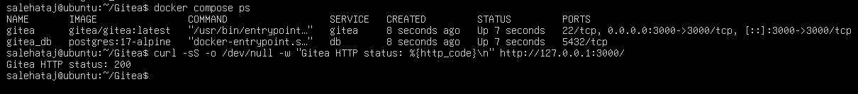
1.2 Push Repository to Gitea
- Created a public Gitea repository named Assignment01.
- Created a local Git repository on Ubuntu.
- Initialized the repository with the main branch.
- Created README.md containing:
  - Full Name
  - Registration Number
- Committed the README file.
- Added Gitea as a remote named gitea.
- Successfully pushed the main branch to Gitea.
Figure 2 – Successful push to Gitea
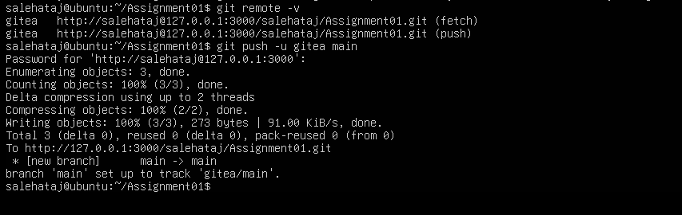
1.3 Gitea Repository Verification
- Opened the Assignment01 repository in Gitea.
- Verified:
  - Repository name
  - Owner
  - Public visibility
  - README file
  - Student information
Figure 3 – Gitea Assignment01 repository
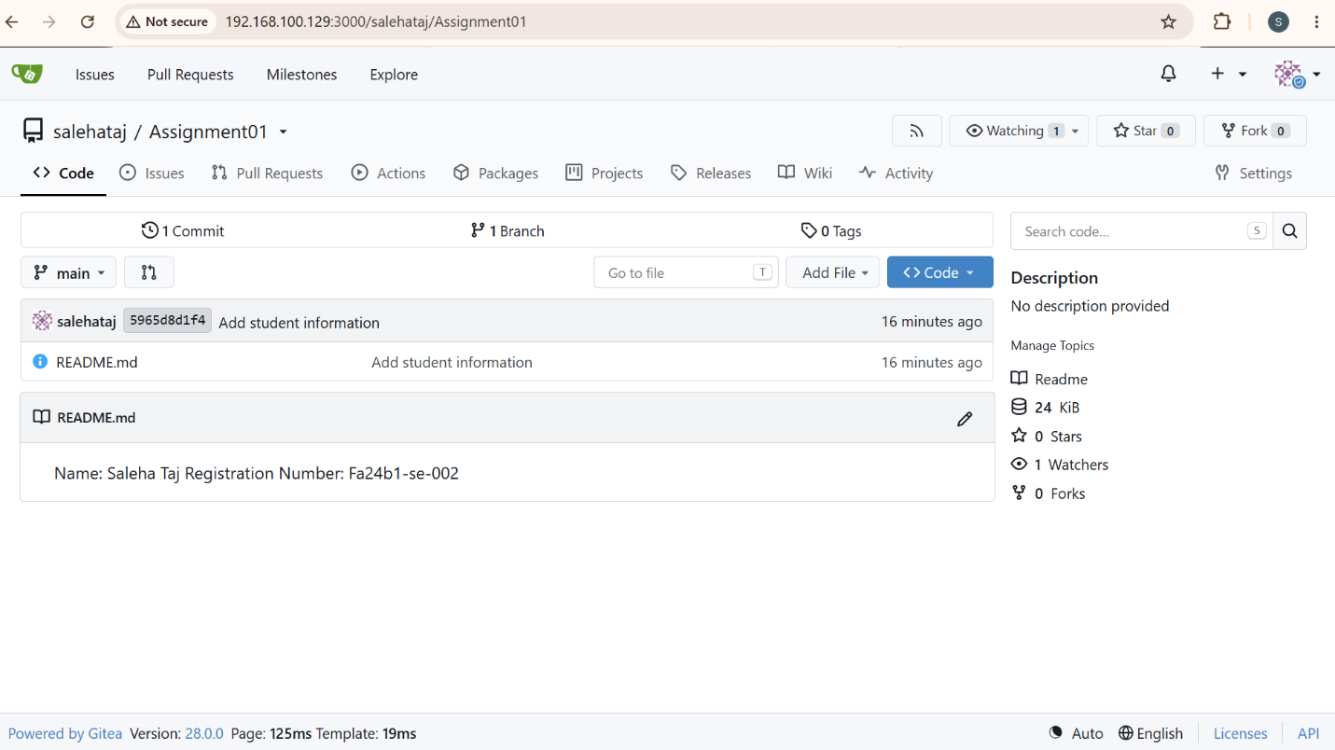
Result
- Gitea was successfully installed.
- Repository was successfully created and pushed.
2. Task 2 – GitHub
2.1 Configure Git Remotes
- Created a public GitHub repository named Assignment01.
- Used the same local repository from Task 1.
- Added GitHub as a second remote named github.
- Verified both remotes using git remote -v.
- The repository now had:
  - gitea remote
  - github remote
Figure 4 – Gitea and GitHub remotes
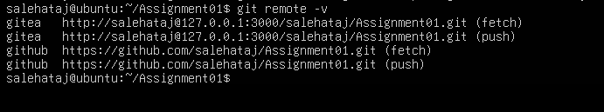
2.2 Push to GitHub
- Pushed the main branch to GitHub.
- GitHub authentication was completed successfully.
- Push completed without errors.
Figure 5 – Successful GitHub push
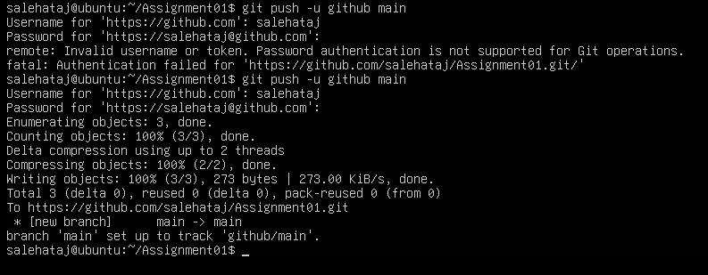
2.3 GitHub Repository Verification
- Opened the GitHub Assignment01 repository.
- Verified:
  - Repository name
  - Owner
  - Public visibility
  - README file
  - Student information
Figure 6 – GitHub Assignment01 repository
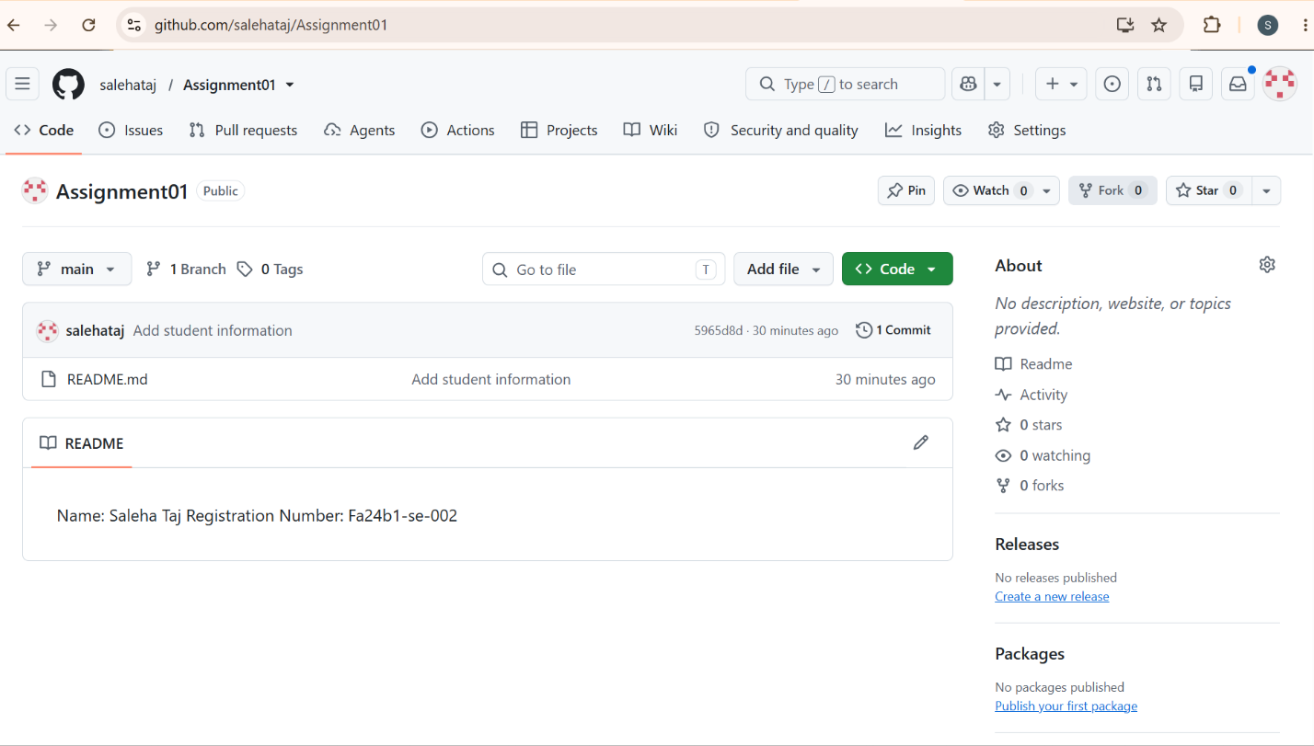Result
- The same local repository was successfully pushed to both Gitea and GitHub.
3. Task 3 – Git LFS
3.1 Git LFS Setup
- Initialized Git LFS in the Assignment01 repository.
- Verified the installed Git LFS version.
- Configured .bin files to be tracked using Git LFS.
- Verified the .gitattributes file.
Figure 7 – Git LFS setup
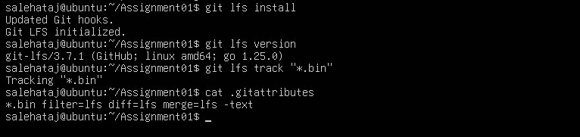
3.2 Large File Creation
- Created three binary files:
  - large-file-1.bin – 101 MiB
  - large-file-2.bin – 102 MiB
  - large-file-3.bin – 103 MiB
- Added the files to Git.
- Verified that all three files were tracked by Git LFS.
Figure 8 – Git LFS tracked files
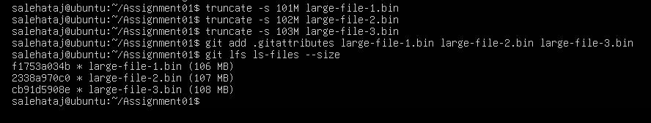
3.3 Git LFS Push
- Committed the three large files.
- Pushed the commit to GitHub.
- Git LFS uploaded the large file objects successfully.
- Push completed successfully.
Figure 9 – Successful Git LFS push
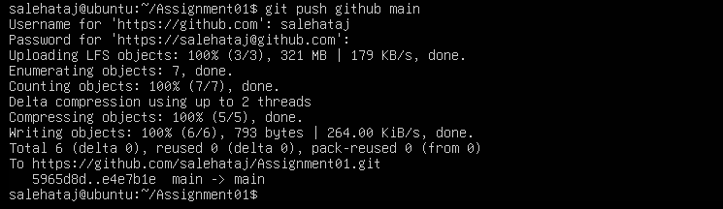
Result
- Three files larger than 100 MiB were successfully managed and pushed using Git LFS.
4. Task 4 – GitHub Pages Portfolio
4.1 Portfolio Creation
- Created a personal portfolio website using HTML and CSS.
- Created the following files:
  - index.html
  - styles.css
- Added the following sections:
  - About Me
  - Education
  - Skills
  - Projects
- Used a green, white, and black design.
- Created a GitHub repository named salehataj.github.io.
- Pushed the portfolio to the main branch.
Figure 10 – Portfolio GitHub repository
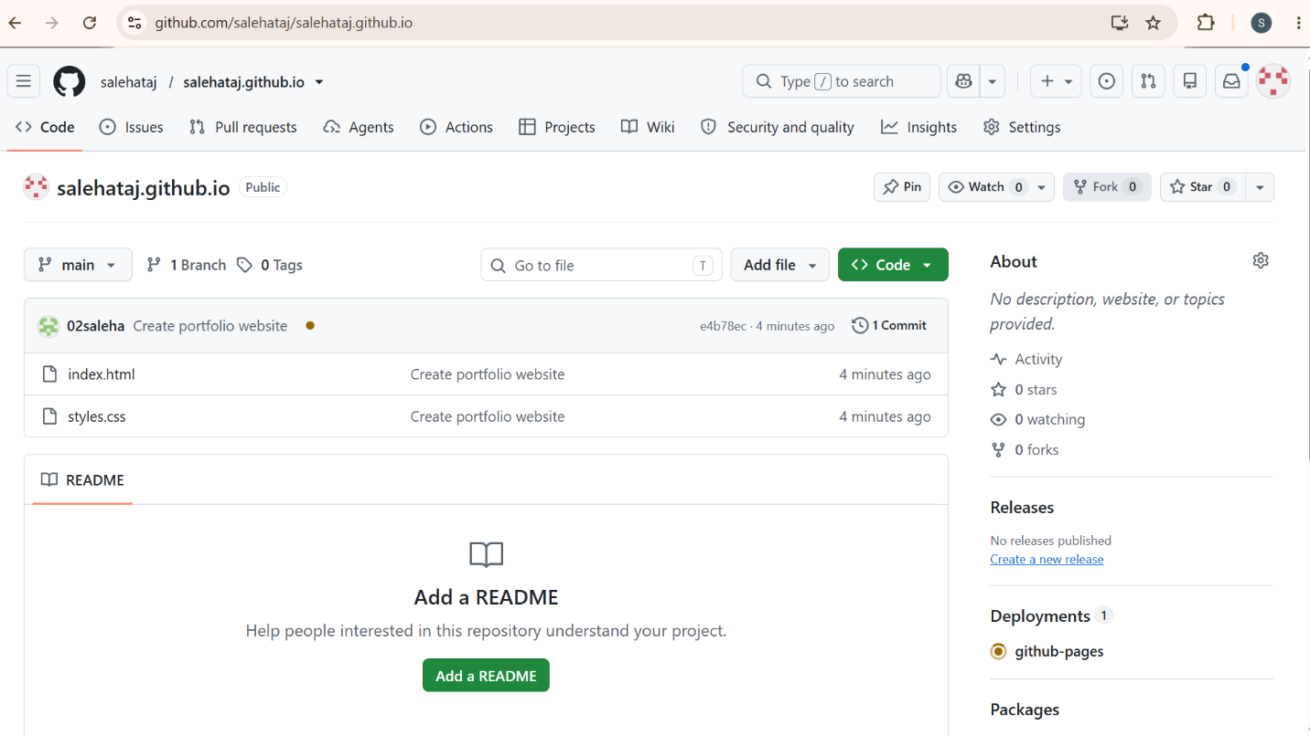

4.2 GitHub Pages Deployment
- Opened the repository's Settings → Pages.
- Selected deployment from the main branch.
- Selected the root directory / (root).
- Saved the configuration.
- GitHub Pages successfully deployed the website.
- Generated live website URL:
https://salehataj.github.io/
Figure 11 – GitHub Pages deployment
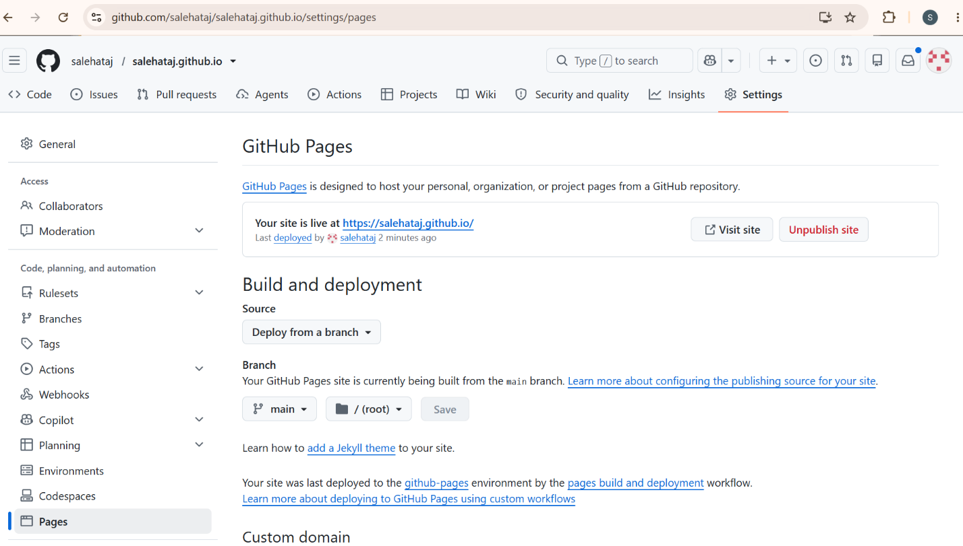
4.3 Live Portfolio
- Opened the GitHub Pages URL in the browser.
- Verified that the website was publicly accessible.
- Confirmed that the portfolio content was displayed correctly.
Figure 12 – Live portfolio website
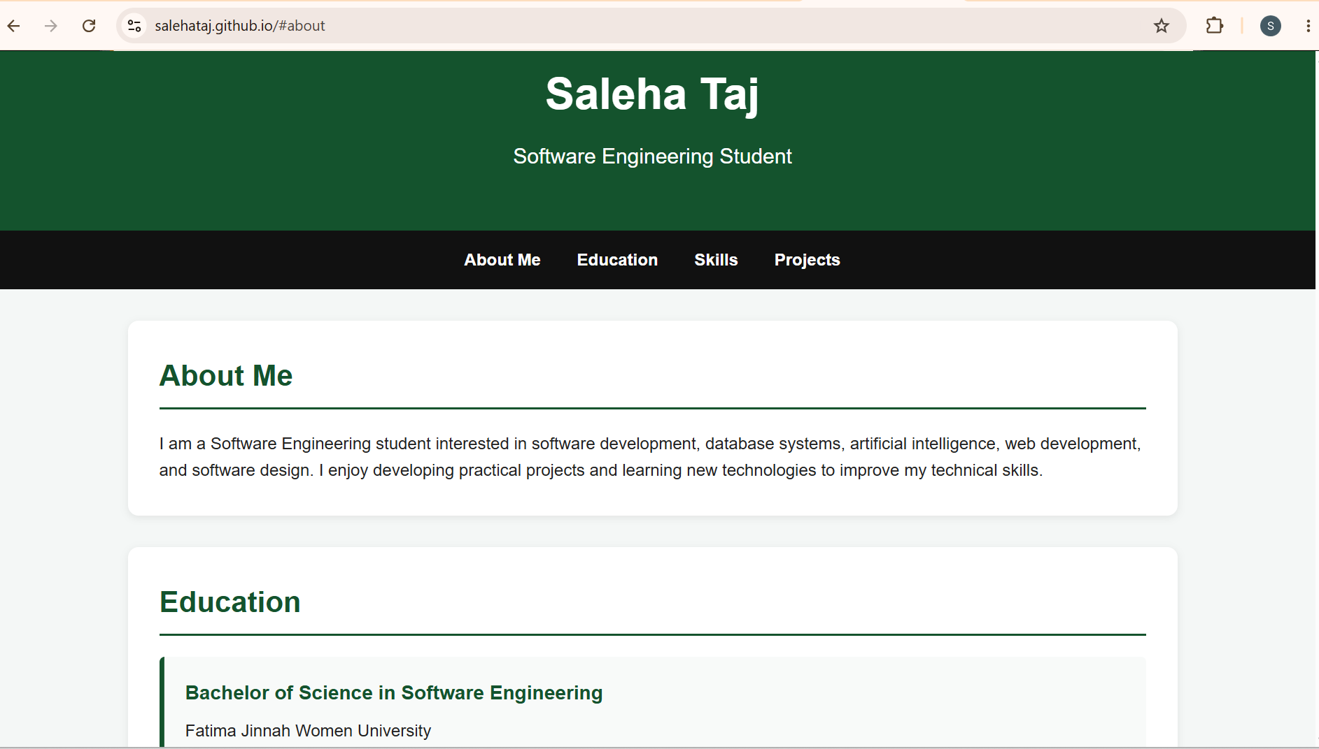
Result
- The portfolio website was successfully created and published using GitHub Pages.

