

Hadhramout University
College of Computers & Information Technology
Department of Information Technology

AlShihr-Mukalla General Information Services Provider - Application

A graduation project report submitted to the Department of Information Technology as partial fulfillment for the Requirements for the Degree of Bachelor of Science in Information Technology

By

Abdulaziz Mohammed Binmahmoud
Saleh Ahmed Baqomri
Salem Ali Almozai
Mohammed Abdullah Alattas
Ahemd Salem Shaihkan

Supervisor
Dr.Engineer \ Ibrahim Eskandar Fadhel

June, 2024
Abstract
The growing use of mobile devices and their expanding capabilities has led to the rise of mobile applications. This project proposes a mobile app that simplifies access to government and private information and services. Users can easily find details about services offered, required documents, and appointment scheduling.

الخلاصة
النمو المستمر في استخدام الهواتف المحمولة و توسع امكانياتها أدى الى صعود تطبيقات الهاتف المحمول. الغرض من هذا المشروع هو توفير تطبيق هاتف محمول يسهل الوصول الى الخدمات و المعلومات الحكومية و الخاصه. المستخدمين يستطيعون بسهولة ايجاد تفاصيل عن الخدمات المتوفرة و الوثائق المطلوبة و جدول المواعيد.

Table of Contents

Title | Page No.
Abstract | i
الخلاصة باللغة العربية | ii
Table of Contents | iii
List of Tables | v
List of Figures | vii
Chapter 1: Introduction | 1
1.1 Introduction | 2
1.2 Problem Statement | 2
1.3 Project Objectives | 3
1.4 Project Scope | 3
1.5 Project Methodology | 4
1.6 Tools & Programing Languages | 5
1.7 Organization of the Project | 6
Chapter 2: Background & Related Works | 7
2.1 Introduction | 8
2.2 Background | 8
2.3 Related Works | 9
Chapter 3: Analysis & Design | 12
3.1 Introduction | 13
3.2 System Analysis | 14
3.2.1 Requirements Gathering | 14
3.2.2 System Users | 14
3.2.3 System Requirements | 14
3.2.4 Use Case Diagram & Scenario | 17
3.2.5 Class Diagram | 32
3.3 System Design | 33
3.3.1 Entity Relationship Diagram | 33
3.3.2 Database Diagram | 34
3.3.3 Details of the Database Tables | 35
Chapter 4: Implementation & Findings | 38
4.1 Introduction | 39
4.2 Hardware and Software Specifications | 39
4.3 Development Tools and Languages | 41
4.4 Interfaces | 42
Chapter 5: Conclusion & Future Work | 64
5.1 Introduction | 65
5.2 Conclusion | 65
5.3 Future Work | 65
References | 66
List of tables
Table Page Number
Table (1-1) Project Methodology......................................................................... 5
Table (3-1) Functional requirements……………............................................... 15
Table (3-2) Scenario of register…………........................................................... 18
Table (3-3) Scenario of login............................................................................... 19
Table (3-4) Scenario of logout ............................................................................ 20
Table (3-5) Scenario of Update account.............................................................. 21
Table (3-6) Scenario of search services................................................................ 22
Table (3-7) Scenario of select services …............................................................ 23
Table (3-8) Scenario of add services ................................................................... 24
Table (3-9) Scenario of Search For services ........................................................ 25
Table (3-10) Scenario of View the services …..................................................... 26
Table (3-11) Scenario of Update services ............................................................ 27
Table (3-12) Scenario of Delete service................................................................ 28
Table (3-13) Scenario of Add Provider................................................................. 29
Table (3-14) Scenario of Update Provider............................................................ 30
Table (3-15) Scenario of Delete Provider.............................................................. 31
Table (3-16) table of Adsimages…………........................................................... 35
Table (3-17) Table of Mainsection........................................................................ 35
Table (3-18) Table of Categories.......................................................................... 35
Table (3-19) Table of Places…............................................................................. 36
Table (3-20) Table of Rolls................................................................................... 36
Table (3-21) Table of Services..................................................................…….... 36
Table (3-22) Table of Users...............................................……………................ 37

List of figures
Figure Page number
Figure (2-1) Yemen Guide………………………...............................................9
Figure (2-2) Atlas………………………............................................................10
Figure (3-1) Use Case Diagram………………………......................................17
Figure (3-2) Class Diagram ................................................................................32
Figure (3-3) Entity Relationship Diagram...........................................................33
Figure (3-4) Database Diagram…...................................................................... 34
Figure (4-1) Onboarding inter….......................................................................... 42
Figure (4-2) Register interface…...........................................................................43
Figure (4-3) Login interface..................................................................................44
Figure (4-4) Homepage interface….......................................................................45
Figure (4-5) Admin Dashboard interface …...........................................................46
Figure (4-6) Providers Management Dashboard interface ….................................47
Figure (4-7) Adding Providers interface ….............................................................48
Figure (4-8) Update Providers interface ….............................................................49
Figure (4-9) Delete Providers interface …...............................................................50
Figure (4-10) Categories management dashboard ..................................................51
Figure (4-11) Provider management dashboard …..................................................52
Figure (4-12) Provider add services interface…......................................................53
Figure (4-13) Provider delete services interface ….................................................54
Figure (4-14) advertisements management page …................................................55
Figure (4-15) advertisements image selection …....................................................56
Figure (4-16) Categories interface …......................................................................57
Figure (4-17) Service interface …...........................................................................58
Figure (4-18) Categories section interface …..........................................................59
Figure (4-19) Service interface …...........................................................................60
Figure (4-20) Profile management interface ….......................................................61
Figure (4-21) Profile update interface ….................................................................62
Figure (4-22) Who are we interface …....................................................................63

Chapter One
Introduction

Introduction
Citizens often face difficulties navigating the complexities of accessing services offered by both government and private units. This can involve time-consuming visits to various offices, phone calls with long wait times, and uncertainty about required documents, procedures, and schedules. These challenges can lead to frustration and hinder citizens' ability to make informed decisions regarding available services. To address these issues, a mobile application will be developed to provide a user-friendly and centralized platform for information about government and private services.
This application will streamlines the process by offering comprehensive details on required documents, procedures, and schedules in a single, easy-to-navigate interface. Users can search for specific services based on keywords or categories, ensuring efficient access to the relevant information they need. By collaborating with government units, the application will guarantee the accuracy and up-to-date of the information provided. This will empower citizens to navigate the complexities of accessing services with confidence and make informed decisions.[1]

Problem Statement
Accessing information and services provided by government units such as schools, immigration and passports, tourism, and hospitals can often be a complex and time-consuming process for citizens. There is a lack of centralized and easily accessible platforms that provide comprehensive details about these government units, including the required documents and the services they offer with specific dates and times. As a result, citizens face difficulties in understanding the necessary documentation, procedures, and schedules associated with accessing government services, leading to confusion, wasted time, and increased frustration. The problem the application aims to address is the lack of a user-friendly and consolidated platform that provides citizens with accurate and up-to-date information about government units and their services. Citizens currently need to visit multiple sources or contact various government offices to gather relevant information, which can be inconvenient, inefficient, and prone to errors. There is a need for a centralized application that simplifies the process of accessing information, eliminates the need for physical visits or phone calls, and enables citizens to quickly find the required documents and understand the services provided by government units with specific dates and times.[2]

Project Objectives
- To develop a mobile application dedicated to inquiries, providing citizens with comprehensive details about information, services, and the required documents and procedures for accessing services offered by each government unit, guiding users through the inquiry process offered by government units such as schools, immigration and passports, tourism, and hospitals.
- To collaborate closely with government units to ensure the accuracy and reliability of the information provided in the application.
- To conduct thorough user testing and gather feedback to continuously enhance the application's usability, responsiveness, and effectiveness in addressing user inquiries.

Project Scope
The scope of the application encompasses providing citizens with detailed information about government units, including schools, immigration and passports, tourism, and hospitals. The primary focus is on facilitating inquiries and accessing information about the services provided by these government units for citizens who live in mukalla and AlShihr. The application will not support the ability to perform the service online by sending the required documents to the service provider and after the service is done it will be sent to the citizen.

Project Methodology
The waterfall methodology is a linear project management approach, where stakeholder and customer requirements are gathered at the beginning of the project, and then a sequential project plan is created to accommodate those requirements. The waterfall model is so named because each phase of the project cascades into the next, following steadily down like a waterfall [7].
It’s a thorough, structured methodology and one that’s been around for a long time, because it works. Some of the industries that regularly use the waterfall model include construction, IT and software development. As an example, the waterfall software development life cycle, or waterfall SDLC, is widely used to manage software engineering projects.
Team decided to follow the waterfall methodology because it’s the most appropriate method to satisfying the project requirements and to success in the implementation of the software [9].
here an explanation of what Activities each phase would have:

Table (1.1): Project Methodology
Phase | Description | Duration
Requirement Gathering | Interviewing multiple  organizations and businesses. | 2 Weeks | 14 Weeks
Requirement Analysis | - Specify the functional and non-functional requirements.  - Analyze, document and validate the requirements  - Draw UML Diagrams:  1. Use Case | 2 Weeks | 14 Weeks
Design | - Database Diagram.  - ERD. | 2 Weeks | 14 Weeks
Development (Programming) | Using programming tools to  build the actual application. | 4-6 Weeks | 14 Weeks
Testing | Apply testing technique to  verify and validate the use of  the application. | 2 Weeks | 14 Weeks

Tools & Programming Languages
This section lists all the tools and programming Languages that we have use them to build the software.
• Backend Languages: PHP v8.2.2.
• Frontend Language: Dart v3.3.4.
• Framework: Flutter v3.19.6.
• Database: MySQL v8.4.0.
• Server: XAMPP v8.0.30.
• Editor: Visual Studio Code v1.83.0
• Design Diagrams: Draw.io v22.1.18.

Project Organization
- Chapter one: Introduction: This chapter describes the general idea of the project, the problem that the system will solve, the main objective and sub objectives that the system will achieve, the scope that determines functional and geographical boundaries, and the methodology that has been followed to accomplish the project. Finally, this chapter ends with a mention of the tools and programming language that are used to program the project.
- Chapter two: Background and Related Work This chapter contains the theoretical background that covered the basic concepts and work procedures related to the project. Following that, discussing similar systems using the system concept.
- Chapter three: System Analysis and Design: This chapter begins by describing how requirements were gathered and the users of this system, and then goes on to detail non-functional and functional requirements using software engineering tools (case diagrams, scenarios, and class diagrams). Finally, an ERD, database, and description of database table details were created.

Chapter Two
Background & Related Works

Introduction
An estimated five billion people use mobile phones, constituting more than 60% of the global population. This level of penetration is continually increasing as mobile technology becomes more accessible and affordable allowing both young and old in high, middle, and low income countries to make use of mobile services applications. Defined as technologies to improve community outcomes, services, and research using mobile and wireless devices, is an enabler of improved access and uptake of services, especially in Low and Middle Income Countries (LMICs), given the development of new innovations and the wide availability of mobile phones[1].

Background
Country services needs an application to give the users information they need. Basically one of several applications that are used from electronic media is the services guide application. This application is an application for government general services announce that can help convey information to the entire community, especially those who access the application. In the world of tourism, prospective tourists, local, national and international, can obtain information directly about the various attractions that are provided in the application [2].
The application is expected to be a complete multi-service application; regional destinations that have not been published yet indirectly contribute to potential areas of the City. Business opportunities will impact the community and business people in the city, where people can take part in promoting tourism and opening business opportunities. This study aims to develop the first step which is a simple application to announce about the governments units services [3].
Past few years from a mere marketing presence to a platform that can support all facets of organizational work. As a result, important information systems efforts are geared increasingly toward exploiting the benefits of this platform, leading to the development of information systems based on Web technology and now on mobile application, which we call “Web-based Information Systems” (WISs) or Mobile-based Information Systems” (MISs) . We believe this type of system will become more pervasive than client/server systems did a decade ago, with an exponentially higher impact on people’s lives, simply because the Web has the potential of reaching a much wider audience than client/server systems based on proprietary networks [6].

Related Works

Yemen Guide
Yemen's Guide, is a commercial electronic search guide provides a service information (contact, addresses data, sites on the map, products and services, Reviews and ratings) with advanced search for places, business and companies in Yemen system [11].
The following figures are the interface of Yemen Guide application


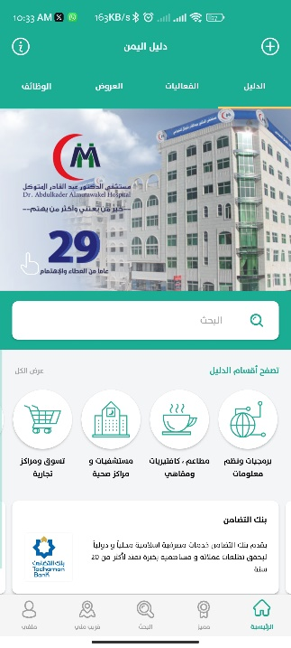
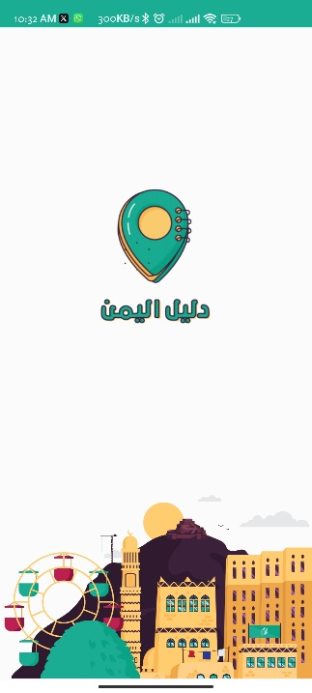

Figure 2.1: Yemen Guide

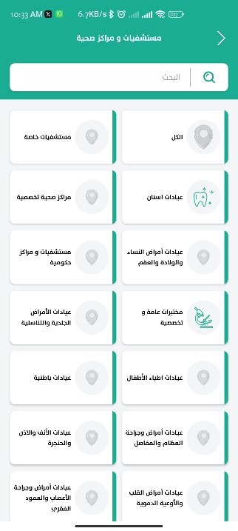
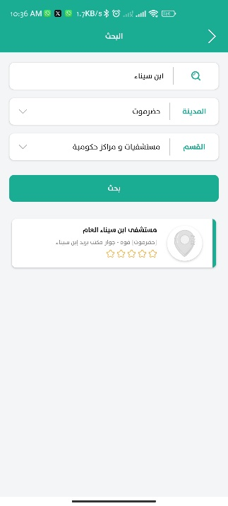
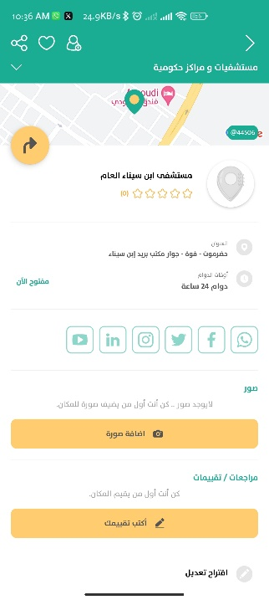

Atlas
The application aims to provide comprehensive and up-to-date information about all the commerce and services activities in Yemen. The application provides an electronic and printed guidance contains many comprehensive information about the companies in all states in Yemen[12].
The following figures is the interface of Atlas application

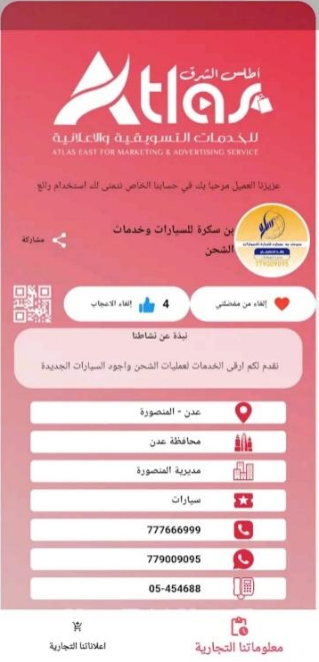
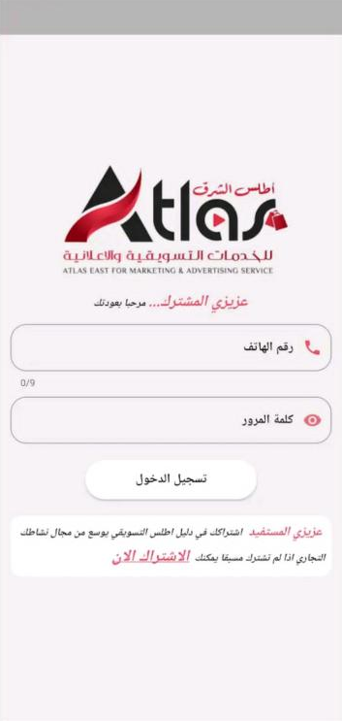


Figure 2.2: Atlas
- Competitors application disadvantage:
- less detailed information, may lack specifics like fees or appointment availability.
- Limited local detail, primarily focused on large urban areas
- No direct government affiliation

- Our application features:
- Comprehensive: covers government, private, hotels, hospitals, etc.
- Up-to-date: regularly refreshed information.
- Direct: partnered with governments entities for reliable information.
- Depth: detailed information on each service , including opening hours, contact details, required documents, booking options, fees
- Local focus: provides dedicated sections for major cities and districts within provinces.

Chapter Three
Analysis & Design

Introduction
The analysis and design phase of the application encompasses a comprehensive approach to ensure an efficient solution. The system analysis focuses on understanding the requirements and gathering essential information from stakeholders. Through careful requirements gathering, identifying the specific needs and objectives of the application, and ensuring that it aligns with the diverse requirements of government services.
System users play a vital role in the Android application. In system users the actors and their functions are identified .After identifying the roles and interactions of system users, ensuring that the application provides a seamless and tailored experience to each user group. System requirements define the functional and non-functional aspects of the application. The functional requirements explain the function of the actors in more details with their input and output. the non-functional requirements emphasize performance, security, and usability, ensuring that users have a reliable and secure platform. To provide a visual representation of the application's functionalities, we employ use case diagrams and scenarios. These diagrams visually depict the interactions between system users and the Android application, showcasing how users can navigate through different services and access the desired information. Scenarios further illustrate specific sequences of events and user actions, providing a concrete understanding of how the application will be used in real-world scenarios. The class diagram forms the backbone of the application's architecture. By modeling the object-oriented structure, we define the classes, their attributes, relationships, and methods. This detailed design component enables us to develop a robust application, ensuring efficient code organization and implementation [10].

System analysis

Requirements Gathering
Throughout the process of the project, a contacting with government and private providers were done to let them know about the project and its benefits to them such as reduce crowding. They agreed with the idea. So the next point is how to provide the requirements and information about a specific service, should we provide the service or the providers themselves will have their own account and will have different functionalities than others which are updating services and adding services. At the end the decision was to give them their own account

System users
- Users: users will be able to browse the services and see the information and requirements of each services
- Administrators: administrators will be able to browse the government and private providers with the ability to block , add , or update the provider
- Private providers: private providers will be able to add services as well as browse their services to update or suspend the service
- Government providers: government providers will be able to add services as well as browse their services to update the service

System requirement
System requirements are the configuration that a system must have in order for a hardware or software application to run smoothly and efficiently. Failure to meet these requirements can result in installation problems or performance problems. The former may prevent a device or application from getting installed, whereas the latter may cause a product to malfunction or perform below expectation or even to hang or crash

- Functional requirements
The following table will show the actors and what the functions that each actor will use with their input and output
Table 3.1: Functional Requirements
Actors | Function | Input | Output
User | Register | Email  Password  Confirm password  Username | The user will be added to the system
User | Login | Email  password | The user login
User | Search For Services | The keyword | The desired service appear
User | Filter The Services | Select one or more filtering options | The services is displayed based on the filtering options
User | Select The Services | Select a particular service | The detailed information of service appears
User | View The Service | Select a particular service | View the service
User | Update Account | Change the information that needs to be updated | The account is updated successfully
User | Logout | Click logout button | The user logged out of the application
services provider | Login | Email  password | The government provider login
services provider | Add Service | Title  Description  Details | A new service is added
services provider | Update Service | New description and details | the service is updated successfully
services provider | Suspend Service | Selects the service | The selected service is marked as “Suspend”
services provider | Search For Services | Enter the keyword or the name of the service | The matching services is displayed
Admin | Add Provider | Email  Username  Password  Address  City  Determine private/government | The provider is added successfully
Admin | Update Provider | Change the information that needs to be updated | The provider is updated successfully
Admin | Block Private Provider | Select the private provider and clicks “Block” | The private provider is blocked successfully

- Non-Functional requirements
The non-functional requirements of the proposed system include the
Following:
• Security:
The data of providers and Users are private and secure; so the software must ensure the integrity of the providers and Users accounts information and that each Provider and User has his own information that he can access by entering his own account data
(Login email and password).
The admin can block the private account.
• Interface:
The user interface is easy and effective, its design is simple and flexible,
With fewer inputs, and quick and easy navigation between pages to access
The general functions of the Application.

• Performance:
The system must be high-performance so that the code is written in an
Ideal and simple way in order to provide the correct inputs and outputs, and the performance is flexible, easy to use, reliable and complete tasks in record time.

Use Case Diagram & Scenario
At this point analyzed each user’s interactions with the system. In the beginning a use case diagram was created for each user separately to clarify all the properties that will be used by the user and was then clarified the work sequence for each feature by scenario.

Use Case Diagram
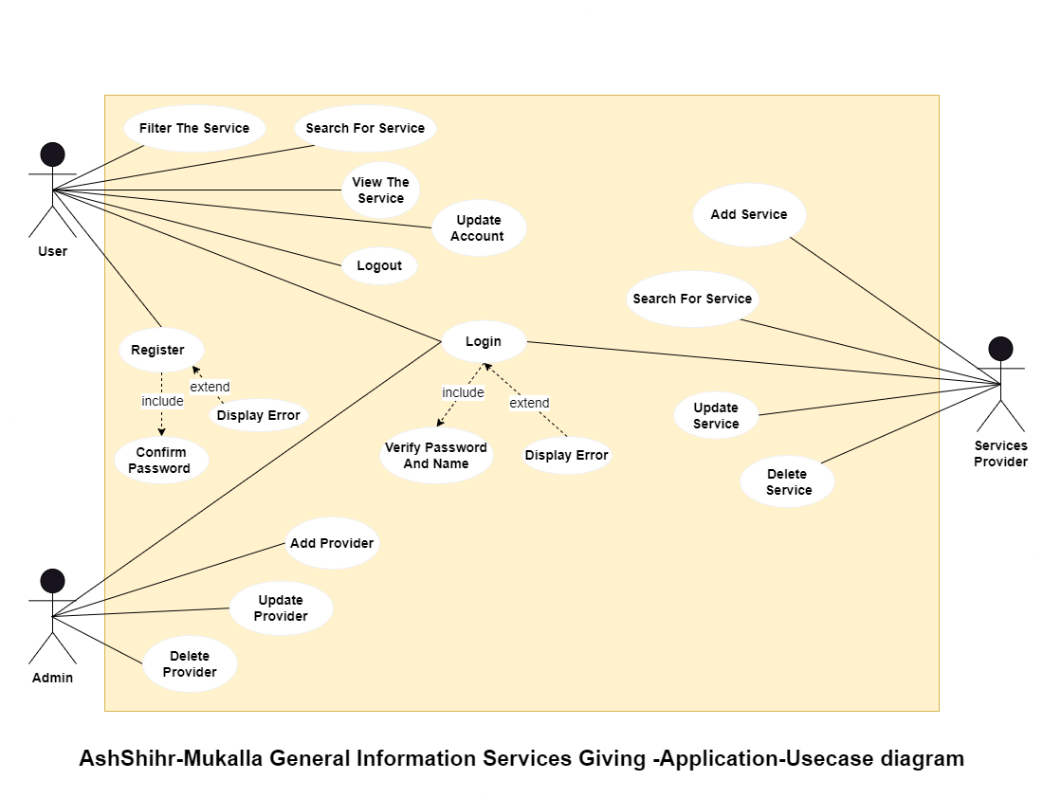
Figure 3.1: Use Case Diagram

Use Case Scenario
The following table is describing how each function will be used in real-world
Table 3.2: scenario of Register
Use Case Name | Register
Overview | Register to the application
Actor | User
Normal flow | - User opens the application.  - The user selects the register option.  - The system presents a registration form to the user.  - User enters the information for registration.  - User submits the registration form.  - The system validates the entered information.  - The system creates a new user account  - Login page appears.
Alternative flow | 6.1 if email already exist , choose another email.
precondition | User access the application.
Post-condition | If the user registered successfully the login page appears.

Table3.3: scenario of Login
Use Case Name | Login
Overview | Login to the application
Actor | User, services provider, Admin
Normal flow | - User, provider, or admin opens the application.  - The system displays the login page for the user, provider, or admin.  - The user, provider, or admin enters his email and password into the input field.  - The user, provider, or admin clicks “login” button.  - The system verifies the provided credentials.  - The system validates the credentials.  - The system authenticates the user, provider, or admin.  - The system displays the homepage or dashboard.
Alternative flow | 6.1 if the credentials are invalid:  6.1.1 The system displays an error message indicating that the login failed.  6.1.2 Give an option to try again by entering his email and password.  6.1.3 Return to step 3.
precondition | The user must have a registered account in the system
Post-condition | If the login is successful, the homepage or dashboard appears.

Table 3.4: scenario of Logout
Use Case Name | Logout
Overview | The users can logout from their accounts temporarily before if they do not need to use the application
Actor | User
Normal flow | - A user is currently using the application and intend to log out.  - The user navigates to “My profile“.  - The system displays the my profile page.  - The user clicks “Logout” button.  - The system logs the user out of the application.  - The user is returned to the login page.
Alternative flow
precondition | The user is logged into the application.
post-condition | The user is logged out of the application.  The user is redirected to the login page.

Table 3.5: scenario of Update Account
Use Case Name | Update Account
Overview | The user can update his account information
Actor | User
Normal flow | - A user opens the application.  - The user navigates to his profile.  - The system displays my profile , update my profile , and log out  - The user clicks on update my profile.  - The system displays an interface with user’s current account information.  - The user modifies the necessary fields in the provided input fields.  - The user submits the updated account details by clicking “Save” button.  - The system validates the entered information.  - The information is validated.  - The system updates the user’s account with the new information provided by the user.  - The system saves the changes in the database.
Alternative flow | 11.1 the information is invalid:  11.1.1 The system displays an error message indicating the issues that need attention.
precondition | The user must login to the application.
post-condition | The user’s account is updated with the changes made by the user.  The changes made to the account details is saved in the database.

Table 3.6: scenario of Search for Services
Use Case Name | Search For Services
Overview | Searching for the services
Actor | User
Normal flow | - User opens the application.  - The user navigates to the services section.  - The user enters search keywords related to the desired service in the search bar.  - The user clicks “search” button.  - The system retrieves services that match the search keywords.  - The system displays a list of services that match the search keywords.
Alternative flow | 5.1 if the search keyword does not match any services:  5.1.1 The system displays a message indicating that no services matching the search criteria.  5.1.2 The user can modify or try different keywords to broaden the search.  5.1.3 Return to step 4.
precondition | The user must access the services page.  There must be a list of available services to search through.
Post-condition | The system displays a list of services that match the user’s search keyword.  The user can continue searching for services.

Table 3.7: scenario of Select Services
Use Case Name | Select Services
Overview | Selecting a particular services to be displayed
Actor | User
Normal flow | - User opens the application.  - The system displays the home page with some of the main categories.  - User selects one of the categories  - The system displays a list of services within the selected category.  - The user scrolls through the list to find a specific service.  - The user selects the desired service from the list.  - The system displays detailed information about the selected service.  - The user reviews the information.
Alternative flow | 4.1 if there are no services listed under the selected category:  4.1.1 The user can scroll back to the previous page and explore other service categories.
precondition | The user must access the homepage.
Post-condition | The user has accessed the detailed information about the selected service.

Table 3.8: scenario of Add Services
Use Case Name | Add Services
Overview | The service provider adds a service to the application
Actor | services provider
Normal flow | - A provider opens the application.  - The system displays the dashboard of the provider.  - The system displays search bar and a list of services and an option to add service.  - The provider clicks “Add Service” button.  - The system displays an interface for adding a new service.  - The provider enters the required information into the input field to be displayed to the user.  - The provider attaches any image related to the service.  - The provider clicks “submit” to add the new service.  - The system validates the entered information.  - The entered information is valid.  - The system creates a new service.  - The service is added to the list of services.  - The system generate an ID for the new service.
Alternative flow | 12.1 if the entered information is invalid:  12.1.1 The system displays an error message indicating the required fields or a specific error that need attention.
precondition | The provider must login to the application.
Post-condition | The service is added to the application.  The service information is saved in the database

Table 3.9: scenario of Search for Services
Use Case Name | Provider search For Services
Overview | Searching for the services
Actor | services provider
Normal flow | - Provider opens the application.  - The system displays the dashboard of the provider.  - The system displays search bar and a list of services.  - The provider enters search keywords related to the desired service.  - The system processes the search keywords.  - The system retrieves services that match the search keywords or the name of the service.
Alternative flow | 4.1 if the search keyword does not match any services:  4.1.1 The system displays a message indicating that no services matching the search criteria.  4.1.2 The user can modify or try different keywords to broaden the search.  4.1.3 Return to step 7.
precondition | The provider must log in to the application.  There must be a list of available services to search through.
Post-condition | The system displays a list of services that match the provider's search keyword.  The provider can continue searching for services.

Table 3.10: scenario of View The Services
Use Case Name | View The Services
Overview | View a particular service
Actor | User
Normal flow | - User opens the application.  - The system displays the home page with various service categories.  - The user selects the desired service category from the available category.  - The system displays a list of services within the selected category.  - The user scrolls through the list to find a specific service.  - The user selects the desired service from the list.  - The system displays detailed information about the selected service.  - The user reviews the information.
Alternative flow | 4.1 if there are no services listed under the selected category:  4.1.1 The system displays a message indicating that no services are currently available.  4.1.2 The user can scroll back to the previous page and explore other service categories.
precondition | The user must login to the application.
Post-condition | The user has access the detailed information about the selected service.

Table 3.11: scenario of Update Services
Use Case Name | Update Services
Overview | The providers update the details of an existing service
Actor | services provider
Normal flow | - A provider opens the application.  - The system displays the dashboard of the provider.  - The system displays search bar and a list of services.  - The provider select a service from the list or after searching.  - The provider clicks “Update services” button.  - The provider reviews the existing information and identifies the field the needs to be updated.  - The provider submits the updated service details by clicking an “Update” button.  - The system validates the entered details and checks for any incorrect or missing field.  - The details are validated.  - The system updates the service with the new information or details.  - The system saves the changes in the database.
Alternative flow | 8.1 if the entered details are invalid:  8.1.1 The system displays an error message indicating the required fields or a specific error that need attention.
precondition | The provider must login to the application.
Post-condition | The service is updated.  The service information is saved in the database..

Table 3.12: scenario of Delete Service
Use Case Name | Delete Services
Overview | The provider delete the service
Actor | services provider
Normal flow | - A provider opens the application.  - The system displays the dashboard of the provider.  - The system displays search bar and a list of services.  - The system displays update and delete buttons next to a service from the list or after searching.  - The provider will click on the delete button.  - The system asks the provider to confirm the action.  - The provider confirms the action.  - The service is deleted.
Alternative flow | 8.1 if the provider canceled the action:  8.1.1 The provider clicks “Cancel” button.  8.1.2 the service is not deleted
precondition | The provider must login to the application.
Post-condition | The selected service is deleted.

Table 3.13: scenario of Add Provider
Use Case Name | Add Provider
Overview | Add provider to the application
Actor | Admin
Normal flow | - Admin opens the application.  - The system displays the dashboard of the admin.  - The system displays providers, categories, and advertisements.  - The admin selects the “Providers” button.  - The system displays a list of providers.  - The admin selects Add provider icon button  - The system displays a registration form to the admin.  - The admin enters the information for registration.  - The admin submits the registration form.  - The system validates the entered information.  - The information is validated.  - The system creates a new provider account.  - The system displays the list of providers including the new provider
Alternative flow | 11.1If the information is Invalid:  11.1.1 The system displays error message indicating the specific issues with the entered information.
precondition | Admin opens the application.  Admin log in to the dashboard
Post-condition | The provider is logged into the application.  A new provider is inserted in the database.

Table 3.14: scenario of Update Provider
Use Case Name | Update Provider
Overview | The admin update the provider
Actor | Admin
Normal flow | - Admin opens the application.  - The system displays the dashboard of the admin.  - The system displays providers, categories, and advertisements.  - The admin selects the “Providers” button.  - The system displays a list of providers.  - The admin clicks “Update Provider” button.  - The system presents a form pre-filled with existing information of the selected provider.  - The admin modifies the necessary fields in the provided input fields.  - The admin submits the updated account details by clicking “Update” button.  - The system validates the entered information.  - The information is validated.  - The system updates the Provider’s account with new information.  - The system saves the changes in the database.
Alternative flow | 10.1 If the admin enters Invalid provider information:  10.1.1 The system displays error message indicating the specific issues with the entered information.
precondition | The provider already exist in the system that needs to be updated.
Post-condition | The provider’s information already updated in the system’s database.  The updated provider’s information is reflected in the application.

Table 3.15: scenario of Delete Provider
Use Case Name | Delete Provider
Overview | The admin delete the provider
Actor | Admin
Normal flow | - Admin opens the application.  - The system displays the dashboard of the admin.  - The system displays providers, categories, and advertisements.  - The admin selects the “Providers” button.  - The system displays a list of providers.  - The admin clicks “Delete Provider” button.  - The system asks the admin to confirm the action.  - The admin confirms the action.  - The provider is deleted.
Alternative flow | 7.1 if the admin canceled the action:  7.1.1 The admin clicks “Cancel” button.  7.1.2 The provider is not deleted
precondition | The admin login to the application
Post-condition | The selected provider is deleted

Class Diagram
The following figure is describing the classes that will be used in the application, in addition to their attributes and methods
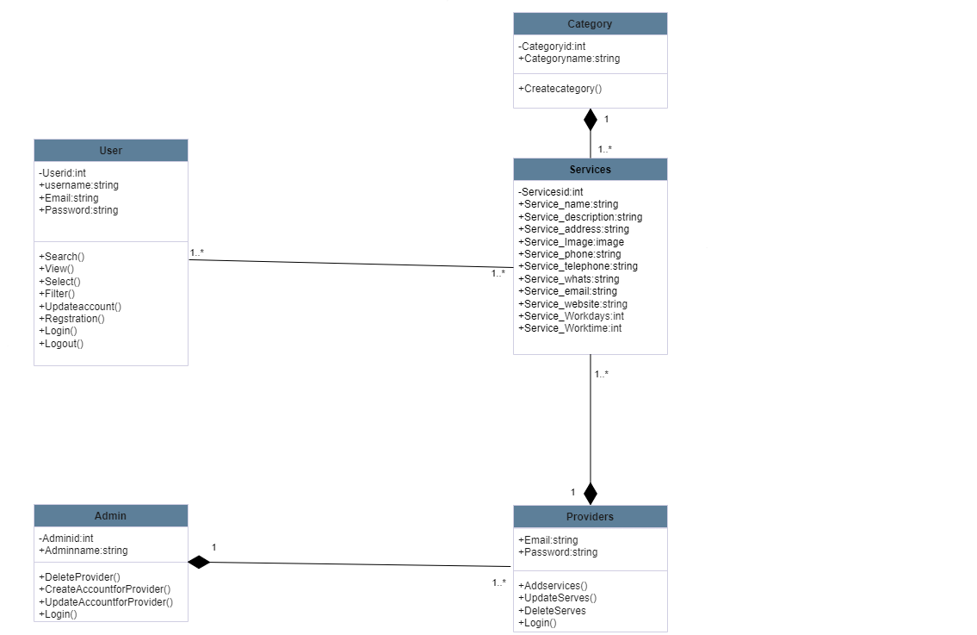

Figure 3.2: Class Diagram

System Design

Entity Relationship Diagram
The following figure is describing the relationships between the tables of the database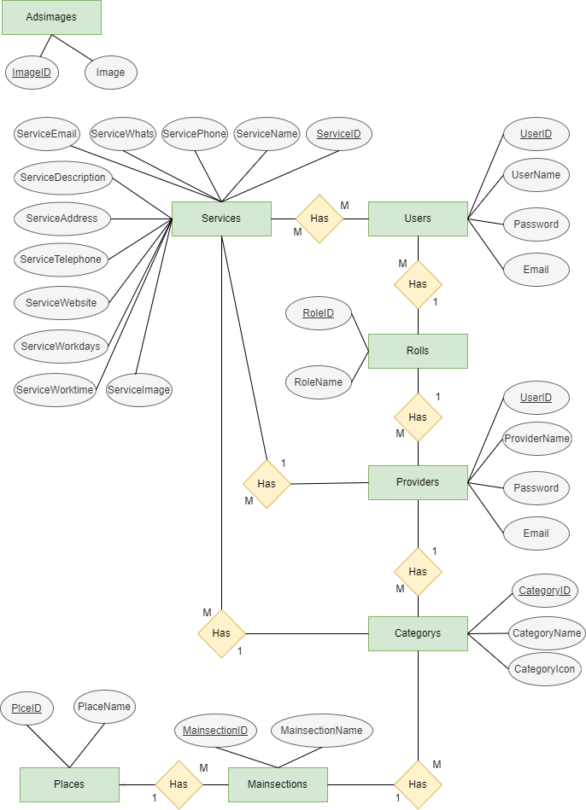
Figure 3.3: Entity Relationship Diagram

Database Diagram
The following figure is showing the data base of the application

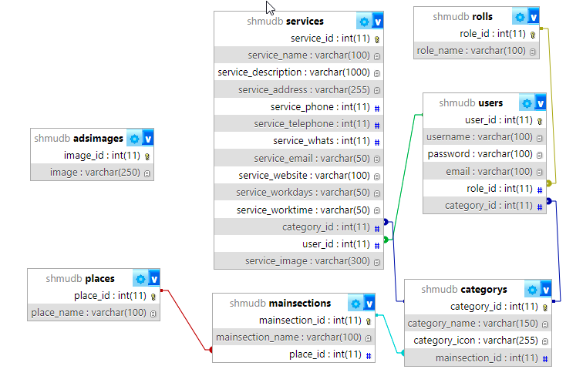

Figure 3.4: Database Diagram

Details of the Database Tables
The following tables is showing the database with the description
Adsimages: contains the Adsimages Images
Table 3.16: table of Adsimages
No | Field Name | Data Type | null | Description
1 | ImageID | int(11) | Not null | Adsimages number is a primary key
2 | Image | varchar(250) | Not null | Display the image of Ads

Mainsections: contains all the entities Mainsections
Table 3.17: table of Mainsections
No | Field name | Data type | null | Description
1 | MainsectionID | int(11) | Not null | Mainsections number is a primary key
2 | MainsectionName | varchar(50) | Not null | Displays The name of Mainsections
3 | PlaceID | int(11) | Not null | Foreign key from the Place table

Categories: contain the categories of the main sections
Table 3.18: table of Categories
NO | Field name | Data type | null | Description
1 | CategoryID | int | Not null | Category number is a primary key
2 | CategoryName | varchar(50) | Not null | Displays the category name
3 | CategoryIcon | varchar(255) | Not null | Displays the category icon
4 | MainSectionID | int(11) | Not null | Foreign key from the MainSections table

Places: contains the information of Places
Table 3.19: table of Places
NO | Field name | Data type | Null | Description
1 | PlaceID | int(11) | Not null | Place number is a primary key
2 | PlaceName | varchar(100) | Not null | Displays the place name

Rolls: contains the rolleid and name
Table 3.20: table of Rolls
No | Field name | Data type | Null | Description
1 | RolleID | int(11) | Not null | Rolls number is a primary key
2 | RolleName | varchar(50) | Not null | Displays name of the Rolls

Services: contain the information of Services
Table 3.21: table of Services
NO | Field name | Data type | Null | Description
1 | ServiceID | int(11) | Not null | The Services number is a primary key
2 | ServiceName | varchar(100) | Not null | Displays the name of the Services
3 | ServiceDesciption | varchar(1000) | Not null | Displays the description of the Services
4 | ServiceAddress | varchar(255) | Not null | Displays the address of the Services
5 | ServicePhone | int(11) | Not null | Displays the phone number of the Services
6 | ServiceTelephone | int(11) | Not null | Displays the telephone number of the Services
7 | ServiceWhats | int(11) | Not null | Displays the Whatsapp number of the Services
8 | ServiceEmail | varchar(50) | Not null | Displays the email of the Services
9 | ServiceWebsite | varchar(100) | Not null | Displays the website of the Services
10 | ServiceWorkdays | varchar(50) | Not null | Displays the workdays of the Services
11 | ServiceWorktime | varchar(50) | Not null | Displays the work time of the Services
12 | CategoryID | int(11) | Not null | Foreign key from the Category table
13 | UserID | int(11) | Not null | Foreign key from the User table
14 | ServiceImage | varchar(300) | Not null | Displays the image of the Services

Users: contain the information of the Users
Table 3.22: table of Users
NO | Field name | Data type | Null | Description
1 | UserID | int(11) | Not null | Users number is a primary key
2 | UserName | varchar(100) | Not null | Displays the name of Users
3 | Password | varchar(100) | Not null | Displays Users password
4 | Email | varchar(100) | Not null | Displays the email of Users
5 | RoleID | int(11) | Not null | Foreign key from Rolls table
6 | CategoryID | int(11) | Not null | Foreign key from categories table

Chapter Four
Implementation & Findings

4.1 Introduction
This chapter dives into the implementation details of our Android application. We'll explore the hardware and software that power the app, the development tools used to create it, and the user interfaces that users will interact with. This section provides a technical overview of the development process and the final product.

Hardware and software specification:
This section addresses the technical bedrock of our Android application. We'll explore the hardware and software requirements that ensure smooth operation. Here, we'll outline the minimum and recommended specifications for both aspects, allowing users to assess their device's compatibility and optimize their experience.

Hardware components
Minimum Hardware Requirements (Budget-friendly option):
- Processor: Quad-core processor (at least 1.8 GHz) - This can handle basic app usage and light multitasking, similar to processors found in entry-level or older mid-range devices.
- RAM: 2 GB RAM - Allows for running essential apps and basic background services without major slowdowns. This is becoming less common, but some budget phones might still offer this configuration.
- Storage: 2 GB storage - Provides enough space for the app itself, essential data, and a few additional apps. Users with limited storage might need to manage app installations carefully.
- Display: HD display (720p resolution) - Offers a decent viewing experience with acceptable sharpness for basic tasks like browsing and using social media.

Recommended Hardware Requirements (Smooth performance):
- Processor: Octa-core processor (at least 2.0 GHz) - Provides smoother performance for multitasking and more demanding app usage. This is commonly found in mid-range and some high-end devices.
- RAM: 4 GB RAM - Allows for seamless app switching and background processes, enabling multitasking without significant lag. This is becoming the standard for mid-range devices.
- Storage: 4 GB storage - Offers ample space for the app, user-generated content (if applicable), essential apps, and some additional data.
- Display: Full HD + display (1080p or higher resolution) - Provides a high-quality viewing experience with sharper visuals and richer colors, ideal for enjoying multimedia content and detailed graphics.

Software specification

- Operating System:
- Minimum Supported Version: Android 5.0 Lollipop (API level 21)
- Recommended Version: Android 12 (API level 32)
Choosing Android 5.0 as the minimum allows the app to reach a wider user base with older devices, while Android 12 ensures compatibility with the latest features and APIs used within the app.

Development Tools and languages
- Backend Languages: PHP v8.2.2.
Used to build the backend in our application, as REST API. So, the application can create, read, updated, or deleted data by using our API
- Frontend Language: Dart v3.3.4.
That language we used to create our application connectivity with flutter framework with the help of some external libraries for examples (http, shared preferences, image picker, etc..) .
- Framework: Flutter v3.19.6.
It’s an open source framework by Google that we use for building beautiful, natively compiled, applications from a single codebase. So, we used to create the frontend interfaces that will connect with backend.
- Database: MySQL v8.4.0.
Connect to instance of MySQL and create database, tables, and its processes.
- Server: XAMPP v8.0.30.
Used for scripts written in the PHP programming languages. Where the Apache server was used in the application.
- Editor: Visual Studio Code v1.83.0.
The main integrated development environment that we work on it, and it's powered by Microsoft. It allows us to create the interfaces that will be interactive with the user when it in last version with its backend.
- Design Diagrams: Draw.io v22.1.18.
An online free tool that u can use to create different kind of diagrams such as (class diagrams, database diagrams, etc..).

Interfaces

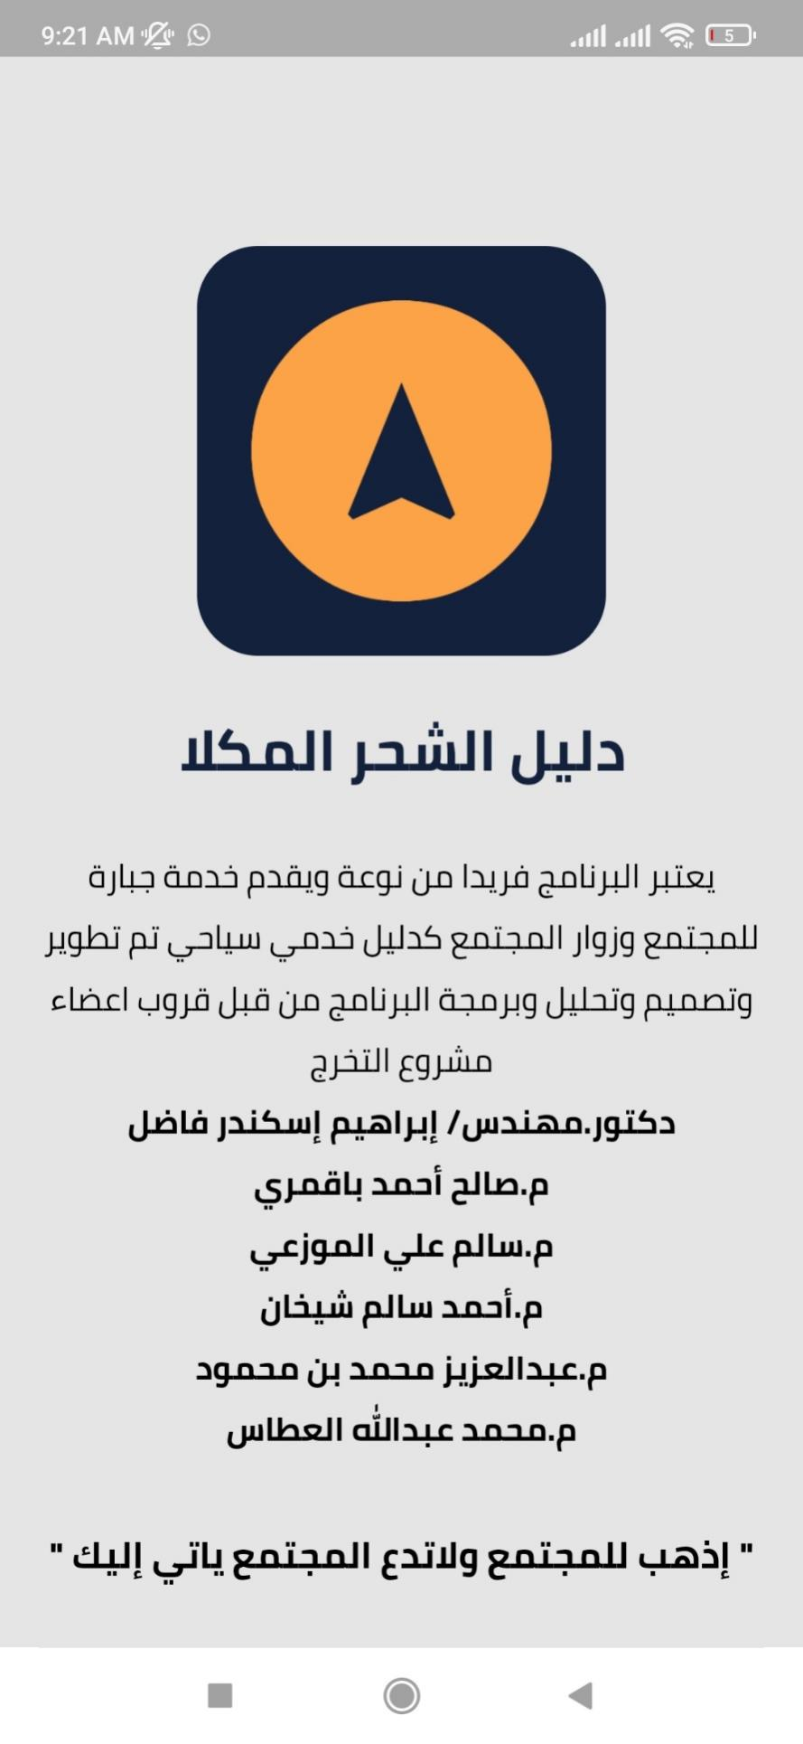

Figure 4.1 Onboarding interfaces

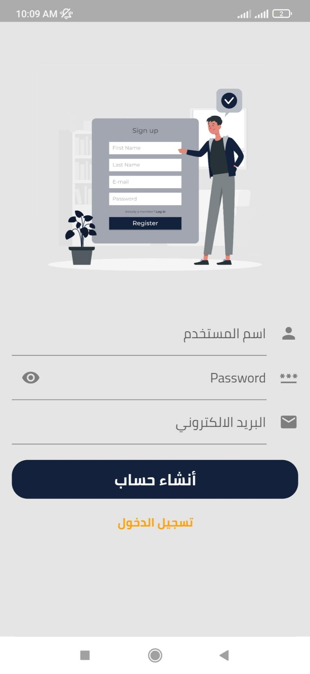

Figure 4.2 Register interface

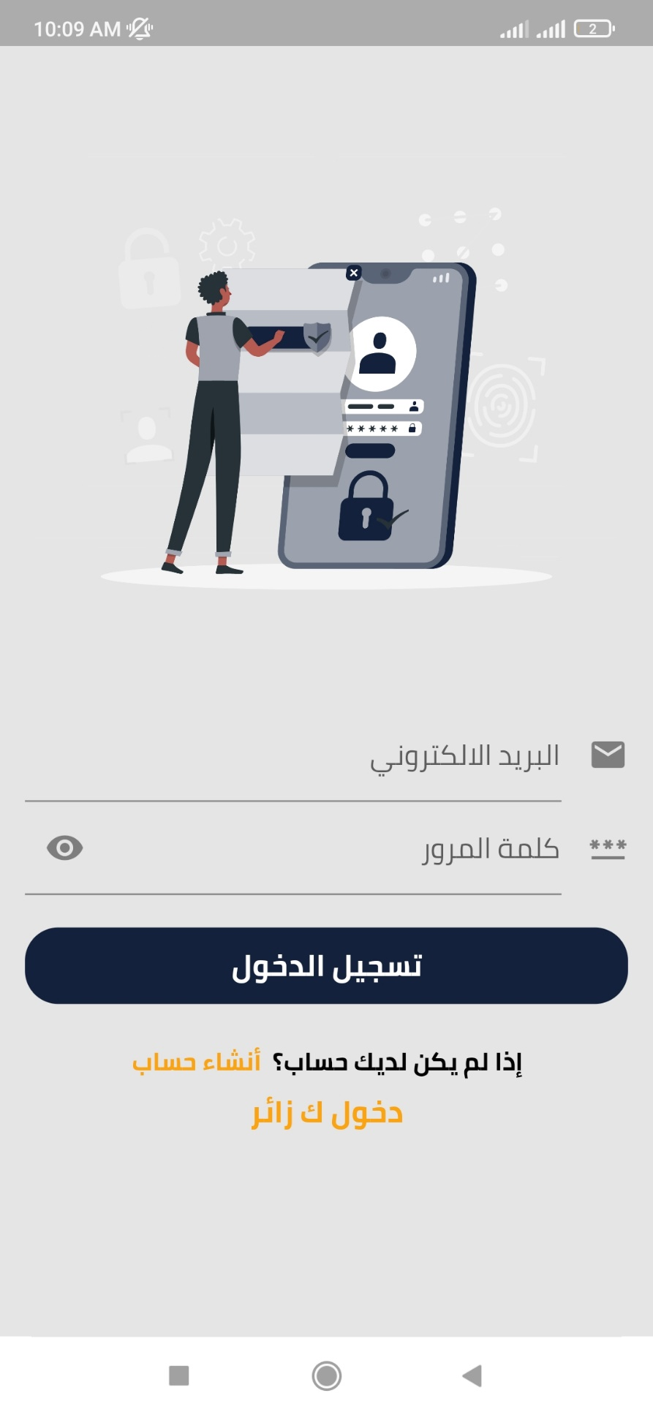

Figure 4.3 Login interface

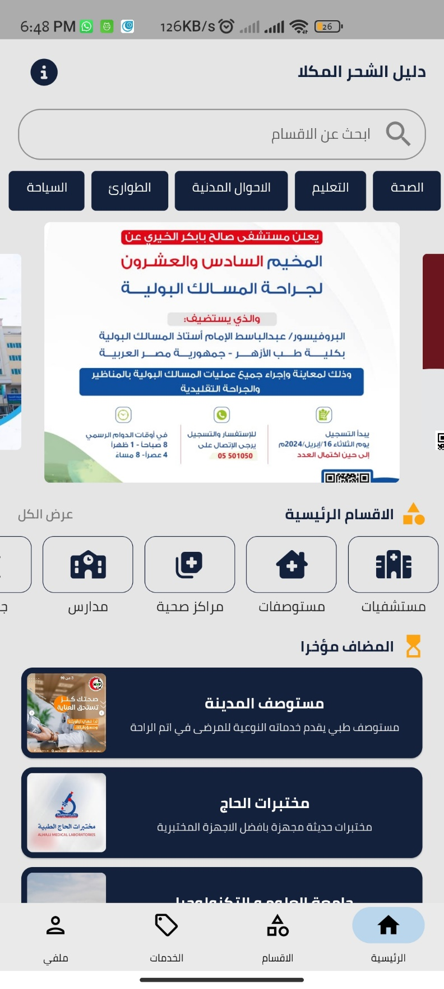

Figure 4.4 Homepage interface

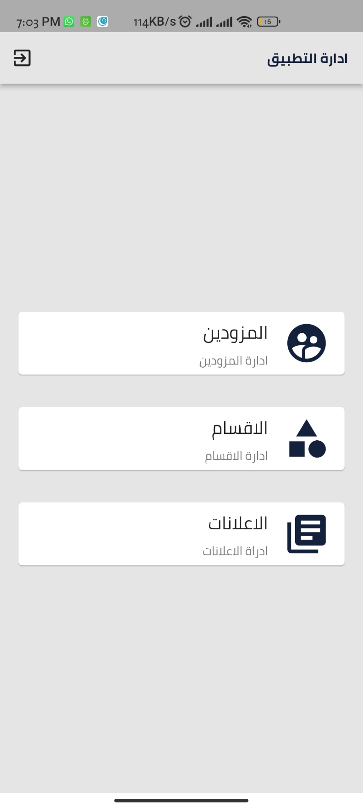

Figure 4.5 Admin Dashboard interface

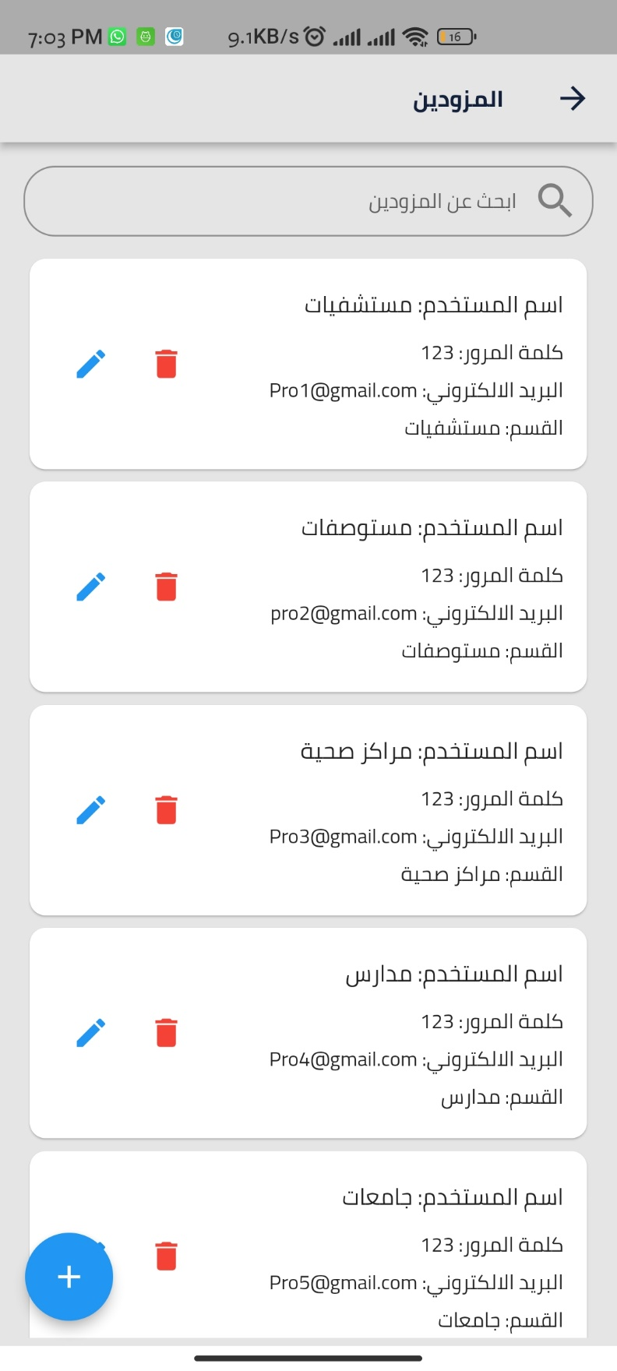

Figure 4.6 Providers Management Dashboard interface

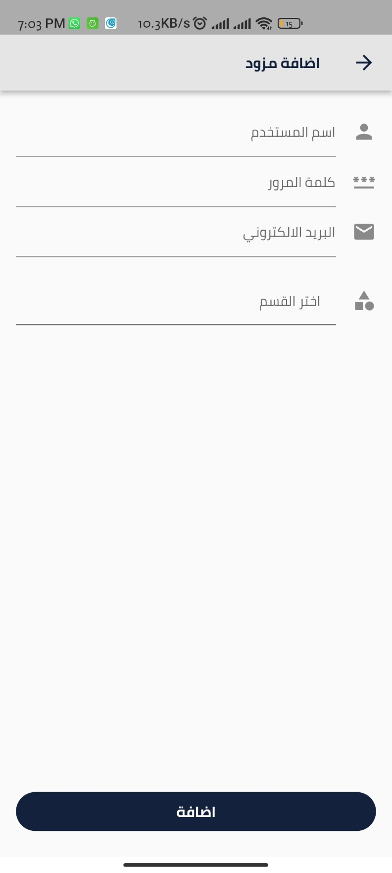

Figure 4.7 Adding Providers interface
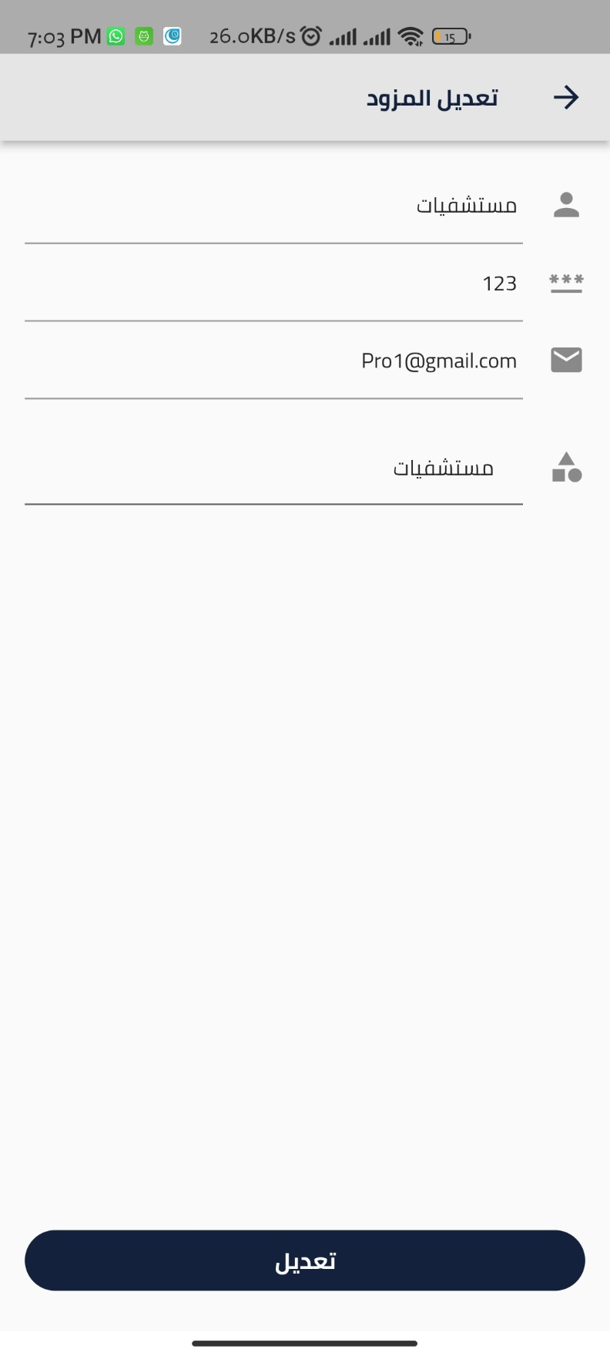

Figure 4.8 Update Providers interface

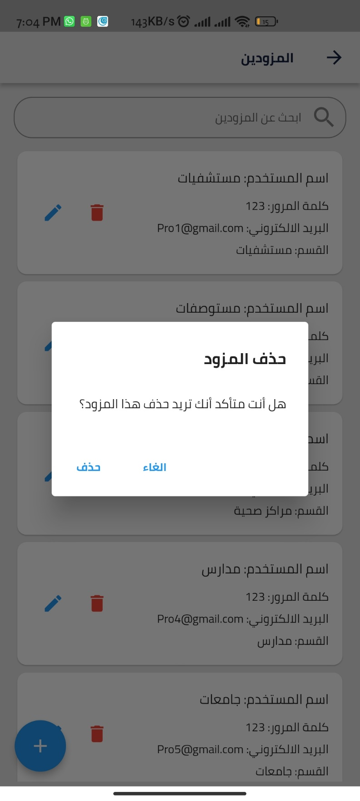

Figure 4.9 Delete Providers interface

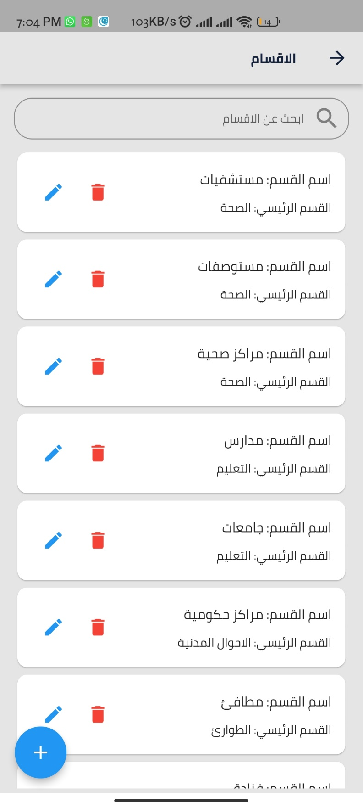

Figure 4.10 Categories management dashboard

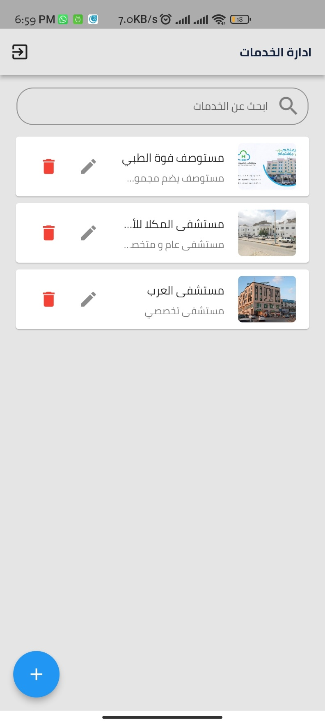

Figure 4.11 Provider management dashboard
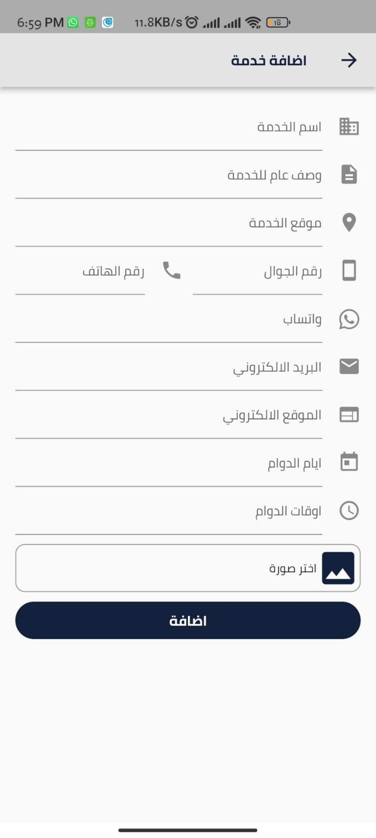

Figure 4.12 Provider add services interface
Figure 4.18 Categories section interface
Figure 4.20 Profile management interface
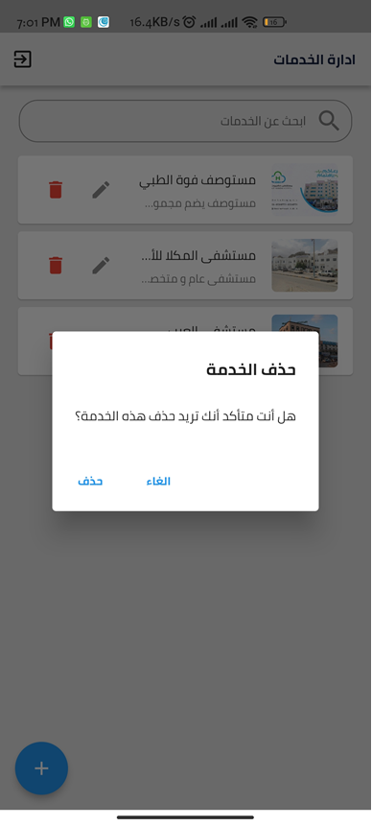

Figure 4.13 Provider delete services interface

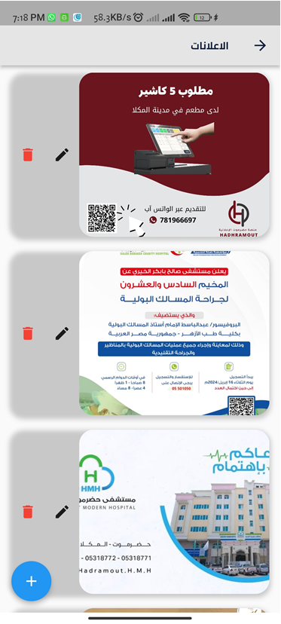

Figure 4.14 advertisements management page

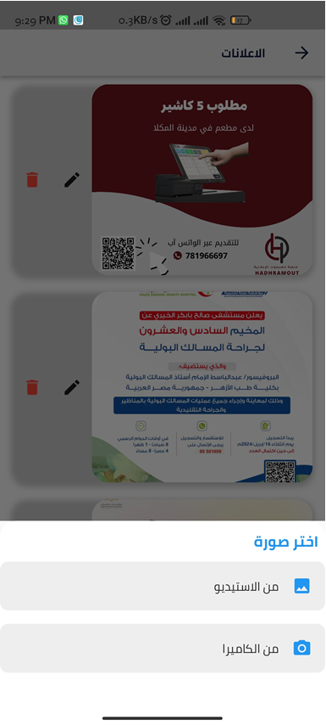

Figure 4.15 advertisements image selection

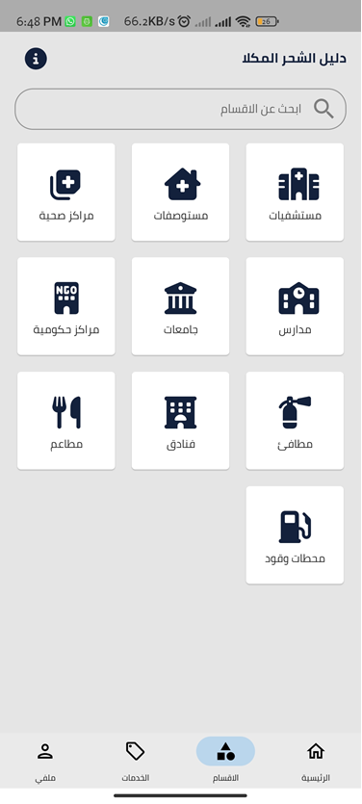

Figure 4.16 Categories interface

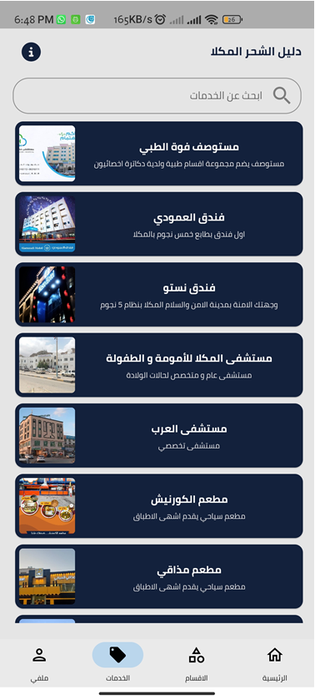

Figure 4.17 Services interface
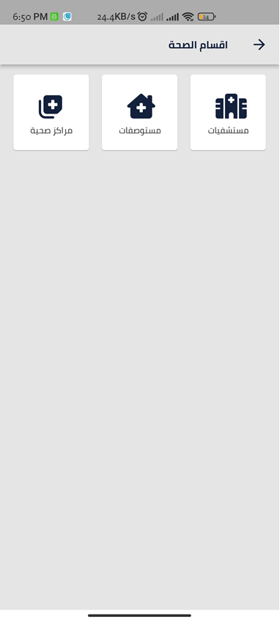

Figure 4.18 Categories section interface

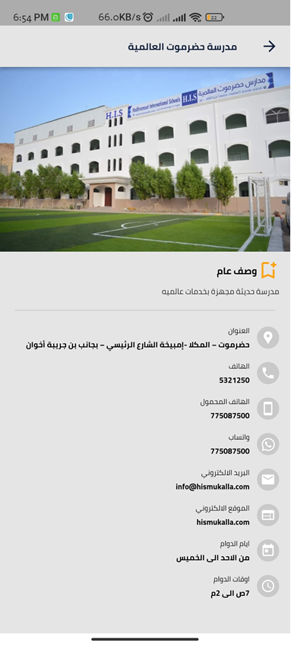

Figure 4.19 Service interface
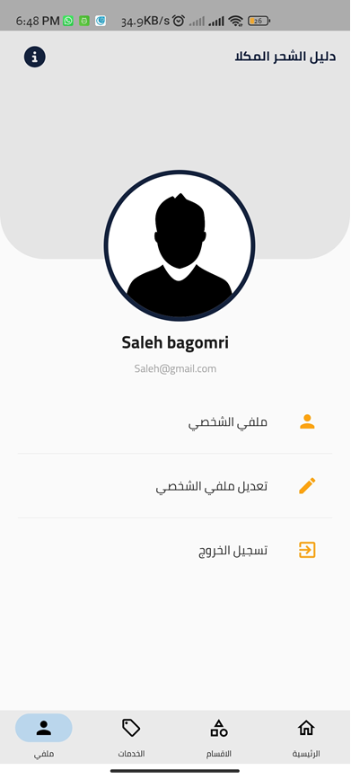

Figure 4.20 Profile management interface
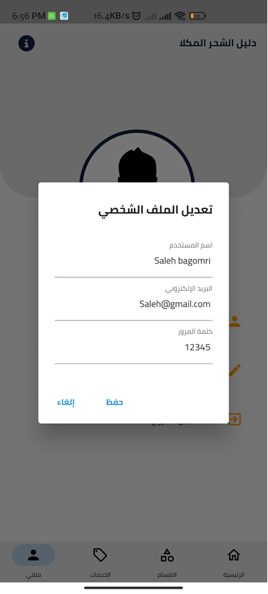

Figure 4.21 Profile update interface

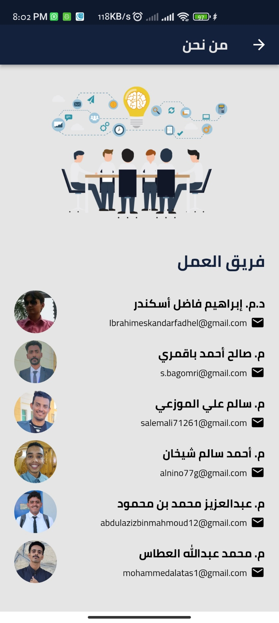

Figure 4.22 who are we interface

Chapter Five
Conclusion & Future work

5.1 Introduction
In this final chapter, conclusion of our research is presented briefly which illustrated the final summery of the project accompanied with the future work.

5.2 Conclusion
The objective of the project was to provide a user-friendly and centralized platform for information about government and private services, so users will be able to know the information and requirements of each service without visiting the entity. To achieve these objectives we collaborated with the government and private units. Thus, the government and private units can add or update their services which will help users to obtain up-to-date information. We also provided an easy-to-use Graphical interface which allow users to search for a specific service either using a Keyword or filtering the services based on their categories. The methodology we used to analyze and build our project was waterfall.

5.3 Future work
- Planning to add rating feature soon
- Expansion outside al-mukalla and al-shehr
- Adding map to determine the location of the entity

5.4 Reference
[1] H. T. R. Freddy, W. Achmad, and M. S. Nasution, “The Effectivity Of Public Services Based On Smart Goverment In Bukit Raya Distric Pekanbaru City,” J. Gov., vol. 7, no. 1, pp. 239–259, 2022.
[2] J. Trischler and J. Westman Trischler, “Design for experience–a public service design approach in the age of digitalization,” Public Manag. Rev., vol. 24, no. 8, pp. 1251–1270, 2022.
[3] E. Dong, H. Du, and L. Gardner, “An interactive web-based dashboard to track COVID-19 in real time,” Lancet Infect. Dis., vol. 20, no. 5, pp. 533–534, 2020.
[4] M. Wali, R. Akbar, T. Iqbal, and F. P. Al-Bahri, “Development of an android-based tourism guide (A case study: Sabang City, Indonesia),” Int. J. Sci. Technol. Res., vol. 8, no. 11, pp. 887–893, 2019.
[5] C. Frisby, R. Eikelboom, F. Mahomed-Asmail, H. Kuper, and D. W. Swanepoel, “m-Health applications for hearing loss: a scoping review,” Telemed. e-Health, vol. 28, no. 8, pp. 1090–1099, 2022.
[6] T. Isakowitz, M. Bieber, and F. Vitali, “Web information systems,” Commun. ACM, vol. 41, no. 7, pp. 78–80, 1998.
[7] I. Sommerville, Engineering software products. Pearson London, 2020.
[8] I. E. I. Fadhel, S. Z. B. S. Idrus, M. S. Y. Abdullah, A. A. E. A. Ibrahim, M. Omar, and A. Ghazi, “An Integration between Information Systems Engineering and Software Engineering Theories towards Engineering a Novel Instrument and Framework of Web-Based systems Success: Results of the Pilot Test,” in Journal of Physics: Conference Series, 2020, vol. 1529, no.2, p. 22007.
[9] A. Rodov and J. Teixidó, “Blending agile and waterfall: the keys to a successful implementation,” 2016.
[10] M. Wali, R. Akbar, T. Iqbal, and F. P. Al-Bahri, “Development of an android-based tourism guide (A case study: Sabang City, Indonesia),” Int. J. Sci. Technol. Res., vol. 8, no. 11, pp. 887–893, 2019.
[11] Platform . (2017, July 26). دليل اليمن [Android application]. Retrieved from https://play.google.com/store/apps/details?id=com.wneet.yemendirectory.
[12] Developer Hisham. (2023, August 7). دليل اطلس الشرق التسويقي [Android application]. Retrieved from https://play.google.com/store/apps/details?id=com.client.guide.atlas.east

