**User Manual of School Supplies Cost Calculator**

1. Brief Description of the app

This manual is users guide on how to use the School Supplies Cost Calculator.

1. There are two windows in this application. When user invokes the application, two windows appear.
   1. Supply Entry Window.
      1. This is for entering quanties of school supplies as it appears in the following picture:

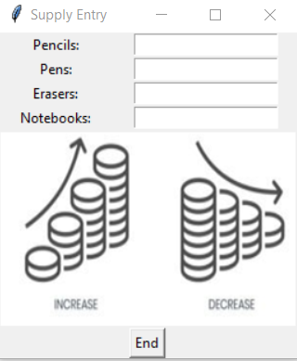

ii) This window allows user to enter any value equal to or greater than zero. A negative value and a floating point values are considered invalid and results in a meesage asking user to enter a valid value as following:

1. This Supply Entry window also has an end button which the user presses to exit the program. Once the supply quantities are entered by the user, the user proceeds to the Cost Calculation window.
2. Cost Calculation window
   1. This window allows user to calculate cost of each items as well as total cost of all items by pressing the Calculate Cost button.

* 1. It also allows user to apply a 10% discount by clicking the Apply 10% Discount button as shown in the picture above. When user clicks on the discount button, the calculated cost of each item and the total cost is reduced by 10%.