Student: Saleh Bhai.

Following is the validation steps taken to validate the Final Project for the SDEV course.

Validation is broken into two parts essentially.

1. Validating the expected behavior that is running the application through different valid input values and noting the results in form of screen capture.
2. Validating the behavior when invalid inputs are provided, such as negative quantity and noting the output in form of screen capture.

Cost of each item, pencil = $1 for pen = $3 eraser = $1 and notebook = $5

1. Enter following supply quantities and determine exptected output. Then execute program and take screenshot of the results.
   1. Input
      1. Pencil = 1, pens = 1, erasers = 1, notebook = 1.
   2. Expected output
      1. Pencil = 1, pens = 3, erasers = 1 and notebook = 5 and total cost = $10
      2. Results are following and as expected:
         1. A screenshot of a computer screen

            Description automatically generated
      3. After applying 10% discount
         1. Expected output: Pencil = 0.9, pens = 2.7, erasers = 0.9 and notebook = 4.5, total cost = $9
         2. Results are following and as expected:
         3. 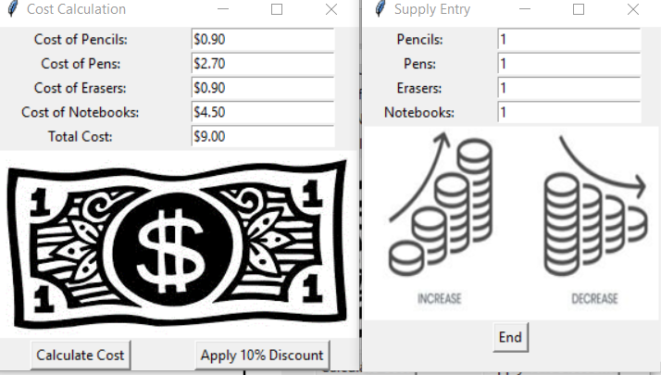
   3. Input
      1. Pencil = 3, pens = 5, erasers = 3, notebook = 7.
   4. Expected output
      1. Pencil = 3, pens = 15, erasers = 3, notebook = 35
      2. Results are following and as expected

* + 1. After applying 10% discount-expected output:
       1. Pencil = 2.7, Pens = 13.5, erasers = 2.7, notebook = 31.5, total=$50.4
    2. Results as expected
       1. 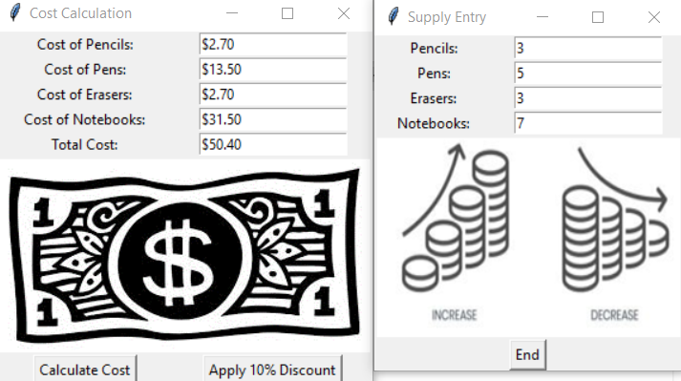
  1. Input
     1. Pencil = 5, pens = 3, erasers = 1, notebook = 5
  2. Expected output
     1. Pencil = 5, pens = 9, erasers = 1, notebook = 25, total = $40
  3. Results are following and as exptected
     1. 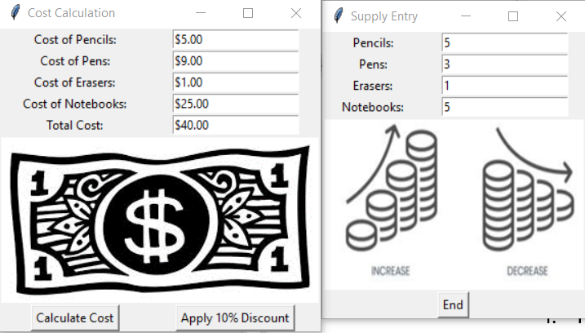
     2. After applying 10% discount-expected results
        1. 4.5, pens = 8.1, erasers = 2.7, notebook = 22.5, total = $36.0
     3. Results are following and as expected
        1. 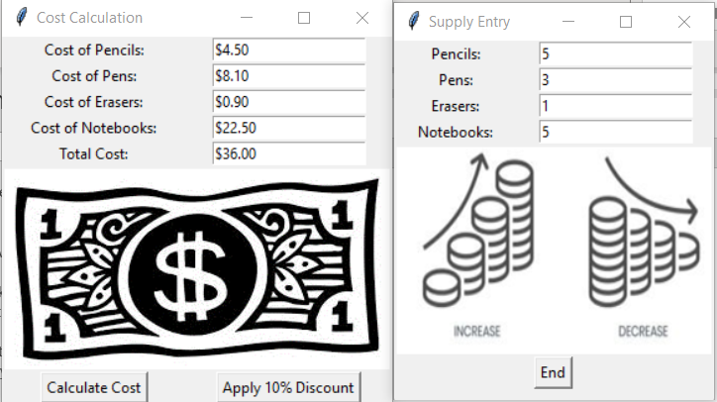

1. The following checks output when invalid input is entered
   1. Enter floating point value for pencil quantity of 5.5
   2. Expected output is “Please enter valid integer quantities”.
   3. Actual output mataches expected and is following:
      1. 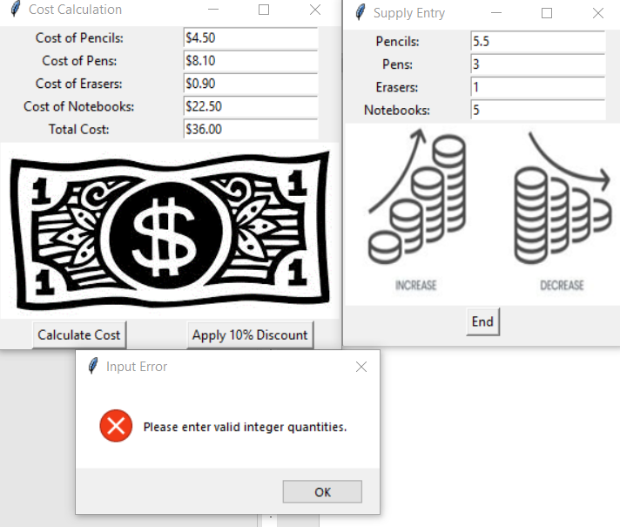
   4. Enter a negative value for the quantity for pen of -1
   5. Exptected output is “Please enter valid integer quantities”.
   6. Actual output mataches expected and is as following:
   7. 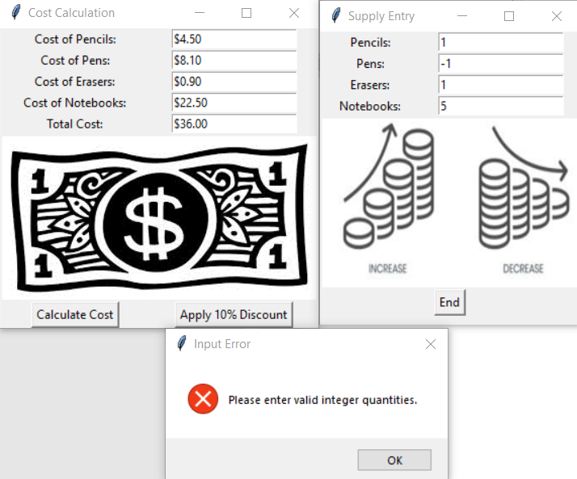
2. Results are as expected because both valid inputs resulted in expected output as well as invalid input.
3. What I had to fix is detecting negative quantity values as invalid. At one point only floating point quantity values, I detected as invalid then added another condition to detect any quantities below 0 as invalid also. This I realized while testing it. I thought that was important to do that as quantities of these school supplies can either be zero or a positive integer value.