Saleh alshehri
436108011

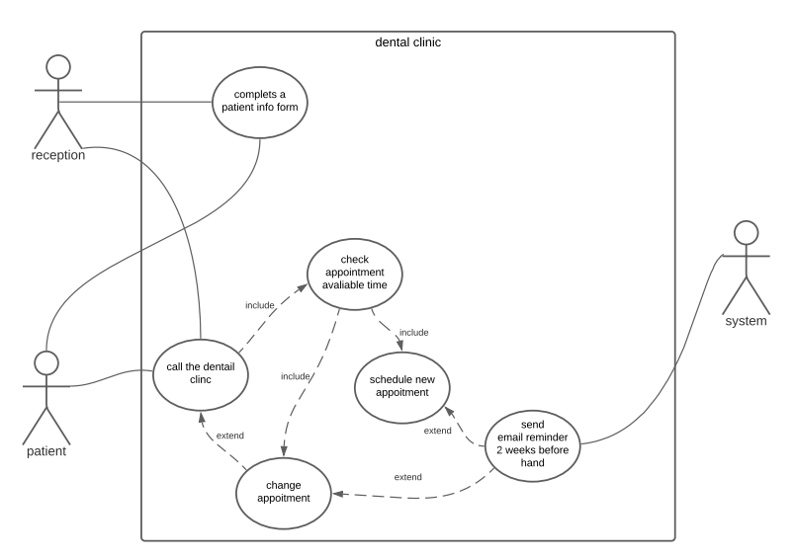

complets a patient info form: necessary, atomic, testable, feasible, unambiguous
call the dentail clinc: necessary, atomic, feasible, unambiguous
check appointment avaliable time: necessary, atomic, testable, feasible, unambiguous
change appointment: necessary, atomic, testable, feasible, unambiguous
schedule new appointment: necessary, atomic, testable, feasible, unambiguous
send email reminder 2 weeks before hand: atomic, feasible, unambiguous

