1. **Distribution of points in high-dimensional spaces (10 points)**

**Warmup (0) points:**

1. In a 2-dimensional unit ball (a disk), around $20\%$ of the volume is located at most $0.1$ units from the surface.
2. In a 9-dimensional unit ball, around $60\%$ of the volume is located at most $0.1$ units from the surface.

In both of the previous cases we received those answers because the Volume of a d-dimensional ball can be described as: $V_{d}=k_{d}*R^{d}$. Where $R$ is the radius of the ball, $k_{d}$ is some constant.

**Exercise (10) points:**

We received the following plot for $n_{d}(ϵ)$ for $d=2..10, ϵ=0.2,0.1,0.01$:

As we can see in the plot, as the dimension- $d$ grows, the fraction of the volume for a given $ϵ$ value grows as well.

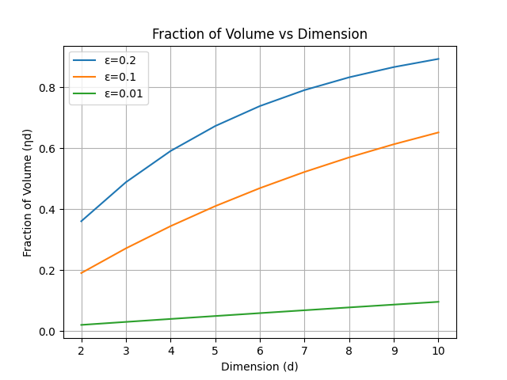

Discussion: As we saw in class, asymptotically, the nearest neighbor computation dominates the running time of sampling-based algorithms. In addition, from a set of $n$ sampled points the number of expected neighbors is $k_{r}=O(n ∙r^{d})$. Therefore, as the connection radius decreases the nearest neighbor computation time decreases because the expected number of neighbors decreases as well as apparent from the relationship above, and in turn decreases the overall computation time. Moreover, with a smaller connection radius could more accurately capture the connectivity of the configuration space and potentially lead to a better approximation of the optimal path, especially in cases with narrow passages.

1. **Tethered robots (20 points)**
2. A
3. A
4. A
5. **Motion Planning: Search and Sampling (70 points)**