**Lab Assignment 2:**

1. We received the following figures of the performance for the different goal bias values:

For

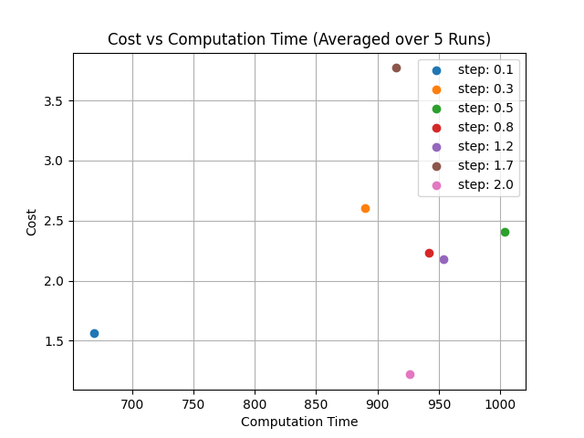

And for

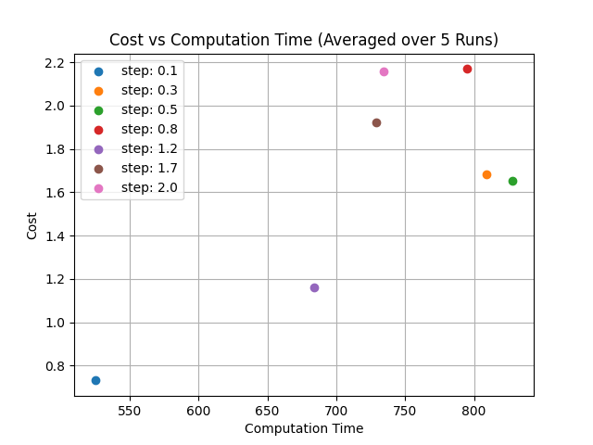

As we can see in the figures above, the average computation time for is generally lower than the computation time for . Moreover, the cost of the solution that was found is also generally lower for run with , this makes sense because for greater bias values we would expect a faster convergence to the solution. In addition, there weren’t many obstacles in the running environment in the path to the goal configuration hence whenever we take a step in the goal’s direction it’s more likely to be part of the shortest path to the goal, shortening both the path cost and computation time.

Furthermore, we can’t really distinguish a clear pattern between the step size and the performance. In both figures we noticed that was the value with either the best path or very close to it, meaning this value of step size is compatible with our environment. Other than that, we can’t really make a clear distinction between the quality of the paths based on the step size.

1. **from the paths you have found, Choose the path with the lowest cost and execute it on the UR5e manipulator. include a video that visualizes it.**

To open the video, double click on the icon below:



1. **Compare the path with the shortest time you found to the path found by OMPL.**

TODO