**BGTZ -- *Branch on greater than zero :*** Branches if the register is greater than zero  
 if $s > 0 advance_pc (offset << 2)); else advance_pc (4);

**opcode name description operation**

**000111 (7) bgtz rs, label branch if greater than zero if ([rs] > 0) PC = BTA**

**we don’t change in the data-path** 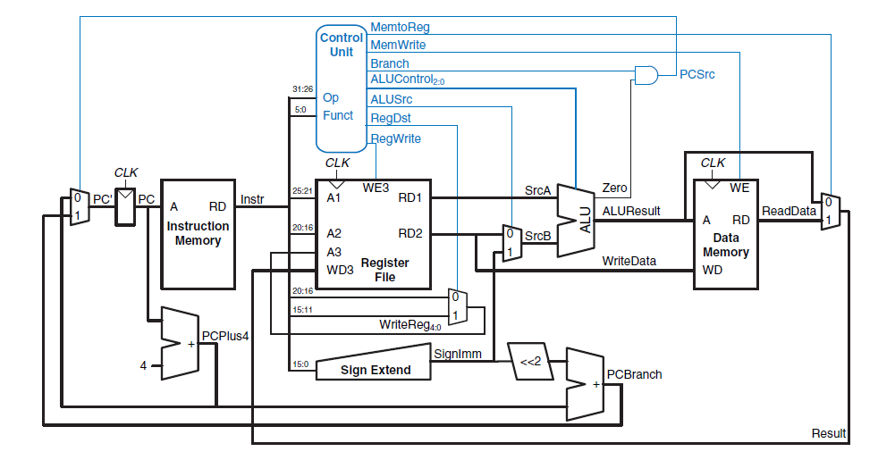

**Alu :**

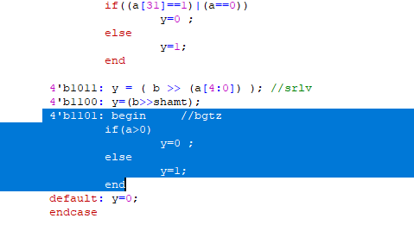

**Aludec :**

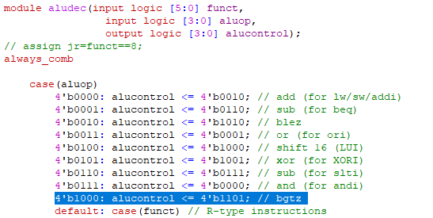

**Maindec:**

