Julia Abbott

Aleisha Smith

**Final Summary – Changes to the initial design:**

Our initial design did change quite a lot, in the way that it became a lot simpler. For example, the class BusBoy was removed, as were many functions in Menu.h, Customer.h, and Resturant.h. We also removed the double pay_rate variable from all of the children of Staff, and wrote functions that handed off control of the timing and of the simulation to the class Cycle.h, which, as its name suggests, controls what happens in a cycle, and how many cycles occur. We also went ahead and removed the option of having the user choose how many tables were in the restaurant, as it was refusing to work well with the rest of the program. Finances also increased in complexity, although the majority of functions that were added were get and set functions. Constructors were added to all of the classes with the exception of util, whose sole purpose is to ask the user whether or not they want to run the simulation again. The children of Menu also gained an iterator to find specific items in their maps of menu options. More detail is given in both the Final UML Diagram FinalSpec.jpg file and final_dd.docx.

**Final Summary – Graphs:**

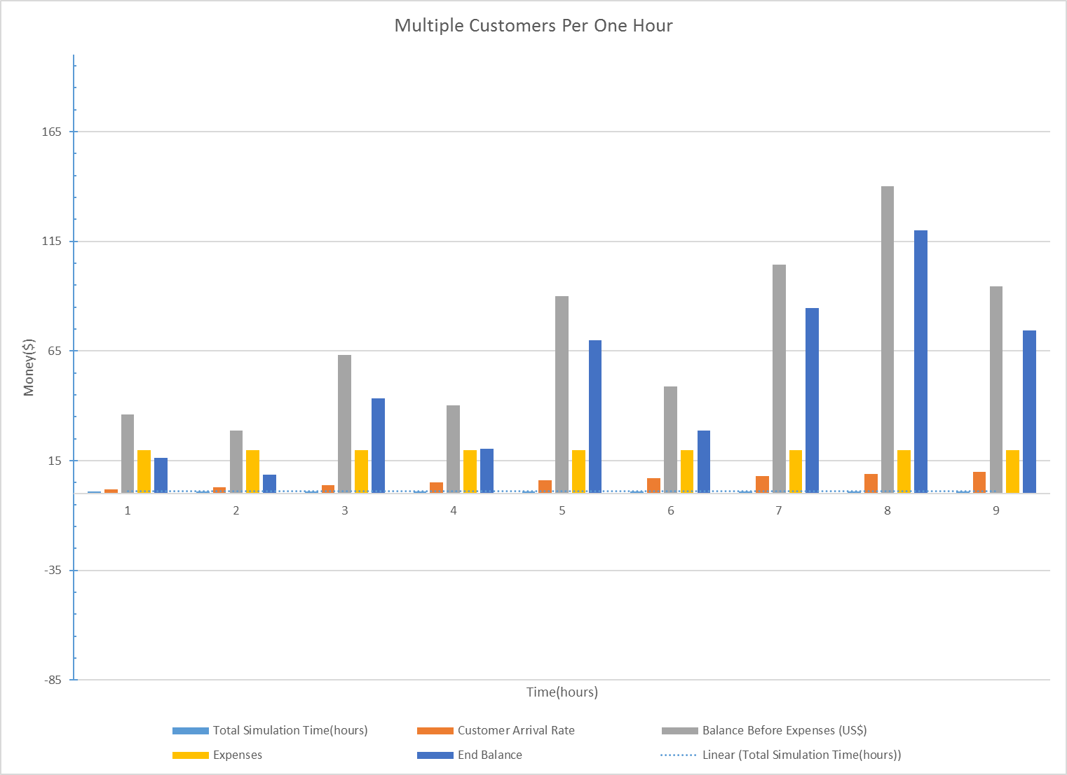

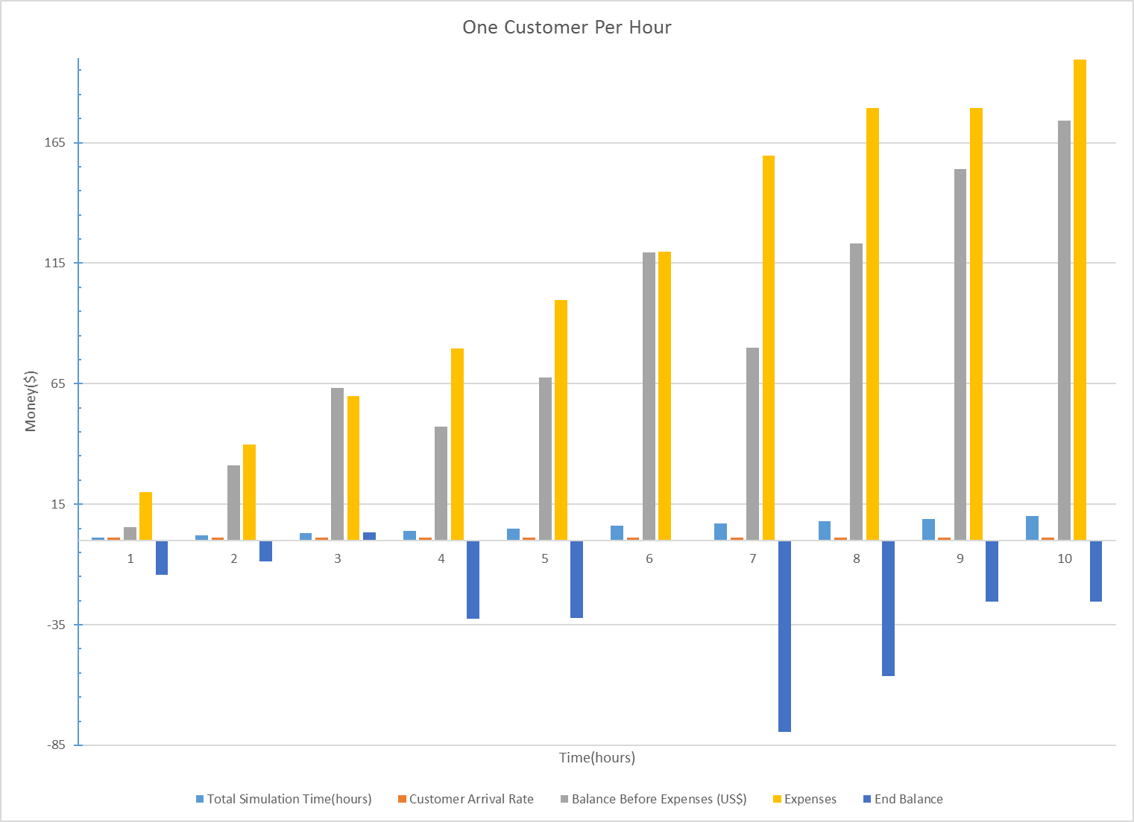

Note: The graphs are explained in more detail in final_dd.docx