FROM denoland/deno:2.1.7
EXPOSE 8000
WORKDIR /app
COPY . /app
CMD ["deno", "run", "start"]
The Dockerfile uses the deno base docker container, it exposes the port 8000, sets the working directory to “/app” and copies everything from the host current working directory into it, and then finally the command to run the application is “deno run start”, which is a task defined in my deno.json file, this command is the same as “deno –R –W –N –E ./src/mains.ts”.

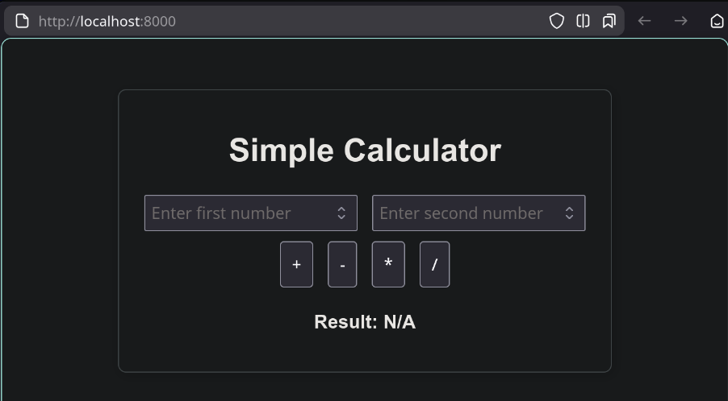
Here is the simple html site being served by the container.

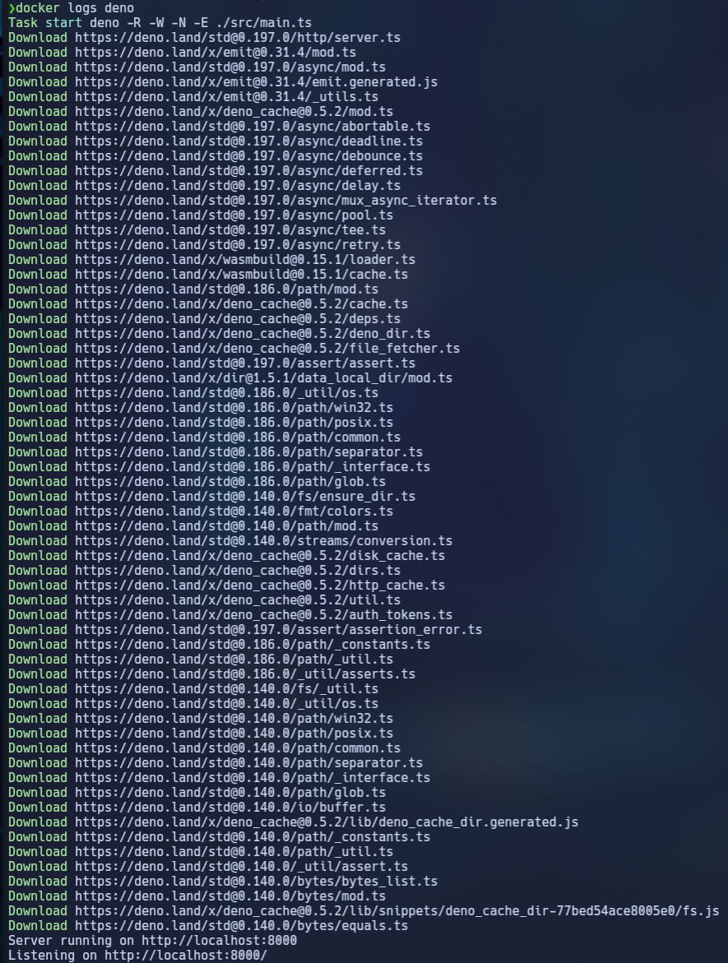
These are the logs of the docker container.

