Deployment Manual

# Document Description

The deployment manual is designed to provide a step-by-step guide for deploying the Text Based Role Playing Adventure. This document aims to ensure an efficient and error-free deployment process, catering to both novice and experienced users.

# Project Team

**Project members** (Students)

Gössl, Marcel, [if23b093@technikum-wien.at](mailto:if23b093@technikum-wien.at)

Salem, Karim, [if22b240@technikum-wien.at](mailto:if22b240@technikum-wien.at)

Schrenk, Dominik, if23b026@technikum-wien.at

Wirth, Sebastian, [if23b296@technikum-wien.at](mailto:if23b296@technikum-wien.at)

Table of Contents

Document Description 1

Project Team 1

Source Code Download 2

Software start - Integrated Development Environment 2

Question & Answer 4

Where can I download Visual Studio Code? 4

It is possible to use any configuration other than VS Code and Live Server? 5

Why are there no options to select after starting the game? 5

More Questions? 5

# Source Code Download

1. **Download the „ITP-Group-23-Project-main“ zip folder**.
2. **Navigate to the directory** where the folder is located. Per default, it can be found in the „Downloads“ folder on windows devices.
3. 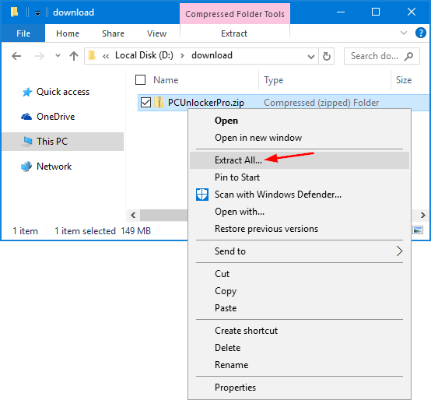**Unpack the ZIP archive** by right clicking the folder:
4. **Click „Extract“**:

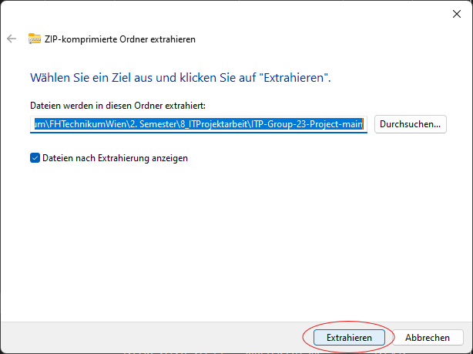

# Software start - Integrated Development Environment

For this part, an IDE (Integrated Development Environment) and a server are needed. In the following, the procedure is shown using Visual Studio Code in combination with the „Live Server“ extension.

1. **Install Visual Studio Code** (VS Code):  
   This step only needs to be executed when VS Code has not been installed on your computer!   
   If VS Code has already been installed, skip this part and continue with step 2.
2. 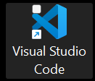**Open Visual Studio Code** by double clicking the application:
3. **Navigate to „File“ -> „Open Folder“**:  
   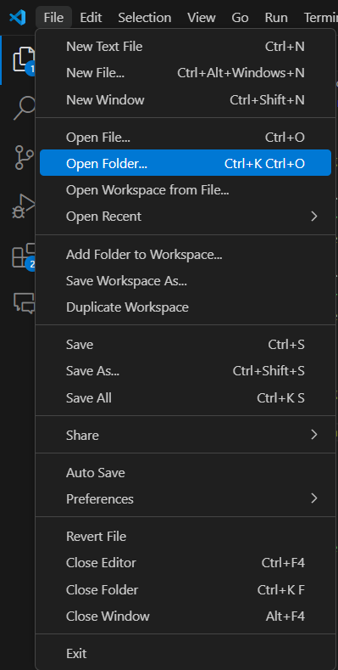
4. **Select the unpacked folder** from section ZIP Archive named „ITP-Group-23-Project-main“ and click „Open Folder“:  
   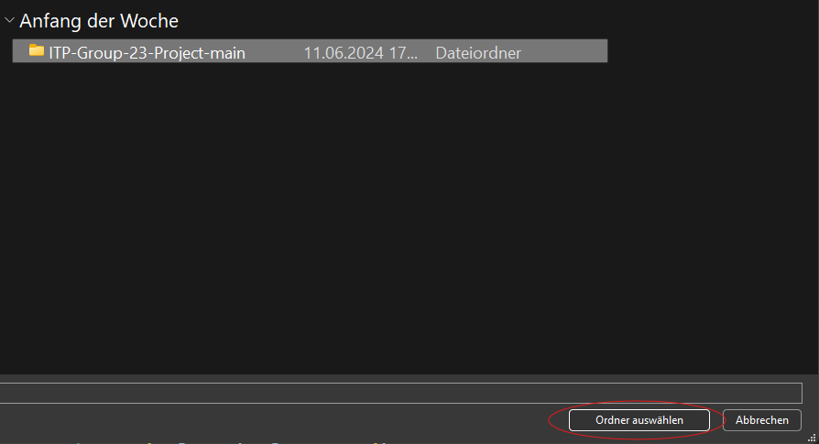
5. **Navigate to „Extensions“ and search for „Live Server“**:  
   This step only needs to be executed the „Live Server“ extension has not been installed on your computer! If it has already been installed, skip this part and continue with step 7.  
   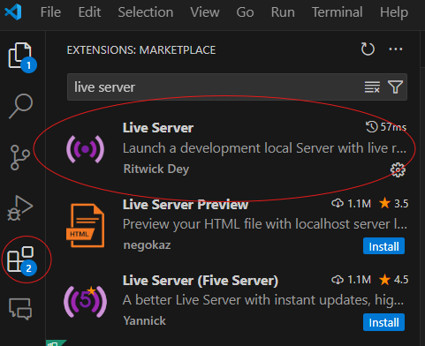
6. After selecting „Live Server“, **click on „Install“**:   
   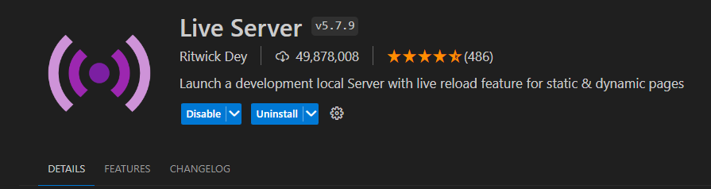
7. **Click on „Go Live“** in the bottom right:  
   
8. **Your default browser will open.** Now you are able to enjoy the game.  
   More detailed instructions on how to start the game can be found in the User Manual.

# Question & Answer

## Where can I download Visual Studio Code?

Visit the following page <https://code.visualstudio.com/download> and select your operating system. Proceed by executing the required steps to finish the download and installation.  
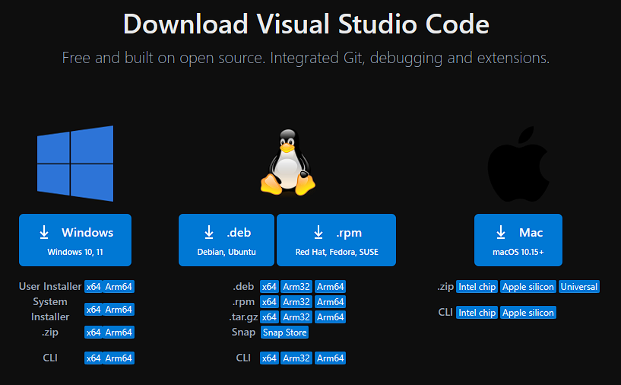

## It is possible to use any configuration other than VS Code and Live Server?

Please note that only VS Code and Live Server has been tested and are therefore the only options hat are supported from our team.

## Why are there no options to select after starting the game?

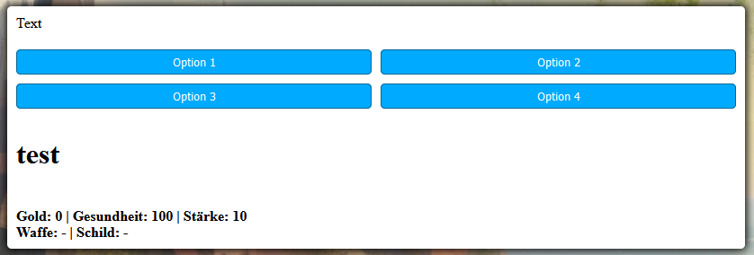

The cause of this issue is connected to the Live Server. Please execute the steps described during steps 5-8 in Integrated Development Environment.

## More Questions?

Please feel free to contact our support team:

Gössl Marcel: [if23b093@technikum-wien.at](mailto:if23b093@technikum-wien.at) (Project Lead & Minigame Engineer)

Salem Karim: [if22b240@technikum-wien.at](mailto:if22b240@technikum-wien.at) (Senior Backend Engineer & Software Design)

Schrenk: Dominik, [if23b026@technikum-wien.at](mailto:if23b026@technikum-wien.at) (Senior Backend Engineer & Creative Thinking)

Wirth Sebastian: [if23b296@technikum-wien.at](mailto:if23b296@technikum-wien.at) (Senior Full stack Engineer & Frontend Design)